Written contribution

by Sandya Ekneligoda

(wife of disappeared journalist and cartoonist Prageeth Ekneligoda)

On The Review of The Initial Report Of

Sri Lanka

Submission made to the Committee on Enforced Disappearances

July 2025
Public document

The following written contribution is prepared by me, Sandya Ekneligoda, wife of journalist and cartoonist Prageeth Ekneligoda, who disappeared on 24th January 2010. Since Prageeth’s disappearance, I have been struggling for justice for my husband over a period of 15 years. The journey for justice for my husband has been long and tortuous. Although the government appointed a trial-at-bar in 2019, the case pertaining to Prageeth’s disappearance has faced many postponements due to a lack of cooperation by state officials. Moreover, interference by government authorities in the form of pardons given to perpetrators by a Commission on Political Victimisation further eroded the space for justice to be delivered.

Those who see my quest for justice as a threat, have harassed me and threatened my life both within and outside of court. However, I strive to seek accountability for the disappearance of my husband despite the many challenges I have faced and continue to face.

Sandya Ekneligoda.
July 2025

Background:
At the time of his disappearance on 24th January 2010, Prageeth Ekneligoda, an investigative journalist and cartoonist working for Lanka e news, was involved in the presidential campaign of Sarath Fonseka, an opponent of the Rajapaksa regime’s second term in office, at the January 2010 Presidential elections. Prageeth who was abducted on a previous occasion in August 2009, was also putting together a dossier titled the ‘Family Tree’ based on the corrupt Rajapaksa family (extended family). In addition, Prageeth had also written an article regarding the use of chemical weapons by the Rajapaksa government in the war against the LTTE, a factor which resulted in his abduction in 2009.

On the day of the disappearance, 24th January 2010, I filed a police complaint at the Homagama police station following which, the police filed a B report at the Homagama Magistrates Court. However, the police took no interest in conducting an investigation into my complaint. The lack of progress in relation to investigating my complaint led my two sons and I, to file a writ of habeas corpus at the Court of Appeal on 19th February 2010 (Case No. CA writ 01/2010). This was referred to the Magistrates Court in Homagama (Case No. AR 3170/2011) and after many postponements, the hearings finally commenced in August 2011. The case dragged on, with the Criminal Investigation Department (CID) showing little interest in conducting investigations under the government headed by Mahinda Rajapaksa.

However, in 2015, following the election of a new government, the habeas corpus case was laid by and the IGP handed over the B report initially filed by the Police to the Criminal Investigation Department (CID). In October 2015, nine suspects were taken into custody followed by three others in September 2018. Thus, 12 suspects were taken into custody in relation to Prageeth’s abduction and subsequent disappearance. They included military intelligence officials, a Lieutenant Colonel, and a Corporal. The investigations carried out by the CID revealed that Prageeth had been abducted on the evening of 24th January 2010, detained in Colombo and later taken to a Military Intelligence Corp (MIC) camp located in Giritale where he was interrogated. Evidence led by the CID also showed that on the following day, i.e 25th January, 2010 he was taken to Akkaraipattu.

Based on the CID investigation of the B report filed at the Homagama police station and evidence led by the prosecution in more than 300 court hearings since 2015, the Attorney General, in November 2019, indicted 9 military intelligence officers on 17 charges including abetment, concealment of the design to commit a crime, unlawful assembly, kidnapping or abduction to murder, and murder. These charges were brought under section 450(4) of the Criminal Procedure Act No 15 of 1979 as amended by Act No 21 of 1988. A special trial at bar comprising three judges was appointed for the case (Case No: HC (TAB)725/19). Since then, the case has been heard at 60 trial dates across a span of 5½ years, facing numerous setbacks - particularly under the administration of President Gotabaya Rajapaksa (2019 - 2022), as outlined below.

In this report, I focus on the progress made in relation to the trial-at-bar.

Fifteen years have passed since the disappearance of Prageeth, and six years since a trial at bar was appointed in 2019. Despite the progress made in the Magistrate Court inquiry, the case has continued to face many obstacles including unaccountable delays, evidence tampering and prosecution witnesses turning hostile.

The International Convention for the Protection of All Persons from Enforced Disappearance Act, No. 5 of 2018 of Sri Lanka guarantees the right of any person who alleges that a person has disappeared, to report the facts and to have the case promptly and impartially investigated. Moreover, Section 17(1) of the Act makes the interfering in the conduct of an investigation and influencing the progress of one, through pressure, acts of intimidation or reprisal of complainants and witnesses a punishable offence. In the following report, I outline how many of these provisions are being violated in the case pertaining to Prageeth’s disappearance under the following themes:
- Evidence gathering and evidence tampering
- The timely prosecution and process of the case
- Threats and intimidation made to the survivor (Article 18 of the convention)

I also highlight the shortcomings of the Office for Missing Persons (OMP) and the manner in which appointments of officials to the office has contributed to my lack of confidence in the organisation.

1) Evidence gathering and evidence tampering
Key determinants in this case were the evidence given by two eye-witnesses at the Giritale camp and mobile phone logs of those involved in the disappearance of Prageeth. This evidence was vital in uncovering the identity of those who were involved in the abductions and more importantly revealing the identity of officials holding high office responsible for the abduction and consequent disappearance of my husband.

However, a few weeks after the trial-at-bar- was appointed, presidential elections were held in Sri Lanka and a new President, Gotabaya Rajapaksa was elected. In January 2020, the new President appointed a commission titled the Presidential Commission to Investigate Allegations of Political Victimisation (PCIAPV), which had an extremely negative impact on the trial at bar. It is no secret that the accused in the Ekneligoda case had a supporter interested in their exoneration in the former President.

Following the appointment of the PCIAPV, seven of the nine the accused in the Ekneligoda trial at bar filed complaints before this Commission, claiming that the police, despite a lack of evidence, took the accused into custody and charged them in the Homagama High Court. They also claimed that the charges made against them were without merit and based on a political witch-hunt. The complaint named Former Minister Mangala Samaraweera, Former Director, CID Shani Abeysekera, and several investigating officers of the CID for wrongfully charging the accused in the abduction and disappearance of Prageeth Ekneligoda.

In September 2021, the AGs Department informed the Trial-at-Bar that the 3rd witness for the Prosecution in the Magistrate Court inquiry into the disappearance of Prageeth Ekneligoda, Corporal Ran Banda (a retired army officer), was called as a witness to appear before the PCIAPV. Corporal Ran Banda had provided evidence at the Magistrate Court inquiry that he witnessed Prageeth at the Giritale camp and that to his knowledge Prageeth was brought there under the orders of Gotabaya Rajapakse who was then Secretary Defence.

The High Court ordered Corporal Ran Banda to not give evidence in any judicial or quasi-judicial forum in relation to this case. Nevertheless, on 29th September 2020 at the trial at bar hearing Ran Banda claimed that the commission strong armed him into giving evidence, when he went before the commission to inform them of the court order.

Moreover, when called upon to confirm his earlier evidence given to the Magistrate Court, Ran Banda retracted the earlier evidence and alleged that he was forced by the CID to provide false evidence implicating the accused. He claimed that he in fact had not seen Prageeth at the Giritale camp. The fact that Ran Banda had retraced his evidence due to intimidation by the Gotabaya Rajapakse government was pointed out by the AGs department during the cross examination of the witness.

A second key eyewitness in the case, Sumathipala Sureshkumar AKA Muralitharan (the 4th witness in the case who was a LTTE surrendee working as an army operative at the Giritale MIC), also retracted his statement in which he had given evidence in the hearings of the magistrate court case in 2015. At that hearing, Sumathipala Sureshkumar had given evidence that he had seen Prageeth at the Giritale camp and had been told by the 1st accused, Shammi Kumararatne, that the order was given directly by Secretary Defence, Gotabaya Rajapaksa to bring Prageeth to the camp.

Therefore, the appointment of the PCIAPV led to key witnesses backtracking on vital evidence provided by them due to fear and intimidation under a government led by Gotabaya Rajapakse, who was himself implicated in the court proceedings. The court advised the AG’s Department to file two cases against these two witnesses for providing false evidence in this case but this is to be done on the conclusion of the present case.

The PCIAPV on 24th November 2020 concluded that the Magistrate Court inquiry was an attempt by state officials to victimise the complainants. They went on to exonerate and acquit the accused despite the commission having no power to do so. In particular, the PCIAPV concluded:

- That the respondents (i.e the Police and AGs) were involved in wrongfully charging and detaining the complainants in the abduction and disappearance of Prageeth Ekneligoda based on fraudulent evidence.

- That all complainants (the accused) should be acquitted and released from all the charges in case no: B7417/2010 (erroneously reordered as 2015).

- The case against complainants 1,2,3 and 4 in case number HC 209/19 should be withdrawn and be made null and void.

- The MIC officers were subjected to political victimisation because they did not comply with the orders to provide evidence under section 127 of the Penal Code.

The PCIAPV went on to acquit all nine complainants from the charges in the HC trial at bar (HC TAB 725/19)

Some of the recommendations of the commission were as follows:
- With the exception of the 1st respondent all other respondents should be charged under the penal code for manufacturing evidence to politically victimise the complainants in this case.

- Respondents should be charged for producing false documents, manufacturing false evidence, aiding and abetting in the production of false documents.

- The respondents should be charged for wrongfully detaining the complainants under the PTA which amounts to a punishable offence under the penal code.

- The good name and reputation of the police department was undermined by the actions of the respondents and therefore action should be taken against them and that they should be punished accordingly.

- The complainants should be compensated for the personal damage and loss caused by the actions of the respondents. This included the restoration of the appointments made to positions made to diplomatic offices, restoration of loss of wages and wage increases, promotions, loss of seniority, and any harm done to the complainants. Complainants should be compensated for any setbacks to entry into schools of the children of the complainants.

Some General Recommendations made by the Commission were as follows:

- That the anti-corruption unit created by the United National Front government in 2015 in keeping with its election manifesto was aimed at targeting political opponents, including public servants, armed forces and police officers who were subjected to mental trauma as a result of the action taken against them by the anti-corruption unit. The commission determined that there should be a law prevent such political victimisation.

- That the CID had been subjected to extreme politicisation and the IGP should address this situation.

Thus the trial at bar in relation to the Ekneligoda case was seriously undermined by the PCIAPV which ensured that key witnesses withdrew their evidence in order to exonerate the accused. However, several other developments since then have completely delegitimised the PCIAPV.

In July 2022, President Gotabaya was ousted from power in a people’s uprising. Ranil Wickramasinghe was elected as President by parliament.

In March 2024, the Court of Appeal issued a writ of certiorari quashing the recommendations, findings, decisions and material of the Commission of Inquiry to Investigate Allegations of Political Victimisation during the United Front Government. The court determined that the PCIAPV had acted outside its mandate and that the findings and recommendations of the Commission were contrary to the principles of natural justice.

Moreover, in a dramatic reversal during the trial at bar hearing held on 4th April 2025, the 4th witness, Sumathipala Sureshkumar retracted the testimony he had given in 2020/21 (the testimony given under duress of the PCIAPV). He stated that he was forced to withdraw his statement given to the Magistrate Court in 2015 and that he is now seeking witness protections from the police.

Phone Records
In addition to the damage done to the trial at bar case by the PCIAPV, there were setbacks which occurred on various occasions due to the non-cooperation of private institutions and on the part of the court. A case in point is that in August 2023, the Attorney Generals (AGs) department requested the court that the phone records of certain mobile phone numbers be requested from service providers to be added to the court records. The court failed to give this order until 28 June 2024, i.e. close to a year later. A prominent mobile service provider then took the position that they did not hold records going beyond 3 months. Despite this proclamation by the service provider, the CID was later able to obtain phone records from over 5 years. On 18th September 2024, the said mobile provider gave evidence that the sim numbers pertaining to the case, belonged to the military and were paid for by the military. In addition, they provided vital evidence that these numbers were all linked to the same mobile tower as Prageeth’s sim on the day of his disappearance. They also informed court that two sims in particular were specifically allocated to make calls to Prageeth’s mobile number. As at April 2025, 3 mobile service providers have presented incriminating evidence in court (on the dates of 18.9.2024, 28.10.2024, and 6.12.2024) demonstrating the Army’s involvement in Prageeth’s disappearance.

2) Timely prosecution and process of the case:
Sec. 2 of The Code of Criminal Procedure (Amendment) Act (No. 21 of 1988) clearly states that a trial by the High Court at Bar shall, unless exceptional circumstances so warrant be heard from day to day to ensure the expeditious disposal of the same.

However, the trial at bar, unlike the trial at bar in other cases (eg. the rape and murder of Krishanthy Kumaraswamy in 1996, in which a verdict was delivered within a matter of months), has stagnated for six long years and is still in progress.

When the trial at bar was first initiated in 2019 the case proceeded at a fairly regular pace. However, over time, there are increasing delays in the hearings. The case which was called twice a month decreased in frequency to once a month in 2022. As at present, the case is sometimes heard approximately once in 3 months. Therefore, the intended purpose of appointing a trial at bar for the expeditious disposal of a case, has been defeated.

The Role of the AG’s Department
The AGs department played a critical role in indicting the nine accused in the Prageeth Ekneligoda case at a trial at bar. Yet, their interest and commitment to the case is not consistent. with each change of government, the position of the AG’s department keeps changing. Under the United National Front government (2015-2019) the AG’s office actively worked to prosecute the case. This situation however changed under the government of Gotabaya Rajapaksa. During the latter period, the AG’s department worked more in the interest of the state than fighting on Prageeth’s behalf. Even after Gotabaya Rajapaksa was ousted from power, the AG’s Department remained lukewarm. On 23rd May 2023, the Deputy Solicitor General, Dileepa Pieris even failed to make an appearance in court (See Annex 1- Letter written to AGs Department on the conduct of the DSG).

Turnover of Judges
Judges appointed to the case have been changed on numerous occasions and delays in appointing judges have resulted in undue interruptions and postponements. This is despite clear direction given in the Code of Criminal Procedure on the appointment of judges to a trial at bar. Certain appointments to the three-judge bench have also been questionable.

In 2021, Gihan Kulatunga, one of the judges in the three-judge bench trial at a bar, was replaced by Damith Thotawaththa, a former military judge with strong links to the army, which contributed to the case being in favour of the army (see Annex 2 and 3 - Letters written to Army Commander and Chief Justice on this matter). On 5th May 2023, the case was delayed by Thotawaththa on spurious grounds that the petitioner was not present. I wrote several letters asking for a change in the judge to no avail. On 11th March 2024, Thotawatte resigned and he was replaced with a new judge only in June 2024.

On 4th September 2023 one of the judges of the three-judge bench was promoted to the Court of Appeal and there was no replacement till 4th Apil 2024. As a result, although the case was called no orders were given with the case being prolonged without progress as it was a two-judge bench. However, the Code of Criminal Procedure (Amendment) Act (No. 21 of 1988) - Sect 2 clearly states that:
Where any Judge of the High Court at Bar dies, or resigns, or requests to be discharged from hearing the whole or part of any trial, before or after its commencement, or refuses or becomes unable to act, the Chief Justice may nominate another Judge of the High Court of Sri Lanka in his place, to hear whole or any part of such trial.

(e) Until such nomination is made the trial may be continued before the remaining Judge or Judges of the High Court at Bar and if no such nomination is made within one week of the death, resignation, discharge, refusal or inability to act referred to in paragraph (d), the trial shall be continued and concluded before the remaining Judge or Judges, of such High Court at Bar.

On occasion, there have also been instances where the representatives from the AGs Department and the CID were not present purely due to the failure of court to inform or remind them of the court case. Therefore, the trial at bar appointed with the intention of expediting justice in a timely manner, is now dragging on at a snail’s space and still on-going.

Persecution and arrest of key investigators
It must also be mentioned that four top investigators who were responsible for uncovering vital evidence which would have ultimately revealed the involvement of former President Gotabaya Rajapakse in this case, were persecuted because of their role in this and other cases. These senior police officials played a central role in the investigation of Prageeth’s disappearance. In particular Director of the CID Shani Abeysekera along with two other officers were arrested on spurious grounds, accusing them of fabrication false evidence. However, under the newly elected National Peoples Power (NPP), one Government officials have been reinstated and now hold key positions. (See annex 7)

3) Threats and intimidation made to the survivor:
As a survivor, I have faced isolation from friends and family and the general public due to my search for justice and accountability for the disappearance of Prageeth which I have highlighted internationally. As a consequence, I have attracted unwanted attention from security and intelligence forces leading to friends and family fearing reprisal for their association with me. In an interview given in 2021 I stated:

I have faced many trials in the quest for justice for my husband. The state continues to deny the disappearance of Prageeth, with Mohan Pieris, the Attorney General in 2011 claiming at the UN CAT Committee meeting in Geneva, that Prageeth had taken refuge in a foreign country. Following my visit to Geneva to attend a side event at the 19th session of the United Nations Human Rights Council I was harassed at length in court, by the Deputy Solicitor General, appearing for the Attorney General’s department on issues pertaining to the sponsorship of my travel expenses to Geneva and as to why I had taken the matter of the disappearance of my husband to the UN Human Rights Commission.

Statements were also made against me by members of parliament representing the United Peoples Freedom Alliance headed by the Rajapaksa’s. Between 2010 to 2014, prominent politicians alleged that I was lying about the disappearance of Prageeth as I did not shed tears for my husband in public. A member of parliament alleged that Prageeth was living abroad.

I was therefore compelled to summon two public officials to court to share evidence if any, of Prageeth’s whereabouts. Consequently, both officials admitted in court that their statements on the whereabouts of Prageeth Ekneligoda was based on hearsay.

In 2016, a Buddhist monk, the leader of the Bodu Bala Sena, called me a traitor and claimed that my husband belonged to a terrorist group popularly known as the Tamil Tigers. His very words in court that day are imprinted in my brain “Your husband is a tiger; you should go and beg.” In the wake of this incident there was a spike in harassment and hate speech posts against me on social media threatening to kill my sons and feed them to me. Moreover in 2019, I was subjected to harassment in busses, three wheelers, shops and more damagingly, I was not given any cooperation at the courts due to the nationalist narratives and propaganda floated against me by the incumbent government (see Annex 4).

Consequently, in 2018, the Buddhist monk, was convicted by Court of Appeal for his behaviour against me that day. The court ordered the monk to pay Rs 50,000 as compensation, which was handed over to me in two bags of small change. At the judge’s request, I was compelled to count the coins myself. Upon realizing that this was a deliberate attempt by the monk to ridicule and harass me further, the judge instructed him to provide compensation in easily countable currency.

The monk who was convicted for his conduct in court in 2018, initially received a 6 year prison sentence. However, following his appeal in 2019, he was given a reduced sentence of 5 years. He was consequently granted a Presidential pardon by President Maithripala Sirisena in a separate case, allowing him to walk free.

The governments law enforcement agencies have not hesitated to use force against me during my participation in campaigns for justice. In 2023, during a peaceful ceremony at the Borella cemetery commemorating those killed during the July 1983 riots, I sustained injuries as a result of being manhandled by riot police deployed to disrupt the peaceful event. During my participation with other family members of the disappeared in Kilinochchi in 2021 I was under surveillance and have been photographed by military intelligence operatives of the government. Moreover, in 2022, when I tried to lodge a complaint regarding a military intelligence officer tyring to obtain my phone number, the Fort Police station refused to accept my complaint.

Despite assurances given in the Enforced Disappearance Act section 16(2) that provides that “any relative of a person deprived of liberty, … shall be protected from any ill-treatment, intimidation or sanction as a result of the search for information concerning a person deprived of liberty,” in the prevailing climate of violence and intimidation, I live in continuous fear for the lives of my two children who have been followed by unknown parties and threats made to their lives on multiple occasions.

- The shortcomings of the Office for Missing Persons (OMP)
In In 2018, the government appointed the Office on Missing Persons (OMP) as an office in perpetuity to search for the whereabouts of the disappeared persons. The OMP has considerable power to search for the missing and the forcibly disappeared. Yet, the credibility of the OMP has been undermined due to several reasons.

The OMP when it was first established under its first Commissioner was more effective than it is today. At the time, the OMP actively engaged with my case, mediated witness protection for me, and were present at all my court hearings in Colombo. Yet, some governments have sought to make various political appointments to the OMP as its Commissioners. It should be noted that the Government under Gotabaya Rajapaksa went on to appoint the head of the infamous PCIAPV as the Chief of the Office on Missing Persons (OMP) in 2020 after he had directed significant damages to, not just the case pertaining to Prageeth but several other cases on disappearances and undermining evidence given by key witnesses in relation to Prageeth’s. this left victims like myself and others having absolutely no faith in this organisation.

Since February 2020 and the change of the chairmanship of the institution, the OMP has not attended any of the Trial at Bar proceedings related to my case except to harass me at every turn by requesting me for copies of birth certificates marriage certificates and letters written by me to the ICRC, UNWGEID etc on the disappearance of my husband (see Annex 5.) I do not believe that I am obligated to provide the OMP documents which are already available with court which technically the OMP should have access to. Nor am I obligated to provide them with confidential documents provided by me to the ICRC and the UNWGEID etc. (see Annex 5).

Moreover, I have informed the OMP that I have no longer any faith in the institutions -especially since its former chairperson, who was also the Chairman of the Presidential Commissions on Political Victimisation, was responsible in undermining my case.

In this background, the OMP summoned me for an interview on 9th December 2024 at 5pm. Although I went to the OMP on the scheduled date where my presence is registered in their visitor’s book, I was unable to stay for more than half an hour as I was feeling unwell. Despite this, the OMP failed to offer a rescheduled date for the interview but reported to the UNWGEID that I had failed to respond to their request. In light of this, I wish to state that the OMP, in its current form, does not serve the families of the disappeared in any meaningful way. Instead, it appears to function primarily as a mechanism to dispose of cases through compensation, thereby avoiding the pursuit of justice for those who have disappeared.

Recommendations:

Considering the above, I kindly recommend that the CED demand that the government:

- Expedite this case by having hearings at a much faster pace (as a trial at bar case should be heard) and ensure that the case be concluded speedily by 2025.

- Ensure that all key witnesses in the case are called to testify before the trial-at-bar.

- Amend the Enforced Disappearance Act to expressly recognize the crime of enforced disappearance as a continuous crime.

- Establish an independent and credible institution other than the current Office on Missing Persons (OMP) to investigate CED/UNWGEID queries to the GOSL as the current OMP has no credibility.

- Establish a proper witness protection mechanism, to prevent intimidation and threats by military, state officials or through other means.

List of Annexures

- Annex 1- Letter written to AGs Department on the conduct of the DSG

- Annex 2 & 3 - Letters written to Legal Director of SL Army and the Chief Justice

- Annex 4 - UNHRC 51 - UNSG report on reprisals

Annex 5 & 6 – Letters written to the OMP and the UNHRC Regarding the OMP

- Annex 7 – Letter to the UN Secretary General on Shani Abeysekera’s situation

Annex 1 — p1/3
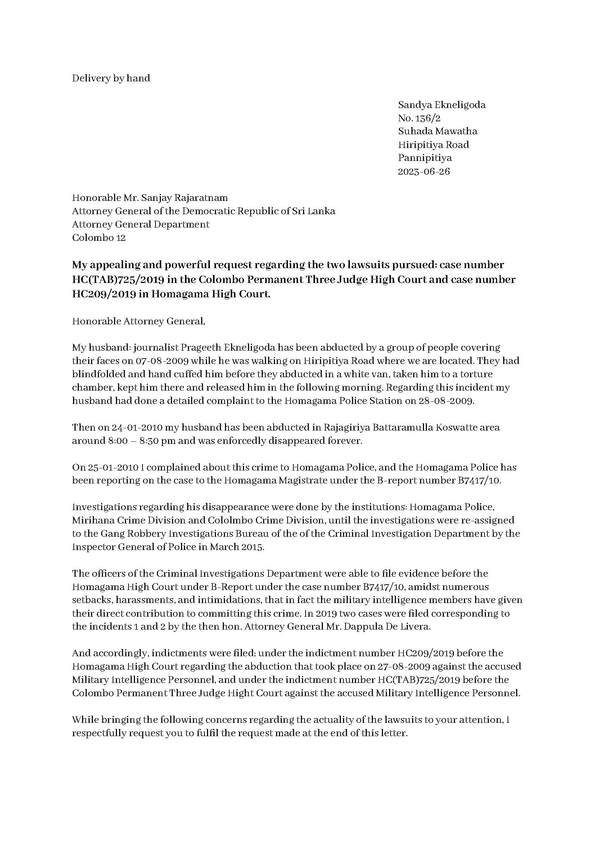
Annex 1 — p2/3
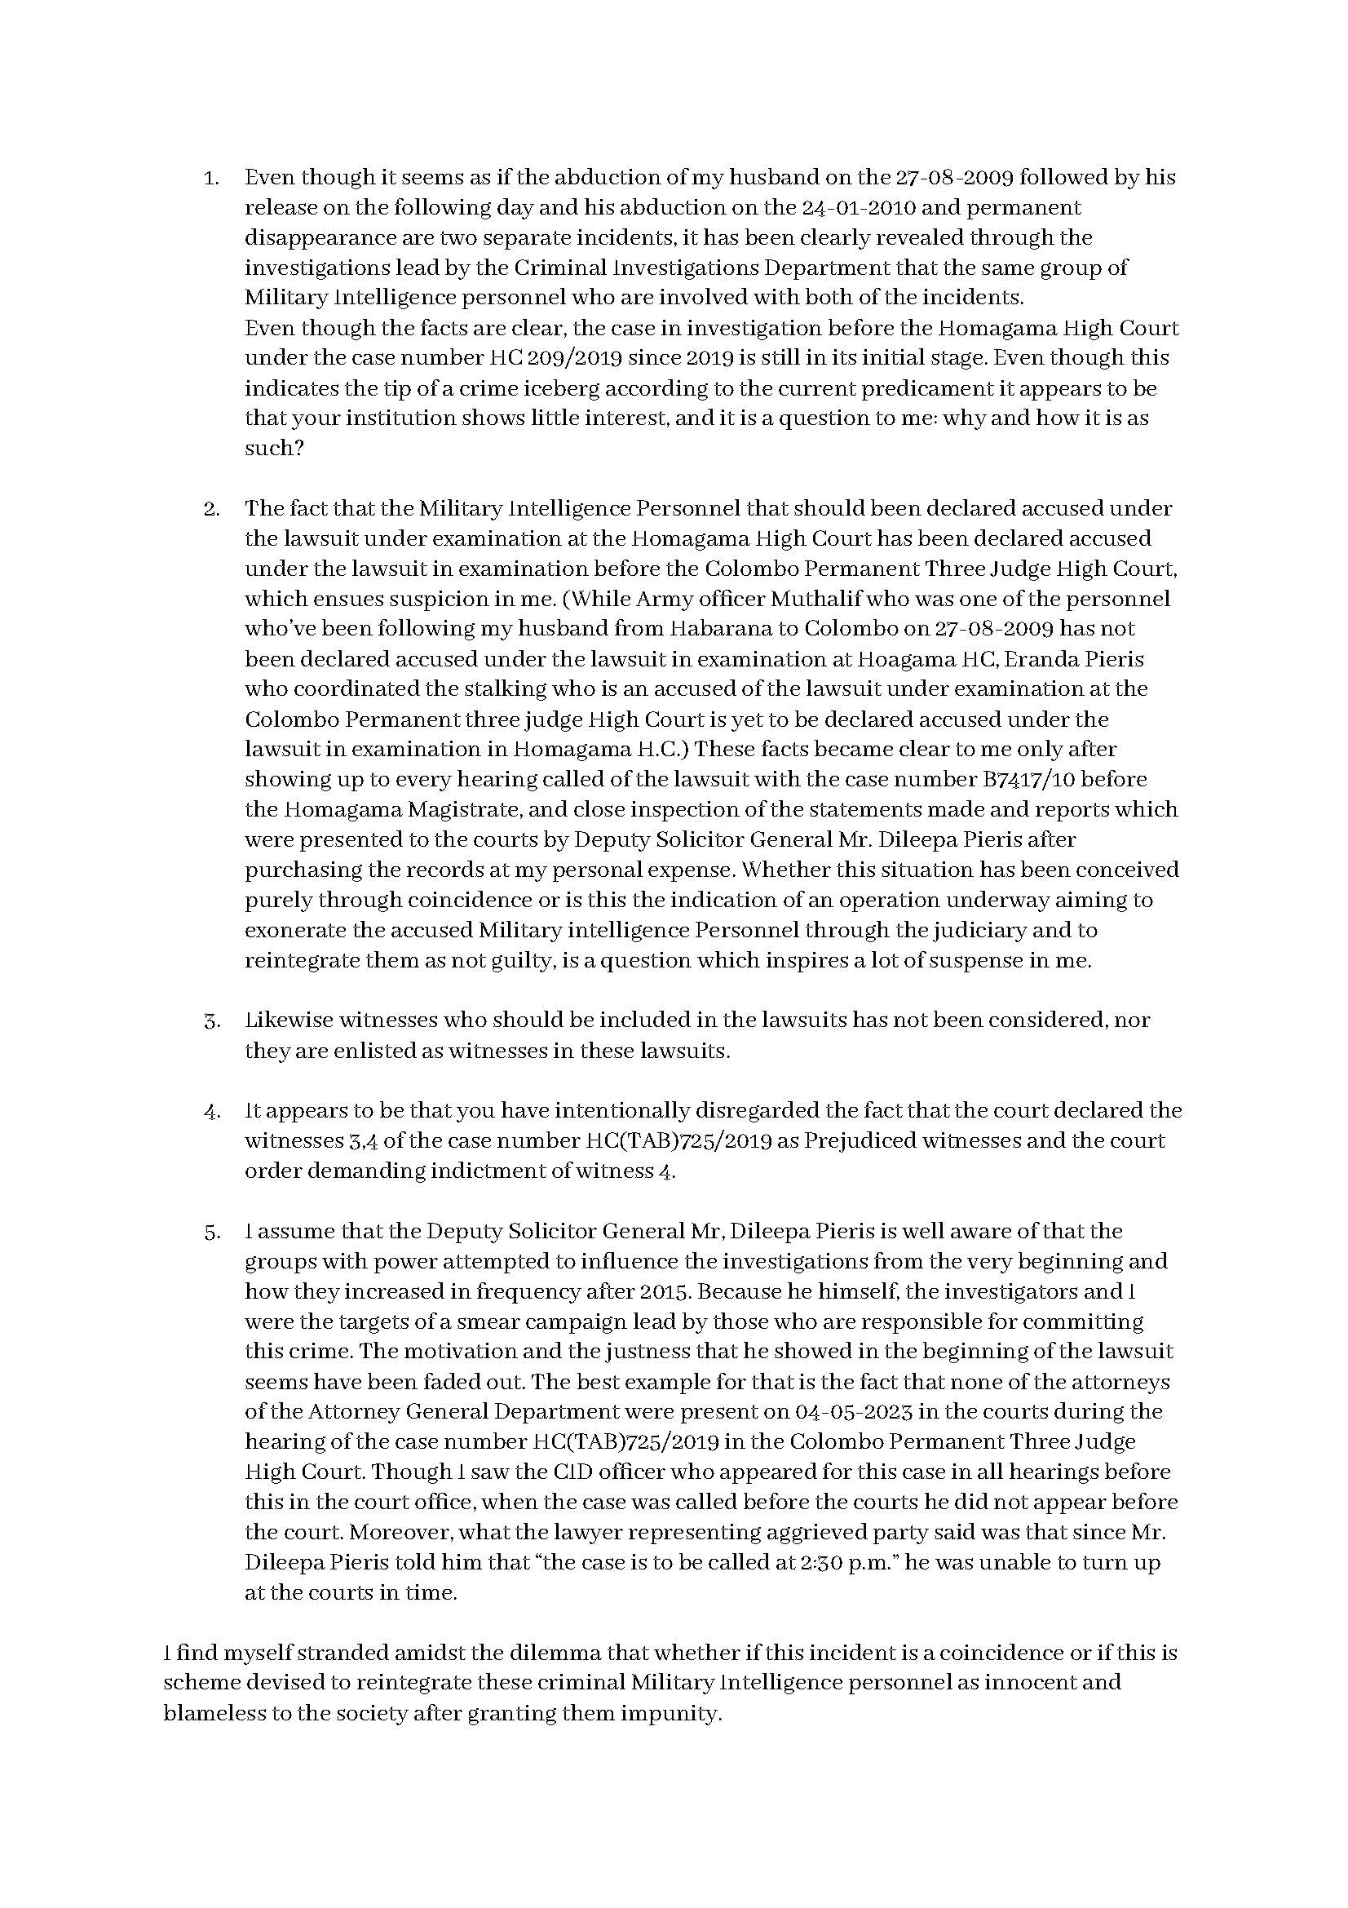
Annex 1 — p3/3
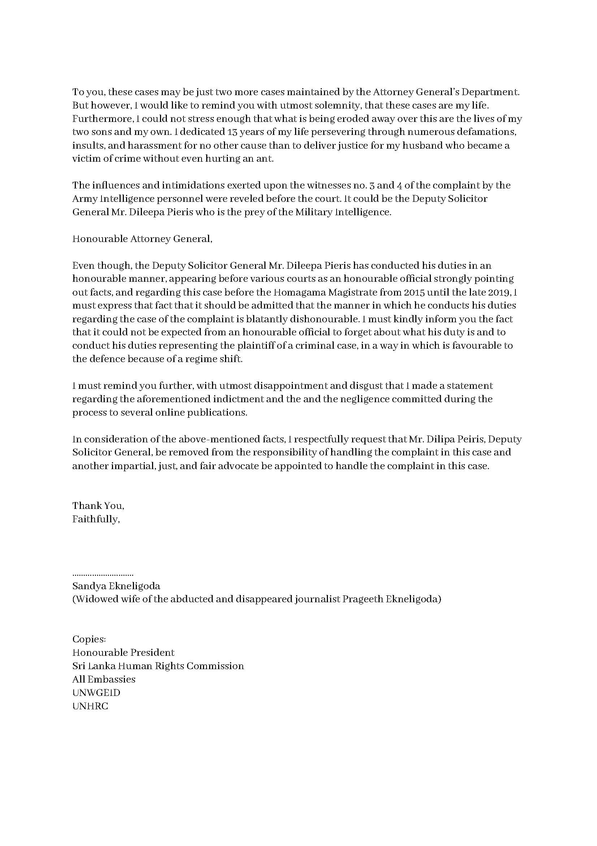

Annex 2
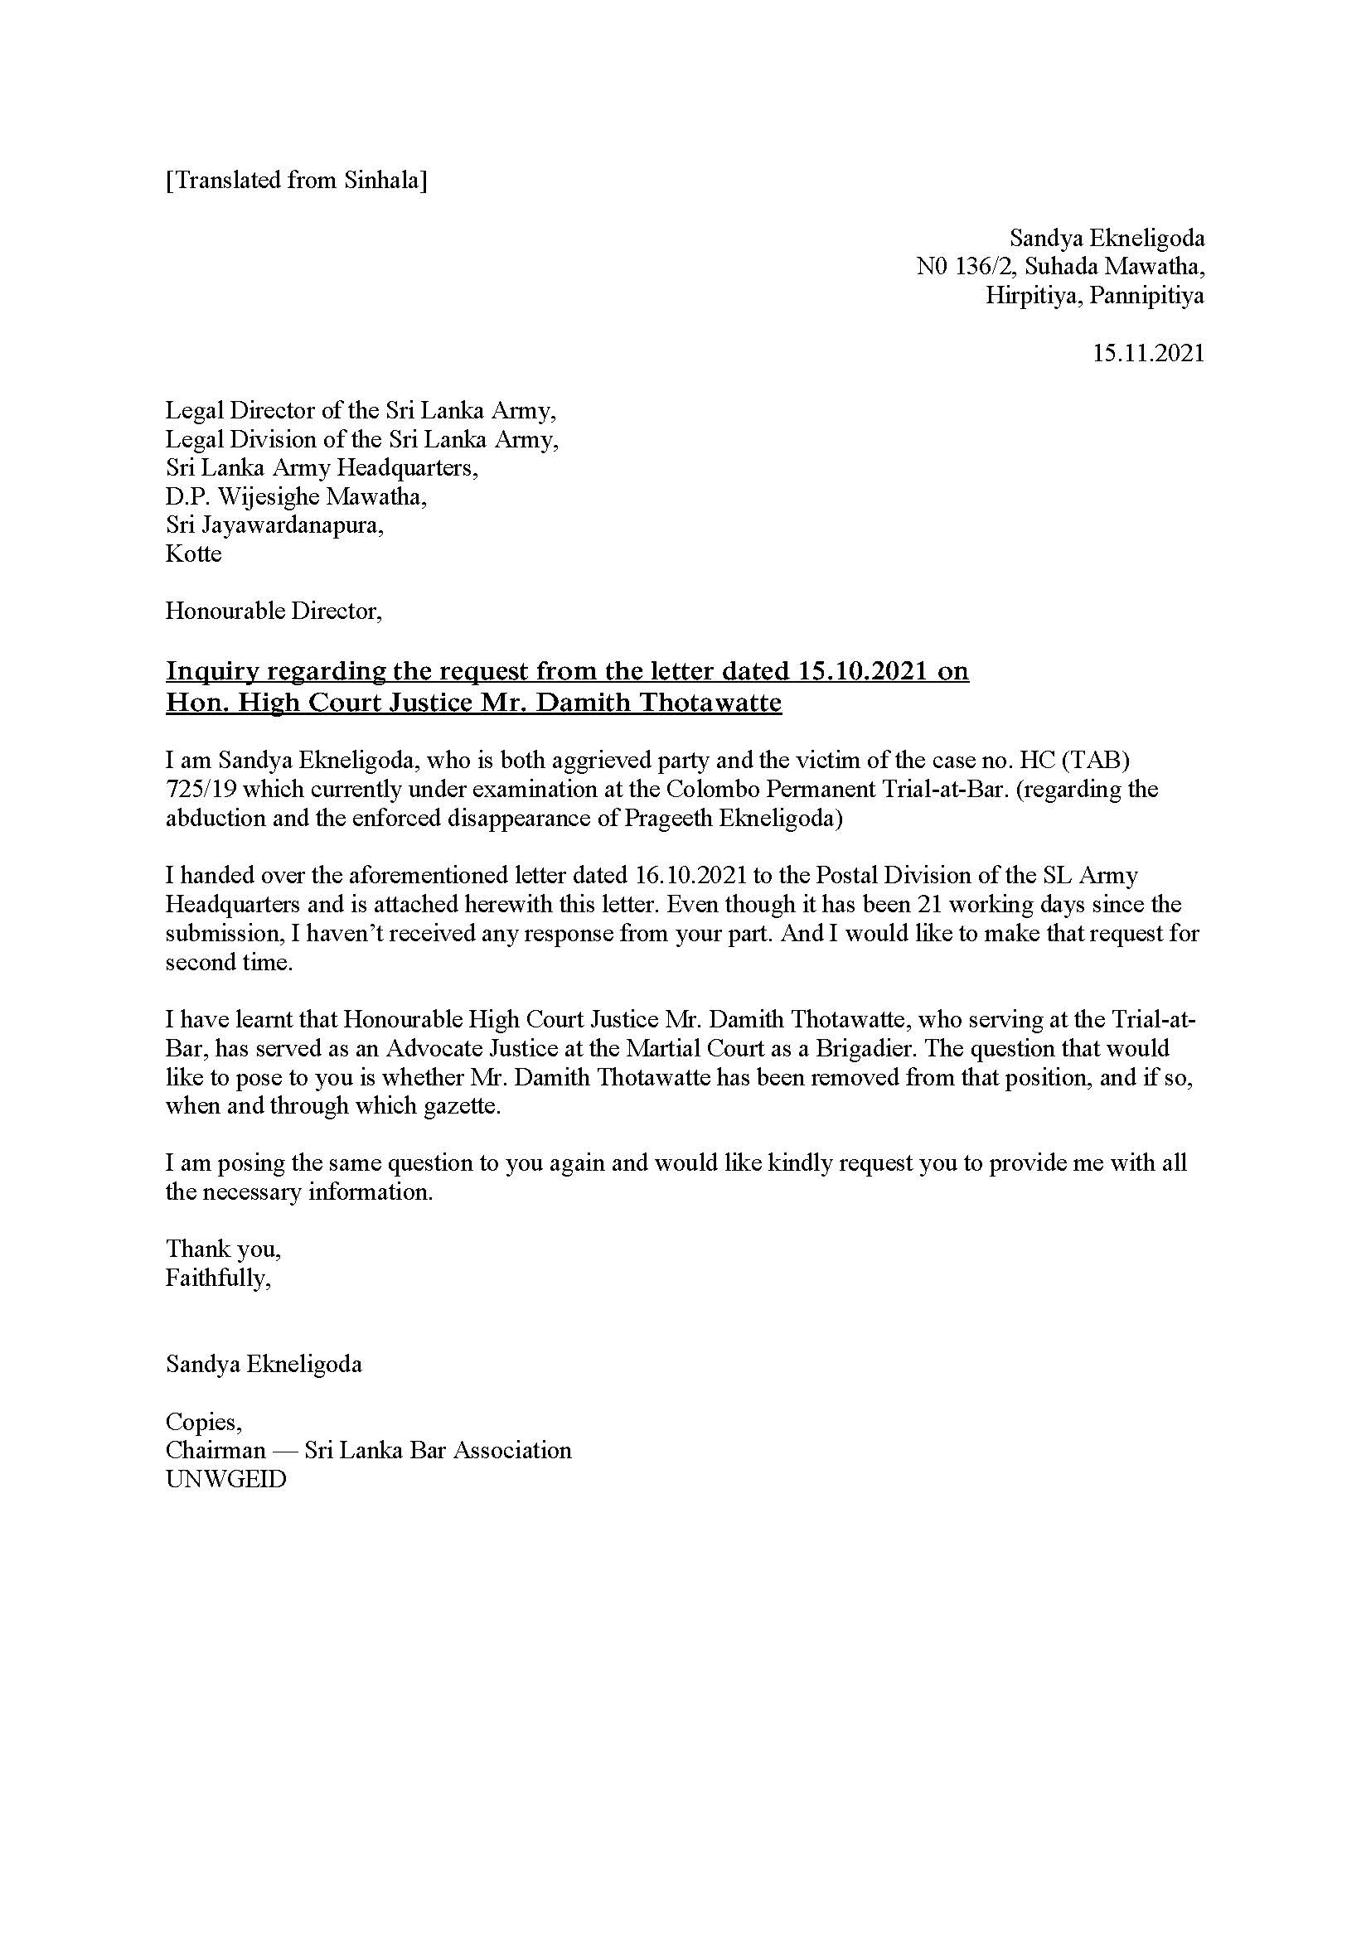
Annex 3 — p1/2
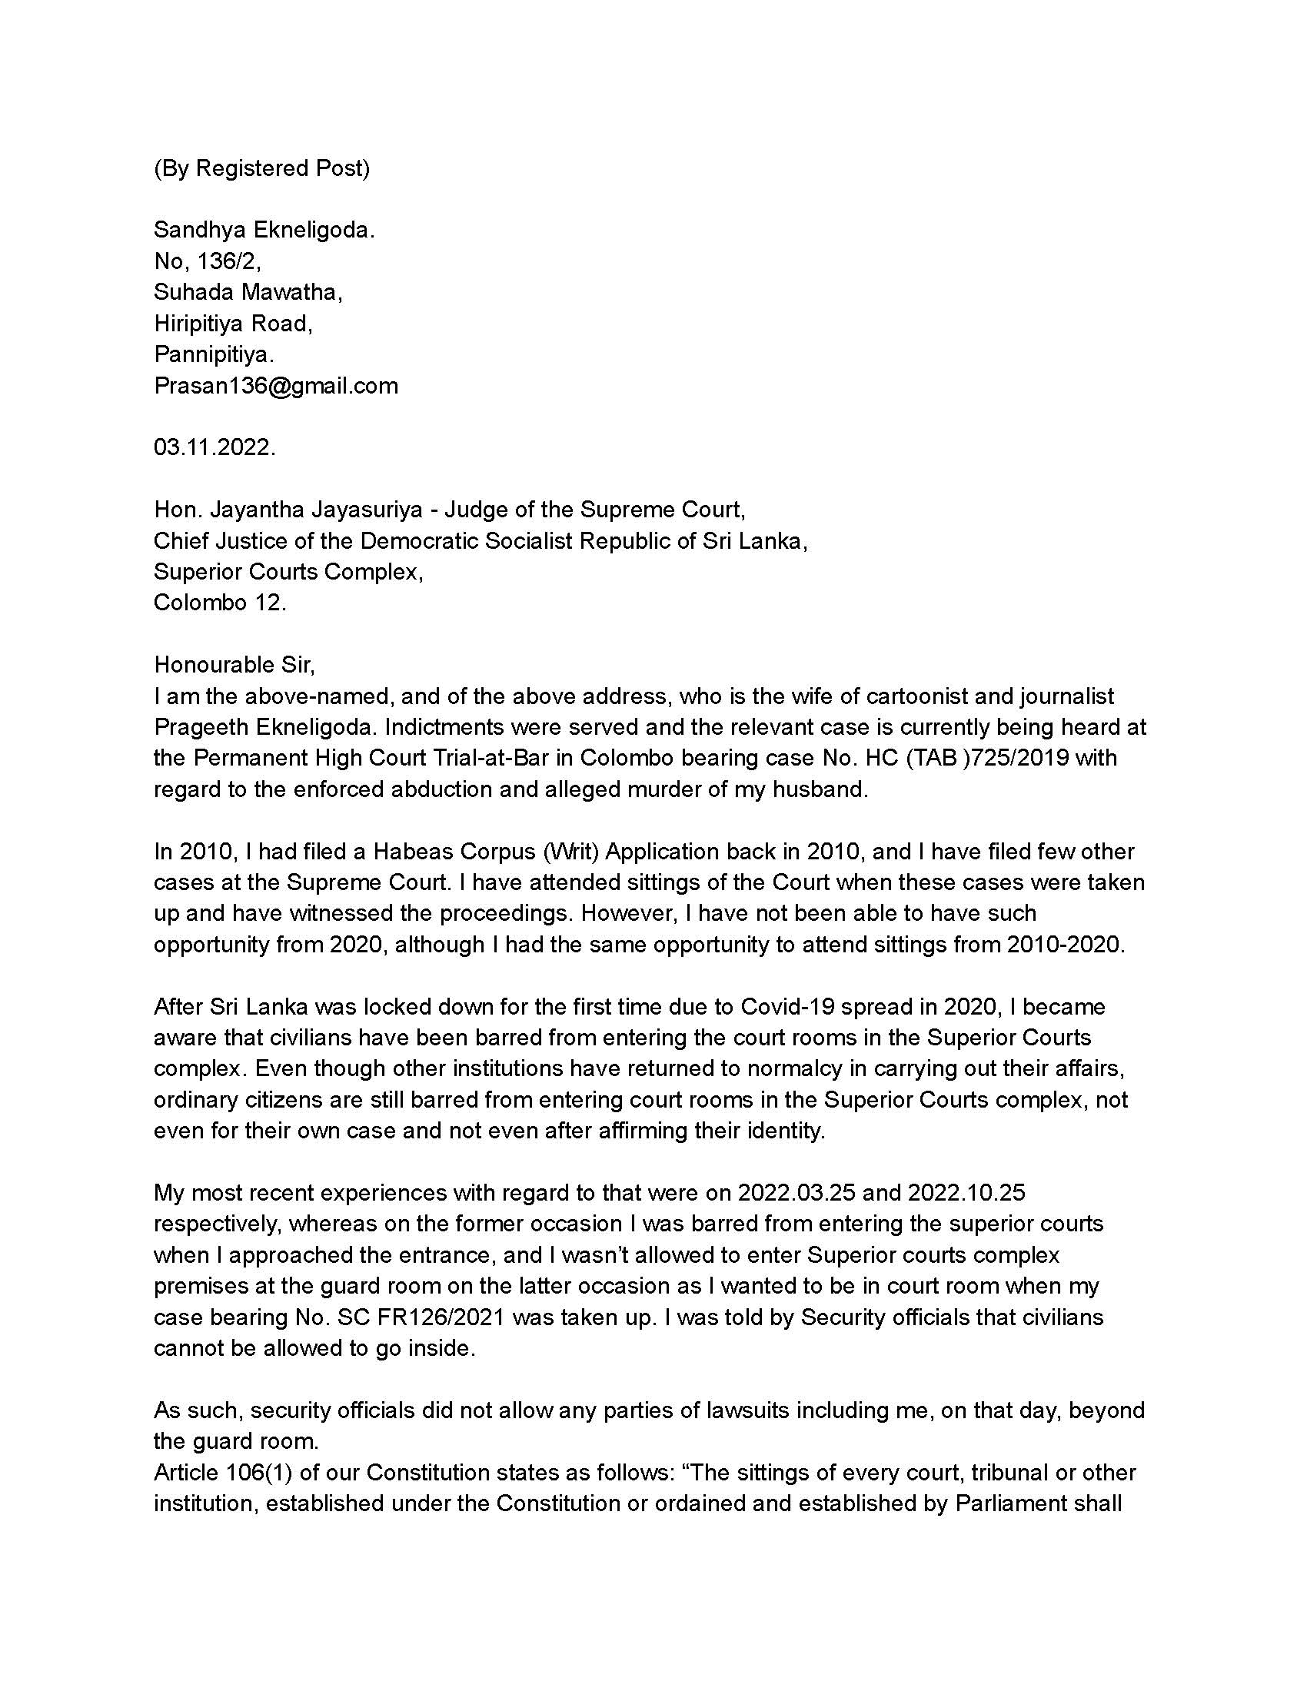
Annex 3 — p2/2
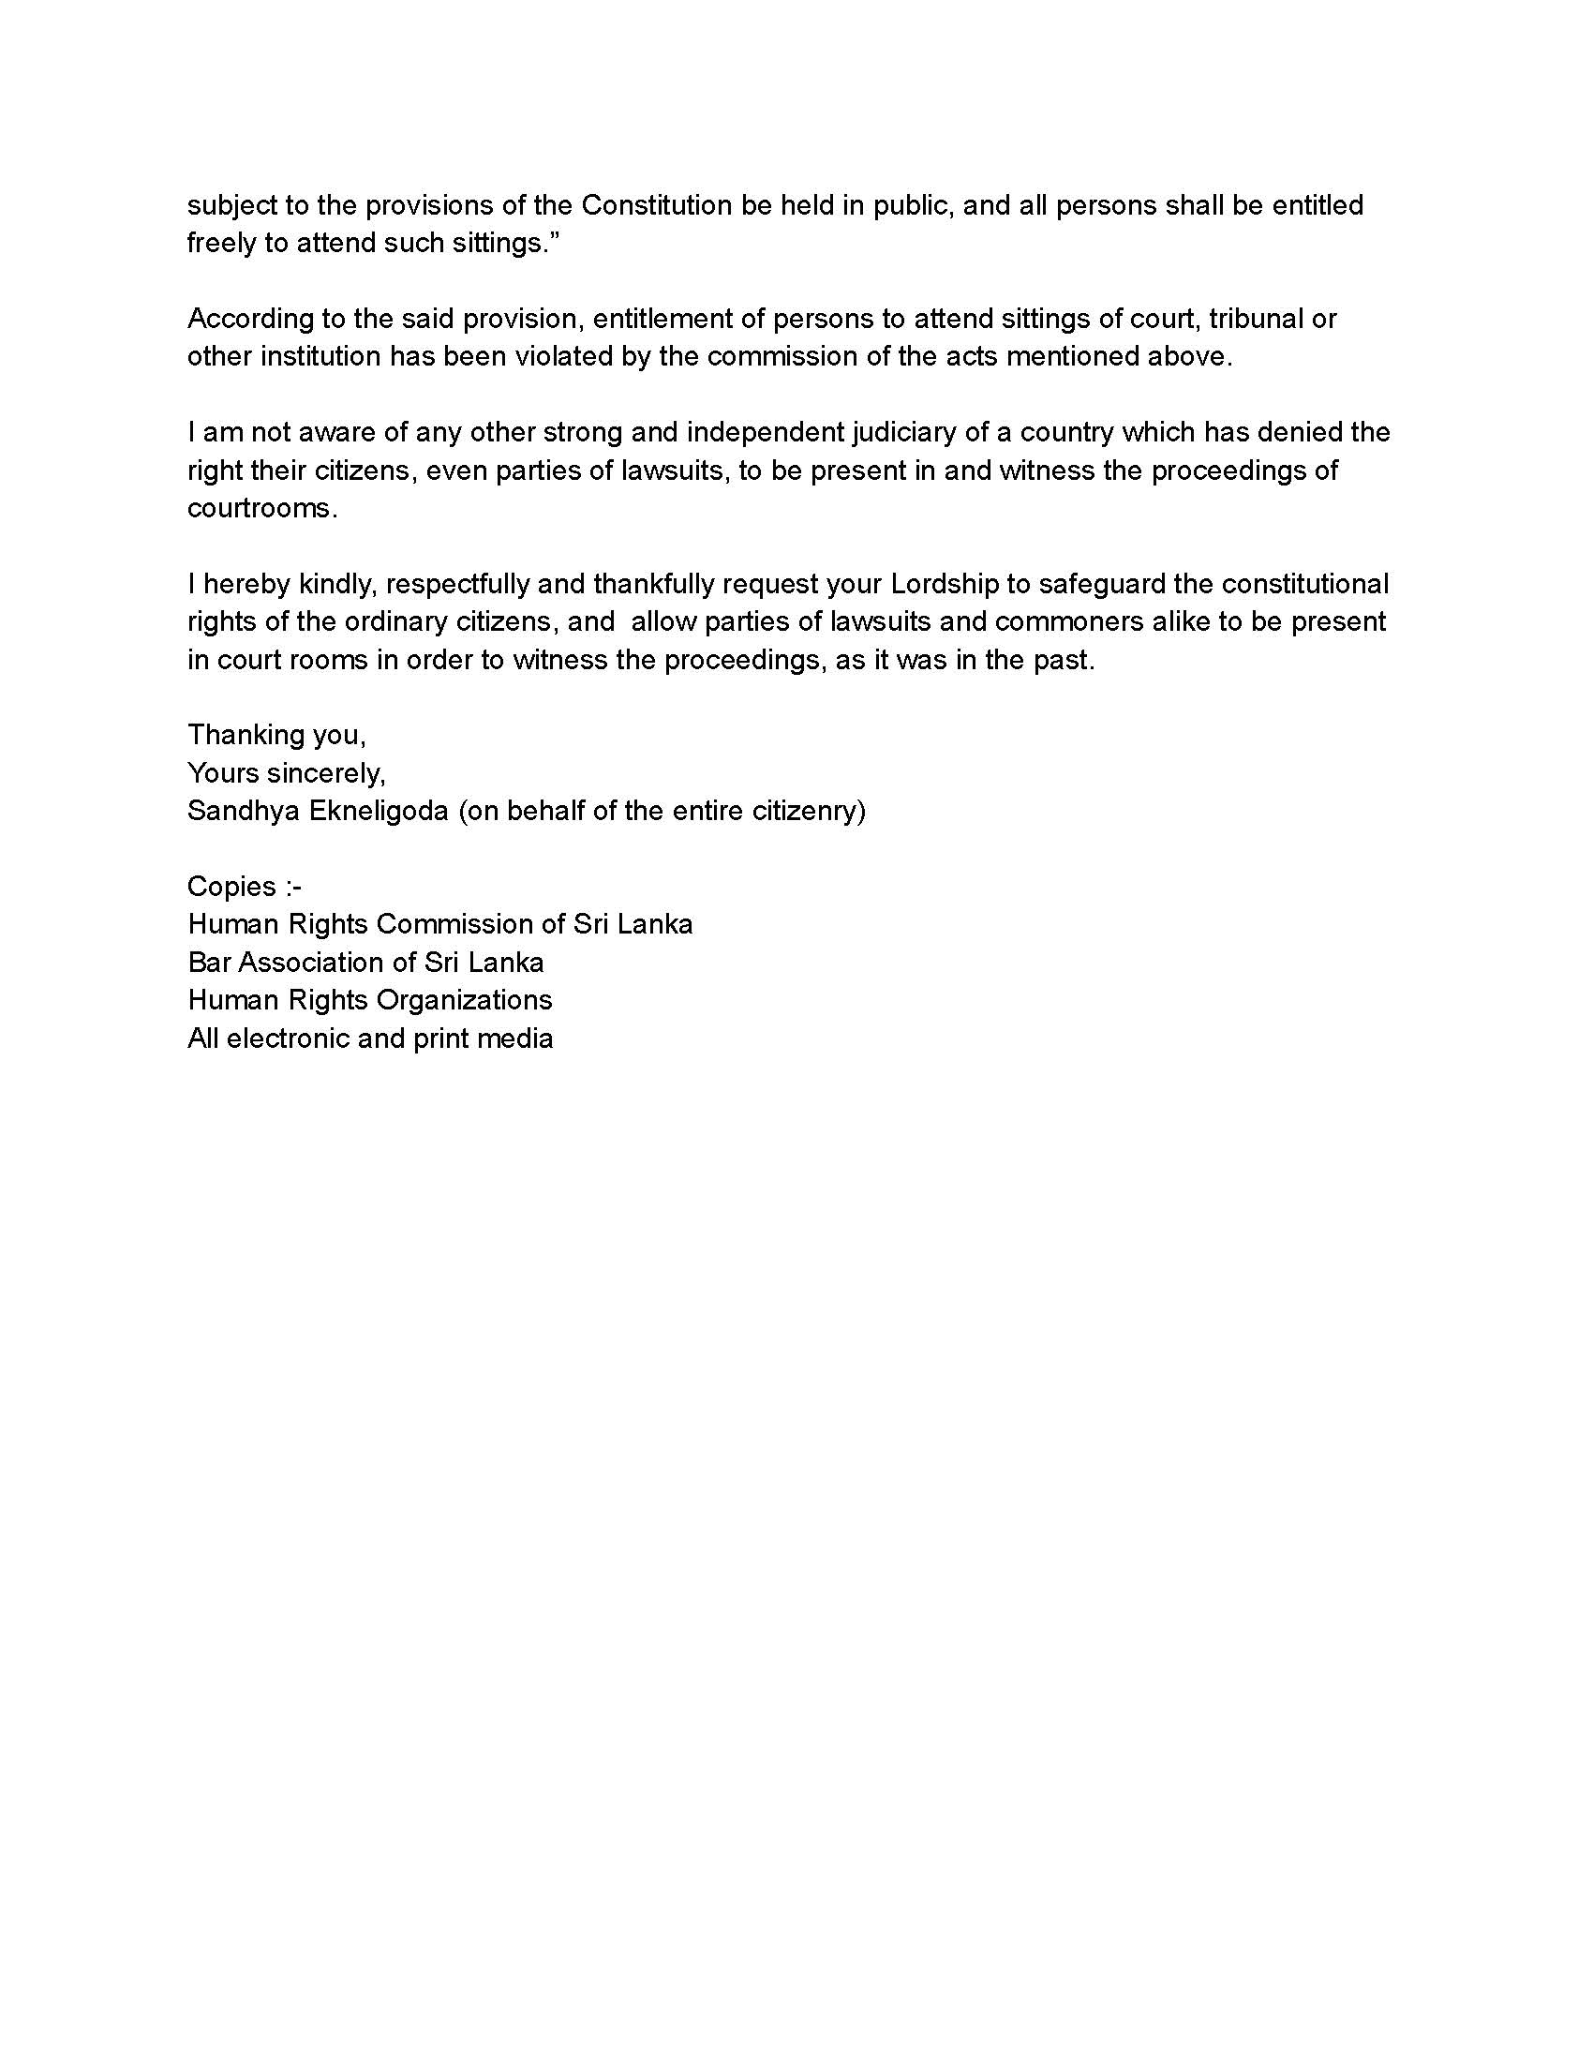

Annex 4 — p1/3
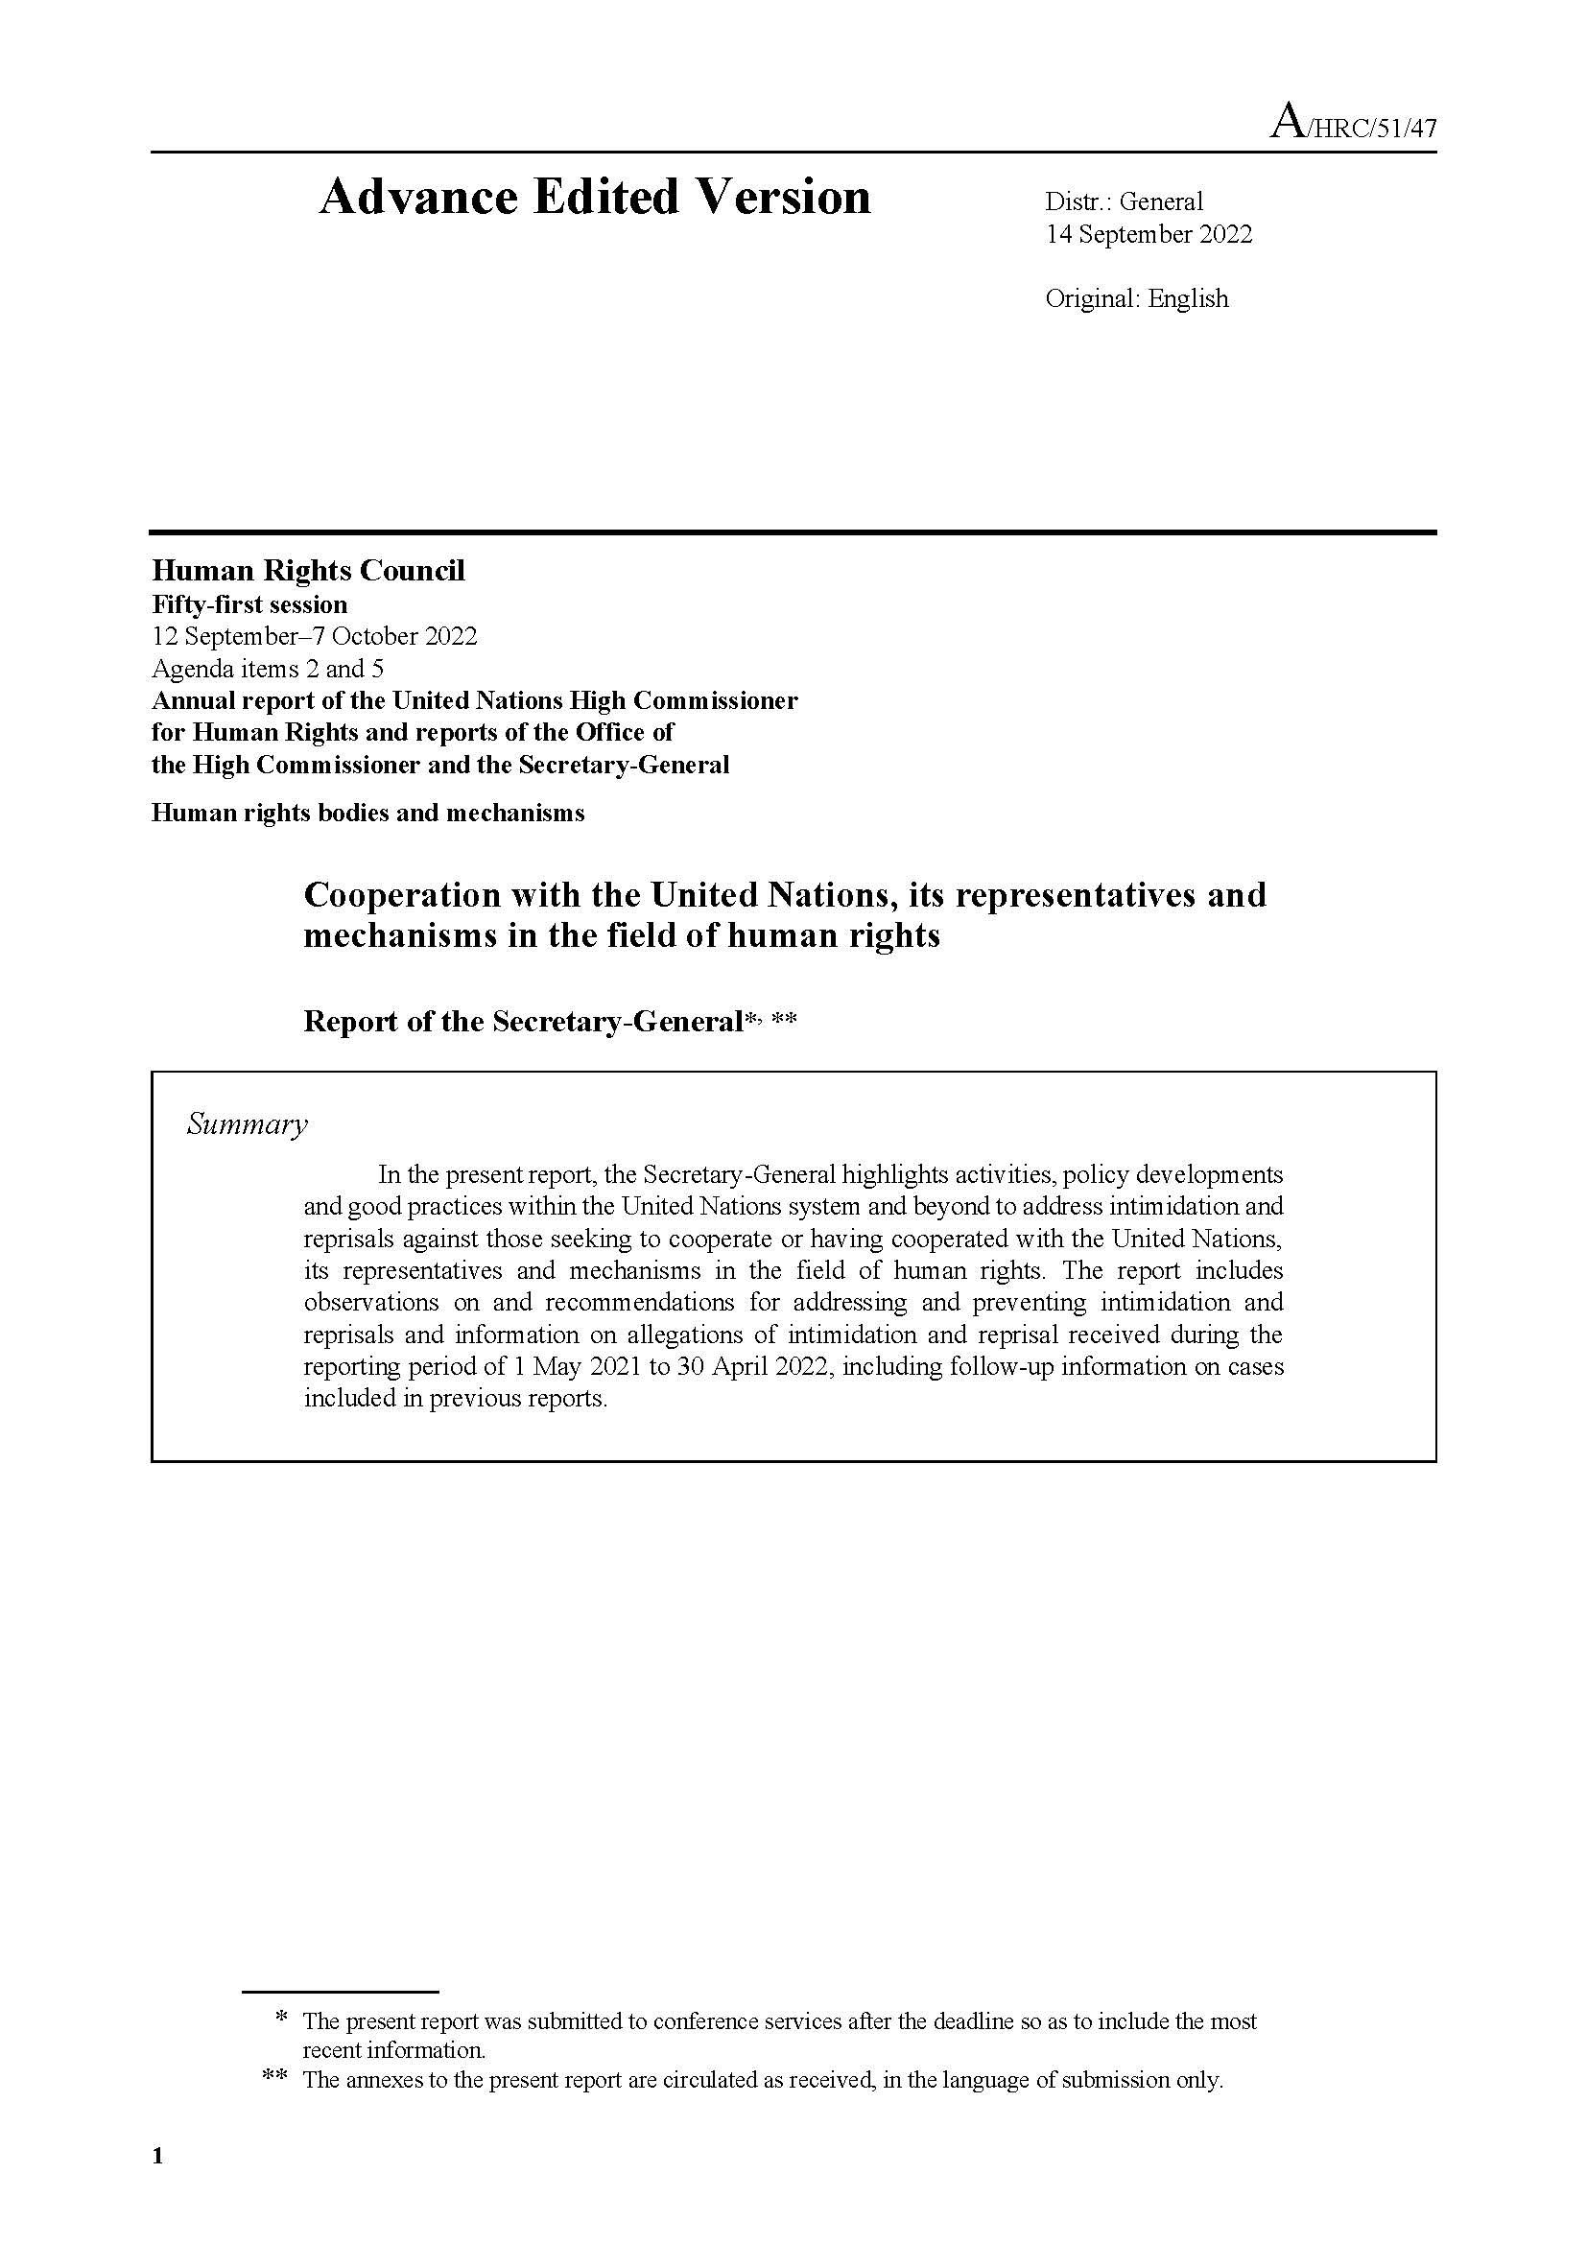

Annex 4 — p2/3
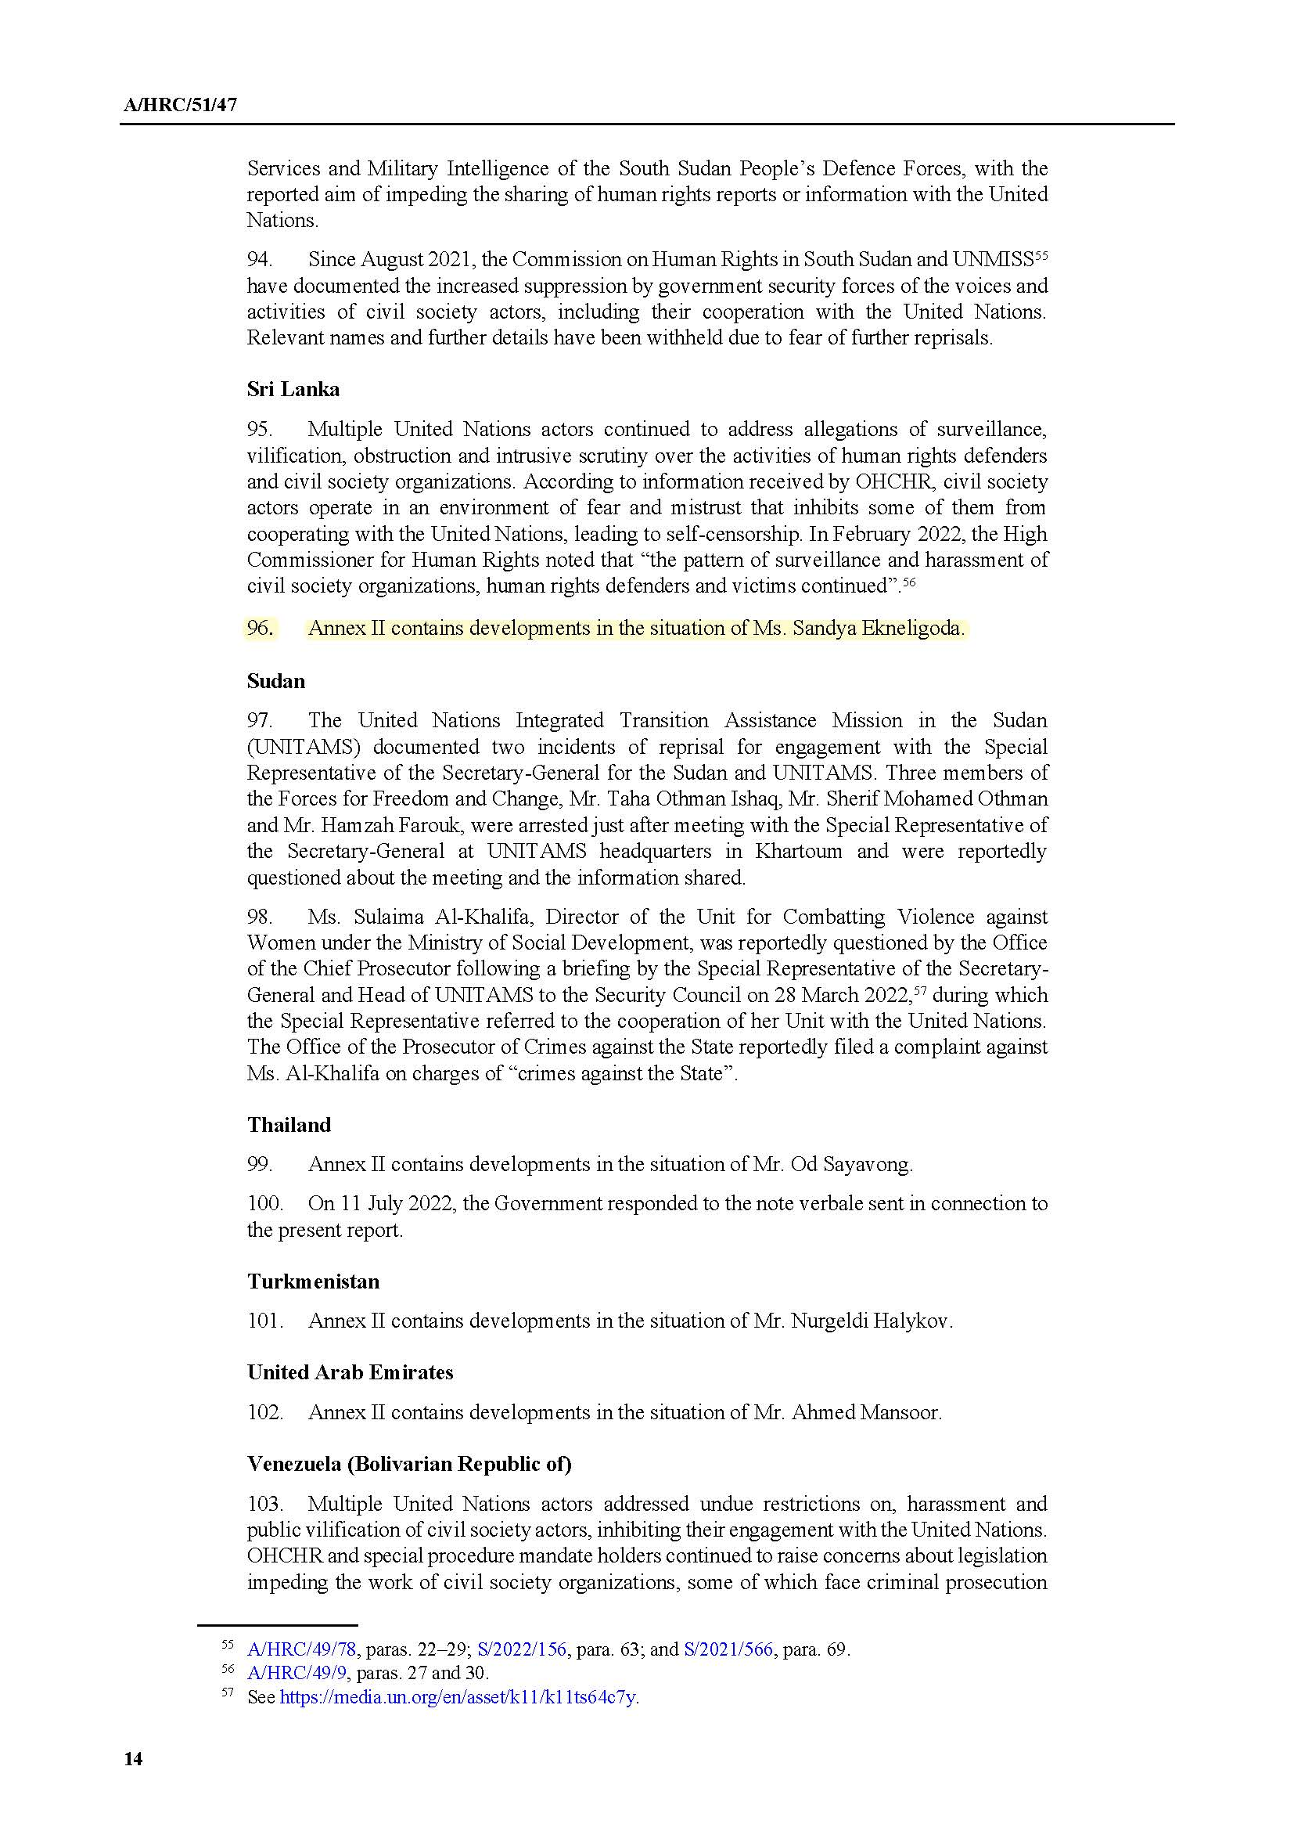
Annex 4 — p3/3
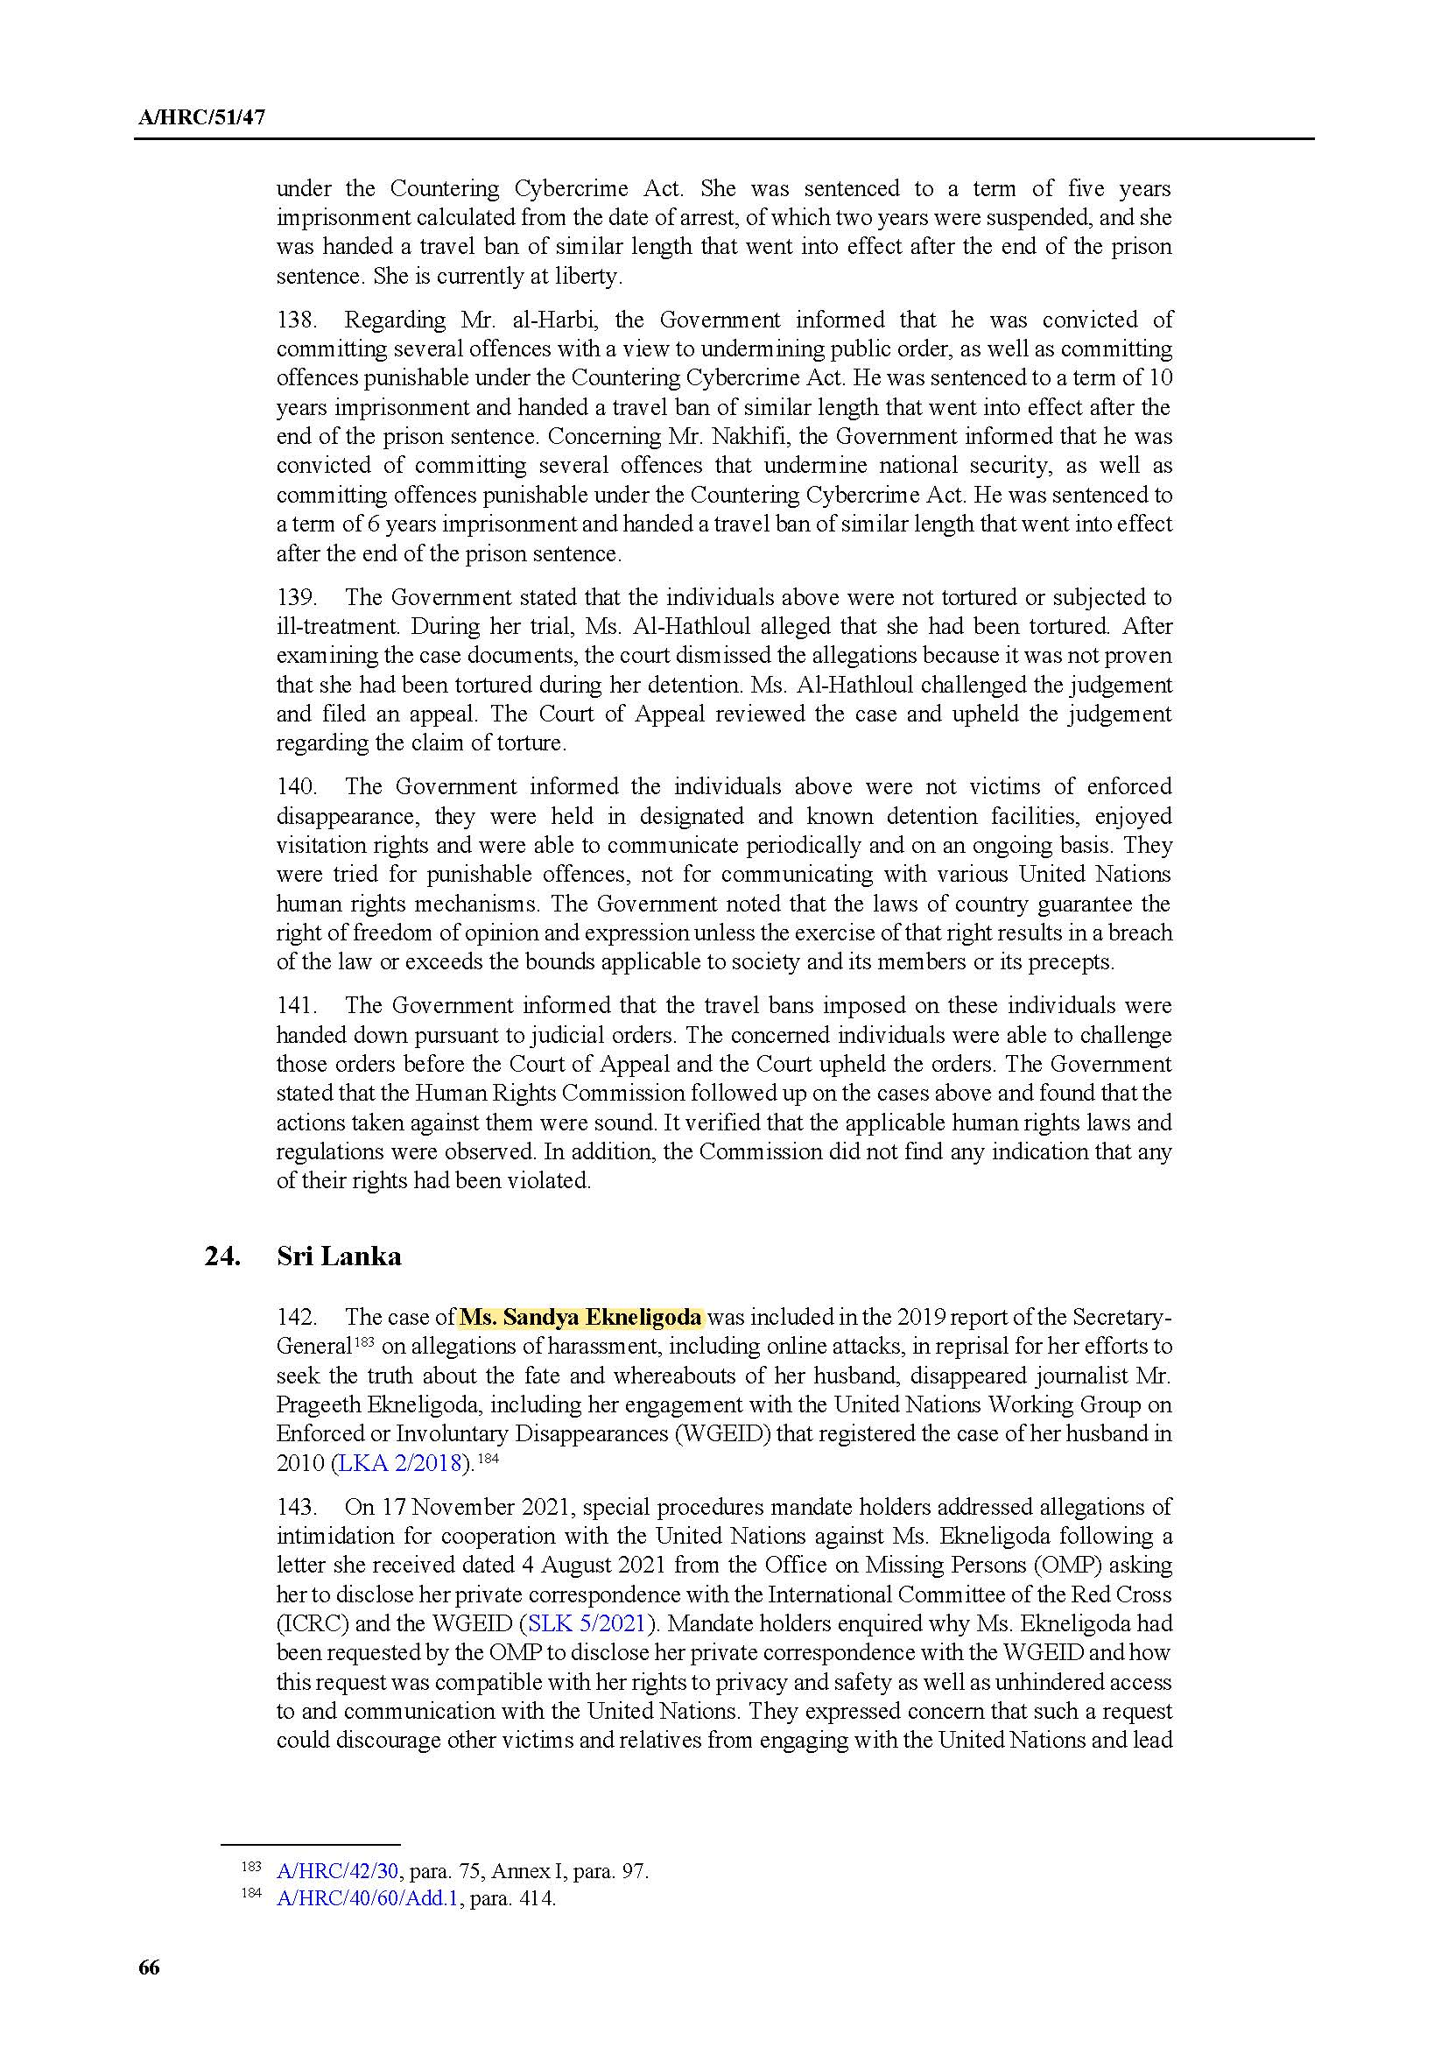

Annex 5 — p1/4
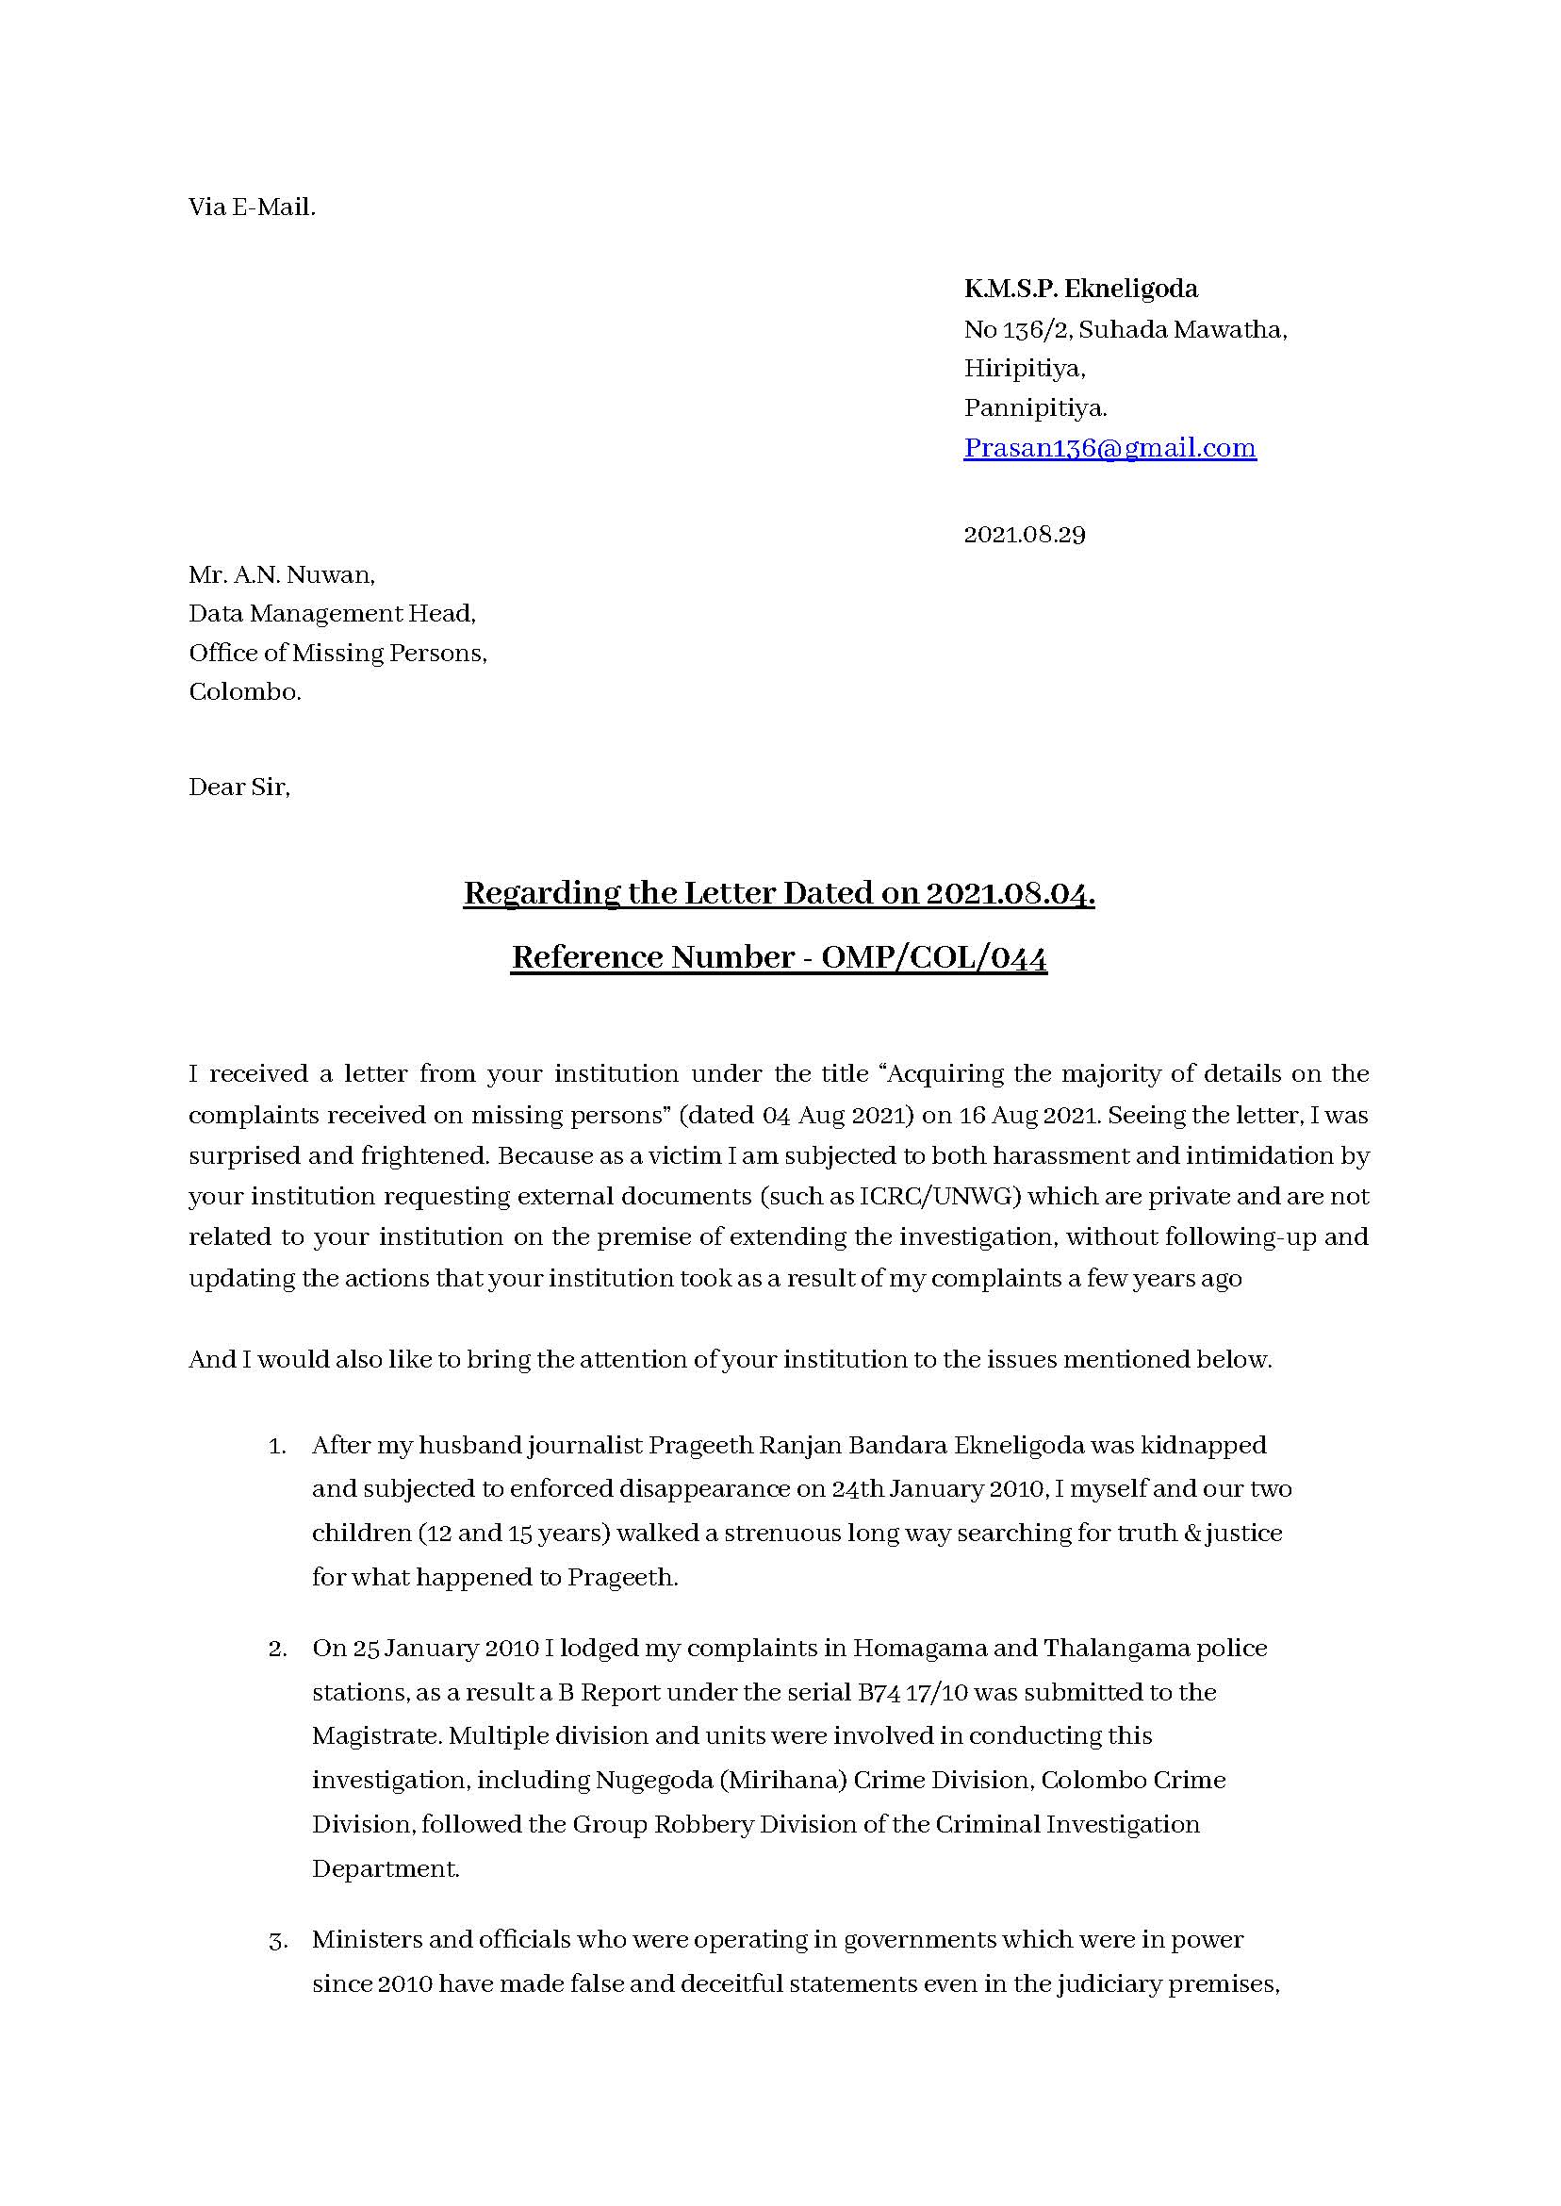
Annex 5 — p2/4
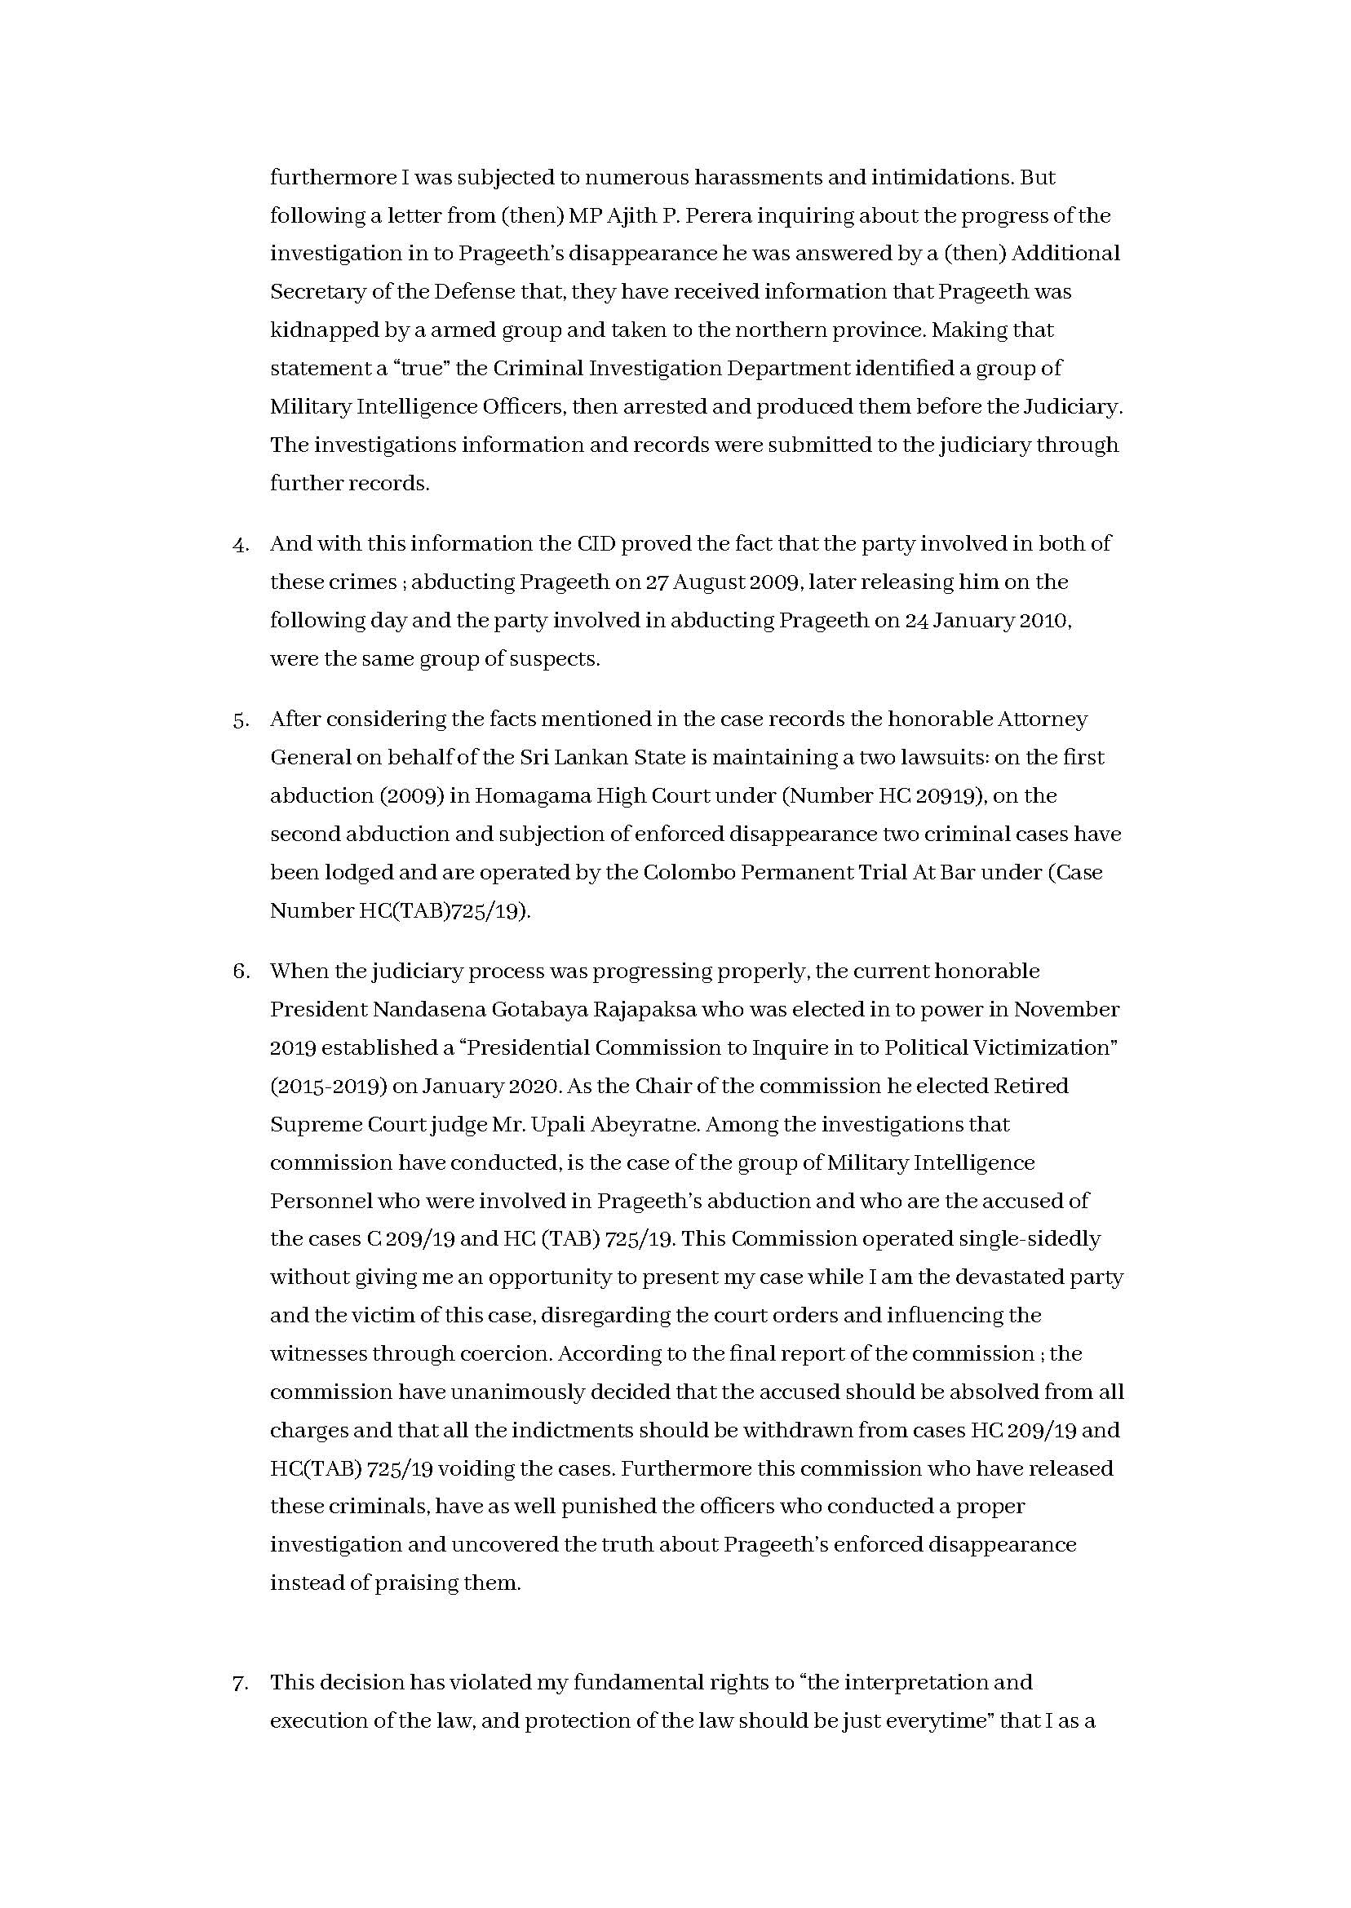
Annex 5 — p3/4
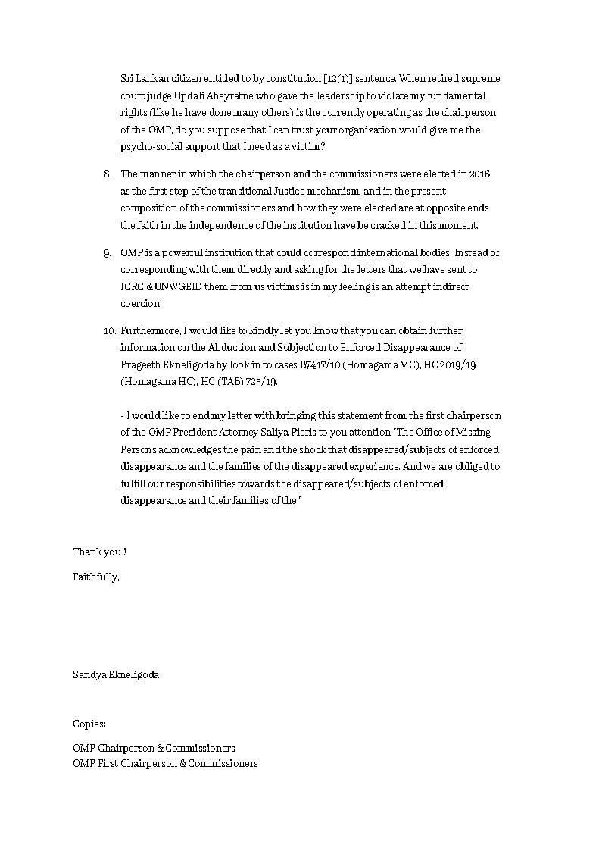
Annex 5 — p4/4


Annex 6 — p1/2
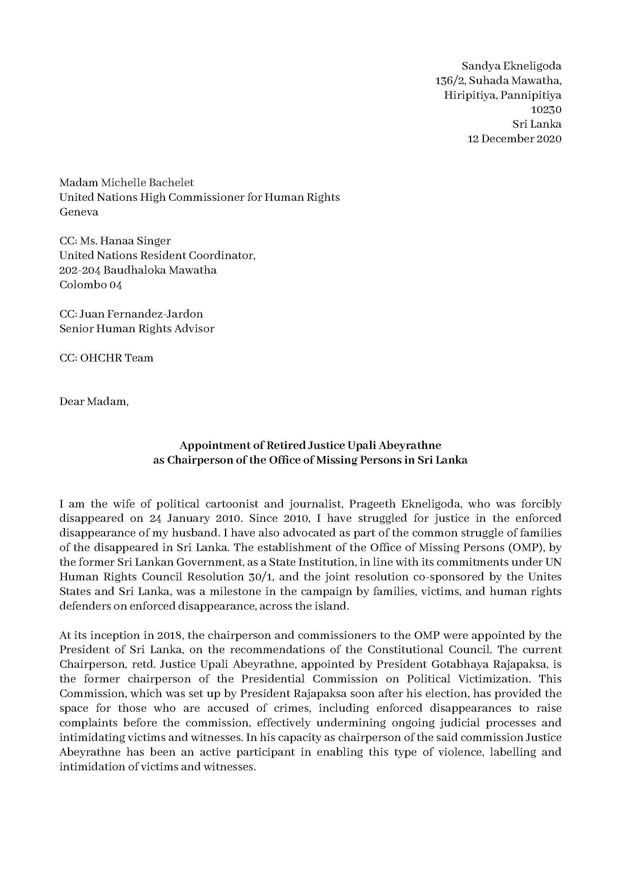

Annex 6 — p2/2
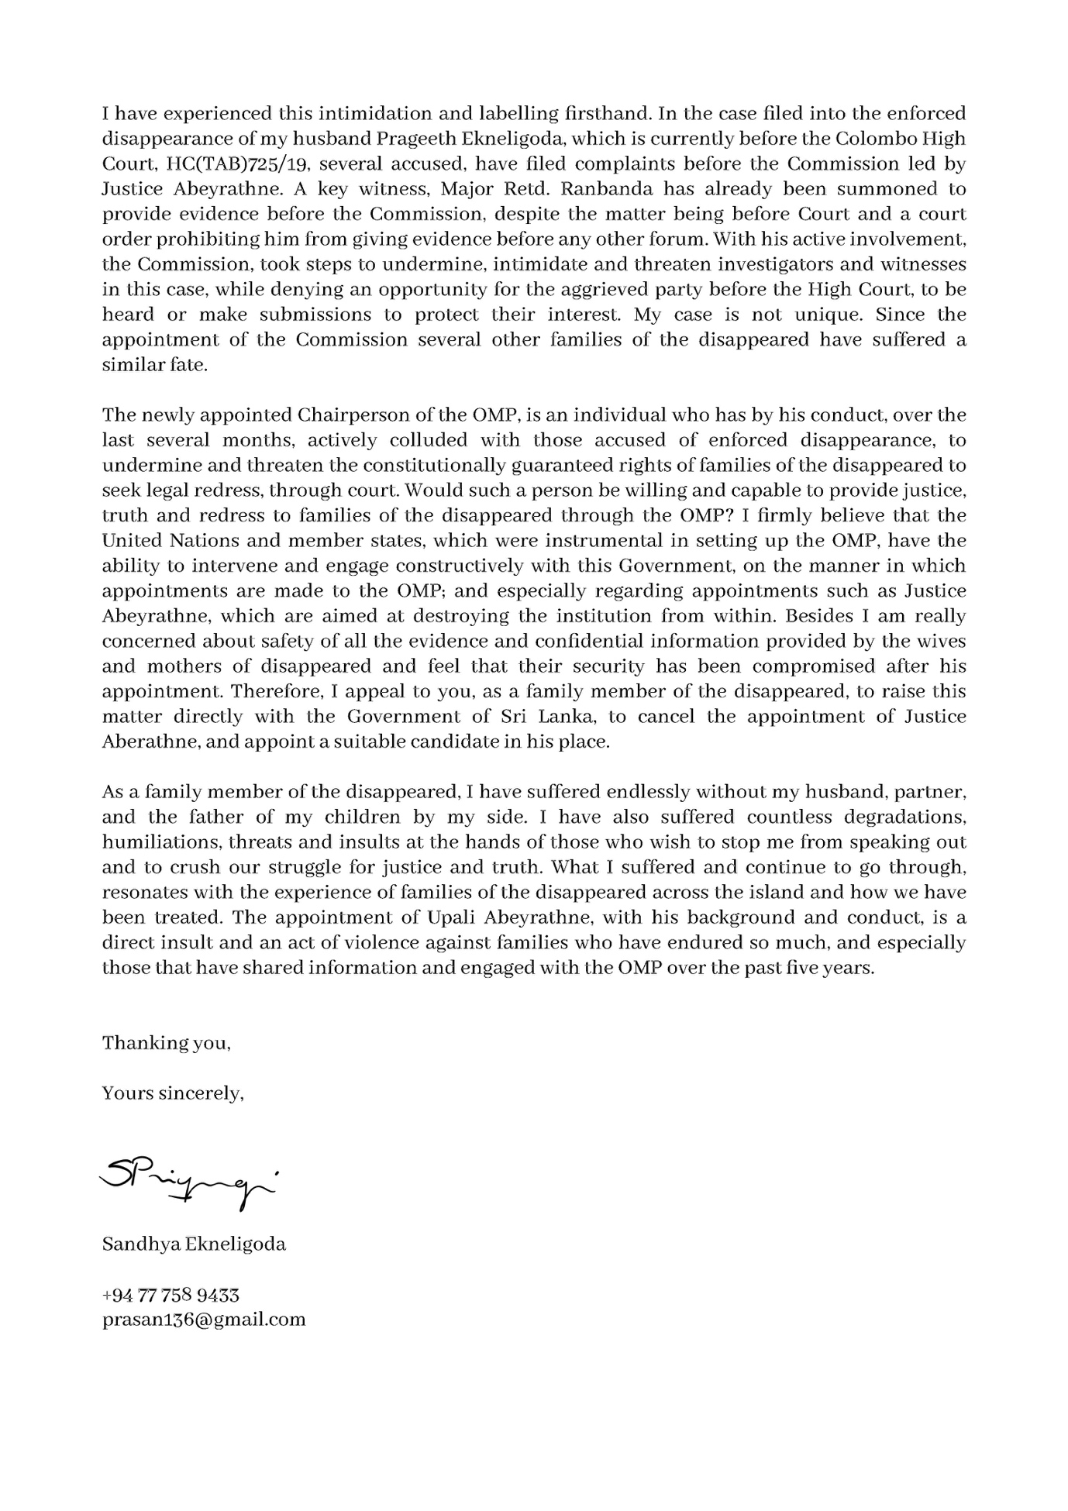

Annex 7 — p1/2
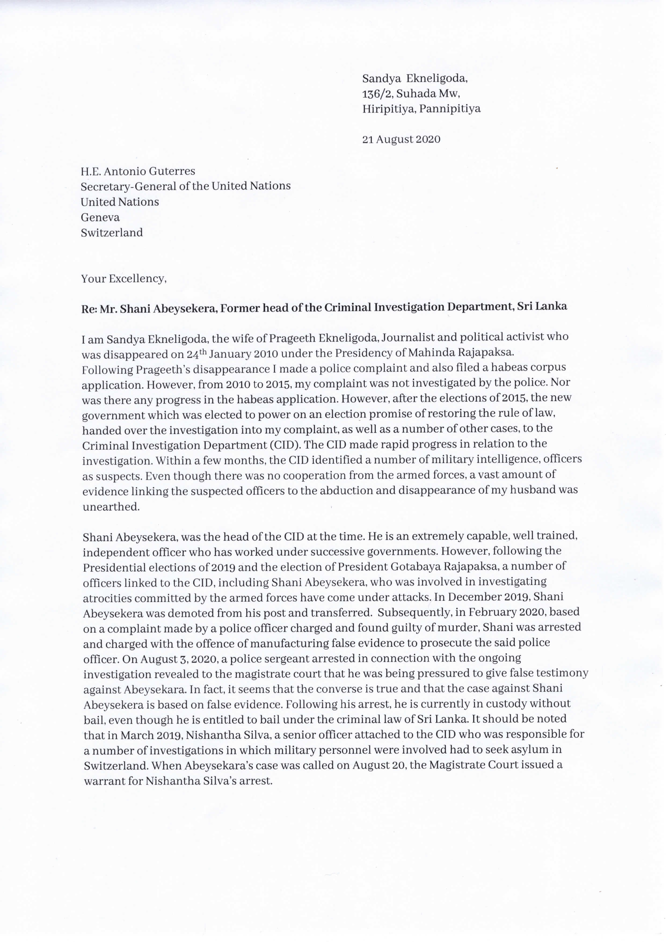
Annex 7 — p2/2
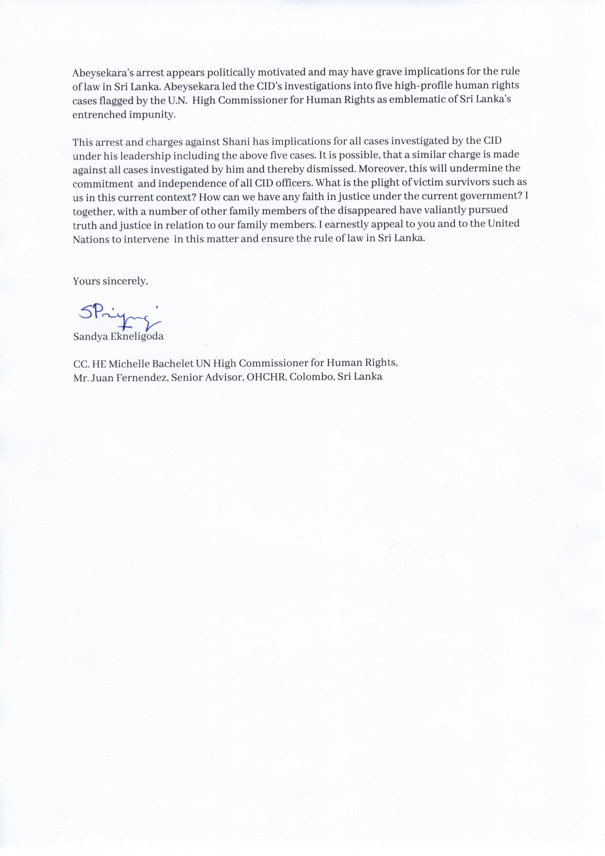

Under Sri Lankan law, if an investigation cannot be completed within 24 hours and if there are grounds to believe that further investigation is necessary, the OIC of a police station or the inquirer, can forward the suspect along with a report of the case, with a summary of statements made by witnesses to the Magistrate. The purpose of a ‘B report’ is therefore, to report the offence to the court, present the productions detained related to the offence, request time from the court to conduct investigations and to obtain orders regarding suspects and productions. Moreover, the law requires the complainant/ witness to execute a bond to appear in court to give evidence. Failing which, the magistrate court can issue a warrant or summons to the complainant/ witness to give evidence.
See Kodikara, Chulani. “The Prageeth Ekneligoda Disappearance Case: Entanglements of Law and Politics.” In Elusive Justice & Emblematic Cases in Sri Lanka, edited by Bhavani Fonseka, pg 26. Colombo, Sri Lanka: Centre for Policy Alternatives (CPA), 2023. https://www.cpalanka.org/wp-content/uploads/2023/04/Elusive-Justice-and-Emblematic-Cases-in-Sri-Lanka-Book-Online-Version-1.pdf.
ibid pg 33, 34
Ibid pg. 34
Ibid pg. 23
UN, International Convention for the Protection of All Persons from Enforced Disappearance, Report submitted by Sri Lanka under article 29 (1) of the Convention, due in 2018*,CED/C/LKA/1, 12 September 2023, pg 15,16
Y The Gazette of the Democratic Socialist Republic of Sri Lanka, EXTRAORDINARY, No. 2157/44 - THURSDAY JANUARY 09, 2020, http://documents.gov.lk/files/egz/2020/1/2157-44_E.pdf
Case no 2009/19 HIC Court trial at bar HC (TAB 725/19).
See: The Presidential Commission on Political Victimisation 2020/2021, https://www.colombotelegraph.com/wp-content/uploads/2021/01/Gotabaya-Rajapaksas-PCoI-Report-on-Political-Victimisation-complete.pdf
Case no: HCTAB7252019
Kodikara, Chulani. “The Prageeth Ekneligoda Disappearance Case: Entanglements of Law and Politics.” In Elusive Justice & Emblematic Cases in Sri Lanka, edited by Bhavani Fonseka, Colombo, Sri Lanka: Centre for Policy Alternatives (CPA), 2023. https://www.cpalanka.org/wp-content/uploads/2023/04/Elusive-Justice-and-Emblematic-Cases-in-Sri-Lanka-Book-Online-Version-1.pdf. pg. 39
The Morning, OMP Chief Upali Abeyratne accused of contempt of court, 16.11.2021 https://waww.themorning.lk/articles/174025, Accessed 26.05.2024
“CA Quashes Political Victimisation Panel’s Findings Against the Yahapalana Govt.,” Print Edition - the Sunday Times, Sri Lanka, n.d., https://www.sundaytimes.lk/240331/news/ca-quashes-political-victimisation-panels-findings-against-the-yahapalana-govt-553723.html.
Ibid pg. 34-35
Kodikara, Chulani. “The Prageeth Ekneligoda Disappearance Case: Entanglements of Law and Politics.” In Elusive Justice & Emblematic Cases in Sri Lanka, edited by Bhavani Fonseka, pg 35. Colombo, Sri Lanka: Centre for Policy Alternatives (CPA), 2023. https://www.cpalanka.org/wp-content/uploads/2023/04/Elusive-Justice-and-Emblematic-Cases-in-Sri-Lanka-Book-Online-Version-1.pdf
“Code of Criminal Procedure (Amendment) Act (No. 21 of 1988) - Sect 2,” n.d., http://www.commonlii.org/lk/legis/num_act/cocpa21o1988356/s2.html#:~:text=(2)%20Where%20the%20Chief%20Justice,any%20person%20for%20that%20offence.
ibid
“Code of Criminal Procedure (Amendment) Act (No. 21 of 1988) - Sect 2,” n.d.
DM Editorial, “5000 Days Later, Sandya Still Awaits Truth and Justice...,” Opinion | Daily Mirror, October 8, 2023, https://www.dailymirror.lk/opinion/5000-days-later--Sandya-still-awaits-truth-and-justice---/172-268783.
Kodikara, Chulani. “The Prageeth Ekneligoda Disappearance Case: Entanglements of Law and Politics.” In Elusive Justice & Emblematic Cases in Sri Lanka, edited by Bhavani Fonseka, pg 26. Colombo, Sri Lanka: Centre for Policy Alternatives (CPA), 2023. https://www.cpalanka.org/wp-content/uploads/2023/04/Elusive-Justice-and-Emblematic-Cases-in-Sri-Lanka-Book-Online-Version-1.pdf
Our Name is Mud Ltd, “Harassment and Intimidation Faced by Mrs. Sandya Ekneligoda, Wife of the Disappeared Journalist, Mr. Prageeth Ekneligoda,” OMCT, January 5, 2021, https://www.omct.org/en/resources/urgent-interventions/harassment-and-intimidation-faced-by-mrs-sandya-ekneligoda-wife-of-the-disappeared-journalist-mr-prageeth-ekneligoda.
Kodikara, Chulani. “The Prageeth Ekneligoda Disappearance Case: Entanglements of Law and Politics.” In Elusive Justice & Emblematic Cases in Sri Lanka, edited by Bhavani Fonseka, Colombo, Sri Lanka: Centre for Policy Alternatives (CPA), 2023. https://www.cpalanka.org/wp-content/uploads/2023/04/Elusive-Justice-and-Emblematic-Cases-in-Sri-Lanka-Book-Online-Version-1.pdf, pg. 27- 28
Ibid pg. 29-30
The Liberation Tigers of Tamil Eelam(LTTE) also commonly referred to as the Tigers of Tamil Tigers
Ruki Fernando, “Sandya Ekneligoda: 5,000 Days of Struggle for Truth and Justice - Groundviews,” Groundviews, October 4, 2023, https://groundviews.org/2023/10/04/sandya-ekneligoda-5000-days-of-struggle-for-truth-and-justice/.
UN, International Convention for the Protection of All Persons from Enforced Disappearance, Report submitted by Sri Lanka under article 29 (1) of the Convention, due in 2018*,CED/C/LKA/1, 12 September 2023, pg 21

