BRIEFING ON SLOVAKIA FOR THE COMMITTEE AGAINST TORTURE, SESSION 76 – April/May 2023
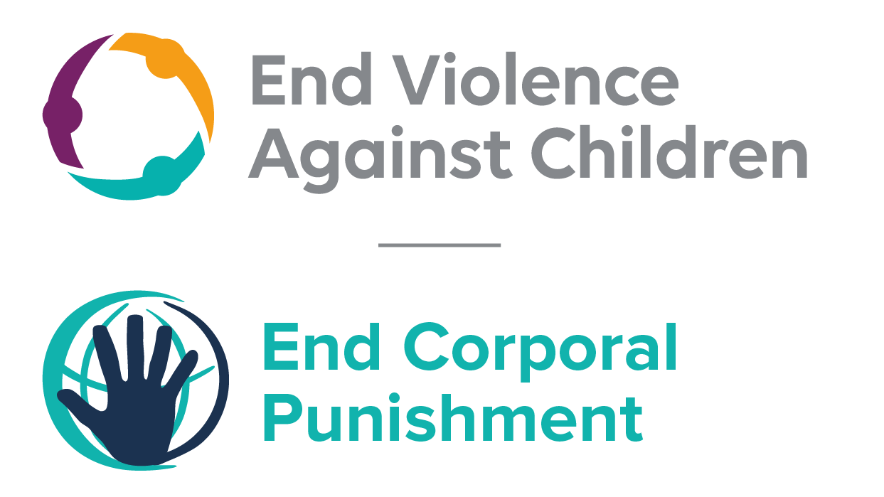
The Global Partnership to End Violence Against Children
March 2023

This briefing describes the legality of corporal punishment of children in Slovakia. In light of the obligation under international human rights law to prohibit all corporal punishment of children, the recommendation of the UN Secretary General’s Study on Violence against Children, the repeated recommendations to prohibit all corporal punishment made to Slovakia by the Committee on the Rights and other human rights treaty bodies, and considering the global commitment to ending all violence against children in the context of the 2030 Agenda for Sustainable Development, we hope the Committee will:
• in its concluding observations on the fourth report of Slovakia, recommend that legislation is immediately enacted to explicitly prohibit corporal punishment of children in all settings including the home, and to repeal all legal defences for its use.

Summary of necessary legal reform to achieve full prohibition
Prohibition is still to be achieved in the home.
There is no specific defence available to parents and others who use corporal punishment but the Family Law provides for the right to use “adequate upbringing measures”: corporal punishment is tolerated in society and legal provisions against violence and abuse are not interpreted as prohibiting all corporal punishment in childrearing. The near universal acceptance of corporal punishment in “disciplining” children necessitates a clear statement in law that all corporal punishment, without exception, is prohibited.

- The report of Slovakia to the Committee Against Torture

  - The fourth report of Slovakia states that “corporal punishment from parents, including at home, is outlawed under Slovak law”. However, it specifies that Slovak laws only prohibit corporal punishment that “could injure a child or degrade a child’s dignity”. It also acknowledges that current stipulations regulating matters between parents, children and other relatives in the Family Code “do not establish an explicit prohibition on corporal punishment in the family environment”.

- Current legality of corporal punishment in Slovakia

  - Home: Corporal punishment is lawful in the home. Law reform to date has not yet fully prohibited corporal punishment in the home. Article 7(3) of Act No. 305/2005 Coll. On Social-Legal Protection of Children and Social Guardianship, as amended by Act No. 27/2009, states (unofficial translation): “By implementing measures according to this law, it is forbidden to use any form of corporal punishment of the child and other cruel or degrading forms of treatment and forms of chastisement of the child, which cause or may cause the child the physical or mental harm.” This law is regarded by some as a “zero tolerance” approach to corporal punishment; others question this. In any case, it provides for state intervention only when corporal punishment reaches some degree of severity. In reporting to the Committee on the Elimination of Discrimination Against Women, the Government confirmed that corporal punishment is prohibited except with regard to the family, stating that family law “is governed by the principle that parents have the right and also the duty to choose reasonable forms of discipline in bringing up their children”. The same confirmation was provided to the Committee on the Rights of the Child in 2015.

  - The Family Law 2005 does not explicitly prohibit corporal punishment. Rather, it authorises the use of “adequate” childrearing methods, stating in article 30(3) that in exercising their parental rights and duties, parents “may use adequate upbringing measures in such a way that the child’s health, dignity and mental, physical and emotional development are not endangered”. The Government argued in 2016 that this provision necessarily means that corporal punishment is not tolerated – “given the fact that corporal punishment in an ordinary sense may induce threat to health, dignity, mental, physical and emotional development of the child” – but this fails to take account of the near universal acceptance of some degree of physical punishment in childhood and the fact that those who advocate its use to do not perceive it as harmful.

  - Provisions against violence and abuse in the Penal Code 2005, the Civil Code 2002 and the Constitution 1992 are not interpreted as prohibiting all corporal punishment in childrearing.

  - The Government had initially signalled its commitment to reform in 2009 by accepting the recommendations to prohibit made during the Universal Periodic Review of Slovakia. In reporting to the Universal Periodic Review of Slovakia in 2014, the Government stated that the Civil Code is being prepared and there are proposals to include in it “the ban of physical punishment in exercising parental rights and obligations”. A similar statement was made by the Government to the Committee Against Torture in 2015. The Government reported in September 2016 to the Human Rights Committee that the “re-codification of the Civil Code … will be completed during this parliamentary term”; we have no further information.

  - Alternative care settings: Corporal punishment is unlawful in all alternative care settings under article 7(3) of the Act No. 305/2005 Coll. as amended by Act No. 27/2009 (see under “Home”).

  - Day care: Corporal punishment is unlawful in early childhood care and in day care for older children under article 7(3) of the Act No. 305/2005 Coll. as amended by Act No. 27/2009 (see under “Home”).

  - Schools: Corporal punishment is explicitly prohibited in schools in article 3 of Act No. 245/2008 Coll. on Upbringing and Education (the Education Act): “Education and training under this Act are based on the principles of … (r) prohibiting the use of all forms of corporal punishment and sanctions in education.”

  - Penal institutions: Corporal punishment is unlawful as a disciplinary measure in penal institutions under article 3(1) of the Act No. 475/2005 Coll. on the exercise of the confinement penalty, which prohibits cruel, inhuman or degrading forms of punishment or treatment.

  - Sentence for crime: Corporal punishment is unlawful as a sentence for crime. There is no provision for judicial corporal punishment in criminal law.

Recommendations by human rights treaty bodies and during the UPR

  - CRC: On four occasions, the Committee on the Rights of the Child has recommended to Slovakia that legislation be enacted to explicitly prohibit corporal punishment in all settings: in its concluding observations on the state party’s initial report in 2000, on the state party’s second report in 2007, on the state party’s third-fifth report in 2016.

  - CEDAW: In its concluding observations on the state party’s second-fourth report in 2008, the Committee on the Elimination and Discrimination of Violence against Women recommended that Slovakia include in its legislation the prohibition of corporal punishment of children in the home.

  - HRC: The Human Rights Committee recommended that Slovakia put an end to corporal punishment in all settings, in its concluding observations on the state party’s third report in 2011, and on the state party’s fourth report in 2016.

  - ECSR: On four occasions, the European Committee on Social Rights of the Child concluded that that “the situation in the Slovak Republic is not in conformity with Article 17 of the Charter, as the corporal punishment of children is not prohibited”: in 2012, 2016 and 2020.

  - UPR: Slovakia was examined in the first cycle of the Universal Periodic Review in 2009 (session 5). Recommendations to prohibit corporal punishment in all settings, including in the home were made and accepted by the Government. At the second cycle of the Universal Periodic Review in 2014, recommendations to prohibit corporal punishment inflicted by parents were made and accepted by the Government. During the third cycle examination of Slovakia in 2019, a recommendation to put an end to corporal punishment of children in all settings was made and supported by the Government.

10 March 2020, CAT/C/SVK/4, Fourth periodic report submitted by Slovakia under article 19 of the Convention pursuant to the simplified reporting procedure, due in 2019, para. 178
Appendix to the Fourth Periodic Report of Slovakia on the implementation of the UN Convention against Torture and Other Cruel, Inhuman and Degrading Treatment or Punishment, para. 125
Information provided to the Global Initiative from Detsky Fond Slovenskej Republiky, July 2013; see also 8 November 2013, A/HRC/WG.6/18/SVK/1, National report to the UPR, para. 25; 23 September 2014, CAT/C/SVK/3/Rev.1, Third state party report, para. 96; 14 July 2014, CEDAW/C/SVK/5-6, Fifth/sixth state party report, para. 266
Coalition for Children Slovakia, correspondence with the Global Initiative, 24 June 2015
14 July 2014, CEDAW/C/SVK/5-6, Fifth/sixth state party report, para. 266
16 September 2015, CRC/C/SVK/3-5, Third-fifth state party report, para. 73
12 May 2016, CRC/C/SVK/Q/3-5/Add.1, Reply to list of issues, para. 35
5 June 2009, A/HRC/12/17, Report of the working group, paras. 89(40) and 89(42)
8 November 2013, A/HRC/WG.6/18/SVK/1, National report to the UPR, para. 25
3 June 2015, CAT/C/SVK/Q/3/Add.2, Reply to list of issues, para. 148
15 September 2016, CCPR/C/SVK/Q/4/Add.1, Reply to the list of issues, para. 52
23 October 2000, CRC/C/15/Add.140, Concluding observations on initial report, para. 32
10 July 2007, CRC/C/SVK/CO/2, Concluding observations on second report, paras. 36 and 37
3 June 2016, CRC/C/SVK/CO/3-5, Concluding observations on third-fifth report, paras. 26 and 27
18 July 2008, Part of A/63/38, Concluding observations on second-fourth report, paras. 34 and 35
20 April 2011, CCPR/C/SVK/CO/3, Concluding observations on third report, para. 12
22 November 2016, CCPR/C/SVK/CO/4, Concluding observations on fourth report, paras. 34 and 35
January 2012, Conclusions 2011
January 2016, Conclusions 2015
March 2020, Conclusions 2019
5 June 2009, A/HRC/12/17, Report of the working group, paras. 89(40) and 89(42)
5 June 2009, A/HRC/12/50, Report of the Human Rights Council on its twelfth session, para. 650
26 March 2014, A/HRC/26/12, Report of the working group, paras. 110(72) and 110(73)
12 June 2014, A/HRC/26/12/Add.1, Report of the working group: Addendum para. 17
16 April 2019, A/HRC/41/13, Report of the Working Group, para. 121(149)
13 June 2019, A/HRC/41/13/Add.1 Advance version, Report of the Working Group: Addendum

