Inclusion Ireland – Civil society report to UN Committee on Economic, Social and Cultural Rights
Date: January 2024
Date: day/month/year
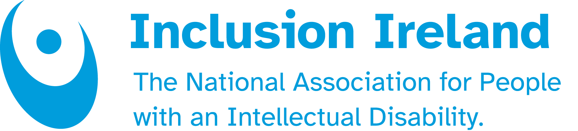
TABLE OF CONTENTS

About Inclusion Ireland
Concerns
Right to Education
Poverty and Unemployment
Institutionalisation & lack of Adequate Housing
Conclusion

About Inclusion Ireland

Inclusion Ireland is a national, rights-based advocacy organisation that works to promote the rights of people with an intellectual disability.

We work towards the full inclusion of people with intellectual disabilities by supporting people to have their voices heard and advocating for rights under the United Nations Convention on the Rights of People with Disabilities (UNCRPD).

The vision of Inclusion Ireland is that of people with an intellectual disability living and participating in the community with equal rights as citizens, to live the life of their choice to their fullest potential. Established in 1961, Inclusion Ireland’s work is underpinned by the values of Respect, Inclusion, Equality, Voice and Choice.

Concerns

Right to education

CESCR concluding observations to Ireland in 2015
(b) Discriminatory criteria against children with special educational needs contained in many admissions policies and the lack of a regulatory framework;
(c) Adverse effects of the austerity measures on the education sector, including the reduced number of teachers, rationalization of teacher/student support services, abolition of grants to schools, increase in transport charges and reduced allowance for clothing and footwear, which further restrict disadvantaged children from attending schools (arts. 13 and 14).
The Committee recommended that the State party:
(b) Review admissions policies of all schools with a view to removing all discriminatory criteria for enrolment and establish a regulatory mechanism to monitor school policies, including admissions policies;
The Committee recommended that the State party step up its efforts to promote inclusive education for all, including the implementation of the Education for Persons with Special Educational Needs Act 2004, to ensure equal opportunities for all children to quality education.

Issue: Segregated system of education in Ireland.
As noted in our previous submission in 2022, a parallel system of education provision exists in Ireland at present, with around 2% of pupils being educated in segregated classes and schools. In Ireland according to the most recent numbers, there are 140 special schools and 2,919 special classes in the country. The number of special classes was only 1,620 in 2019. The budget on special education has been increased by a significant amount in recent years with increased provision of resource teaching and Special Needs Assistant support. However, a significant amount of the increase in the special education budget has been spent on segregated education provision with autism classes (in particular) increasing in number year on year. Segregated special classes have increased from about 700 to almost 3,000 between 2012 and 2024. Currently there is no policy position from Government on the future of inclusive education. The lack of a coherent policy leads to ad hoc approaches which are not strategically aligned with our obligations under UNCRPD and UNCRC and further enables segregates and exclusionary practices.

Since our submission for the List of Issues in January 2022, a review of the Education for Persons with Special Educational Needs (EPSEN) Act 2004 has finally started, 20 years after its initial adoption.

In Ireland, the legislation specifically focusing on addressing the needs of children with disabilities is the EPSEN Act While the Act puts inclusive education on a statutory footing, it allows for an exception to this principle. It provides for a statutory assessment of supports and an individual education plan. However, these provisions have never been enforced as the Act has not fully commenced.

The UNCRPD has been ratified in 2018 but contradicts the ESPEN Act as the Convention does not allow for exceptions to inclusive education. It has been made clear in both the CRPD general comment four and assessment of other countries by the CRPD Committee that “having a separate special education system operating in parallel with a mainstream education system is not compatible with the provisions of the CRPD”.

Additionally, Ireland reviewed by the UN Committee on the Rights of the Child (UNCRC) in 2023 received the following recommendations in its concluding observations:
- Review relevant legislation, including the Equality Acts, Disability Act and Education for Persons with Special Education Needs Act, to bring them in line with a human rights-based approach to disability (36)
- The Committee is concerned about the establishment of special classes for children with disabilities (36.d)
- Ensure inclusive education in early childhood education and mainstream schools for all children with disabilities by adapting curricula and training and assigning specialised teachers and professionals in integrated classes so that children with disabilities and learning difficulties receive individual support and due attention; and ensuring reasonable accommodation within school infrastructure and for transportation; (37.c)

Suggested Inquiries:
6.1 What is the government doing to ensure that all children and young people can go to their local school and learn together?
6.2 When will the Inclusive Education Policy position form the National Council for Special Education be published? This will set out the policy direction for the state.
6.3 Once the policy position has been published, when will an implementation plan be forthcoming from Government?
6.3 What is the government planning to review, commence and implement in the EPSEN Act 2004?

Poverty and unemployment

CESCR recommendations to Ireland in 2015
24. The Committee is concerned at the increase in the number of people living in consistent poverty or at risk of poverty, particularly among (…) persons with disabilities. It is also concerned at the lack of integration of economic, social and cultural rights into poverty reduction policies as well as at the absence of concrete policies addressing the specific needs of the groups affected (art. 11).
The Committee recommends that the State party step up its efforts to reduce poverty, paying special attention to disadvantaged and marginalized individuals and groups, including through the adoption of poverty reduction programmes and strategies with concrete targets and a time frame for implementation. It also recommends that the State party integrate a human rights-based approach in all poverty reduction programmes and strategies, guaranteeing entitlements to individuals and ensuring accountability

Issue: The higher rate of poverty for people with disabilities and high unemployment
The comprehensive, government commissioned “Cost of Having a Disability in Ireland” report was published in 2021 and it estimated that the total annual additional cost of disability for people with intellectual disabilities is €13,107.12 Care and assistance was one of the highest average costs (€541) that people with an intellectual disability could not afford, together with adequate housing (€505) and transport (€384). Other areas like mobility (€193), communications (€185) and medicines (€107) were also highlighted.
In a 2023 survey led with our members that gathered more than 600 responses, 70% of respondents said that they struggled to pay bills in the past year. 56% said that this was a cause of stress and poor health in their household.
Finally, the 2022 SILC said that disabled individuals were six times more at risk of poverty (35.2%) compared to the general population (5.8%).

While the government acknowledged the poverty faced by disabled people, the response through the current Green Paper consultation and suggested measures will be far from sufficient to address the economic challenges faced by disabled people in Ireland.

A consequent and personalised cost of disability needs to be established as well as a response to the diverse level of needs within the population of disabled people.

According to Irish Census Survey 2016, 36% of people with disabilities of working age (aged 20-64 years) are in employment, compared to 73% of the general population. This rate is one of the lowest in the European Union where on average, 50.6% of people with disabilities are in employment. Employment rates are even lower among those with intellectual disabilities: 17% of those with an intellectual disability are in employment. A report from the OECD highlighted that the employment gap between disabled and non-disabled people (40%) was the highest in Ireland compared to the OECD average (27%).

Moreover, the remuneration rate of employees with an intellectual disability is an important issue. The Cost of Disability report mentioned above, the lowest figures for average annual income from employment are reported by respondents with intellectual disabilities (€12,553). Section 35(1) of the Employment Equality Act (EEA) still allows in 2024 for an employer to pay a disabled employee less on the basis that he or she is not doing the same amount of work as an employee without a disability. There is a possibility that this provision may be used to exploit those with disabilities.

Suggested Inquiries:
4.1: Given that persons with disabilities consistently have disproportionately higher poverty rates in Ireland, what measures, actions, strategies and timelines has Ireland taken to specifically address the poverty rates of disabled people?
4.2 How does the government intend to implement the recommendations from the Cost of Disability report and include a comprehensive strategy to tackle the cost of disability?
4.3 How is the government addressing the high rate of unemployment among people with disabilities, especially those with an intellectual disability?

Institutionalisation & lack of adequate housing

Institutionalisation & lack of adequate housing
CESCR concluding observations to Ireland in 2015
13. The Committee is concerned at the persistent institutionalization of persons with disabilities, at the poor living conditions of residential centres for persons with disabilities and at the lack of regular inspections of such centres (…)
The Committee recommends that the State party take all the steps necessary to make available alternatives to institutionalization, including community-based care programmes, and to improve living conditions in residential centres, including through regular inspections. It also recommends that the State party enhance access for persons with disabilities, including by cancelling the cuts in social benefit programmes.
Also see para 26, 27 on adequate housing, especially:
26. The Committee is concerned at the overall difficult housing situation in the State party, which includes the:
(a) Continuing gaps between availability and demand for social housing, which result in long waiting list for social housing;
(b) Increased costs of rental housing and reduced family incomes;

Issue: Lack of strategy to move all people out of institutions, inadequate settings and adequately housepeople .
As noted in 2022, Ireland has a strategy to move people with disabilities out of institutions (called A Time to Move on from Congregated Settings). The strategy, which started in 2011, had the goal that all people with disabilities would be living in the community in 2018. According to the most recent figures, 2,279 people are still living in congregated settings. In addition to this, a report from 2021 from the Ombudsman estimated that more than 1,300 people under the age of 65 have been put in nursing homes because of a lack of places in other settings. More recent figures from May 2023 highlight that the number slightly decreased to 1,250.

Since our last report, the number of individuals living with a parent over the age of 70 has increased from 1,250 to 1,500 (including 450 carers over the age of 80).

Thousands of others are waiting endlessly on a housing list for a place of their own. In 2023, a survey led by Inclusion Ireland gathering more than 600 responses, highlighted that nearly 50% of those on the housing list had been on it for more than five years, including nearly 20% of people who are waiting over 10 years. The Disability Capacity review to 2032 highlights the blatant lack of places for people in these situations and estimates the budget should be to address current unmet needs and future demographic changes.

Suggested Inquiries:
2.1 What is the governmental plan to ensure that all people with disabilities and others have a suitable and supported place to live in? Can the government give a clear timeline for such a plan? This should include people under 65 who are currently living in nursing homes because there is no suitable alternative, people living in congregated settings and people living at home with ageing carers.
2.2 How will the government ensure that people with disabilities are fully included in the Housing for All strategy, the national housing strategy for Ireland? what does it mean to be included? Do you mean targets achieved ?
2.3 How will the government ensure that disabled person organisations and civil society/advocacy organizations are included in the implementation of de-institutionalisation and housing plans?

Conclusion

Ireland still has a long way to go before fully implementing the UNCRPD as well as the recommendations of the UN Committee on Economic, Social and Cultural Rights.

The lack of meaningful access to education for children with an intellectual disability is paving the way for a life of “othering” and a lack of opportunities. This results in poorer outcomes in virtually all aspects of life, including unemployment, a disproportionate risk of poverty, endless waiting lists to health services, a lower life expectancy, and a lack of access to housing. This inequity leads to exclusion from community and triggers negative stereotypes from the general population.

We know Ireland will be a better place when the barriers our society has created are removed. This is when real inclusion begins to happen, and all citizens are valued equally and belong exactly as they are and exactly how they want to live. This has got to start in the early years by building a fully inclusive model of education, where all children get to go to school together and learn from one another.

For further information, contact;
Guillaume Jacquinot, Policy Co-ordinator.
00353 86 035 3888
guillaume@inclusionireland.ie

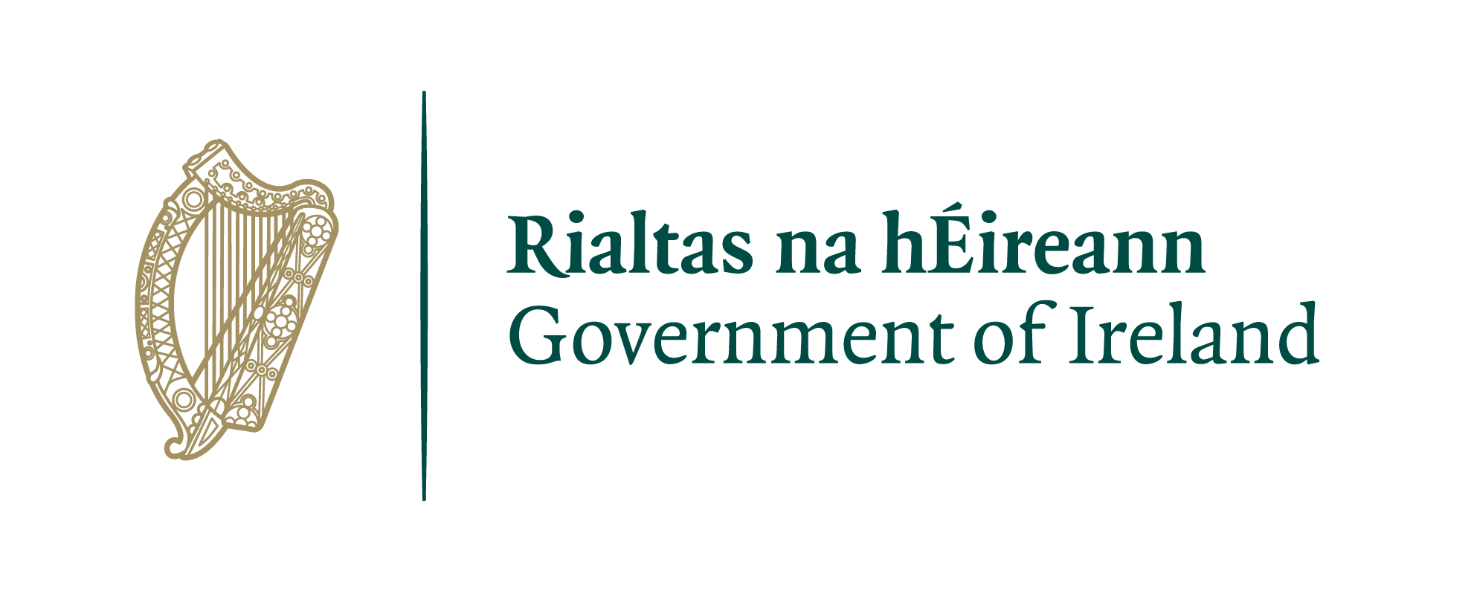



https://www.oireachtas.ie/en/debates/question/2023-10-24/250/#:~:text=Of%20the%202%2C919%20special%20classes,to%201%2C345%20mainstream%20schools%20nationwide.
UNCRPD, General Comment 4 and Concluding Observations of the UNCRPD Committee to most countries.
Cost of Disability Report in Ireland, available here,
Inclusion Ireland Budget Submission 2024.
Survey on Income and Living Conditions (SILC) 2022
Data from Census 2016, a more recent Census has been done in 2022 but counted disabled people through different mechanisms and therefore does not enable for a comparison to be made.
Ibid
OECD Disability, Work and Inclusion: Mainstreaming in All Policies and Practices. See here
Cost of Having a Disability in Ireland” report. 2021
HIQA Annual Report 2022
Office of the Ombudsman, Wasted Lives-Time for a better future for younger people in nursing homes, 2021.
https://www.rte.ie/news/2023/0515/1383629-nursing-homes-under-65/
National Federation of Voluntary Service Providers, Members survey, 2020.
Disability capacity review to 2032. gov.ie - Disability Capacity Review to 2032 - A Review of Social Care Demand and Capacity Requirements to 2032 (www.gov.ie)

