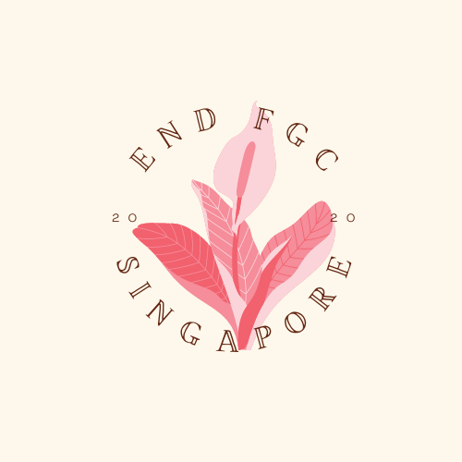

Committee for the Elimination of Discrimination against Women
Human Rights Treaties Division (HRTD)
Office of the United Nations High Commissioner for Human Rights (OHCHR)
Palais Wilson - 52, rue des Paquis
CH-1201 Geneva, Switzerland
By email: ohchr-cedaw@un.org

15 April 2024

Information on Singapore for consideration by the Committee for the Elimination of Discrimination against Women at its 88th session (13 - 31 May 2024)

Introduction:

- We respectfully present this report to supplement the sixth periodic report submitted by Singapore scheduled for review by the Committee on the Elimination of Discrimination against Women ("the Committee") during its 88th session (13 - 31 May 2024). This report is submitted jointly by End FGC Singapore and Equality Now and highlights in the main the issue of Female Genital Mutilation/Cutting (FGM/C) in Singapore.

- End FGC Singapore (EFS) is a community-led independent campaign to empower Muslim communities in Singapore to end the practice of Female Genital Cutting (FGC). EFS has a 3-pronged mission to (a) Create a paradigm shift within Muslim communities, (b) Engage relevant religious and healthcare leaders to have a public stance on FGC, (c) Educate the broader community to create solidarity and allyship to inspire action within the Singapore population.

- Equality Now is an international human rights NGO with ECOSOC status with the mission to achieve legal and systemic change that addresses violence and discrimination against all women and girls around the world. Founded in 1992, Equality Now is a global organisation with partners and supporters in every region. Ending sexual violence, ending sexual exploitation, ending harmful practices, and achieving legal equality are the main areas of Equality Now’s work.

- The issues and practices detailed in our report highlight the State's failure to fulfil its duty to protect women and girls from FGM/C under the Convention on the Elimination of All Forms of Discrimination against Women (‘the Convention’) (Article 2(c) and (e)) and that the decisions and faults of the authorities and their agents constitute demonstrable direct and indirect discrimination against women (Article 2(d)). We argue that the root causes of the failures of the State are due to the failure to comply with the obligation to transform gender hierarchies and stereotyped attitudes towards women, which violate Articles 2(f) and 5(a) of the Convention since the State has an obligation to combat FGM/C, as outlined in the Committee’s General Recommendations 14, 19 and 31.

- While the practice of Female Genital Mutilation (FGM) in Singapore undoubtedly involves the mutilation of the genitals, activists, many of whom are survivors deeply involved in grassroots efforts, prefer the term 'Female Genital Cutting' (FGC). This terminology shift aims to foster a less defensive atmosphere. It has been found to encourage a more open dialogue within the community about the real and profound harms caused by this practice rather than getting entangled in semantic debates. FGC is perceived as a more neutral term than FGM and also accurately depicts the procedure while evoking a less emotional reaction, particularly in the Asian context. As such, we strongly recommend that the CEDAW Committee adopt the term FGC or FGM/C when engaging with the Singapore government on this critical issue.

Prevalence of FGM/C in Singapore

- FGM/C is a harmful practice that involves the partial or total removal of the external female genitalia or other injury to the female genital organs for non-medical reasons. It is recognized internationally as a violation of the rights of women and girls and an extreme form of violence that infringes on their right to be free from all forms of discrimination, their right to life, and physical integrity, including freedom from violence and the right to health. Recent data released by UNICEF in March 2024 shows that there are 230 million women and girls globally who are affected by FGM/C. For the first time, the data also shows the extent of the practice in Asia-Pacific, with 80 million women and girls affected in this region.

- There is no available official data/statistics indicating the prevalence of FGC in Singapore. However, research studies have documented FGM/C amongst various Muslim communities in Singapore (which constitute around 23.4% of the total population). A qualitative study from 2011 also gathered evidence on the existence and practice of FGM/C within the Malay community in Singapore. A pilot survey of 360 Muslim women in Singapore conducted in 2020 by End FGC Singapore found that 75% of Muslim women in the study sample had been cut in their early childhood. Of the 360 respondents from the survey, 57% were from the Malay community, while the rest identified as belonging to Javanese, Indian, Boyanese, Arab, and other communities.

- The experiences of two survivors of FGM/C from Singapore, as highlighted in Equality Now’s joint report, Female Genital Mutilation/Cutting: A Call for a Global Response, are detailed in Annex-2 to the submission.

Medicalization of FGM/C in Singapore

- In February 2023, the Singapore government responded to the Committee’s List of Issues regarding FGM/C noting that, “Female genital mutilation is not a recognized medical procedure in Singapore”. However, this is untrue as FGM/C continues to be practiced regularly at General Practitioner Clinics in Singapore (refer to Annex-1 for evidence). It is believed that at present, almost 100% of FGM/C in Singapore has been medicalized, occurring in about 5 General Practitioner (GP) clinics by Muslim female doctors across the island. Evidence is provided in Annex 1.

- Thus, while the Singapore government may not explicitly recognize FGM/C is being performed as a medical procedure, considering that it is continuing to take place in the country, it is necessary for the Government to issue a circular/guideline explaining the lack of medical necessity of the procedure, the potential side effects and calling on medical professionals to refrain from practicing FGM/C. For instance, a similar circular has been issued by the Ministry of Health in Sri Lanka in 2018.

- The most common type of cutting done in Singapore is Type I and IV FGM/C (with anecdotal evidence of Type II FGM/C) - cutting varies from pricking, scraping to surgical removal of tissue. In the pilot survey, 38.4% of women reported that their clitoral hood or clitoris was cut. A variety of instruments were used for the cutting: penknife/blade, scissors, needle, or laser. There is no clear standard or consistency amongst the general practitioners, as it is not part of any medical curriculum. These results show that doctors cut using different techniques, with varying severity, on different parts of the vulva and with a variety of equipment.

- There is difficulty drawing causation between Type 1 and Type 4 FGM/C and reported medical harms since most existing literature on the medical harms of FGM/C either focuses on Type 2 and Type 3 or fails to distinguish between various types of FGM/C in their results. The following are potential and actual harms that were found by the pilot study in Singapore:
  - Accidental over-cutting or laceration of other parts of the vulva, requiring surgical repair.
  - Infection at site, keloid scars, abscesses, cysts, pain during sex or menstruation, tearing of scar during vaginal childbirth, shock, urinary tract infections.
  - Long term desensitisation of clitoris. FGM/C in an infant means disproportionately more nerve endings are lost, affecting future sexual function and pleasure.
  - Negative impact on attachment to caregiver. One common defense mechanism of the nervous system to extreme pain is shutdown (lethargy or falling asleep immediately afterward), which negatively affects interactions with the caregiver, e.g., feeding.
  - Negative impact on childhood brain development. Exposure to acute pain in babies and children will activate the biological stress response, preventing optimal development.
  - Negative impact on the adult nervous system and, therefore, mental well-being. Any acute biological stress response under the age of one can cause elevated levels of cortisol in the hair throughout adulthood.
  - Injury on the clitoral nerves. These nerves sit only millimeters under the surface of the clitoral hood of an adult and, therefore, may be even closer for infants. Each nerve contains an average of 5,140 nerve endings, which means that the clitoris is an extremely sensitive organ with an average of 10,281 nerves concentrated in an adult clitoris. Dr Paul Pin, a researcher from the study, emphasized that “[the nerves] are very large, [close to the surface] and therefore very susceptible to injury if you don’t know what you’re doing.

Legal and Policy Measures aimed at addressing FGM/C

- In its response to the List of Issues, the Singapore government noted that:

42. Singapore does not condone harmful practices and where harm to an individual can be established in a procedure, the procedure should be avoided. Female genital mutilation is not a recognised medical procedure in Singapore.
43. Singapore does not track the prevalence of this practice.

- There is credible information that FGM/C continues to be practiced regularly at General Practitioner Clinics in Singapore as reported by survivors and NGOs working for the protection of survivors of FGM/C. However, there are no laws, rules, or guidelines in place to address FGM/C in Singapore.

- There are also no policy measures or government strategies to address FGM/C. The Ministry Of Health (MOH) categorizes FGM/C as a practice that is “not prevalent in Singapore. It is a private and long-standing custom that some have chosen to practise.” However, this stance is contradicted by the results of available research on the continued prevalence of FGM/C in Singapore, including from the pilot study.

- Most importantly, there are no prohibitions, regulations, or checks and balances for the doctors who do this practice. Further, the government has not undertaken any awareness or community education campaigns involving affected communities or attempted to protect girls from undergoing FGM/C.

- End FGC Singapore has consistently engaged the MOH, Islamic Religious Council of Singapore (MUIS), and Muslim Healthcare Professionals Association (MHPA) since 2017, but the responses have been disparate and minimal. This has remained the same to date.

- As any policy on FGM/C would affect a substantial proportion of Singapore’s population, the government must undertake public consultations with a wide range of stakeholders, including by constituting a citizens’ panel to provide recommendations and advise on appropriate policy measures to address FGM/C (as it has done for other issues such as diabetes, recycling, and work-life harmony).

Marital Immunity for Rape and Sexual Activity with Minors
- We commend the government of Singapore for amending sections 375 and 376A of the Penal Code to remove the exception for marital rape. However, with respect to those who have been married as children, there is still a protection gap. The Singapore government’s response to the List of Issues notes that there are “legal provisions that criminalise sexual activity with a child, regardless of consent, with severe penalties for these offences.” That is true in the general law, however Sub-section 4 of Section 375 notes that “[n]o man shall be guilty of an offence under subsection (1)(b) or (1A)(b) for an act of penetration against his wife with her consent.”; while subsection 4 of Section 376-A similarly states that “[n]o person shall be guilty of an offence under this section for an act of penetration against his or her spouse with the consent of that spouse.” (emphasis added).

- These provisions could encourage “child marriage” and could lead to the assumption that children, mostly girls, are willingly consenting to sexual activity and not coerced (notwithstanding any significant differential in age and power) merely because they are married to the offender. A man who has sex with a 15-year-old girl would ordinarily be deemed guilty of sexual penetration of a minor, regardless of her apparent agreement, but the law deems such a minor wife capable of “consenting” to sexual activity with her husband. The law needs to be amended to remove all marital exceptions for sexual offences.
Suggested Recommendations for State Party
- We respectfully urge the Committee to issue the following recommendations to the Singaporean government:

- Undertake comprehensive measures to raise awareness of, eliminate and address the harmful practice of FGM/C within the country; including through hosting a citizen’s panel on the topic.
- Establish support groups and networks for women and girls living in Singapore who have undergone FGM/C and ensure that survivors of FGM/C have access to medical, psychological and mental healthcare and support services.
- Implement legal and policy measures to prevent and address the practice of FGM/C in Singapore, including addressing the medicalization of FGM/C.
- Immediately collect statistical and other relevant data on the number of women and girls living in Singapore who have either undergone FGM/C or are at risk of undergoing FGM/C, disaggregated according to community, age, religion and ethnicity.
- Collect statistical and qualitative data on the health consequences and outcomes of women and girls living in Singapore who have undergone FGM/C that was conducted in Singapore.
- Amend the Penal Code to remove all marital exceptions for sexual offenses which include those relating to minors.

ANNEX - 1

EVIDENCE OF FGM/C IN GENERAL PRACTITIONER CLINICS IN SINGAPORE
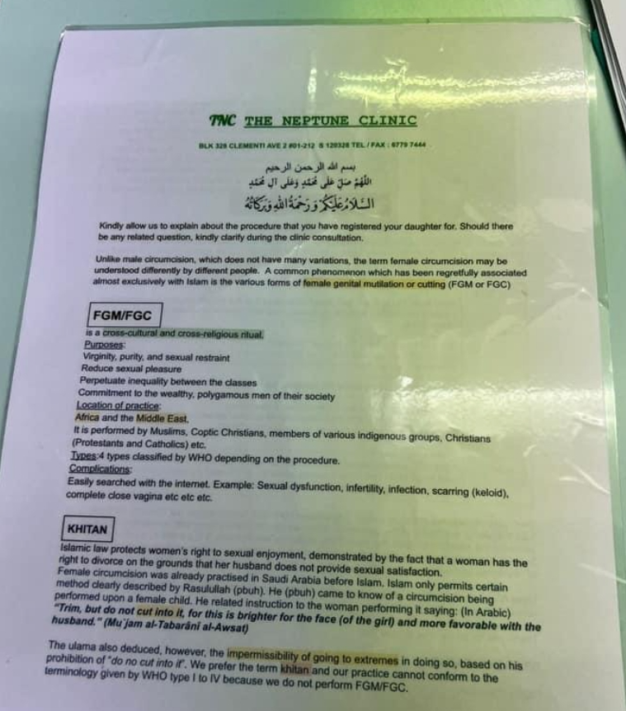
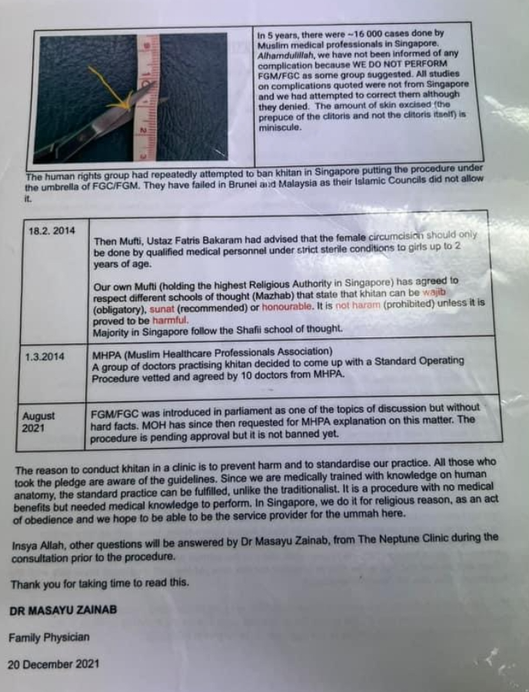

ANNEX -2
TESTIMONIES OF FGM/C SURVIVORS

Saza’s Story:

It was at my niece’s second birthday party when my sister-in-law mentioned that her daughter had been circumcised the previous week. I said, “This is wrong, it’s a violation of human rights!” And that is when my older sister told me I’d been cut as a baby. It felt like a bomb had gone off, I had no idea it had happened to me.
My experience inspired me to research female genital cutting (FGC) for my university thesis. FGC is practiced among Singapore’s Malay community and around 60% of Malay women have been cut. It is done for a range of reasons as an expression of culture and religion that is passed down the matriarchal line.
Islam has been mixed with traditions and patriarchy in the region and used to justify FGC. Women are often the custodians of culture and there is an understanding that we are required to remain virginal and untouched.
The Malay language has a lack of vocabulary to discuss women’s sexuality and the idea of female pleasure is missing from the culture. Female sexuality is seen as something that needs to be cured and FGC is a tool to control it.
FGC used to be performed by traditional midwives at homes but now the practice is medicalized and there are clinics where doctors operate. There is no law or legislation banning FGC in Singapore and the government has no public stance.
Type I FGC is practiced and it is often viewed as not serious enough to address but this shows a lack of understanding about the harm. It is a child rights violation as the child cannot consent to something being permanently removed from their body.
Since I shared my research, I have heard people talking about FGC within the Malay community. I have female friends who didn’t realize they were cut or didn’t think it was problematic but because of our discussions, they have confronted their parents. This can unravel a lot of trauma and Malay culture is not one where parents apologise to their children, but it is providing the space for important conversations between parents and their daughters.
For Saza’s full story head to equalitynow.org/Saza

Aisha’s* Story:

*name changed

I was told as a child that every girl had to go through it. There is basically nobody that you know who hasn’t gone through it. I believed everything my mother said.
As a nurse, I cleaned the vagina of women of different ethnicities. Of course, I noticed the difference. They had the hood and the two labia folds, and I did not.
At that time, as a Malay Muslim, I believed that my vagina was “cleaner” than those who were not circumcised. I felt I belonged to a much “higher status” because I was “cut”.
I realized my sexual desire plummeted and I wasn’t really interested in sex much longer.
I had my daughter at home, assisted by my husband. The natural delivery left a stinging burning sensation on my clitoris region. I thought it would go away, but it lasted much longer than I expected.
I deeply pondered: Why am I still feeling this? Why does it still feel sore? Is it because of the FGC that my mother made sure I underwent when I was a baby?
My mother kept insisting that I took my daughter to the clinic for “sunat”. She said it would be “over before you know it.” My husband is Muslim, but he’s not Malay. My husband refused to have it done to our daughter. He said women in his country did not have it done.
I’m sad it was done to me. I will never let it happen to my offspring.
When we educate women, we educate the entire nation. Women have to choose wisely what is right and wrong. Don’t succumb to social pressure – just because everyone is doing it, doesn’t make it right.
A longer version of this story was originally published on Sahiyo’s blog.
For Aisha’s* full story head to equalitynow.org/Aisha

World Health organisation, Female Genital Mutilation, https://www.who.int/news-room/fact-sheets/detail/female-genital-mutilation#:~:text=Female%20genital%20mutilation%20(FGM)%20comprises,organs%20for%20non%2Dmedical%20reasons.
UNICEF, Female Genital Mutilation: A Global Concern, 2024 update, https://data.unicef.org/resources/female-genital-mutilation-a-global-concern-2024/
https://data.unicef.org/topic/child-protection/female-genital-mutilation/
See Gabriele Marranci, Female circumcision in multicultural Singapore: The hidden cut, 26(2) The Australian Journal of Anthropology 276 (2015). Available at https://onlinelibrary.wiley.com/doi/abs/10.1111/taja.12070; and Equality Now, U.S. End FGM/C Network and End FGM European Network, Female Genital Mutilation/Cutting: A Call for a Global Response, https://www.equalitynow.org/resource/female-genital-mutilation-cutting-a-call-for-a-global-response/
End FGC Singapore, Pilot study on female genital cutting (FGC) in Singapore (unpublished and available on file with authors). Please see https://www.instagram.com/p/CP0OSZzBQE3/ for a summary of the study findings.
Equality Now, U.S. End FGM/C Network and End FGM European Network, Female Genital Mutilation/Cutting: A Call for a Global Response, https://www.equalitynow.org/resource/female-genital-mutilation-cutting-a-call-for-a-global-response/
Replies of Singapore to the list of issues and questions in relation to its sixth periodic report, CEDAW/C/SGP/RQ/6, paras 42 and 43.
Evidence found online by End FGC Sg
See Equality Now, U.S. End FGM/C Network and End FGM European Network, Female Genital Mutilation/Cutting: A Call for a Global Response, https://www.equalitynow.org/resource/female-genital-mutilation-cutting-a-call-for-a-global-response/
Ifah03, ‘Sunat, female circumcision - but they dr cut too much, labia is cut and dangling’, MummySG Singapore Motherhood and Parenting Forum, http://www.mummysg.com/forums/threads/sunat-female-circumcision-but-they-dr-cut-too-much-llabia-is-cut-and-dangling.99146/, (accessed 4 December 2020).
Rouzi, Abdulrahim A., et al. "Type I female genital mutilation: a cause of completely closed vagina." The journal of sexual medicine 11.9 (2014): 2351-2353; Alsibiani, S. A., & Rouzi, A. A. (2010). Sexual function in women with female genital mutilation. Fertility and sterility, 93(3), 722-724.; Yoong, W. C., Shakya, R., Sanders, B. T., & Lind, J. (2004). Clitoral inclusion cyst: a complication of type I female genital mutilation. Journal of Obstetrics and Gynaecology, 24(1), 98-99; Rouzi, A. A., Sindi, O., Radhan, B., & Ba’aqeel, H. (2001). Epidermal clitoral inclusion cyst after type I female genital mutilation. American Journal of Obstetrics and Gynecology, 185(3), 569-571.
Marshall, R. E., Porter, F. L., Rogers, A. G., Moore, J., Anderson, B., & Boxerman, S. B. (1982). Circumcision: II. Effects upon mother-infant interaction. Early human development, 7(4), 367–374.
De Bellis, M. D., & Zisk, A. (2014). The biological effects of childhood trauma. Child and adolescent psychiatric clinics of North America, 23(2), 185–vii.
Köbach, A., Ruf-Leuschner, M., & Elbert, T. (2018). Psychopathological sequelae of female genital mutilation and their neuroendocrinological associations. BMC psychiatry, 18(1), 187.
Maria Ulko, Erika P. Isabey, Blair R. Peters, "How many nerve fibers innervate the human glans clitoris: a histomorphometric evaluation of the dorsal nerve of the clitoris," The Journal of Sexual Medicine, 20(3), 2023: 247-252.
Kelling JA, Erickson CR, Pin J, Pin PG. Anatomical Dissection of the Dorsal Nerve of the Clitoris. Aesthet Surg J. 2020 Apr 14;40(5):541-547. doi: 10.1093/asj/sjz330. PMID: 31768527.
Replies of Singapore to the list of issues and questions relating to its sixth periodic report, 14th March 2023, CEDAW/C/SGP/RQ/6
EM/20/Oct/02772, Email from Ministry of Health Singapore to End FGC SG on 10 November 2020.
https://www.straitstimes.com/singapore/citizens-panels-have-improved-perceptions-of-govt-engagement-efforts-ips-study
See Sections 375 and 376-A of the Singapore Penal Code, https://sso.agc.gov.sg/Act/PC1871?WholeDoc=1
https://www.equalitynow.org/discriminatory_law/singapore_the_penal_code/
AWARE urges complete closing of gaps in rape law; urges further reform and public education on consent, repeal of Section 377A, 13 February 2019, https://www.aware.org.sg/2019/02/aware-urges-complete-closing-of-gaps-in-rape-law-urges-further-reform-and-public-education-on-consent-repeal-of-section-377a/

