South Sudan Independent Children Report

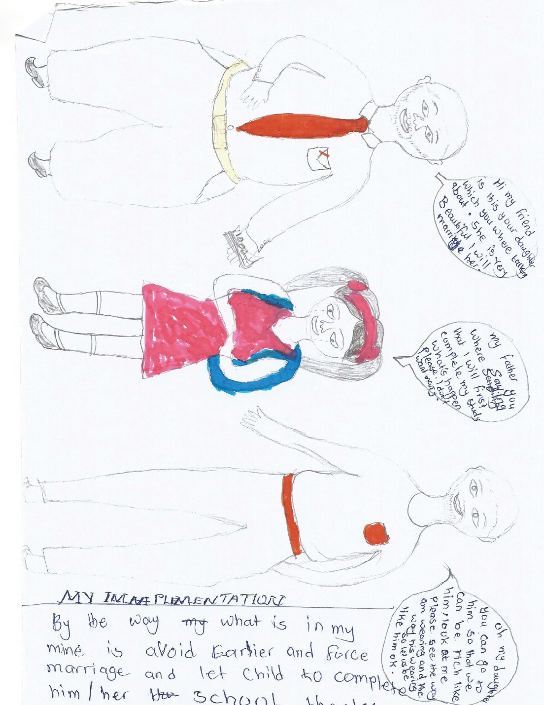

Submission to the Committee on the Rights of the Child

Report submitted by South Sudan Child Led Groups

Introduction to the report
This report has been prepared by Child Led Groups. The groups of children emerged for one-day conference in Lakes, Northern Bahr el Gazal, Juba and Jonglei states followed by a focus groups discussion with different categories of children in the country with the support of Save the Children. 8 Child Led Groups that are involved in the advocacy, lobby, promotion and protection of child rights in South Sudan participated in the conferences and focus groups discussions sharing experiences on our own situation and on the issues affected us in the country. The data collection started from 2018 and updated in 2020 respectively
We, the children in South Sudan have the pleasure to report our issues of concern to our government and to the UN Child Rights Committee. The fact that we children exist in this nation, while going through suffering from unknown reason which put us under difficult lives; this is really unimaginable situation giving the fact that, we children in this country suffered enough and beyond description. We believe that our ability to identify and pursue these issues, confirmed that, there is a need by our government to create a conducive environment for us as children to live in peace and harmony.

This report focuses on the following eight clusters of child rights:
- Definition of the Child.
- General Principle.
- Civil Rights and Freedoms.
- Violence against Children.
- Family Environment and Alternative Care.
- Disability, Basic Health and Welfare.
- Education, Leisure and Cultural Activities.
- Special Protection Measures.

THIS REPORT IS A CALL AND OUR VOICES TO OUR GOVERNMENT AND TO THE UNITED NATIONS CHILD RIGHTS COMMITTEE that, children in South Sudan both in town and in all the villages, in and out of schools have raised these concerns on child rights violations that need improvements as recommended in this report. We children hope if these recommendations are address and put in good practice, its can result to better future for us (children’s) and entire nation. Based on CRC clusters we (children) have selected some key child rights issues which we have experiences and have knowledge about and which need our government attention that we children are not enjoying these rights due to the reasons best explained in this report. Here is the full text of our (children) discussions and recommendations on the issues affecting us. The methodology for drafting this report has been participatory and involved consultations during conferences and focus groups discussion with many children across the country which informed this report

- Definition of the child
According to UNCRC, ACRWC and South Sudan Child act 2008, we understand that a child is a person under the age of 18 years old, but in South Sudanese diverse cultures especially in some communities, if a child is initiated, he/she is considered as an adult and he/she is treated equally as an adult even though he/she is still under age and this practice exposed children who goes through initiation to many risky life’s, e.g. an initiated child according to many cultures in South Sudan have an obligation to defend his or her community from an aggression from other community and that’s why many children took part in current conflict in the country.

Recommendation: We (children) need both the traditional elders and political leaders to be fully inform about child rights such that we children below 18 years should not be subjected to cultures that put us on risks and violated our rights.

- General Principle
Non-discrimination: Division exercises by adults on children, it existed in many societies including in school, homes and in the community, and it occurs due to gender based violence where boys are treated better than girls, because girls get married and stays with in-laws whereas boys take good care of parents when they became old. In school teachers hate children with poor performance and love high scoring children in class. These characters of discrimination bring in jealousy, isolation and hatred among children and parents. “My father loves my followers and never treats me equal,” said a child club member.

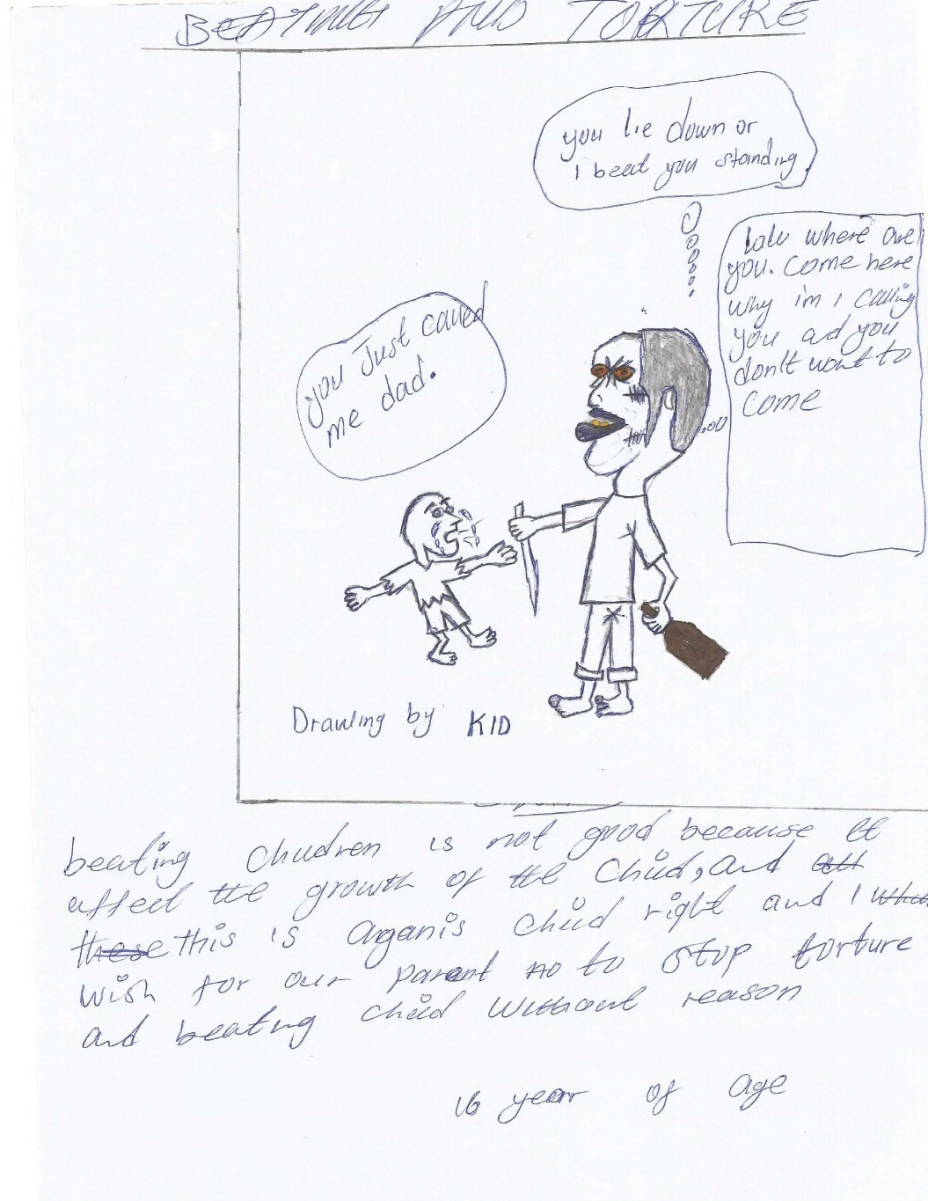

Recommendation: Parents and teachers need to be trained thoroughly on child rights to put equality in action at home and in school.

Government must tell everyone about all the rights in the convention on the rights of the children.
Many people are not taught about the rights of the children contained in the United Nations convention on the rights of the children, only children clubs, National and international organization working on children rights and few government institutions knows the rights in the convention but the general public, even our parents, do not know about the 54 articles. That is why child rights violations is more than it improvement in South Sudan.

Recommendation: We need government of The Republic of South Sudan to create awareness about the rights of the children in the convention. Knowing these rights will lead to smooth implementation of all the rights hence improvement of children lives.

Best interest of the child
In term of participation we are not allowed in community talk show, government rallies and in peace building table negotiations to present our opinions and discuss issues related to us due to our ages, in this matter we are disregarded and not represented and latter becomes the victims of what adult discussed and decided for us which exposed us at risk some time e.g. forced marriage. When we girls are forced to get marriage to those whom we do not love, it makes us run away from their homes and decided to stay on our own which sometimes gave us hard time to cope with the lives as we get to lives with our parents during our childhood.

Recommendation: we need community elders and government leaders to allow us to present our views in discussions that matters to us such as education, health, child protection and policy making and if allowed we can participate as well as adults in policy formulation so that our opinion are reflected in laws ad policy for better future we can call our own.

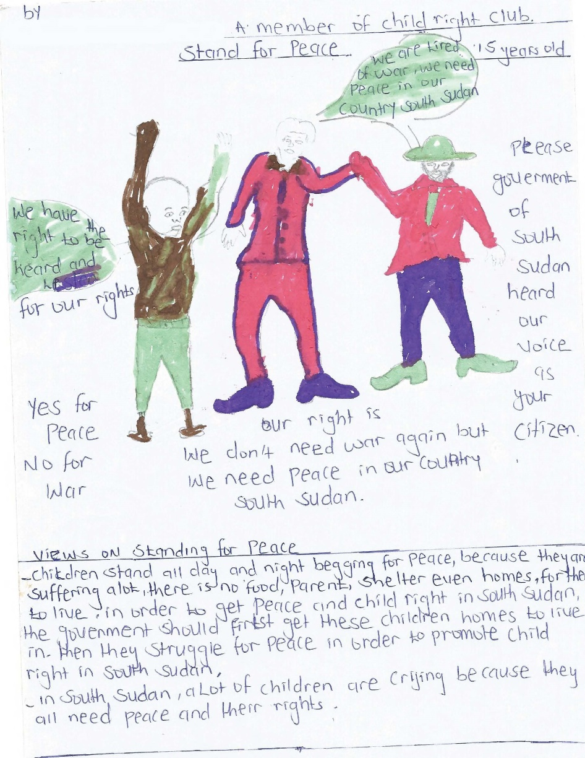

Right to life, survival and development
Based on the current situation of civil war in South Sudan we have been killed, injured, raped and lack basic needs and others left orphans, some children were left on river’s shore no one to rescue them until now not yet found. Many tensions happened in bushes when other parents decided to throw away infants who cried in bushes in order to avoid being notice by armed groups.

Recommendation: We need the government of South Sudan to protect children in conflict, provide education and bring long lasting peace and trust among communities.

Respect for the views of the child
Some educated people respect and others ignore children’s opinions during difficulties, most children suffered because they are not being listened to, other decisions are assumed as suitable for children when they are not even consulted to find out whether decision are accepted by us (a child).

Recommendation: Adults shouldn’t assume suitable decisions for children without their consent or knowledge.

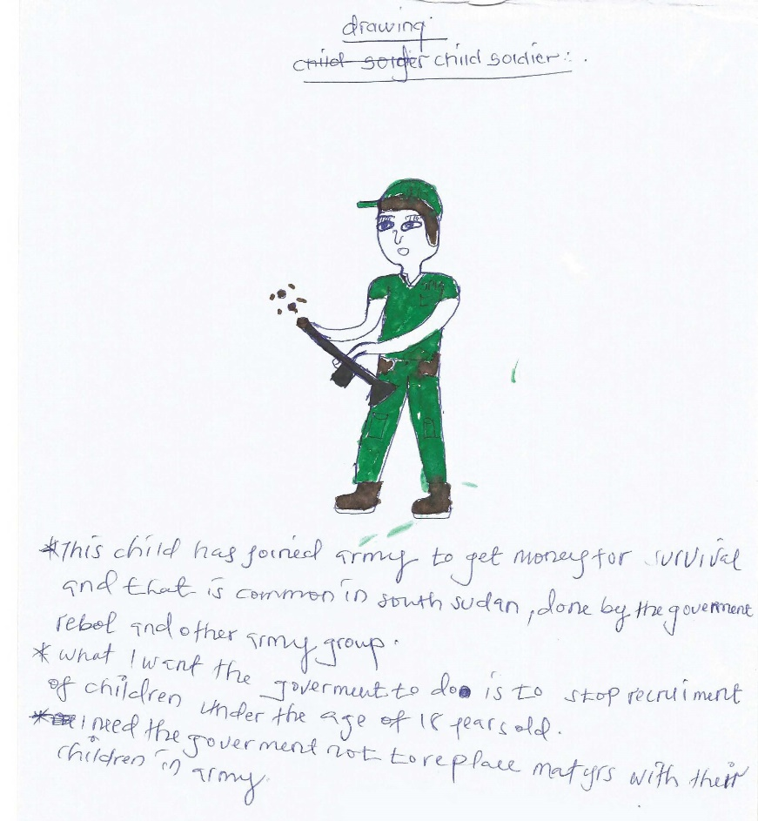

- Civil Rights and Freedoms
Birth registration, name and nationality: Children don’t have birth registration, nationality and good names in South Sudan, others are given bad names such as Ateer meaning conflict, Achinrrin meaning nameless, Anyijong meaning vulture and many more…… this bring bullying among children and adults which resulted to fighting and hatred at some point and this makes many drop out from school and some deserted their parents and community to stay in isolation in order to avoid bullying that comes from bad naming of a child

Recommendation: Parents have the responsibility to give children good names with best record of the child data, and the government need to develop birth registration system for children born daily at homes and in hospitals rather than to be given age assessment certificate which is some time not recognized by other countries when a child even have to travel outside the country.

Right to seek, receive and impart information
In South Sudan towns and villages, children don’t have access to information due to lack of media centers such as radio, TVs at home. Children are not informed about country progress, events and daily lives of the families and this is because most families are illiterate.

Recommendation: there is a need to build radio stations across the state to give necessary information to public including children about the country and the world. Parents also should be encouraged to sit after work and discuss with children about future perspectives.

Freedom of association and of peaceful assembly
In the past children used to gather in the playing ground but now they can sit as child right club members and discuss solutions to their problems.

Recommendation: there is a need to increase funding for child rights organizations and child led groups to increase children participation and wider coverage of child rights awareness.

Every child has rights to have his or her own beliefs and religion.
In term of religion children have express deep meaning by describing it as a natural choice that is determined by one’s own beliefs, that is personal opinion spiritually, and in South Sudan religion is not restricted both Muslims, Christians and African traditions believers have equal freedom of worship. In our opinion as children we do not determine our religion of choice because at earlier age we only move with parents, relatives and guardians without knowledge and objectives of the religion.

Recommendation: Whatever religion chosen by the child after realizing religion that is suitable for his or her need should not be denied but to be given more knowledge about it
We children also suggested that all religions should be put in all schools both primary and secondary school curriculum to equip children with free religious choice knowledge for example we need all children to study both Islamic religious education and Christian religious education in their studies, this will help us determine our own beliefs and religion.

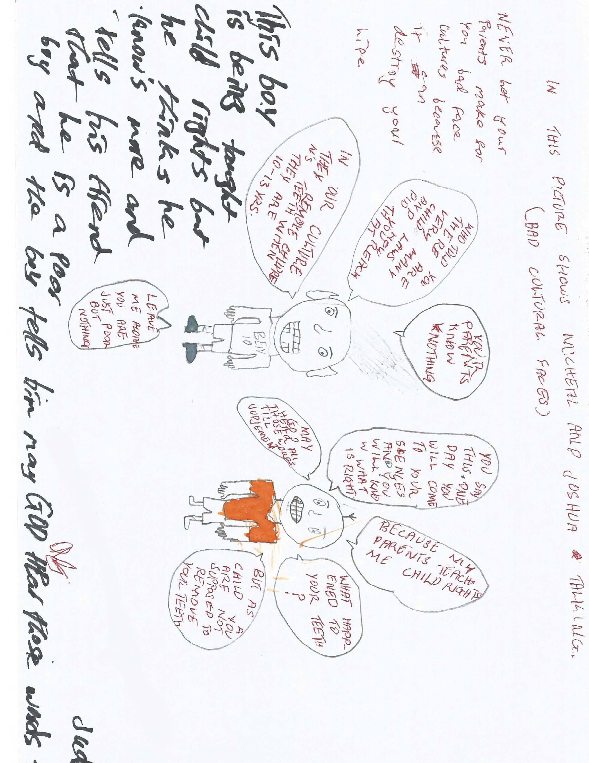

- Violence against Children
Right not to be subjected to torture or other cruel, inhuman or degrading treatment or punishment including corporal punishment.
At home and in school we are always beaten thoroughly when we did mistakes, most parents and teachers use to slap and beat us with “uncle-black’’ a plastic black cane that weakened body function, most adults tortured us if we failed to listen to them.

Recommendation: Children learn through advises rather than uncle black, parents and teachers need to sit down with children and teaches them how to handle mistakes.

- Family Environment and Alternative Care
Separation from parents.
In South Sudan court if divorce happened, children are given to father and if children want to stay with their mother they are not allowed to do so.

Recommendation: Children have right to be given a chance to decide who to stay with if divorce case is finalized by the judge.

Parents’ common responsibilities, assistance to parents and provision of child care services.
Most men don’t struggle for living to take care of children, they spent times playing games and later come home at night to disturbed women what to eat without asking whether children are ok or not, some women also do the same they don’t work for their children only wait from husband pocket.

Recommendation: Parents must struggle and work for their children and give parental care.

The law must protect every child’s right to privacy.
For us children privacy is something that is secret no need to interfere without concern, in our country South Sudan there is no protection about this rights because rights such as clothing and respect of child dignity are not in place, our privates parts are expose to public sight with pictures taken randomly pretending as a way to help improve our living conditions from well wishes and donors but later end up in vain, some time we share bed with adults of the different gender which is not good.

Recommendation: We need our parents and relatives to make extra care for our privacy by providing all material requirements for this right especially for girls and boys undergoing adolescent change, also children should not sleep together in the same bed with adults of the same gender.

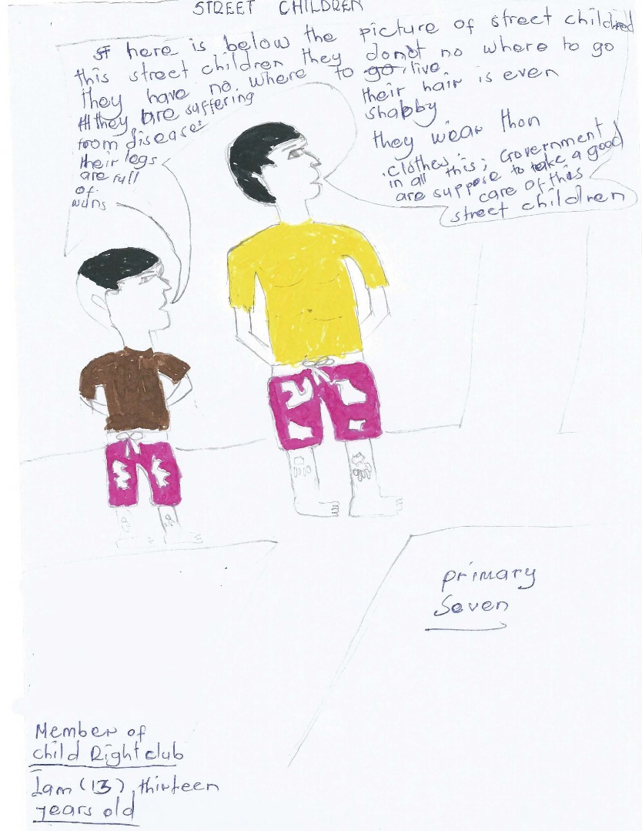

- Disability, Basic Health and Welfare
Survival and development
Most of the children are born and die in acute poverty in villages and some grow with poor growth, easily attack by diseases causing death.

Recommendation: the full growth and strong development of a child comes as a result of good feeding and medication, the government should support to vulnerable families in order for them to rise up their children in a better way for their children future and better lives.

Standard of living and measures
We are really starving some time, we eat once a day and sometime no food at all and this is because most families live on poverty lines everything was destroyed by conflict, other families are polygamous overcrowded more than ten people live in one house.

Recommendation: Humanitarian organizations need to deliver food with medicines to areas of much concern to rescue children situation and train parents to practice agriculture. Government need to improve on security so that to allow our parents to farm in order to get rid of the poverty in our communities

Measures to prohibit and eliminate all forms of harmful practice
There is cultural harmful practice where children are given marks on forehead, stomach, face and removing of lower teeth and all these are done to distinguish tribes, which later bring easy identification and target tribal killing in our societies and should stop.

Recommendation: We need the government to put law that prevents those cultures that harm and divide people in the society.

Disable children have the rights to a full life and to be part of the community.
Disable children are children who have some natural or artificial body parts inabilities, these children are common in South Sudan most inabilities were caused by war and diseases. Their rights have been violated often denied education, no extra care and negligence even at home they feel isolated no love from parents, no special center and services provided by the government.

Recommendation: Children with disabilities are human being like you who is upright and they deserve to be treated equally like love one in community, they must be given priorities in societies to participate like other children, women and men.
We children need government and international organizations to provide centers for extra protection units in education for these children with disabilities.

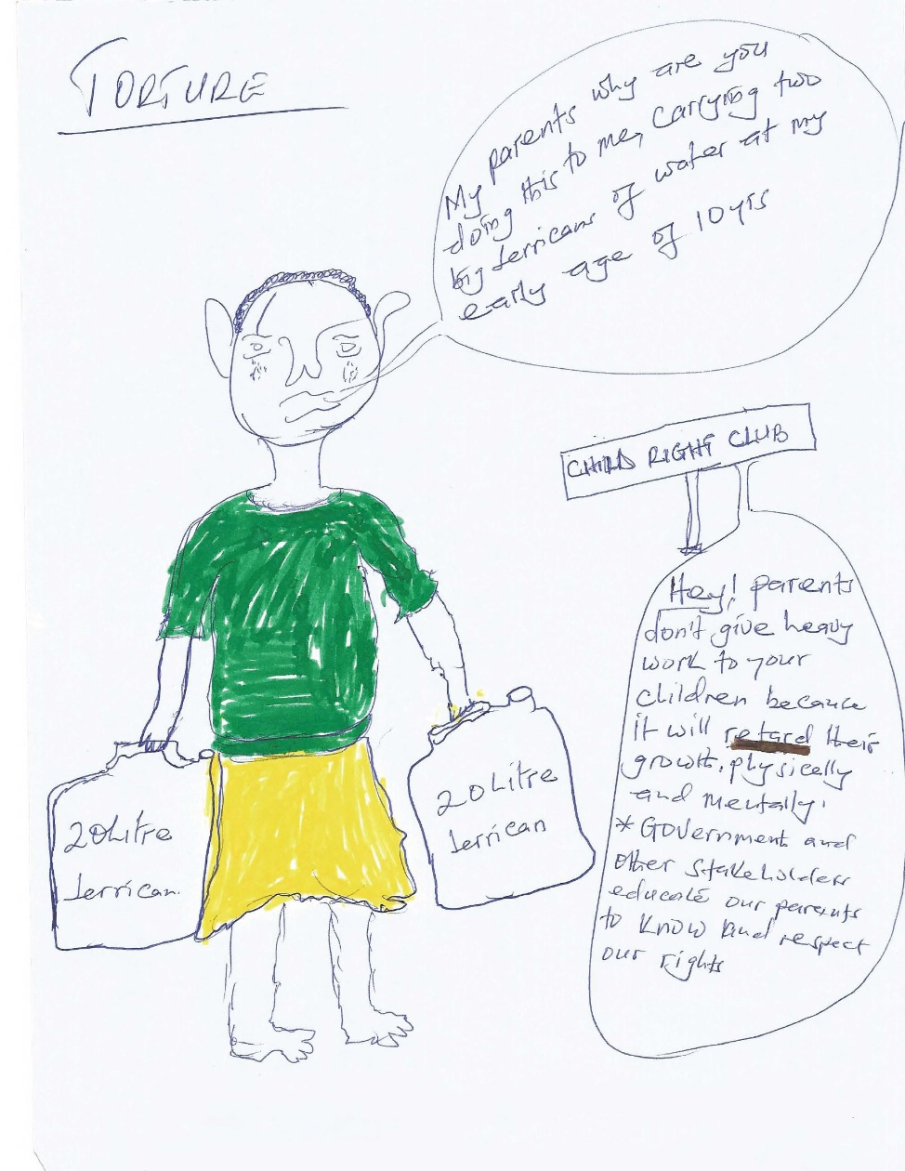

- Education, Leisure and Cultural Activities
Right to education, including vocational training and guidance
South Sudan’s education is the poorest education in the world. There is no good curriculum developed and no adequate source of funding for education sector, teachers are paid less than 30$ a month, no unified primary leaving examination. Also teachers are not well trained in their field of teaching, some classes still under trees.

Recommendation: There is a need for our government to improve on budget allocation to education and other sectors which are beneficial to us and make education a priority for all children in villages and towns.

Every child has rights to education
Education is the first basic right to be given to the child and in this we are so proud of our mothers who begin teaching us the first language. In South Sudan education is being provided in lowest term, no good schools both primary and secondary school built by government, no unified examination for primary school pupils leaving for secondary, most children live in cattle camps with cows and youth no access to education at all, girls are being dropout from school by parent to get marry to men that are not of their choice in order for parents and relatives to get dowry.

Recommendation: We need our government to provide free accessible, affordable and quality education for all children. Also to promote girl child education because a girl denied education has been denied equality, said 9 years old boy from children voice for peace who have been abandoned by their father.

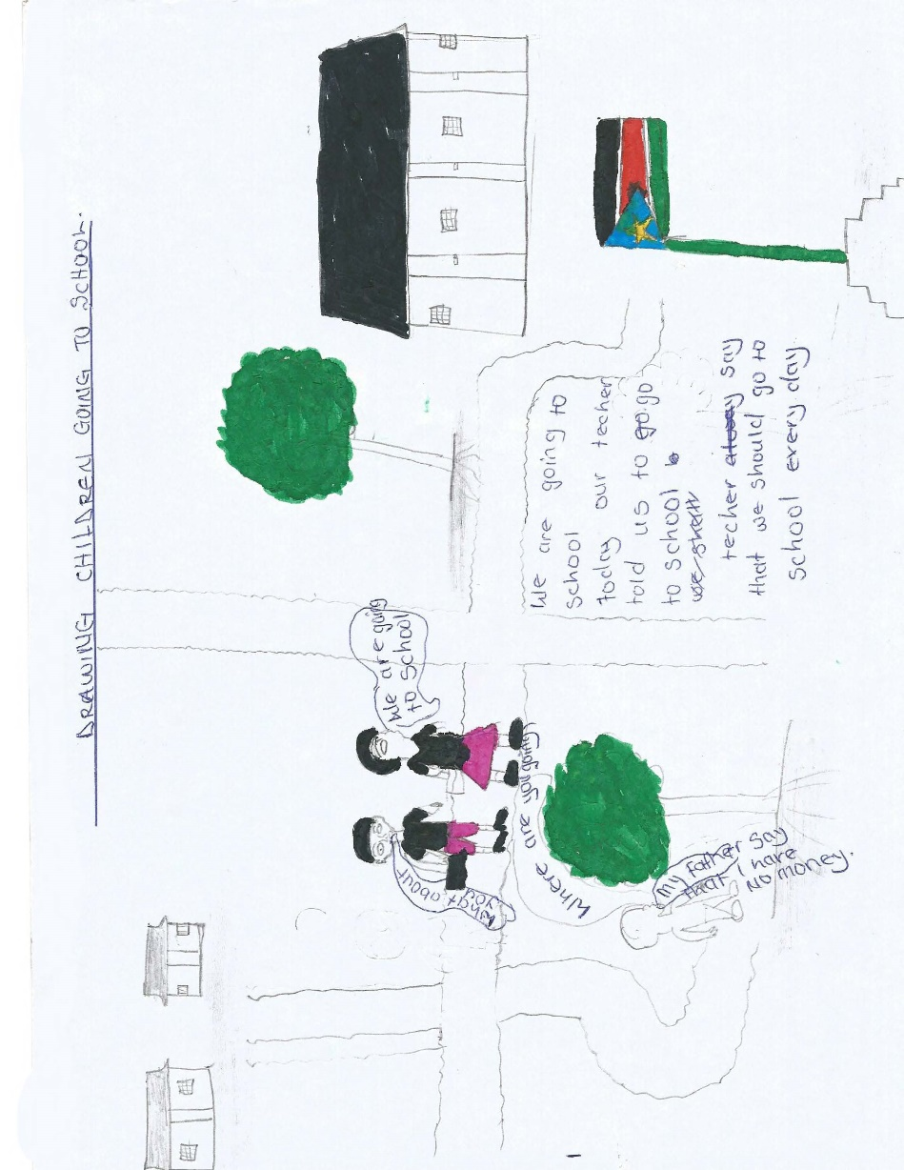

Play, leisure, recreation and cultural and artistic activities.
Most of the schools and homes lack playing materials and there is limited time in schools and hard labor at home that not allow children to play, leisure and creational activities.

Recommendation: Time to play and relax need to be given to children at home and in schools and the government to have cleared that will regulate that.

- Special Protection Measures
Children in armed conflict
Children are being recruited by army forces and armed groups to fight for other people’s interest, other children join the army with aims to support education and parents most of these children have died during the conflict.

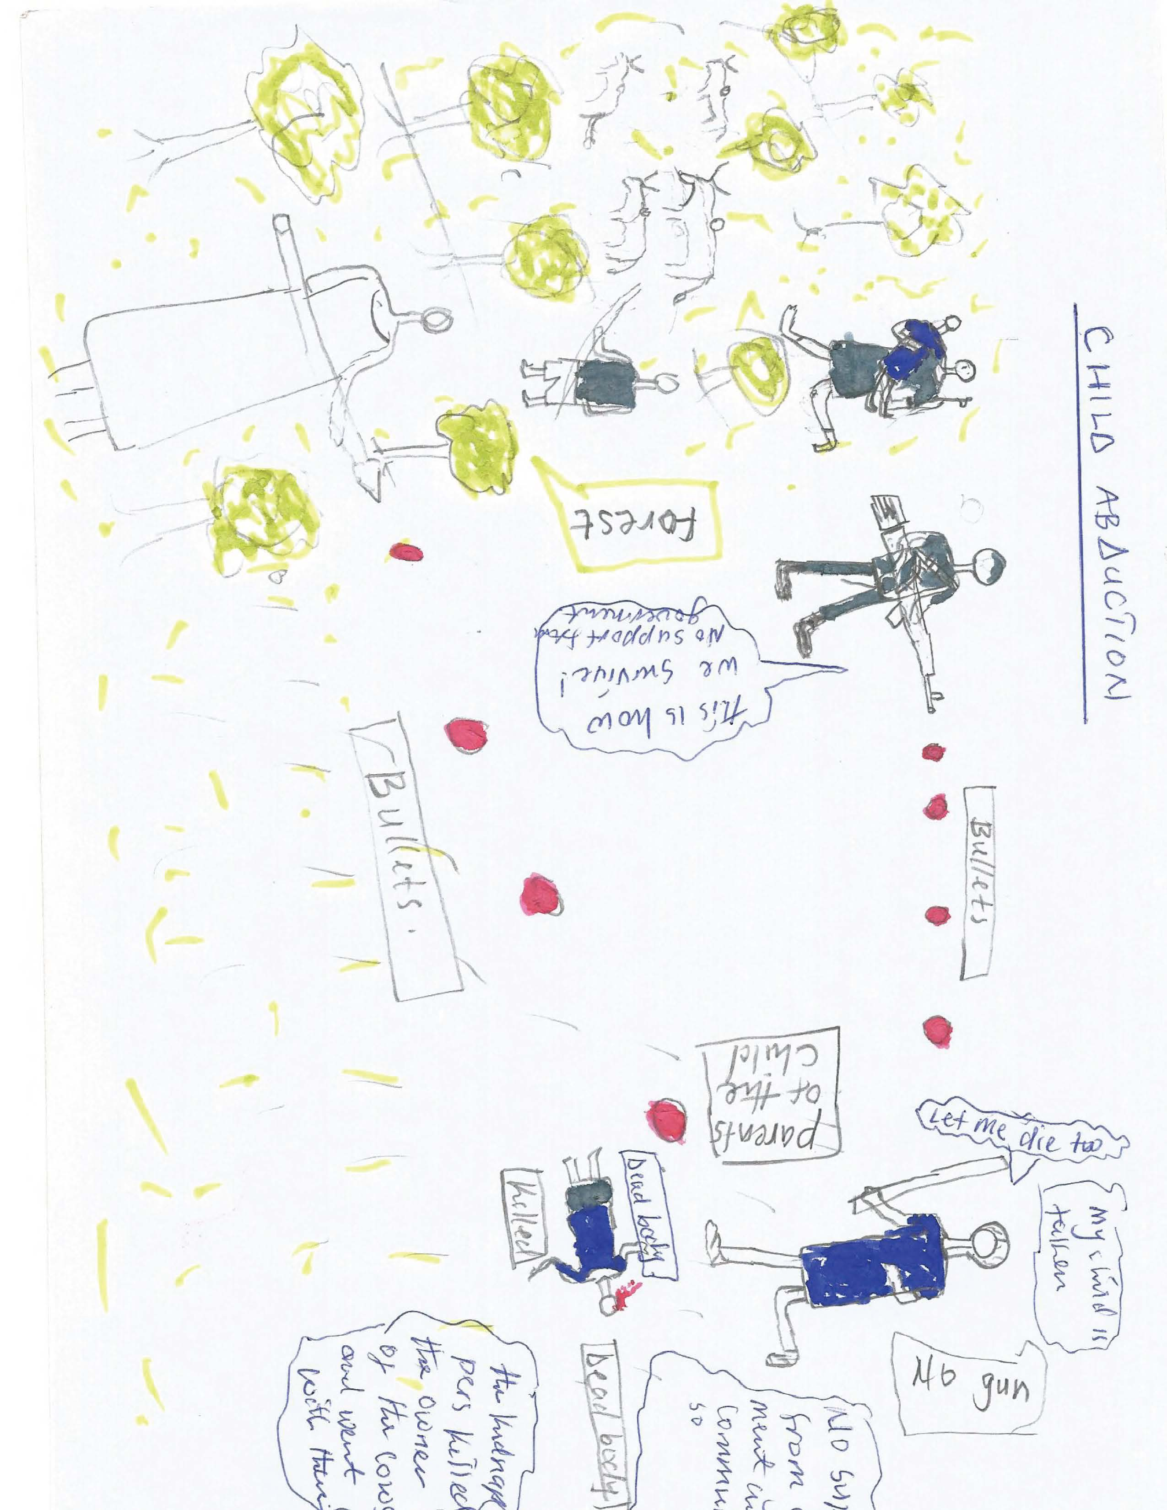

Recommendation: Our government should develop policy that prevent use of children in armed conflict and the army need to be fully inform that persons under the age of 18 years are children and have nothing to do with army or armed group.

Children who are refugees or trying to be refugees have the rights to extra protection.
Refugee children are children displaced from their own country and forced to live in other countries due to wars and conflict. This rights has been violated thoroughly no protection for children both in IDPs and when seeking for refuge for example in 2013 children were killed in Bor and Bentiu trying to enter UN camp for protection and within the camp.
This has become a culture in South Sudan since people are forced to leave their farms and villages to move to the neighboring countries of Kenya, Uganda and Ethiopia as children. For how long will every generation in South Sudan be refugees? Our parents were refugees during SPLA war with Khartoum government and again now after two years of fruitful independence celebration of our martyrs blood who have cemented our national foundation another war of hatred and self-interest started again, are we in a cursed nation?
We children have suffered more than enough for what we do not know about, in the course of fighting our legs could not carry us as fast as we could escape bullets and slaughtering, small infants die on the long way run as we seek for refuge and in other countries.

Recommendation: We need our government to stop war and embrace peace, make ruling to be so democratic and inclusive in order to make strong nation that is based on fundamental principle of equality, justices and good governance to avoid conflict and being refugee again said a 13 year girl member of children voice for peace whose mother and followers stays in Kakuma refugee camp in Kenya.

We also request all our heroes and heroine who have fought for our nation freedoms and liberty to work together because there is a need for them to work together more than before, we need leaders to put the love for our country South Sudan before every man interest and to remember who they are giving timeless efforts. We need protection and zero South Sudanese refugees in the next five years please act, now is the time!

We also need provision of maximum humanitarian assistance in all fields to satisfy our needs since our parents have nowhere to look for our needs.

Every child has rights to protection from torture and every bad treatment
Torture and bad treatment means beating, slapping, and hitting of children with sticks, hands, plastic cane and other dangerous items that harm children physically and internally. In South Sudan children are beaten thoroughly in schools and at homes when they committed mistakes, most parents and guardians always use hand to slap children. I was slapped by my father now I have hearing problems, sometimes I cannot listen at a far distance when call said child rights club member from Jubek state.

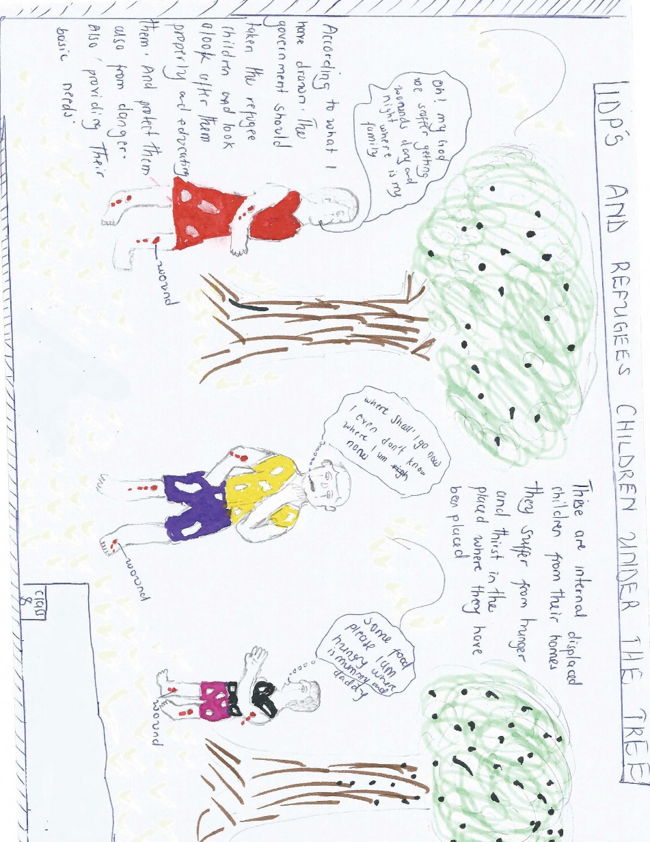

Recommendation: Most communities have a saying that, African children only listen through stick this is not true it is baseless; we children listen when being advised like adults. Some people beat us without asking what happen when something is wrong, if adults sit with us and discuss problems peacefully before beating we can learn more and they can also learn from us too.

Advices matters more than corporal punishment, all people must stop beating and slapping of children it affect the growth and health condition.

Sale and abduction
Abduction of children among counties in South Sudan has become a traditional concept where people attack villages, killing parents and taking children, sale them to other far areas making it difficult for children to escape. More than one hundreds children are abducted yearly in the country.

Recommendation: the government and traditional elders and leaders should come together to bring people who abducted children to justice.

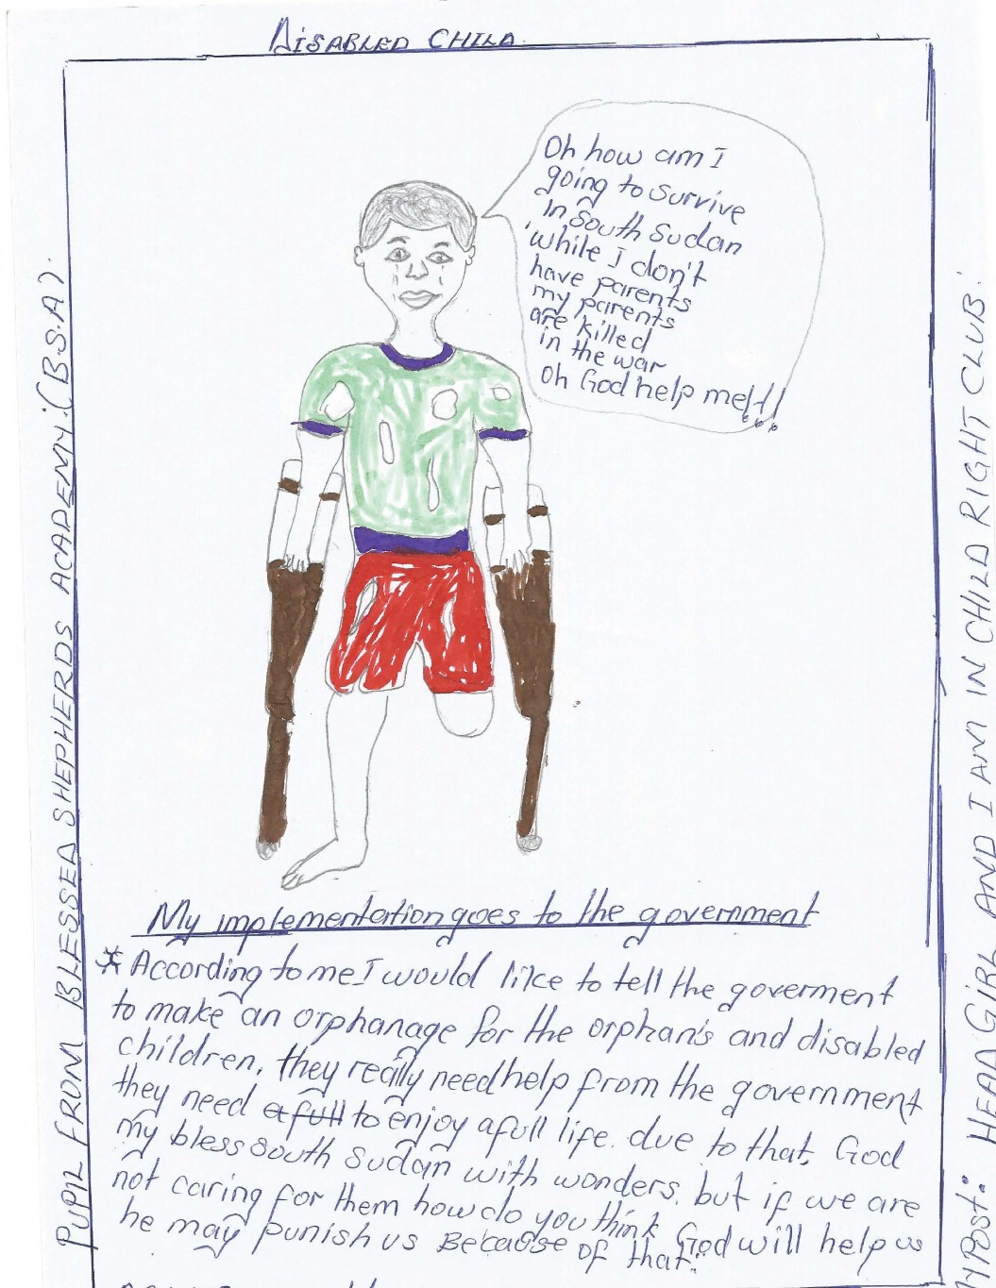

Sexual exploitation and sexual abuse
Adults do this in term of force and earlier marriages, girls are determined as wealth makers in the communities, when a rich man admire a young girl definitely heads of families come to agreement without child consent and later a child is given options to marry or to be disown, some young boys are force to inherit step mothers and brothers’ wives. Other girls got married on their own.

Recommendation: Any marriage should have a document to show that couples are adults. Any person forcing and marrying a child should be given a penalty. Sensitization on girl child education and enrollment of child mothers needs to be done to encourage girls struggle for their future.

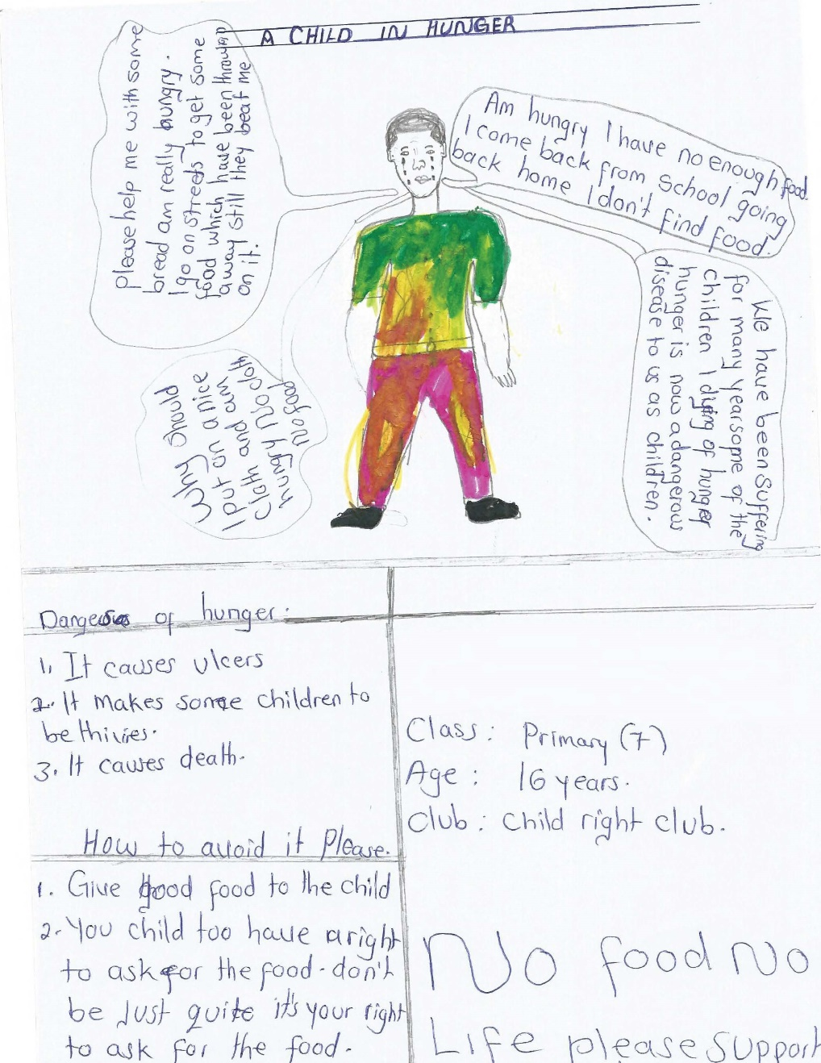

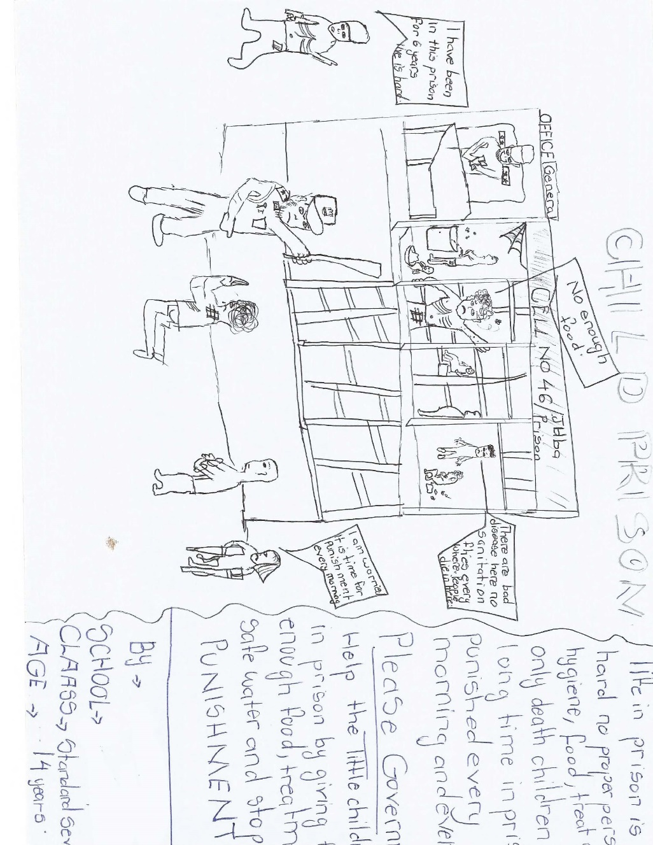

Administration of juvenile justice
Children are imprisoned without investigation and trial, put together in jail with adults, torture and beaten every morning and evening, mostly the victims of this are children struggling for survival on the street accused of stealing and robbery daily.

Recommendation: Juvenile court need to be established at all level to deal with children issues related to justice, children should not be put in prison with adults. Child led organization should work and create network to rescue children in prison.

Government must support parents. Parents must always try to do what is best for their children.
Almost rural population is more in South Sudan this has limit government to support parents in term of jobs and other vocational training to support their families because of illiteracy hence parents end up with no service delivery to their children.

Recommendation: Though there is no support done by the government we encourage our parents not to rely on other authorities but to support us by ensuring equality among kids and provision of quality education with the little resources they have.



