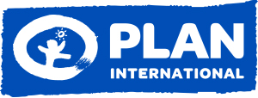
Committee on the Rights of the Child
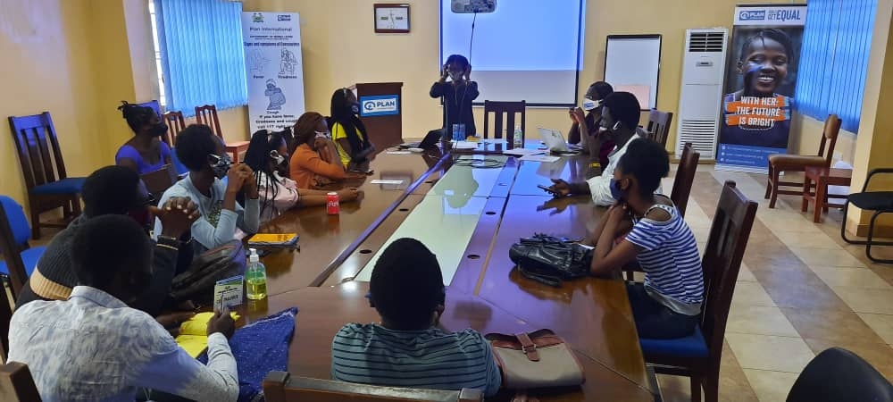
The Picture of Sierra Leone – Children and Young People Perspective
SUBMITTED BY
YOUTH ADVISORY PANEL - PLAN INTERNATIONAL SIERRA LEONE
90th session- Submission for the List of Issues Prior to Reporting

The Youth Advisory Panel was established in 2014 by Plan International Sierra Leone as a body of young people from different youth advisory groups in Sierra Leone, striving to vocalize the needs of youths by serving as advisors and ambassadors to Plan International. The panel is geared towards creating and nurturing a network between youth partners and decision makers at Plan International Sierra Leone in order to reinforce Plan’s mission of empowering children across the world.

The Children Forum network is a child led advocacy organisation established by the Ministry of Social Welfare Gender and Children’s Affair’s in the year 2000 to serve as a respective voice for children in issues that relates to their wellbeing and protection in the country. The CFN also advocates for individual and group rights of children.
LIST OF ACRONYMS
YAP | Youth Advisory Panel
PWDs | People Living with Disabilities
FQE | Free Quality Education
YACAN | Youth and Children’s Advocacy Network
CFN | Children’s Forum Network
EGRA | Early Grade Reading Assessment
SLTSC | Sierra Leone Teaching Service Commission
UNICEF | United Nations Children Emergency Fund
MBSSE | Ministry of Basic Senior Secondary Education
NPSE | National Primary School Examination
BECE | Basic Education Certificate Examination
RTP | Radio Teaching Programme
TSC | Teaching Service Commission
MTNDP | Medium-Term National Development Plan
MEST | Ministry of Education Science and Technology
SLTSC | Sierra Leone Teaching Service Commission
SGBV/GBV | Sexual and Gender Based Violence
MOGCA | Ministry of Gender and Children’s Affairs
FGM | Female Genital Mutilation

INTRODUCTION
Sierra Leone is one of the countries that has tendered its commitment through the ratification of the Convention on the Rights of the Child that gears towards upholding fundamental human rights of children. While progress working on these commitments is recognized here, it is however noted that significant improvement is needed in certain areas, particularly on girl’s rights. There was a demanding interest from children and young people to focus their submission on three critical areas. These include i) Gender Based Violence, specifically FGM, sexual violence and early marry, and ii) Education. Also, the report intermittently presents a picture of the gains made by the country thus far, highlighting the challenges and gaps, and what can be done to nip these loopholes in the bud.
Consultation and interviews of children and youth led groups namely, Children’s Forum Network (CFN), Youth and Children’s Advocacy Network (YACAN), and Youth Advisory Panel (YAP), were held to elaborate this document. The report is therefore a child/youth-centered submission recognizing the prevailing vulnerability of children especially girls in Sierra Leone, and the significance of their concerns and recommendations.

SITUATION ANALYSIS: Expanding the Picture in Detail
- Violence against Children (Arts 24, para. 3 and 34) specifically Gender Based Violence

Female Genital Mutilation and Sexual Violence (Arts 24, para. 3 and 34)
Existing cultures have condoned different forms of violence against women and girls. Nonetheless, the new government of Sierra Leone has made strides to tackle sexual and gender-based violence by establishing the “One stop center’’ to respond to victims of abuse in six districts out of the sixteen districts in sierra Leone, a toll-free line to report issues of SGBV, amendment of the sexual offences act of 2019, setting up of a special court for speedy trial and the development of the male engagement strategy on SGBV prevention. In addition, the government declared a national emergency on Rape and established the Ministry of Gender and Children’s Affairs (MOGCA) in January 2020 as the national machinery for the promotion of gender equality, women and children’s rights and wellbeing in Sierra Leone. Consistent with the strategic objectives in the Medium-Term National development plan, the ministry is focusing on five key priorities (prevention of sexual and gender base violence, strengthening the response mechanism for SGBV, women’s economic empowerment, child protection, strengthening coordination and partnership). Whilst we applaud the ministry’s effort on issues affecting women and girls, we however note that specific reference is not made on gender-based violence. For example, almost half the women in Sierra Leone are reported to face sexual or physical violence during their lifetime, and 90% of females aged 15 to 49 have been victims of female genital mutilation, according to United Nations’ data, and no criminal penalties or laws have been made by Sierra Leone Government against FGM.
While gains are gradually made on GBV issues, there are still significant improvements needed. For instance, between 2018 and 2020, there have been several reported cases of sexual violence against girls including months old babies. For instance, in 2019, Rainbow Initiative stated in a radio discussion program that a three-year old baby was sexually penetrated.
According to UNICEF’s annual report, in 2018, out of 55% of GBV cases that were referred to courts, only 1.2% were successfully prosecuted. The Family Support Units (FSU), Legal Aid Board (LAB) and the Judiciary provided legal services to 24,352 children (10,849 boys, 13,503 girls) in 2019. Of the 4,211 child victims of sexual assault reported to FSU-Sierra Leone Police in 2019, 3,537 were girls.
In addition, there are already several laws and policies instituted by the Government to ensure compliance to children and girls’ rights. These include the Sierra Leone Child Rights Act of 2007, the Amended Sexual Offences Act of 2019, and the Three Gender Acts: Domestic Violence Act of 2007, the Devolution of Estate Act, and the Customary Marriage and Divorce Act of 2009. Nevertheless, GBV remain to be overarching challenges women and girls grapple with, thereby hindering gender equality, their empowerment and full access to their rights.

  - CHILD MARRIAGE (Art 24 para. 3)
Sierra Leone has enacted legislations to prevent child marriage. Article 34(1) of the child rights act states that the minimum age of marriage whether formal or informal shall be eighteen years. Article 2 states that no person should force a child to be betrothed; to be the subject of a dowry transaction or to be married. Notwithstanding the legislation, the issue of child or early marriage remains one of the greatest challenges facing women and girls especially those in rural communities.
Enforcement of the laws remains the biggest challenge. Despite the existence of the Family Support unit (FSU) of the Sierra Leone Police (SLP) in all the districts headquarter towns and some chiefdoms, complaints against child marriage have been very low due to the fact that some marriages are done informally or secretly. Even though very few matters are reported and, in some cases, brought to the public domain, these matters normally die a natural death during the investigation process.
There is a challenge in prosecuting customary marriage cases because of the provisions of section 2 (2 & 3) of the Customary Marriage and Divorce Act 2009. The said provision overrides sections 34 (1, 2 & 3) and 41 (1) of the Child Rights Act 2007, because of discrepancies in age of marriage between the laws.
Some of these laws relating to early/child marriage are contradictorily encouraging the practice of child marriage. NGO intervention has however recommended and presented to parliament, the harmonization of these laws since 2018 but it is yet to be achieved. This report therefore urges the government to take urgent action on this bill.
Finally, there is a challenge as Sierra Leone is yet to abide with the provisions of chid marriage as provided in the Convention on the Rights of the Child 1990.

RECOMMENDATIONS
While we note the efforts made by the government to address GBV issues through the Ministry of gender, we recommend that:
- The MOGCA should apply a holistic approach to violence against girls.
- The government of Sierra Leone should have a clear position or policies in ending FGM.
- Prevent sexual exploitation and abuse of children and specifically girls through endorsement and enforcement of the law through community engagement and designing of monitoring systems to minimize the risk.
- Increase and train individuals such as family support unit in order to prevent and respond to GBV cases.
- Government to speedily establish one stop centers in the remaining ten districts.
- Develop guidance for building systems to eliminate gender-based violence.
- Government to urgently establish a forensic laboratory to respond to SGBV matters.
- Government to establish a register of sexual perpetrators in Sierra Leone
- Government to draft and enact a new law that prohibits child marriage or find a way of amending the discrepancies as provided in the other sections of the other laws especially that of the age of marriage.
- Government should engage on massive outreach and sensitization on laws that protect girls on early marriage and all forms of violence.
- Government should put and enforce strict penalties on people that facilitate early marriage, especially by the community and law enforcement agencies.
- Government and donor partners should source more funds and structure to provide psychosocial and counseling facilities for victims of early marriage.
- Judiciary system should enforce speedy trials on early marriage and sexual abuses cases in court.
- Government /partners should collaborate with the judiciary to provide legal representative for victims’ families in court.
- Conduct strong monitoring of the implementation of laws protecting the rights of children, specially girls.

Education, leisure and cultural activities (arts. 28–31)

RIGHT TO EDUCATION
Sierra Leone’s government under the new leadership of His Excellency the president, Julius Maada Bio launched a flagship programme – “Free Quality Education”, in February 2019, under the New Direction manifesto. The Free Quality Education (FQE) aims at removing barriers to education, so that every child particularly, the extremely vulnerable in Sierra Leone fully access their right to education. The 2019 Early Grade Reading Assessment (EGRA) estimated that 97% of students between seven to ten years old (class 2 to 4) in Sierra Leone do not know how to read and write. In respect to gender, there are more non-reader females, 72% are girls whilst 67% are boys. The 2015 Early Grade Reading Assessment also reports that 34% of teachers are classified as unqualified. According to UNICEF’s Country office annual report, the country saw an increase of over 700,000 more students enrolled in 2019: pre-primary enrolment saw a 41.1% increase of 40,000 students; primary a 29.4% increase of 403,000; junior secondary a 43.2 per cent increase of 136,000; and senior secondary a 47.9% increase of 99,000.
The new administration has overturned a five year policy banning pregnant girls from attending school. This policy has been repealed and is to be replaced by a proposed new policy (radical inclusion and comprehensive safety for all children). This commitment was made through a press release by the Government dated 30th March 2020, indicating that its decision is based on both evidence and constitutional due process. Notwithstanding the Government’s effort in overturning the policy on pregnant girls, there are divergent views on the said policy among many Sierra Leoneans.
Additionally, during the Ebola crisis, adolescent girls suffered the most in Sierra Leone. Thousands who got pregnant were prevented from accessing formal education when schools reopened. In the context of the Covid-19 pandemic, the Government noted in its Ministry of Basic Senior Secondary Education (MBSSE) COVID 19 response plan that in anticipation of school closures, it had decided to overturn the ban on pregnant girls from attending school. During the recently concluded 2020 public examinations (NPSE and BECE), it was revealed that over 1,055 schoolgirls were pregnant during the examinations. The Government has also embarked on a campaign to achieve zero pregnancy among adolescent schoolgirls across the country using social mobilization, radio programmes and other direct means of communication.
In response to the unprecedented educational challenges created by school closures due to the COVID-19 pandemic, the Government through MBSSE developed a COVID 19 response plan. This plan makes provision for the establishment of the education emergency taskforce, which is geared to advice and support the government on strategic education activities with a goal of improving learning outcomes for Sierra Leonean children during post Covid-19. The Government rolled out the radio teaching programme (RTP) immediately after schools closed. This programme is championed by the Teaching Service Commission (TSC).
The government further demonstrated a commitment by launching the Medium-Term National Development Plan (MTNDP) 2019-2023 – ‘Education for Development’. The plan focuses on national priorities ranging from social, macroeconomic, and human capital development for the empowerment of children, women, and girls. MTNDP Cluster One – ‘Human Capital Development’ articulates an approach to investing in the education sector for the well-being of children.
In Sierra Leone, the continuous learning of many children especially those in rural areas is hindered by several challenges. These include the unavailability of enough radios, electricity supply, internet facilities and electronic devices, and the lack of knowledge on the effective use of digital solutions. It is therefore important to understand the characteristics and number of children who were not able to benefit from these remote learning policies and facilities so that they can be improved. By providing insights on which school children did not have access to digital or broadcast remote learning opportunities during school closures, policymakers will be able to design choices that will ensure more children continue to access their rights to education midst of crisis. There are, for instance, remote learning policies (such as the Radio Teaching programme and other E-learning opportunities), and NGOs’ such as Plan’s intervention on solar wind radios.
While the government has launched its free quality education and the disability act of 2011 there is a great gap in promoting the welfare of persons with disabilities to access inclusive education. The government of Sierra Leone through the then Ministry of Education Science and Technology (MEST) made a commitment to support the establishment of an inclusive establishment for all learners. PART V of the 2011 disability act clearly gives persons with disability the right to free education, ensures that educational institutions are accessible to persons with disability, provide them with learning facilities, and should not deny them admission or expulsion from these institutions. While noting the above provisions, little or no progress has been made by the government to ensure the full implementation of inclusive education.
The government through the Sierra Leone Teaching Service Commission (SLTSC) has revised and validated the teachers code in 2019. The new code of conduct takes into consideration laws like the child rights act, the persons with disability act, and the sexual offences act. It also focuses on four components which are: access, equity and completion, quality and relevance, integrity and system strengthen. We also note that the new code of conduct makes provision for a reporting channel against teachers.
RECOMMENDATIONS
- Sierra Leone ensures equal access for girls to all levels of education, retain more girls in school, reduce geographical disparities in access to education and improve the educational infrastructure, especially in rural areas especially by implementing programs to ban discrimination against girls.
- Government should set a clear timeline on the development of the new policies on radical inclusion and comprehensive safety for all children.
- Government should act fast in mobilizing enough resources to finance the “Free Quality Education, as well as budget allocation for the provision of learning materials for persons with disability and accessibility services.
- Government should fully implement provisions on education in the disability act of 2011.
- We urge the Teaching Service Commission (TSC) to popularize and create access to child friendly reporting mechanism in consultation with children for proper action and monitoring to be done in schools for safety of girls.
- The government should support programmes that promote early childhood development and also prioritize adult literacy especially for young women.
- More schools should be registered under the free quality education system, increase the amount of buses so as to create accessibility on education for pupils especially children with special needs.
- Furthermore, despite the school feeding programme being launched, there still remains a lot of schools not benefiting from the scheme.

CONCLUSION
Although the Government of Sierra Leone has taken remarkable steps towards addressing education issues, ending early/child marriage and GBV issues, and economic exclusion of girls and young women in terms of putting in place relevant laws and policies, there is need for adequate implementation and monitoring. We not only call for allocation of resources, but also a framework for effective monitoring to ensure compliance of the laws by both the public and private sector.

Unicef CO annual report; https://www.unicef.org/about/annualreport/files/Sierra-Leone-2019-COAR.pdf
Early Grade Recording Assessment (EGRA) done 2019
UNICEF CO annual report; https://www.unicef.org/about/annualreport/files/Sierra-Leone-2019-COAR.pdf

