Assessment of Economic and Social Rights Fulfilment in Colombia
Submission from the Human Rights Measurement Initiative to the United Nations Committee on Economic, Social and Cultural Rights for the 78th Pre-Sessional Working Group, Geneva,
September 2025.
I. Reporting Organisation
1. The Human Rights Measurement Initiative (HRMI) measures the human rights performance of countries, including Colombia. HRMI is an independent, not-for-profit NGO with its primary base of operations in New Zealand, and a second base in the United States of America at the University of Georgia’s Center for the Study of Global Issues (GLOBIS).
II. Assessment Methodology
2. HRMI uses the award-winning and peer-reviewed SERF Index methodology to measure the fulfilment of economic and social rights (ESRs).
3. This methodology uses bellwether indicator data from international organisations—such as the World Health Organization and UNICEF—and compares each country’s achievement to what other countries at the same level of income have achieved. In this way, HRMI measures progressive realisation of economic and social rights as defined in the International Covenant on Economic, Social, and Cultural Rights (ICESCR). A country’s ‘income adjusted’ HRMI score is a measure of how well its government is converting its resources into good human rights outcomes for its people.
4. HRMI supplements these scores with qualitative information sourced by a secure survey of on-the-ground human rights experts, such as NGO researchers, journalists, and human rights advocates. Further details on the methodology are available in the resources on our website.
5. All HRMI’s data are published annually on the Rights Tracker and are freely available for
non-commercial use under a Creative Commons License. HRMI’s Rights Tracker is a certified
Digital Public Good with the Digital Public Good Alliance.

III. Overview of Economic and Social Rights Fulfilment in Colombia
6. HRMI’s most recent ESR scores for Colombia measure its achievement as of 2022 and show a considerable margin for improvement. They are shown in the graph below.
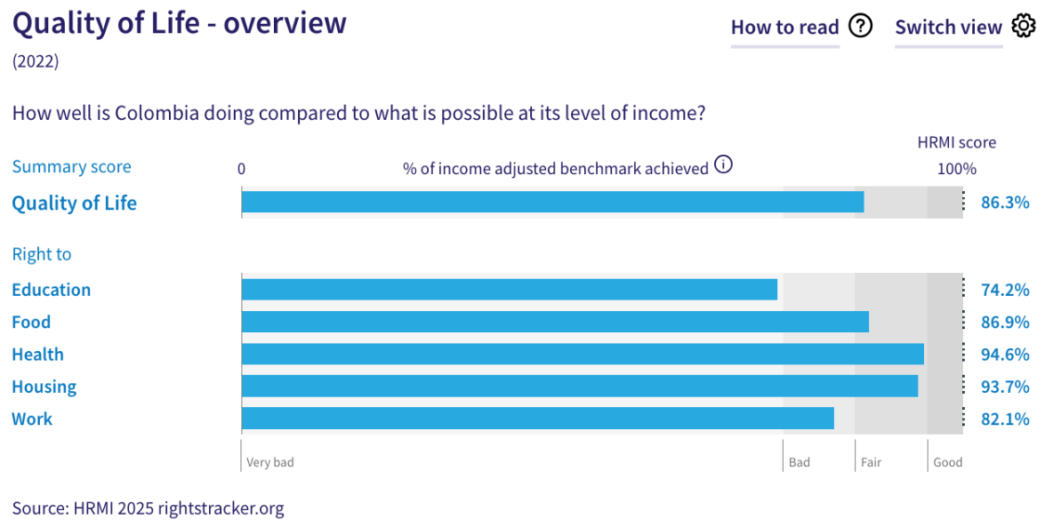
7. Colombia’s scores for 2022 are as follows:
- Overall Quality of Life score = 86.3% (in the ‘fair’ range)
- Right to education = 74.2% (‘very bad’)
- Right to food = 86.9% (‘fair)
- Right to health = 94.6% (‘fair’)
- Right to housing = 93.7% (‘fair’)
- Right to work = 82.1% (‘bad’)
8. Colombia’s scores for all the five rights fall across the ‘very bad’, ‘bad’, and ‘fair’ ranges, with no overall score reaching the ‘good’ performance range.
9. Colombia scores 86.3% on overall ‘Quality of Life’ when scored against the ‘income adjusted’ benchmark. This score takes into account Colombia’s resources and how well it is using them to make sure that the ‘Quality of Life’ rights of its people are fulfilled.
10. This score tells us the Colombia is doing 86.3% of what should be possible to achieve with its existing level of resources. Some of these scores may seem positive; however, on an ‘income adjusted’ benchmark, any score less than 100% indicates that a country is not meeting its current obligations under international human rights law. Therefore, our assessment is that Colombia still has some way to go to meet its immediate economic and social rights obligations.
IV. Right to Education
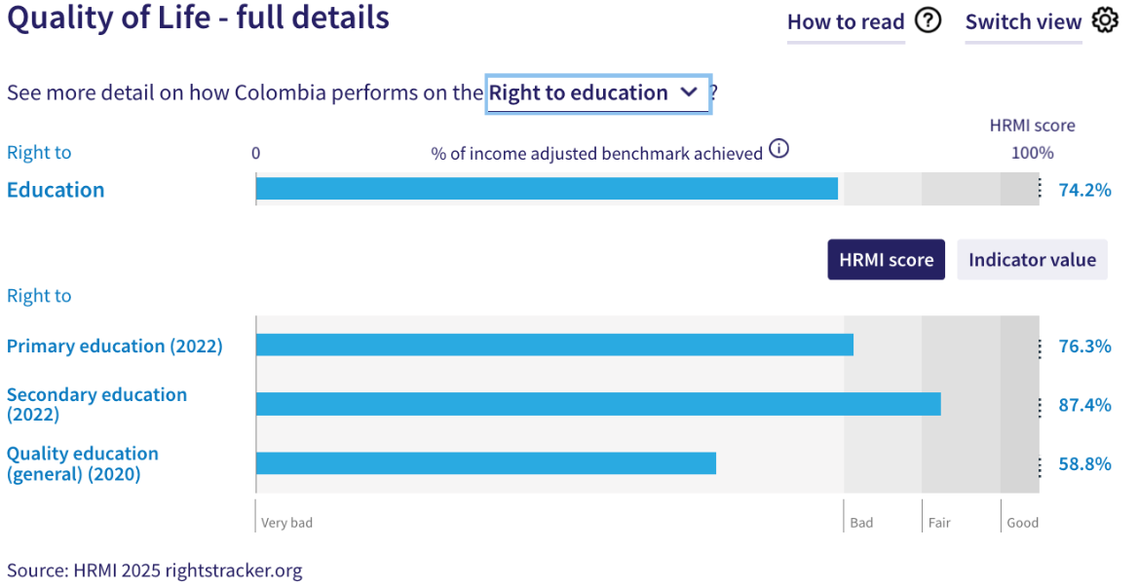
11. HRMI defines the right to education in accordance with ICESCR Article 13 and CESCR General Comments 11 and 13. For low- and middle-income countries such as Colombia, HRMI further breaks down the right to education into three areas of measurement: primary school enrolment, secondary school enrolment, and quality of education. Our scores (adjusted for income) indicate some challenges across these three areas, especially on the right to primary education and the right to quality education.
12. Colombia scores an ‘income adjusted’ 74.2% on the right to education, which means that it is achieving only 74.2% of what should be possible with its available resources. This score falls within the ‘bad’ performance range. While this score for Colombia has largely plateaued since 2010, it has shown a slow but steady decline from 77.1% in 2017 to 74.2% in 2022.
13. Colombia’s score for the right to primary education (adjusted for income) is 76.3%, which falls within the ‘bad’ range. The underlying indicator value drawn from the UNESCO database shows that only 92.7% of primary school-aged children were enrolled in school in 2022. It is worth noting that over the past two decades, this score has declined from a peak of ‘income adjusted’ 100% in 2002 to 94.6% in 2012, and dropped rapidly thereafter to 76.3% in 2022. Colombia ranks 12th among 20 low- and middle-income countries in the Americas on the right to primary education.
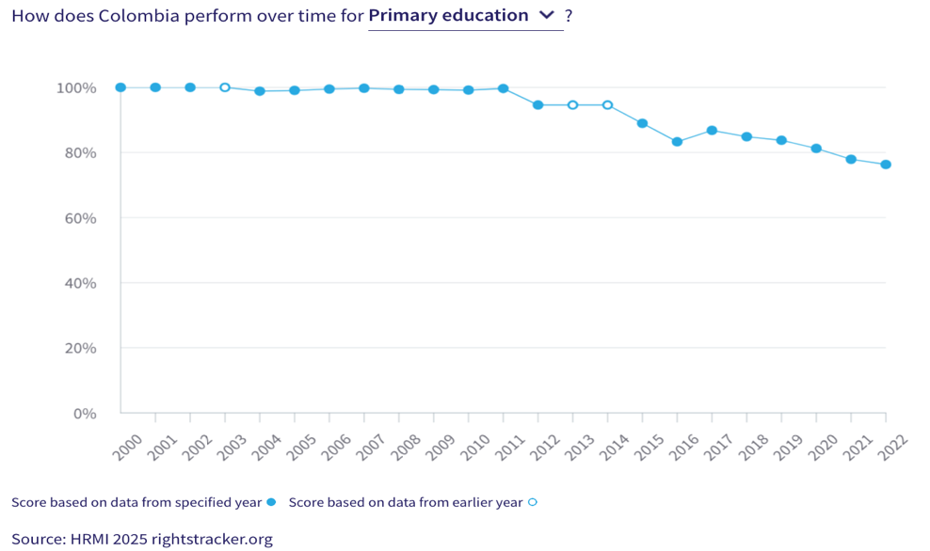
14. Colombia’s ‘income adjusted’ HRMI score for the right to secondary education is 87.4%, and falls in the ‘fair’ range. Overtime trend for this score shows that it has slowly but steadily increased; after some minor fluctuations between 2005 and 2014, this score rose from 79.5% in 2014 to a peak of 87.4% in 2022.
15. Colombia has a HRMI score of 58.8% on the quality of education, placing it within the ‘very bad’ range. This suggests that Colombia is not achieving what should be possible given its available resources and is falling short of meeting its immediate obligations under this right. This score has stagnated in recent years, with no notable improvement.
V. Right to Food
16. HRMI defines the right to food in accordance with ICESCR Article 11 and CESCR General Comment 12. For low- and middle-income countries such as Colombia, HRMI uses a bellwether indicator of how many children are growing well (are not stunted). Colombia’s score for the right to sufficient healthy food is 86.9%, which means that it is doing 86.9% of what should be possible at its current income levels to ensure the right to food for its people. This score draws on indicator data on child stunting rates from the UNICEF-WHO-World Bank: Joint child malnutrition (JME) database.

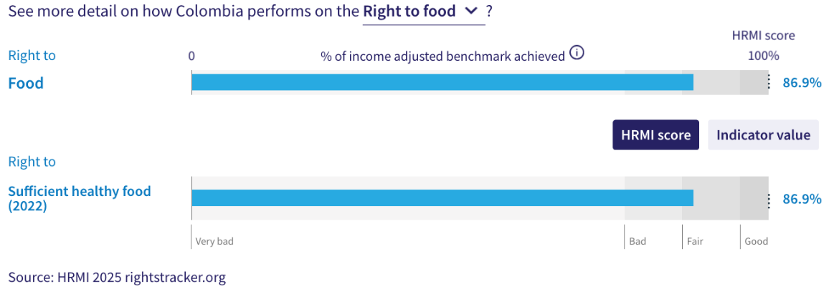
17. The score for the right to sufficient healthy food in Colombia has only shown marginal improvement from 80.4% in 2000 to a peak 87.4% in 2020. Between 2017 and 2022, the scores have largely remained unchanged, showing no marked progress. Colombia ranks 14th among 19 low- and middle-income countries in the Americas on this right.
VI. Right to Health
18. HRMI defines the right to health in accordance with ICESCR Article 12.1 and CESCR General Comment 14. For low- and middle-income countries such as Colombia, HRMI uses three indicators to measure the country’s achievement in child health, adult health, and reproductive health. Colombia scores an ‘income adjusted’ 94.6% on the right to health, which falls within the ‘fair’ range. Overtime trends indicate fairly consistent improvement over the past two decades.
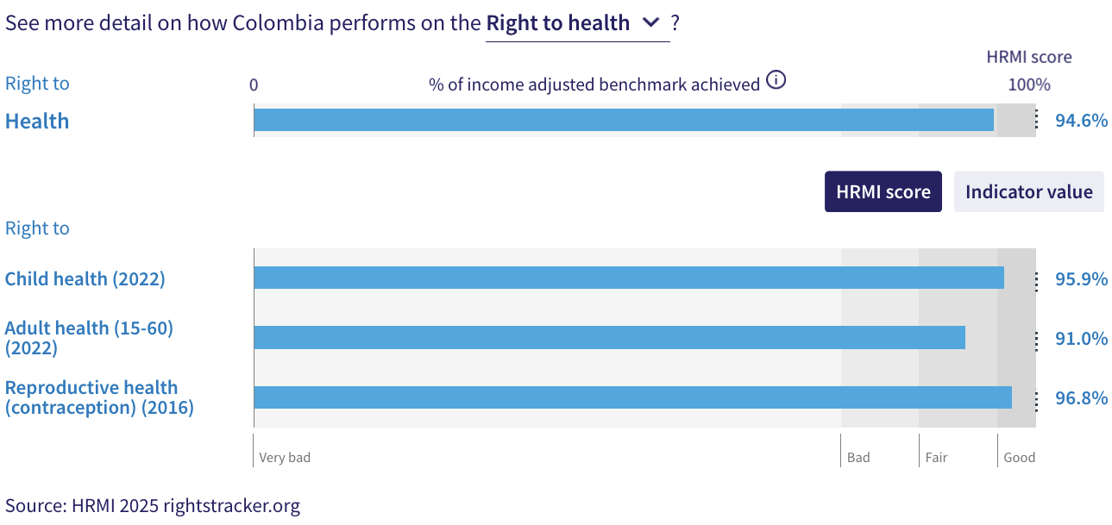
19. For low- and middle-income countries, HRMI measures the right to child health using the indicator of survival to age 5. According to the UN IGME data, 98.8% of children in Colombia survived to their fifth birthday in 2022, which translated into a ‘good’ HRMI score of 95.9%. Over the past two decades, this score has shown slow but consistent progress, rising from 92.5% in 2000 to a peak of 96% in 2020, which is encouraging.
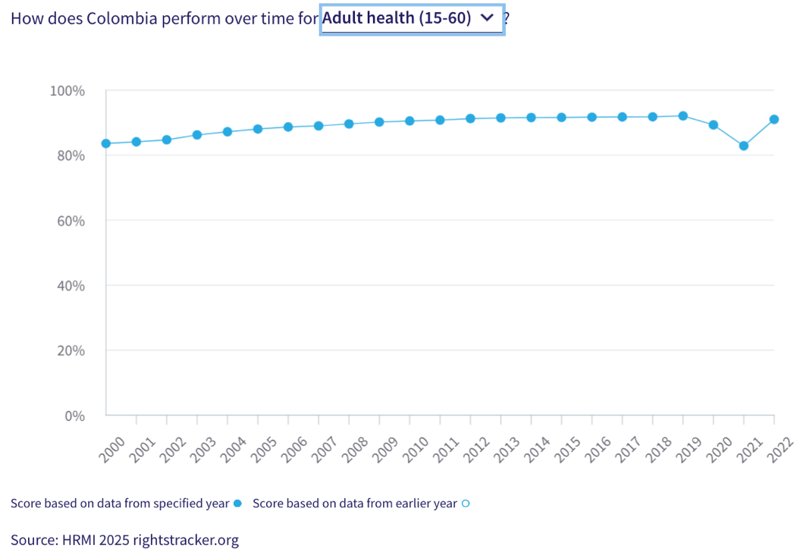
20. The HRMI score for the right to adult health is based on the adult (15-60) survival rate indicator. According to the UNDP and Max Planck Institute Human Mortality Database, the adult survival rate in Colombia was 89.2% in 2022, translating into an ‘income adjusted’ HRMI score of 91.0%. This score falls within the ‘fair’ range and has shown consistent improvement, rising from 83.6% in 2000 to 92.1% in 2019. It dropped to 82.9% during the 2020-2021 period, likely due to the COVID-19 pandemic, but rebounded to 91.0% in 2022.
21. HRMI measures the right to reproductive health in low- and middle-income countries by the rate of modern contraceptive use. In 2016, which is the most recent available data, Colombia reported a contraceptive use rate of 75.9%, which translated into a ‘good’ HRMI score of 96.8%. This score has also shown an upward trend from 83.7% in 2000 to a peak of 96.8% in 2016. Colombia ranks 3rd among 24 countries in the Americas on the right to reproductive health.

VII. Right to Housing
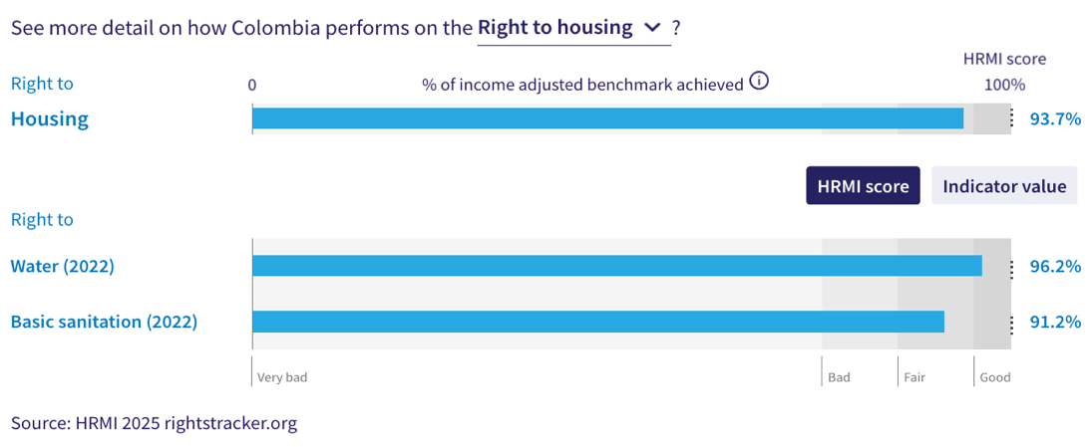
22. HRMI defines the right to housing in accordance with ICESCR Article 11.1 and CESCR General Comment 4. For low- and middle-income countries such as Colombia, HRMI measures this right using the indicators of access to water on premises and access to basic sanitation (each household having its own improved toilet facilities). Colombia has an ‘income adjusted’ HRMI score of 93.7% on the right to housing based on these two components, and falls within the ‘fair’ performance range. This right also showed a sustained improvement over two decades from 80.2% in 2000 to a peak of 93.7% in 2022.
23. The WHO UNICEF Joint Monitoring Project (JMP) data show that 96.9% of households in Colombia have access to water on premises as of 2022. Given what other countries with the same level of income have shown to be possible, Colombia’s ‘income adjusted’ HRMI score for the right to water is a ‘good’ 96.2%. Over the last two decades, this score has shown consistent progress from 91.2% in 2000 to the current peak score of 96.2% in 2022.
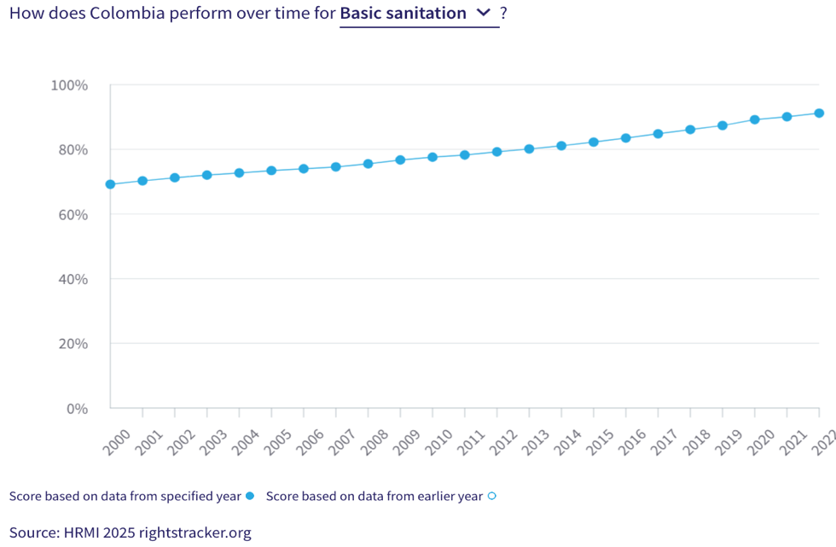

24. On the right to basic sanitation, Colombia has an ‘income adjusted’ HRMI score of 91.2%, which falls within the ‘fair’ range. According to the WHO UNICEF Joint Monitoring Project (JMP), 94.7% of people in Colombia have access to at least basic sanitation as of 2022. Trends indicate encouraging progress on this right over the past two decades growing from 69.2% in 2000 to a peak of 91.2% in 2022.
VIII. Right to Work
25. HRMI measures the right to work in accordance with ICESCR Articles 6 and 7. For low- and middle-income countries such as Colombia, HRMI uses a subsistence income indicator to measure the right to work. According to World Bank PovcalNet data, 86.0% of people in Colombia were classified as ‘not absolutely poor’ in 2022. This translated to an ‘income adjusted’ HRMI score of 82.1% on the right to work, which falls in the ‘bad’ range.
26. Over the last two decades, Colombia has shown moderately steady progress on the right to subsistence work, improving from an initial HRMI score of 66.4% in 2000 to a peak of 85% in 2017. Thereafter, this score showed some notable fluctuations where it fell to 77.0% in 2020, but recovered to 82.1% in 2022. While this trend is positive, the current score still indicates that Colombia has a significant ground to cover to meet its immediate obligations. Notably, Colombia ranks 16th among 19 low- and middle-income countries in the Americas on the ‘income adjusted’ right to at least subsistence income.
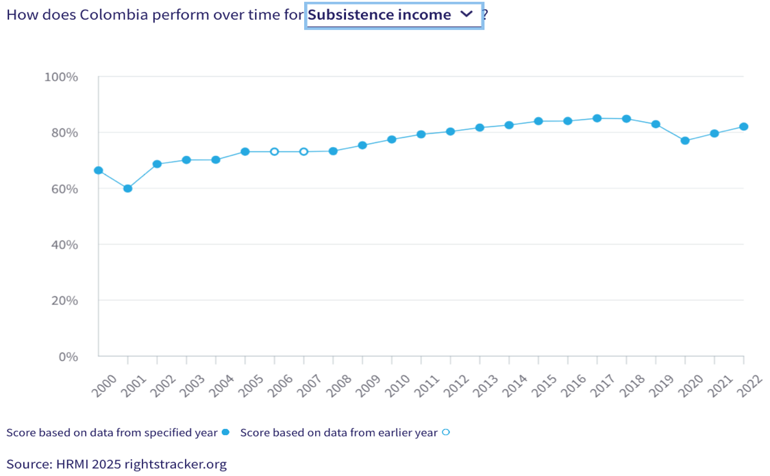

IX. Concluding Remarks
27. Colombia's strongest HRMI scores are for the right to child health, the right to reproductive health (contraception), and the right to water. All three fall within the ‘good’ performance range and reflect a positive trajectory towards achieving an ‘income adjusted’ 100% score.
28. Colombia’s lowest HRMI scores are for: (i) the right to primary education, which has experienced a steep decline in recent years; (ii) the right to quality education, which falls within the ‘very bad’ range and has shown no progress in recent years; and (iii) the right to subsistence income, on which Colombia ranks among the lowest-performing low- and middle-income countries in the Americas.
29. Our analysis is that Colombia is not constrained by resources from making improvements in areas with low scores. Rather, it has the income available, and can prioritise to put it to use to improve its people’s economic and social rights. We recommend that the Committee assure the State Party that it has the available resources to make progress, especially in the areas of primary education, quality education, and subsistence income.
30. We also recommend the following questions:
- What steps will the State Party take to improve access to and enrolment in primary education?
- What measures will the State Party take to enhance general quality of education?
- What steps will the State Party take to lift access to at least subsistence income?
31. HRMI respectfully submits its data and findings on the fulfilment of economic and social rights in Colombia. We hope that this submission will serve as a useful resource to the Committee on Economic, Social and Cultural Rights for drafting specific and meaningful questions to Colombia during the CESCR’s 78th Pre-Sessional Working Group.

Visit HRMI’s website to learn more about our mission and work, https://humanrightsmeasurement.org/.
This content represents the opinions of the Human Rights Measurement Initiative. It carries no endorsement of the University of Georgia.
See HRMI’s methodology for measuring economic and social rights: https://humanrightsmeasurement.org/methodology and https://rightstracker.org/page/methodology.
Ibid.
HRMI 2025 Rights Tracker, https://rightstracker.org/
See Human Rights Measurement Initiative (HRMI) Digital Public Good Certificate, https://app.digitalpublicgoods.net/a/11781 The Digital Public Goods Alliance is endorsed by the UN Secretary General’s “Roadmap for Digital Cooperation,” https://www.un.org/en/content/digital-cooperationroadmap/assets/pdf/Roadmap_for_Digital_Cooperation_EN.pdf.
HRMI 2025 Rights Tracker, https://rightstracker.org/country/COL?tab=report-esr
The labels on the country charts of good, fair, bad, and very bad are used to give a general indication of how to understand the scores. HRMI’s income adjusted Quality of Life scores can be broadly interpreted as showing the percentage of the country’s obligation it has met, compared to what the best performing countries have achieved at each income level. A country scoring below 75% with a label of “Very bad” is failing to put in place the kinds of structures and policies that help people claim the right concerned, but the structures and policies in place most likely prevent many people from claiming their rights. See HRMI’s methodology for measuring human rights, https://rightstracker.org/page/methodology.
HRMI 2025 Rights Tracker, https://rightstracker.org/country/COL?tab=report-esr
Ibid.
HRMI 2025 Rights Tracker, https://rightstracker.org/metric/education.
HRMI 2025 Rights Tracker, https://rightstracker.org/country/COL?tab=report-esr
Ibid.
HRMI 2025 Rights Tracker, https://rightstracker.org/metric/tot-net-primary?income=lmi
HRMI 2025 Rights Tracker, https://rightstracker.org/country/COL?tab=report-esr
Ibid.
Ibid.
HRMI 2025 Rights Tracker, https://rightstracker.org/metric/not-stunted
HRMI 2025 Rights Tracker, https://rightstracker.org/country/COL?tab=report-esr
HRMI 2025 Rights Tracker, https://rightstracker.org/metric/food?region=americas&income=lmi
HRMI 2025 Rights Tracker, https://rightstracker.org/metric/health
HRMI 2025 Rights Tracker, https://rightstracker.org/country/COL?tab=report-esr
Ibid.
Ibid.
HRMI 2025 Rights Tracker, https://rightstracker.org/metric/contraception?region=americas
HRMI 2025 Rights Tracker, https://rightstracker.org/country/COL?tab=report-esr
Ibid.
Ibid.
Ibid.
Ibid.
HRMI 2025 Rights Tracker, https://rightstracker.org/metric/work?region=americas&income=lmi

