THEMATIC REPORT ON MUSLIM FAMILY LAW AND
MUSLIM WOMEN’S RIGHTS IN
MALAYSIA

88th CEDAW Session
Geneva, Switzerland
May 2024

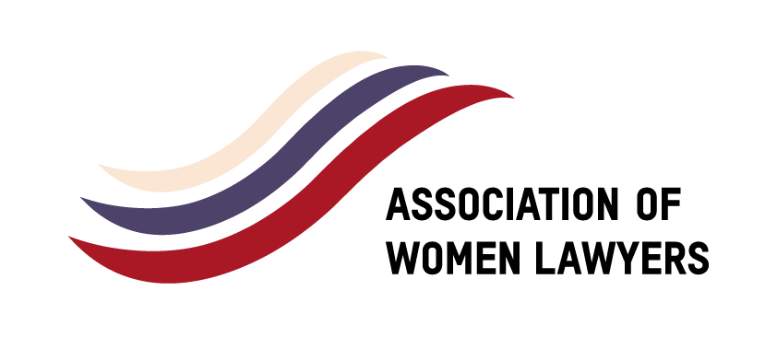
SUBMITTED BY:

  Sisters in Islam  No. 4 Jalan 11/8E, 46200 Petaling Jaya,  Selangor Darul Ehsan, Malaysia  Tel: +603-7960 3357 Fax: +603-7960 8737  Email: sis@sistersinislam.org.my  Website: www.sistersinislam.org.my | ​​    Musawah  15, Jalan Limau Purut, Bangsar Park, 59000 Kuala Lumpur, Malaysia  Tel: +603 2083 0202 Fax: +603 2202 0303  Email: musawah@musawah.org  Web: www.musawah.org

Address: H-2-12, Block H, Jalan Sri Hartamas 1,
50480 Kuala Lumpur
Email: awlmsia@gmail.com
Web: awlmalaysia.org

Table of Contents

A. INTRODUCTION 3
B. BACKGROUND, LEGAL FRAMEWORK AND CONTEXT 3
C. KEY ISSUES AND RECOMMENDATIONS 5
1. Child Marriage 5
2. Discrimination Under Islamic Family Law 9

A. INTRODUCTION

This shadow report is jointly submitted by Sisters in Islam (SIS), a national NGO working towards equality and justice for women within the Malaysian Islamic legal framework; the Association of Women Lawyers (AWL), whose aim is to ensure the attainment and full enjoyment of all rights for women from all walks of life based on principles of substantive equality; and Musawah, the global movement for equality and justice in the Muslim family, for consideration by the CEDAW Committee in its review of the Government of Malaysia, reporting before the 88th Session of the CEDAW Committee in May 2024.

This is the CEDAW Committee’s sixth engagement with the Government of Malaysia, which ratified the Convention in July 1995, with reservations to articles 5 (a), 7 (b), 9 and 16. On 6th February 1998, the Government of Malaysia notified the Secretary-General of a partial withdrawal of reservations to articles 2(f), 9(1), 16(b), 16(d), 16(e) and 16(h). In July 2010, the government removed its reservations to CEDAW Articles 5(a), 7(b) and 16(2). However, reservations still remain on five CEDAW Articles: 9(2),16(1)(a), 16(1)(c), 16(1)(f) and 16(1)(g) as barriers that preclude full equality for women in family life.

In 2018, Concluding Observations of the CEDAW Committee on Article 2 requested Malaysia to take effective measures to ensure that civil law and Syariah law are in full compliance with the provisions of the Convention at the local, state and federal levels so as to ensure that the rights of all women are legally guaranteed on an equal footing throughout the State party. The Committee also reiterated its recommendation on Article 16 for the State to undertake a process of law reform to ensure equality in the family. Recommendations were also made to the State party that a strong federal mechanism be put in place to harmonize and ensure consistency of application of Syariah laws across all states. However, it is noted that there has been no progress towards implementation of these recommendations. As this report shows, inequalities in law and practice remain entrenched in Malaysia, and no effort at law reform has taken place.

This report examines Malaysian laws and practices that enforce de jure and de facto discrimination against Muslim women in the following areas: trends in reform of Islamic Family Laws; discriminatory legal frameworks; early and child marriage; spousal inequality; polygamy; inequality in financial rights of women; rights of mothers whose children unilaterally converted to Islam; the requirement of a guardian’s consent to marriage. Also included in this report are relevant statistics from ‘Telenisa’ - Sisters in Islam’s free legal advisory services on legal rights of Muslim women and men under Islamic Family Laws and the Syariah Criminal Offences Law.

We hope that the research, analysis, and recommendations in this report will provide critical information in:

- Highlighting key concerns and identifying gaps in the State party report and the State party’s response to the list of issues;

- Providing alternative arguments within Muslim legal theory that challenge the ways the State party uses religion to justify discrimination, including reservations and non-implementation of its international human rights treaty obligations; and

- Suggesting recommendations for reform based on good practices in Muslim contexts.

We hope that the CEDAW Committee will utilise this report as a key resource during its Constructive engagement with the State party, and in identifying follow-up issues in the Concluding Observations.

B. BACKGROUND, LEGAL FRAMEWORK AND CONTEXT

Muslims in Malaysia constitute 63.5% of the population (Census 2020). They primarily belong to the Sunni sect and follow the Shafi’i madhab (school of Islamic jurisprudence).

Malaysia operates a plural legal system, based on English common law, Islamic law and customary laws. The Federal legislature (Parliament) enacts the majority of laws, including laws on contracts, torts, property, crime and constitutional and administrative matters. These laws are enforced through a Federal judiciary.

Islamic laws are enacted by the state legislative bodies and only apply to Muslims. Islamic laws are enforced by Syariah Courts that are established at State level. The Constitution limits the matters that can be legislated at State level under the Ninth Schedule of the Second List (State List). In relation to Islamic laws, they are:

1. “Except with respect to the Federal Territories of Kuala Lumpur, Labuan and Putrajaya, Islamic law and personal and family law of persons professing the religion of Islam, including the Islamic law relating to succession, testate and intestate, betrothal, marriage, divorce, dower, maintenance, adoption, legitimacy, guardianship, gifts, organization and procedure of Syariah5 courts, which shall have jurisdiction only over persons professing the religion of Islam …”.

Article 121(1A) of the Federal Constitution (introduced in 1988) states that the civil courts have no jurisdiction in matters that fall within the Syariah court jurisdiction. It was introduced to remove jurisdictional overlaps between the two legal systems.

However, over the years, conflicting judgments on the interpretation of this Article gave rise to significant injustices, particularly where the constitutional rights of individuals were being undermined. There was uncertainty over whether Islamic laws override constitutional rights and federal laws, and whether civil courts have the authority to judicially review the powers exercised by Islamic authorities. In February 2024, the Federal Court ruled 16 provisions in the Kelantan Syariah Criminal Code Enactment null and void as these are existing offences under the federal law.

The issue of jurisdiction of courts was recently resolved in the case of unilateral conversion of children into Islam by one party in the marriage. The Federal Court, in its landmark judgement in January 2018, decided that the civil courts have jurisdiction over judicial review, interpretation of laws and administrative justice even where the matter refers to Islamic laws or Islamic authorities. The Federal Court also decided that in the best interest of the child, both parents must consent to the conversion of a child to Islam.

We hope that this once and for all resolves the issue and will set a healthy precedent for the future. It should be noted however, that there were certain developments after the landmark Federal Court decision that were of concern. In particular, was the outcry from certain Islamist groups stating that the decision relegated the Syariah Courts to a secondary court, and it did not respect Muslim rights.

LEGISLATION ON MARRIAGE AND DIVORCE

While the Law Reform Marriage and Divorce Act (1976) regulates marriage relations for persons who do not profess the Islamic faith, Muslims are governed under Islamic Family Laws (IFL), which are legislated at the state level, without option.

In Malaysia there are 14 states (one of which is the Federal Territories encompassing three areas i.e., Kuala Lumpur, Labuan and Putrajaya). This means that each of the 14 jurisdictions is able to enact its own set of laws through its state legislature, governing Muslims in that state. The head of state (in many states being the Sultan) is also the head of religion and thus laws require assent of the head of state and public gazette prior to enforcement.

In 1984, the Federal Parliament enacted the Islamic Family Law (Federal Territories) Act 1984 (IFLA) for the Federal Territories (Kuala Lumpur, Labuan and Putrajaya). Many of the states adopted slightly altered versions of the IFLA, but several states, including Kelantan, Melaka and Kedah, have adopted their own family law enactments that restrict women’s rights in marriage and divorce much more than the IFLA.

What is of urgent concern to women’s rights groups in Malaysia is the way the plural legal system operates. Since 1976, the government has undertaken a series of law reforms to end discrimination against women in marriage and in the family. However, this only applies to women of other faiths. In the name of Islam, Muslim women not only remained discriminated against, but subsequent law reforms rolled back rights provided in the IFLA and added further grounds for discrimination.

In 1976, the Law Reform (Marriage and Divorce) Act was amended to abolish all forms of discrimination against non-Muslim women. Polygamy was banned. The same rights to enter into marriage and grounds for divorce applied to both men and women.

In 1999, the Guardianship of Infants Act was amended to provide for the father and mother to have equal rights to guardianship of their children and the Distribution Act was amended in 1999 to provide for equal inheritance rights for widows and widowers. However, none of these law reform efforts were extended to Muslim women.

Furthermore, the law reform process adopted for the Law Reform (Marriage and Divorce) Act observed a robust legislative process and was conducted in a democratic and consultative manner. A Parliamentary Select Committee was established and it travelled all over the country to listen to diverse views from the ground before this law was drafted. However, when it came to family law reform for Muslims, no consultation with women’s rights groups were held. It was primarily driven by
a small Syariah Technical committee in consultation only with like-minded people at the state level – religious leaders, the state executive committee members for religion and the legal advisers – majority of whom are men.

This resulted in two rounds of law reform to the IFLA (1994 and 2003) that further discriminated against Muslim women. In effect, Muslim women in Malaysia face double discrimination – firstly, discriminated vis-à-vis Muslim men within the IFLA and secondly, discriminated vis-à-vis women of other faith, with Muslim women enjoying far less rights in marriage, divorce, guardianship of their children and inheritance.

In the context of political Islam, rising conservatism and perpetual identity politics in Malaysia, the State party remains wilfully oblivious to the gross injustice it perpetuates against more than half of its female population.

C. KEY ISSUES AND RECOMMENDATIONS

Child Marriage

Child marriage remains legally permissible under civil, Islamic and native customary laws despite Malaysia’s removal of its reservation to Article 16(2) of CEDAW and the launch of its National Strategy Plan in Handling the Causes of Child Marriage (2020-2025).

In 2020, the government embarked on a five-year National Strategy Plan to end child marriage . The
plan outlines 7 objectives, 17 strategies, 58 programmes and actions to address the causes of child
marriage in Malaysia and will involve 61 agencies in stages, including agencies from the federal government, state government, NGOs and international organisations for a phased series of short-, medium- and long-term programmes. The plan covers Muslim marriages conducted under Syariah laws, non-Muslim marriages under civil laws and adat (customary) marriages conducted under native laws. The plan addresses the root causes of child marriage, including cultural and religious aspects and are proposed to be addressed through policy changes, legislative reforms as well as awareness programmes and activities. The main purpose of these programmes is to achieve an end to child marriages in Malaysia by changing perceptions, stereotypes and stigmas associated with child marriage.

These programmes include raising the legal minimum age limit of marriage to 18 years for girls (and boys), strengthening existing socio-economic support, providing child-friendly reproductive health services for both children and adolescents, and strengthening the collection of marriage and divorce. A committee is also required to be established to monitor the implementation and development of planned programmes and actions.

However, to date, no report has been provided to the Parliament on the progress of the National Strategy Plan in Handling Causes of Child Marriage by the government, nor has it been made available to the Human Rights Commission of Malaysia (SUHAKAM), civil society, the Malaysian Bar Council and the public to evaluate the progress on this Plan.

Laws on child marriage under Syariah laws were the same across all 14 enactments. Generally, under the Islamic Family Law (State Jurisdiction), the minimum age of marriage in Malaysia is 16 for females and 18 for males. There is also a common feature in these enactments- that Syariah courts have the discretion to give written permission for the marriages under these ages. As a result of sustained advocacy by NGOs on the issue of child marriages and a series of high-profile publicized cases of child marriages, the government called for states to review their Islamic Laws on child marriage. In 2019, the Woman, Family and Community Development Minister revealed the states that have agreed and disagreed to increase the minimum age of marriage to 18 years old, as follows:

Agree to Amend State Islamic Family Law | Disagree to Amend State Islamic Family Law
Federal Territories | Sarawak
Penang | Pahang
Sabah | Terengganu
Johor | Perlis
Melaka | Negeri Sembilan
Perak | Kedah
 | Kelantan

Only the state of Selangor has taken the necessary steps and amended the state Islamic Family Law increasing the minimum age of marriage to 18 (albeit with exceptions). In a recent development, in 2022, Kedah joined Selangor by amending the state Islamic Family Law increasing the minimum age of marriage to 18 with exceptions. However, Kedah has not yet enforced the following amendment. Other states agreeable to amend State Islamic Family Law are still silent on their efforts to increase the age to marry.
Thus, the situation remains unchanged. Even in Selangor and Kedah, the exceptions that allow Syarie Judges to allow marriages below 18 years old have not been removed. In 2020, the Director of the Department of Syariah Judiciary Malaysia (JKSM) and holding the position of the Chief Syarie Judge of Malaysia issued a Practice Direction to all Syarie judges in Malaysia on the format and usage of the social/moral report form from the social welfare department (JKM) for cases of underage marriage applications. However, the legal effect of the practice direction is only persuasive. There are no legal consequences if a Syarie judge does not follow the practice direction issued. In addition to that, the law and practice direction are unclear as to the circumstances or situations to allow or reject an application for child marriage. The decision remains dependent on the discretion of the Syarie judges without strict and specified criteria for such evaluation.
In March 2020, it was reported in the state of Perak that underage marriages are one of the main reasons for students to drop out of school. In December 2021, it was reported that in 2020, out of 445 teenagers who dropped out of school to get married, 441 of them were girls . These marriages and dropouts from school took place during the time of the pandemic when Malaysia had imposed severe lockdowns which affected students and their schooling experience to a great degree. As of 2022, there is still a lack of efforts to coordinate and publish transparent underage marriage and divorce data.
Additionally Islamic Family Laws are silent on the issue of consent of the child. In practice, consent is not necessarily requested in each case. There are circumstances where the child is not called in by the Court for an interview. Frequently, the parents’ testimonies are accepted as sufficient. The laws are also silent on requiring the court to decide in the best interest of the child.

RECOMMENDATIONS
We recommend the CEDAW Committee urge the State party to:

- Provide the steps that Malaysia is taking to prohibit marriage below the age of 18 all over the country without exception.
- Provide a timeline and plan to report to the Parliament the progress of the National Strategy Plan in Handling Causes of Child Marriage by the government and made available to the Human Rights Commission of Malaysia (SUHAKAM), civil society, the Malaysian Bar Council and the public to evaluate how far Malaysia has come in ending child marriages.
- Provide to the public regular, timely disaggregated data on child marriages which include age of marriage, location, race and ethnicity, economic position, etc. to enable a proper assessment of motivations for child marriage, which can in turn contribute to policy formulation, law reforms and effective educational campaigns to achieve the purpose of ending child marriage in Malaysia.

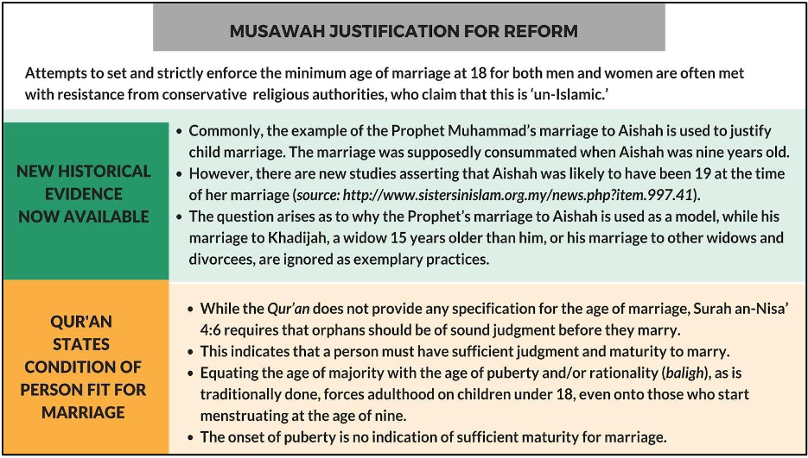
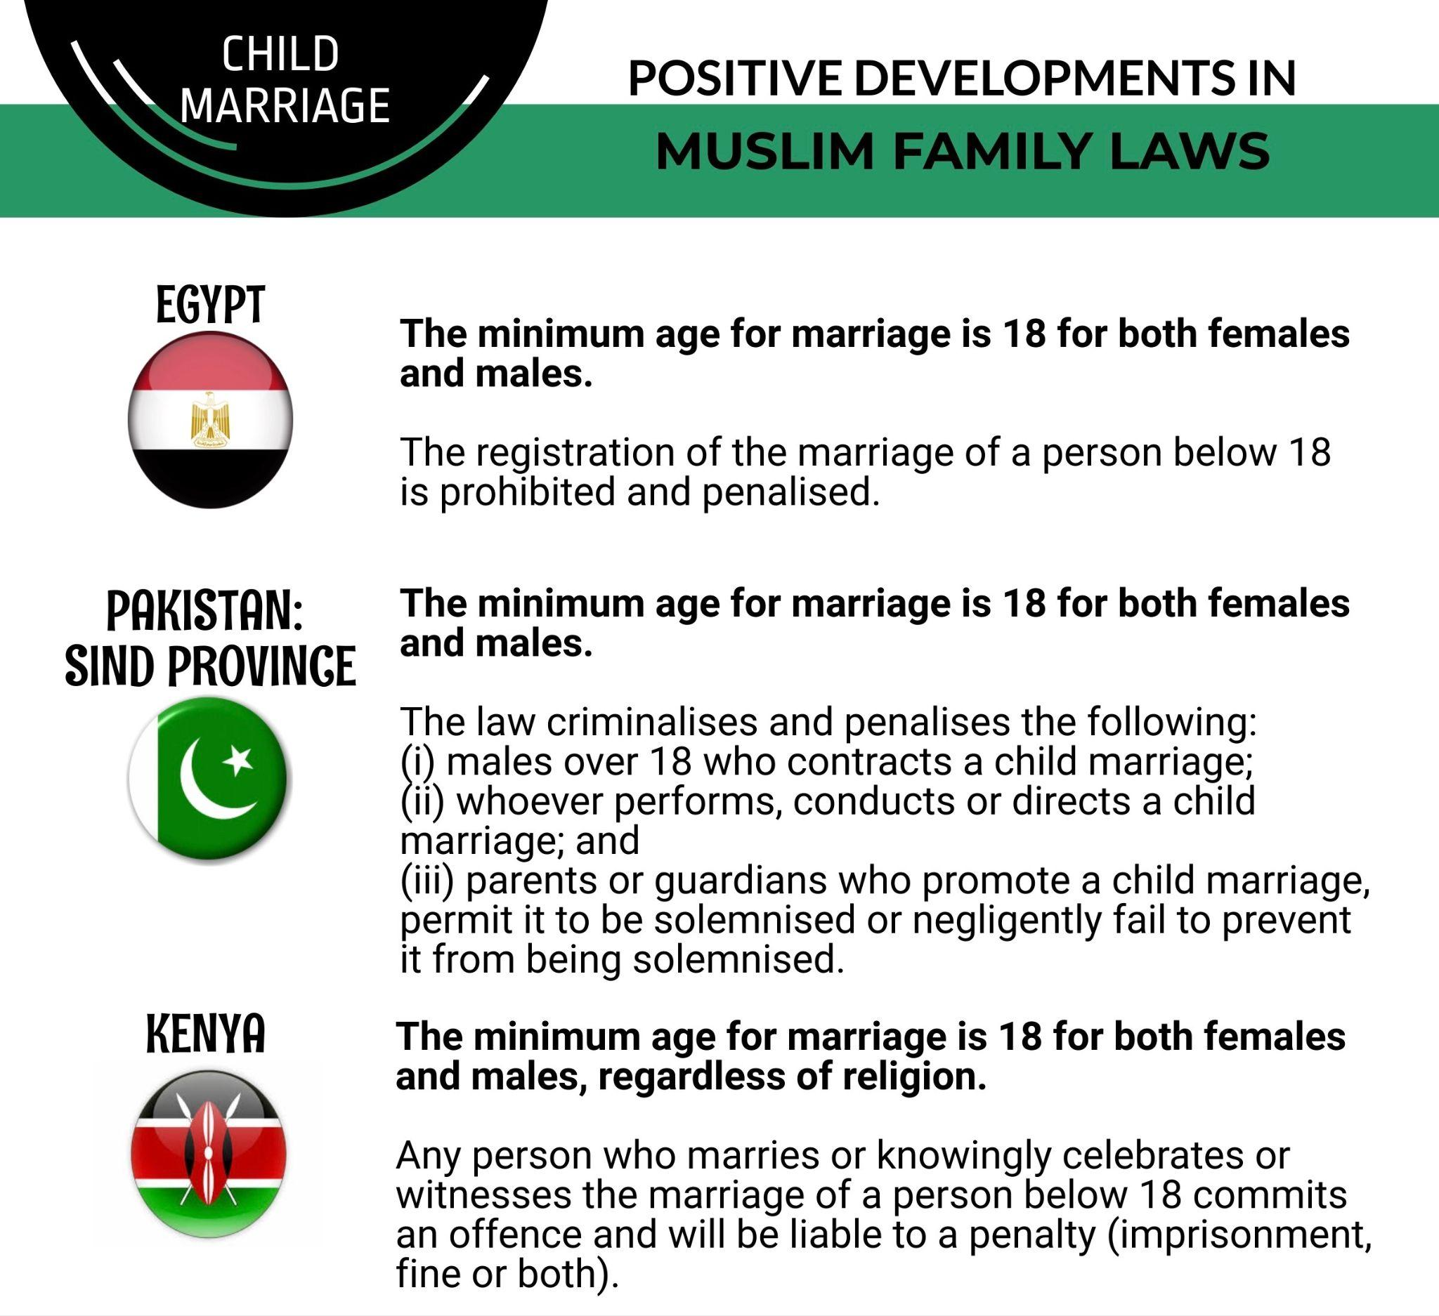

Discrimination Under Islamic Family Law

While the Law Reform Marriage and Divorce Act (1976) regulates marriage relations for persons who do not profess the Islamic faith, Muslims are governed under Islamic Family Laws (IFL), which are legislated at the state level, without option.

Equality among Spousal Rights in Muslim Marriages

Paragraph 118 of the Malaysia’s State Party Report states that “Malaysia guarantees that Muslim women have equal rights in all family and marriage matters, including equal capacity as men to enter into marriage and its dissolution, covering matters related to maintenance, custody and guardianship of their children and inheritance.” However, a number of issues remain as some related laws continue to discriminate against Muslim women. These include the following:

- Muslim women still require a guardian (wali) to enter into a marriage, regardless whether she is single, divorced or widowed, even though various interpretations in Islamic jurisprudence do not stipulate such a requirement, particularly for divorced or widowed Muslim women. This is discussed further in a later section.

- Muslim men can pronounce unilateral divorce (talaq). Women do not have this right, thus would have to apply for other forms of divorce (e.g.: fasakh) which is usually a protracted process involving complex legal documentation and can take up to two years in court, if not more. She would not be able to move on with her life immediately unlike the husband. Her personal/marital life status is on hold until the divorce proceedings are over and the divorce is pronounced by the court. Conditions on which a woman may apply to the court for fasakh include if her husband: has failed to provide maintenance; has been insane or has a communicable sexually transmitted disease; treats her cruelly, including habitual assaults or making her life miserable by cruel conduct; does not treat her equally with other wives (if he has multiple wives); disposes of her property or hinders her legal rights over her property; attempts to force her to lead an immoral life; or associates with “women of ill repute.” The Syariah Court requires the wife to provide strong grounds before pronouncing divorce through fasakh. Fasakh divorce takes a much longer time. The normal range is between six months to a year but there have been cases, which have stretched from five to ten years. These extensive delays are often the result of husbands using technical legal processes to delay the case hearing, husbands not turning up for hearing, husbands filing significant numbers of matters so as to disrupt the hearing of the matter at hand and so on.

- Muslim mothers have the right to custody but not guardianship. Legal guardianship remains with the Muslim fathers, even if the mother has custody of the children. There are also no grounds to challenge a father’s right to guardianship i.e.: his incapability to provide for the family, or the act of domestic violence, whereas the law listed down grounds to challenge a mother’s right to custody;

How right of custody is lost

83. The right of hadhanah of a woman is lost—
(a) by her marriage with a person not related to the child within the prohibited degrees if her custody in such case will affect the welfare of the child but her right to custody will revert if the marriage is dissolved;
(b) by her gross and open immorality;
(c) by her changing her residence so as to prevent the father from exercising the necessary supervision over the child, except that a divorced wife may take her own child to her birth-place;
(d) by her abjuration of Islam;
(e) by her neglect of or cruelty to the child.

The position of the law itself is discriminatory towards women. While the father’s position remains untouchable and unquestionable regardless or not in the best interest of the child.

- Inheritance remains a highly challenging area when it comes to equal distribution between men and women, for instance between sons and daughters. While there are efforts to work around this by granting ‘hibah’ (gift)’ to the daughters while the estate holder is still alive, we assert that this is not a solution that is available for all. Where e.g., the beneficiaries are reliant on the savings of the deceased including the contributions made to the Employees Provident Fund (EPF), equal distribution is not possible as faraid rules apply automatically, even if equal distribution is the wish of the deceased. In addition, the existing ‘faraid’ rules affect how other people can inherit from Muslim women, regardless if she is married or not, with or without children. Baitulmal, the government body for inheritance management of Malaysia’s Muslim citizens stands to have a significant portion, if not all, of her estate.

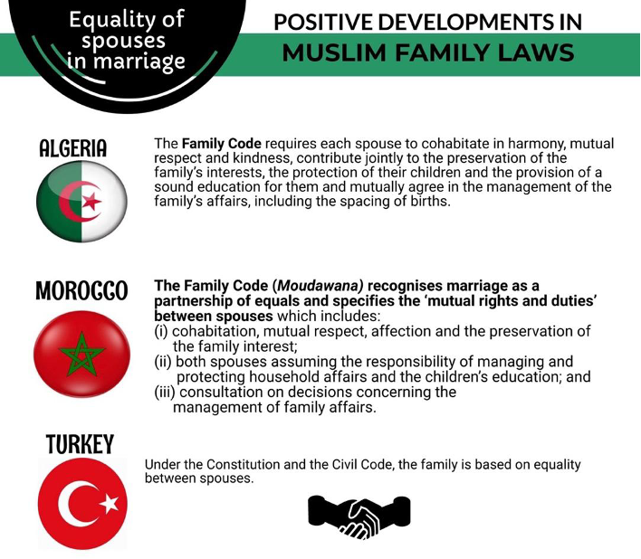
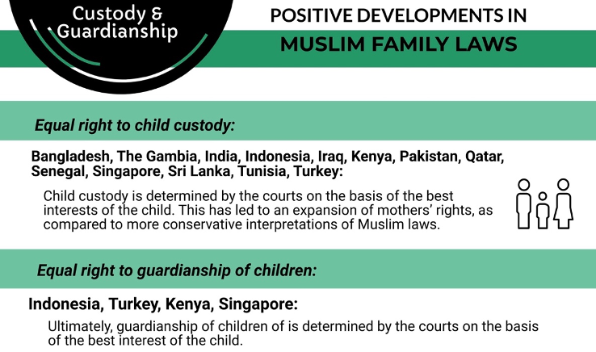

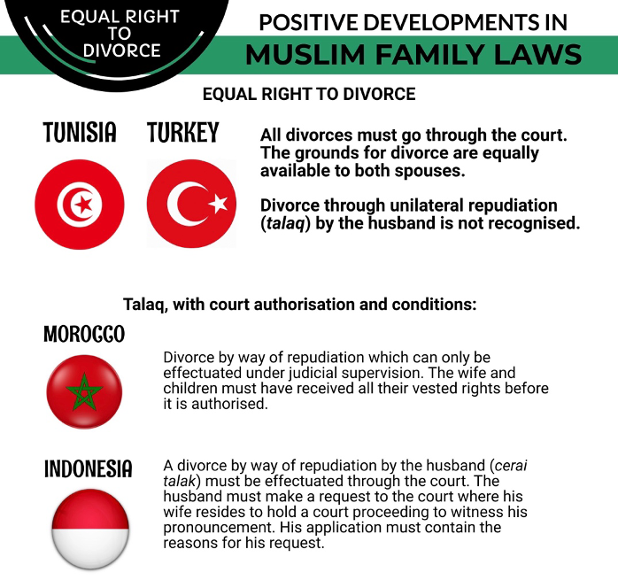

RECOMMENDATIONS
We recommend the CEDAW Committee urge the State party to:

- Provide the steps Malaysia is taking to allow women to divorce themselves from marriage without imposing complex legal documentation and burden of proof.

- Amend the Islamic Family Law for mothers to have equal rights of guardianship and custody and eliminate discriminating custody laws towards mothers.

Polygamy

Since 1994, several rounds of law reform have chiselled away at rights of wives in polygamous marriages. For example, polygamy committed without the court’s permission can be registered as legal, upon payment of a small fine - creating a legal loophole which led to a proliferation of men who divorce their wives at will and who take second, third and fourth wives without the permission of the court. The fifth condition for polygamy– ‘no drop in standard of living of existing family’ – was repealed, thus eliminating an important condition that a man has to fulfil before the court would consider giving him permission to marry again. Ten years forward, more legal rights were given to men which extended to them rights that historically were seen as the rights of women. Amendments were first introduced in the state of Selangor in 2003, and thereafter the Islamic Family Law (Federal Territories) (Amendment) Act 2006 was passed in Parliament applicable for Federal Territories. For example, the husband now has the right to claim a share of the matrimonial assets upon his polygamous marriage (section 23(9)); This provision created a gross injury upon the rights of an existing wife where a husband who is going to marry a new wife would be able to seek the sale of the matrimonial home and make claims on the matrimonial assets in order to support his new family. Malaysia’s State Party Report states that ‘in making sure that the existing wife’s concerns are heard and considered before the court decides the husband’s application to contract a polygamous marriage, the Syariah Judiciary Department (JKSM) has issued Practice Direction No. 7 of 2021 which stipulates that the Syariah court is to summon the existing wife as a party in the application case.”8 However, it is important to note that the Practice Direction No.7 of 2021 issued by the Syariah Judiciary Department (JKSM) is only persuasive in nature. Thus, the husband’s application for a polygamous marriage can continue regardless of whether the existing wife and/or family is consulted or not.
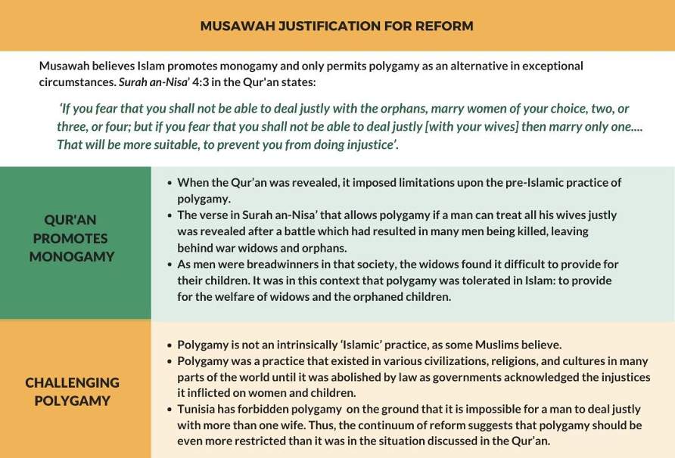

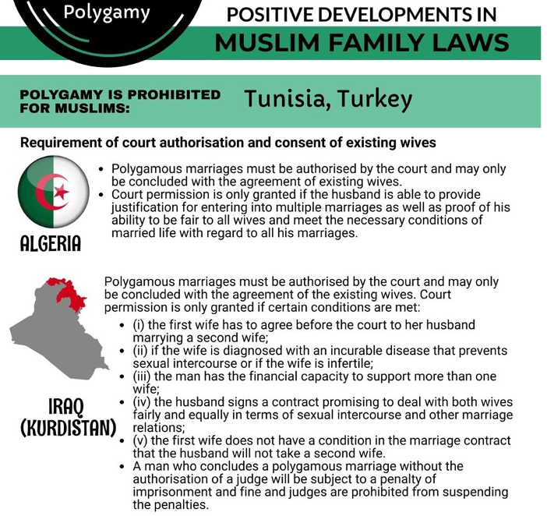

RECOMMENDATIONS
We recommend the CEDAW Committee urge the State party to:

- Amend the Islamic Family Law to make provision for prenuptial agreements, in order for the husband and wife to decide whether a subsequent marriage may be contracted by the husband, and giving the option of divorce to the wife.

- Amend the Islamic Family Law to make provision, even without prenuptial agreements, the wife has the option of divorce, given at any stage of the polygamous marriage she is not happy or satisfied, for any reasons being, for her to exercise her own agency.

- Reinstate the fifth condition for polygamy– ‘no drop in standard of living of existing family’

- Provide a timeline and plan to make the consent of an existing wife mandatory for her husband to contract a second marriage, and to make Practice Direction No. 7 of 2021 a legally binding requirement as opposed to a direction of persuasive value

Inequality in Financial Rights of Women

The issues highlighted in the NGO CEDAW Shadow Report for the Malaysian government review in 2018 have not been addressed and still remain relevant. Owing to the lack of action from the government Muslim women's financial rights continue to regress. The provisions pertaining a Muslim wife’s financial rights as stated in paragraph 121 of Malaysia’s sixth periodic report, is the written law which is not disputed. It is the extent to which these rights are granted and fulfilled which is the cause for concern. The practice on division of matrimonial assets is inconsistent; insights shared from lawyers stated there are cases where a wife may obtain up to one-third of the total matrimonial property while there are others where they were awarded only two percent from the total matrimonial property. It is unjust and discriminatory as in most cases, the wife is the person in charge of the household and childcare. Even one-half may be inadequate in circumstances where the woman has carried a double burden i.e., financially providing for the well-being of the family as well as her non-financial or indirect contribution in doing most of the housework and looking after the children and husband. Although the relevant provisions in IFLA and other similar state enactments provide for indirect contribution to be taken into account in division of matrimonial property, the specific circumstances applicable to every claim must also be considered. For example, a spouse who is the sole provider should not be able to make a claim against the total matrimonial property. In a 2022 case, the Syariah court heard an application from the husband to claim for harta sepencarian (matrimonial property) from the non-working wife, which caused a lot of hardship to her. The application was ultimately rejected, but there is a need to ensure there is no abuse in seeking matrimonial property division.

Divorced or widowed mothers often have to provide for their children’s needs without assistance (or adequate assistance) from the father or male relatives who were traditionally regarded as responsible for the children’s maintenance. Sisters in Islam has operated a legal helpline since 2003 called Telenisa and reports on its statistics annually since 2016. The Covid pandemic has affected women’s financial rights in marriage even while the marriage is ongoing. In 2021, 76% of Telenisa clients claimed that their husbands didn’t give sufficient maintenance, while those with court orders for maintenance, their former husbands didn’t fulfil them as ordered (11%). Financial rights for the children remain at an all-time high in terms of cases that came to the helpline with the issue of non-payment of maintenance. According to the data, 63% of the fathers were not paying maintenance at all, 16% were unemployed, 14% were violating court orders to pay maintenance and 6% were paying insufficient maintenance. The main issue faced by women is the non-payment of maintenance as agreed in the divorce settlement agreement. In many cases, the ex-husband disappears or just refuses to pay. Even when there is a court order for the father to maintain the children, it is rarely enforced. The onus then falls onto the mother to apply for an enforcement of the court order. Yet, there is no strong enforcement action taken against the father if he does not pay. Where there is payment made by the father, the amount is often inadequate.

In November 2021, the Department of Syariah Judiciary announced that restrictions would be imposed on the husbands’ or fathers’ bank accounts if they do not fulfil maintenance payment. Nevertheless, information to the public and legal fraternities as to how these can be exercised is still unknown so access to this provision is unrealised. This execution procedure, known as Hiwalah procedure (garnishee procedure), was newly introduced. The Syariah court will issue a court order for the husband’s bank to pay up the amount of maintenance owed to the wife. We put forth that this newly introduced Hiwalah execution itself is problematic, tedious and burdensome for women. There are layers of problem to this execution mechanisms;

- In cases where the bank refuse to follow the Syariah court’s order, or negligently delayed in enforcing the order, and the husband as successfully removed or transferred all amount in the account - the wife is left with no ways of solution, as she is unable to take action towards the bank in Syariah court, as a private organisation cannot appear in Syariah court as a party. Whereas, the wife also is unable to take this action in Civil court, as this is an issue of Muslim personal issue, the jurisdiction is within the Syariah court to hear it. Again, the wife is left in a defeated position.

- Secondly, to even arrive at the stage where this execution mechanism is available for the wife, she would need to go through a gamut of procedures. The bureaucracy is burdening for women, especially for women from low-income groups. Women would have to carry the burden to expose all bank accounts available of the other party to the court, would then be required to appear in court at least 3-5 times. Not only is this costing women in monetary form but also time.

The issue of children’s maintenance is critical to ensure that children’s welfare continues to be taken care of even when the parents are separated or divorced.

Rights of Mothers whose Children were Unilaterally Converted to Islam

While the Federal Court judgement on Indira Gandhi regarding this issue is welcomed, the implementation of this judgement and its applicability to Malaysian women still falls severely short. Despite the judgement, Indira Gandhi still hasn’t had access to her youngest daughter who was taken away from her since 2009 and enforcement agencies have been evasive as to whether they know where she is or to take any positive action that would lead to reuniting Indira and her daughter, even for a moment, if not permanently. In addition, there is a new case of another mother initially being denied access to her children, also converted to Islam. Added to this denial of right, the Perlis state religious authorities, and the Perlis State Mufti had intervened to prevent the mother from taking custody of her children . The Islamist political party, PAS, and Muslim individuals and groups had also publicly campaigned against the mother from acting to nullify the children’s conversion to safeguard their status and creed as Muslims . While the mother may have custody of her children now, she lives in fear of the converted Muslim father, who was released from prison, taking her children away at any time. In the meantime, the mother has been granted leave by the High Court in her judicial review application to challenge her three children’s conversion to Islam .

Women’s Capacity to Enter into Marriage – Guardian’s (Wali’s) Consent

Islamic Family Laws do not grant women equal consent and capacity as men to enter into marriage. Regardless of her age, a prospective bride requires the consent of a male guardian (wali) to marry. The guardian must be a Muslim and a male relative of the prospective bride (father, followed by the paternal grandfather, and others). According to paragraph 124 of Malaysia’s State Party Report, both women and men are able to enter into marriage with the spouse of their choice without the consent of a third party (the wali) by application and approval from the Syariah court. However, there are a number of issues that the woman can encounter in this process, making the process impractical, inconvenient, troublesome and discriminatory for women.

For example, under the Selangor state Islamic Religious Department (JAIS), women must prepare the following list of documents for the marriage consent application:

Requirements for First Time Women Applicants | Requirements for a Woman who has been Married Previously (or Widowed)
1. One (1) copy of an Identification Card/ Passport  2. One (1) copy of an Identification Card/ Passport for 2 male witnesses on behalf of the applicant  3. One (1) copy of an Identification Card of the Wali  4. HIV test report from government’s clinic or hospital  5. An original and one (1) copy of the pre marriage course certificate  6. Form 1 (A domicile/residency verification)  7. A marriage permission letter for the husband-to-be  8. The parents’ marriage certificate and copies 9. Marriage permission letter from the embassy/ Consulate and Immigration (for foreigner).  10. Letter or Conversion Card and the copies (for Convert/Muallaf)  11. Letter of Approval from KAGAT/PDRM (if applicants are a part of police force/army)  12. One (1) copy of Application form 2C, 2D and copy of support documents (if the applicants will be married outside of state/ countries) | 13. One (1) copy of an Identification Card/ Passport  14. One (1) copy of an Identification Card/ Passport for 2 male witnesses on behalf of the applicant  15. One (1) copy of an Identification Card of the Wali  16. HIV test report from government’s clinic or hospital  17. An original and one (1) copy of pre marriage course certificate  18. Form 1 (A domicile/residency verification) 19. The parents’ marriage certificate and copies 20. Original and a copy of the Wali Death Certificate  21. Original and a copy of the Divorce Certificate (if divorced)  22. Original and a copy of the spouse Death Certificate (if previous spouse passed away) 23. Marriage permission letter from the embassy/ Consulate and Immigration (for foreigner).  24. Letter or Conversion Card and the copies (for Convert/Muallaf)  25. Letter of Approval from KAGAT/PDRM (if applicants are a part of police force/army)  26. A marriage permission letter for the husband-to-be  27. One (1) copy of Application form 2C, 2D and copy of support documents (if the applicants are marrying outside of state/ countries)

As illustrated above, a woman has to go through numerous additional steps to register her marriage. She must prove that she is born in a lawful marriage whereby she has to provide a certificate of her parents’ marriage to prove that she is not born out of wedlock. The requirement of proving lineage is imposed towards the woman only, and not the man. In addition, the presence of wali is mandatory in the woman's marriage application. Regarding this, a woman may face any of the situations below that make it unable for her to get legally married. She may:

a. Have no eligible wali (Passed away/Missing)
b. Be an adopted child
c. Be a converted Muslim
d. Be a child born out of wedlock
e. Have an unwilling wali, or one refusing to be at the wedding ceremony

Moreover, although a woman has a legal right to obtain permission from a Wali Raja or Wali Hakim or Testamentary Guardian (appointed by the court) through the application to the Syariah court in advance, in practice, the requirements for this application to be allowed in court are impractical, inconvenient and troublesome for women to meet. Many women’s voices from the ground have shared their experiences of having to make an official search at the National Registration Department and advertise in the national newspapers in their effort to search for their long-lost wali. The preliminary requirements mentioned above are also time and cost-consuming. Some have been cases where the wali has abandoned and/or abused them. In these cases, the experiences are also traumatising for women, as they need to find and approach their abuser to be present at their wedding day and give his consent to the marriage as the wali. Sometimes, these factors become a catalyst for couples to cross over the Malaysia-Thailand border and marry in Thailand instead, which exposes the couples further to scam marriages and lack of legal protection.

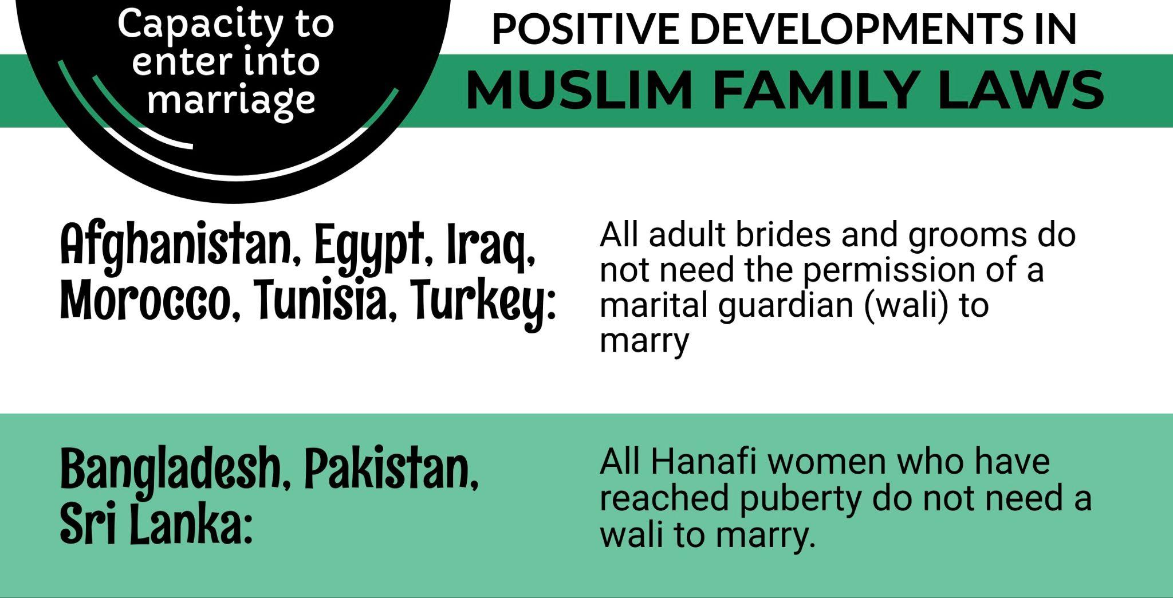

RECOMMENDATIONS
We recommend the CEDAW Committee urge the State party to:

- Amend Section 122 of IFL to include a written criteria determining the status of the party that is allowed to claim for matrimonial property; so as to not allow a sole provider to claim the total matrimonial property from a non-provider in the marriage.

- To include in IFL the minimum percentage of 30% of the total matrimonial property be awarded to applicants by the courts.

- Provide the steps Malaysia is taking to remove the requirement of the consent of guardian (wali) for women to enter into marriages.

- Provide information about the action Malaysia is taking to popularise and implement fully the announcement made by the Department of Syariah Judiciary that restrictions would be imposed to the husbands’ or fathers’ bank accounts if they do not fulfil maintenance payment of their children.

- Establish a national level child support agency that can ensure payment of child support/ maintenance and enforce in situations of non-payment.

- Tighten enforcement with regard to children being unilaterally converted to Islam and ensure no interference by government agencies at both Federal and State levels in the judicial process.

Article 73 of the Federal Constitution of Malaysia
Other areas where States legislate laws are such as land and other natural resources of the State.
Federal Court rules 16 provisions in Kelantan Syariah Criminal Code Enactment null and void, Feb 9 2024, Astroawani, https://www.astroawani.com/berita-malaysia/federal-court-rules-16-provisions-kelantan-syariah-criminal-code-enactment-null-and-void-457547
Press Release | Only Civil Courts, and Not Syariah Courts, Have Jurisdiction to Review Constitutional Issues Relating to Conversion of Religion http://www.malaysianbar.org.my/press_statements/press_release_%7C_only_civil_courts_and_not_syariah_courts_have_j urisdiction_to_review_constitutional_issues_relating_to_conversion_of_religion.html
Executive Summary, National Strategy Plan In Handling The Causes Of Child Marriage (2020-2025) https://www.kpwkm.gov.my/kpwkm/uploads/files/Dokumen/Pelan%20Strategi%20Perkahwinan%20Bawah%20 Umur/EXECUTIVE%20SUMMARY.pdf
Statutory Amendments to Raise Minimum Age for Muslims to Marry in Selangor Passed, Sept 2018, The Star, https://www.thestar.com.my/news/nation/2018/09/05/statutory-amendments-to-raise-minimum-age-for-muslimsto-marry-in-selangor-passed/
Islamic Family Law (State of Selangor) (Amendment) Enactment 2018, https://www.jakess.gov.my/pdffile/ENAKMEN/Enakmenenakmen%20negeri%20Selangor/Enakmen%20Keluarga/RUU%20UNDANGUNDANG%20KELUARGA%20ISLAM%20%28NEGERI%20SELANGOR%29%20%28PINDAAN%29%202018. pdf
Minimum age for women to marry increased to 18 in Kedah, July 2022, The Star, https://www.thestar.com.my/news/nation/2022/07/18/minimum-age-for-women-to-marry-increased-to-18-inkedah-one-year-jail-for-polygamy-without-permission
Arahan Amalan No. 2 Tahun 2020, https://jksp.pahang.gov.my/wp-content/uploads/2022/07/ARAHANAMALAN-TAHUN-2020.pdf
445 teens left school to get married in 2020, Dec 2021, FMT, https://www.freemalaysiatoday.com/category/nation/2021/12/02/445-teens-left-school-to-get-married-in-2020/
Sisters in Islam and Musawah: A Report on Malaysia’s Progress and Commitment to the Sustainable Development Goal (SDG) (Indicator 5.1.1) (2023)
Malaysia Sixth State Party Report submitted to the CEDAW Committee under article 18 of the CEDAW Convention (2022), https://tbinternet.ohchr.org/_layouts/15/treatybodyexternal/Download.aspx?symbolno=CEDAW%2FC%2FMYS%2F6&Lang=en
Islamic Family Law (Federal Territories) Act 1984, Section 83 http://jafbase.fr/docAsie/Malaisie/FamilleIslamique.PDF
Managing Application Redeem Inheritance (Baitulmal), Family Institution, MyGovernment Malaysia, https://www.malaysia.gov.my/portal/content/27712
NGO CEDAW Shadow Report at the 69th CEDAW Session in February 2018, submitted on 29 January 2018 by 37 NGOs.
Selangor Syariah Court Case No.14600-017-0031-2022
Telenisa, Sisters in Islam, https://sistersinislam.org/telenisa/
Malaysia’s State Party Report to CEDAW, Para 117. “The judgment…echoes that Malaysian women have equal access to justice irrespective of their religion…the latest amendments to the Act 164 ensures that the rights of spouses whose marriages were solemnised under the civil law are protected despite the conversion to Islam by one spouse.”
We’ll find you, Indira Gandhi tells daughter on Deepavali, Oct 2022, FMT, https://www.freemalaysiatoday.com/category/nation/2022/10/24/well-find-you-indira-gandhi-tells-daughter-ondeepavali/; Indira Gandhi's suit against IGP, three others to go for full trial, July 2021, Astroawani, https://www.astroawani.com/berita-malaysia/indira-gandhis-suit-against-igp-three-others-go-full-trial-308774
High Court rejects MAIPs' bid to vary Loh's child custody order, June 2022, NST, https://www.nst.com.my/news/crime-courts/2022/06/805219/high-court-rejects-maips-bid-vary-lohs-childcustody-order
“Think of the consequences”, PAS leader tells Loh on challenging children’s unilateral conversion, March 2022, Focus Malaysia, https://focusmalaysia.my/think-of-the-consequences-pas-leader-tells-loh-on-challengingchildrens-unilateral-conversion/
High Court grants Hindu mum Loh Siew Hong leave to challenge kids' unilateral conversion to Islam, Aug 2022, Malaymail, https://www.malaymail.com/news/malaysia/2022/08/01/high-court-grants-hindu-mum-lohsiew-hong-leave-to-challenge-kids-unilateral-conversion-to-islam/20351

