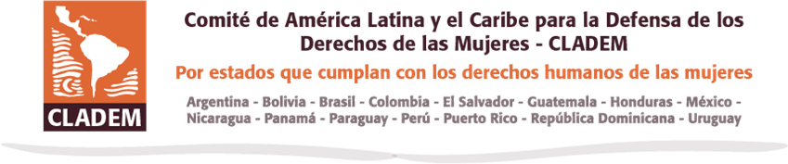

ALTERNATE REPORT FROM CIVIL SOCIETY ORGANIZATIONS DOMINICAN REPUBLIC

On the occasion of the presentation of the 8th Report of the Dominican State to the Committee on the Elimination of All Forms of Discrimination against Women

-CEDAW-

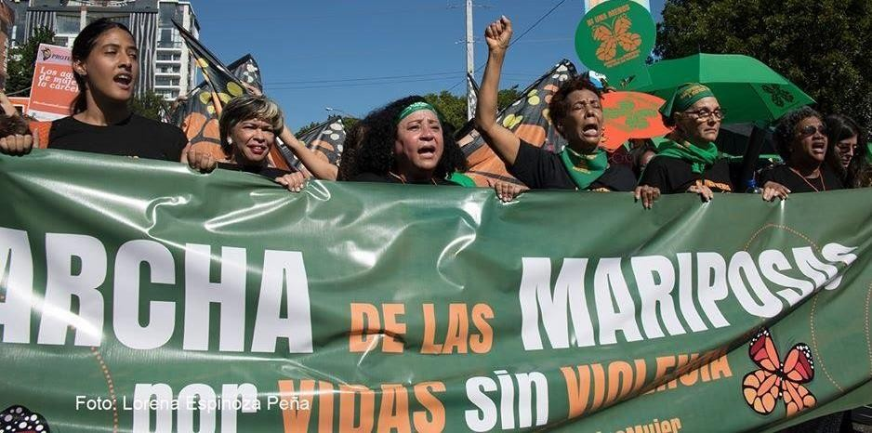

June 2020 Geneva, Switzerland


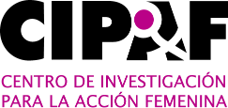




COORDINATION AND EDITING
-
- LATIN AMERICAN AND CARIBBEAN COMMITTEE FOR THE DEFENSE OF WOMEN'S RIGHTS - DOMINICAN REPUBLIC (CLADEM-DR): regional network that articulates women and organizations that, from a socio-legal feminist approach, seek social transformation and the construction of radical democracies, for the full exercise and enjoyment of human rights by all women.

PARTNER ORGANISATIONS

- CENTRO DE ESTUDIOS DE GÉNERO DE INTEC (CEG-INTEC): organization dedicated to higher education, research and public policy advocacy from a gender perspective.
- CENTRO DE INVESTIGACIÓN PARA LA ACCIÓN FEMENINA (CIPAF): founded in 1980 to contribute to the integral development of women by promoting their participation in conditions of equality in all areas of the country's economic, social and political life.
- FRIEDRICH-EBERT-STIFTUNG (FES): working since 1979 in the Dominican Republic. It advocates for a more sustainable development model in terms of social inclusion, decent work and impact on the environment
- PLAN INTERNATIONAL REPÚBLICA DOMINICANA (PLANRD): working in the country since 1987, it is one of the most recognized international organizations in the promotion of children's rights.
- ASOCIACIÓN PRO BIENESTAR DE LA FAMILIA (PROFAMILIA): a pioneering organization in sexual and reproductive health services, founded in 1966 to promote and educate about the importance of contraceptives.

COUNTRY CONTEXT

The Dominican Republic is one of the countries in the Latin American and Caribbean region that has experienced the highest rates of economic growth in the last 8 years, registering an average increase of 5.6% in GDP¹. However, this economic growth has not meant social inclusion for large population groups, but on the contrary has had a differentiated impact for reasons of age, sex, disability, race, ethnicity, origin, or socioeconomic status, resulting in unequal conditions and access to opportunities for access to productive resources, development of skills, expression of voice and respect for individual and collective economic, social and cultural rights.
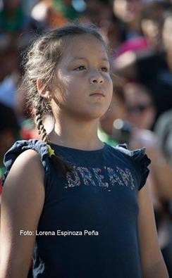
The population groups that have experienced decline in monetary poverty levels are women, young people, early childhood children, people with disabilities and migrants, and people living in rural areas, who do not have equal access to sufficient opportunities to achieve their well- being. By 2016, the percentage of poor people is higher in rural areas (37.9%) than in urban areas (26.6%), and in households headed by women (26.7%) than by men (20.9%). Similarly, there is a higher percentage of women (30.37%) in poverty than men (27.4%) at the national level, and within the group of women, those living in rural areas are the most affected by poverty (40.41%) .

When human development is calculated considering gender differences, the value drops substantially by 47%, due to: lower participation of women in the labor market, deficient provision of goods and services in sexual and reproductive health, high rates of adolescent pregnancy (20.3%), high rates of maternal mortality (102 per 100 thousand live births) and low participation in political representation seats.

The circumstances surrounding the COVID-19 crisis in the Dominican context where women have the burden of unpaid work and care in the home, has increased violence in the home, as well as the increase in the price of the family basket has repercussions on the possibility of women and girls to obtain the necessary items for menstrual care. Similarly, the impact of the crisis on the economy will have repercussions mainly on the informal sector, which represents 49% of the country's economic activity and in which women represent 23%.

ARTICLE 1. VIOLENCE AGAINST WOMEN

The Dominican Republic is the fifth country in Latin America with the highest rate of femicide per 100,000 women, after El Salvador, Honduras, Bolivia and Guatemala. According to the Attorney General's Office (PGR), 1,444 femicides were recorded between 2005 and 2019. In 2019, there were 77,837 complaints of gender and domestic violence, 6,914 complaints of sexual offences, 77 femicides and 19,908 protection orders issued. Most of the victims of femicide had not filed complaints.

It is estimated that less than 5 per cent of all complaints of gender violence, domestic violence and sexual offences are finally adjudicated. Despite this, neither the judiciary nor the Office of the Attorney- General of the Republic has conducted investigations in which they have made public the reasons for this very high rate of impunity. Civil society organizations, when trying to undertake investigations in this regard, have encountered obstacles from the highest levels when trying to access files, victims and personnel of the agencies that process the complaints.
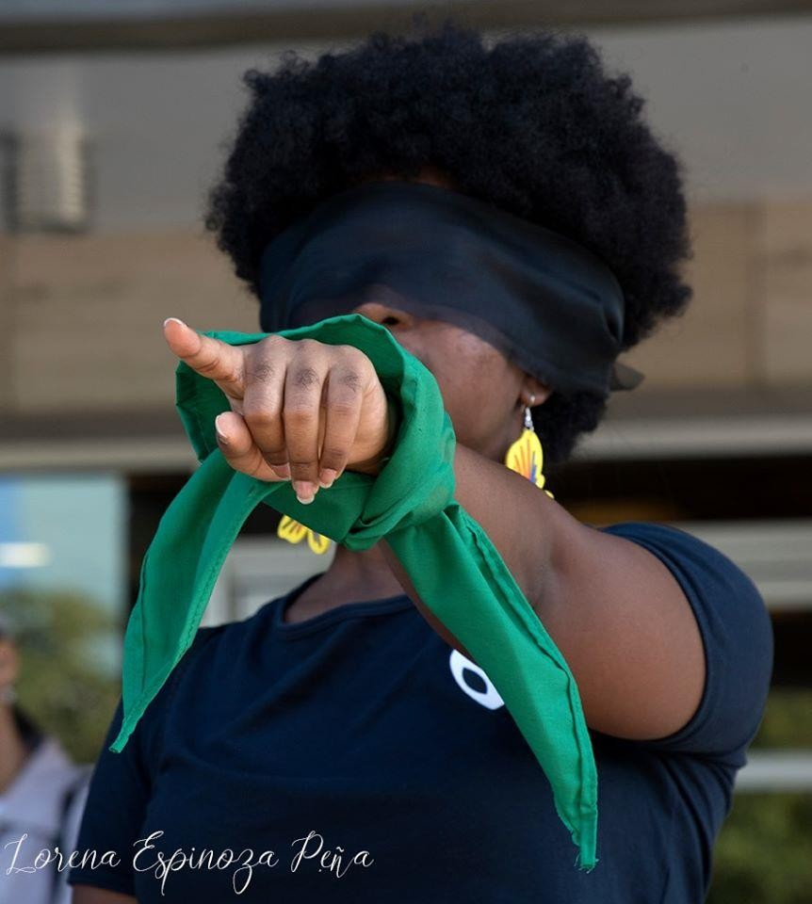
Another element that contributes to impunity in cases of gender-based violence and, in many cases, even the death of the victim, is the persistence of conciliation, both in criminal law and in the practice of Public Ministry officials, who promote it, as well as promote and approve abbreviated criminal agreements that significantly reduce the penalties of the aggressors. These agreements, only in 2019, claimed the lives of Anibel González and Juana Domínguez, whose perpetrators were benefited by abbreviated criminal agreements despite the fact that the figure did not legally qualify for them and despite the risk this posed to the victims.

Since 2012, the women's movement, feminists and civil society organizations have proposed the approval of the bill that creates the Integral System of Prevention, Attention and Sanction
of Violence against Women. Despite the fact that this project has been enriched, welcomed by the Gender Equality Commission of the Chamber of Deputies, presented and discussed on several occasions before the National Congress, no consensus has been reached for its approval.
Discrimination and violence against women is even greater if they belong to one of the vulnerable populations such as migrants, LGBTI+ community, de-nationalized people, older women, women with disabilities and afro-descendants. In particular, the lack of protection of lesbian and trans women in situations of violence, where State agencies designed to do so deny them protection and assistance, as is the case with the Ministry of Women's Affairs itself, which has indicated that it only provides legal services to women victims of gender violence or domestic violence where an aggressor man is involved, if the aggression comes from a partner of the same sex, assistance is not provided. The same is true of the Public Prosecutor's Office, where domestic violence between lesbian couples is registered as a quarrel, despite the fact that Act No. 24-97 on domestic violence guarantees protection without discrimination for all persons in a family.

The Ministry of Women reports that during the state of emergency declared by the Covid-19 pandemic, between March 17 and June 28, 2020, it provided 2,322 services through its hotline and in coordination with the National System of Emergency Care, 911. Of these, 1,262 referred to physical, psychological, verbal and property violence. They also provided protection from extreme violence to 1,241 women and their children under 13. Half of this figure, 662, was received in June alone, when confinement and curfews were relaxed¹². The services of the Línea Mujer *212 and Las Casas de Acogida, declared as essential services during the pandemic.

RECOMMENDATIONS

- Approval of the draft law creating the Comprehensive System for the Prevention, Treatment and Punishment of Violence against Women, assigning its governing body to the Ministry of Women's Affairs and providing it with sufficient resources for its implementation
- Strengthen the internal policies of the Office of the Attorney General of the Republic and the Public Prosecutor's Office for the efficient and timely investigation, processing and prosecution of crimes of violence against women and domestic violence, ensuring that impunity, re- victimization and discrimination are avoided
- To strengthen the internal policies of the judiciary for the comprehensive care of victims of violence against women and domestic violence without discrimination in the process of access to justice.
- To strengthen the policies of the Ministry of Women's Affairs, as well as its technical and operational resources for the prevention and care of victims of violence against women and domestic violence without discrimination.
- Promote transparency in the handling of cases of violence against women and domestic violence in all State institutions, with a clear regime of consequences.
- To make the detection, prevention and comprehensive care of violence against women and domestic violence in the health and education systems an institutional priority.
- Strengthen and expand services available to respond to violence against women and domestic violence in emergency settings, particularly during the Covid-19 pandemic, in which many women are confined with their abusers.
- Strengthen the supervision, monitoring and guarantee of application of health protocols on violence against women and domestic violence by the Ministry of Public Health.
- To effectively implement the detection, prevention and assistance to victims of violence against women and domestic violence from all levels of care of the National Health Service, efficiently applying the corresponding protocols
- Allocate sufficient public resources to expand the capacity and territorial coverage of the shelters, which are the responsibility of the Ministry of Women's Affairs.

ARTICLE 4 - DISCRIMINATION

Structural and racial discrimination against migrants of Haitian citizenship and their descendants born in the Dominican Republic is historical, manifesting itself in systematic patterns of economic, social and cultural marginalization. In the case of women and girls of Haitian origin (and generations) who live in extreme poverty in isolated communities called "bateyes", the non-recognition of the right to Dominican nationality and under-registration is disproportionate, seriously impacting their rights. A UNFPA study in 2018 showed the difference and reduced access to rights and services by the Haitian-born population in the country compared to another national origin.

Constitutional Court Ruling No. 168 of September 23, 2013 is still in force, massively and retroactively denationalizing Dominicans of Haitian origin born in the country, whether or not they are registered in the Dominican civil registry, based on the irregular migratory origin of their parents.

Six years after Law 169-14 it has been a total failure. Based on data received by the Inter-American Commission on Human Rights (IACHR) from the State between 2016-2019, approximately 49% of the 61,000 registered in the civil registry (Group A of the Law) would be available to return their documents and 51% are not ready for delivery. The 8,750 who applied for naturalization today do not have Dominican nationality, and the process encountered obstacles: the mother's document was required for registration and the Law does not establish this, difficulties in identifying the mother and obtaining the document from the hospital of birth. The Law has no solution for the registration of descendants or minors of Group A or those who applied for special naturalization. Approximately 75,000 of the people who have applied are under 15 years of age registered in a Book of Foreigners that does not indicate nationality. In addition, there is a number of people of Haitian descent, a number that is still unclear, who were born in the country, did not apply to the Law, therefore they have no legal solution, remaining stateless.

The State has not relaxed the requirement for a foreign mother's passport when the father is Dominican in order to register the minor as Dominican. The civil law presumes the child born to the mother and the father can only recognize him if it is his will; without the mother's passport the child cannot be registered as Dominican by blood, nor the subsequent generations, increasing the risk of statelessness. Gender discrimination is clear, as it does not happen when the mother is Dominican. Furthermore, as a result of his context, the statistical health records of the Haitian migrant population and the population of Haitian origin are racially discriminatory, if a mother does not have documents in the hospital she is registered as "Haitian", which is reflected in the statistics.

During Covid19 the civil registry offices have been closed, without information on extensions of time for timely registration, considering costs and distances and home births. The government's measures did not consider women domestic workers, nor those of Haitian descent or migrants, since the food program required them to have a Dominican identity document.

Also, during the quarantine, Ana Maria Belique, leader of the Recognized Stateless People's Movement, was illegally detained by the national police for protesting against racial discrimination and in solidarity with the African-American people over the death of George Floyd; while because of this initiative, ultra- nationalist groups have intensified threats, hate speech and xenophobia against her, as well as against Haitian migrants and their descendants, and the government has not taken action.

RECOMMENDATIONS

  - Automatic restitution of Dominican nationality to all those denationalised by Judgement No. 168- 13 still in force, born in the Dominican Republic before 26 January 2010, without procedures or administrative formalities, as ordered by the IACHR and the Inter-American Court of Human Rights. Through another Ruling of the Constitutional Court, Ruling No. 168-13 is revoked. To this end, mobile units for civil registration and delivery of identity documents should be made operational throughout the country.
  - In the statistics of births, disaggregate the data on mothers and their children born in the Dominican Republic in health centers and children's homes, eliminating "phenotypical-racial" criteria in the statistics in which they indicate "Haitian" nationality, and indicate that their nationality is "Dominican" or "born in the Dominican Republic.
  - The State should criminally punish ultra-nationalist groups for hate speech and incitement to public violence, not tolerating these behaviors through public pronouncements and official school education programs on interculturality.
  - Adopt a procedure in conjunction with the migration authorities and the corresponding training to avoid deportations of women and minors born in the Dominican Republic without documents.
  - The JCE should adopt a resolution for the timely registration of babies born during the State of Emergency due to Covid19, in view of the total closure of its offices, and thus avoid the risk of statelessness.

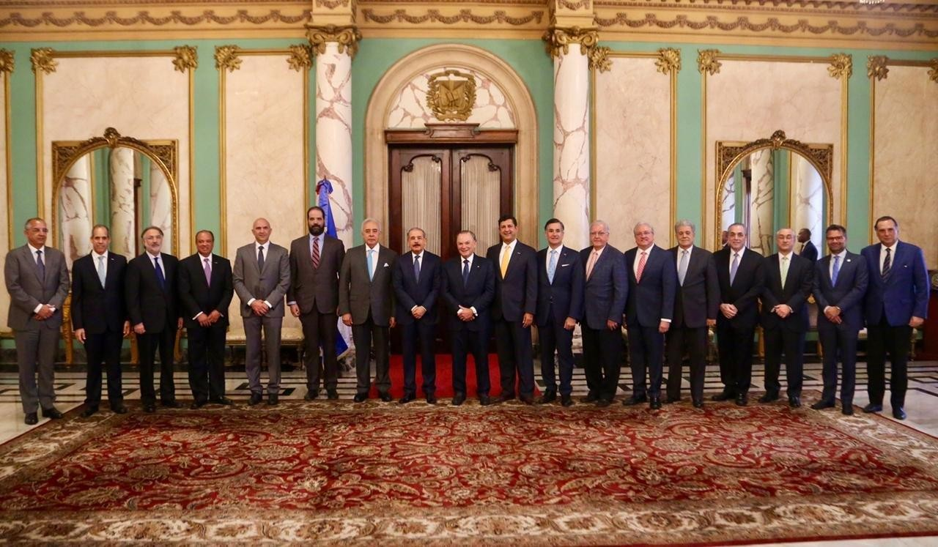
ARTICLE 7. RIGHT TO POLITICAL PARTICIPATION

In past years 2018 and 2019, the National Congress approved important reforms to the Dominican electoral legislative framework: Law 33-18 on Political Parties, Groups and Movements and Law 15-19 on the Electoral Regime. These legislative pieces brought with them an increase in the percentage allocated to the electoral gender quota for certain popularly elected positions at the municipal and congressional level, whose proportion rose from 33% to a minimum of 40%.

The effective implementation of the gender quota has been hindered by political parties that are reluctant to comply and by administrative and jurisdictional bodies that apply and interpret the law without a gender perspective. In this regard, the Central Electoral Board (JCE) issued Resolution 28-2019, by which it distributed the seats in the municipal and congressional electoral districts in accordance with the gender quota. In calculating how many male and female candidates would fill the quota according to the total number of seats in each district, the JCE made incorrect calculations (equivalent to percentages below 40 per cent) for several districts at the governorship and provincial levels.

Given that these calculations would result in the exclusion of candidates from the electoral ballots, the High Administrative Court, after being empowered to file an action of protection, ordered through sentence No. 0030-04-2019-SSEN-00506 the immediate modification and adaptation of Resolution 28- 2019¹⁶, establishing that¹⁷:"As the shareholders argue, since there are 6 and 13 candidates (provincial and municipal governments), the figures of 2 and 5 spaces, respectively, intended to cover the corresponding percentage, do not cover the minimum 40%, since the interpretation made by the respondent - the Central Electoral Board - deviated from the pro homine principle that should prevail in the interpretation of rules, especially when the law establishes a minimum for women (...)".

Although this was a favorable interpretation of women's political rights, the sentence was never complied with by the JCE, so Resolution 28-2019 was not modified and the ballots for both the already completed municipal and congressional contests and the next congressional event were cast by a smaller number of women than the legal percentage. In fact, as a result a total of 69 women candidates for deputy were excluded from their parties' ballots. This could also explain the decrease of two percentage points in terms of women's representation in the councils (32.30% of women councilors elected in 2016; 30.25% of women councilors elected in 2020⁾.

In addition to the role that the JCE has played to the detriment of women's political participation, at the jurisdictional level, the Superior Electoral Court (TSE) has also performed poorly in safeguarding the effectiveness of the gender quota. Ruling TSE-091-2019 shows a misguided and ignorant interpretation of political party gender dynamics, by providing that the gender quota must be covered by making use of the seats that parties have reserved for themselves. In short, this implies that women who competed in elections within their parties could be displaced by the women who the leadership of their parties decides will fill the seats. This interpretation opens the door for parties to place women with little chance of winning their candidacies or, failing that, women as wives and daughters of political leaders -as has in fact happened at the level of deputies- who could then be coerced into resigning their positions.

The representation in the Senate 2016-2020 had only 3 women in 32 positions. In the Chamber of Deputies for the same period, women held only 28.1% of the seats. The Senate 2020-2024 will have 4 women. At the Central Bank, which is the body where the main economic decisions are taken, none of the 10 members of its Monetary Board is a woman. In the municipal elections held in March 2020, it was only possible to reach the quota at the municipal council level (30.25 per cent), and in the mayoral offices women barely reached 12.03 per cent.

Women's participation in decision-making bodies has historically remained very low, despite the regulations in place to reverse this situation. In the government administration that only ends in August 2020, out of 22 ministries in the Executive Branch, only 3 are occupied by women, in roles that are otherwise traditional, the Ministry of Women, the Ministry of Youth and the Ministry of Higher Education, Science and Technology.

RECOMMENDATIONS

    - Adopt effective mechanisms to monitor and control compliance with the electoral gender quota, including sanctions for political parties and electoral bodies that fail to comply with it.
    - Train political parties, members of the Central Electoral Board and judges of the Superior Electoral Tribunal in the gender perspective, so that their administrative and/or jurisdictional actions and decisions do not ignore or obscure the partisan political dynamics that disproportionately affect women
    - Promote the necessary legislative reforms to Law 33-18 on Political Parties, Groupings and Movements and Law 15-19 on the Electoral System to extend the mandatory application of the gender quota to elected positions in the Senate and the Mayor's Office;
    - Promote the necessary legislative reforms to Law 33-18 on Political Parties, Groups and Movements and Law 15-19 on the Electoral Regime to guarantee the allocation of specific budgets to political parties that allow for the training and investment of campaign funds for their female candidates;
    - To design policies that pursue parity in freely appointed public positions, including positions in the public administration and in the formation of high courts, such as the Supreme Court of Justice and the Constitutional Tribunal.

ARTICLE 10. RIGHT TO EDUCATION

The information available shows a favorable panorama for women in terms of insertion into the formal education system, showing that women have higher educational levels than men in terms of: average years of study (8.9 years for men and 9.5 years for women); levels close to parity in early education (0.94) and primary education (0.97); and greater presence in secondary and university education, presenting a gender parity index of 1.07 and 1.73, respectively.

There are deficits in the levels of coverage of educational services at all levels, especially in initial education (net enrolment rate of 34.9% for boys and 32.9% for girls) and secondary education (57.6% and 67.2% for men and women), as well as in university education (21.6% for men and 34.4% for women); and in primary education the enrolment rate is 94.7% for boys and 94.9% for girls. These data in education are explained despite the extensive program of building new schools and rehabilitating classrooms, the implementation of the extended school day and the Comprehensive Early Childhood Care Program -focused on the most impoverished sectors, and still with limited coverage, and the programs of school feeding, adult literacy, and the conversion of school centers into vocational technical training programs, among other advances.

For the LGBT population, school environments are both explicitly and implicitly hostile, as they feel subject to discrimination and homophobic and transphobic bullying, compounded by a lack of teacher training on diversity issues.

Information and Communication Technologies (ICT)
Women in the Dominican Republic have overcome the so-called first gap, or access gap. Dominican women represent a little more than 50% of those connected; however, this change in the access gap has not meant changes in the gaps in skills and transformational uses associated with the study of careers linked to science, technology and mathematics, and therefore they maintain a low level of labor insertion in the technological field.

The above is verified from secondary education in the selection of young women in the courses of the technical-professional modality, women are 50.2% of the students, but they are concentrated mainly in technical training lines that reinforce the trades traditionally assigned to women, such as hotel management (cooking, bakery and pastry, room service, hotel reception), commerce (secretarial, accounting and human resources), and services (beauty and hairdressing, police, domestic service, nursing), among others

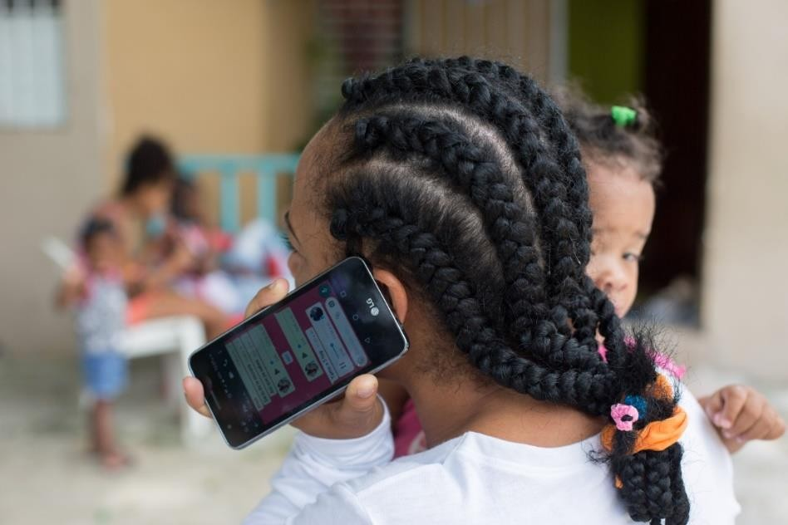
In careers related to ICTs and engineering, women are still underrepresented, for example in civil engineering (index of femininity 0.43), Computing (0.69); and Industrial (0.61), which are generally better valued and better paid in the market, and in²⁸ technological areas (cutting edge), such as electronic engineering, computer science degree, computer technician and communication technologies (networks and connectivity) are still very masculine, with women representing less than 43%.

The most worrying thing is that the trend in ICT careers for women in recent years shows a decrease of almost 50%. Likewise, this absence of women in the training of technological and STEM-related careers is reflected in a significant gender gap in the country's scientific work. Of the 268 researchers selected for the 2019 call, only 36% are women researchers.

RECOMMENDATIONS:

- Transparent use and management of 4% of GDP for education.
- Removing from the public school curriculum content and teaching practices linked to diverse religious beliefs, which do not meet the commitment to non-denominational education
- Improve school curricula, including sexual and reproductive education and education for peace and gender equality.
- Create comprehensive policies in the national education sector to prevent and combat violence based on sexual orientation, gender identity and sexual characteristics to ensure inclusive curricula and teaching materials.
- Promote programs and initiatives for continuous learning and gender-sensitive training for women and girls in specialized areas of digital skills from primary and secondary school.
- Ensure technology affirmative action for elementary and high school girls to inspire careers in Science, Technology, Engineering and Arts and Design and Math (STEAM) studies.
- Include in the National Strategy for the Information Society or the National Digital Development Plan and the National Science and Technology Plan a cross-cutting gender approach, including a chapter on closing the gender digital gap in education, skills development and technological leadership.

ARTICLE 11. RIGHT TO EMPLOYMENT

In the Dominican Republic, it is estimated that the average hourly wage for men is RD$108.00 while for women it is RD$99.00, equivalent to 91.7% of that received by men. Such differences are also seen in the average monthly income, where women's wages represent 83.4% of those received by men in general, 89.1% in the formal sector and 64.2% in the informal sector. Gaps in monthly labor income are present in all sectors and branches of activity and occupational groups and categories, except in the construction sector (194.5% is the ratio of women's wages to men's)

Women spend an average of 31.2 hours per week in unpaid work, while men work only 9.6 hours in unpaid work. The difference of 21.6 hours shows the great inequalities in the distribution of unpaid work on the basis of gender in the performance of tasks that are carried out without pay and without social recognition to the disadvantage of women, and limiting their economic independence. In contrast, men devote an average of 37.1 hours per week to paid work, and women devote 19.5 hours.

Domestic work
The feminization of migration, the absence of a national care policy, the growing participation of women in the workforce and the ageing of society are some of the reasons for the increased demand for domestic services both at home and abroad. In the Dominican Republic, there are approximately 266,000 domestic workers, 96% of whom are women and more than half of whom are heads of household or single mothers, the vast majority of whom live in conditions of poverty and extreme poverty.

Although the constitution establishes that domestic work is an economic activity that creates added value, produces wealth and social well-being (Art. 55, section 11), in practice, it has little social value and the women who perform it are invisible. The income of domestic workers is equal to or less than 50% of the average employed person, according to data disseminated by the International Labor Organization (ILO).

Low wages in the sector force domestic workers to take on more than one job in order to meet the family's most pressing needs, and they also face the formidable challenge of having to combine paid work, which is often vital to the family's livelihood, with their maternal role and the need to devote many hours to unpaid care work.

Given that there is no correlation of force in favor of amending the Labor Code and that there is no political will within the Ministry of Labor to make administrative progress in guaranteeing the rights of domestic workers, the trade unions of domestic workers, with the support and accompaniment of civil society organizations and trade union centers, have drawn up a proposed law to regulate domestic work in order to implement the provisions of Convention No. 189 and make progress in effectively guaranteeing rights.

RECOMMENDATIONS

  - Adoption of policies that secure elimination of the gender pay gap.
  - Adoption of a legal framework regulating paid domestic work
  - Amendment of the provisions of articles 258 to 265 of the Labor Code, in order to ensure that those engaged in paid domestic work enjoy the same labor rights as other workers.
  - Regulate the operation of private employment agencies, in order to protect workers against abusive and/or fraudulent practices.
  - Inclusion of domestic workers in social security, while ensuring access to health, pension and occupational risks.

ARTICLE 12: RIGHT TO HEALTH

Teenage pregnancy and forced infant pregnancy
Teenage pregnancy in the Dominican Republic is a complex issue of high concern on the national agenda. Available official data indicate that 22% of women between the ages of 12-19 have been pregnant. This rate is 34% higher than the average for Latin American and Caribbean countries.
The evidence shows that the most vulnerable adolescent population is that of the lowest socioeconomic strata, the least educated, those living in territories and areas of greater vulnerability and belonging to the most excluded groups (disabled adolescents, migrants, those with HIV, orphans, among others). As in our country it is prohibited to interrupt the pregnancy in all cases, it is correct to say that all child pregnancies presented correspond to forced child pregnancies. The statistics of the Ministry of Public Health show a trend of increase in forced child pregnancies in the country where 1,615 girls under 15 years gave birth in 2016
With broad participation from different government institutions and civil society, the country adopted a National Plan for the Reduction of Adolescent Pregnancies in 2019, which has defined objectives and strategies to address this scourge in a comprehensive manner throughout the country. Progress has been made in structuring and monitoring the Plan, and full implementation by the new government is awaited.

Right to abortion

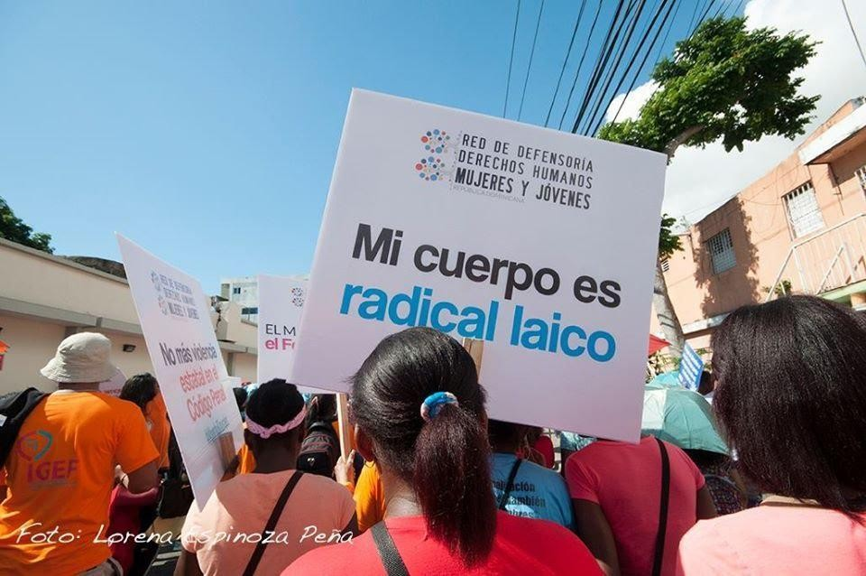
The Dominican Republic is one of only six countries in the Central American and Caribbean region that still maintains an absolute penalization of abortion, with a Criminal Code that dates from 1884. Feminist and women's organizations have promoted an arduous struggle for the decriminalization of abortion in three specific cases, when the woman's life is in danger, when it is a question of sexual violation or when there are fatal malformations for the survival of the fetus, applying criminal sanctions both to health personnel who intervene and to women who voluntarily seek or attempt an abortion. This forces those women who want to save their lives to perform abortions in unhealthy, unsafe and clandestine conditions.

The only official data on the number of abortions performed in the country is provided by the Directorate of Epidemiology of the Ministry of Public Health, which reports a total of 15,472 abortions among obstetric procedures performed in public sector facilities during 2019, but does not provide data that relates this figure to maternal mortality.

For its part, the Attorney General's Office (PGR) reports cases prosecuted for the crime of abortion established in the current Penal Code:
- 2016: 1 case;
- 2017: 3 cases;
- 2018: 27 cases;
- 2019: 5 cases;

The increase in cases between 2017 and 2018, represents a 900% increase that calls powerfully for attention. As of 2019, the General Directorate of Prisons, an agency of the PGR, reports three persons deprived of their liberty for this crime, two men and one woman.

For more than 20 years, there have been attempts to reform the Penal Code and to include the decriminalization of abortion in three grounds, at the time of this report, Congress has not yet been able to pass these provisions.

Maternal Mortality
Government efforts to reduce the incidence of maternal death have resulted in the establishment of public policies, budgets, plans and programs, which recognize that the main challenge in this area is to achieve the highest standards of quality of care. This work has begun to bear fruit in terms of reducing both the ratio of maternal deaths and the absolute number of deaths. By comparison, 54 maternal deaths were recorded in June 2018, while for the same period in 2019, the data show 46 deaths.

In May 2019, through Ministerial Resolution 00004, the Ministry of Public Health put into effect the Framework Document: National Alliance to Accelerate the Reduction of Maternal and Child Mortality, which is a proposal aimed at strengthening actions to reduce maternal mortality by 70 per 100,000 live births.

RECOMMENDATIONS:

- Budget and implement the National Plan for the Reduction of Adolescent Pregnancies 2019- 2023
- Adopt comprehensive public policies to fully guarantee the sexual and reproductive rights of the population, with a gender-differentiated approach and targeting young people and vulnerable populations, in order to expand access to sexual and reproductive health services nationwide.
- Promote sexual and reproductive health services with warmth and quality, without discrimination to the entire population, from the first level centers of the national health system, which are located in urban and rural communities.
- Continue to expand the supply and availability of contraceptive methods to the population
- Decriminalize abortion in at least three cases: when the woman's life is in danger, when it is a question of rape or when there are fatal malformations for the survival of the fetus;
- To continue the adoption and implementation of strategies to reduce maternal mortality, from an approach to improving the quality of medical care received by women and including strategies to reduce unsafe abortions.

ARTICLE 16 - DISCRIMINATION WITH RESPECT TO MARRIAGE

The vast majority of child marriages that occur in the Dominican Republic affect girls and adolescents and according to ENHOGAR-MICS 2014 23.4% of adolescents between 15 and 19 years of age in child marriages or unions had a male spouse at least 10 years older than them. De facto maritalunions have the same legal and social consequences as civil marriage, but do not have the same legal protection.

In the Dominican Republic, marriage is a civil contract, so it is regulated by the Dominican Civil Code, which dates from 1884. The requirements for contracting marriage are:

For the man to be 18 years old and for the woman to be 15 years old.
Minors under 18 years of age may marry with parental consent, but a man before his 16th birthday and a woman before her 15th birthday may marry if they apply to the competent judge for a dispensation from the age requirement.

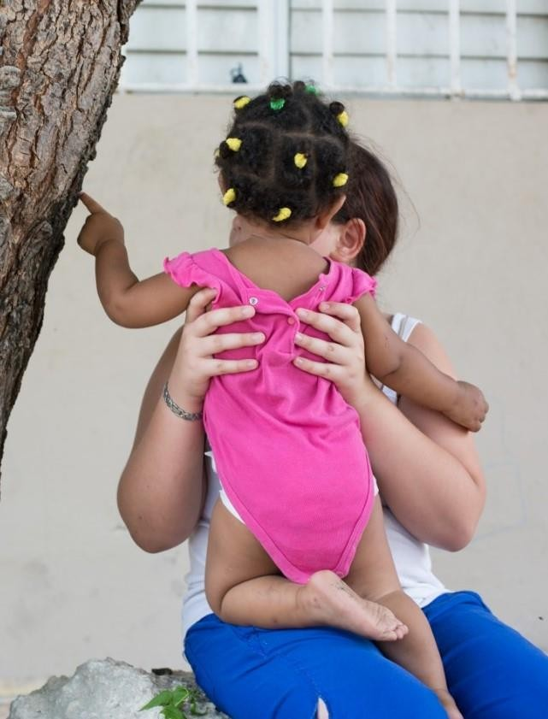
Law 136-03, which establishes the Code for the System for the Protection of the Fundamental Rights of Children and Adolescents, restricts the request for dispensation from the age of marriage to adolescents. Therefore, from the age of 13, adolescents may marry if they have the authorization of the courts for children and adolescents.

These requirements establish a discriminatory age difference against women that is based on gender stereotypes about the position of women in marriage as dependents of their husbands, and thus violates the principle of equality in marriage and family relations, protected by the Dominican Constitution and the Convention on the Elimination of All Forms of Discrimination against Women.

Law 136-03 criminalizes sexual practices with a child or adolescent by an adult, or a person five (5) years older, for their own sexual gratification, without consideration of the child's or adolescents psychosexual development, even when no physical contact occurs. However, the Dominican Criminal Code establishes that when the abuser, also called the seducer, marries the aggrieved child, that is, raped, he can only be prosecuted if the persons or guardians in charge of the child demand the annulment of the marriage, and he can only be convicted after this annulment has been pronounced.

This legal framework legitimizes transactional practices where the family does not criminally prosecute the adult male who joins the child. Research in the country shows how it is common, for example, to agree to pay pensions to family members, financial compensation, purchase of goods or land, move or rent a house/room and pay for services, in exchange for avoiding a complaint with the Prosecutor's Office This type of "transaction" is classified under our legislation as Sexual and Commercial Exploitation of Children and Adolescents, punishable by 3 to 10 years' imprisonment under Law 136-03.

RECOMMENDATIONS

- Modify the Dominican Civil Code so that the minimum age for marriage is 18 years of age, without establishing exceptions, not even through a court order.
- Regulate de facto marital unions by setting the minimum age of consent to the union at 18 years of age without establishing exceptions.
- Establish the obligation to register de facto marital unions in a public registry as a measure to regulate the system of paternal filiation within this type of union,
- Eliminate the discriminatory difference that places children born in a marital union at a disadvantage compared to children born in marriage.

Ministry of Economy, Planning and Development. Sistema de Indicadores Sociales Dominicanos, published on the website www.economia.gob.do
ECLAC. Gender Equality Observatory for Latin America and the Caribbean. Feminicide. https://oig.cepal.org/es/indicadores/feminicidio
PGR. Homicides of women and femicides in the Dominican Republic, by type. Period January - December 2019. https://transparencia.pgr.gob.do/Inicio/VisualizarDocumento?DocumentoId=27561
PGR. Homicides of women and femicides in the Dominican Republic, by type. Period January - December 2019. https://transparencia.pgr.gob.do/Inicio/VisualizarDocumento?DocumentoId=27561; Gender violence, domestic violence and sexual crimes. January - December 2019. https://transparencia.pgr.gob.do/Inicio/VisualizarDocumento?DocumentoId=27879
The Day. "Anibel Gonzalez's family asks to submit to the head prosecutor of San Pedro de Macoris" https://eldia.com.do/familia-de-anibel-gonzalez-pide-someter-a-fiscal-titular-de-san-pedro-de-macoris/; Diario Libre. "Another woman killed by agreements of the Prosecutor's Office and inobservance of judges in San Pedro de Macoris" https://www.diariolibre.com/actualidad/justicia/otra-mujer-muerta-por-acuerdos-de-la-fiscalia-e-inobservancia-de-jueces-de-san-pedro-de-macoris-IB15146196
Ministry of Women of the Dominican Republic. Summary of statistical data in quarantine period. Línea Mujer and Casa de Acogida. 17 March to 21 June 2020; Bulletin MMujer News. 5 June 2020. https://mujer.gob.do/transparencia/phocadownload/Publicaciones/Boletines/2020/BOLETIN%20JUNIO%202020.pdf
¹³ UNFPA 2018. Descendants of migrants in the Dominican Republic. https://dominicanrepublic.unfpa.org/es/publications/descendientes-de-inmigrantes-en-la-rep%C3%BAblica-dominicana
Law No. 33-18, on Political Parties, Groups and Movements, G.O. 10917, of 15 August 2018, art. 33; Law No. 15-19, Organic Law on the Electoral System, G.O. 10933, of 20 February 2019, art. 136.
Acento. "TSA Orders Board to Amend Resolution Establishing Gender Quota Distribution." Online: https://acento.com.do/politica/tsa-ordena-a-la-junta-modificar-resolucion-establece-distribucion-de-la-cuota-de-genero- 8764842.html
Third Chamber of the High Administrative Court. Judgement 0030-04-2019-SSEN-00506, dated 26 December 2019, para. 11
See publication El Mitin. Online: https://www.instagram.com/p/CAQ4yNKDL9_/
Espinal, R et al. More women, more democracy: challenges for gender equality in politics. UNDP: Santo Domingo, 2018, p. 77.
Meet Your Candidate. Computer graphics: results of the 2020 municipal elections. Conocetucandidata.com] UNDP, 2020. Online: https://conocetucandidata.com/infografia-resultados-elecciones-municipales-2020/
See: Diario Libre. "Parties place wives of deputies for quotas." Online: https://www.diariolibre.com/actualidad/politica/partidos-colocan-esposas-de-diputados-para-cuotas-CG15574767
Meet Your Candidate. Computer graphics: results of the 2020 municipal elections. Conocetucandidata.com] UNDP, 2020. Available at: https://conocetucandidata.com/infografia-resultados-elecciones-municipales-2020/
Centro de Estudios de Género de INTEC- Las deudas sociales del país con las mujeres- enero 2019, p.25 See https://www.intec.edu.do/downloads/documents/CEG/Las_deudas_sociales_del_pais_con_las_mujeres.pdf
Ministry of Women's Affairs - National Gender Equality and Equity Plan Topic Education page 186 See https://cne.one.gob.do/sei/pdf/PLANEG%20III.pdf
UNDP-DR, Human Development Report 2015 http://www.do.undp.org/content/dominican_republic/es/home/library/human_development/informe-sobre-desarrollo- humano-2015.html
With information from the Report of the results of the Call 2019 of the National Fund for Innovation and Scientific and Technological Development (FONDOCYT)
SISDOM 2016 See http://economia.gob.do/wp- content/uploads/drive/UAAES/SISDOM/2016/Datos%20estadisticos/SISDOM%202016.%20Volumen%20II%20Serie%20 de%20Datos.pdf
National Statistics Office and Ministry of Women 2018. Unpaid work in the Dominican Republic: analysis based on the time use module of ENHOGAR 2016 https://oig.cepal.org/es/documentos/trabajo-no-remunerado-republica-dominicana-un- analisis-partir-modulo-uso-tiempo-la
UNDP- 2017 "Adolescent Pregnancy: a multidimensional challenge to generate opportunities in the life cycle" see https://www.undp.org/content/dam/dominican_republic/docs/odh/publicaciones/pnud_do_INDH2017.pdf
Social Policy Coordination Cabinet - National Plan for Adolescent Pregnancy Reduction 2019-2023 - https://repositorio.msp.gob.do/handle/123456789/1218
Ministry of Public Health. Dominican Republic. Hospital Services Production Statistics. January - December 2019. https://www.msp.gob.do/web/Transparencia/estadisticas-institucionales/#EIPSSS
Attorney General's Office. Directorate of Statistics and Analysis. Preliminary report on the number of cases registered in the various prosecutor's offices. Year 2019, and information obtained by request via access to public information.
General Directorate of Prisons. General statistics on the typology of crimes. 2018
National Statistics Office. National Multipurpose Household Survey 2014. Main results. 2015, p. 24
TINEO, J. D. Handcuffed girls: Characterization of forced child marriage in the provinces of Azua, Barahona, Pedernales, Elías Piña and San Juan [online]. Approaches. Dominican Republic: Plan International, March 2017, No. 2. ISBN 2518- 895X. Available at: https://plan-international.org/sites/files/plan/field/field_document/planteamientos_2_arte_final_print.pdf

