113th Session of the Human Rights Committee:
4th Periodic Review of the Republic of Korea

Alternative Report on the Republic of Korea’s Compliance with Article 24 of the International Covenant on Civil and Political Rights

9 September 15


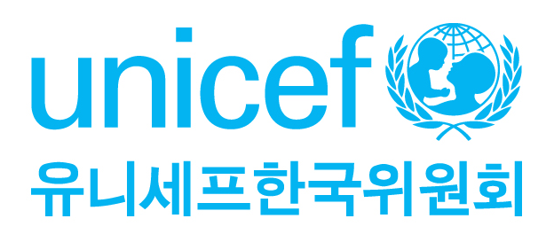
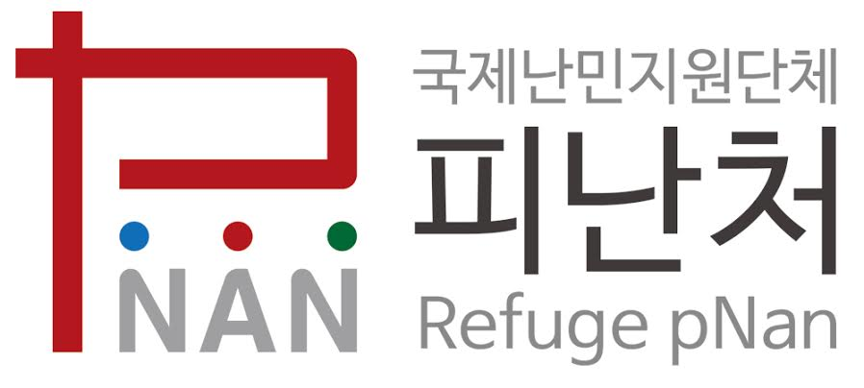
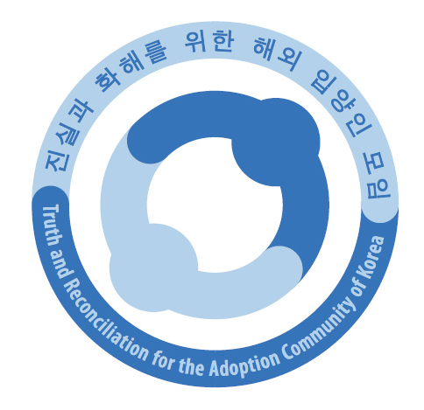

The Birth Registration Working Group of Korea

Introduction

The Birth Registration Working Group of Korea compiled the following report to present the current situation and concerns on birth registration in the Republic of Korea.

The Birth Registration Working Group of Korea is composed of the following members:

Ansan Migrant Children & Youth Center

International Child Rights Center (InCRC) aims to enhance the capacity and understanding of all stakeholders, including children, individuals, organizations and government, to effectively ensure, promote and protect children and their human rights. The UN Convention on the Rights of the Child (CRC) is the legal framework that guides our work in building a better world for all children.

Korean Committee of UNICEF
UNICEF promotes the rights and wellbeing of the child, focusing special effort on reaching the most vulnerable and excluded children, to the benefit of all children, everywhere. On behalf of UNICEF in Korea, the Korean Committee for UNICEF advocates, educates and raises money for the critical actions that improve children's lives.

KoRoot is an NGO that supports the return and settlement process of overseas adoptees into Korean society and contributes to the promotion of their human rights.

Refuge pNan
A pNan(避難處) in Korean means a refuge for refugees. The Refuge pNan is a Christian NGO that protects and assists North Korean and international refugees seeking asylum in Korea and abroad.

Save the Children Korea

Truth and Reconciliation of the Adoption Community of Korea (TRACK)
Truth and Reconciliation for the Adoption Community (TRACK) is a Korean civil society organization that advocates for the full knowledge of past and present Korean adoption practices to protect the human rights of adult adoptees, children, and families. TRACK is a member of Child Rights Connect, Child Rights Connect UBR Working Group, and Make Mothers Matter.

This submission addresses Issue 28 raised in the Human Rights Committee’s list of issues.

Ross Oke
CCPR Coordinator
rossoke@gmail.com

Methodology:

- Information was collected through a variety of means. As birth registration problems in the Republic of Korea (ROK) have been repeatedly raised at the international level, this report aims to expand on and update the Committee with the current situation by presenting a compilation of problems, complaints, testimonies, research, etc. from discussions and participation with affected parties.

Substantive violations of Article 24 of the CCPR:

Article 24 (Rights of the Child) - Need for immediate birth registration

- The current birth registration system of the ROK fails to guarantee immediate birth registration, and instead operates as a voluntary birth reporting system whereby parents, with Korean citizenship, must register their child at a city district office within 30 days after the child’s birth. The birth certificate given at the hospital (usually without the name of the child) is not a legal document, and is not connected to any state administration system. For children of foreign nationals born within the ROK, their births may be registered through their respective embassies. However, for a child whose status may be unrecognized by the parents’ country of origin, his or her status as a refugee, child of a refugee applicant, child of an undocumented foreign labourer, or child of displaced persons prevents his or her birth from being registered.

- In 2011, the Committee on the Rights of the Child expressed concern, recommending that the ROK in accordance with Article 7 of the CRC, ensure that all children are registered and that registration is verified to ensure its accuracy.

- These concerns were reiterated in 2012 in the UN Universal Periodic Review when nine States issued recommendations for the ROK to amend the Act on the Registration, Etc. of Family Relationship to ensure immediate birth registration for all children. Although the ROK Ministry of Justice announced it would send an amendment to the National Assembly in Nov. 2014, it did not address immediate birth registration, the role of unwed fathers in registering their children, or the inclusion of any administrative verification.

- This lack of compliance runs counter to the Human Rights Committee’s recommendation that State Parties improve their birth registration systems and ensure that all children within the State Party’s territory are registered and receive an official birth certificate.

- Although the ROK Government does not provide statistics on the number of unregistered children, it’s estimated 17,000 children born to undocumented migrants are unregistered and living in the ROK. This lack of registration prevents them from obtaining health care, including basic vaccinations and in some cases, education. Several unregistered migrant children recently reported that although they were born in Korea and were able to attain an education until middle school, their lack of registration prevented them from entering high school. This left them with little resort but to continue their education at alternative schools.

- While the ROK Government informed the OHCHR that foreign nationals may register their child’s birth at their respective embassies, undocumented Vietnamese and Uzbekistani reported that in the Busan Metropolitan area, some embassies did not register the child if the parents were undocumented. This problem is not only isolated to these parties, but also includes people of other nationalities, such as the Ivory Coast and Pakistan. In Seoul, when registering the birth at the Jongno District Ward, where most births are registered, parents who were both foreign nationals reported that their application fell under the ‘special filing’ process. As such, the child received a certificate indicating the document was accepted, but this is not an official document of the child’s birth.

- Testimonies confirm the hardship undocumented children may suffer under such circumstances. The Korean Women’s Policy Institute interviewed a Liberian woman who sought asylum in Korea to escape armed conflict. She applied for refugee status, but Korean Immigration Services later informed her that it rejected her application due to insufficient grounds. After she gave birth to a child with medical problems, she attempted to obtain refugee status for the child, but this was also denied, leaving the child stateless. As a consequence, these circumstances have forced the mother to disrupt her child’s medical care to seek treatment at different hospitals and organizations to offset the high medical costs.

- There have been media reports of some undocumented parents requesting Korean nationals to adopt their child to obtain citizenship. A Cambodian couple, unable to register their child with the Cambodian Embassy due to their undocumented status, requested the head of a migrant center to adopt the child. However, the manager refused to do so and the child remains stateless.

- In the case of children born to unwed mothers, they are particularly vulnerable to falsified documentation for adoption, whether misrepresenting a single child as the only member of his/her family (which was used in the past to send most adoptees overseas), or by being reported as the biological children of adoptive parents. Moreover, a birth certificate isn’t required for the voluntary birth report at the city office, which is the legal document that provides future identification for the child.

- Illegal adoption and child selling, with children being offered both by parents and brokers, became widely reported in Korean news media after the newly amended Special Adoption Law was enforced in 2012.These kinds of “adoptions” were and still are possible because of the insufficient birth registration system.

- Abandoned children may also fall vulnerable to statelessness. For those children who have not stayed at a social welfare facility (e.g. residential care or adoption agency), the district offices and the hospitals are not responsible for making their IDs. This has left 70 children at Seoul Children’s Hospital without a family registry.

- Some undocumented parents have abandoned their children so that, by chance, the child may obtain Korean nationality as a foundling. A mother from Sri Lanka had initially done this, but decided to take the child back. However, before she was able to do so, the Korean Immigration Service apprehended and deported her.

- A recent news report detailed how a Vietnamese woman abandoned her baby daughter so the child could obtain Korean citizenship. This child was later placed in an orphanage, and although the mother continues to visit her, the mother refuses to acknowledge her as her daughter for fear that the child’s citizenship may be taken away due to the mother’s undocumented status.

- In its response to the List of Issues, under Issue 28, the ROK Government responded that the National Assembly was reviewing a bill that would mandate hospitals issuing birth certificates to report births through a computer network.

- The ROK Government reiterated that a person whose father or mother is a national of the Republic of Korea at the time of the person’s birth shall attain Korean nationality. However, this doesn’t address the problems faced by undocumented children whose parents are foreign nationals.

A/HRC/WG.6/14/KOR/3, para 55; Act on the Registration, Etc. of Family Relationships, Art. 44(1): Reports of birth shall be filed within one month from the date of birth
Para. 37, CRC/C/KOR/CO/3-4
Para 124.29, A/HRC/22/10
Notice on the Amendment to the Act of Registration, Etc. Family Relationships, Ministry of Justice Notice #2014-250 (2014 Nov. 10)
(Bosnia & Herzegovina) CCPR/C/SR.2945 para 17; Belize (CCPR/C/SR.2974 Para 22); Montenegro (CCPR/C/SR.3127 Para 17); Sudan (CCPR/C/SR.3090 Para 25); Japan (CCPR/C/JPN/CO/5 Para. 15, 28 & 108); Iceland (A/60/40 vol. I (2005) 50 at para. 87(4))
Minority Rights Group International. (2013). State of the World's Minorities and Indigenous People 2013 - South Korea. Retrieved March 23, 2014, from http://www.refworld.org/docid/526fb73014.html; also refer to Save the Children Korea's OHCHR submission on birth registration at http://www.ohchr.org/Documents/Issues/Children/BirthRegistration/SaveChildrenKorea.docx;
“Registration the most important human right, says overseas children in Korea”. (15 Sept. 2015). OhMyNews. Retrieved 10 Sept. 2015 from http://www.ohmynews.com/NWS_Web/View/at_pg.aspx?CNTN_CD=A0002141552
Subject: OHCHR report on birth registration – Human Rights Council Resolution 22/7. Retrieved 11 Sept. 2015 from www.ohchr.org/Documents/.../BirthRegistration/RepublicofKorea.docx
Kim Chulhyo et al (2013). Birth Registration of Migrant Children in the Republic of Korea, Save the Children. Retrieved 10 Sept. 2015 from https://www.sc.or.kr/sc/images/business/The_Birth_Registration_In_Republic_Of_Korea.pdf
Korean Women’s Development Institute and Refuge Pnan. (11 Aug. 2015). Republic of Korea: Birth Registration Case Study Series: Interview with “S”.
Parents take extreme measures. (14 Sept. 2015). Korea Joongang Daily. Retrieved 18 Sept. 2015 from http://koreajoongangdaily.joins.com/news/article/Article.aspx?aid=3009149
A/HRC/WG.6/14/KOR/3, para 55
Kim, C. (2013, Nov. 8). Research on Birth Registration: Findings and Recommendations. Presentation given at 2013 Conference on Statelessness and Birth Registration, Seoul, Korea.
See, for instance: Impoverished couple in their 20s sends baby for adoption for 2 million won… Supreme Court rules not a crime, “not child selling.” Kookmin Ilbo, Retrieved 20 Dec. 2014 from http://news.kmib.co.kr/article/view.asp?arcid=0922871339&code=11131900&cp=nv. Person who ran daycare center who treated a child as merchandise sentenced to 6 years. Newsis, Retrieved 20 Dec. 2014 from http://www.newsis.com/ar_detail/view.html?ar_id=NISX20141117_0013300513&cID=10811&pID=10800 https://www.tjb.co.kr/sub0301/bodo/view/id/13829
“Even though one dies, one cannot really die; Even though one lives, one cannot exist”. (23 March 2015). Joogan Donga. Retrieved 10 Sept. 2015 from: http://weekly.donga.com/docs/magazine/weekly/2015/03/23/201503230500002/201503230500002_1.html
Undocumented Children 4: Lawful Living Difficulties in Korea. (25 Sept. 2014). Kyeongin Ilbo. Retrieved 10 Sept. 2015 from http://www.kyeongin.com/?mod=news&act=articleView&idxno=901671
Parents take extreme measures. (14 Sept. 2015). Korea Joongang Daily. Retrieved 18 Sept. 2015 from http://koreajoongangdaily.joins.com/news/article/Article.aspx?aid=3009149
Republic of Korea Government Written Responses to Questions from the United Nations Human Rights Committee Concerning the Fourth Periodic Report of the United States on the International Covenant on Civil and Political Rights (ICCPR), ¶ 87 & 88 (31 July 2015)
Ibid.

