About disabilty
About disabilty it is possible to find every data on persons with disability.
From these data, there are also those about education and students by type of disabilities, intellectual, auditive, visual, physical, psychomotor disabilities.

https://disabilitaincifre.istat.it/dawinciMD.jsp?a1=u2kCa94&a2=_-&n=$$$1$$$$$$$&o=&p=0&sp=null&l=1&exp=0

From ANVUR data on people with disabilities about tertiary education 3,585 students graduated in 2019: 1,944 with disabilities ≥ 66% (54.2%), 400 with disabilities < 66% (11.2%) and 1,241 with DSA (34.6%). Among the graduates, 56% are female.

Source: GLI STUDENTI CON DISABILITÀ E DSA NELLE UNIVERSITÀ ITALIANE. Una risorsa da valorizzare.
ANVUR-National Agency for the Evaluation of Universities and Research Institutes10 March 2022.

See for references and more information the attached report.

About Tertiary education
Tertiary education indicators
Academic year 2020/2021
 | Entry rate to tertiary education  (a) |  |  |  | Enrolment rate in tertiary education  (b) |  |  |  | Graduation rates (c)
Year/Region of residence |  |  |  |  |  |  |  |  | First university degree graduation rate |  |  |  | Master degree graduation rate  (e)
Year/Region of residence | Male | Female | Total |  | Male | Female | Total |  | Male | Female | Total |  | Male | Female | Total
2016/2017 | 44,9 | 55,6 | 50,3 |  | 33,6 | 45,1 | 39,1 |  | 27,8 | 40,6 | 34,1 |  | 16,7 | 24,5 | 20,5
2017/2018 | 44,7 | 56,2 | 50,5 |  | 34,0 | 46,1 | 39,8 |  | 28,5 | 42,0 | 35,1 |  | 17,4 | 25,4 | 21,3
2018/2019 | 44,5 | 56,2 | 50,4 |  | 34,5 | 47,2 | 40,6 |  | 29,2 | 42,7 | 35,7 |  | 17,9 | 25,7 | 21,7
2019/2020 | 45,1 | 57,7 | 51,4 |  | 35,3 | 48,6 | 41,7 |  | 31,1 | 45,4 | 38,1 |  | 19,1 | 27,7 | 23,3
 | Academic year 2020/2021
Piemonte | 48,8 | 62,5 | 55,7 |  | 33,7 | 47,3 | 40,1 |  | 30,5 | 44,8 | 37,4 |  | 17,9 | 23,8 | 20,8
V. d'Aosta/V. d'Aoste | 37,2 | 47,8 | 42,6 |  | 31,3 | 47,1 | 38,8 |  | 32,0 | 47,2 | 39,5 |  | 18,2 | 28,9 | 23,5
Liguria | 51,5 | 64,4 | 58,1 |  | 36,0 | 51,4 | 43,3 |  | 31,6 | 45,5 | 38,3 |  | 19,2 | 28,6 | 23,7
Lombardia | 49,3 | 61,7 | 55,7 |  | 30,2 | 42,6 | 36,1 |  | 30,0 | 43,8 | 36,7 |  | 17,7 | 24,4 | 20,9
Trentino-A. Adige/Südtirol | 33,6 | 36,6 | 35,2 |  | 20,2 | 31,3 | 25,5 |  | 19,9 | 33,4 | 26,4 |  | 10,8 | 18,2 | 14,4
Bolzano/Bozen (f) | 13,1 | 13,9 | 13,5 |  | 10,9 | 19,2 | 14,9 |  | 10,0 | 19,4 | 14,6 |  | 5,5 | 10,5 | 7,9
Trento | 52,5 | 58,8 | 55,9 |  | 30,2 | 44,0 | 36,8 |  | 30,4 | 48,5 | 39,2 |  | 16,5 | 26,7 | 21,4
Veneto | 47,4 | 57,9 | 52,7 |  | 32,1 | 42,8 | 37,2 |  | 33,1 | 47,0 | 39,8 |  | 18,6 | 25,3 | 21,8
Friuli-Venezia Giulia | 49,5 | 61,1 | 55,3 |  | 34,3 | 47,7 | 40,6 |  | 33,5 | 49,1 | 40,9 |  | 20,0 | 27,6 | 23,6
Emilia-Romagna | 48,5 | 62,5 | 55,6 |  | 31,7 | 45,5 | 38,3 |  | 30,4 | 46,2 | 38,0 |  | 17,7 | 26,1 | 21,8
Toscana | 48,8 | 62,9 | 55,9 |  | 36,4 | 51,2 | 43,5 |  | 30,9 | 44,9 | 37,7 |  | 18,3 | 25,0 | 21,5
Umbria | 52,3 | 70,1 | 61,1 |  | 39,5 | 57,3 | 48,0 |  | 32,2 | 48,1 | 39,9 |  | 22,3 | 34,2 | 28,1
Marche | 50,0 | 65,6 | 57,8 |  | 39,0 | 55,5 | 46,8 |  | 36,2 | 54,1 | 44,8 |  | 22,4 | 34,8 | 28,4
Lazio | 47,6 | 63,5 | 55,3 |  | 44,8 | 61,0 | 52,5 |  | 36,4 | 51,5 | 43,6 |  | 24,8 | 35,9 | 30,1
Abruzzo | 50,3 | 68,0 | 59,1 |  | 46,3 | 64,7 | 55,1 |  | 35,8 | 52,7 | 44,0 |  | 23,4 | 37,5 | 30,2
Molise | 48,5 | 70,9 | 59,5 |  | 44,2 | 64,9 | 54,0 |  | 36,4 | 56,5 | 45,8 |  | 26,2 | 42,5 | 33,8
Campania | 34,0 | 50,2 | 41,5 |  | 40,4 | 54,8 | 47,3 |  | 34,3 | 47,4 | 40,7 |  | 21,9 | 32,1 | 26,9
Puglia | 43,8 | 57,7 | 50,6 |  | 38,6 | 53,5 | 45,8 |  | 33,7 | 49,3 | 41,2 |  | 20,8 | 31,5 | 26,0
Basilicata | 46,4 | 65,7 | 55,6 |  | 44,7 | 65,8 | 54,6 |  | 35,4 | 51,4 | 43,2 |  | 23,0 | 37,8 | 30,2
Calabria | 42,4 | 59,6 | 50,9 |  | 43,3 | 64,8 | 53,7 |  | 34,6 | 54,3 | 44,1 |  | 21,7 | 35,8 | 28,5
Sicilia | 39,6 | 54,5 | 46,8 |  | 37,8 | 52,9 | 45,0 |  | 33,5 | 46,7 | 39,9 |  | 20,5 | 32,2 | 26,2
Sardegna | 43,0 | 56,6 | 50,1 |  | 39,2 | 62,1 | 50,0 |  | 28,5 | 48,5 | 37,9 |  | 16,6 | 29,3 | 22,6
Nord-ovest | 49,3 | 62,0 | 55,8 |  | 31,7 | 44,6 | 37,8 |  | 30,3 | 44,2 | 37,0 |  | 17,9 | 24,7 | 21,1
Nord-est | 47,0 | 58,0 | 52,6 |  | 30,9 | 43,1 | 36,7 |  | 30,7 | 45,4 | 37,8 |  | 17,6 | 25,0 | 21,2
Centro | 48,6 | 64,1 | 56,2 |  | 41,1 | 57,0 | 48,7 |  | 34,4 | 49,6 | 41,7 |  | 22,4 | 32,4 | 27,2
Sud | 39,3 | 55,7 | 47,1 |  | 41,0 | 57,2 | 48,8 |  | 34,4 | 49,7 | 41,8 |  | 21,8 | 33,3 | 27,4
Isole | 40,3 | 54,9 | 47,5 |  | 38,1 | 54,8 | 46,1 |  | 32,4 | 47,1 | 39,5 |  | 19,7 | 31,6 | 25,5
ITALY | 44,7 | 59,1 | 51,9 |  | 36,3 | 51,0 | 43,3 |  | 32,5 | 47,2 | 39,6 |  | 19,9 | 29,2 | 24,4
Source: Ministry of University and Research (MUR) and Ministry of Education (MI) for Entry rate to tertiary education; Istat elaboration on MUR data for others.
(a) School graduates in calendar year t-1 who enrolled at university in the same year
(b) University enrolled resident in a region, per 100 young people aged 19-25 resident in the same region.
(c) Graduates per 100 population aged 25. For each academic year t-1 / t, graduates refer to the calendar year t-1.
(d) Includes bachelor programmes, master programmes and long master programmes degree (4-6 year), degrees of the old system. The indicator is a proxy measure of the share of 25-year-olds who have graduated for the first time.
(e) Includes master programmes and long master programmes degree (4-6 year), degrees of the old system. The indicator is a proxy measure of the share of 25-year-olds who complete a "long" university training course.
(f) For the Autonomous Province of Bolzano the rate does not include approximately 7,000 young people who are enrolled in Austrian public universities.

University Bachelor and Master graduates by region
Year/Region (a) | Bachelor programmes |  |  | Master programmes |  |  | Long master programmes degree (4-6 year)
Year/Region (a) | Total | % of female |  | Total | % of female |  | Total | % of female
2016 | 178.334 | 57,4 |  | 91.930 | 56,4 |  | 38.561 | 61,5
2017 | 180.996 | 57,2 |  | 94.850 | 56,1 |  | 40.230 | 62,6
2018 | 185.928 | 56,8 |  | 98.927 | 54,9 |  | 41.080 | 63,0
2019 | 193.316 | 56,4 |  | 105.758 | 54,8 |  | 40.000 | 63,9
 | Year 2020
Piemonte | 14.291 | 52,6 |  | 8.772 | 47,0 |  | 1.775 | 68,2
Valle d'Aosta/Vallée d'Aoste | 211 | 69,7 |  | 50 | 72,0 |  | 12 | 100,0
Liguria | 3.304 | 57,1 |  | 1.628 | 52,1 |  | 756 | 64,9
Lombardia | 37.919 | 55,4 |  | 23.346 | 53,4 |  | 5.375 | 64,1
Trentino-Alto Adige/Südtirol | 2.890 | 57,3 |  | 1.504 | 48,9 |  | 609 | 72,4
Bolzano/Bozen | 614 | 73,8 |  | 194 | 47,9 |  | 173 | 96,0
Trento | 2.276 | 52,9 |  | 1.310 | 49,1 |  | 436 | 63,1
Veneto | 15.018 | 59,9 |  | 8.533 | 59,1 |  | 1.700 | 65,4
Friuli-Venezia Giulia | 3.565 | 55,1 |  | 1.667 | 49,8 |  | 685 | 66,1
Emilia-Romagna | 19.121 | 57,3 |  | 11.584 | 54,9 |  | 3.694 | 66,5
Toscana | 12.037 | 55,2 |  | 6.185 | 53,9 |  | 2.615 | 63,9
Umbria | 2.576 | 59,4 |  | 1.319 | 55,7 |  | 670 | 67,8
Marche | 5.210 | 59,5 |  | 2.493 | 57,4 |  | 1.078 | 71,4
Lazio | 25.580 | 52,6 |  | 16.915 | 55,8 |  | 5.684 | 61,2
Abruzzo | 5.021 | 59,4 |  | 1.997 | 63,9 |  | 1.328 | 67,1
Molise | 765 | 61,8 |  | 326 | 54,6 |  | 260 | 71,9
Campania | 23.560 | 54,1 |  | 11.946 | 56,3 |  | 6.134 | 59,7
Puglia | 8.495 | 59,7 |  | 3.745 | 60,4 |  | 1.815 | 62,6
Basilicata | 602 | 52,2 |  | 206 | 51,5 |  | 191 | 88,5
Calabria | 4.060 | 58,1 |  | 1.606 | 55,3 |  | 1.238 | 70,1
Sicilia | 10.246 | 59,9 |  | 4.894 | 62,3 |  | 3.822 | 64,4
Sardegna | 3.710 | 62,0 |  | 1.464 | 63,8 |  | 818 | 65,8
Nord-ovest | 55.725 | 54,8 |  | 33.796 | 51,7 |  | 7.918 | 65,2
Nord-est | 40.594 | 58,1 |  | 23.288 | 55,7 |  | 6.688 | 66,7
Centro | 45.403 | 54,5 |  | 26.912 | 55,5 |  | 10.047 | 63,5
Sud | 42.503 | 56,3 |  | 19.826 | 57,6 |  | 10.966 | 63,1
Isole | 13.956 | 60,4 |  | 6.358 | 62,6 |  | 4.640 | 64,6
Italy | 198.181 | 56,1 |  | 110.180 | 55,2 |  | 40.259 | 64,4
Source: Istat elaboration on MUR data
(a) Region refers to the geographical location of the university.

Post-master programmes graduates by region
Year/Region (a) | P.h.D |  | University specialisation |  | University Post-Bachelor programme |  | Unversity Post-Master programme
Year/Region (a) | Total | % of female | Total | % of female | Total | % of female | Total | % of female
2016 | 9.803 | 51,8 | 10.053 | 64,2 | 18.721 | 68,0 | 13.602 | 58,6
2017 | 9.597 | 51,5 | 8.991 | 64,2 | 22.254 | 70,1 | 12.545 | 56,7
2018 | 8.605 | 50,5 | 7.709 | 63,1 | 35.178 | 71,0 | 12.882 | 57,2
2019 | 8.198 | 51,1 | 8.120 | 59,2 | 31.134 | 69,9 | 13.501 | 56,4
 | Year 2020
Piemonte | 423 | 40,0 | 427 | 57,8 | 835 | 59,5 | 701 | 32,5
Valle d'Aosta/Vallée d'Aoste | - | - | - | - | - | - | - | -
Liguria | 308 | 51,6 | 240 | 63,8 | 247 | 52,6 | 155 | 50,3
Lombardia | 1.153 | 46,9 | 1.288 | 57,2 | 28.196 | 71,7 | 1.801 | 60,0
Trentino-Alto Adige/Südtirol | 204 | 35,3 | - | - | 73 | 80,8 | 30 | 53,3
Bolzano/Bozen | 38 | 42,1 | - | - | - | - | - | -
Trento | 166 | 33,7 | - | - | 73 | 80,8 | 30 | 53,3
Veneto | 629 | 50,4 | 761 | 56,2 | 1.273 | 62,2 | 964 | 57,7
Friuli-Venezia Giulia | 234 | 41,9 | 216 | 61,1 | 156 | 79,5 | 67 | 43,3
Emilia-Romagna | 745 | 50,1 | 774 | 62,7 | 1.797 | 70,1 | 662 | 61,2
Toscana | 749 | 46,3 | 643 | 59,4 | 1.526 | 65,1 | 1.205 | 51,5
Umbria | 97 | 54,6 | 18 | 55,6 | 60 | 58,3 | 10 | 80,0
Marche | 210 | 48,6 | 149 | 54,4 | 337 | 78,0 | 397 | 64,0
Lazio | 1.493 | 54,3 | 1.361 | 60,2 | 4.659 | 67,6 | 4.344 | 58,8
Abruzzo | 154 | 55,8 | 218 | 54,6 | 170 | 63,5 | 192 | 66,7
Molise | 22 | 72,7 | 6 | 83,3 | 224 | 71,4 | 8 | 50,0
Campania | 539 | 53,4 | 721 | 53,4 | 3.254 | 73,7 | 895 | 62,9
Puglia | 277 | 55,2 | 387 | 61,0 | 495 | 58,8 | 1.130 | 53,7
Basilicata | 36 | 58,3 | 8 | 62,5 | - | - | - | -
Calabria | 126 | 54,0 | 127 | 60,6 | 13.814 | 74,6 | 281 | 61,2
Sicilia | 311 | 50,2 | 734 | 57,9 | 209 | 62,2 | 389 | 71,0
Sardegna | 160 | 48,1 | 370 | 60,0 | 28 | 85,7 | 180 | 62,2
Nord-ovest | 1.884 | 46,1 | 1.955 | 58,2 | 29.278 | 71,2 | 2.657 | 52,2
Nord-est | 1.812 | 47,5 | 1.751 | 59,7 | 3.299 | 67,7 | 1.723 | 58,4
Centro | 2.549 | 51,5 | 2.171 | 59,5 | 6.582 | 67,5 | 5.956 | 57,7
Sud | 1.154 | 54,8 | 1.467 | 56,4 | 17.957 | 73,9 | 2.506 | 58,8
Isole | 471 | 49,5 | 1.104 | 58,6 | 237 | 65,0 | 569 | 68,2
Italy | 7.870 | 49,6 | 8.448 | 58,6 | 57.353 | 71,4 | 13.411 | 57,4
Source: Istat elaboration on MUR data
(a) Region refers to the geographical location of the university.

Resident populatione aged 15-89 by educational level, sex and age class.
Year 2021, (thousands and percentage)
Age class | Tertiary |  |  | Upper secondary |  |  | Lower secondary or less
Age class | Absolute value | % |  | Absolute value | % |  | Absolute value | %
 | MALE
15-19 | - | - |  | 220 | 15,0 |  | 1.247 | 85,0
20-24 | 140 | 9,2 |  | 1.081 | 71,2 |  | 297 | 19,6
25-29 | 376 | 24,2 |  | 815 | 52,5 |  | 360 | 23,2
30-34 | 332 | 20,4 |  | 822 | 50,6 |  | 470 | 29,0
35-39 | 371 | 21,4 |  | 811 | 46,8 |  | 551 | 31,8
40-44 | 360 | 18,2 |  | 882 | 44,5 |  | 740 | 37,3
45-49 | 371 | 16,1 |  | 1.005 | 43,5 |  | 935 | 40,5
50-54 | 325 | 13,7 |  | 919 | 38,8 |  | 1.123 | 47,4
55-59 | 279 | 12,3 |  | 847 | 37,4 |  | 1.136 | 50,2
60-64 | 234 | 12,3 |  | 704 | 36,9 |  | 968 | 50,8
65-89 | 533 | 9,1 |  | 1.364 | 23,4 |  | 3.938 | 67,5
Total | 3.321 | 13,5 |  | 9.470 | 38,6 |  | 11.765 | 47,9
 | FEMALE
15-19 | - | - |  | 224 | 16,2 |  | 1.155 | 83,7
20-24 | 207 | 14,7 |  | 1.015 | 72,1 |  | 186 | 13,2
25-29 | 529 | 35,6 |  | 676 | 45,6 |  | 279 | 18,8
30-34 | 532 | 33,3 |  | 723 | 45,3 |  | 341 | 21,4
35-39 | 596 | 34,4 |  | 728 | 42,1 |  | 406 | 23,5
40-44 | 526 | 26,4 |  | 887 | 44,5 |  | 582 | 29,2
45-49 | 523 | 22,2 |  | 1.038 | 44,2 |  | 790 | 33,6
50-54 | 411 | 16,9 |  | 1.010 | 41,4 |  | 1.018 | 41,7
55-59 | 335 | 14,1 |  | 945 | 39,9 |  | 1.089 | 46,0
60-64 | 247 | 12,0 |  | 753 | 36,7 |  | 1.054 | 51,3
65-89 | 443 | 6,2 |  | 1.226 | 17,1 |  | 5.514 | 76,8
Total | 4.347 | 16,7 |  | 9.225 | 35,5 |  | 12.414 | 47,8
 | TOTAL
15-19 | - | - |  | 444 | 15,6 |  | 2.402 | 84,4
20-24 | 347 | 11,9 |  | 2.096 | 71,6 |  | 483 | 16,5
25-29 | 905 | 29,8 |  | 1.491 | 49,1 |  | 640 | 21,1
30-34 | 864 | 26,8 |  | 1.546 | 48,0 |  | 811 | 25,2
35-39 | 967 | 27,9 |  | 1.539 | 44,5 |  | 957 | 27,6
40-44 | 886 | 22,3 |  | 1.769 | 44,5 |  | 1.321 | 33,2
45-49 | 894 | 19,2 |  | 2.043 | 43,8 |  | 1.725 | 37,0
50-54 | 736 | 15,3 |  | 1.929 | 40,1 |  | 2.141 | 44,5
55-59 | 614 | 13,3 |  | 1.792 | 38,7 |  | 2.225 | 48,0
60-64 | 481 | 12,1 |  | 1.457 | 36,8 |  | 2.022 | 51,1
65-89 | 975 | 7,5 |  | 2.590 | 19,9 |  | 9.451 | 72,6
Total | 7.668 | 15,2 |  | 18.695 | 37,0 |  | 24.179 | 47,8
Source: Istat, Labour force survey

About digital competencies

Individuals aged 16-74 with high levels of digital competence (a) by gender and age group
Age group | 2021
16-19 | 27
20-24 | 34
25-34 | 32
35-44 | 28
45-54 | 24
55-64 | 18
55-74 | 13
All | 23
Survey Aspects of daily life
(a) Individuals with above basic overall digital skills (all five component indicators are at above basic level)

Individuals aged 16-74 with high levels of digital competence (a) by gender, region. - Years 2015-2016-2019 (Percentage value)
REGIONI E  RIPARTIZIONI GEOGRAFICHE | 2015 |  | 2016 |  | 2019
males
Piemonte | 24,4 |  | 26,0 |  | 25,9
Valle d'Aosta/Vallée d'Aoste | 28,7 |  | 23,3 |  | 27,5
Liguria | 22,7 |  | 21,5 |  | 27,0
Lombardia | 26,3 |  | 27,0 |  | 29,7
Trentino-Alto Adige/Südtirol | 22,2 |  | 24,8 |  | 27,0
Bolzano/Bozen | 19,0 |  | 21,6 |  | 25,9
Trento | 25,2 |  | 27,8 |  | 28,1
Veneto | 24,6 |  | 24,7 |  | 28,2
Friuli-Venezia Giulia | 30,9 |  | 26,1 |  | 29,3
Emilia-Romagna | 22,7 |  | 25,1 |  | 28,0
Toscana | 23,3 |  | 24,5 |  | 25,5
Umbria | 24,6 |  | 23,7 |  | 23,9
Marche | 25,4 |  | 24,0 |  | 22,8
Lazio | 24,3 |  | 25,3 |  | 28,7
Abruzzo | 17,6 |  | 19,8 |  | 25,1
Molise | 17,2 |  | 18,2 |  | 20,9
Campania | 15,7 |  | 13,9 |  | 19,2
Puglia | 16,0 |  | 15,5 |  | 19,9
Basilicata | 18,4 |  | 18,0 |  | 19,2
Calabria | 15,9 |  | 12,2 |  | 21,2
Sicilia | 17,5 |  | 15,1 |  | 18,3
Sardegna | 22,5 |  | 21,6 |  | 22,3
Nord- | 25,0 |  | 25,7 |  | 28,3
Centro | 24,1 |  | 24,8 |  | 26,6
Mezzogiorno | 17,0 |  | 15,5 |  | 19,9
Italia | 22,0 |  | 22,0 |  | 25,1
females
Piemonte | 19,8 |  | 20,1 |  | 21,4
Valle d'Aosta/Vallée d'Aoste | 22,0 |  | 21,5 |  | 29,0
Liguria | 19,3 |  | 14,9 |  | 17,3
Lombardia | 21,4 |  | 21,4 |  | 23,4
Trentino-Alto Adige/Südtirol | 18,2 |  | 21,3 |  | 24,4
Bolzano/Bozen | 15,1 |  | 18,9 |  | 21,2
Trento | 21,3 |  | 23,7 |  | 27,4
Veneto | 20,1 |  | 21,0 |  | 19,5
Friuli-Venezia Giulia | 22,3 |  | 18,8 |  | 22,3
Emilia-Romagna | 20,2 |  | 19,1 |  | 22,0
Toscana | 18,6 |  | 19,7 |  | 22,1
Umbria | 17,9 |  | 17,1 |  | 20,8
Marche | 17,5 |  | 18,4 |  | 20,2
Lazio | 16,4 |  | 20,5 |  | 19,4
Abruzzo | 15,0 |  | 14,5 |  | 18,0
Molise | 13,0 |  | 13,0 |  | 16,8
Campania | 8,7 |  | 9,7 |  | 14,1
Puglia | 10,3 |  | 10,7 |  | 16,1
Basilicata | 15,0 |  | 14,3 |  | 16,3
Calabria | 11,8 |  | 12,2 |  | 12,3
Sicilia | 10,5 |  | 8,7 |  | 10,7
Sardegna | 20,4 |  | 20,0 |  | 23,7
Nord | 20,5 |  | 20,3 |  | 21,8
Centro | 17,3 |  | 19,7 |  | 20,4
Mezzogiorno | 11,3 |  | 11,2 |  | 14,6
Italia | 16,7 |  | 17,0 |  | 19,0
Survey Aspects of daily life
(a) Individuals with above basic overall digital skills (all 4 component indicators are at above basic level)
Individuals aged 16-74 with high levels of digital competence (a) by, region,
- Years 2015-2016-2019
REGIONI E  RIPARTIZIONI GEOGRAFICHE |  | 2015 |  | 2016 |  | 2019
males and females
Piemonte |  | 22,0 |  | 23,0 |  | 23,6
Valle d'Aosta/Vallée d'Aoste |  | 25,3 |  | 22,4 |  | 28,3
Liguria |  | 21,0 |  | 18,1 |  | 22,0
Lombardia |  | 23,8 |  | 24,2 |  | 26,6
Trentino-Alto Adige/Südtirol |  | 20,2 |  | 23,0 |  | 25,7
Bolzano/Bozen |  | 17,0 |  | 20,2 |  | 23,6
Trento |  | 23,2 |  | 25,7 |  | 27,8
Veneto |  | 22,4 |  | 22,8 |  | 23,8
Friuli-Venezia Giulia |  | 26,6 |  | 22,4 |  | 25,8
Emilia-Romagna |  | 21,4 |  | 22,1 |  | 25,0
Toscana |  | 20,9 |  | 22,0 |  | 23,8
Umbria |  | 21,2 |  | 20,4 |  | 22,3
Marche |  | 21,4 |  | 21,2 |  | 21,5
Lazio |  | 20,3 |  | 22,9 |  | 23,9
Abruzzo |  | 16,3 |  | 17,2 |  | 21,5
Molise |  | 15,0 |  | 15,6 |  | 18,9
Campania |  | 12,2 |  | 11,8 |  | 16,6
Puglia |  | 13,1 |  | 13,0 |  | 18,0
Basilicata |  | 16,7 |  | 16,1 |  | 17,8
Calabria |  | 13,8 |  | 12,2 |  | 16,7
Sicilia |  | 13,9 |  | 11,9 |  | 14,4
Sardegna |  | 21,4 |  | 20,8 |  | 23,0
Nord |  | 22,7 |  | 23,0 |  | 25,0
Centro |  | 20,7 |  | 22,2 |  | 23,5
Mezzogiorno |  | 14,1 |  | 13,3 |  | 17,2
Italia |  | 19,3 |  | 19,5 |  | 22,0
Survey Aspects of daily life
(a) Individuals with above basic overall digital skills (all 4 component indicators are at above basic level)

Individuals aged 16-74 with high levels of digital competence (a) by gender and age group
Age Group | 2015 | 2016 | 2019
males
16-19 | 32,3 | 30,3 | 35,5
20-24 | 36,7 | 35,0 | 42,9
25-34 | 33,9 | 32,2 | 35,8
35-44 | 25,9 | 28,2 | 30,5
45-54 | 19,3 | 20,2 | 24,1
55-59 | 15,1 | 16,6 | 17,7
60-64 | 11,6 | 11,2 | 13,6
65-74 | 5,6 | 4,9 | 7,7
Totale | 22,0 | 22,0 | 25,1
females
16-19 | 34,2 | 32,5 | 37,0
20-24 | 38,7 | 38,0 | 40,0
25-34 | 30,5 | 30,7 | 34,0
35-44 | 20,1 | 21,9 | 24,7
45-54 | 12,7 | 12,7 | 16,6
55-59 | 7,8 | 8,3 | 10,3
60-64 | 4,2 | 5,4 | 5,5
65-74 | 1,0 | 1,2 | 1,5
Totale | 16,7 | 17,0 | 19,0
males and females
16-19 | 33,2 | 31,3 | 36,2
20-24 | 37,7 | 36,5 | 41,5
25-34 | 32,2 | 31,5 | 34,9
35-44 | 23,0 | 25,1 | 27,6
45-54 | 16,0 | 16,4 | 20,3
55-59 | 11,4 | 12,2 | 13,8
60-64 | 7,8 | 8,3 | 9,5
65-74 | 3,1 | 2,9 | 4,4
Totale | 19,3 | 19,5 | 22,0
Survey Aspects of daily life
(a) Individuals with above basic overall digital skills (all 4 component indicators are at above basic level)

About Agricultural drought monitoring

In the framework of the activities of CREA (Council for Agricultural Research and Economics), supervised by the Italian Ministry of Agriculture, Food and Forestry, a specific research group (“Osservatorio di Agro-meteo-climatologia”) deals with the agro-meteorological monitoring and publishes a monthly report on Pianeta PSR, the online magazine of the Italian National Rural Network (Italian NRN). This work is also related to the Agrometeore project, which is part of the Italian NRN. The analyses published are based on a set of agro-meteo-climate indices, derived by processing the ERA5 gridded dataset (European Copernicus Climate Change Service). A general table introduces the section, where the indices are aggregated at the NUTS0 and NUTS1 level.
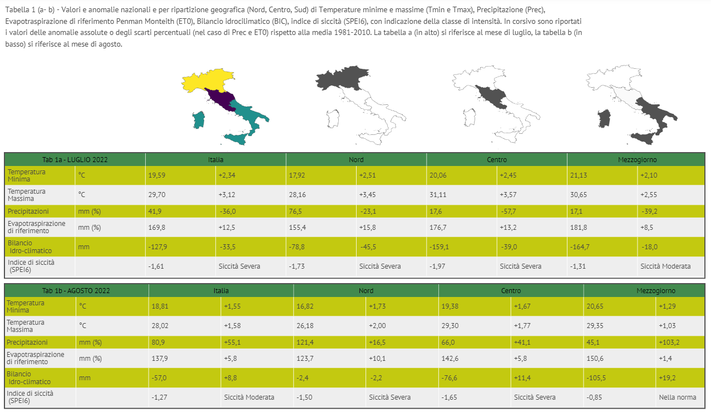
The general situation is shortly discussed in the light of several technical reports available online from local, national and international services.
The detailed results are shown on several maps, which represent the distribution of the indices and in most cases also their anomalies. The choice of the indices varies across months, with an additional set of phenological indices for specific crops during the growing season and some further elaborations in particular critical conditions.
In this context, specific indices are provided for the agricultural drought monitoring: the climatic water balance (CWB) and the standardized precipitation and evapotranspiration index (SPEI), both requiring the estimation of the daily reference evapotranspiration, which is obtained through the Penman-Monteith equation (Allen et al., 1998)
The CWB represents the difference between monthly Precipitation and Evapotranspiration, while the SPEI index (Vicente-Serrano, 2010) is based on the comparison between the monthly CWB values and their pattern during the time series considered (in our case 1981-2021): SPEI values less (or equal to) -1 identify moderate drought conditions, which become severe when the values reach -1.5 and extreme besides -2. This estimation considers the last 3 (SPEI3) or 6 months (SPEI6), which are the time scales suitable to describe meteorological and agricultural water stress respectively.
The time series of the agro-meteorological indices mentioned above will be soon published on the Zenodo repository, both in text table and data cube format.
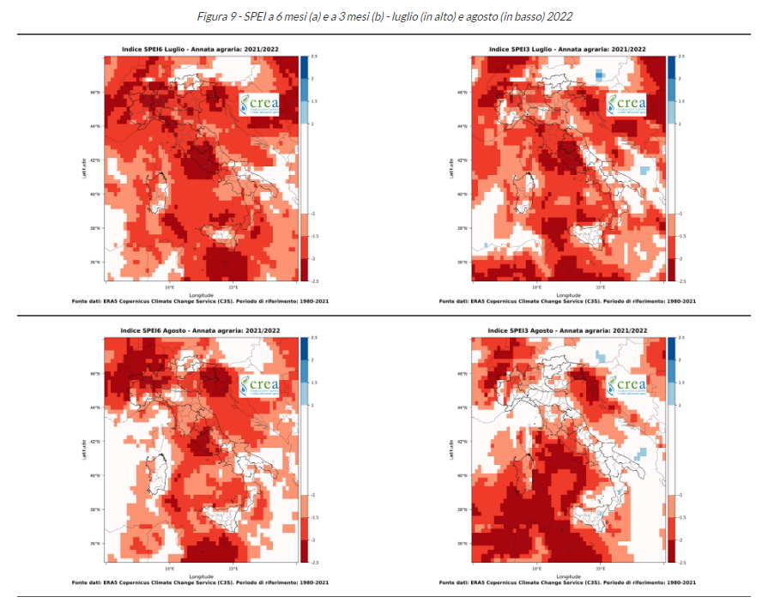
During 2022, at national scale, the SPEI6 index has continuously risen since January, showing an increase of both intensity and spatial extension, more remarkable in the NUTS1 North-West zone, where conditions of extreme aridity have been widely reached. In this area, a special focus on drought has been published within the March monthly report, which analyzed the 10-daily accumulated precipitation and reference evapotranspiration series since the start of the crop season (1st of November 2021).
In 2022, another important issue is related to the crop phenological advance, which has been highlighted also in the PSR report, in relation to grape.
An analysis of the SPEI6 drought index and other climate extreme indices was carried out at NUTS1 level for the period 2003-2018, with the aim of highlighting relationships with damages on productions, farm structures and agricultural infrastructures (Parisse et al., 2020).
Another important source of information about drought in Italy, is represented by the Drought Observatory, realized by the Council of National Research (CNR-IBE), which provides a monthly bulletin (also based on remote sensing data) and a dedicated WebGis service.
References
Allen R.G., Pereira R.S., Raes D., Smith M., 1998. Crop evapotranspiration – Guidelines for computing crop water requirements. FAO Irrigation and Drainage Paper No. 56, Roma Italy, 300 pp.
B. Parisse, A. Pontrandolfi, C. Epifani, R. Alilla, F. De Natale (2020) An agrometeorological analysis of weather extremes supporting decisions for the agricultural policies in Italy. Italian Journal of Agrometeorology (3): 15-30. doi: 10.13128/ijam-790
Vicente-Serrano S.M., Begueria S., Lopez-Moreno J.I., 2010. A Multiscalar Drought Index Sensitive to Global Warming: The Standardized Precipitation Evapotranspiration Index. J. Climate. 23: 1696-1718

Roberta Alilla, Flora De Natale, Barbara Parisse (CREA - Council for Agricultural Research and Economics, Research Centre for Agriculture and Environment)
http://www.pianetapsr.it/flex/cm/pages/ServeBLOB.php/L/IT/IDPagina/2794
http://www.pianetapsr.it/flex/cm/pages/ServeBLOB.php/L/IT/IDPagina/2725
https://droughtsdi.fi.ibimet.cnr.it/dogui/ ; https://drought.climateservices.it/

