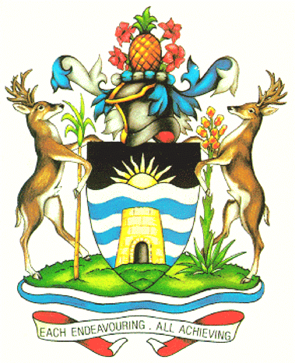

GOVERNMENT OF ANTIGUA AND BARBUDA

Follow-up information requested by the Committee on the Elimination of Discrimination against Women.
Directorate of Gender Affairs disaggregated data (Para 44, 45 & 46)
The data that was collected by the Directorate of Gender Affairs in 2013 and 2014 did not disaggregate the type of violence by sex. This gap was identified and has been remedied by the introduction of a system through the National Electronic Database, along with a paper-based system to disaggregate data across various fields which include: sex, type of violence, age, employment status, nationality, relationship to accused, language etc. As of 2015, the data can be broken down further to provide a more accurate picture of gender-based violence based on the administrative data collected.

