Global Alliance of National Human Rights Institutions  Palais des Nations, Office B423-425  1211 Genève, Switzerland  Tel + 41 22 917 16 74  www.ganhri.org | 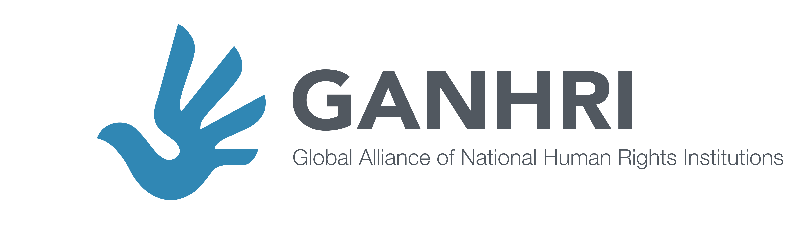

May 13, 2019

STATEMENT
Opening of the 81st session of the Committee on the Rights of Children (13 May – 31 May), Palais Wilson
Presented by GANHRI Geneva Representative Katharina Rose

Distinguished Chairperson, Committee Members,
Ladies and Gentlemen,

It is a pleasure to be here today and to deliver this statement on behalf of the Global Alliance of National Human Rights Institutions (GANHRI).
GANHRI is the network of more than a 120 national human rights institutions (NHRIs) from all regions of the world, with currently 80 NHRIs being accredited with A status, in full compliance with the UN Paris Principles.

NHRIs are independent institutions of the State mandated to promote and monitor implementation of human rights. Under the UN Paris Principles, NHRIs are mandated to perform a broad range of functions such as receiving complaints, investigating violations, and producing public reports. They also provide human rights education and training, advise governments, and work with civil society actors to protect human rights. Although NHRIs have a broad human rights mandate, promotion and protection of children’s rights is part of the broad mandate of the majority of our members.

GANHRI views this exchange as a unique opportunity to discuss joint priorities and to update Committee members, with a special attention to the new Committee members, on the work that NHRIs around the world have undertaken to promote ratification and implementation of the International Convention on the Rights of the Child and its Optional Protocols.

The Committee on the Rights of the Child has long recognised the critical value of NHRIs. In General Comment No. 2 (2002), the CRC recognised that children’s access to the organisations that protect their rights is generally limited and that NHRIs therefore play a crucial role in defending these rights while helping to harmonise national legislation, regulations, and practices.

In recent years GANHRI facilitated NHRIs exchange of experience and good practices in the area of children’s rights; in particular:

- In November 2016, GANHRI and UNICEF organised a seminar titled “National Human Rights Institutions & Accountability for Children”. A similar initiative was co-organised by GANHRI, UNICEF, and OHCHR in March 2017 to explore the role of NHRIs in the promotion and protection of children’s rights with respect to the 2030 Agenda. This collaboration in 2017 provided a platform for NHRIs to deepen their exchange of experiences, and good practices in promoting the implementation of children’s rights.

- In May 2018, the GANHRI Chairperson presented to this Committee a joint UNICEF/GANHRI initiative commissioned to the German Institute for Human Rights, concerning a mapping study of NHRIs’ work on child rights. The study revealed that for nearly 90 percent of respondents from the NHRIs, the primary reason for working on children’s rights is the broad mandate that is characteristic of NHRIs. The study also showcast that there is no one-size-fits-all structure on how to best institutionalise child rights. Many different structures can fit the purpose, provided they are well resourced and that child rights are not promoted in isolation from other human rights agenda. However, challenges still remain. For example, this study showed that only few NHRIs are providing children’s rights education, collecting and analysing statistics in a disaggregated manner, and ensuring a comprehensive degree of child participation in their work.

- Building on these experiences, GANHRI collaborated to the development by UNICEF of toolkits, also addressed to NHRIs, that provide concrete and detailed guidance to istitutions on what it means to implement a child rights based approach and include child participation when carrying out their mandates.

The effects of the work undertaken by the CRC to support and strengthen NHRIs around the world has also been vital. GANHRI/UNICEF study revealed that NHRIs welcome opportunities to report under the CRC and its Optional Protocols because it allows them to examine child rights-related issues in great depth and to make use of the concluding recommendations in their engagement with relevant states authorities. For this reason, NHRIs welcome the support offered by the CRC in the form of jurisprudence, concluding recommendations, and concluding observations to States.

A perfect illustration of this is the establishment of specialised child rights units by the NHRIs of Albania and Egypt as a direct result of recommendations by the CRC Committee. Similarly, the German NHRI was entrusted as the primary CRC monitoring body following Committee recommendations. Several NHRIs have also pointed out that recommendations from international human rights bodies, in general, have made their governments invest more in ensuring the NHRIs’ independent functioning.

GANHRI has continued strengthening its collaboration with this Committee, organizing regular meetings and exchanges with its members to support NHRIs’ coordinated engagement with Treaty Bodies and is willing to continue this close collaboration with the Committee in this new composition.

GANHRI remains committeed to facilitate the link with the NHRIs and to support its members’s engagement with the CRC Committee.

We look forward to continuing our close collaboration with the Committee, and wish you all a fruitful session ahead.

Thank you.

