



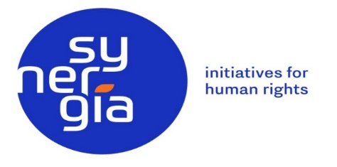

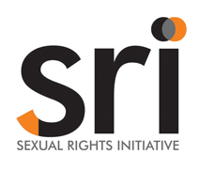

Violation of Human Rights of Women and LGBTI Persons in Ecuador

Listo of Issues submmitted before Commitee Against Trorture
68º Session – November 11 – December 6, 2019
June 2019
Informe presented by:
- CPM - Taller de Comunicación Mujer
- Centro de Apoyo y Protección Surkuna
- Fundación Pakta
- Akahatá – Equipo de trabajo en sexualidades y géneros
- Synergia - Initiatives for Human Rigths
- SRI – Sexual Rights Initiative

CPM/Taller de Comunicación Mujer; Centro de Apoyo y Protección de Derechos Humanos; Surkuna; Fundación Pakta; Akahatá - equipo de trabajo en sexualidades y géneros; Synergia - Initiatives for Human Rigths; y la SRI – Sexual Rights Initiative; are honored to submit the following list of issues to the Committee Against Torture with the aim of assisting the Committee in examining the implementation of the Convention against Torture and Other Cruel, Inhuman or Degrading Treatment or Punishment by Ecuador.

LEGISLATIVE AND INSTITUTIONAL FRAMEWORK

- Ecuador has a normative framework that recognizes and incorporates the rights of people in general and of women in particular, contained in international instruments. Despite the broad legal guarantees provided by the Ecuadorian laws on the right to a life free of violence and discrimination, the ineffectiveness in the prevention of these violence by the State in addition to the numerous obstacles encountered by sex-gender diverse persons to access to justice, allow the persistence, impunity and systematicity of gender based violence that these persons experience, especially lesbian women, due to their sexual orientation and gender identity in Ecuadorian society.

- In recent years, there have been setbacks in rights related to health, sexual rights and reproductive rights, as well as how to address systematic and daily gender-based violence.

LIST OF SUGGESTED ISSUES AND QUESTIONS TO THE COMMITEE

GAPS IN THE PROTECTION OF WOMEN AND GIRLS TO PREVENT GENDER BASED VIOLENCE, IN PARTICULAR FEMICIDE, AND LACK OF DUE DILIGENCE IN THE INVESTIGATIONS OF VIOLENT DEATHS RELATED TO GENDER.

INEFICACIA EN LA PROTECCIÓN DE MUJERES Y NIÑAS PARA PREVENIR LA VIOLENCIA DE GÉNERO, EN PARTICULAR EL FEMICIDIO, Y FALTA DE DEBIDA DILIGENCIA EN LAS INVESTIGACIONES DE MUERTES VIOLENTAS POR RAZONES DE GÉNERO.
Article 2
Article 4
Article 12
Article 16

- In Ecuador, a large number of women and girls are victims of gender violence perpetrated by individuals, both in the family and in the community. With regard to the phenomenon of femicide, the Technical Subcommittee on Validation of Femicides has registered a total of 320 cases from August 10, 2014 to February 10, 2019, of which only in 40% of the cases a judgment was issued condemnatory until February 2019.

- There are significant disparities between femicide statistics compiled by the Judiciary and those registered by civil society that imply a sub-registration in the official figures issued by the State. This is because violent deaths of women and girls due to gender reasons are not always classified as criminal femicide. On the contrary, a significant number of them have been prosecuted or punished for the crime of murder, homicide or rape followed by death, especially when they occur outside the scope of relationships and ex-partner.

- With regard to the State's response to gender-based violence, there are still shortcomings in the application of protection measures for women and children victims of it, that result in ineffectiveness in preventing the risk of torture or cruel, inhuman and degrading treatment, or even a violent death. In this regard, it is verified that at a national level, a significant number of victims of femicide had previously went to the competent authorities to report situations of violence.

- The existence of femicides perpetrated within the penitentiary system in different provinces of the country during the regimes of intimate visits, shows serious omissions in the prevention of the risk of torture or cruel, inhuman and degrading treatment, inside Social Rehabilitation Centers. In this sense, it is concerning that in some of these cases, the condemned persons were in prison due to the previous commitment of other femicides of their partners or daughters.

- It should be emphasized that more than a year after the enactment of the Comprehensive Organic Law to Prevent and Eradicate Violence against Women, the budget allocated by the Ministry of Economy and Finance is insufficient for its implementation; which implies serious risks in the guarantee of prevention and protection of women and girl victims.

- The lack of due diligence corroborated at the national level is serious, which exists -among others- in the investigations of several femicides where the irregularities in the pre-procedural stage result in the absence of sanctions against those responsible for the crime. This is especially worrisome when the victims are girls and sexual violence -even that committed in educational facilities- culminates in femicide.

Questions for Ecuador

- What measures will the State adopt to generate a significant increase in the budget of the Comprehensive Organic Law to Prevent and Eradicate Violence against Women that guarantees the effective implementation of protection measures and the Early Warning System of Risk of Femicide stipulated in the Law?

- What measures will the State take to ensure inter-institutional coordination at the national level that will adequately assess the risk of femicide and establish truly effective protection measures to protect women and girls?

- What measures will the State take to evaluate the diligent application of protection measures in situations of violence against women and girls, by all the public institutions competent in their implementation?

- What measures is the State willing to adopt in case of detection of flaws in the application of protective measures by the competent public institutions, which guarantee the prevention and elimination of such shortcomings?

- What mechanisms will the State implement to ensure due diligence in investigations of violent deaths of women and girls, particularly in the collection of evidence and expert witness procedures, including a gender and human rights approach?

- What measures is the State willing to take in case of detection of flaws or negligence in the application of the due diligence principle by public officers in proceedings and investigations related to cases of femicide or cruel and inhuman treatment of women and girls, to sanction and eliminate the occurrence of possible errors and prevent impunity?

- What mechanisms will the State implement to prevent and eliminate the occurrence of femicides in Social Rehabilitation Centers during the regimes of intimate visits?

OMISSIONS REGARDING THE OBLIGATION OF COMPREHENSIVE REPARATION IN CASES OF FEMICIDE

Artícle 14

- Documentation on cases of femicide provided by civil society organizations accounts for the extreme cruelty with which many of these violent deaths are committed: multiple stabbings, asphyxia, beatings and previous sexual violence, pre-mortem mutilation and decapitation, among other . For relatives, the signs of torture or cruel, inhuman and degrading treatment that victims’ bodies present increase their suffering in relation to the facts and their traumatic experience. However, even though in some of the cases a condemnatory sentence is achieved, the omissions in the integral reparation are evident.

- In relation to reparation, a paradigm of economic compensation against a comprehensive reparation approach that prioritizes the elimination of the structural discrimination that sustains gender-based violence prevails in judicial decisions. In a high percentage of cases, psychosocial rehabilitation measures, guarantees of non-repetition of the facts and satisfaction and restitution of violated rights are not issued. The omissions are especially serious when they refer to children and family members, especially when they have witnessed the femicides of their mothers.

- In this sense, although the State has created in March 2019 a Bonus for Girls, Boys and Adolescents in Orphanhood due to Femicide, civil society is concerned that only a fragment of the affected population has access to it, given that one of the conditions to be granted is the existence of a condemnatory sentence. Delays in legal proceedings and cases that do not result in a penalty, imply discrimination in access to this bonus for a significant number of children and adolescents.

Preguntas al Estado Ecuatoriano

- What measures will the State adopt to guarantee comprehensive reparation to the victims of the crime of femicide that goes beyond the model of economic compensation and, therefore, include the psychosocial recovery of relatives, symbolic measures of satisfaction, guarantees of no repetition of the events that affect the structural dimension of gender violence, and the effective restitution of rights, especially of children and adolescents relatives?

- What mechanisms will the State implement so that both prosecutors and judges request and dictate comprehensive reparation measures in accordance with the expectations of the victims, ensuring their participation and taking into account their opinion on them?

- What public policy measures will Ecuador design and implement to guarantee comprehensive reparation to victims of femicide whose judicial proceedings have resulted in acquittals, dismissals or filing of the case, or where criminal charges not been carried out due to the suicide of the aggressors; taking into account for the above that the condition of victims of criminal acts or human rights violations does not depend on the arrest or criminal punishment of those responsible and, therefore, the right to comprehensive reparation prevails?

CRUEL, INHUMAN AND DEGRADING TREATMENTS TO WOMEN DUE TO THE CRIMINALIZATION OF VOLUNTARY INTERRUPTION OF PREGNANCY

Article 2
Article 4
Article 12
Article 16

- Despite the observations made by the Committee against Torture, in Ecuador women continue to be criminalized and subjected to cruel, inhuman and degrading treatment for making autonomous decisions about their reproductive life. The Ecuadorian legislation contemplates the criminal type of abortion, by which women who decide the termination of a pregnancy are punished by imprisonment from 6 months to 2 years. This type of crime violates human rights and involves torture against women, as it affects their personal integrity, dignity and life; makes reproduction a disproportionate burden and generates inequality between men and women, which is exacerbated in social contexts and unfavorable socio-economic conditions.
- The criminalization of abortion violates the right to life of women, since it exposes them to unnecessary risks when it compels them to resort to clandestine abortion and violates women's right to guarantee conditions for a dignified life, including their right to the highest level of physical, mental and social well-being, as well as not to be subjected to cruel, inhuman or degrading treatment.

- The condemnation to carry out an unwanted pregnancy is a form of torture that becomes worse when it comes to disadvantaged women, young people with a low level of education, indigenous peoples, with few material, social and cultural resources; because they are the ones that run the greatest risk of resorting to an illegal abortion.

a. Sexual violence and forced pregnancy

- In Ecuador, raped women who do not have a mental disability cannot determine for the legal interruption of pregnancy, being enforced into compulsory motherhood that violates their rights to a dignified life, to health, to personal integrity, to no be subjected to torture cruel inhuman and degrading treatment and a life free of violence. To these considerations we must add the fact that the sexual violence that women, adolescents and girls live intensely affects their lives. Rape is the crime that women fear the most and those who become pregnant as a result of rape perceive this as a double violation, which has a permanent impact on their health and life plan.

- One of the foreseeable consequences of rape is forced pregnancy. This means that the risks inherent to pregnancy in girls are compounded by risks derived from the emotional impact of violence, silencing, blaming, lack of support, concealment and stigma. Several studies establish that around 10 to 15% of women who were raped become pregnant.

- Another risk faced in Ecuador by raped women who do not want to continue their pregnancies is judicialization and imprisonment. According to the trial file 133-2013, fiscal instruction 080101813060741; raped women who for this reason seek to interrupt a pregnancy are prosecuted for this cause, which shows the structural violence to which they are subjected, which generates helplessness, revictimization and impunity. In this as in other similar cases, abortion is investigated, but never the legal complain upon sexual violence; This establishes a bias that generates greater resistance on the part of the victims to denounce due to the lack of effectiveness of the Ecuadorian penal system.

- In addition to the foregoing, although the Organic Comprehensive Criminal Code (hereinafter COIP) recognizes that abortion will not be punishable if pregnancy is the result of a rape in a woman suffering from mental disability, the State does not guarantee the rights of those women who have become pregnant as a result of rape. With regard to this point, there is, first of all, a lack of adequate public policies to understand the realities faced by women with disabilities. In a second place, there is a systematic denial of the right of women to access a legal abortion: among others, they are not given information about this possibility, which makes it impossible for them to make an informed decision; in the same way, even when women request this procedure, it is denied or they are not given a response in a timely manner. Third, the person is restricted in their ability to give consent to abortion, since the Guide to the Clinical Practice of Therapeutic Abortion states that it must be signed by a family member. This provision contradicts international standards and constitutes both a factor of vulnerability and cruel, inhuman and degrading treatment, as it objectifies them and many times allows their aggressors to make decisions about their reproductive life. Although the law (COIP) does not establish percentages of disability for access to abortion, its regulation does so, thus violating the rights of women with mental disabilities who have less than 40% disability and want to access abortion.

b. Reporting and criminalization of women who arrive at hospitals with bleeding or after a home birth

- Criminalization of women in Ecuador occurs mainly in cases of obstetric emergencies arising from an abortion or domestic birth, since they are evaluated in the judicial system as consented abortions, murders and culpable homicides.

- Women who arrive at the health service in search of care for incomplete, ongoing, deferred abortions or home births are considered criminals and are denied access to comprehensive post-abortion health care and obstetric emergencies. In most cases, there are no factors that allow determining that these obstetric emergencies were caused; however, many health professionals - leaving aside their obligation to keep professional secrecy - denounce them, thus violating women's right to the presumption of innocence, to health and to confidentiality in health.

- The situations mentioned imply torture, cruel, inhuman and degrading treatment. In many cases it has been recorded that women - even at risk of life - are forced to testify in hospital as a condition for their access to health care. Likewise, they are subjected to long waits before giving them attention, since from the services wait prosecutors and medical examiners to authorize the procedure, despite the risk for health and life of the woman that may imply such waiting.

c. Judicialization and Prosecution of Women Due to Obstetric Emergencies

- In the cases of women prosecuted for abortion and childbirth, the way in which conservative socio-cultural prejudices and patterns, contrary to the exercise of women's human rights, influence the decisions of Prosecutors and Judges is strongly evidenced to the point of leading them to fail to fulfill with the obligations arising from their positions, since they act in a biased manner in the cases, violate due process and condemn women without proof or with illegal evidence. As we have mentioned, the main violations of due process that we have identified are: a) the admission of illegal evidence derived from the breaking of professional secrecy in health and b) the testimonies of accused women, obtained through torture, cruel, inhuman and degrading treatment.

Questions for Ecuador

- What judicial, legislative and administrative measures are Ecuador willing to adopt to decriminalize abortion?

- What judicial, legislative and administrative measures does the Ecuador intend to take to ensure access to abortion for women and girls who are victims of rape?

- Through what measures will the Ecuador guarantee the right to comprehensive health care, including confidentiality for women who present obstetric emergencies, as well as due compliance with professional secrecy by health agents?

- What measures will Ecuador take to sanction professionals and health agents who violate their obligation regarding due professional secrecy?

- What measures will Ecuador take to avoid torture involved in obtaining testimony from women in cases of obstetric emergencies, in illegal conditions and in unauthorized premises, when they are in state of obvious vulnerability?

- What measures will Ecuador take to guarantee compliance with due process and thus prevent women from being criminalized for abortion and childbirth based on prejudicial and untested opinions?

- What measures is Ecuador willing to adopt to guarantee access to abortion in cases where abortion is legal, especially when it comes to women with mental disabilities?

ABSENCE OF REPARATIVE MEASURES TO THE RIGHTS OF LGBTI PERSONS AFTER THE FINDINGS OF HISTORICAL VULNERATIONS THAT INCLUDE TORTURE AND BAD TREATMENTS

Article 14.
Observations: 23, 24, 42 y 50 (CAT/C/ECU/CO/7)

- Before the decriminalization of homosexuality in Ecuador on November 27, 1997, Ecuadorian public policy directed at the LGBTI population was traversed by discrimination and violence that resulted in cruel, inhuman and degrading treatment.

- On December 5, 2013, the National Assembly adopted the "Law for the Reparation of Victims and the Judicialization of Serious Violations of Human Rights and Crimes against Humanity, which took place in Ecuador between October 4, 1983 and December 31, December 2008 ", with the objective of regulating the integral reparation to the victims In addition to this Law, the Ministry of Justice, Human Rights and Worship created the Ministerial Agreement No.0865 to make the material reparation viable and the Ombudsman's Office prepared the Resolution Ombudsman No.198-DPE-CGAJ-2014 to develop the procedure of material reparation.

- In relation to the Collective Reparation of the LGBTI Population in Ecuador, the Fundación Ecuatoriana Equidad submitted a request for collective reparation on December 1, 2015 to the Ombudsman's Office. The Victims’ Law, in its article 13, admits the entry of collective requests to benefit from the Reparation Program by administrative means. From 2015 to date, the Ombudsman's Office has held three meetings with civil society organizations to move forward on this reparation. On September 7, 2018, Fundación Pakta contacted again the Ombudsman's Office so that this entity could decide on the petition without clear answers to date.

Questions for Ecuador

- What have been the advances regarding the collective reparation for LGBTI population from the mechanism of reparation opened by the "Law for the Reparation of Victims and the Judicialization of Serious Violations of Human Rights and Crimes against Humanity Occurred in Ecuador between October 4, 1983 and December 31, 2008 "?

- What policies will the State adopt to adequately address the specific needs of LGBTI victims, including special provisions, for the development of the reparation measures established by the "Law for the Reparation of Victims and the Judicialization of Serious Violations of Human Rights and Crimes against Humanity Occurred in Ecuador between October 4, 1983 and December 31, 2008 "?

- How many cases of torture against the LGBTI population within the context of the Commission for Truth are under investigation in the State Attorney General's Office?

TORTURES AND BAD TREATMENTS TOWARDS THE LGBTI POPULATION MOTIVATED BY THEIR GENDER IDENTITY OR SEXUAL ORIENTATION

Article 2.
Article 4.
Article 10.
Article 12.
General Observation 2

- Currently, the Ecuadorian normative and institutional framework regulates and controls addiction rehabilitation centers, among other reasons, in order to prevent the use of so-called "dehomosexualization therapies" in these institutions. In the presentation of various reports and meetings held in compliance with their international duties, the State has claimed to have expressly prohibited the practices of dehomosexualization and, consequently, to proceed to make closures and closings of the centers where these practices were carried out.

- Taller de Comunicacion Mujer have issued letters to the State Attorney General's Office, the Ministry of Public Health and the Council of the Judiciary, to verify the assertions that the State has made to the International Covenant on Civil and Political Rights; the Committee Against Torture; and in the Universal Periodic Review, without up to now having been able to access reliable information in support of what the State has said. For this reason, the organization has undertaken an Access to Information Action due to the weaknesses and inconsistencies presented by the partial and incomplete responses of the aforementioned public entities.

- Based on partial and incomplete responses from the State, it has been found that there are only nine cases in which the Office of the Prosecutor has acted. Of these nine cases, three present incomplete data that do not allow their tracing, among which there is the only sentence executed for hate crimes, which is the only state manifestation to sanction the crime under the corresponding type. This sentence is not enough to send a message to society, regarding the prohibition of this type of torture.

- Due to the aforementioned, there is no precise data on measures that ensure that dehomosexualization practices in addiction treatment centers are no longer practiced. In cases of internment or suspicion of internment of LGBTI persons, it has been partners and friends of the victims who have denounced the disappearance or abduction of them, without these denunciations having been taken into account by the authorities. Even in response to petitions for the application of Habeas Corpus, the State has not acted, despite the fact that this type of practice has been classified as torture by the Organic Comprehensive Criminal Code (COIP).

- Not receiving the complaint and denying the veracity of it has been a systematic practice by agents of justice before this type of crimes and violations of rights. The preponderant prejudice and stereotype do not allow them to be classified as crimes, because, according to the cultural conception, the family acts for the victim's benefit by wanting to normalize the sexual orientation of some of its members.

Questions for Ecuador

- What mechanisms does the State have in place so that civil society can easily access specific and reliable information that supports the State's statements to international bodies regarding the actions taken to combat "re-sexual orientation" or "Dehomosexualization"?

- What mechanisms does the State have in place to guarantee, in particular in the case of practices of dehomosexualization, its impartial judicialization, according to due process, in order to punish said practices in all cases reported?

- Through what measures Ecuador prepares to eliminate prejudices and stereotypes against the LGBT population that prevail among judges, experts and prosecutors, preventing access to justice and due process of LGBTI persons, in Particularly in cases of sexual reorientation treatments, prohibited by the same State?

- What are the criteria used by the State, and in particular the Ministry of Public Health to contract or subsidize health services to private institutions?

- On the basis of what criteria, rehabilitation centers in which violation of rights has been found for practicing "re-sexual orientation or dehomosexualization" therapies are still in operation and their services continue to be contracted by the State?

- In what way and in what deadlines does the State consider amending the legal and normative gaps in public health matters, so that health facilities in which cases of torture have occurred are not still hired by the State and are sanctioned criminally and permanently dismissed?

Annex
Violation of Human Rights of Women and LGBTI Persons in Ecuador - List of Issues submmitted before Commitee Against Trorture

Note 1.
The Constitution of the Republic of Ecuador adopted in 2008 (CRE) stipulates the right to a life free of violence in the public and private sphere and the obligation to adopt all necessary measures to prevent, eliminate and punish violence against women, girls, children and adolescents (CRE- Official Register 449, 2008, Art. 66, subsection b). In addition, it establishes that victims of intrafamily and sexual violence will be priority attention groups (Article 35). Additionally, it provides comprehensive reparation without delay for all victims of criminal offenses as well as their right to non-revictimization (Article 78).

The Organic Comprehensive Criminal Code (COIP) in force in the country since 2014, includes the criminal type of femicide and four specific constituent aggravating elements of this offense, Official Registry Supplement 180, 2014, Arts. 171 and 172. Likewise, it recognizes victims the right to full reparation, special protection and non-revictimization throughout all the proceedings and proceedings of the judicial process, Art. 11, paragraphs 3, 4 and 5, and Arts. 77, 78 and 78.1.; and extends the status of victims to indirect victims of crimes, Art. 441.

In February 2018, the National Assembly approved the Comprehensive Organic Law to Prevent and Eradicate Violence against Women (Law on Violence against Women) that provides for the creation of an Early Warning System to detect the risk of femicide and an axis of protection that includes additional measures of protection in cases of gender violence to those already stipulated in the COIP, Official Registry Supplement 175, 2018, Arts. 45-58 and 59-61. Executive Decree No. 397 of April 2018, establishes a Regulation for the application of the Law on Violence against Women, Executive Decree No. 397.

On the other hand, Executive Decree No. 696 of March 2019, establishes the creation of a Bond for Girls, Boys and Adolescents in Orphaned Situation due to Femicide whose article specifies as a condition of assignment of mentioned bond the existence of an executory conviction of perpetrator of violent death of their mothers. This bonus is aimed at those girls, boys and adolescents who are in a situation of poverty, Executive Decree No. 696.

The COIP, in Art.150 states that abortion ... will not be punishable in the following cases: 1. If it has been practiced to avoid a danger to the life or health of the pregnant woman and if this danger cannot be avoided by others media. 2. If the pregnancy is the consequence of a rape in a woman suffering from mental disability, COIP, Art.150.

On the other hand, the COIP in articles 177 and 151 clause 3, considers crimes that constitute acts of hatred and torture those acts motivated by the gender identity and the sexual orientation of the victims in an explicit manner.

Ecuador has a Guide for Clinical Practice of Therapeutic Abortion, approved in official registry in December 2014, in accordance with what was stated (COIP, Art. 150), since it states that through its implementation "the prevention of any danger posed by at risk of life or integral health of the woman (...) that includes her care in all aspects ", Ministry of Public Health of Ecuador. Therapeutic Abortion Guide 2014.

The Organic Health Law (Official Registry Supplement # 423, Current Status, 22-12-2006) regarding the regulation and control of public or private health services determines that for acts that violate the norm, and those that constitute criminal offenses, the health authorities are obliged to act ex officio to denounce such acts. In that sense, the law only presents administrative sanctions for those health services that do not comply with the norm. The sanctions considered, according to article 240, are fines, suspension of the permit or license, suspension of the professional exercise; confiscation and partial, temporary or definitive closure of the corresponding establishment.

Both the Control Regulation for Recovery Centers for People with Addictions, Ministerial Agreement 767, of May 2012; as the Sanitary Regulation for the Control and Surveillance of the Health Establishments that provide Treatment Services to Persons with Problematic Consumption of Alcohol and Drugs, Ministerial Agreement 080, of August 2016, the Ministry of Public Health (hereinafter MSP) prohibit practices that seek to attack the gender identity or sexual orientation within the centers or establishments. They have been applied to lesbian women in particular, but also to bisexual women, transgender and gay men (LGBT population), for more than a decade.

Agreement 767 (Regulation for the regulation of recovery centers to treat people with psychoactive addictions, May 11, 2012), mandates creating interinstitutional committees called CTIN for the National and CTIL, Art. 24 and 32, for the local area that involves the Ministry of Public Health; Ministry of Justice, Human Rights and Worship (currently the powers passed to the Secretary of Human Rights); Ministry of Interior; Ministry of Economic and Social Inclusion; Ombudsman's Office; State Attorney General's Office; National Council of Narcotic and Psychotropic Substances - CONSEP. These institutions would jointly have powers for regulating and controlling addiction rehabilitation centers, investigate cases of corruption, Art26, receive and investigate cases of violation of rights, art. 39, as well as publicizing the status of their actions to civil society, Arts. 34, 38 and 40.

Note 2.

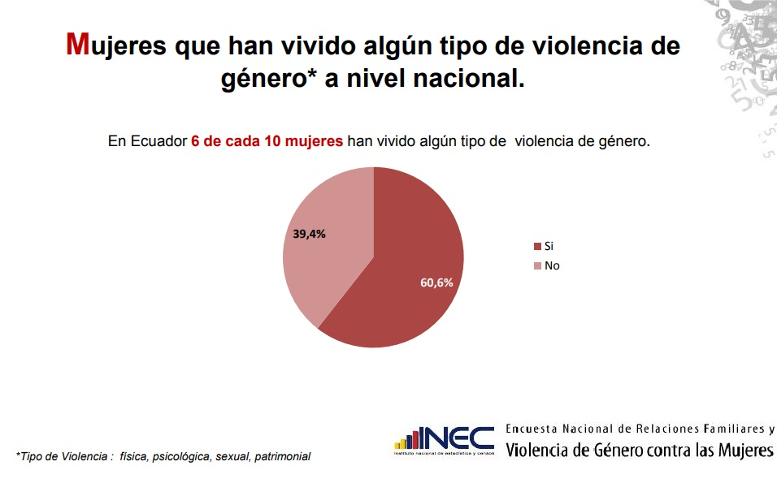

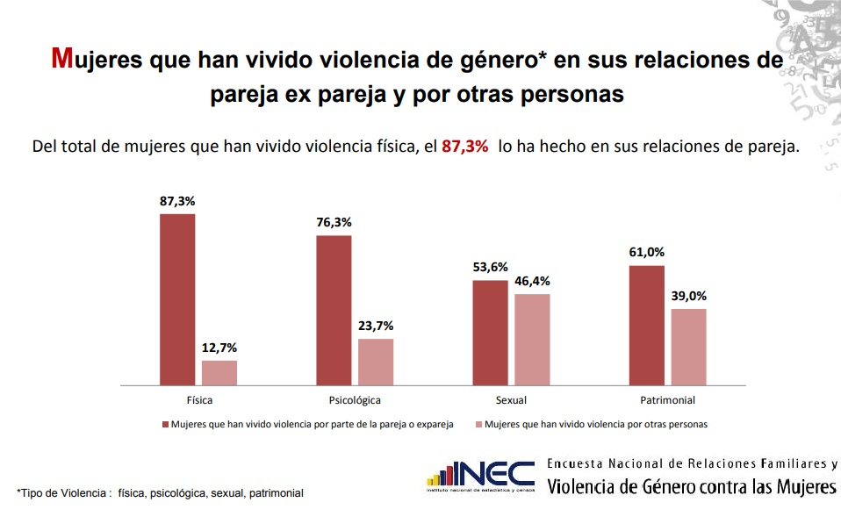

Note 3.

The Validation Technical Subcommittee of the Special Inter-institutional Security and Justice Commission has the following results as of February 10, 2019.

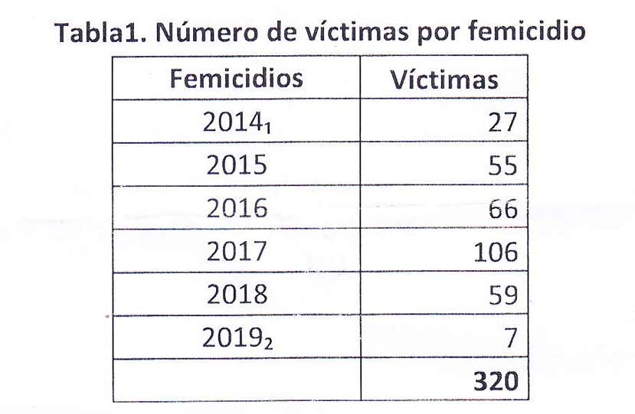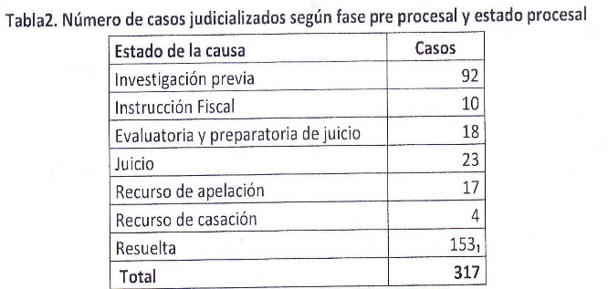

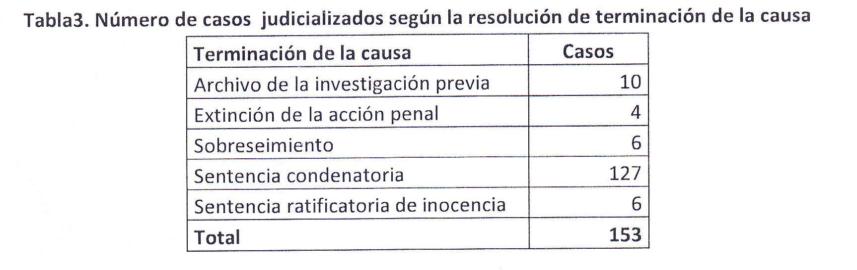
Note 4.

Taller de Comunicación Mujer; Comisión Ecuménica de Derechos Humanos (CEDHU); Asociación Latinoamericana para el Desarrollo Alternativo (ALDEA); Red Nacional de Casas de Acogida, have recorded, through the follow-up of cases, a total of 642 femicides between January 2014 and February 2019.
https://www.masinformacionmenosviolencia.com/index.php/noticias/32-femicidio-mayo

Note 5

Taller de Comunicación Mujer, CEDHU, ALDEA and the National Shelter Network have identified that 26% of the women murdered in the country between January and May of 2019 had reported violence to the competent authorities prior to the acts of femicide. https://www.masinformacionmenosviolencia.com/index.php/noticias/32-femicidio-mayo.

Some cases where there have been deficiencies in protection of women and girls victims of gender violence since 2016 are:

Case 1
16-year-old B.D.N.L, was murdered in 2016 by a 38-year-old man who forced her to have a relationship with him. The testimony of his father at the trial hearing shows serious flaws in the police action in these cases: "[...] we went to my daughter's house with police officers, we knocked on the door, one day before the problem happened, we went and the police said they could not do anything, he was inside and he did not let her leave, the policemen said that we had to file a complaint in DINASED, we could not that that day and the next day, he shot my daughter".

Judicial process #09284-2016-01750. http://consultas.funcionjudicial.gob.ec/informacionjudicial/public/informacion.jsf.

Case 2
P.M.P.C. was murdered by multiple stabbing at her home in Santa Elena in July 2017 around 10:30 p.m. On the day of the incident, she had gone to a judicial unit specialized in domestic violence at 4:00 pm to denounce the violence she was suffering from her ex-partner who had threatened her with death. However, the complaint was not registered by the officer responsible because the victim did not carry his identity card.

Judicial process #24281-2017-00658. http://consultas.funcionjudicial.gob.ec/informacionjudicial/public/informacion.jsf.

Case 3
Femicide of D.C.R.R. occurred on January 19, 2019 in the city of Ibarra, after being held and threatened with a knife in the middle of the street for 90 minutes in front of the rest of the citizens and a heavy police presence that could not avoid femicide. In this case, it is known that D.C.R.R. he had informed the authorities of previous aggressions on the part of the femicide.

Newspaper Elcomercio.com: “Diana Carolina had reported physical and verbal attacks with calls to the ECU 911, "January 21, 2019, https://www.elcomercio.com/actualidad/diana-carolina-llamadas-agresiones-femicidio.html

Nota 6.

Some cases of femicide that occurred within the Social Rehabilitation Centers since 2015 are:

Case 4
R.E.S.S. was murdered in a Social Rehabilitation Center in Portoviejo (Manabí). Her body was found with multiple knife wounds, half naked. The aggressor was serving a sentence of deprivation of liberty for the rape and murder of his daughter under the age of 18. In addition, the mother of R.E.S.S. testified at the trial hearing that she was a victim of violence by the femicide prior to the events.

Judicial process #13283-2015-02135. http://consultas.funcionjudicial.gob.ec/informacionjudicial/public/informacion.jsf.

Case 5
O. O. R. Q. was found with signs of suffocation and naked in the cell of intimate visits’ bathroom of the of a Social Rehabilitation Center of Guayaquil (Guayas). Her relatives testified at the trial hearing that the femicide physically and psychologically assaulted her frequently and that she had an assistance coupon. In addition, the brother of O.O.R.Q. pointed out that the aggressor threatened her if she did not go to prison visits.

Judicial process #09281-2017-00921. http://consultas.funcionjudicial.gob.ec/informacionjudicial/public/informacion.jsf.

Caso No. 6
M. I. P., an indigenous mother of a 12-year-old child, was asphyxiated in a prison in Ambato (Tungurahua) during a conjugal visit. The assailant was serving a 20-year sentence since 2015 for the murder of his spouse and son.

Newspaper El Universo.com: “PPL kills woman and then hangs himself in Ambato prison", January 20, 2018., https://www.eluniverso.com/noticias/2018/01/20/nota/6576373/ppl-mata-mujer-luego-se-ahorca-carcel-ambato ; Newspaper Ultimasnoticias.com: “Woman murdered in a cell is buried ", January 23, 2018, https://www.ultimasnoticias.ec/las-ultimas/ambato-entierran-mujer-asesinada-celda.html.

Note 7

Caso No. 7

S. V. M., an 11-year-old girl who was a victim of femicide in June 2016, was found with signs of sexual violence in the courtyard of a private school she attended. From the beginning of the investigation there were irregularities in the investigation and preservation of the evidence as well as the realization of forensic procedures. It was even necessary to carry out a second autopsy of the girl's body with the consequent revictimization for her family members. Although the case has been taken by a prosecutor specializing in gender-based violence, the repercussions of the irregularities that occurred at the beginning of the pre-procedural phase have generated complications in the investigation that entail the risk of filing the case, taking into account that as of June 2019 there is no fiscal accusation and the maximum period of prior investigation is 2 years. It should be added that, although the school was closed after an administrative complaint process, the entity opened a new school in another sector of the same city.

The present case is kept in judicial reserve (File No. 170101816065031). There are several news items published in different media that account for the irregularities and delays of the process: Newspaper ElTelegrafo.com, "The Attorney of Gender Violence Investigates the Death of Valentina", July 19, 2016, <https://www.eltelegrafo.com.ec/noticias/judicial/1/la-fiscalia-de-violencia-de-genero-investiga-la-muerte-de-valentina>;
Newspaper ElTelegrafo.com, “Judiciary will investigate why Valentina's case is still in preliminary investigation", June 21, 2017, https://www.eltelegrafo.com.ec/noticias/39/13/con-planton-exigen-justicia-para-valentina-a-un-ano-de-su-muerte;
Newspaper ElComercio.com, “Reparation and justice: Mothers struggle to find the truth after the murder of their daughters ", November 25, 2018, <https://www.elcomercio.com/actualidad/testimonios-madres-samira-valentina-juliana.html>.

Note 8

Among 137 sentences related to violent deaths of women and girls due to gender in 2015, 2016 and 2017, 120 resulted in a conviction of the persons prosecuted. However, only in 32.5%, measures of psychosocial rehabilitation were dictated; in 12.5%, satisfaction; in 1.7%, restitution measures; and in 10%, guarantees of non-repetition. However, in al lof them, judgments compensation was issued.

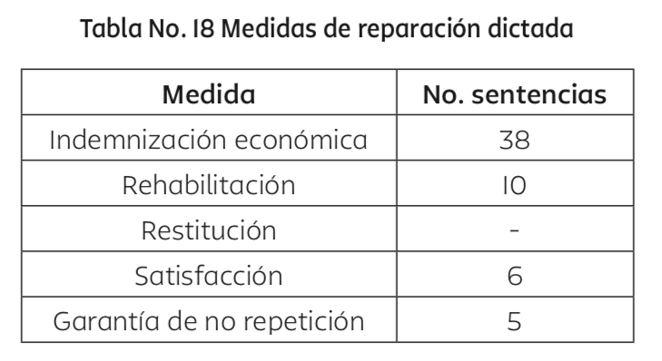

Source: Taller de Comunicación Mujer and CEDHU: The Judicial Response to Femicide in Ecuador. Analysis of Judgments Concerning Violent Deaths of Women, 2017, Vol I. p. 97, http://www.tcmujer.org/dct/tmp_adjuntos/noEn/000/000/La%20respuesta%20Judicial%20del%20Femicidio%20en%20Ecuador-2015.pdf.

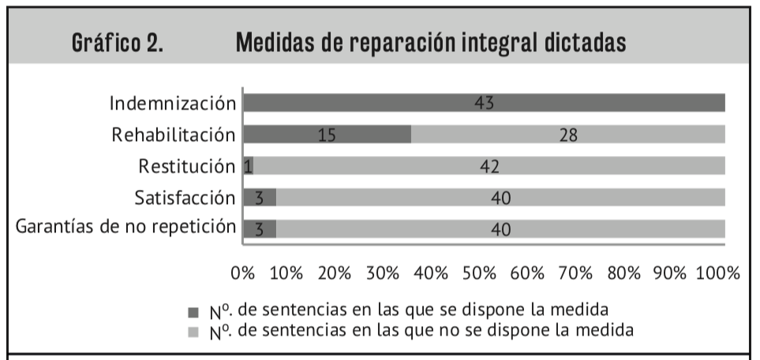

Source: Taller de Comunicación Mujer and CEDHU: The Judicial Response to Femicide in Ecuador. Analysis of Judgments Concerning Violent Deaths of Women, 2018, Vol II. p. 75, http://www.tcmujer.org/dct/tmp_adjuntos/noEn/000/000/Libro%20Respuesta%20Judicial%20II%20para%20web.pdf.

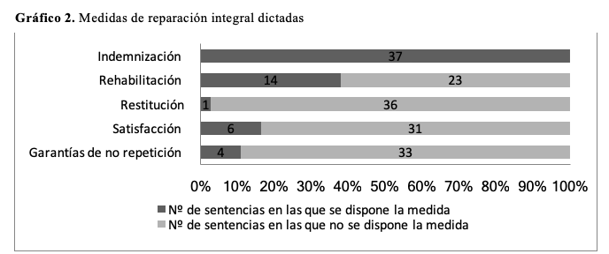

Source: Taller de Comunicacion Mujer y la CEDHU: Women's Communication Workshop and the CEDHU: The Judicial Response to Femicide in Ecuador. Analysis of Judgments Concerning Violent Deaths of Women, Vol III (in the process of publication)

Note 9

According to the study carried out by Taller de Comunicación Mujer and CEDHU, among the cases of femicide that occurred in 2016 and 2017 that obtained some type of sentence, it was identified that 119 girls, boys and adolescents were orphaned and only 51% were recognized in the resolution as subjects with the right to measure psychosocial rehabilitation. It should be added that of these 119 children and adolescents orphaned by femicide, 48 also witnessed the events and only 34 received reparations in their favor in the sentences.

Source: Taller de Comunicacion Mujer y la CEDHU: Women's Communication Workshop and the CEDHU: The Judicial Response to Femicide in Ecuador. Analysis of Judgments Concerning Violent Deaths of Women, 2018, Vol II, p. 77 y 78 and Vol III (in the process of publication)

Note 10

According to statistics in Ecuador, women who suffer the most complications from abortion are the poorest women who are treated in public health services and continue with pregnancies they do not want, contributing to reproduce a "female circle of failure and poverty". "(Romero, 2001). This circle of failure and poverty is the result of a complex network of social, economic, cultural and political factors that deepen inequalities through social and ethical devaluation, the progressive economic and cultural precarization of women and of the feminine in the patriarchal system. In other words, all these factors contribute to sustaining a system that structurally and systematically hinders women's compliance with their goals and objectives.

In Ecuador, maternal deaths raise up to 15.6% and represent the third cause of death in the country. Similarly, the National Sexual and Reproductive Health Plan 2017-2021 states that: "the majority of deaths occur in women living in impoverished rural or urban-marginal areas, many of whom lack basic services and environmental sanitation, deficient access roads and educational units ".

Figures recorded, which reflect that abortion is an issue that puts lives of women at risk, demonstrate the need to decriminalize abortion. Thus, according to the figures from the Yearbook of Hospital Beds and Discharges of the National Institute of Statistics and Census of Ecuador, in 2015 there were 31,302 hospital discharges related to abortion. Likewise, in 2015, 10 maternal deaths occurred as a result of the risks that women must face when performing an abortion in hiding and for the lack of timely assistance when they arrive at the health services with abortion procedures in progress, incomplete or deferred.
Note 11

Regarding the decision on the continuation or not of pregnancy, in the study reported by Távara et al, 50% of women chose to interrupt it and, in another investigation, conducted in Colombia in a center that provides services to women who were raped, over 121 women, 63% interrupted the pregnancy. Finally, "studies indicate that between 50% and 60% of adolescents who become pregnant have a history of having been physically or sexually abused." This is compounded by the fact that many adolescents resort to abortion in advanced stages of pregnancy, when the risk of complications is greater.

Note 12

Although the last Population and Housing Census of 2010 indicated that 5.6% of the Ecuadorian population has some type of disability, with a higher percentage of women with 51.6%, there is no research on their situation and needs, which translates into greater invisibility and lack of access to justice. (National Council for Equality of Disabilities, National Agenda for Equality in Disabilities 2013-2017,
http://www.planificacion.gob.ec/wp-content/uploads/downloads/2014/09/Agenda-Nacional-para Discapacidades.pdf)

More specifically, according to the concluding observations of the initial report of Ecuador submitted to the Committee on the Rights of Persons with Disabilities, it has been shown that there is a high level of adolescents with disabilities who were mothers between 12 and 19 years of age. This is a serious reality, since women and girls with disabilities, mainly intellectual, lack services and judicial measures to prevent their infringement and revictimization, as well as their access to safe abortions.

Note 13.

In case 17282-2017-02055 of María A. who has been detained since May 2016 for the crime of murder for having given birth at home, the doctors kept her for 7 hours without adequate medical attention until the prosecution authorized her intervention, during this time she was interviewed by three police forces. The lack of medical attention resulted in a great loss of blood that required that he later be transfused with two pints of blood.

Nota 14.

Main violations of due process regarding the criminalization of abortion:

a) Admission of illegal evidence derived from the breaking of professional secrecy in health
In Ecuador, health professionals have the duty to keep professional secrecy about everything they see, discover or hear in the exercise of their profession; according to article 66 of the Constitution that establishes that health information is confidential; to art. 4 of the law of safeguard and protection of patients; and the COIP Art. 179, which establishes the breaking of professional secrecy as a crime. Similarly, article 503 of the COIP establishes that the testimonies of persons who have professional secrecy are inadmissible.

b) Testimonies obtained through torture, cruel, inhuman and degrading treatment
Women who enter the health system due to complications of abortion or childbirth are forced to testify in serious health conditions and without the presence of their lawyers. Handcuffed in their beds, the women are interviewed by the police and the prosecution, even without having safeguarded their life and physical integrity and even conditioning the attention to which they give these declarations; despite the fact that in Ecuador, pregnant women are considered priority care population according to article 35 of the Constitution.

Note 15.

This is based on the work of the Commission for the Truth of Ecuador, reflected in its 2010 report. The chapter entitled "Sexual violence and gender focus" (Volume 1) describes the ways in which State Terrorism and Ecuadorian society undermined the rights of LGBTI people by applying control mechanisms and violence focused on sexuality, for denigration of the person. The Commission for the Truth conducted a section dedicated to documenting this violence, called "Homophobia and transphobia: violence and discrimination against the LGBTI community in the 1990s and 2000s." This section divides the violation of rights to the LGBTI population in various areas, these being the following:

• The context of discrimination against LGBTI people.
• Local security policies: systematic violence and invisibility
• Passivity of the authorities against acts of homophobic violence
• Homophobic discrimination and violence in society
• Fear of retaliation and invisibility
• Violation of human rights
• Sexual violence.

Note 16.

As stated by Ecuador:

From 2012 to 2017, there have been closures of centers, rescuing hundreds of people, as indicated by the State in the Sixth Periodic Report to the Human Rights Committee on the International Covenant on Civil and Political Rights, on November 3 of 2015. In paragraph 102, it was reported that: ... [t] he MSP (Ministry of Public Health) as part of the coordination team for control operations in "dehomosexualization" clinics, carried out in 2013 the intervention in 4 clinics, rescuing approximately 349 people, 5 centers were temporarily closed, 19 centers were definitively closed and 1 case has been judicialized.

In July 2014, Ecuador, in its Seventh Periodic Report to the Committee Against Torture, stated that regarding the complaints of forced confinement and mistreatment of women in private drug treatment centers, the MSP intervened and opened proceedings for the imposition of sanitary sanctions to the following centers where therapies of "sexual reorientation" were practiced for women between 2013 and 2014: a) Manantial Center (Quito); b) Life and Family (Quito); c) Volver a Vivir (Manta); d) La Esperanza (Tena); e) Volver a Nacer (Chone); f) 12 Pasos (Cuenca), and, g) Hogar Renacer (Cuenca). In addition, the MSP filed the corresponding complaints with the FGE against those responsible for the centers where human rights violations were verified in order to initiate the pertinent investigations.

During the interactive dialogue and responses of Ecuador to the Universal Periodic Review, on July 10, 2017, Ecuador states that: ... it had eliminated the obstacles that impeded access to health for vulnerable or marginalized groups and eradicated all forms of discrimination or degrading treatment. In this context, the State had expressly prohibited the practices of "dehomosexualization" and closed 25 centers dedicated to these.

On the other hand, TCM has had access to the list of Purchase of Services for the years 2017 and 2018, which the State makes to Alcohol and Drug Rehabilitation Centers to subsidize, through private services that the State cannot cover. In said list, as adjudicators, there were centers that had been reported by the State -in 2014 during the UPR- as places where "sexual reorientation" therapies were practiced; namely: the centers Volver a Nacer (Chone) and 12 Pasos (Cuenca).

See Annex. Note 1
See Annex. Note 2.
See Annex. Note 3.
See Annex. Note 4.
Taller de Comunicación Mujer y CEDHU: The Judicial Response to Femicide in Ecuador. Analysis of Sentences Relating to Violent Women's Deaths, 2017, Vol. I; 2018, Vol. II; and s / f, Vol. III. This investigation, three volumes, analyzes judicial decisions in cases of violent deaths of women due to gender, occurring in 2015, 2016 and 2017 and classified as femicide, murder, homicide and rape with death; Vol. III is in the process of being published. http://www.tcmujer.org/web/plantillaLink.php#/publicaciones.
32 cases in which women had reported gender violence prior to the fact of femicide, are compiled in Taller de Comunicación Mujer and CEDHU: The Judicial Response of Femicide in Ecuador. Analysis of Judgments Concerning Violent Deaths of Women, 2017, Vol. 1, p. 52; 2018, Vol. II, p. 28; and Vol. III. In addition, between January and May 2019, Taller de Comunicación Mujer, CEDHU, ALDEA and the National Shelter Network have identified that 26% of the women murdered in the country had previously reported violence. See Annex, Note 5 (statistics and example cases).
See Annex. Note 6.
Ibíd. Cases No. 4 y 6.
Ombudsman of Ecuador, Pronunciamiento de la Defensoría del Pueblo a un año de vigencia de la Ley para Prevenir y Erradicar la Violencia contra las Mujeres, 5 de febrero de 2019.
See Annex. Note 7.
Taller de Comunicación Mujer y CEDHU: The Judicial Response to Femicide in Ecuador. Analysis of Judgments Concerning Violent Deaths of Women, 2017, Vol. I, p. 62; 2018, Vol. II, pp.41-43; and s / f, Vol. III in the process of publication.
See Annex. Note 8.
See Annex. Note 9.
Among the cases of femicide where under no circumstances are girls, boys and adolescents entitled to the bonus described under the condemnatory sentence of the aggressor, those that the femicides commit suicide stand out. The Technical Subcommittee on Validation of Femicides registered 40 cases of this type between February 2014 and February 2018. See the Accusatory Opinion section in https://www.fiscalia.gob.ec/conformacion-del-subcomite-tecnico-de-validacion-de-femicidios/.
COIP, Art. 150
The Inter-American Court of Human Rights establishes in the case of the Pueblo Bello v. Colombia case.
See Annex, Note 10
According to the British Crime Survey; Public Defender of Ecuador; Proposed Reform to the 2016 Comprehensive Criminal Code.
Cheitier (2018), Sexual abuse and forced pregnancy in childhood and adolescence: guidelines for its inter-institutional approach. National Secretariat for Children, Adolescents and the Family
See Annex, Note 11
See Annex, Note 12
In several cases reported to our Organizations this reality is evident. Since the prosecutors do not inform women of their right to a legal abortion after a report of rape when there is mental disability.
Ministry of Public Health (2015), Guide to Therapeutic Abortion. This provision is contrary to the provisions of the Convention on the Rights of Persons with Disabilities, which establishes that women with disabilities must participate in these decisions.
See Annex, Note 13. Our organizations have confidential records of several cases in which the care has been postponed for more than 12 hours.
See Annex, Note 14
See Annex, Note 15.
See Annex, Note 16
Process No: 17296201900054 initiated on March 8, 2018, First Instance hearing. The Judicial Unit of the Calderón parish, denied the action on March 21, currently resides in the Provincial Court of Justice, after the appeal made by the defense of the Taller Comunicacion Mujer. Actions: State Attorney General's Office, Ministry of Public Health, Judicial Council and Human Rights Secretariat
Memorandum No. FGE-GPP-2018-01062-M, dated June 11, 2018 in response to the letter TCM_02_2018 issued on April 5, 2018 by Taller de Comunicación Mujer
This is the case of Zulema Constante, which involved 10 days in jail and 6 dollars in compensation for the person responsible. Report of the Judicial function of the Zulema Constante process. No. process: 15251-2013-0076. Link: http://consultas.funcionjudicial.gob.ec/informacionjudicial/public/informacion.jsf
Silvia Buendía, regarding the case of confinement of Zulema Constante remembers it this way: the operator of the Prosecutor's Office threw the paper in my face. He told me: "This is not a crime, madam. Surely the parents have decided that, in effect, you have to confine this girl because she has behaved badly. "
Seventh Periodic Report of Ecuador to the Committee Against Torture, July 2014, INT_CAT_ADR_ECU_25068_S Link:https://tbinternet.ohchr.org/_layouts/15/treatybodyexternal/Download.aspx?symbolno=INT%2fCAT%2fADR%2fECU%2f25068&Lang=en
Ídem, paragraph 105.

