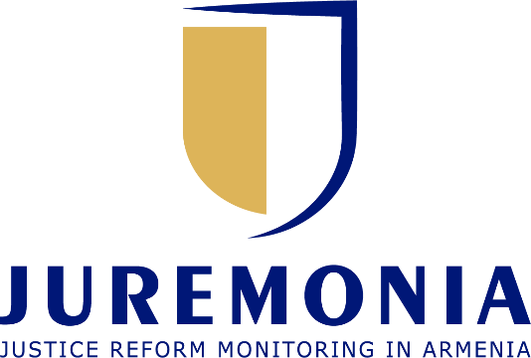

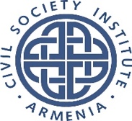



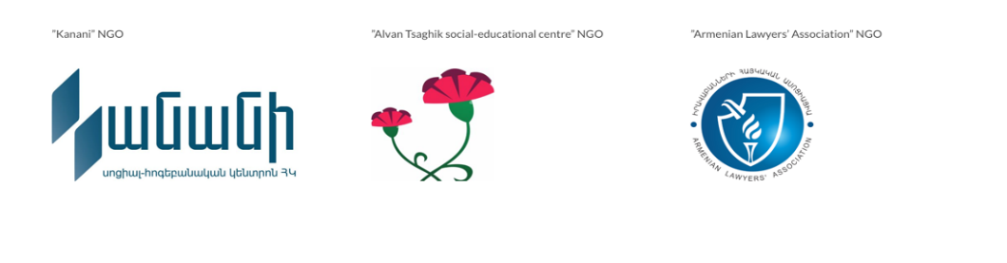
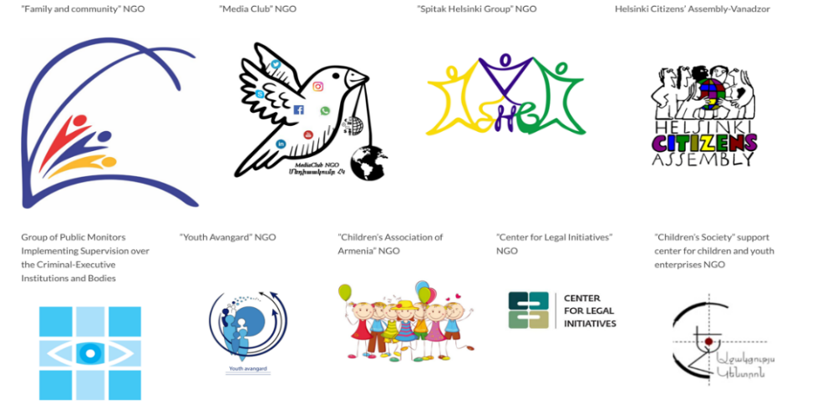
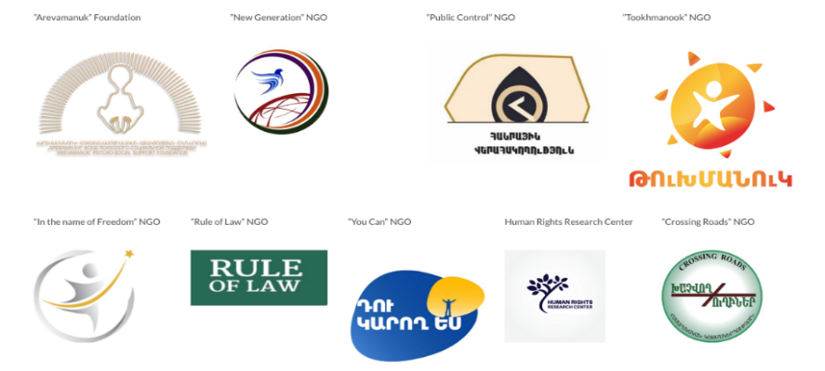
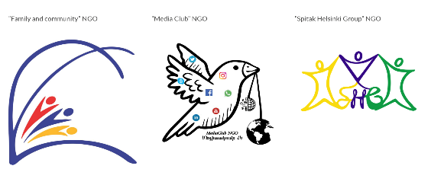
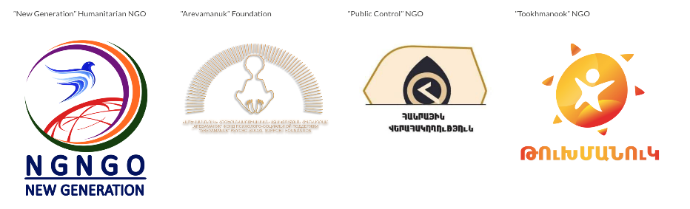
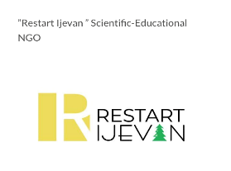

UN Committee against Torture (CAT)
82nd session of the CAT (7 April – 2 May 2025)
ARMENIA

JUREMONIA platform
E-mail: info.sjngo@gmail.com
Website: www.juremonia.am

The JUREMONIA platform was founded in September 2022. The objective of creating the platform is to discuss and analyse issues in the justice sector. Promote dialogue between government and civil society as well as influence conceptual or strategic field processes. The activities of the Platform are focused on 4 main directions of Justice Sector: Anti-corruption sector reform, polices reform, probation and penitentiary reforms, legal and judicial reforms. The Platform has 24 members.

Contributing Organisations:
- Rights Centre NGO
Address: Nor Nork 3, Kocharyan 6, apt 39, 0056 Yerevan, Armenia
Tel: +374 (91) 501027, Email: info@rights.center

Rights Centre NGO is a dedicated NGO committed to the advancement of human rights and freedoms. The mission of the organization is to promote and protect human rights through monitoring, advocacy, strategic litigation, and non-formal education. Through monitoring and identifying human rights violations the organization provides in-depth analyses, and offers actionable recommendations to redress these violations while preventing their recurrence. It aims to foster a society where human rights are respected, protected, and upheld for all.

- Social Justice NGO
Address: 2 Arshakunyants Avenue, 0023 Yerevan, Armenia
Suites #303-#305
Tel: +374 (99) 051 314, Email: info.sjngo@gmail.com
The organization was founded in 2004. By implementing and participating in various initiatives and programs, the Organization has had its most active role since 2011, especially in the judicial and legal reforms taking place in Armenia. The organization has had its participation in the development of the judicial and legal reform strategy and Action plan, also engaging in the implementation and establishment of the most important institutions in the field of punishment, such as the Juvenile Justice System and Probation Service in Republic of Armenia.

- Civil Society Institute NGO

Address: 117/2 Zakaria Kanaketsi, 39, 0091Yerevan, Armenia
Tel: +374 (94) 807807, Email: artak@csi.am
Website: www.csi.am

Civil Society Institute is one of the most experienced civil society organizations in Armenia that has implemented a vast number of projects and initiatives in the area of rights protection and democratic development, rule of law and state accountability, social integration and response to conflict. Established in 1998 CSI has been actively working on programs aimed at civil society development, penal system reform, human rights advocacy and awareness, peace building and conflict resolution.

Submitted on 10 March 2025

Executive summary
- This joint submission was developed by Juremonia platform members-Rights Centre NGO, Civil Society Institute NGO and Social Justice NGO in response to Armenia’s 5th periodic report for the 68th Session of the Committee Against Torture. Its purpose is to provide supplementary information regarding Armenia’s fulfilment of its obligations under the UN Convention against Torture and Other Cruel, Inhuman, or Degrading Treatment or Punishment.
- Despite Armenia's legislative framework prohibiting torture, inhuman, and degrading treatment, significant gaps remain in both legal definitions and practical implementation. While Article 450 of the RA Criminal Code criminalizes torture, inhuman or degrading treatment is not explicitly defined or penalized, leaving arrestees vulnerable to ill-treatment without adequate legal redress.
- Fundamental legal safeguards for detainees/arrestees, such as immediate access to medical examinations, remain inconsistent, with examinations often conducted in the presence of law enforcement officers, compromising medical confidentiality. Additionally, the records of medical examinations in temporary detention facilities (TDFs) are frequently inaccurate, with documented instances of alterations and deletions.
- The investigation of torture cases also remains ineffective. The transfer of investigative jurisdiction from the Special Investigation Service to the National Security Service in 2021, and subsequently to the Investigative Committee in 2022, has not resulted in greater independence or impartiality. The majority of cases involving elements of torture are either terminated or remain unprosecuted, raising concerns about accountability.
- Furthermore, while Armenia's legal framework provides for the compensation of non-pecuniary damages for victims of torture, the absence of a clear definition of inhuman or degrading treatment creates uncertainty in judicial proceedings. Additionally, despite commitments outlined in the National Action Plan on Human Rights (2023-2025) to establish rehabilitation centers for victims of torture, no concrete steps have been taken to implement these measures.
Legislative prohibition of torture, inhuman and degrading treatment
- Article 450 of the RA Criminal Code establishes liability for torture. However, inhuman or degrading treatment or punishment is not criminalized. There are instances where individuals deprived of liberty are subjected to inhuman treatment, such as when necessary medication is not provided for a prolonged period, leaving them without any means of redress. In such cases, the fault of an official (e.g., the head of a penitentiary institution or a doctor) may be absent. However, the failure to provide essential medication can result in a violation of the state’s positive obligations and constitute inhuman treatment of the person deprived of liberty.
- According to the precedents of the European Court of Human Rights, inhuman or degrading treatment need not be deliberate nor inflicted for a purpose. Since Armenian legislation does not define inhuman or degrading treatment, such cases cannot be effectively addressed.
Fundamental legal safeguards
- Detained persons do not enjoy the fundamental legal safeguards from the very outset of their detention, including prompt access to a doctor (including a doctor of their own choice) and notification of their detention.
- There are several concerns regarding the initial medical examination of individuals admitted to temporary detention facilities (TDFs) under the Police. Medical examinations in these facilities are conducted by emergency medical services only when injuries are detected or when arrestees explicitly report health complaints.
- In the case of TDFs operated by the National Security Service (NSS), a medical examination is performed only if bodily injuries, clear signs of illness, or health-related complaints are identified. This assessment takes place if TDF officers notice injuries or symptoms of illness during the search process. However, a significant issue remains regarding the ability of TDF officers to accurately recognize medical conditions due to their limited professional medical training. Individuals are often asked to confirm their health status by signing a statement declaring that they don’t have health problems.
- It is essential to emphasize that all individuals entering a TDF should undergo an external medical examination, regardless of whether they request one or display visible bodily injuries.
- An essential aspect of organizing medical care and services for arrestees is ensuring the preservation of medical confidentiality. However, a persistent issue remains—the initial medical examinations of arrestees in TDFs are still conducted in the presence of law enforcement officers.
- In cases where a arrestee’s medical examination was conducted by an emergency medical service physician, personal data and medical complaints were sometimes documented by law enforcement officers. These registers are maintained by TDF officers, further compromising medical confidentiality and violating medical ethics.
- To address these concerns, it is crucial to emphasize that medical examinations should be conducted exclusively by a physician and in conditions that ensure privacy-out of the hearing range and visual field of detention facility staff.
- A comparison of the registers related to medical care in TDFs revealed discrepancies, with records frequently lacking accurate information about arrestees. The review also documented instances of alterations and deletions in the recorded dates and times of medical examinations or first aid.
Effective investigation
- Ensuring an effective investigation into cases of torture and ill-treatment remains a concern. According to the statistics of the RA Prosecutor’s Office
- In 2022, a total of 340 criminal cases involving elements of torture were investigated, with 90 cases terminated and 1 case referred to court.
- In 2023, 507 such cases were investigated, with 106 terminated and 5 referred to court.
- In 2021, the Special Investigation Service was dissolved, and the jurisdiction over torture cases was transferred to the National Security Service of Armenia. As a result of active advocacy by civil society, on May 5, 2022, the function of investigating torture cases was transferred to the Investigative Committee of Armenia. However, the Investigative Committee does not possess the institutional and functional level of independence and impartiality required for the investigation of torture cases.
Redress, including compensation and rehabilitation
- The procedure and conditions for compensating non-pecuniary damages resulting from the violation of fundamental rights—including the right not to be subjected to inhuman or degrading treatment or punishment—are defined in Article 1087.2 of the Civil Code of the Republic of Armenia. According to part 3 of this article, non-pecuniary damage is subject to compensation regardless of the fault of the official responsible for the harm.
- Furthermore, based on part 9 of Article 1087.2, a claim to establish the fact of a violation of the right not to be subjected to inhuman or degrading treatment or punishment may be submitted to the court alongside a compensation claim. This implies that, before addressing the issue of compensation, the court handling the civil claim must first determine whether the individual has indeed been subjected to inhuman or degrading treatment. However, as mentioned above a significant challenge remains: domestic legislation does not define the concepts of inhuman or degrading treatment or punishment, and it is not clear how the court will establish such a violation.
- There is no public specialized center providing multidisciplinary, holistic rehabilitation services for the victims of torture and ill-treatment established or financed by the State party.
- The National Action Plan derived from the National Strategy on Human Rights (2023-2025) Armenia provides for establishment of such centers. Action 2.13 of the Plan stipulates that in Yerevan and in at least three regions, centers shall be established to provide individuals affected by torture with the legal, psychological, social, and other services, through which the health status of those affected will be improved. However, so far no activities have taken place in this regard.
Recommendations
- Criminalization of Inhuman and Degrading Treatment: Amend the RA Criminal Code to explicitly define and criminalize inhuman and degrading treatment, ensuring full alignment with international human rights standards.
- Strengthening Medical Safeguards: Ensure that all arrestees undergo an independent medical examination upon entry to a TDF, conducted by a physician in a confidential setting, without law enforcement officers present.
- Enhancing Medical Record-Keeping: Establish strict protocols for documenting medical examinations, preventing unauthorized alterations, and ensuring arrestees have access to their medical records.
- Ensuring Effective Investigations: Strengthen the independence and impartiality of the Investigative Committee, enhance its technical capacities, and improve the professionalism of investigators to ensure thorough and objective investigations of cases.
- Improving Victim Redress and Rehabilitation: Expedite the establishment of multidisciplinary rehabilitation centres for victims of torture, as outlined in the National Action Plan, and ensure state funding for their operation.

https://coe.int/en/web/echr-toolkit/interdiction-de-la-torture?utm_source=chatgpt.com
These problems are also highlighted in the RA Ombudsman’s report, pages 242-245 https://ombuds.am/images/files/b718618abb9d1adc41bb47b8a6f6571a.pdf

