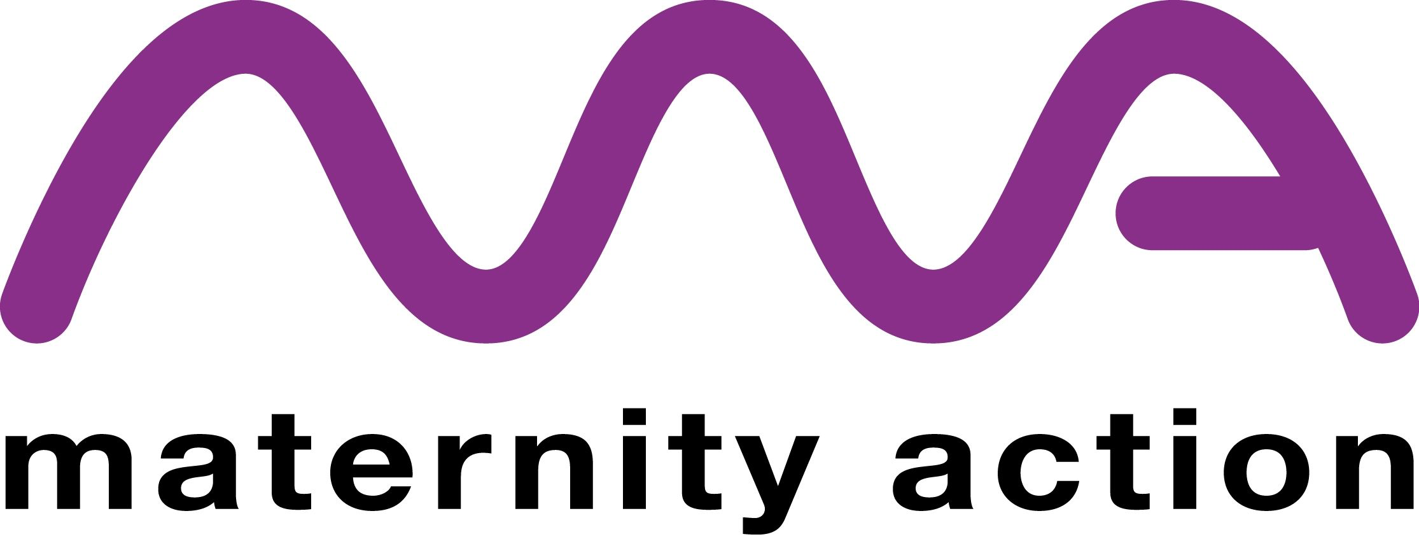

Submission to the 77th session of the UN Committee on Economic Social and Cultural Rights (CESCR), in relation to the UK’s compliance with the Convention on Economic Social and Cultural Rights (ICESCR).

This submission aims to update the Committee on the Uk government’s compliance with Article 10 (2) of the ICESCR, namely that during a reasonable period before and after childbirth, working mothers should be accorded paid leave or leave with adequate social security benefits.

About us

Maternity Action is a charity providing specialist legal advice to pregnant women and new parents on their maternity pay, benefits and rights at work. Our advisers and caseworkers respond to more than 3,000 enquiries a year.
The UK’s system of maternity pay and associated benefits does not meet the needs of modern parents.

Employed women can usually claim Statutory Maternity Pay (SMP), while Maternity Allowance (MA) is a safety net for some who have very low earnings, do not meet other eligibility requirements for SMP, or are self-employed.

From April 2025, the £187.18 weekly rate of SMP and MA will be only 44% of the standard rate National Living Wage of £427.35, compared to 62.5% in 2012.

Women who are reliant on Maternity Allowance, including employed women, have their payments deducted from Universal Credit awards, because of the way Universal Credit treats MA as unearned income, this can result in this cohort of women losing out to the sum of up to £6000 per year.

Judith Dennis
Head of Policy
Maternity Action
January 2025.

