Assessment of Economic and Social Rights Fulfilment in Kenya
Submission from the Human Rights Measurement Initiative to the United Nations Committee on Economic, Social and Cultural Rights for its 79th Session scheduled to be held in February 2026.
I. Reporting Organisation
1. The Human Rights Measurement Initiative (HRMI) measures the human rights performance of countries around the world, including Kenya. HRMI is an independent, not-for-profit NGO with its primary base of operations in New Zealand, and a second base in the United States of America at the University of Georgia’s Center for the Study of Global Issues (GLOBIS).
II. Assessment Methodology
2. HRMI uses the award-winning and peer-reviewed SERF Index methodology to measure the fulfilment of economic and social rights (ESRs).
3. This methodology uses bellwether indicator data from international organisations—such as the WHO and UNICEF—and compares each country’s achievement to what other countries at the same income level (GDP per capita) have achieved. HRMI measures progressive realisation of economic and social rights as defined in the International Covenant on Economic, Social, and Cultural Rights (ICESCR). A country’s ‘income adjusted’ HRMI score is thus a measure of how well its government is converting its resources into good human rights outcomes for its people.
4. HRMI supplements these scores with qualitative information sourced by a secure, online survey of in-country human rights experts, such as NGO researchers, journalists, and human rights lawyers and advocates. For more details, please refer to the resources on our website.
5. All HRMI’s data are published annually on the Rights Tracker and are freely available for non-commercial use under a Creative Commons License. The Rights Tracker is a certified Digital Public Good with the Digital Public Good Alliance.
III. Overview of Economic and Social Rights Fulfilment in Kenya
6. HRMI’s most recent ESR scores for Kenya measure its achievement on four main rights and some other component rights as of 2022, and indicate a significant room for improvement. They are shown in the graph below.
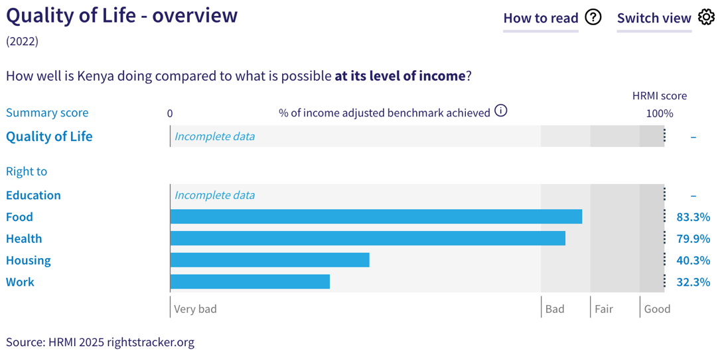
7. Kenya’s scores for 2022 are as follows:
- Right to education = There is insufficient international data for HRMI to be able to produce an overall score, but the score for the component on general quality education is available.
- Right to food = 83.3% (‘bad’)
- Right to health = 79.9% (‘very bad’)
- Right to housing = 40.3% (‘very bad’)
- Right to work = 32.3% (‘very bad’).
8. The four overall scores available for Kenya fall either into ‘bad’ or ‘very bad’ performance ranges, highlighting an underperformance by the State Party towards fulfilment of its immediate economic and social rights obligations.
9. We do not have an overall ‘Quality of Life’ score for Kenya as there are some gaps in the international indicator data necessary to produce all the scores. The available scores are measured against an ‘income adjusted’ benchmark, which means that they take into consideration Kenya’s existing resources and how well it is using them to fulfil the ‘Quality of Life’ rights of its people.
10. Most of these scores indicate that Kenya is not achieving what ought to be possible with its current level of resources. Although some scores may indicate progress, any ‘income adjusted’ score that is less than 100% indicates that a country is underperforming, and not meeting its current obligations under international human rights law. Therefore, our assessment is that Kenya is performing ‘lower than average’ compared to other countries in Sub-Saharan Africa, and still has a long way to go to meet its immediate economic and social rights obligations.
IV. Right to Education
11. HRMI defines the right to education in accordance with ICESCR Article 13 and CESCR General Comments 11 and 13. For low- and middle-income countries such as Kenya, HRMI further breaks down the right to education into three areas of measurement: primary school enrolment, secondary school enrolment, and quality of education. However, due to lack of international data on Kenya’s fulfilment on the rights to primary and secondary education—based on actual enrolment rates in the country—we cannot calculate the overall HRMI score for the right to education. However, the HRMI score for the right to general quality of education is available.
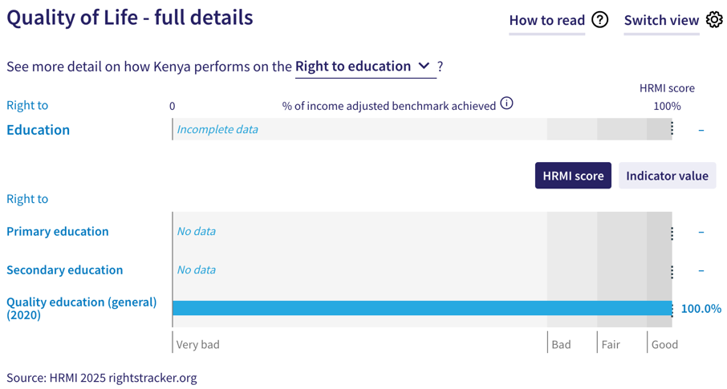
12. For low- and middle-income countries such as Kenya, HRMI measures the general quality of education based on the percentage of TIMSS (Trends in International Maths and Science Study) equivalent range from The Human Capital Project of the World Bank. While Kenya achieves 47.7% of the TIMSS equivalent range, it scores an ‘income adjusted’ 100% on the right to quality education indicating that it is doing the best that it can with what it has to fulfil this right.
13. It is crucial to note that the raw indicator data on primary and upper secondary school enrolment in Kenya has not been available for over a decade in the UNESCO database.
14. Based on our 2025 Expert Survey, human rights experts from Kenya identified ‘people with low social or economic status’, ‘homeless people’, ‘people from particular geographic locations’, among others, as being at risk of not enjoying their right to education. Experts noted unaffordability, terrorist attacks, and protests as factors responsible for restricting the right to education. It was also mentioned that girls from some cultural backgrounds are not allowed to attend schools.
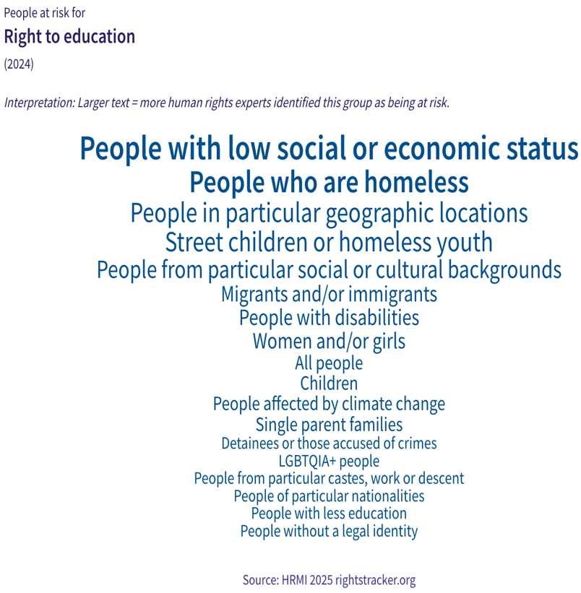
V. Right to Food
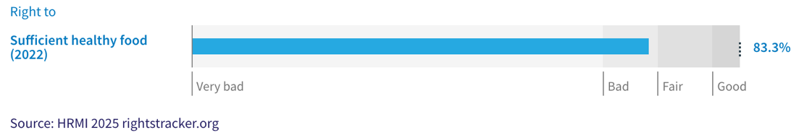
15. HRMI defines the right to food in accordance with ICESCR Article 11 and CESCR General Comment 12. For low- and middle-income countries such as Kenya, HRMI uses a bellwether indicator of how many children are growing well (are not stunted) published by the UNICEF-WHO-World Bank: Joint child malnutrition (JME) database. Kenya’s ‘income adjusted’ HRMI score for the right to sufficient healthy food is 83.3%, which falls in the ‘bad’ range.
16. This current score, however, reflects gradual improvement in Kenya to ensure that many more children under the age of five grow well and are not stunted. The overtime graph shows an encouraging trend over two decades from 56.0% in 2000 to the current peak of 83.3% in 2022. Despite this progress, this score indicates a considerable underperformance on the right to food.
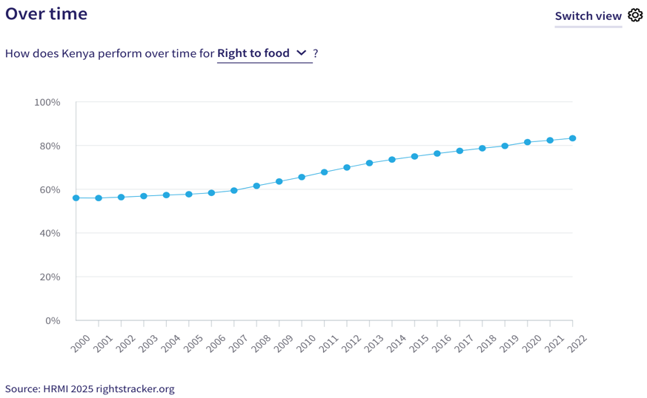
17. A considerable number of human rights experts identified ‘people with low socio-economic status’ as being at greater risk of having their right to food violated. Other prominently identified groups were ‘street children’, ‘homeless people’ and ‘people affected by climate change’. Notably, a large number of experts identified ‘all people’ to be at risk of not being able to enjoy their right to food. High food prices, low incomes, evictions and demolition of informal settlements, insufficient rainfall, and poor infrastructure, were identified as some factors responsible for food insecurity and inadequate access to sufficient healthy food.
VI. Right to Health
18. HRMI defines the right to health in accordance with ICESCR Article 12.1 and CESCR General Comment 14. For low- and middle-income countries such as Kenya, HRMI uses three indicators to measure the country’s achievement on the right to health: child health, adult health, and reproductive health. Kenya’s score on the right to health is 79.9% and falls in the ‘very bad’ range. While overtime trends show progress on this right from 57.5% in 2000 to the current peak of 79.9% in 2022, there has not been any marked improvement since 2015.
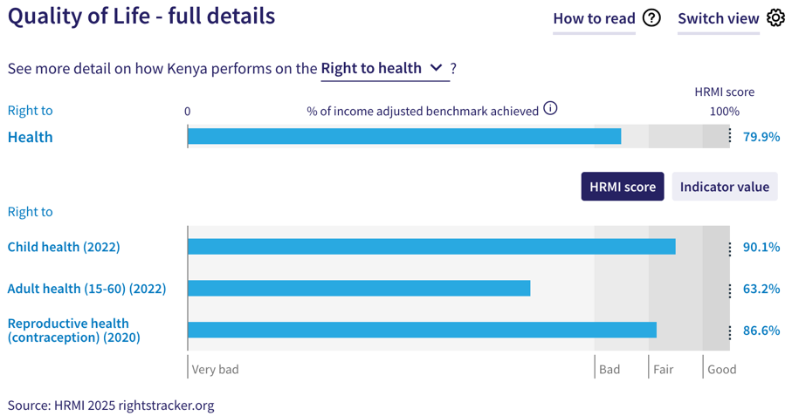
19. For low- and middle- income countries such as Kenya, HRMI measures the right to child health using the indicator of survival to age five from the UN Inter-Agency Group for Child Mortality Estimation (UN IGME). Kenya scores an ‘income adjusted’ 90.1% on the child health, and it falls in the ‘fair’ range. This score has appeared to have gradually improved over the 2000-2022 period, reaching a current peak ‘income adjusted’ HRMI score of 90.1 in 2022.
20. Kenya has an ‘income adjusted’ score of 63.2% for the right to adult health, which lies in the ‘very bad’ range. This score is based on the indicator of adult (15-60) survival rate. According to the UNDP and Max Planck Institute Human Mortality Database, the adult survival rate in Kenya was 68.3% in 2022. While the overtime graph for this right is slightly upward trending, there has not been much substantial progress, especially in the last decade.
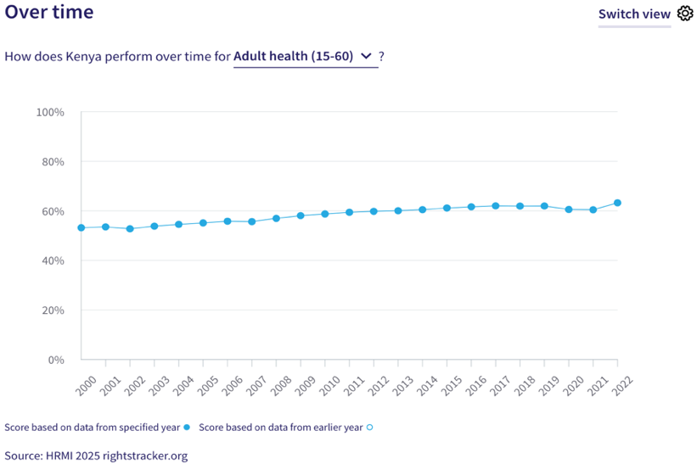
21. For low- and middle-income countries such as Kenya, HRMI measures the right to reproductive health based on modern contraceptive use rate. In 2020, which is the most recent available data, Kenya reported a contraceptive use rate of 61.2%. This translates into its current ‘income adjusted’ HRMI score of 86.6% and falls in the ‘fair’ range. This score has shown sporadic progress, and has especially fluctuated over the last decade.
22. Notably, 60% of human rights experts from Kenya who took HRMI’s 2025 Expert Survey identified ‘all people’ people to be at risk of violations of their right to health. Other groups that were prominently identified included ‘people with low socio-economic status’, ‘people from particular geographic locations’, ‘people with disabilities’, and ‘LGBTQIA+ people’. Experts also mentioned costly and inadequate healthcare system, healthcare workers’ strikes, changes to insurance system, among factors affecting the right to health. Some experts also identified ‘women and girls, especially those living in rural areas’ as being unlikely to enjoy their right to health.
VII. Right to Housing
23. HRMI defines the right to housing in accordance with ICESCR Article 11.1 and CESCR General Comment 4. For low- and middle-income countries, HRMI measures this right using the indicators of access to water on premises and access to at least basic sanitation. Kenya has an ‘income adjusted’ HRMI score of 40.3% on the right to housing based on these indicators, and it falls in the ‘very bad’ performance range.
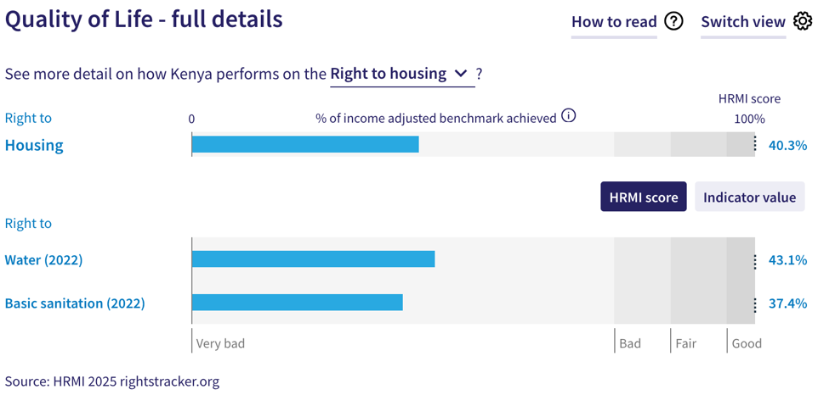
24. The WHO UNICEF Joint Monitoring Project (JMP) data show that only 39.8% of people in Kenya have access to water on premises as of 2022. Given what other countries at the same level of income have achieved, Kenya’s score for the right to water is 43.3% and falls in the ‘very bad’ range. The score shows an overall upward trend, but the progress has been very slow.
25. Kenya’s score for basic sanitation it is deeply concerning, and is one of its weakest scores. According to the WHO UNICEF Joint Monitoring Project (JMP), only 36.5% of people in Kenya have access to improved sanitation facilities which are not shared with other households; this translates to an ‘income adjusted’ HRMI score of 37.4% and falls in the ‘very bad’ performance range. Notably, over two decades, there has not been any marked improvement on this right.
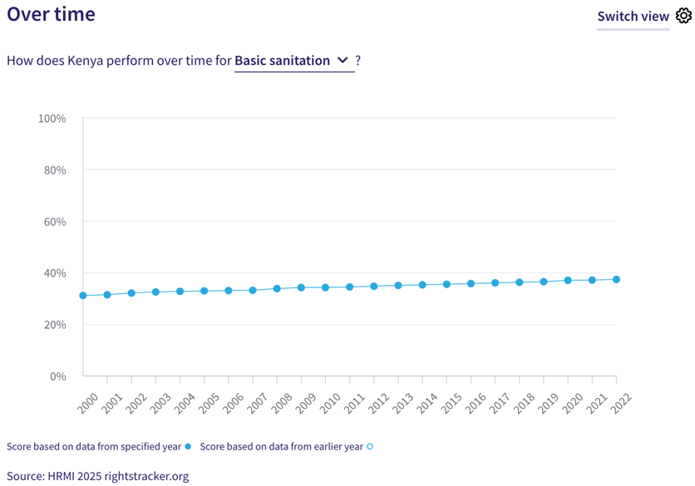
26. Human rights experts from Kenya prominently identified ‘people with low socio-economic status’, ‘street children’, ‘people affected by climate change’, ‘people from particular socio-cultural backgrounds’, and ‘women and girls’ as being unlikely to enjoy their right to housing. A significant number of experts stated that ‘all people’ were at risk of having this right violated. Unaffordability of quality housing, forced evictions and unlawful demolitions, were identified as some factors contributing to these violations. Experts also identified ‘people in north-eastern Kenya’ as being particularly vulnerable to these violations.
VIII. Right to Work
27. HRMI measures the right to work in accordance with ICESCR Articles 6 and 7. For low- and middle-income countries such as Kenya, HRMI uses subsistence income indicator to measure this right. According to the World Bank PovcalNet, only 29.9% of people in Kenya were classified as ‘not absolutely poor’ in 2021, which translated into an ‘income adjusted’ HRMI score of 32.3%.
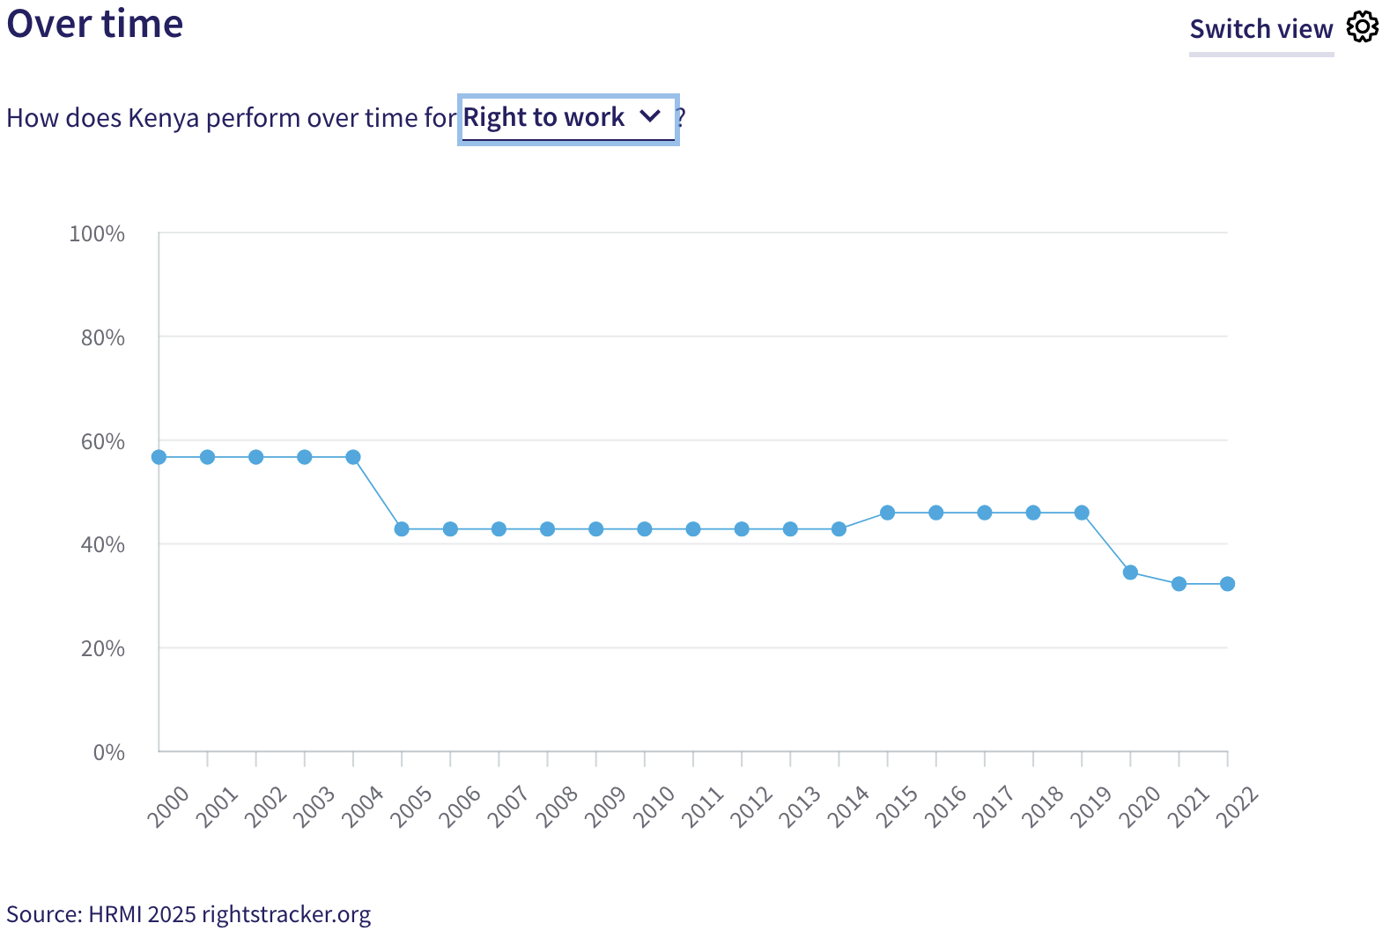
28. Over the course of the last two decline on the right to work from 56.7% in 2000 to the current lowest score of 32.3%. There was a particularly steep decline after 2019. Kenya ranks 37th out of 43 countries in Sub-Saharan Africa on the right to work.
29. Notably, ‘all people’ was the most prominently identified group as being at risk of violation of their right to work, along with other groups. Experts noted other factors such as high unemployment rates; lack of opportunities due to limited availability of jobs in both formal and informal sectors as well as significant competition; corruption in the employment process; discrimination against women and people with disabilities; and political unrest, among others, that adversely affect the right to work of the people in Kenya.
IX. Concluding Remarks
30. Kenya scores an ‘income adjusted’ 100% on the right to general quality of education, which means that it is doing the best that it can with its available resources. Its other relatively better scores are for the rights to child health and reproductive health, which fall in the ‘fair’ range.
31. Kenya’s most concerning scores are for both the components of the right to housing (access to water and sanitation) and the right to work. These scores fall in the ‘very bad’ range; especially the score on the right to work has shown a concerning decline. Notably, the updated indicator data required to construct scores for the right to primary education and the right to secondary education in Kenya have not been available for over a decade.
32. Many vulnerable groups in Kenya face compounded challenges in the enjoyment of their economic and social rights, with some groups consistently identified as being at heightened risk.
33. Our analysis is that Kenya is not constrained by resources from making considerable improvements in areas with low and declining scores. It has the income available to make progress, and can prioritise to put it to use to improve the economic and social rights of its people.
34. We recommend that the Committee assure the State Party concerned that it has the available resources to make significant improvements, especially in areas of access to water, basic sanitation, and subsistence income, as well as adult survival rates.
35. We also recommend that the following questions be asked of the State Party:
- What steps will the State Party take to improve equitable access to water?
- What measures will the State Party take to expand access to basic sanitation?
- What steps will the State Party take to lift access to at least subsistence income?
- What actions will the State Party take to provide updated data on primary and upper secondary school enrolment rates?
36. HRMI respectfully submits its data and findings on the fulfilment of economic and social rights in Kenya. We hope that this submission will serve as a useful resource to the Committee on Economic, Social and Cultural Rights in their review for drafting specific and pertinent questions to the State Party concerned during the CESCR’s 79th Pre-Sessional Working Group.

Visit HRMI’s website to learn more about our mission and work, https://humanrightsmeasurement.org/.
This content represents the opinions of the Human Rights Measurements Initiative. It carries no endorsement of the University of Georgia.
See HRMI’s methodology for measuring economic and social rights: https://humanrightsmeasurement.org/methodology and https://rightstracker.org/page/methodology.
Ibid.
HRMI 2025 Rights Tracker, https://rightstracker.org/.
See Human Rights Measurement Initiative (HRMI) Digital Public Good Certificate, https://app.digitalpublicgoods.net/a/11781. The Digital Public Goods Alliance, endorsed by the UN Secretary General’s “Roadmap for Digital Cooperation”, defines digital public goods as: “open source software, open data, open AI models, open standards and open content that adhere to privacy and other applicable laws and best practices, do no harm, and help attain the SDGs”, https://digitalpublicgoods.net/standard/.
HRMI 2025 Rights Tracker, https://rightstracker.org/country/KEN?qolFdScore=hrmi&tab=report-esr
The labels on the country charts of good, fair, bad, and very bad are used to give a general indication of how to understand the scores. HRMI’s income adjusted Quality of Life scores can be broadly interpreted as showing the percentage of the country’s obligation it has met, compared to what the best performing countries have achieved at each income level. A country scoring below 75% with a label of “very bad” is either underperforming to put in place the kinds of structures and policies that help people enjoy the right, or that the structures and policies in place most likely prevent many people from claiming their rights. See HRMI’s methodology for measuring human rights, https://rightstracker.org/page/methodology.
HRMI 2025 Rights Tracker, https://rightstracker.org/country/KEN
Ibid.
Ibid.
HRMI 2025 Rights Tracker, https://rightstracker.org/metric/education
HRMI 2025 Rights Tracker, https://rightstracker.org/country/KEN?qolFdScore=hrmi&tab=report-esr
Ibid.
Ibid.
HRMI 2025 Rights Tracker, https://rightstracker.org/country/KEN?region=sub-saharan-africa&tab=atrisk
HRMI 2025 Rights Tracker, https://rightstracker.org/metric/not-stunted
HRMI 2025 Rights Tracker, https://rightstracker.org/country/KEN?qolFdScore=hrmi&tab=report-esr
Ibid.
HRMI 2025 Rights Tracker, https://rightstracker.org/country/KEN?qolFdScore=hrmi&tab=report-esr
HRMI 2025 Rights Tracker, https://rightstracker.org/country/KEN?region=sub-saharan-africa&tab=atrisk
HRMI 2025 Rights Tracker, https://rightstracker.org/metric/health
HRMI 2025 Rights Tracker, https://rightstracker.org/country/KEN?qolFdScore=hrmi&tab=report-esr
Ibid.
Ibid.
HRMI 2025 Rights Tracker, https://rightstracker.org/country/KEN?tab=report-esr&qolFdScore=indicator&as=core
Ibid.
Ibid.
HRMI 2025 Rights Tracker, https://rightstracker.org/country/KEN?region=sub-saharan-africa&tab=atrisk
HRMI 2025 Rights Tracker, https://rightstracker.org/country/KEN?qolFdScore=hrmi&tab=report-esr
Ibid.
Ibid.
HRMI 2025 Rights Tracker, https://rightstracker.org/country/KEN?region=sub-saharan-africa&tab=atrisk
HRMI 2025 Rights Tracker, https://rightstracker.org/country/KEN?qolFdScore=hrmi&tab=report-esr
HRMI 2025 Rights Tracker, https://rightstracker.org/metric/work?region=sub-saharan-africa
HRMI 2025 Rights Tracker, https://rightstracker.org/country/KEN?region=sub-saharan-africa&tab=atrisk

