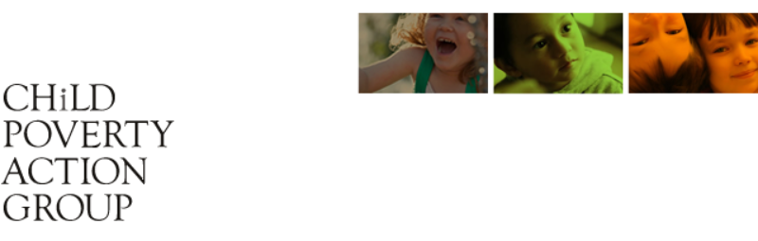

Child Poverty
A Thematic Report for the
United Nations Committee
on the Rights of the Child

August 2022

Child Poverty Action Group is a registered charity committed to research on child poverty and child poverty related issues. The group’s work can be found at www.cpag.org.nz. We are thankful for discussions with others in the formulation of this report, in particular Professor Mark Henaghan (School of Law, University of Auckland) and Dr Claire Mason (Aotearoa NZ Centre for Indigenous Peoples and the Law). Any errors made are the sole responsibility of the author.

Correspondence to:
Dana Wensley, PhD
Child Poverty Action Group
Email: research@cpag.org.nz

Table of Contents
1. Update on observations from the committee’s Fifth Periodic Report (2016) 5
2. Standard of Living: (Question 24) Article 27 6
3. Higher rates of poverty in Māori, Pasifika and children with disability questions (Question 9: Non-discrimination) Article 2 7
4. Statistical data (Question 32 , 33) 13
5. Link Between Poverty, Health and avoidable hospitalisations Article 24 (Question 22) 16
6. Impact of COVID-19 pandemic (Question 2(b))- New Developments 16
7. Government obligations and Article 4 (Question 5: Allocation of Resources) 19
8. The right to adequate food and nutrition: Articles 24, and 27: Question 2 (c) New Development – High rates of food Insecurity 21
9. Best Interest of the child (Question 10) Article 3 26
10. Child and youth wellbeing strategy (Question 24) Standard of living 26
Associated data: (Question 41) 30
11. Recommendations 35
12. Immediate recommendations 36
13. Further recommendations 37

PART ONE

1. Update on observations from the committee’s Fifth Periodic Report (2016)
1.1 We draw the Committee’s attention to a number of matters relating to observations made in the UN Committee’s Fifth Periodic Report (2016).
1.2 New Zealand has not taken sufficient steps to incorporate the United Nations Convention on the Rights of the Child (the Convention) into domestic law, and there is no comprehensive ‘code of compliance’ that has been developed to ensure that new legislation is consistent with the provisions and principles of the Convention.
1.3 Domestic legislation has not been sufficiently updated to ensure compliance with the Convention, particularly in relation to ‘best interests of the child’, the Social Security Act, and the Working for Families Package. [See Appendix 2 for in-depth analysis of ‘best interest’ and social security including sanctions, Working for Families, and debt related to ‘benefit fraud’ [Question 24 (d), (e)]
1.4 In relation to the Committee’s 2016 suggestion that the Children’s Commissioner has adequate financial and human resources to monitor the application of the Convention, (point 11 (a)) and that the independent role of the Commissioner is strengthened (point 11(b)), we are concerned that this strengthening has not occurred. We draw the Committee’s attention to the fact that proposed legislative changes will repeal the position of Children’s Commissioner, and replace the Commissioner with a Board to oversee the Convention. [See Appendix 2]
1.5 There have been insufficient steps taken to develop a data collection system that disaggregates data by age. The current data around child poverty is dominated by broad age brackets (0 – 17 years) and fails to facilitate deeper analysis on the differing experiences of children (particularly Māori, Pasifika, and children with disabilities) or the effect of poverty on their development.
1.6 While we acknowledge the amendment to the Public Finance Act 1989 (to require the government to publish a child poverty report as part of the Budget) we would find further breakdown and modelling helpful, with specific reference to age and impacts on child development. We also seek a strengthening of the budget implementation tracking system covering all child related expenses. We also recommend that while the child poverty report and reporters remain government-funded, they are made independent of government departments.
1.7 We acknowledge the significant step of introducing the Child Poverty Reduction Act 2018 as a systemic approach to reducing child poverty, but we seek further measures to address poverty for Māori, Pasifika, and children with disabilities, and call for a revised action plan with adequate resources and short, medium, and long term goals to achieve this.
1.8 We note a failure to fully implement the UN Committee’s suggestion (2016) that there be budgetary lines to address disadvantage, and that ‘affirmative social measures’ may be required ‘even in situations of economic crisis, natural disasters or other emergencies.’

2. Standard of Living: (Question 24) Article 27
2.1 Child poverty and standard of living are linked, and we consider these concepts through the lens of the Articles of the Convention on Rights of the Child (the Convention), and for tamariki Māori, te Tiriti o Waitangi (te Tiriti) and the UN Declaration on the Rights of Indigenous Peoples (the Indigenous Declaration) .
2.2 We note that child poverty in New Zealand / Aotearoa must also be understood in the context of colonisation. The rights of tamariki Māori, and their whānau, hapū and iwi, to live, develop and thrive in accordance with their own customs, and have authority over their lands, resources and affairs are guaranteed by te Tiriti.
2.3 As discussed in the Thematic Report by the Te Puna Rangahau o te Wai Ariki / Aotearoa NZ Centre for Indigenous Peoples and the Law, the guarantees made to Māori under te Tiriti have ‘been largely dishonoured by the New Zealand Government’ and this has had a “devastating flow-on effects for the wellbeing of tamariki Māori and the fulfilment of their rights”.
2.4 We draw the Committee’s attention to the fact that New Zealand is currently undergoing a Royal Commission of Inquiry into Abuse in Care. The interim report (December 2021) has made 95 recommendations, and noted the link between poverty, state and faith-based abuse, and colonisation, which have had devastating intergenerational effects:

For Māori, the undermining of whānau, hapu and iwi structures and networks was “not merely a result of colonisation, but an essential part of the process”. This colonial history, as well as ongoing structural racism, has caused high rates of poverty among Māori and contributed to a disproportionate number of Māori children and young people in care. [emphasis added]

2.5 This finding is concerning and requires further state response. A February 2022 review of the Child and Youth Wellbeing Strategy (the Strategy) found significant areas of improvement were needed: “ …key groups, particularly Māori as well as Pasifika, disabled and migrant children and youth are not accorded adequate priority within the Strategy.” Moreover, at the governance level, the Strategy was found to lack Māori participation, and failed to fulfil the Crown’s te Tiriti obligations., The review noted that lack of specific priorities for tamariki (children), rangatahi (youth), and their whānau (extended family), operated to ‘undermine’ the ability of the Strategy “to make meaningful change for Māori.”

3. Higher rates of poverty in Māori, Pasifika and children with disability questions (Question 9: Non-discrimination) Article 2

3.1 One in ten children (11%) live in material hardship. However there are significant discrepancies in the rates of poverty for different groups. Māori and Pasifika children suffer much higher rates (23-28%) compared with that for European or Asian children/ethnicities (6-10%). Figure 1 below sets out additional data from the Child and Youth Wellbeing Strategy Annual Report for year ending 30 June 2021, which shows data on the trends for years 2019/2020, and 2021/2022.

- Material hardship rates for Māori and Pasifika children are far above national rates overall
- Around one in five Māori children (20.2% of 298,000 or 60,300 children) live in material hardship
- Around one in four Pasifika children (24% of 141,500 children or 34,000) live in material hardship.
- These are compared to just over one in ten children overall (11%).

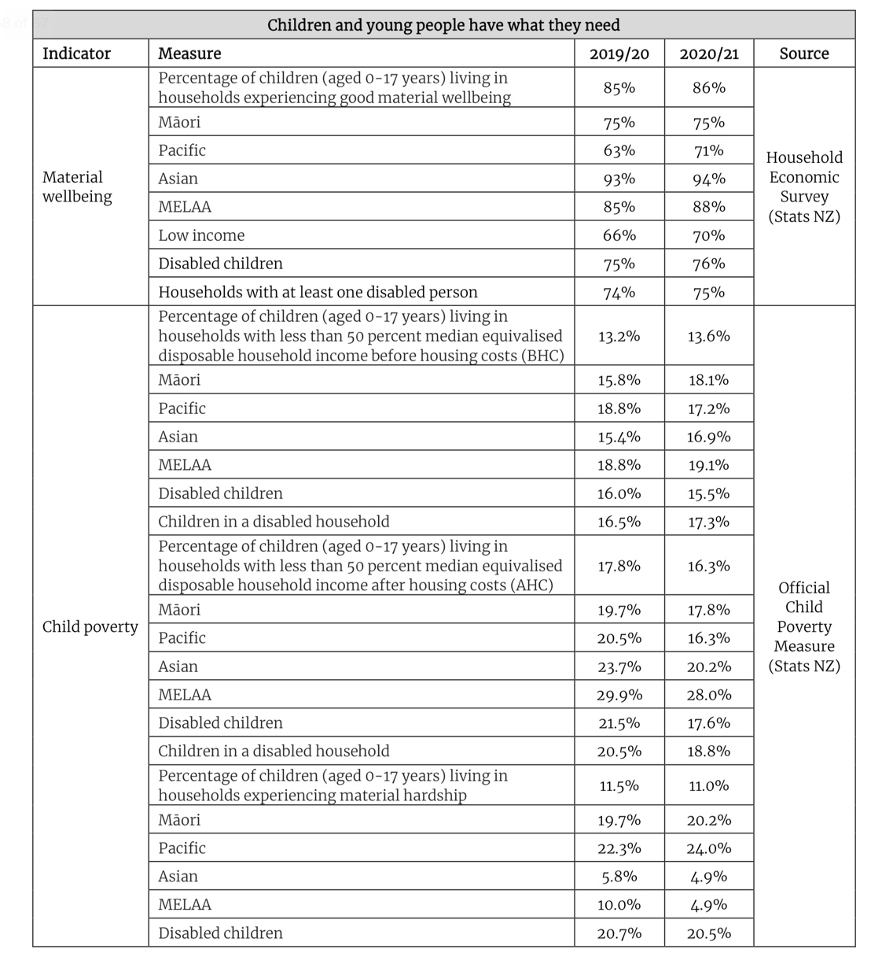
Figure 1 Source: From Child and Youth Wellbeing Strategy Annual Report for Year Ending 30 June 2021, p58

3.2 There also significantly higher rates of poverty for children with a disability or those who are cared for by a family member who has a disability. According to the Child Poverty Monitor, “disabled children, and children living in a household with at least one disabled person, were left behind in the progress toward the child poverty reduction targets.”

3.3 For disabled children, the material hardship rate is one in five (20.5% of 126,800 children). For severe material hardship it is 10.3% compared, with non-disabled children (at 4.2%). Children in households with a disabled member have four times the rate of severe material hardship compared to children in a non-disabled household (10.3% and 2.5% respectively)

3.4 For the year ended June 2021, the annual household disposable income for disabled people was $42,239 which is lower than the average household equivalised disposable income for non-disabled people of $51,683. However, the costs associated with disability are high. Given the high impact of increased housing costs on household expenses, it must be a priority for the government to ensure that people living in poverty with a disability have equitable access to public housing. Currently only 2% of public housing meets accessibility standards. Improvements were planned but it is concerning to see this programme to retrofit current state housing may be put on hold due to a desire to meet costs. Currently only 15% of new builds of state housing are aimed to be assessable.
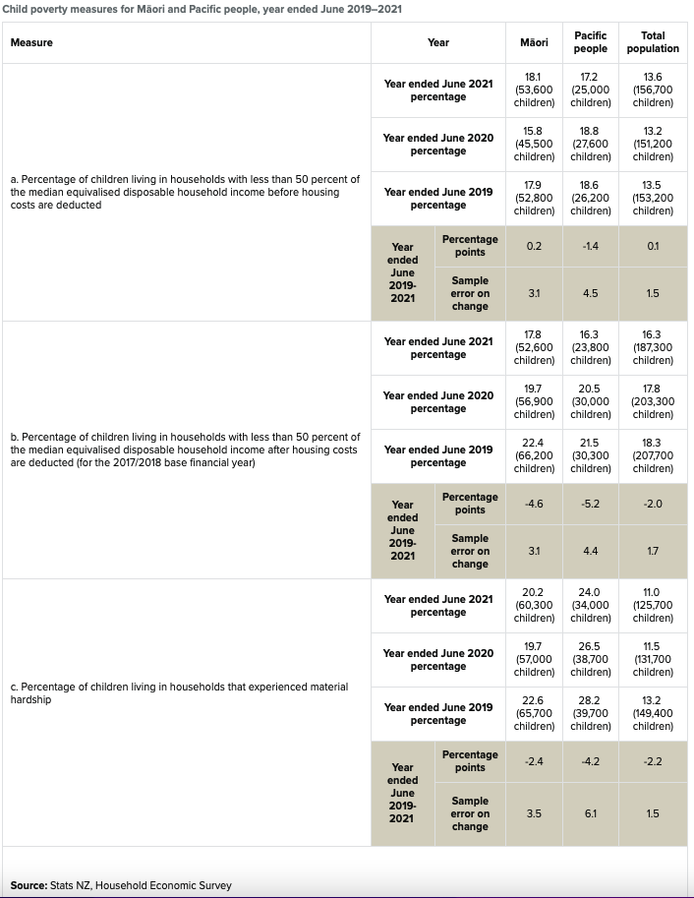

Figure 2 Source Stats NZ, based on Household Economic Survey

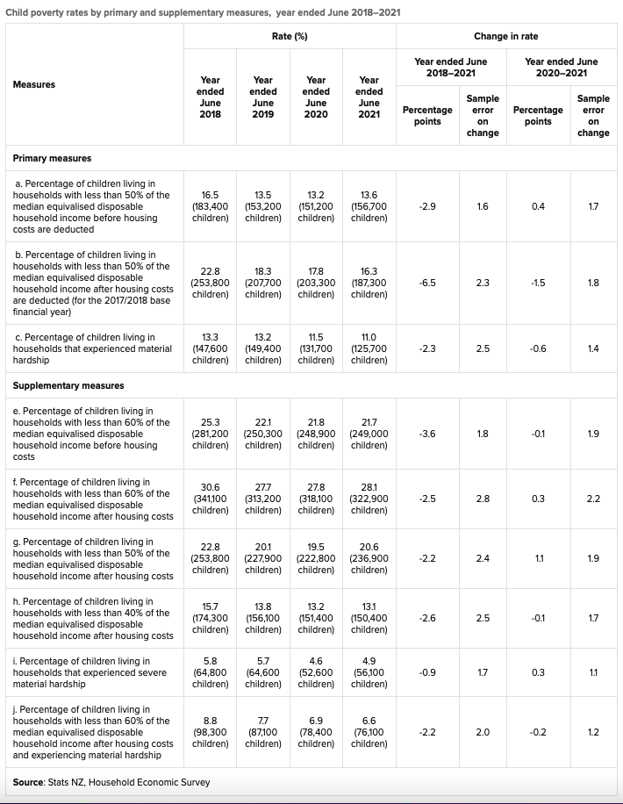
Figure 3 Source Stats NZ

4. Statistical data (Question 32 , 33)
4.1 StatsNZ is mandated under the Child Poverty Reduction Act 2018 to report on ten official measures of Child Poverty, broken down by ethnicity, disability status and region. Governments are required to set three (2020/2021) and ten (2027/2028) yearly targets for child poverty reduction, against three primary measures.
4.2 Statistics are based on the Household Economic Survey for the previous year. Children living in emergency housing are not captured in this data. The Government is required to report on material hardship, and severe material hardship. The definition of those terms is delegated under the Act to the statistician who provides a written determination (see section 6 and section 34 of the Act).

July 2020-June 2021 Data on after housing costs (AHC)* poverty measures
- 322,900 children (28.1%) were living in after-housing-costs income poverty (60% of equivalised household median, moving-line AHC measure)
- 236,900 children (20.6%) were living in income poverty (related 50% AHC measure)
- 150,400 children (13.1%) were living in severe income poverty (40% or less AHC measure).
*While ‘after housing costs’ (AHC) are not among the government’s three chosen measures but we use them as a reflection of high housing costs in New Zealand.
4.3 We note, however, that income and material measures such as the ability to buy shoes, food and pay the rent do not capture the full impact of child poverty. In the words of one rangatahi:

Youth Poverty can look like many things. It can look like coming to school with the wrong uniform because their family cannot afford the proper clothes but the school rules punish students for it. It also looks like rangatahi who miss out on opportunities because their families do not have the funds to support them. Furthermore, child poverty can look like a kid who sleeps on the floor on a mattress because there aren't enough beds. It’s important to note when having a kōrero around child poverty that there are many layers and experiences underlined with mamae and guilt. Every child will have a different experience and so it’s vital when laws are being debated on and kaupapa are being introduced that they are as versatile and as equitable as possible, so that no child misses out on awhi.
4.4 While we acknowledge the progress made towards lifting some children out of poverty, we remain concerned with the lack of progress for Māori, Pasifika, and disabled children. Progress against the baseline measures since 2017/2018 is shown below.
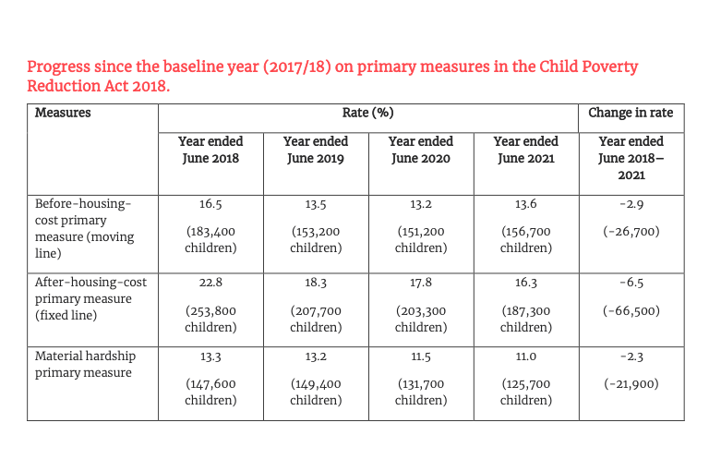
Figure 4 Source: Child and Youth Wellbeing Strategy Annual Report for Year Ending 30 June 2021 (April 2022) p 30
4.5 Figure 17 below sets out the graph for severe material hardship broken down by ethnicity for the years 2019-2021. Figure 18 provides the data for material hardship by ethnicity for years 2019 - 2021. Figure 20 shows trends in the rates of material hardship from 2013 – 2021. Material hardship is used because income measures capture only one aspect of child poverty. Not all low-income households are in hardship, but some households with incomes above low-income lines (income poverty lines) are in hardship. In addition to income, a more ‘child-centric’ material hardship approach is adopted. A helpful infographic for how child poverty is measured in New Zealand can be found at: https://www.stats.govt.nz/infographics/how-we-measure-child-poverty
4.6 Figure 5 outlines the questions asked to capture the experience of living in poverty from the perspective of a child, and the responses for years 2018/2019 and 2019/2020.
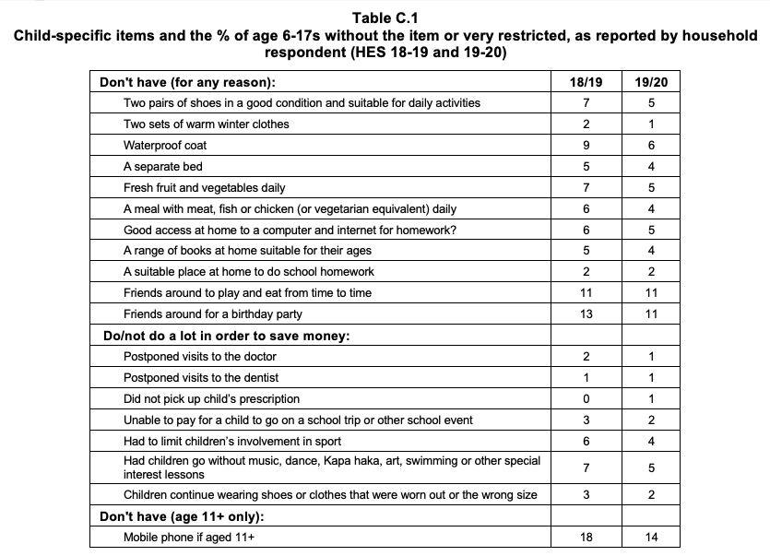
Figure 5 Source, Bryan Perry, 'Child Poverty in New Zealand’, Ministry of Social Development, at p32.

5. Link Between Poverty, Health and avoidable hospitalisations
Article 24 (Question 22)

5.1 We are concerned with the impact on the health and development potential of children living in poverty [Article 24]. This is linked to persistent inequalities in health and developmental outcomes. The Child Poverty Related Indicators report on rates of potentially avoidable hospitalisations for ages 0-14 years of age. Poverty can be a barrier to health outcomes through a complex matrix of causes. These range from overcrowding, damp and/ or cold homes, poor diet, parents unable to take time off work to take children to medical appointments, and costs of medical care.
- We refer the Committee to the Thematic Report, ‘Basic Health and Welfare Rights of Children 0-5 years of age’ to which we have contributed additional information on poverty and its link to poor health outcomes.

6. Impact of COVID-19 pandemic (Question 2(b))- New Developments

6.1 The government undertook steps to mitigate the severest impacts of the COVID-19 pandemic (COVID) on incomes (until June 2021), but COVID has nonetheless exacerbated inequalities in New Zealand, with financial strain disproportionately impacting those on fixed and low incomes. There is high demand in food bank usage, an increase in those receiving benefits, higher food costs and rising petrol prices.

6.2 The government’s COVID response has been criticised for favouring the most well-off. The ‘Wage Subsidy Scheme’ (which saw $20 billion spent) has had little impact on those experiencing the most hardship, and the government proceeded despite Treasury warnings the scheme would create increased inequality. Recent analysis from the Auckland University of Technology shows that young Pasifika women under the age of 30 years have been particularly affected by the pandemic policies, with inequalities between Pākehā and Pasifika exacerbated. In the year ended June 2021 (compared with the year ending June 2020) Stats NZ data shows that while average annual household equivalised disposable income (after tax and transfer payments) increased from $47,727 to $50,164 (up 5.1%), average weekly housing costs increased 2.5% (from $340 to $348.60) and there was an increase of 5.4% for those paying rent (the average went from $372.30 - $392.30 per week).

6.3 Worryingly, COVID has significantly affected school attendance, with mandatory lockdowns. There is now close to double the number of children who are missing or not enrolled in schooling. [See Figure 6] While there is no clear data as to how many of these absent are due to children leaving school to help support families, Secondary Principals Association president Vaughan Couillault has stating that, "If there was a choice, students would stay in school, but there are those who don't have that luxury."This threatens to create a cycle of poverty where children are supporting families at the expense of completing their education. As one rangatahi has observed:

“In the 2020 lockdown hundreds of students left school to find employment mainly in warehouse and factory jobs. These kinds of jobs, although earn a lot of money, are tiring, extensive, and are long hours which push rangatahi to overwork. Instead of focusing on education the government forces them to leave school in order to ensure there is food on the table. The issues of food insecurity and dropout rates at high school are linked. They are catalysts for each other and so they need to be solved together. Initiatives like kids can, food for schools, and breakfast club help to normalise students seeking support.”
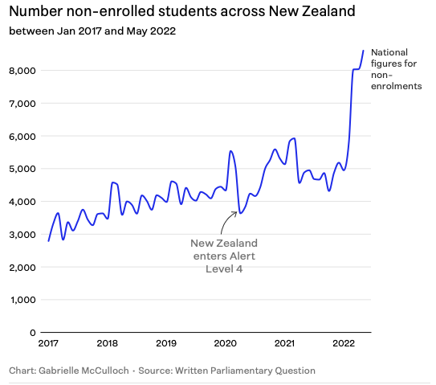
Figure 6 Source Parliamentary Question
6.4 We draw the Committee’s attention to the fact that the current government statistics do not take into account the August-September 2020 lockdown, or the 2021 lockdown in Auckland (August-December). These lockdowns, and the recent dramatic increase in inflation have put more families in financial stress, and hardship grants are increasingly being used to make ends meet. [See Figure 7]

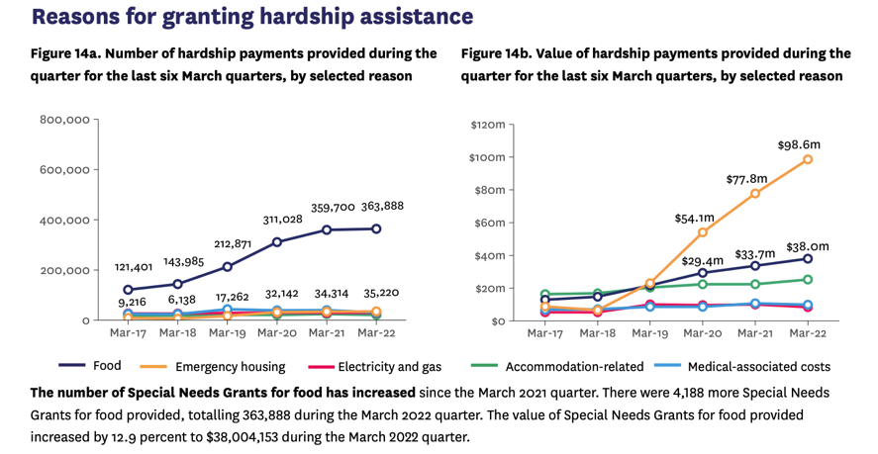
Figure 7 Benefit Fact Sheet March Quarter , p7.

6.5 COVID has also affected the ability to conduct face-to-face interviews in homes, resulting in a smaller sample size for the Household Economic Survey. While Stats NZ states that they have found “no discernible impact” on their survey results, homeless families, and those in emergency housing are not captured. Therefore we consider that using additional datasets is justified. In this report we refer to foodbank statistics and qualitative studies to supplement the Stats NZ data. For example, the Child and Youth Wellbeing Strategy Annual Report for year ending 30 June 2021 (released April 2022) stated that there was a 26% decrease in food insecurity for children. We suggest that this figure no longer accurately reflects foodbank usage, and refer to independent data from the Auckland City Mission that show a dramatic increase in foodbank reliance in the last two years [See Figure 13].

7. Government obligations and Article 4 (Question 5: Allocation of Resources)

7.1 Article 4 of the Convention requires the state to “undertake measures to the maximum extent of their available resources”. The state’s response and its obligations under the Convention must be gauged with reference to its current economic profile. New Zealand is a high-income country with GDP $355 million (StatsNZ). Current financial statements show that “Core Crown revenue was $2.9 billion higher than forecasts driven by core tax revenue, while core Crown expenses were $1.4 billion lower than forecast.”
7.2 New Zealand’s debt cap is low when compared with debt caps in other countries [ see Figure 8]. New Zealand’s net debt as a percentage of GDP is only 20%, around half that of Australia (at 38%). Net debt in the US is nearly five times higher than New Zealand. This demonstrates that New Zealand can support higher net debt levels up to 30%, which would allow better state responses to poverty to help those children who are suffering in the harshest conditions of severe material hardship.

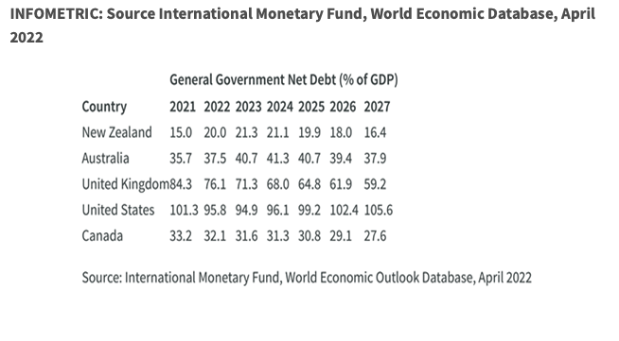
Figure 8 Source International Monetary Fund, World Economic Outlook Database, April 2022
7.3 In the last decade there has been two independent investigations into child poverty and welfare inequity in New Zealand. One was initiated and led by the Commissioner for Children (Expert Advisory Group on Solutions to Child Poverty, 2012), and the other initiated by the Government and led by the now current Governor General, Professor Cindy Kiro (Whakamana Tāngata: Restoring Dignity to Social Security in New Zealand, 2019). The full recommendations from these reports have not been implemented. Crucially, child poverty in New Zealand exists in a society where adult and senior rates of poverty have largely been resolved.
7.4 We acknowledge the commitment this government has made to lift benefits and income since it came in to power in 2017. [See Figure 9]. In our view New Zealand’s economic profile is robust enough to sustain additional economic responses to reduce entrenched rates of child poverty. Its failure to do so must, at some level, be read as being due to a political reluctance to make the transformational changes necessary. We remain concerned that there is a lack of significant ‘affirmative social measures’ (as suggested in UN Committee’s Fifth Periodic Report) that the UN considered are required ‘even in situations of economic crisis, natural disasters or other emergencies’ to shift poverty for the children left behind.
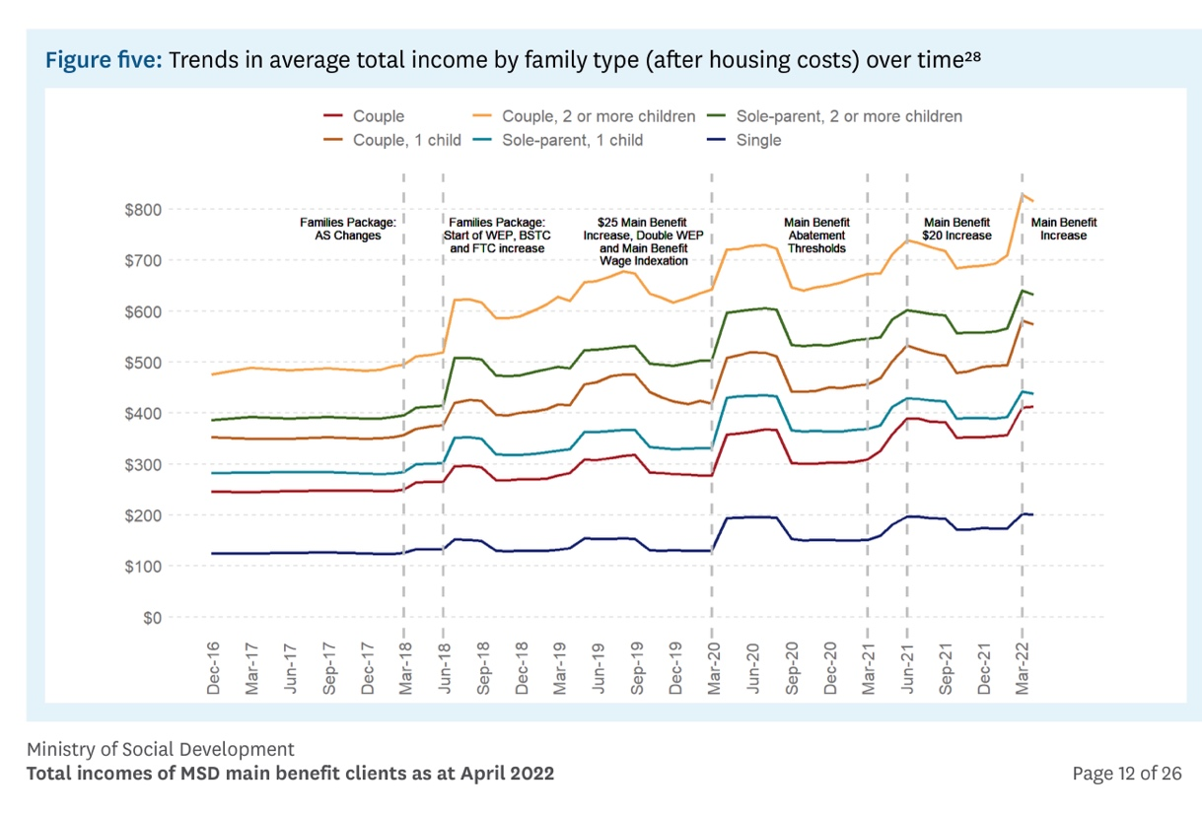
Figure 9 Working Paper: Total Incomes of MSD, Ministry of Social Development p 12

8. The right to adequate food and nutrition: Articles 24, and 27:
Question 2 (c) New Development – High rates of food Insecurity

8.1 Food security is related to the right to food or nutrition. We note the Convention uses the term ‘nutrition,’ not merely ‘food’. We note that Article 24(1) states that “State Parties shall strive” but this must be balanced against Article 24 (2) which states “State Parties shall pursue full implementation of this right, and in particular, shall take appropriate measures.” [Emphasis added].

8.2 We assert that in the context of New Zealand’s economic profile these provisos cannot be read to justify significant food insecurity experienced by children who are going hungry.

“Around 40% of families experience material hardship at any single time point during the formative first two years. When this occurs, many make sacrifices (household heating, cheaper food choices) in order to pay for other things.”

8.3 Food Insecurity 2019/2020 at a Glance:
- One in five children lived in households that ran out of food due to costs ‘sometimes’ (15.6%) or ‘often’ (4.3%).
- For Pasifika children 35.4% ‘sometimes’ run out (c.f. 10.0% for ‘often).
- For Māori children this figure is 21.9% ‘sometimes’ and 7.9% “often’. [See Figure 10 for additional data]
8.4 It is helpful to categorise food security by the three “A’s”: ‘available’, ‘accessible’, and ‘adequate’. While food in New Zealand may be readily ‘available’ (e.g. we are a food producing nation), we note that for many children, food is not ‘accessible” (which encompasses economic affordability) and neither is the food which is economically viable ‘adequate’.
Adequacy means that the food must satisfy dietary needs, taking into account the individual’s age, living conditions, health, occupation, sex, etc. For example, if children’s food does not contain the nutrients necessary for their physical and mental development, it is not adequate. Food that is energy-dense and low-nutrient, which can contribute to obesity and other illnesses, could be another example of inadequate food.
8.5 Stats NZ figures show that food price inflation rose to 6.6 per cent in June 2022 (compared with June 2021) with meat, poultry, and fish prices increased 6.8 per cent. Fruit and vegetable prices increased 5.5 per cent. The largest monthly contributor to the rise was the cost of fruit and vegetable prices which rose 4.9 per cent.
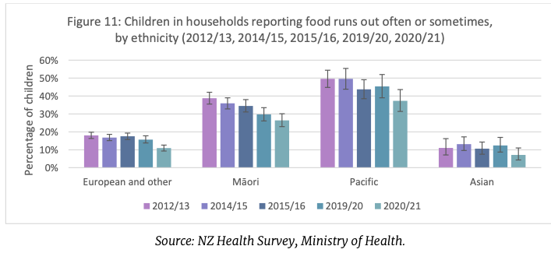

Figure 10 Child Poverty Related Indicators Report for year ending 30 June 2021, at p 19
8.6 While the right to food is distinct from the right to be fed, it does encompass (especially in relation to childhood nutrition) the right of children to have their nutritional needs met through the state enabling conditions where parents can meet the nutritional needs of the child. In New Zealand many families rely on food banks to feed their family. This has been exacerbated by COVID.

8.7 The government has responded to increasing food costs by creating a new position of a ‘Groceries Commissioner’ to sit within the Commerce Commission. We welcome this new initiative, but note that there are calls to think more broadly to solve the issue of continuing access to healthy food. Mothers are going without food to enable their children to eat, and a recent study led by the University of Otago states that due to women adapting to sacrifice for the sake of their children, the full extent of the problem is likely to be masked.
8.8 Chair of the Māori Food Network (which supports 38,000 households across Tāmaki Makaurau, Auckland) Hurimoana Dennis calls on the government to examine more innovative solutions:
“We’re looking at some stuff that goes well beyond food banks, well beyond food vouchers, well beyond kai packs. We are over that type of thinking and response to food, it’s a deficit. That is not mana enhancing.”[emphasis added]
8.9 One suggestion is to remove GST from basic groceries like fresh fruit, vegetables, milk, and bread. In the words of one woman:

There needs to be no GST on fresh fruit, meat, milk, yoghurt and bread, and maybe basic baseline cereals … because why would you buy your child a bottle of milk, when you can buy them three times as much coke for the same price?! It disturbs me, like it’s all backwards!

8.10 Children living in households under 40% AHC are most deprived on fresh fruit and vegetables (a “lot”). See Figure 11.
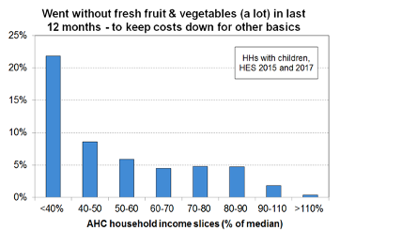
Figure 11 Bryan Perry, ‘Child Poverty in New Zealand’ Ministry of Social Development, p 94
8.11 Food security is highly linked to debt for many families. One whānau-based survey found that 82% of those who made the choice between food and debt were servicing debt to Work and Income. [See Figure 12].
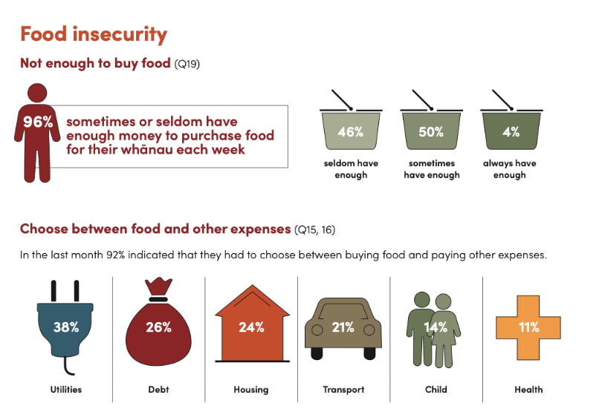
Figure 12 Source Kore Hiakai Zero Hunger Collective report- April 2022
8.12 Statistics from the Auckland City Mission show that the number of food parcels distributed each year (ending June from 2008/09 to 2020/21) has risen sharply. Over ten years (2010/11 to 2020/21) the number of food parcels increased from 9,239 to 48,679. [See Figure 13]
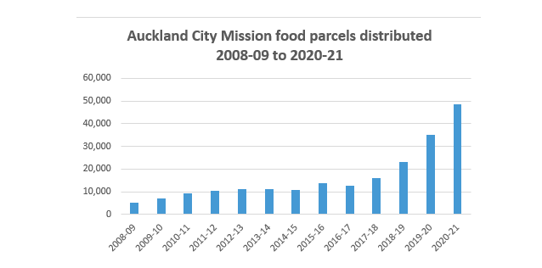
Figure 13 Auckland City Mission

9. Best Interest of the child (Question 10) Article 3

9.1 New Zealand currently fails to put the “best interests” of the child as a matter of primary consideration in key legislation and policy. As a result of this failure (particularly in relation to the Social Securities Act and the ‘Working for Families’ package) many families of young children face higher degrees of material hardship than they otherwise would. The government’s progress on this is slow. We note that this issue was raised by the Commissioner for Children’s Expert Advisory Group on Solutions to Child Poverty in 2012. In the New Zealand context ‘best interest’ of the child for tamariki must be understood as being both ‘a collective and individual right’.

- Note: Due to word constraints we are unable to provide the depth of discussion we consider necessary to address the level of concern we have around these issues. Please see a fuller analysis in Appendix Two.

10. Child and youth wellbeing strategy (Question 24) Standard of living

10.1 Child poverty links to the government’s Child and Youth Wellbeing Strategy (the Strategy) and its Programme of Action, particularly the outcome ‘Children and Young People Have What They Need’, where the main focus is increasing material wellbeing of households living in poverty and hardship. There are four main areas of focus. A record of government programmes allocated to address child poverty in the 2022 Budget is available. Under the Strategy, the government has chosen five indicators to track its progress that relate “Children and Young People have What they Need”:

- Material wellbeing
- Child Poverty
- Food insecurity (CPRI)
- Housing quality (CPRI)
- House affordability (CPRI)

10.2 Figure 14 shows how the government is tracking against these indicators.

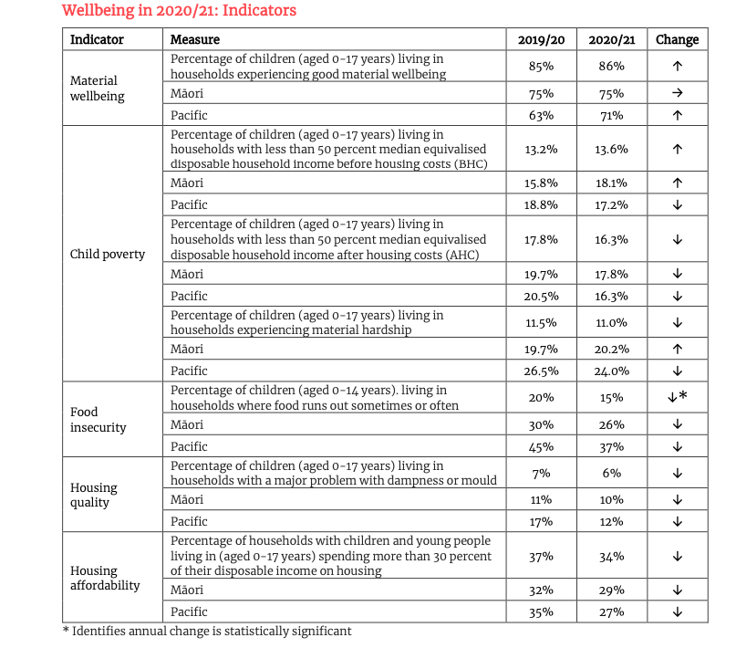
Figure 14 Source: Child and Youth Wellbeing Strategy Annual Report for Year Ending 30 June 2021, p29

10.3 Currently the government has five Child Poverty Related Indicators (CPRI) :
- Housing affordability: percentage of children (ages 0-17) living in households where housing accounts for more than 30 percent of disposable income.
- Housing quality: percentage of children (ages 0-17) experiencing dampness or mould as a major problem.
- Food insecurity: percentage of children (ages 0-14) reporting that food runs out ‘often’ or ‘sometimes’.
- Regular school attendance: percentage of children and young people (ages 6-16) regularly attending school.
- Potentially avoidable hospitalisations: rate of children (ages 0-14) hospitalised for potentially avoidable illnesses.
10.4 See Figure 15 for the government’s analysis of how they are tracking against these measures.
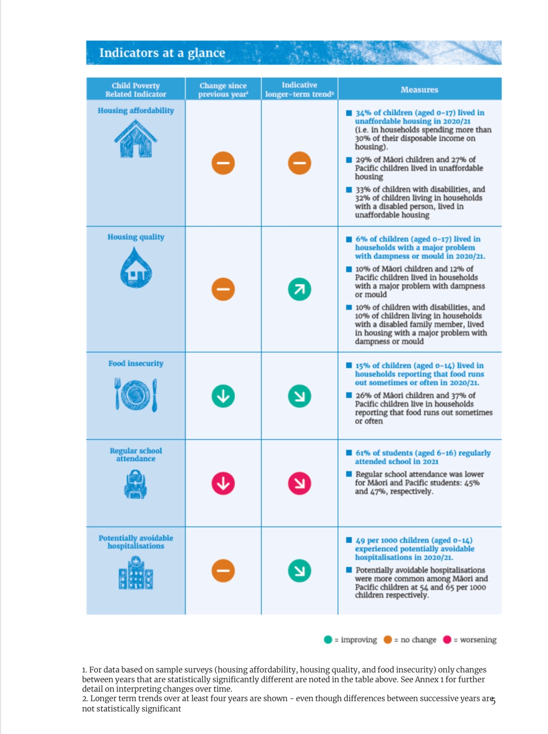
Figure 15 Source, From Child Poverty Related Indicators Report for Year Ending 30 June 2021 (Released April 2022) p 5

Associated data: (Question 41)

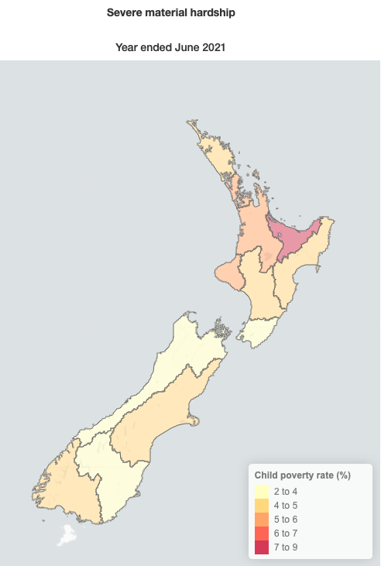
Figure 16 Severe Material Hardship per region Source: Stats NZ

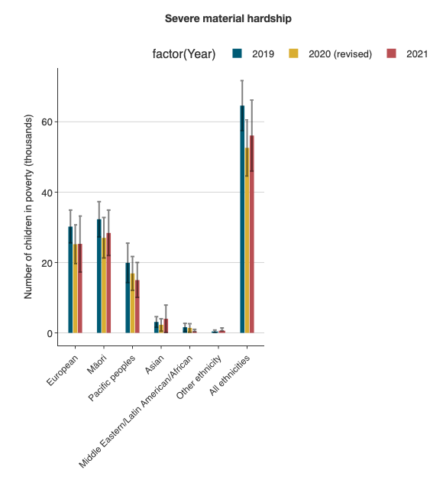
Figure 17 SOURCE Stats NZ Severe Material Hardship 2019-2021 by ethnicity

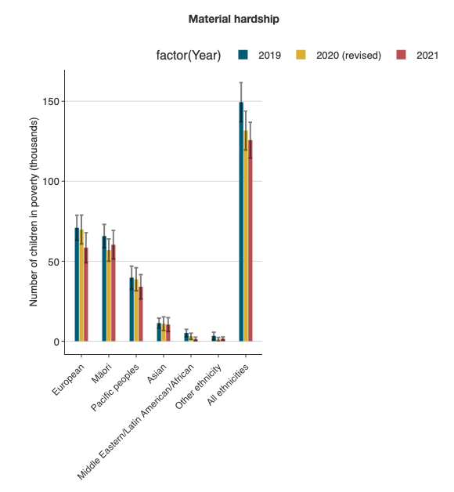
Figure 18 Source Stats NZ Material Hardship 2019- 2021 by ethnicity

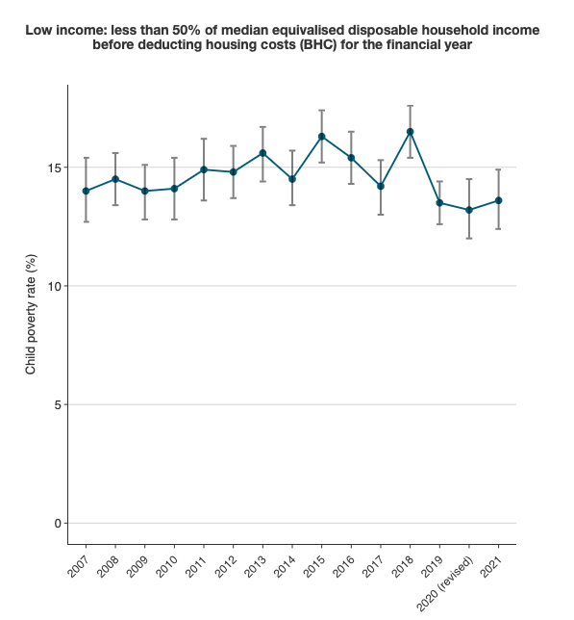
Figure 19 Source Stats NZ Mean equalised disposable household income before deducting housing costs 2007-2021

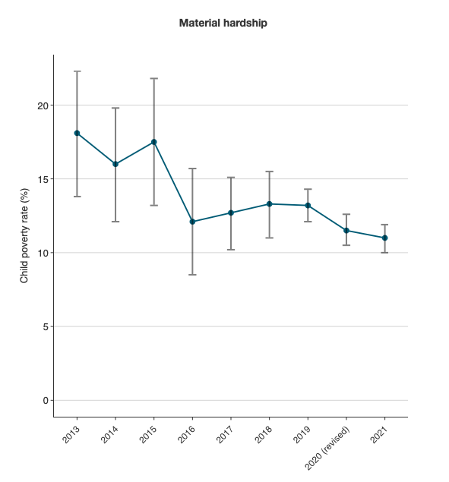
Figure 20 Source Stats NZ Material hardship % poverty rate years 2013-2021

PART TWO

11. OBSERVATIONS
11.1 The government must formulate an action plan (with adequate resourcing and timelines) to address inequalities and reduce poverty for the most severely affected groups in society (Māori, Pasifika, and children with disabilities).
11.2 It is concerning that New Zealand is in the process of losing its Children’s Commissioner, and transitioning over to a new board structure at this time. We have concerns that in this transition, the focus on child poverty will be lost in the overall mix of issues that the new board will face. We strongly recommend that the position of Children’s Commissioner is retained. [See Appendix 2]
11.3 We recommend that New Zealand create a new position, (similar to the approach taken in Canada) of a legislated advisory council on poverty, that sits as a monitor for progress. This should have powers to independently monitor, advise, and recommend the government on actions needed to ensure that targets set in the Child Poverty Reduction Act are met. This will ensure objective, independent, analysis of the trends and efficacy of the strategy that allows monitoring distinct from political ideology.
11.4 At the moment New Zealand’s targets under the Child Poverty Reduction Act are broad, so that targets under the Act may be met in the aggregate, but Māori, Pasifika and disabled children are ‘left behind’. As discussed in further detail in the Thematic Report by the Aotearoa NZ Centre for Indigenous Peoples and the Law, when it comes to the reducing disparity experienced by tamariki Māori, while it is essential that they achieve parity with other children, the ultimate aim, and responsibility, of the government is to ensure that their unique rights under te Tiriti and the Indigenous Declaration are also achieved.
11.5 Addressing child poverty for Māori requires responses that recognise the wider impact of colonisation and give effect to the guarantees under te Tiriti that Māori would exercise authority over their own peoples, lands and resources, live in accordance with their own laws and customs and have equal rights to British citizens. For example, high rates of child poverty, food insecurity and obesity can be linked to the failure to give effect to te Tiriti and the impacts of colonisation, which have both worked to erode the Māori resource and economic base, including their access to, cultivation and preparation of traditional foods in accordance with Māori laws and customs.
11.6 Current research suggests that part of the solution to food insecurity for Māori will be a ‘decolonising approach where Māori voices and values are central within NZ policies policy-making process’. We support the position taken in the Thematic Report by the Aotearoa NZ Centre for Indigenous Peoples and the Law that any action taken to reduce disparities experienced by tamariki Māori must also seek to give effect to their unique rights as te Tiriti partners and Indigenous people, in addition to achieving their parity with non-Māori children. We support the Centre’s call for the “Government to develop a mechanism…in partnership with Māori, including tamariki Māori, to ensure that all the rights of tamariki Māori are recognised and provided for in government-led action going forward.”

12. Immediate recommendations

- Retain the position of Children’s Commissioner. We do not support repealing the Children’s Commissioner Act 2003 and replacing the Commissioner with a Board known as the Children and Young People’s Commission. [See Appendix 2]
- We call on the Government to develop a ‘partnership model’ with Māori to address high rates of poverty experienced by tamariki Māori. This model should recognise the special obligations to tamariki under te Tiriti, the Indigenous Declaration and the Convention.
- A Child Poverty Reduction Advisory Council needs to be established with independent oversight and monitoring of child poverty. This should function to reflect the voices of children, and those with lived experiences of poverty.
- Enshrine ‘the best interest of the child’ as a matter of primary consideration in all relevant legislation.
- We recommend a shift that embeds policy ‘triggers’ with clear budgeted lines for Māori, Pasifika, children with disabilities, and sole parents. Specific measures are needed for these groups to enable parity with others and, for tamariki Māori, to ensure their specific rights under te Tiriti and the Indigenous Declaration are fulfilled. Current measures that focus on the overall profile of poverty are too broad, and fail to address poverty for groups who experience the highest rates of poverty. This is necessary to ensure than no child is left behind.
- There is the need for disaggregated data for children that measure rates of poverty, and its impact on child development. This must include disaggregated data by age range for Māori, Pasifika, and children with disabilities. The current age range of 0- 17 years is too broad to enable any responsive policy interventions, and does not allow adequate consideration of the effects of poverty on child development as anticipated by Article 27.
- Reform Working for Families and apply a ‘best interests’ of the child test to the Income Tax Act 2007 to enable all low-income children (irrespective of whether their parents receive welfare) to receive the ‘In-Work Tax Credit’. [Appendix 2]

13. Further recommendations
- Increase disability allowances to rates provided in other similar countries (note: The median payment for disability-related allowance is close to three times higher in the United Kingdom than in New Zealand).
- Working for Families: Remove the discriminatory effects of policy that mean that children of parents on benefits miss out on at least $72.50 per week. [See Appendix 2]
- Replace the current complex matrix of tax credits with a simplified approach that prioritises a child payment to 100 percent of children aged 0 to 5 years inclusive, then based on family income from age 6 years onward.
- Free public transport.
- Full rollout of the ‘food in schools’ initiative to all schools.
- Collect data from families in emergency housing for the purposes of the Household Economic Survey.
- Prioritise public housing that is ‘fit for purpose’ for families with young children and those with disability.
- Adopt and develop an action plan with adequate resourcing and timelines in consultation with Māori, Pasifika, and disability communities to achieve parity in poverty rates for all children.
- Immediately abolish benefit sanctions, where the beneficiary is the primary caregiver of dependent children.
- Remove GST from basic food items such as meat, cheese, milk, fruit, vegetables, and bread.
- Immediately review MSD debt, as a ‘circuit-breaker’ that creates food insecurity for those with debt to MSD.
- Amend the legislation to explicitly recognise the relationship between poverty reduction and the State’s obligations under te Tiriti, the Convention and other human rights covenants such as UNDRIP, and Sustainable Development Goals.
- Amend legislation to recognise the specific obligations under the Convention in relation to the development potential of the child, and amend the Child Poverty Reduction Act to recognise the development potential of the child as a paramount concern in achieving poverty reduction measures.
- Amend the legislation to require the state to implement an annual budgeted forecast, with ‘trigger points’ requiring responses for Māori, Pasifika, and children with disabilities. Cross-governmental work streams should be developed, alongside a financial commitment to implement these plans, and a timeline.
- Establish a response to poverty that recognises barriers and experiences of poverty for sole parents.
- Immediately amend policy and legislation so MSD and Department of Justice are required to have joint oversight of any administration of a “warrant to arrest” sanction. This is to ensure that the impacts on any child or children in the care of the offender is taken into account.
- Delink the automatic trigger that leaves the Ministry of Justice in sole charge of automatically administering sanctions with little oversight of best interests of the child or MSD.
- Disaggregated data for monitoring purposes that links health outcomes and age / stage of children for the first 1,000 days and under five year olds.
- Urgently reform Working for Families (WFF) to redefine goals so that the focus is on the needs of children, not paid work. [Appendix 2]
- Extend the “In-Work Tax Credit” to all low-income children, including those families on benefits.
- Index all WFF payments to wages annually (and to inflation when it exceeds wage growth) as is the case for NZ Superannuation.
- Increase WFF thresholds from which WFF starts to reduce to restore the real value last set in 2018, and index annually. In 2022, it should be at least $47,000.
- Immediately amend the ‘cost of living payment’ pursuant to the Taxation (Cost of Living Payments) Act. This should be provided to beneficiaries with children under the age of 18 years, regardless of whether they are receiving the Winter Energy Payment.
- Review unfair and outdated rules around ‘relationships fraud’.
- Urgently adjust the indexation of abatement thresholds in line with inflation.
- We note that the government has identified the need for Inland Revenue, the Ministry of Justice and MSD to be joint lead agencies on the review of debt to Government. We seek assurances that this review has the best interests of the child as the paramount concern.

Committee on the Rights of the Child, ‘Concluding observations on the fifth periodic report of New Zealand ’CRC/C/NZL/CO/5 (Adopted by the Committee at its seventy-third session 13-30 September 2016). We note that New Zealand has a number of reservations to the Convention, including the reservation that the Government reserves the right to interpret and apply the Convention accordingly See reservations UN Convention on the Rights of the Child | New Zealand Ministry of Justice website accessed 22 June 2022
Ibid, p7
Ibid, p5
Ibid at point 10(a), p 3
Ibid at point 9(a), p3
As suggested by the Committee, Ibid at point 35(a), p 12. See also Committee on the Rights of the Child, ‘List of issues prior to submission of the sixth periodic report of New Zealand’ CRC/C/NZL/QPR/6 (Adopted intersessionally by the pre-sessional working group on 6 July 2020), question 24 (b) at p 6
Committee on the Rights of the Child, ‘Concluding observations on the fifth periodic report of New Zealand ’CRC/C/NZL/CO/5 (Adopted by the Committee at its seventy-third session 13-30 September 2016) point 36 (B), p 12
Te Puna Rangahau o Te Wai Ariki; Aotearoa NZ Centre for Indigenous Peoples and the Law ‘Thematic Report: The Rights of Tamariki Māori in Aotearoa New Zealand’ (2022) p 7
Ibid, p 7. We note also the discussion of the link between the ability of tamariki to enjoy their rights under the United Nations Convention on the Rights of the Child (the Convention) and the rights of their whānau, hapū and iwi under te Tiriti.
Royal Commission of Inquiry Abuse in Care ‘He Purapura Ora, he Mara Tipu: From Redress to Puretumu Torowhanui’ (December 2021, Volume One) https://www.abuseincare.org.nz/our-progress/reports/from-redress-to-puretumu/
Ibid, p 29.
Allen and Clarke, ‘Process Evaluation of the Child and Youth Wellbeing Strategy: Final Report’ (February 2022), p5 https://www.childyouthwellbeing.govt.nz/resources/process-evaluation-child-and-youth-wellbeing-strategy
Ibid, p 6
This led to a key recommendation that the Government embed Māori participation in strategy leadership, and consider reinstating a Strategy Reference Group to provide independent advice and expertise from Māori and Pasifika. [Recommendation 1 and 2] Ibid, p 47
Ibid, p 6
See Bryan Perry, ‘Child Poverty in New Zealand: The demographics of child poverty, survey-based descriptions of life ‘below the line’ including the use of child-specific indicators, and international comparisons - with discussion of some of the challenges in measuring child poverty and interpreting child poverty statistics’ (Ministry of Social Development, Wellington) June 2021, p 25
M Duncanson, H van Asten, et al, ‘Child Poverty Monitor: Technical Report’ 2021 (Commissioned Report for External Body) New Zealand Child and Youth Epidemiology Service. Retrieved from http://hdl.handle.net/10523/12540
https://www.stats.govt.nz/information-releases/household-income-and-housing-cost-statistics-year-ended-june-2021
https://www.nzherald.co.nz/nz/politics/megan-woods-not-ruling-out-cuts-to-funding-for-housing-for-disabled-people/A3KPKZXL4D5AHZ5QF3M3O2AASE/
“For example, the HES does not include the families in Emergency Housing which includes around 4000 children” in Bryan Perry, ‘Child Poverty in New Zealand’ (June 2021) p 15
The term ‘statistician’ is defined under the Child Poverty Reduction Act with reference to section 2 of the Statistics Act 1975
Susan St John, ‘Commentary: Improving the Child Poverty Monitoring Framework’ (Child Poverty Action Group, 2022) https://static1.squarespace.com/static/60189fe639b6d67b861cf5c4/t/62bbd935210c4b1411e8d647/1656478014065/0513_CPAG+improving+the+framework+23+May++2022.pdf
For a discussion of the wider lasting impacts on health, education, and overall wellbeing (such as the ability to maintain friendships) see Children’s Commissioner’s Expert Advisory Group on Solutions to Child Poverty, ‘Solutions to Child Poverty in New Zealand: Evidence for Action’ (2012), p 17 https://www.occ.org.nz/publications/reports/final-report-solutions-to-child-poverty-evidence-for-action/
Views of Luke, a rangatahi speaking on child poverty from the te ao Māori perspective supplied to the author for inclusion in this report. I am thankful for the assistance of Tineka Kumeroa for the collection of this viewpoint.
Child Poverty Action Group, ‘Bold Policy Change Needed to Support Stagnant Child Poverty Rates’ Feb 24, 2022 https://www.cpag.org.nz/media-releases/bold-policy-changes-needed-urgently-to-shift-stagnant-child-poverty-rates
Bryan Perry, ‘Child Poverty in New Zealand’ (Ministry of Social Development, Wellington) June 2021, p31
Note, these are not used in DEP-17 or the MWI “ as they do not meet two of the key criteria for such measures – they are not suitable for all ages, and do not represent a good range of severity of hardship, only deeper hardship for most of the indicators.” Bryan Perry, Ibid, p 31
See Cure Kids, ‘State of Child Health in Aotearoa New Zealand Report 2021’ (Released 22 June 2022) https://curekids.org.nz/wp-content/uploads/2022/07/2021-State-of-Child-Health-final_2.pdf
Child Poverty Related Indicators Report for the year ending 30 June 2021 (released April 2022)
Including the COVID-19 pandemic response stimulus packages and wage-subsidy schemes, and 8.3% of households received a benefit income increase.
https://www.nzherald.co.nz/nz/bryce-edwards-how-much-of-our-cost-of-living-crisis-is-due-to-incompetence/5ETY6CXQMDUCTA6EM2GJYAI2T4/ (20 July 2022)
Data from Stats NZ shows significant changes in terms of average income from government benefits, (such as Job Seeker Support, paid parental leave, and accommodation supplement) which increased by 26.2%. Note: this excludes COVID-19 wage subsidies and Working For Families payments https://www.stats.govt.nz/information-releases/household-income-and-housing-cost-statistics-year-ended-june-2021
https://www.nzherald.co.nz/nz/bryce-edwards-how-much-of-our-cost-of-living-crisis-is-due-to-incompetence/5ETY6CXQMDUCTA6EM2GJYAI2T4/ (20 July 2022)
G Pacheco, A Plum, & L Tran, ‘The Pacific workforce and the impact of COVID-19’ (NZ Work Research Institute, 2022) https://workresearch.aut.ac.nz/research/the-pacific-workforce-and-the-impact-of-covid-19
https://www.stats.govt.nz/information-releases/household-income-and-housing-cost-statistics-year-ended-june-2021
https://www.stuff.co.nz/national/education/300631038/number-of-students-missing-from-school-has-almost-doubled-in-past-nine-months
https://www.nzherald.co.nz/nz/concerns-over-students-again-dropping-out-of-school-to-support-families/C44XBX66JDUN7YWMMCNQP3R6FA/
The perspective of Luke, a rangatahi speaking on child poverty from the te ao Māori perspective supplied to the author for inclusion in this report. I am thankful for the assistance of Tineka Kumeroa for the collection of this viewpoint.
According to Stats NZ website the survey was “reduced to just over 16,000 households from the planned 20,000 households” This has an impact on margins of error, with the margins for error noted by Stats NZ as “higher than designed for”. https://www.stats.govt.nz/information-releases/household-income-and-housing-cost-statistics-year-ended-june-2021
https://www.stats.govt.nz/information-releases/household-income-and-housing-cost-statistics-year-ended-june-2021
Child and Youth Wellbeing Strategy Annual Report for year-end 30 June 2021 (Released April 2022) at p32. https://www.childyouthwellbeing.govt.nz/resources/child-and-youth-wellbeing-strategy-annual-report-20202021
https://www.treasury.govt.nz/system/files/2022-07/fsgnz-11mths-may22.pdf
Susan St John, ‘Government Debt Rethink Removes Barriers for Tackling Poverty’ (Child Poverty Action Group Press Release, May 2022) https://www.cpag.org.nz/media-releases/government-debt-rethink-removes-barriers-to-tackling-poverty
Children’s Commissioner’s Expert Advisory Group on Solutions to Child Poverty, ‘Solutions to Child Poverty in New Zealand: Evidence for Action’ (2012)
Kia Piki Ake/ Welfare Expert Advisory Group, ‘Whakamana Tāngata: Restoring Dignity to Social Security in New Zealand’ (2019)
https://www.msd.govt.nz/documents/about-msd-and-our-work/publications-resources/working-papers/wp-total-incomes-of-msd-main-benefit-clients-as-at-april-2022.pdf
See point 36 (B), p 12 Committee on the Rights of the Child, ‘Concluding observations on the fifth periodic report of New Zealand ’CRC/C/NZL/CO/5 (Adopted by the Committee at its seventy-third session 13-30 September 2016)
Food security exists “when all people, at all times, have physical, social and economic access to sufficient, safe and nutritious food that meets their dietary needs and food preferences for an active and healthy life.” United Nations Fact Sheet 34, ‘The Right to Adequate Food’, p4 https://www.ohchr.org/sites/default/files/Documents/Publications/FactSheet34en.pdf
This approach can be compared with Article 27 which appears to limit the obligation of State Parties with the proviso “and within their means, shall take appropriate measures.” [Article 27 (3)].
Growing Up in New Zealand, ‘Key Findings’ https://www.growingup.co.nz/key-findings
M Duncanson, H van Asten, et al, ‘Child Poverty Monitor: Technical Report’ 2021 (Commissioned Report for External Body) New Zealand Child and Youth Epidemiology Service. Retrieved from http://hdl.handle.net/10523/12540
M Duncanson, G Richardson et al, ‘Child Poverty Monitor 2020: Technical Report’ (Child Poverty Monitor Series) New Zealand Child and Youth Epidemiology Service, Retrieved from http://hdl.handle.net/10523/10585
United Nations Fact Sheet 34, ‘The Right to Adequate Food’, p3 https://www.ohchr.org/sites/default/files/Documents/Publications/FactSheet34en.pdf
Ibid
Ibid
https://www.nzherald.co.nz/business/grocery-food-leads-rise-in-annual-food-price/JWJHZR7P3WHG3J575DZQRY76PI/
See United Nations Fact Sheet 34, p3 https://www.ohchr.org/sites/default/files/Documents/Publications/FactSheet34en.pdf
https://www.beehive.govt.nz/release/new-supermarket-watchdog-latest-action-give-kiwis-fairer-deal
Grace Macaulay, Jean Simpson, et al, ‘Food insecurity as experienced by New Zealand women and their children’, Journal of the Royal Society of New Zealand, (2022) DOI: 10.1080/03036758.2022.2088574
https://www.newshub.co.nz/home/new-zealand/2022/07/cost-of-living-single-mothers-struggling-to-feed-children-due-to-food-insecurity-study.html?fbclid=IwAR0e1_qXYJcQvmIc0FxSiNfYIyiKoiWjABJGTcYYb8vftC4GcOsVPoNPzqI
https://www.nzherald.co.nz/nz/call-for-new-ideas-on-helping-low-income-households-with-high-kai-costs/76STM23S4OJFZFQE43B7YTHTRU/
Grace Macaulay, Jean Simpson, et al, ‘Food insecurity as experienced by New Zealand women and their children’, Journal of the Royal Society of New Zealand, (2022) DOI: 10.1080/03036758.2022.2088574
Bryan Perry, ‘Child Poverty in New Zealand’ (June 2021) p 94
Report for Kore Hiakai/ Zero Hunger Collective, ‘Exploring the Ongoing Need for Food Assistance’ (April 2022) p 8 https://www.zerohunger.org.nz/ongoing-food-assistance-report-public-release
Recommendation 6, Children’s Commissioner’s Expert Advisory Group on Solutions to Child Poverty, ‘Solutions to Child Poverty in New Zealand: Evidence for Action’(2012), p 39
Te Puna Rangahau o Te Wai Ariki / Aotearoa NZ Centre for Indigenous Peoples and the Law, ‘Thematic Report: The Rights of Tamariki Māori in Aotearoa New Zealand’ (2022) p 11
Four areas of focus are; (i) to improve earnings and employment, (ii) create a fairer and more equitable welfare system, (iii) improve housing affordability, quality and security, and (iv) help families with the cost of essentials. Child and Youth Wellbeing, ‘Reducing Child Poverty’ https://www.childyouthwellbeing.govt.nz/our-aspirations/context/reducing-child-poverty
The initial Programme of Action was launched in August 2019 with support from 20 Government agencies and a dedicated fund of close to $3.5 billion to improve child wellbeing. More information on progress is available at https://www.childyouthwellbeing.govt.nz/about/news/child-poverty-report-budget-2022
These are a mix of official measures under the Child Poverty Reduction Act 2018, or gazetted Child Poverty Related Indicators (CPRIs) formally identified under the Act. See Child and Youth Wellbeing Strategy, ‘Annual Report for the year ending 30 June 2021’ (Released 2022) p 27.
Poverty Reduction Act https://www.canada.ca/en/employment-social-development/programs/poverty-reduction/reports/strategy.html#h2.10
See discussion on impact of colonization in Chanel Phillips, Anne-Marie Jackson, Hauiti Hakopa, ‘Creation Narratives of Mahinga Kai’ MAI Journal, (2016) https://journal.mai.ac.nz/sites/default/files/MAI_Jrnl_Vol5_Phillips_final.pdf
Christina McKerchar, et al ‘Ensuring the right to food for indigenous children: a case study of stakeholder perspectives on policy options to ensure the rights of tamariki Māori to healthy food’ International Journal for Equity in Health, (2001)20, Article number 67
Te Puna Rangahau o Te Wai Ariki / Aotearoa NZ Centre for Indigenous Peoples and the Law, ‘Thematic Report: The Rights of Tamariki Māori in Aotearoa New Zealand’ (2022) p 13

