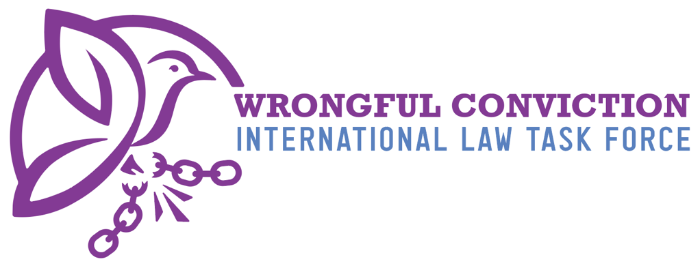

List of Issues for Hungary Prior to Reporting
United Nations Human Rights Committee
Submitted on January 5, 2026

- Authors
The Wrongful Conviction International Law Task Force (WCILTF) is a global coalition of law professors, attorneys and activists working together to fill the “Innocence Gap” in international law. The WCILTF is supported by a pro bono legal team at the international law firm Proskauer Rose (www.proskauer.com/) located in New York City.
In the past twenty-five years, wrongful conviction of the innocent has emerged as a major problem in criminal justice systems around the world. Research indicates that the problem has always existed but has only come to light in recent decades due to forensic advancements allowing for post-conviction DNA testing of crime scene evidence. Wrongful convictions occur because of human limitations in investigation and evidence collection, such as memory weaknesses and malleability (leading to misidentifications by eyewitnesses), unreliable or faulty forensic evidence, false confessions, confirmation bias or tunnel vision on behalf of investigators, inadequate defense lawyering, and many other human problems. Thus, wrongful convictions exist in all legal systems around the world, as all nations use the same types of evidence and investigation techniques regardless of the precise legal procedures employed in their courtrooms.
NGOs called “Innocence Projects” have sprung up around the globe to combat this problem, and now entire networks of innocence projects exist in Asia, Europe, North America and South America. Innocence Projects are often housed at law schools and are operated by law professors and law students. In one member state, for example, more than 3,000 innocent people have been released from prison in recent years due to the work of NGOs like Innocence Projects. Exonerations of the innocent have occurred across the globe in the past three decades.
For a brief video overview of the global problem of wrongful convictions, and the efforts of Innocence Projects to combat the problem, please view: https://youtu.be/jMATkuFaRU8?si=fO0wXGhPr-oCyhBA
As the innocence movement has developed a global presence in recent years, it has become apparent to legal scholars that an “Innocence Gap” exists in international law. The WCILTF formed to combat this problem and help fill the Innocence Gap. The WCILTF is comprised of more than twenty-five law professors and Innocence Project leaders from across Asia, Europe, North America and South America.

- Filling the Innocence Gap
Due to the relatively recent discovery of wrongful convictions, international law covenants and treaties predate awareness of this problem and thus do not speak directly to issue. In recent years, however, the United Nations Human Rights Committee (HRC) has identified key rights to the benefit of incarcerated person claiming innocence to be derived from the right to a fair trial and other existing rights. For example, in Abdiev v. Kazakhstan, 2023, the HRC stated that the right of incarcerated persons to re-open a criminal case in order to present new evidence of innocence after conviction and appeal have concluded, in order to achieve exoneration and freedom, is essential to the right to a fair trial under Article 14(1) of the ICCPR. Similarly, on October 3, 2023, in Concluding Observations on the Fifth Periodic Report of the Republic of Korea, the HRC observed that South Korea should “provide adequate legal and financial assistance to enable individuals sentenced to death to re-examine convictions on the basis of newly discovered evidence, including new DNA evidence.” Likewise, on July 25, 2024, in Concluding Observations on the Second Periodic Report of Maldives, the HRC expressed concern “about the lack of information on the existence of a procedure enabling individuals sentenced to death to seek a review of their convictions and sentences based on newly discovered evidence of their innocence, including new DNA evidence, and, if wrongfully convicted, to provide them with compensation.” The HRC recommended that Maldives take all necessary measures to ensure that “death sentence can be reviewed based on newly discovered evidence of their innocence, including new DNA evidence, adequate legal and financial assistance is provided to enable this review and, if wrongfully convicted, individuals have access to effective remedies, including compensation” para. 28(e). See Brandon Garrett, Laurence Helfer and Jayne Huckerby, Closing International Law’s Innocence Gap, S. Cal. L. Rev. 95 (2021), available at: https://papers.ssrn.com/sol3/papers.cfm?abstract_id=3803518#

- Rights of Innocent Incarcerated Persons in Hungary
Based on the research of the WCILTF, it is our belief that Hungary has a formal legal framework that allows incarcerated persons to challenge wrongful convictions based on newly discovered evidence of innocence. Hungarian law provides an extraordinary remedy known as retrial, which permits the reopening of a final criminal judgment when new facts or new evidence emerge that could likely have led to acquittal or a significantly different verdict. Hungary does not impose a strict time limitation on innocence-based retrial applications, meaning an incarcerated person may seek to reopen a case whenever genuinely new and compelling evidence arises. There have been documented cases in which Hungarian courts have granted retrials and ultimately exonerated wrongfully convicted individuals, demonstrating that the mechanism can function effectively in exceptional circumstances.
However, although Hungary formally recognizes the right to seek retrial, serious barriers impede meaningful access to justice. Hungary does not appear to provide a dedicated statutory right to post-conviction DNA testing of crime-scene evidence. Individuals claiming innocence cannot independently compel DNA re-analysis after conviction; instead, they remain dependent on prosecutorial or judicial discretion. This constitutes a critical gap, especially given the proven importance of DNA testing in uncovering wrongful convictions worldwide. Compounding this concern, Hungarian law does not establish a clear legal obligation requiring the long-term preservation of biological evidence for potential future DNA testing as scientifica capabilities advance in the future. Once proceedings conclude, evidence may be disposed of, limiting opportunities for scientific re-evaluation even where innocence may later be demonstrable.
Hungary also does not maintain a broad post-conviction transparency or “sunshine law” system granting access to case files for defense attorneys, NGOs, journalists, or incarcerated individuals. While Hungarian criminal procedure provides strong pre-trial access to the prosecution file and imposes a duty on authorities to consider exculpatory circumstances, this openness does not extend to the post-conviction phase.
Hungary has made progress in recording certain police interrogations, particularly those involving vulnerable individuals, but interrogation recording is not universally required in all criminal cases, or even required in serious cases like homicide or rape. Likewise, while Hungary regulates police identification procedures and incorporates meaningful safeguards—such as requiring the presence of similar fillers and the separate viewing of line-ups by multiple witnesses—the law does not expressly incorporate scientifically recommended best practices such as double-blind administration or sequential presentation.
- Questions to Hungary
- Does Hungary have a law allowing incarcerated persons to petition for post-conviction DNA testing of crime scene evidence to prove innocence and seek relief?
- Does Hungary have a legal procedure requiring biological evidence collected from the crime scene to be properly stored and preserved for future DNA testing?
- If so, how long must the biological evidence be preserved?
- Does Hungary have a “sunshine law” or “public records law” granting defense attorneys, NGOs, journalists or incarcerated persons access to police files and documents of an incarcerated person’s case post-conviction?
- Does Hungary have a legal standard requiring the police and prosecution to disclose to the defense pre-trial any exculpatory evidence or other information helpful to the defense or that might lead to new avenues of pre-trial investigation that might be conducted by the defense?
- If so, what is the legal standard pertaining to this disclosure requirement?
- Does Hungary have laws or regulations requiring the recording of police interrogation of suspects? If so, please outline the requirements of such laws or regulations.
- Does Hungary have laws or regulations ensuring that police identification procedures for eyewitnesses adhere to best practices devised by the scientific community, such as the double-blind eyewitness identification requirement? See https://www.ojp.gov/ncjrs/virtual-library/abstracts/double-blind-sequential-police-lineup-procedures-toward-integrated
This document created by the following members of the WCILTF:
Irene Monti, LLM candidate, University of Cincinnati College of Law
Professor Mark Godsey, University of Cincinnati College of Law
To contact the WCILTF generally, please email:
Prof. dr. mr. G.J. Alexander Knoops. Professor Mark Godsey
Advocaat/Attorney at law University of Cincinnati College of Law
Professor Politics of International Law Director, Ohio Innocence Project
alex@knoopsadvocaten.nl markgodsey@gmail.com

