16/12/2020, Vilnius
Lithuanian Prisoners’ Rights Centre
Pravieniskes II, Lithuania

Parallel report on the 3rd periodic review of Lithuania under the CESCR
To the UN Committee on Economic, Social and Cultural Rights

Dear President and Members of the Committee,

The Lithuanian Prisoners’ Rights Centre has the honour to present its parallel report on breaches of the Covenant on Economic, Social and Cultural Rights by Lithuania.

- Breach of Article 6: right to work.

  - Breach of the right to work by confiscation of ID documents of all suspects in criminal cases.
- The breach of the right to work under Article 6 of the CESCR starts during the pre-trial investigation. The general practice is to confiscate an ID card and a passport of a suspect while he remains free, and it is unclear whether he would be convicted in the future.
- A confiscation of the ID documents means that the person loses the right to be employed, and this is a breach of the right to work. For instance, KJ is suspected of acting against political interests of Lithuania, and his ID documents were confiscated by the Order of the Chief Investigator dated 21/10/2022 in the criminal case No. 01-2-00016-22. The Certificate No. RK04-2022-2023 of the Lithuanian Employment Office dated 20/10/2022 confirms that KJ may not be employed due to absence of ID documents (taken by the Chief Investigator):
- Thus, we kindly request the Committee to conclude that Article 6 prohibits Lithuania to confiscate ID documents of suspects seeking employment when employment is not possible without ID documents, as well as to pay pecuniary damages to the persons who had been unable to get employment due to absence of ID documents seized by the police.

  - Breach of the right to work by confiscation of signatures gathered by prisoners from other prisoners during elections to the European Parliament in 2019.
- There is no prohibition to work in prison, and Article 6 of the Covenant provides this right.
- However, there is a very long list of professions that are prohibited by law to prisoners. The Committee should pay particular attention to the following professions:
  - The prisoners shall be granted the right to work as lawyers. If a prisoner may work as a cleaner or in the kitchen, why cannot he work as a lawyer? The State party must amend the Lithuanian Bar Law in order to authorize prisoners to be members of the Bar and to practice law. Particularly so, given the fact that most of the lawyers are imprisons for defense of human rights, and for other political reasons.
  - The prisoners are prohibited to be employed as signature gatherers in political parties. For instance, on 20/03/2019, during the elections to the European Parliament, Deputy Director of the Praveniskiai Prison confiscated over 7,000 signatures of prisoners by arguing that prisoners do not have the right to gather signatures of other prisoners. As a result, due to the absence of signatures, the Prof.S.Tomas List was excluded from running for election in April 2019. Gathering signatures during elections is employment and it is protected by Article 6 of the Covenant. Thus, we request the Committee to find that prisoners have the right to work by gathering signatures of other prisoners contrary to the explanation of the Pravieniskiai Prison dated 20/03/2019 and supported by the Lithuanian Prison Department.
- Thus, we request the Committee to conclude that Lithuania is in breach of Article 6 of the Covenant due to the prohibition for political prisoners to work as lawyers and due to the fact of confiscating electoral signatures gathered by prisoners in the Pravieniskiai Prison on 20/03/2019 during the elections to the European Parliament, and that the State party must authorize prisoners (particularly political prisoners) to work as lawyers, and as gatherers of signatures during elections.

- Breach of Articles 6, 13(c), 15(1)(a), and 15(1)(b) by prohibiting access to internet in prisons.

- If a prisoner has the right to work in prison, why is he prohibited to work in internet?
- If Article 6 provides the right to work, it also provides the right to work in Internet. However, prisoners are prohibited to have access to Internet.
- If Article 13(c) provides the right to higher education, it also provides the right to education online. Therefore, the prisoners have to be granted the access to Internet.
- If Article 15(1)(a) provides the right to take part in cultural life, it also provides the right to take part in cultural life online. Prisoners would like to visit cultural events, museums, art galleries online, to read about art online, to participate in online ceremonies at the Hindu temples. Actually, all Lithuanian Hindu temples have live online broadcasting of their services. Article 15(1)(a) provides the right to practice religion online.
- Article 15(1)(b) provides the right to enjoy the benefits of scientific progress. Internet is a benefit of scientific progress.
- Thus, Articles 6, 13(c), 15(1)(a) and 15(1)(b) provide prisoners the right to access Internet.
- Thus, we request the Committee to conclude that Articles 6, 13(c), 15(1)(a) and 15(1)(b) provide the right of prisoners to access Internet for the purpose of work, education, participation in cultural and religious life, as well as in order to benefit from scientific progress, and Lithuania must provide prisoners access to internet.

- Breach of Articles 10(1): right to family life.

- Article 10(1) of the Covenant provides the right of prisoners to live in family. In a case when both man and woman (or partners of the same gender) forming a family are imprisoned, they must be provided the right to live in the same room or cell.
- Currently, male and female serve sentences in different prisons, and that separates families.
- Even if family is formed homosexuals, they are not authorized to live in the same cell or room.
- Thus, we request the Committee to conclude that Article 10(1) authorises prisoners forming families to live in the same cell or room, and that the State party must provide such opportunity.

- Breach of Articles 2(2), 7(d), 11(2), 15(1)(a): right to practice Judaism.

- The contemporary Western weekend and Article 7(d) of the Covenant have their historic and religious roots in the Jewish Shabbat. Shabbat is celebrated from Friday evening to Saturday.
- In Judaism, Shabbat and other religious holidays are always celebrated by blessing and drinking red wine, as well as by lightening candles. Wine and candles are an essential part of major Jewish rituals. Shabbat’s Kiddush and Havdallah may not be performed without wine. 4 glasses of wine should be drunken in the Passover seder. Essential part of wine is mentioned in the Holy Bible on many occasions (Psalm 104:15, Deuteronomy 27:7).
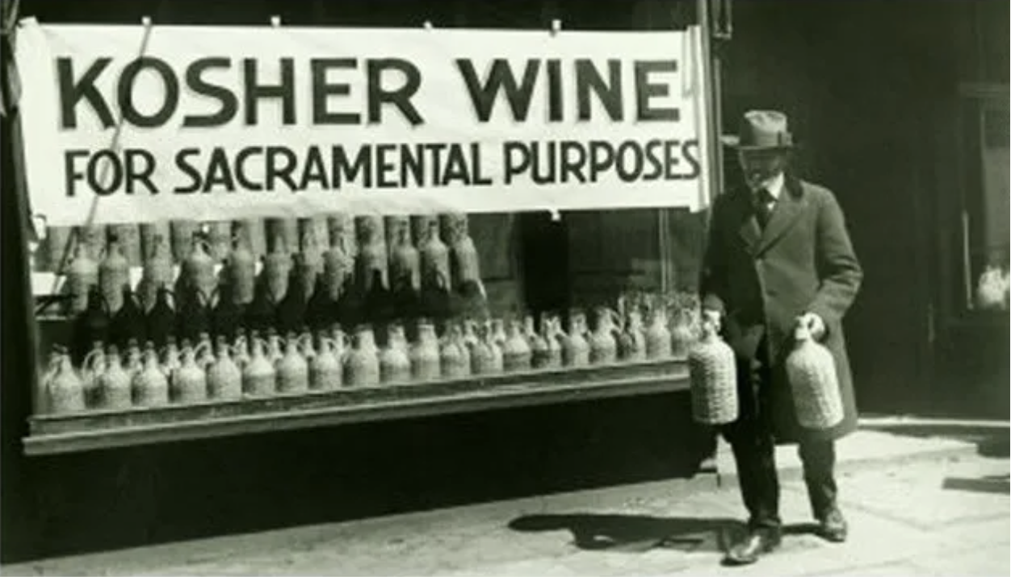
- It is prohibited to drink alcohol for everyone, including Jews celebrating Shabbat and other holidays.
- It is also prohibited to light candles in the Lithuanian prisons. Every Shabbat starts and ends with lightening candles. During Hannukah, Jews light candles every day. Thus, the State party breaches the right to rest and leisure in the prisons.
- Without drinking red wine and lightening candles, Jews may not celebrate Shabbat and other religious holidays, and their right to rest and leisure under Articles 7(d) and 2(2) is breached.
- Moreover, practicing Judaism by celebrating Shabbat and other holidays is protected by the right to cultural life under Article 15(1)(a) of the Covenant.
- Article 11(2) prohibits keeping prisoners in hunger. Observant Jews do not eat non-Kosher food, but the Lithuanian Prison Department does not provide Kosher food. Thus, observant Jews suffer from hunger. By the refusal to provide Kosher food in prisons, the State party breaches Articles 2(2) and 11(2) of the Covenant.
- We request the Committee to conclude that Articles 2(2), 7(d), 11(2), 15(a) provide the right to prisoners to practice Judaism by celebrating Shabbat and other holidays by blessing and drinking red wine and lightening candles. The State party must provide Kosher food to religious Jews in prisons.

- Breach of Articles 2(2), 6 and 12 due to wide spread torture in prisons
  - Breach of Articles 2(2) and 12 in the Lithuanian secret prison
- Article 12 of the Covenant provides the right to the enjoyment of the highest attainable standard of physical health. The purpose of torture is to harm health of a prisoner. Thus, it also prohibits torture in prisons.
- The UN Treaty bodies condemned Lithuania for torturing Arabs in secret prisons in § 9 of its Concluding Observations No. CCPR/C/LTU/CO/3 dated 2012, § 16 of its Concluding Observations No. CAT/C/LTU/CO/3 dated 2014, §§ 21, 22, 37 its Concluding Observations No. CED/C/LTU/CO/1 dated 2017. The Lithuanian torture mechanisms are best described in the judgment of the European Court of Human Rights in the case Abu Zubaydah v Lithuania, No. 46454/11.
- Torture in the secret prison breached Articles 2(2) and 12 of the Covenant, too.
- The duty of Lithuania under Article 12 is to transfer of all the prisoners of its secret prison, including Mr Abu Zubaydah, from the Guantanamo Bay Prison back to Lithuania and to provide them medical help and social assistance, and to prosecute President Valdas Adamkus of Lithuania or at least the Director General of the Lithuanian State Security Department for establishing the secret torture prison in 2004.
- On these grounds, we request the Committee to find that Articles 2(2) and 12 prohibit torture in the secret prison founded in 2004 in Lithuania as established by § 9 of Concluding Observations No. CCPR/C/LTU/CO/3 dated 2012, § 16 of Concluding Observations No. CAT/C/LTU/CO/3 dated 2014, §§ 21, 22, 37 Concluding Observations No. CED/C/LTU/CO/1 dated 2017, and by the judgment of the European Court of Human Rights in the case Abu Zubaydah v Lithuania, No. 46454/11,
and require Lithuania to return to Lithuania all prisoners of that secret prison in order to provide them medical help and social assistance, as well as prosecute President Valdas Adamkus of Lithuania or at least the Director General of the State Security Department for the establishment of the secret torture prison in 2004.

  - Breach of Articles 2(2), 6 and 12 by torture and murder of Arab refugees
- There is a wide spread torture of Arab refugees who are kept in prisons (the Kybartai prison, for instance). Many Arab refugees are murdered by the Lithuanian State Border Defence Service. For instance, on 04/08/2021, the Lithuanian State Border Service tortured and murdered AAK from Iraq who tried to cross the border in order to ask for asylum, or for a job as the Lithuanian Ministry of Interior claims. The Lithuanian State Border Service continued murdering Arab refugees on 18/11/2022.
- The Lithuanian State Border Defence Service tortured and murdered about 100 Arab refugees who tried to cross the Lithuanian border. The Lithuanian Ministry of Interior claims that Arab refugees shall not be allowed to cross the border since their real intention is to find a job in the sense of Article 6 of the Covenant. Thus, Article 12(1) is breached due to the intention of Arab refugees to work under Article 6, and their wrong race under Article 2(2). Therefore, torture and murder of Arab refugees breach Articles 2(2), 6, 12(1).
- These are several photos of Arab refugees tortured and murdered by the Lithuanian State Border Service:
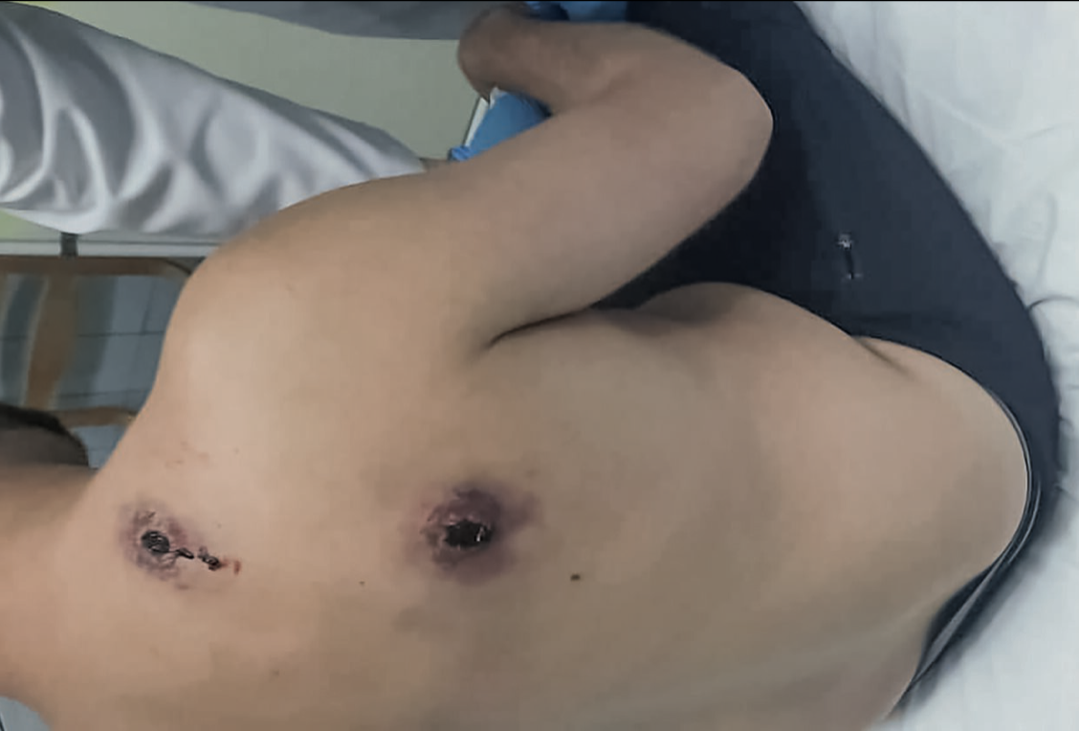
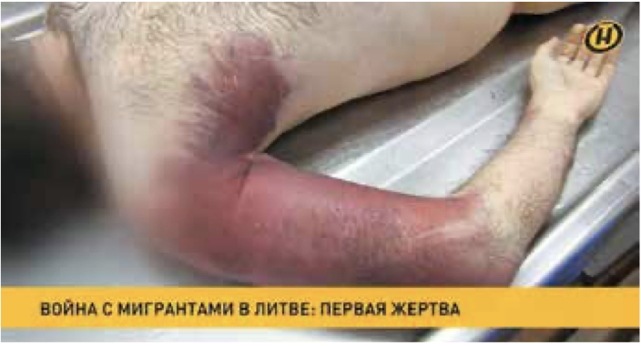
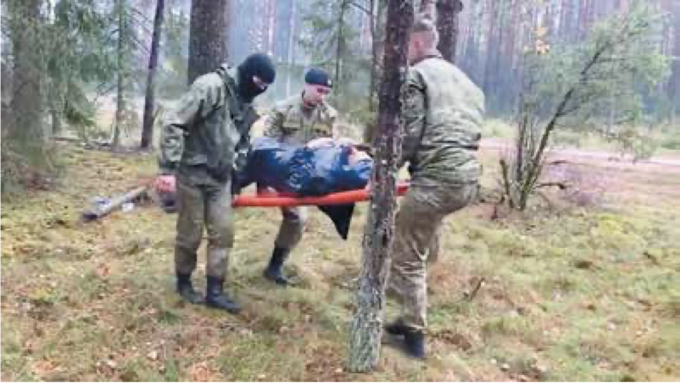
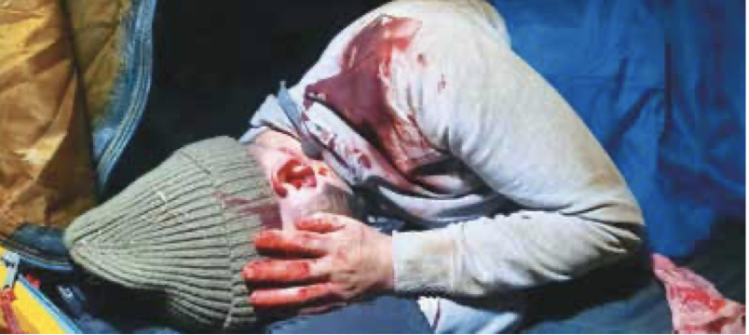
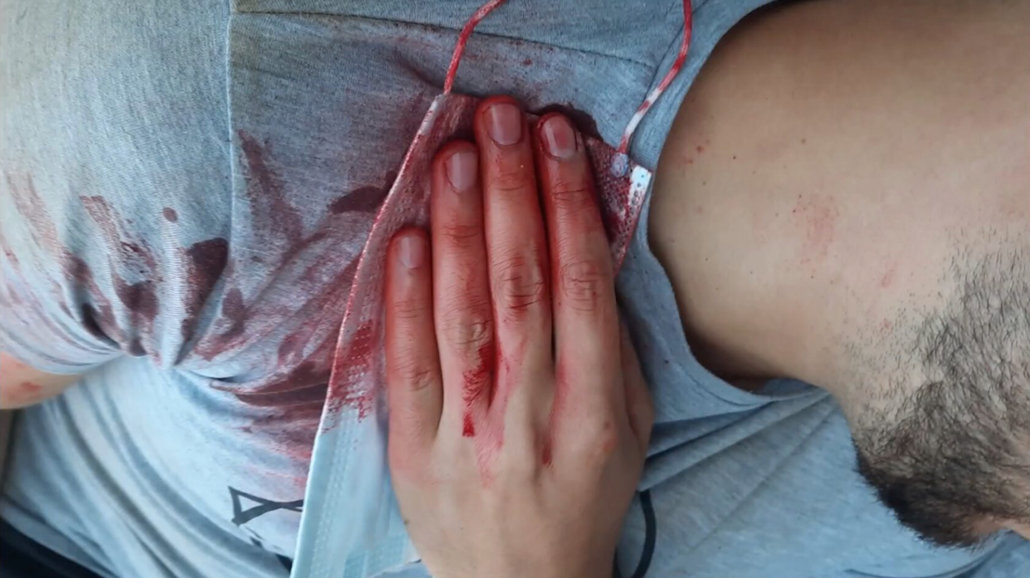
- The Lithuanian Ministry of Interior claims that Arab refugees are tortured and kept in prisons, because their real objective is not asylum, but finding a job, i.e., to work under Article 6.
- Thus, we plead the Committee to conclude that Articles 2(2), 6, and 12 prohibit Lithuania torturing and murdering Arab refugees crossing the Lithuanian border as in the case of AAK on 04/08/2022 and many others,
Require to provide medical assistance and social security benefits to all Arab refugees who became handicapped after torture, as well as require to investigate all the cases of torture and murder by the Lithuanian State Border Service.

  - Breach of Article 12: torture by hypoxemia
- Lithuania tortures not only Arabs in secret prisons, but it is a widely spread day by day practice. All Lithuanian prisoners suffered from torture and inhuman treatment.
- As a rule, prisoners are intensively tortured in order to get self-incrimination.
- The most widely spread of torture is switching off air in the cells, and in the police van cells.
- The most infamous prison is the Vilnius Detention Facility where suspects are kept. None of them is convicted. They are kept in hermetic cells which means that the air does not penetrate the cell from a window or from a door. The only source of air is ventilation. The prison officers simply switch off the ventilation, and remand prisoners die from hypoxemia.
- Prisoners are usually denied medical assistance. Particularly remand prisoners who are kept alone. Since they are kept alone, they have no witnesses that they had actually requested medical help.
- Several famous political prisoners, including Stanislovas Tomas, lodged a complaint requesting a criminal investigation of the fact of switching air in the prison cells and in the police van cells, but the Police Department of Lithuania refused to start investigation of torture by hypoxemia in the case No. 5-S-25971, since the political prisoners were unable to prove that the air had been actually switched off.
- The very fact that Lithuania has several hundreds of hermetic cells in prisons and in police vans where air may not penetrate from windows but exclusively by ventilation on the condition that the ventilation is switched on, is evidence of widely spread torture by hypoxemia.
- In fact, it is impossible to force Lithuania to stop the wide-spread practice of torture by hypoxemia without the assistance of the Committee.
- Thus, we plead the Committee to find that Article 12 prohibits torture by hypoxemia widely practiced by Lithuania against political prisoners in the Vilnius Detention Facility and in the police van cells (particularly in the case No. 5-S-25971), to order Lithuania to close all its hermetic cells where air penetrates by ventilation only, to order Lithuania to use exclusively cells where air penetrated from windows, and to order Lithuania to pay damages to all persons tortured by hypoxemia.

