

Supplementary Information Concerning Women’s Land Rights in Tanzania Submitted to the 63 Session (15 Feb 2016 - 04 Mar 2016) of the Committee on the Elimination of All Forms of Discrimination against Women

January 2016

This submission seeks to supplement the government of Tanzania report by highlighting implementation gaps that adversely affect women in the context of increasing large-scale land-based investments in Tanzania. It is based on analysis and outreach conducted by Landesa, a leading international land tenure organization dedicated to securing land rights for the rural poor with experience in over 50 countries, including Tanzania.
This submission specifically addresses the Committee’s latest Concluding Observations to Tanzania concerning rural women’s “lack of participation in decision-making processes at the community level . . . often lack [of] effective access to the ownership of land, despite the existence of legal provisions providing for such access, as reflected in the low percentage of women who own land; [and] about women’s limited knowledge of their property rights and their lack of capacity to claim them” (para. 43, CEDAW/C/TZA/CO/6 [16 July 2008]).
Rural women’s reality continues to fall short of the equality guarantees in the Convention on the Elimination of All Forms of Discrimination Against Women and fails to reflect the Committee’s guidance to Tanzania to “increase and strengthen the participation of women in designing and implementing local development plans, and . . . ensur[e] that they [rural women] participate in decision-making processes and have improved access to . . . fertile land; and . . . to eliminate all forms of discrimination against rural women with respect to ownership of land” (para. 44, CEDAW/C/TZA/CO/6 [16 July 2008]). Additionally, despite the Committee’s request to Tanzania to “include in its next report comprehensive data on the situation of rural women . . . including the causes for the low percentage of women, as compared to men, who own land, and on efforts by the State party to increase this percentage” (para. 44,CEDAW/C/TZA/CO/6; reiterated in para. 19, List of Issues, CEDAW/C/TZA/Q/7-8 [3 August 2015]), the State report contains no such analysis.
Nor did the State report mention the impact of large-scale land deals and land “grabs” on women’s land rights. While the government of Tanzania has been promoting land-based agricultural investments as a vehicle toward poverty reduction, economic growth, and food security, women smallholders often lack information and have limited technical expertise to negotiate with investors, make informed decisions, and monitor compliance of agreements, risking loss of their land rights and the erosion of their agricultural- and livestock- based livelihoods.

I. Women’s Land Rights are Key to Gender Equality

Ensuring women’s rights to the land they till and inhabit constitutes a foundational aspect of gender equality as envisioned under the Convention on the Elimination of All Forms of Discrimination against Women (CEDAW). Secure rights to land are often a precondition for women’s ability to realize myriad human rights enshrined in CEDAW and other international human-rights treaties. Land rights for women have been linked to greater sustainable development, economic livelihood, equality, adequate living conditions, housing, education, health, freedom from violence, and participation in decision making at all levels. (See graphic on Strengthening Women’s Land Rights below.)

CEDAW Article 14(2) instructs states to facilitate equal participation in and “benefit from rural development” and in particular, women’s right to “equal treatment in land and agrarian reform.” Article 15(2) mandates equal rights to women “to administer property” and Article 16(1)(h) extends equal rights to “both spouses in respect of the ownership, acquisition, management, administration, enjoyment and disposition of property” interpreted to include land. Moreover, even where states have adopted progressive laws, they must still – under Article 5(a) – “modify the social and cultural patterns of conduct of men and women, with a view to achieving the elimination of prejudices and customary . . . practices which are based on the idea of the inferiority or the superiority of either of the sexes or on stereotyped roles for men and women” and as such prevent women from access and control over resources and land.

In its General Recommendation 21, this Committee clarified that “[t]he right to own, manage, enjoy and dispose of property is central to a woman's right to enjoy financial independence, and in many countries will be critical to her ability to earn a livelihood and to provide adequate housing and nutrition for herself and for her family.” It further stressed that “[i]n countries that are undergoing a programme of agrarian reform or redistribution of land among groups of different ethnic origins, the right of women, regardless of marital status, to share such redistributed land on equal terms with men should be carefully observed.”

Numerous Concluding Observations have subsequently affirmed the Committee mandate to instruct state parties to ensure legally enforceable land rights for women facilitated by meaningful participation of rural women in land reforms, effective monitoring mechanisms for the implementation of land reforms, adequate remedies for land disputes involving women, and abolition of all barriers restricting women’s access to land, particularly in rural areas.

Rights to land and property include the right to own, use, access, control, transfer, exclude, inherit, and otherwise make decisions about land-related resources. Women’s land rights are generally considered secure if they are: 1) clearly defined, 2) socially and legally legitimate and recognized, 3) unaffected by changes in women’s social status (such as dissolution of marriage by divorce or death), 4) long-term, (5) enforceable and appropriately transferable, and (6) exercisable without an additional layer of approval that applies only to women.
II. Legal and Application Gaps Hinder Women’s Equal Rights to Information, Decision Making, Benefits, and Compensation from Large-Scale Agricultural Land Investments

Despite steady economic growth over the past decade, over 80 percent of the country’s poor reside in rural areas, with most depending on subsistence agriculture for their livelihood. Meanwhile, investment and large-scale commercial enterprises coupled with government focus on advancing development through natural resources have resulted in an increased demand for land. Set against the backdrop of insufficient legal safeguards for local and public interests, these actions threaten the land tenure security of rural communities, with particularly harsh impact on rural women.
Women, who make up the majority of the agricultural workforce, take charge of food crops, help with cash crops, and provide the bulk of unpaid labor for household production. Overall, men tend to make production and labor-allocation decisions, despite farming fewer hours than women. Even with significant legal changes and programmatic efforts, women hold only an estimated 20 percent of the land registered in Tanzania. The percentage of women holding primary rights to use and control land under customary law is likely far lower. In rural areas in particular, knowledge of land laws is not widespread and even where the formal laws are known, customary law and religious practices continue to govern how land is accessed and transferred.

Although women play a critical role in land-based livelihoods, land reforms have not translated into adequate representation, participation, and benefit from land-related investments. Instead, women are disproportionately affected by large-scale land-related investment projects, which often block their access to the very communally shared productive resources they rely on for their existence and livelihood, such as water sources and foraging areas for firewood and fruit. Access and control of land is critical since the main sources of livelihood in many communities, such as farming, livestock keeping, and harvesting of natural resources, are highly dependent on land.

Application gaps and limited technical expertise undercut women’s land rights
Despite a robust legal framework aimed at strengthening land governance, constraints in implementing national agendas persist. For example, smallholders, as well as village councils and assemblies, often lack information and have limited technical capacity to negotiate with investors, make informed decisions, and monitor compliance of agreements. These challenges undercut the formal and customary land rights of all villagers and prevent women smallholders in particular from benefitting equitably, if at all, from such investments.

For example, unlike other areas of law and policy, ongoing agricultural development programs such as Kilimo Kwanza (Agriculture First) and Southern Agricultural Growth Corridor of Tanzania (SAGCOT) do not place gender issues high on their list of priorities. Despite the State report claim that “through this programme [Kilimo Kwanza], women are given the priority, as leaders in the agriculture sector, to benefit from the proceeds of their agricultural work,” (para. 140, CEDAW/C/TZA/7-8 [3 December 2014]), the overarching aim of Kilimo Kwanza has been to modernize and commercialize agriculture in Tanzania, rather than focus on the majority population of smallholders.

Even with promising land-law reforms, rural populations, and women specifically, are often unaware of potential land deals. For example, less than 10 percent of Tanzania’s estimated 11,000-14,000 villages have village land-use plans. In the absence of village land-use plans and participatory village land-use planning processes, most villages are unable to make informed decisions on land-related investments. In some cases, investors are being asked to fund village land-use plans, raising serious ethical and conflict-of-interest questions. Women’s interests and rights often receive short shrift in such negotiations and as outlined below, women’s representation and participation in such processes remain woefully inadequate.

The land rights of women in the Southern Agricultural Growth Corridor of Tanzania (SAGCOT) are particularly at risk. Tanzania has prioritized large-scale agricultural production for poverty reduction and food security through the SAGCOT initiative. However, there are no mandatory frameworks that require SAGCOT investors to engage in socially responsible investments that address the needs of vulnerable populations in the SAGCOT region, especially women-headed households, the elderly, the disabled, and the landless. Implementation of existing progressive legal protections has been hampered by weak capacity and limited understanding of land laws at the village level. Land and investment deals in Tanzania often lack transparency and stakeholders consultation, as such the rural commons, used by communities including pastoralists and women, lack adequate protections, risking their conversion into unused (and possibly general) land to be traded away to outside investors.
The legal framework for gender equality in land-related investments is largely in place but critical implementation challenges persist:
Women face limited participation in decision making on land-based investments
Although Tanzania’s ambitious land-reform agenda supports women’s rights to land and enables communal management of rangeland and forests, new laws also increased foreign and domestic interest in acquiring land for large-scale investment. Since land is generally controlled

by men, women tend to be excluded from the processes and negotiations concerning land acquisitions by agribusiness investors and as such often do not benefit from compensations. Women may lose their lands in land deals typically negotiated by men as “heads of households,” excluding and marginalizing women from such discussions and transactions.

Given that men constitute the majority members of customary and statutory institutions that adjudicate land disputes, women’s lack of adequate representation further weakens women’s land rights in the face of large-scale land acquisitions. Notwithstanding the strong provisions and quotas on gender in the legislative framework, women are still largely left out of meaningful roles in village decision-making processes. The government report, for example, concedes that only 8 women (19 percent) serve as chairs in the 41 District Land and Housing Tribunals, the appellate body for the Ward Tribunals, which are reported to have a more robust representation of women (82 out of 181 members) but with no specific mention of the ratio of female to male chairpersons (para. 137, CEDAW/C/TZA/7-8).

Moreover, Village Councils and Village Assemblies remain male dominated, making it difficult for women’s voices on land investments to be heard and influential. Compared to men, women tend to attend less and take less active roles in the decision-making processes in Village Assembly meetings, whereas Village Councils are typically chaired by men.

Often, however, even Village Councils and Village Assemblies are not effectively consulted when investors acquire land for agricultural investments through the Tanzanian Investment Center’s land banks. National and district officials typically drive the process, and village authorities often rubber stamp land deals, the implications of which they may not be fully aware. This process not only excludes genuine community participation but also bypasses legislative guarantees for women’s participation in land-related decision-making bodies and processes. Finally, critics contend that the established system of mediation, conflict resolution, and enforcement are ill suited to tackle highly controversial issues such as large-scale land deals.
Low awareness of complex land-investment laws jeopardize women’s land rights While Village Councils and Village Assemblies often do not fully understand the new land laws to enable them to make informed decisions on land-related agricultural investments, women are often even less aware of their rights to land and their ability to protect these rights through village councils and the judicial process. Not the least among barriers to awareness and a nuanced grasp of complex land laws, is the low literacy rate among rural women, which according to the government report is 66 percent and 78 percent for women and men in rural areas, respectively (para. 77, CEDAW/C/TZA/7-8), and limited access to rural-based legal aid. In practice, therefore, men tend to dominate land acquisitions and investment decisions with limited input from female smallholder farmers.
Male-dominated negotiations skew priorities and deny women compensation Large-scale land-related investments affect men and women differently. Recent studies show that women are disproportionately impacted by large-scale agricultural investments. Because women are often excluded when decisions on land-related investments are made, they are also less likely to be compensated fairly or appropriately. For example, a biofuel investor blocked women’s access to water sources, forcing them to travel long distances in search of water. It emerged that these women would have requested the investor to fund alternative water sources closer to their villages. The male negotiators, however, requested that the investor buy a truck, which has proved useless in meeting the women’s daily needs. Women’s influence over decisions carries far-reaching implications for priority setting and community progress. For example, women’s spending priorities frequently differ from men’s and emphasize household needs, nutrition, school fees, and medical services. Moreover, rural women are disadvantaged in attempting to challenge any investment-related decisions, given the limited access to legal aid and counsel in rural areas.

Unclear compensation rules for communal land and secondary land rights further jeopardize women’s rights. Women often bear the brunt of displacement or inadequate compensation; responsibilities socially designated to women (including growing food crops for household consumption) may not be considered when men make decisions, and compensation is less likely to come under their control. Communities using land communally, such as pastoralists, can lose it without compensation. In some cases, women whose rights are considered secondary (e.g., to access forestland for fuelwood or fruit foraging or water sources), and are typically tied to their male kin are not considered for compensation, resulting in loss of land rights and livelihoods.
III. Proposed Recommendations

The following proposed recommendations to the government aim to align state actions toward greater compliance with gender equality under CEDAW in the context of land-related investments:

- Ensure women’s representation and meaningful participation in land-use planning processes and investment negotiations by increasing women’s leadership roles in village governments by rotating village-chair positions between men and women and step up education about land rights among community members, including information about gender-specific impacts of large-scale land investments.

- Reform legal and implementation gaps around large-scale investments to ensure public and community interests are upheld, promote effective gender-equal participation of Village Councils and Village Assemblies in land-related investment processes, assess and address gender-based impacts of investments, and institute gender-responsive compensation practices, including through the inclusion of women smallholder farmers in compensation negotiations and investment contracts.

- Amend the 1999 Village Land Act to clearly protect and compensate communal land acquisitions and clarify land laws to provide for compensation of secondary rights holders such as women, tenants, and informal land occupiers.

- In line with CEDAW’s gender-equality provisions for rural women, adopt the 2012 Voluntary Guidelines on the Responsible Governance of Tenure of Land, Fisheries and Forests in the Context of National Food Security, adopted by the Food and Agriculture Organization of the United Nations and the African Union’s Framework and Guidelines for Land Policy in Africa, to be operationalized at the local, district, regional, and central government levels. In addition, adopt and incorporate the principle of Free Prior Informed Consent in all land and investment deals to enhance public participation in large-scale land acquisitions and investments.

- Document and report on the impacts of large-scale land acquisitions on women smallholder farmers by collecting and disseminating sex-disaggregated data. To ensure effectiveness, accountability, and information sharing, this should be a collaborative effort between the Ministry of Community Development, Gender and Children; the Ministry of Lands, Housing and Human Settlements; the Ministry of Natural Resources and Tourism; the Ministry of Agriculture, Food Security and Cooperatives; the Tanzania Investment Centre; and the Prime Minister’s Office of Regional Administration and Local Government.

- Collect comprehensive data on the de jure and de facto enjoyment of women’s secure rights to land.
***
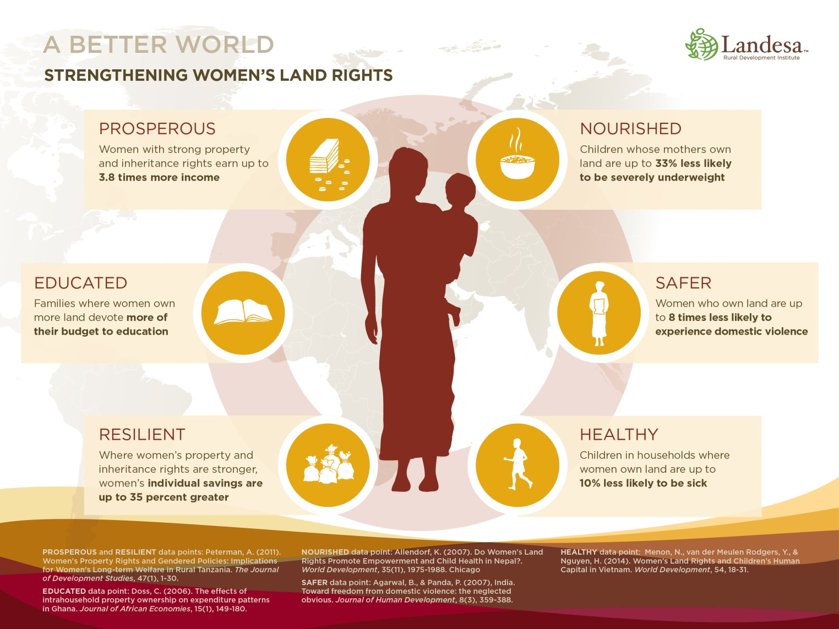

Landesa is an international nonprofit organization dedicated to securing land rights for the rural poor. Landesa has worked in over 50 countries and has contributed to over 110 million families gaining legal land rights, using a combination of robust research, collaborative law and policy design, dedicated advocacy, and tailored evidence-based interventions. www.landesa.org Landesa Center for Women’s Land Rights champions legal norms, policies, and systemic innovations to secure women’s land rights; delivers tailored technical expertise; and nurtures a network of land rights professionals and organizations to strengthen women’s land rights locally, regionally, and globally. ENDNOTES See also, General recommendation No. 28 (47th sess., 2010) - The Core Obligations of States Parties under Article 2 of the Convention on the Elimination of All Forms of Discrimination against Women, para. 31 (“States parties have an obligation to take steps to modify or abolish existing laws, regulations, customs and practices which constitute discrimination against women.”) .
CEDAW Committee, General Recommendation No. 21 (13th sess., 1994) Equality in marriage and family relations, para. 26; see also, CEDAW Committee, General recommendation No. 27 (47th sess., 2010) - Older women and protection of their human rights, para. 48 (“Laws and practices that negatively affect older women's rights to housing, land and property should be abolished. States parties should also protect older women against forced evictions and homelessness); para. 52 (“States parties must repeal all legislation that discriminates against older widows in respect of property and inheritance, and protect them from land grabbing.”).
CEDAW Committee, General Recommendation No. 21, para. 27.
E.g., Bolivia (2015).
E.g., Vietnam (2015).
E.g., China (2014).
Landesa, “Women’s Land Tenure Framework for Analysis: Land Rights” (2013). http://www.landesa.org/resources/womens-land-tenure-framework-for-analysis/. Note also that land rights perceived as secure afford some of these guarantees, even in the absence of formal rights recognition. For example, if a family has lived in a rural area for years without formal documentation, yet they have no threat of being asked to leave, they are said to have perceived tenure security.
World Bank, “Tanzania Mainland Poverty Assessment” (2015), p. xviii. http://www.worldbank.org/content/dam/Worldbank/document/Africa/Tanzania/Report/tanzania-poverty-assessment-05.2015.pdf.
According to the government report, women constitute “53.9 per cent of agricultural labour force” and “69 per cent of women and 62 per cent of men are engaged in agricultural occupations.” Seventh and Eighth Periodic Reports of the United Republic of Tanzania to the Committee, CEDAW/C/TZA/7-8 (3 November 2014), paras. 86, 92.
Jennifer Duncan, “Women’s Land Rights Guide for Tanzania” (Landesa, 2014). http://www.landesa.org/wp-content/uploads/LandWise-Guide-Women’s-land-rights-guide-for-Tanzania.pdf.
USAID, “Property Rights and Resource Governance - Tanzania Country Profile” (2011), p. 11. http://www.usaidlandtenure.net/tanzania.
Ibid.
See, Oakland Institute, “Understanding Land Investment Deals in Africa: Tanzania ” (2011). http://www.oaklandinstitute.org/understanding-land-investment-deals-africa-tanzania
Lawyers Environmental Action Team (LEAT), “Land Acquisitions for Agribusiness in Tanzania: Prospects and Challenges,” (2011), http://landwise.resourceequity.org/record/380, and Future Agricultures, “Lessons for the New Alliance and Land Transparency Initiative: Gender Impacts of Tanzania’s Land Investment Policy,” (2014). http://landwise.resourceequity.org/record/2620.
TNRF. “Understanding Land and Investments in Tanzania” (Info Brief , 2012). http://www.tzdpg.or.tz/fileadmin/_migrated/content_uploads/LBI_Info_Brief_1_.pdf.
TNRF & IIED, “Legal Tools for Citizen Empowerment: A Guide to the Laws Governing Land and Investment in Tanzania” (2012). http://pubs.iied.org/pdfs/G03680.pdf.
See e.g., Mandivamba Rukuni, Cuthbert Kambanje and Gospell Matondi , “Assessment of the Impact of Voluntary Guidelines (VGS) on the Responsible Governance of Tenure on Environmental and Social Safeguards in SAGCOT Region” (Report, 2013). http://www.abcg.org/action/document/download?document_id=557.
See e.g., LEAT (2011) and Rebecka Isaksson and Ida Sigte, “Allocation of Tanzanian Village Land to Foreign Investors - Conformity to Tanzania’s Constitution and the African Charter on Human and Peoples’ Rights,” (2009). http://www.jus.umu.se/digitalAssets/52/52924_ida-sigte-rebecka-isaksson-ht09.pdf;
Tenga and Kironde, “Study of Policy, Legal and Institutional Issues Related to Land in the SAGCOT Project Area” (Draft Report, 2012).
See e.g., LEAT (2011) and TNRF, IIED & REPOA, “Making Land Investment Work for Tanzania Scoping Assessment for Multistakeholder Dialogue Initiative” (2012).
LEAT (2011).
Ibid.
Ibid.; see also, TAWLA, “Position Paper of the Gender Mainstreaming of the Constitution Review Process of Tanzania” (2013).
LEAT (2011).
M. Kennedy Leavens and C. Leigh Anderson, “Gender and Agriculture in Tanzania” (EPAR Brief No. 134, 2011). https://evans.uw.edu/sites/default/files/public/UW_EPAR_Request_134_Gender%20and%20Ag_04102011.pdf.
Rebecka Isaksson and Ida Sigte (2009); LEAT (2011); Rukuni et al (2013).
LEAT (2011), p. 92.
OECD, “Investing in Women and Girls: The Breakthrough Strategy for Achieving All the MDGs” (2010), p 5. http://www.oecd.org/dac/gender-development/45704694.pdf.
Leavens and Anderson (2011), p. 2.
Behrman, Meinzen-Dick and Quisumbing, “The Gender Implications of Large-Scale Land Deals” (2011), p. 9. https://www.researchgate.net/profile/Agnes_Quisumbing/publication/254416923_The_gender_implications_of_large-scale_land_deals/links/00b7d53a80d06da64c000000.pdf
Tenga and Kironde (2012).
UN Food and Agriculture Organization (FAO), “Voluntary Guidelines on the Responsible Governance of Tenure of Land, Fisheries and Forests in the Context of National Food Security” (2012). http://www.fao.org/docrep/016/i2801e/i2801e.pdf
African Union, UN Economic Commission for Africa and African Development Bank Consortium, “Framework and Guidelines on Land Policy in Africa - Land Policy in Africa: A Framework to Strengthen Land Rights, Enhance Productivity and Secure Livelihoods” (2010). http://www.uneca.org/sites/default/files/PublicationFiles/fg_on_land_policy_eng.pdf
The Tanzania Natural Resources Forum (TNRF) has urged the government of Tanzania to adopt the Voluntary Guidelines and the AU Guidelines to accomplish the land-governance reforms promised during election campaigns. Patty Magubira, “Call for new government to adopt AU, FAO models in natural resource governance,” The Citizen (Nov. 8, 2015). http://www.thecitizen.co.tz/News/-/1840340/2948184/-/88ji5x/-/index.html.

