Getting started with INDICO Online Registration in 2 steps:
- Creation of an INDICO account (as 1st user)
- Meeting registration with your INDICO account
NOTE:
Browser: Please use the following browsers, Google Chrome, Mozilla, Firefox, Safari, Edge or Opera.
Passport: Please keep your passport in hand while filling the form. Your personal data must match your details on your passport or ID.
Photograph: You must upload a recent photograph either from your system or taken from the system camera.
Technical Issue: For any technical issue with the registration tool Indico, please contact support.accreditation@unog.ch and not the secretariat of the Committee.

- Create your INDICO account (only for first accreditation)
- Click on the link of the session accreditation
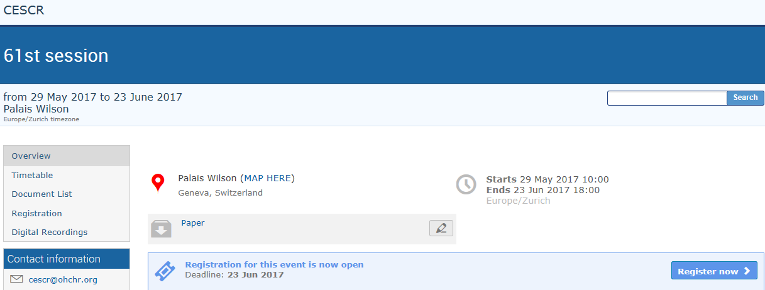

- Go to the Log-in (top right side of the webpage)
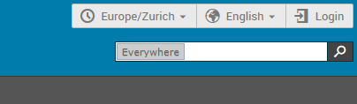
- Click on “Create a new account” 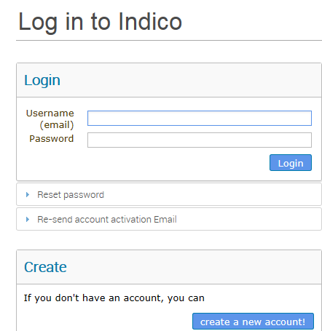

- Fill-in the form for your Indico account
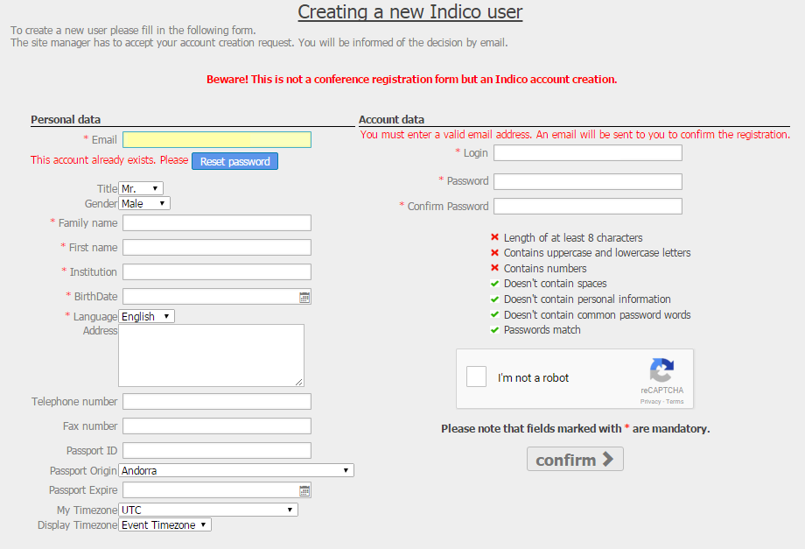
- A confirmation message will be displayed on the screen as shown below.
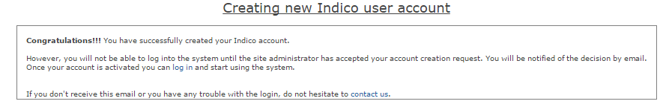
- Once the site administrator has accepted your account creation request, you will be notified by e-mail.
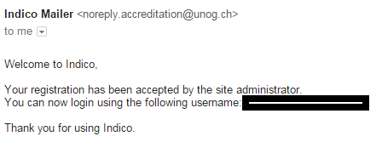
- Meeting Registration with your INDICO account

Once logged in with your credentials, a link will appear to the registration form of the requested session or pre sessional working group.
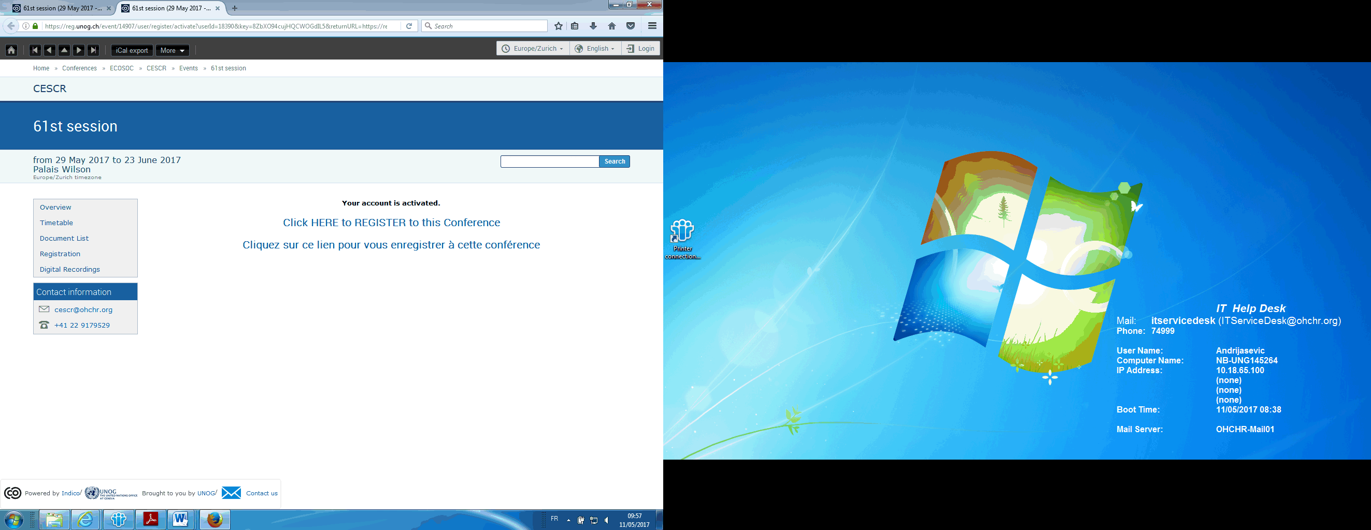

- Click on “the Register to this Conference”
- Fill in the form:
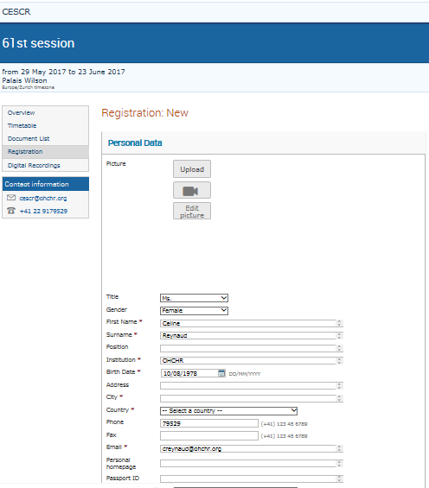
IMPORTANT
- Online registration is mandatory
- Avoid using more than one email account
- The Secretariat is not responsible if you do not register online

Enter the full title of your organization; your name and date of birth; country of origin of your passport or national identity document with date of expiration; telephone number, e-mail, address, occupation and upload a recent photograph or do it directly using the camera icon above.
- Click on Register.
- You will be notified by an email once the secretariat will finish processing your registration.

HOW TO GET YOUR BADGE
In order to get your badge, please bring the confirmation of registration which includes the QR code, with a valid ID bearing a photograph, and appear in person at the security of Palais Wilson (street address: 52 rue des Pâquis, 1201 Geneva, Switzerland)
Important
In certain cases, such as last minute accreditations to the session in Palais Wilson or/and if you haven’t provided any photo on your registration form, you will have to go to pick-up your badge at Pregny Gate (Street address: 8 - 14 avenue de la Paix, 1211 Geneva, Switzerland - which is at Palais des Nations - just opposite the ICRC).

-------------------------
USEFUL TIPS ON INDICO
How to edit your Profile under Indico
- On the top right corner, under user account drop-down, click on My Profile.
- Under Account Details, you can edit your personal details as well as your password.


