27 April 2023

From The European Association of Jehovah’s Witnesses

Submission to the United Nations Human Rights Committee
Prior to the Adoption of the List of Issues
138th session (26 June–28 July 2023)

Republic of Moldova

Contact address: Am Steinfels 1, 65618 Selters, Germany
Tel: 49 6483 41 3802 – Email: inboxopieajw@jw.org

Table of Contents
SUMMARY OF THE SUBMISSION 2
I. INTRODUCTION 2
II. VIOLATIONS OF THE PROVISIONS OF THE COVENANT 3
III. CONCLUSION AND RECOMMENDATIONS 7

Annex
Annex 1 – Venice Commission, Opinion No. 917/2018 on the Draft Law on the Modification of Article 42 of the Constitution of the Republic of Moldova Regarding the Freedom of Association, 19 March 2018

SUMMARY OF THE SUBMISSION
This submission to the Human Rights Committee (CCPR) on the Republic of Moldova highlights violations of the provisions of the International Covenant on Civil and Political Rights prior to the adoption of the list of issues to be taken up in connection with the consideration of the 138th report of Moldova.
Jehovah’s Witnesses in Moldova and as a worldwide organization respectfully request the Government of Moldova and other de facto authorities to:
- Allow Jehovah’s Witnesses to construct, repurpose and use places of worship without arbitrary and unreasonable government interference;
- Respect the rights of Jehovah’s Witnesses to freedom of peaceful association and to peacefully manifest their faith publicly;
- Respect the right of Jehovah’s Witnesses to register their religious associations in the Transnistria Region;
- Respect the right of conscientious objection by maintaining an alternative service programme in the Transnistria Region that is truly civilian in nature, is in line with international standards, is not punitive, is outside of the military sphere, and is not under military control;
- Abide by its commitment to uphold the fundamental freedoms guaranteed by the Covenant for all citizens, including Jehovah’s Witnesses.

INTRODUCTION
  - The European Association of Jehovah’s Witnesses (EAJW) is a charity registered in the United Kingdom. It provides support to Jehovah’s Witnesses facing fundamental human rights violations in various parts of the world.
  - Jehovah’s Witnesses have been in Moldova for more than 100 years. There are some 35,000 worshippers associating in 199 local congregations, which include the Transnistria Region. This is the highest concentration of Jehovah’s Witnesses in Europe. They generally enjoy freedom of worship, as guaranteed by the Covenant, to which the Republic of Moldova acceded on 26 January 1993, and by the European Convention on Human Rights (the Convention), which took effect for Moldova immediately on ratification, 12 September 1997. However, some local government authorities infringe on the rights of Jehovah’s Witnesses to peaceful assembly, and their freedom to peacefully manifest their religion both publicly and in worship within their community, often at the request of leaders of the predominant religion.
  - Officials at times discriminate against Jehovah’s Witnesses by denying building permits or zoning changes for their places of worship (Kingdom Halls). Consequently, Witnesses have been involved in protracted litigation for permission to use a suitable building as a place of worship.
  - The authorities restrict the rights of Jehovah’s Witnesses in the Transnistria Region to practise their faith freely.
    - The de facto authorities in the Transnistria Region refuse to extend legal status to congregations of Jehovah’s Witnesses.
    - Only 2 of the Witnesses’ 29 local congregations in Transnistria, in the cities of Tiraspol and Rybnitsa, have been granted legal registration. The authorities have not allowed either congregation to re-register under the 2009 religion law and are now moving to liquidate the Rybnitsa Religious Community of Jehovah’s Witnesses.
  - The de facto authorities in Transnistria have enacted amendments to the military service law that restrict the rights of Jehovah’s Witnesses who are conscientious objectors.

VIOLATIONS OF THE PROVISIONS OF THE COVENANT
A. Freedom of thought, conscience and religion (article 18)
Manifestation of Religious Belief
  - Firladeni (Hincesti District) On 28 August 2019, Radu Girbu, one of Jehovah’s Witnesses, received a citation by post from the police for peacefully sharing his faith with others. The police alleged that he had violated article 54 (5) of the Administrative Code regarding the law on religious practices, which includes “insulting the religious feelings of individuals”. Mr. Girbu was fined 750 Moldovan lei (MDL), about 38 euros (EUR).
  - The citation and fine were based on a complaint filed by Mr. Mihail Crudu, the local priest, who had harassed Mr. Girbu weekly since December 2018. Mr. Crudu incited local residents to constantly interfere with Mr. Girbu when he was engaged in religious activities. On one occasion, a villager physically assaulted him. Mr. Girbu repeatedly reported these incidents to the police. Finally, on 13 July 2019, the police fined Mr. Crudu MDL 350, about EUR 18, for “obstructing religious freedom”. Thereafter, Mr. Crudu submitted a complaint against Mr. Girbu, claiming that Mr. Girbu had offended his religious feelings, and the citation was issued.
  - On 10 September 2019, Mr. Girbu submitted a complaint to the Hincesti City Court challenging the citation and fine he received on 28 August 2019. On 5 December 2019, the Hincesti City Court granted Mr Girbu’s complaint and annulled the citation and fine. That decision is now final.
  - Ciorescu (Chisinau Municipality) On 5 January 2018, the police summoned Jehovah’s Witnesses Evghenia Petic and Lilia Blanari to the police station for peacefully sharing their faith with others. One of the officers showed the women a copy of a recent decision by the Ciorescu City Council that forbade all religious activity in the city. The police alleged that the Witnesses had violated article 54 (3) of the Administrative Code regarding the law on religious practices and fined each of them MDL 600, about EUR 30.
  - On 19 January 2018, Mss. Petic and Blanari submitted an appeal to the Chisinau City Court, which annulled the fines on 28 March 2018. The Ciorescu Police Department appealed this decision in the Chisinau Court of Appeal (CCA). On 22 May 2018, the CCA rejected the police department’s appeal.
  - On 16 November 2016, amendments to the Law on Freedom of Conscience and Religious Associations went into effect in the Transnistria Region. The Law seriously curbs peaceful religious expression by curtailing “missionary activity”.
Article 18 of the Law states:
“For the purposes of this federal law, missionary activity is recognized as the activity of a religious association, aimed at disseminating information about its beliefs among people who are not participants (members, followers) in that religious association, with the purpose of involving these people as participants (members, followers). It is carried out directly by religious associations or by citizens and/or legal entities authorized by them, publicly, with the help of the media, the internet or other lawful means.”
  - The Law affects the “freedom to seek, receive and impart information and ideas of all kinds”, as protected by article 19 (2) of the Covenant and article 10 of the Convention. It also affects where literature can be distributed (only in houses of worship) and the registering of religious groups (communities, associations and organizations).
    - The US Department of State commented: “Transnistrian ‘law’ prohibits proselytizing in private homes and limits distribution of religious literature to houses of worship and special premises designated by the authorities.” (2021 Report on International Religious Freedom: Moldova)
    - The Law has a chilling effect on the peaceful religious practices of Jehovah’s Witnesses, which have been recognized as legitimate by international tribunals such as the CCPR and the European Court of Human Rights (ECHR). The United Nations Special Rapporteur on freedom of religion or belief, Ms. Asma Jahangir, emphasized the legitimacy of this practice in her 2005 report to the General Assembly, paragraph 63.
Conscientious Objection to Military Service
  - On 12 February 2014, the Alternative Civilian Service Law came into effect in Transnistria. This allowed for conscientious objectors to perform alternative civilian service in lieu of military service. Before this date, conscientious objectors were prosecuted for their stand, or chose to relocate and perform alternative civilian service either in other parts of Moldova or in Ukraine.
  - On 28 February 2018, the Universal Military Service Law was amended to require Moldovan conscientious objectors who visit Transnistria to perform military service even though they no longer live in Transnistria.
  - Jehovah’s Witness conscientious objectors Iury Emelyanov, Vladimir Cotovschi and Mihail Eremeev have been called upon to perform military service under this law and are not permitted to leave Transnistria. Two of these Witnesses, Messrs. Cotovschi and Eremeev, have already completed alternative civilian service elsewhere in Moldova. On 25 May 2019, the three men challenged the decision of the Military Enrolment Committee and filed complaints with the appropriate courts for their place of residence. Their cases are ongoing.
  - Further amendments to the Alternative Civilian Service Law are being considered that will require all purportedly alternative service to be under military control and supervision.
    - This draft provision does not fully comply with CCPR General Comment No. 22, 30 July 1993, on article 18 of the Covenant (freedom of thought, conscience or religion), which Moldova acceded to on 26 January 1993 and which entered into force on 26 April 1993. (CCPR/C/21/Rev.1/Add.4)
    - Forum 18 commented: “If these amendments become law, conscientious objectors in Transdniester [Transnistria] could be deprived of the option of performing an alternative service that is genuinely civilian in nature.”
B. Right of peaceful assembly and association (articles 21 and 22)
Freedom of Association in Places of Worship
  - In 2018, the Venice Commission commended the Government of Moldova for introducing article 42 of the Constitution, which ensures freedom of association in line with article 11 of the Convention. (Opinion No. 917/2018, 19 March 2018) Sadly, this freedom is currently being suppressed for Jehovah’s Witnesses in Moldova.
  - Stefan Voda District. An egregious example of the restriction of religious association is the denial of zoning permits to Jehovah’s Witnesses for a place of worship in the village of Olanesti, Stefan Voda District.
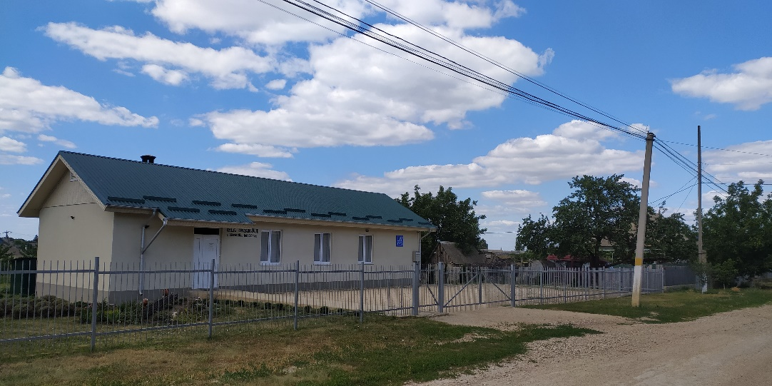
  - In 2016, Jehovah’s Witnesses renovated a house and repurposed it as a place of worship. As required by law, all changes made to the house were approved by the district architect. They submitted the necessary documents to the Olanesti Village Council (the Council) to request a zoning change. When the Council refused the change, the Witnesses filed a complaint with the Stefan Voda City Court (SVCC), which ruled in their favour on 17 August 2021.
Kingdom Hall in Olanesti

  - The Council appealed the SVCC’s decision on 7 September 2021, citing the proximity of the Kingdom Hall to the village church – approximately 200 metres – as the reason for the refusal. The Chisinau Court of Appeal rejected the Council’s appeal and referred the case to the Supreme Court of Moldova, which, on 4 May 2022, ruled that the appellate court’s grounds for dismissal of the case were without merit and remitted it for rehearing.
  - On 7 December 2022, the Court of Appeal rejected the Council’s appeal, leaving the favourable 17 August 2021 decision of the SVCC in force.
Registration of Religions Associations
  - On 19 February 2009, the Law on Freedom of Conscience and Religious Associations in the Transnistrian Moldavian Republic came into force in the Transnistria Region and required the re-registration of all religious associations (communities) by 31 December 2010. All religious associations that failed to re-register were subject to liquidation.
  - Denial of Re-registration of the Tiraspol Religious Community. In 2009, 2013 and January 2014, Jehovah’s Witnesses attempted to re-register their Tiraspol Religious Community. The Ministry of Justice of Transnistria (the Ministry) refused their requests. On 14 March 2014, the Community again submitted their charter to the Ministry for re-registration. After the Ministry refused to re-register the charter, the Community filed a complaint against the Ministry in the Tiraspol City Court. On 28 July 2014, the Court ruled in favour of the Witnesses. However, the Supreme Court of Transnistria overturned the decision on 25 September 2014.
  - On 30 June 2016, Jehovah’s Witnesses submitted communications to the CCPR against both Moldova and the Russian Federation concerning the refusal by the de facto Transnistria authorities to grant re-registration. The communications are still pending.
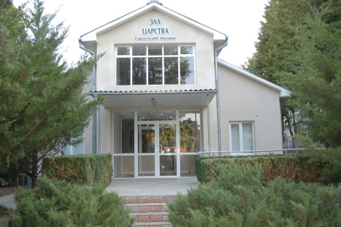
  - Attempted Liquidation of the Rybnitsa Religious Community. In 2009, and again in 2013, Jehovah’s Witnesses tried to re-register their Rybnitsa Religious Community. The Ministry refused their requests on each occasion. On 12 April 2018, the Ministry filed a claim against the Community in the Rybnitsa City Court and requested that it be liquidated on the following grounds: (1) the Community did not re-register their religious association by 31 December 2010; and (2) the Community’s charter no longer corresponds to the laws of Transnistria. The case is ongoing.
Place of worship for Rybnitsa Religious Community of Jehovah’s Witnesses
  - On 14 August 2018, Jehovah’s Witnesses in Rybnitsa again submitted the Community’s charter to the Ministry, having addressed the Ministry’s stated reasons for denial of registration. On 11 February 2019, the Ministry found new reasons to deny registration. On 10 April 2019, the Community submitted a further revised charter to the Ministry. This matter is also ongoing.
Falsely Labelling Peaceful Religious Literature as “Extremist”
  - On 22 November 2022, the Tiraspol City Court ruled to ban eight publications of Jehovah’s Witnesses as “extremist”. This is the same pretext used by Russia to achieve its unlawful and discriminatory goal to ban Jehovah’s Witnesses. However, on 7 June 2022, in the case of Taganrog LRO and Others v. Russia (application Nos. 32401/10 and 19 others), the ECHR decisively ruled that there was no evidence that the publications of Jehovah’s Witnesses are “extremist” or that they “have caused interreligious tensions or led to any harmful consequences or violence, in Russia or elsewhere.”

CONCLUSION AND RECOMMENDATIONS
  - Jehovah’s Witnesses in Moldova and as a worldwide organization express concern for the restrictions to the freedom of religious association, peaceful manifestation of their belief, and conscientious objection to military service. They respectfully request the Government of Moldova and other de facto authorities to take the necessary steps to:
- Allow Jehovah’s Witnesses to construct, repurpose and use places of worship without arbitrary and unreasonable government interference;
- Respect the rights of Jehovah’s Witnesses to freedom of peaceful association and to peacefully manifest their faith publicly;
- Respect the right of Jehovah’s Witnesses to register their religious associations in the Transnistria Region;
- Respect the right of conscientious objection by maintaining an alternative service programme in the Transnistria Region that is truly civilian in nature, is in line with international standards, is not punitive, is outside of the military sphere and is not under military control;
- Abide by its commitment to uphold the fundamental freedoms guaranteed by the Covenant for all citizens, including Jehovah’s Witnesses.
  - EAJW will consider submitting an additional complementary submission with the CCPR after the list of issues has been adopted.

https://undocs.org/A/60/399; paragraph reproduced in Rapporteur’s Digest on Freedom of Religion or Belief (Second edition, 2023) published by UNHCHR, Geneva.
https://www.forum18.org/archive.php?article_id=2511,10 October 2019.

