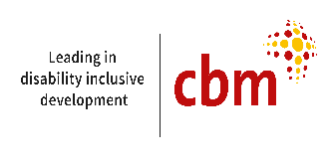
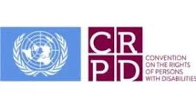  Pakistan 2025 | Alternative Report on the Status of Implementation of the Convention on the Rights of Persons with Disabilities in Pakistan  CBID Network Pakistan

List of Acronyms
ADP | Annual Development Plan
BIMS | Beneficiary Information Management System
BISP | Benazir Income Support Program
BSP | Bureau of Statistics Pakistan
CBM | Christophel Blind Mission
CBDRM | Community-based Disaster Risk Management
CBID | Community Based Inclusive Development
CBID-N | Community-based Inclusive Development Network
CBDRM | Community-based Disaster Risk Management
CNIC | Computerized National Identity Card
CPWB | Child Protection and Welfare Bureau
CSOs | Civil Society Organizations
CWDs | Children with Disabilities
DC | Deputy Commissioner
DEPD | Department of Empowerment of Persons with Disabilities
DDMA | District Disaster Management Authority
DIDRR | Disability Inclusive Disaster Risk Reduction
DIDRM | Disability Inclusive Disaster Risk Management
DRM | Disaster Risk Management
DRR | Disaster Risk Reduction
EWS | Early Warning System
GB | Gilgit Baltistan (Area)
GBV | Gender Based Violence
GDP | Gross Domestic Products
GOP | Government of Pakistan
GOS | Government of Sindh
HANDS | Health and Nutrition Development Society
HI | Humanity and Inclusion
HDIR | Human Development Index Ranking
HHRD | Helping Hands for Rehabilitation of Disabled
HRN | Humanitarian Response Network
ICRC | International Committee of Red Cross
IEC | Information, Education and Communication (material)
INGO | International Non-government Organization
ILC | Independent Living Centers
IP | Implementing Partner
KPK | Khyber Pakhtoon Khawah (Province)
MEAL | Monitoring, Evaluation and Learning
MGDs | Millennium Development Goals
M/o HR | Ministry of Human Rights
NADRA | National Database and Registration Authority
NCCP | National Climate Change Policy
NDMA | National Disaster Management Authority
NDRM | National Disaster Risk Management
NGO | Non-government Organization
NHN | National Humanitarian Network
NCRC | National Commission on the Rights of the Child
OPDs | Organizations of Persons with Disabilities
PD | Project Director
PDMA | Provincial Disaster Management Authority
PSPA | Punjab Social Protection Authority
PWDs | Persons with Disabilities
PWTD | Punjab Welfare Trust for the Disabled
SGDs | Sustainable Development Goals
SNIC | Special National Identity Cards
SPDPA | Sindh Protection with Disabilities Protection Authority
WHO | World Health Organization
WWDs | Women with Disabilities
WB | World Bank

Table of Contents
List of Acronyms 1
1. Background: 5
1.3 Methodology and Approaches: 6
2. Situation Analysis 9
2.1 Reflections to the Pakistan Govt. response to UN on Key Issues 9
Article 1 to 4 of CRPD. General principles and Obligations 9
Article 5 of CRPD. Equality and Non-discrimination 10
Article 6 of CRPD. Women with disabilities 10
Article 7 of CRPD. Children with disabilities 11
Article 8 of CRPD. Awareness raising 11
Article 9 of CRPD. Accessibility 12
Article 10 of CRPD. Right to life 13
Article 11 of CRPD. Situations of risk and humanitarian emergencies 14
Article 12 of CRPD. Equal recognition before the law 15
Article 13 of CRPD. Access to justice 15
Article 14 of CRPD. Liberty and security of a person 16
Article 15 of CRPD. Freedom from torture or cruelty, inhuman or degrading treatment or punishment 16
Article 16 of CRPD. Freedom from exploitation, violence and abuse 17
Article 17 of CRPD. Protecting the integrity of the person 17
Article 18 of CRPD. Liberty of movement and nationality 17
Article 19 of CRPD. Living independently and being included in the community 18
Article 20 of CRPD. Personal mobility 18
Article 21 of CRPD. Freedom of expression and opinion and access to information 19
Article 22 of CRPD. Respect for privacy 19
Article 23 of CRPD. Respect for home and family 19
Article 24 of CRPD. Education 19
Article 25 of CRPD. Health 21
Article 26 of CRPD. Habilitation and rehabilitation 22
Article 27 of CRPD. Work and employment 22
Article 28 of CRPD. Adequate standard of living and social Protection 23
Article 29 of CRPD. Participation in public and political life 24
Article 30 of CRPD. Participation in Cultural life, recreation, leisure and sport 24
Article 31 of CRPD. Statistics and data collection 25
Article 32 of CRPD. International cooperation 25
Article 33 of CRPD. National implementation and monitoring 25
3. Key Findings 27
3.1 Summary of Key Findings (Conclusions) 27
4. Recommendations 29
Annexure 30

1. Background:
UN Convention on the Rights of Persons with Disabilities (UNCRPD) is a key international human rights treaty promoting and protecting the rights and dignity of Persons with disabilities. CRPD has been adapted by UN on Dec. 13, 2006. Pakistan has ratified UNCRPD on July 05, 2011, and was 101st country to ratify the same. Since then, the Federal Government and the Provincial Governments have done legislation for the rights of Persons with disabilities. As per Article 33 - National implementation and monitoring of UNCRPD, States Parties, maintain, strengthen, designate or establish a framework, and civil society organizations (CSOs) shall play a critical role in monitoring and reporting through alternative shadow reports that complement government official reports.

In this background, the process of review for developing alternative report on the status of implementation of UNCRPD and national and provincial legislation is initiated by Community Based Inclusive Development Network (CBIDN) Pakistan with support of Sightsavers, CBM, CHIP and HANDS, and in collaboration with all member organizations.

Community Based Inclusive Development (CBID-N) Network Pakistan is a network of organizations established in Pakistan during 2011. We are a dedicated team of individuals and Organizations of Persons with Disabilities (OPDs) passionate about creating a more inclusive and equitable society for persons with disabilities. BBID collaborative approach with local NGOs, and INGOs has enabled us to implement impactful consultative workshops, advocacy events, training, outreach programs, research, and empowerment initiatives. It works through its National and provincial chapters led by provincial organization of person with disabilities (OPD). Through our commitment to Human Rights advocacy, disability rights, education, and grassroots initiatives for accessibility, we empower individuals and communities, organizations, government and private institutes in Pakistan to be more inclusive. We aim to ensure that every person, regardless of their background, ability, or social status, has equal access to opportunities, resources, and participation in society.

CBIDN Pakistan led facilitation of consultation process in all provinces and federally administered regions (such as GB). Therefore, civil society, in particular Persons with disabilities and their representative organizations, that monitor the policies and efforts of the government, participated in consultation process of developing alternative reports, and analyzed and compared the report by state parties as per Article 35 (Reports by States Parties).

1.2 Objectives:
In line with Article 33, CBIDN Pakistan team conducted the stakeholders’ consultation workshops in Islamabad, Lahore and Karachi to gather diverse views and information on the selected themes, to evaluate the status of Rights of Persons with Disabilities, implementation of the UNCRPD, and in the context of National & Provincial legislations. The current report encompasses progress post UNCRPD ratification (2011), with special focus on the last 5-7 years’ development to share achievements, gaps and suggestions for improvements by the participants ft in selected four articles of CRPD. The consultation meetings were carried out to achieve the following objectives:
- Review of the recommendations made in the last submitted CRPD alternate report (2023)
- Capture and transcribing civil society inputs and perspectives effectively and perform the situation and gap analysis for drafting the report focusing on three thematic areas
a) Education, b) Work and Employment and c) protection during emergencies (Climate change). Efforts will also be made to understand last year’s budget spending on the stated themes and current year’s budgetary allocation and its status till date of consultations.
- Review the responses by Government of Pakistan on list of issues, compile the CBIDN members and other OPDs responses based on realities and develop recommendations.
- Draft an alternative shadow report on the UNCRPD highlighting achievements, gaps, and recommendations from a civil society perspective.

1.3 Methodology and Approaches:
One consultation meeting was carried out to review the responses of Pakistan Government to the list of issues raised by UN committee on the rights of the persons with disabilities and provide feedback and recommendation on a specially designed Matrix.

The other three consultation workshops focus on three specific articles (11, 24 and 27) and rationale for choosing these specific articles is also shared. The workshops were conducted in the cities of Islamabad (covering ICT, KPK, GB and AJK Areas), Lahore (Covering Central and Southern Punjab) and Karachi (Covering Sindh and Baluchistan province). The last list of participants was developed in consultation with collaborating partners that included representatives of Federal and Provincial government ministries and departments, representatives of CBID-Network at national and provincial chapters, representatives of OPDs, legal experts and other stakeholders. The gender perspective was considered in the list of invites.

Figure 1: Geographical Coverage
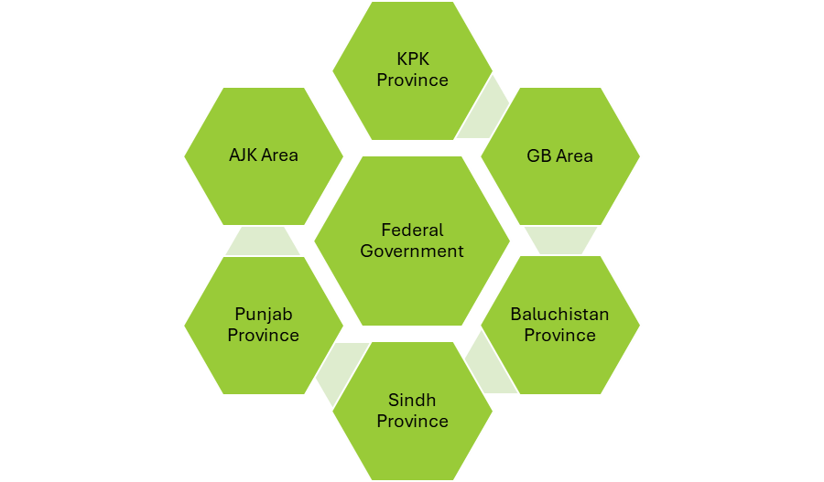
(Figure showing inclusion of representatives from Federal,
KPK, AJK, Punjab, Sindh, Baluchistan and GB governments)

Invitation letters along with concept notes explaining the background, objectives and framework to carry out situation analysis to develop the alternative report was shared via email as well as WhatsApp (Annexure 1 and 2) so that the participants come prepared and actively participate sharing maximum relevant information to develop the report. A Plenary Session was convened in the beginning of the consultation at each location, inviting representatives of the Federal Ministries and provincial departments to share their progress on Disability Acts and their implementation, followed by question answer session by the participants and discussion on list of issues. A power point presentation was developed to share in the beginning of the consultation, for setting the stage before plenary and group work. Participants for the group work were divided into three subgroups to carefully analyze, review the state obligations as per relevant articles (Article 11, 24 and 27) and share views/reflections on the key questions. Each group was chaired by an expert with rich information, expertise and experience in the article under discussion in the group.

The responses were collected in a pre-designed framework, specially designed keeping in mind the federal and provincial Acts for Persons with disabilities. The response of each group was collected in the soft form on the shared format and presented by the group representatives for feedback from the other group participants. Each consultation session ended up with closing remarks and vote of thanks. Participatory approach was used to collect information and feedback from the representatives of the federal and provincial governments. In total the consultations were concluded with a total of 107 representatives from Government N=15 (Federal/Provincial), CSOs N= 31, OPDs (N=56), Academia (N=3) and legal experts (N=2). Efforts were made to ensure representation of Gender (males 78, females 29) and Diversity (Persons with Disabilties 37, Women with Disabilties 10).

Fig 2: Participants by Geographical Coverage

(Figure showing participants %ages from
federal and provincial governments)

Fig 3: Distribution of Stakeholders participated

(Figure showing the number of participants by
stakeholders, gender and diversity/disability split)

Coordination committee comprises of 5 members is proposed to provide oversight and technical facilitation in the consultation process and development of this report. The technical members were comprised of representative from each lead organizations including HANDS, Sightsavers, CBM, CBIDN Pakistan and Technical Consultant.

2. Situation Analysis

2.1 Reflections to the Pakistan Govt. response to UN on Key Issues
Following ratification of UNCRPD in 2011 by the Government of Pakistan, and adoption of Rights of Persons with Disabilities Act by Federal and Provincial Governments from 2017 – 2023, State parties have taken significant measures for implementation of laws and ensuring access of Persons with Disabilities to services. CBID Network and OPDs are aimed to coordinate with the government and its departments, participate in monitoring mechanisms at different levels of implementation.

Looking at the response of the state to the issues submitted to UN committee (Oct.2, 2025), the information provided by the state is quite valid and reality based capturing commendable efforts of the state parties for developing policy (Acts), and rules, regulations to enforce the same. The state parties had taken several initiatives to facilitate the Persons with disabilities (men, women and children) to enjoy their rights as outlined in CRPD and these services reached to reasonable masses. However, there is a need to monitor progress of implementation of the policy framework and legislations at grass root level especially in urban population excluding top 10-15 major cities and in rural areas across Pakistan, to see and measure impact. Federal as well as provincial governments are trying to address, ensure and facilitate almost all the basic rights outlines in UNCRPD which are included in the federal and provincial Acts for the rights of the Persons with disabilities.

However, there are gaps in understanding as well as implementation of the CRPD guidelines to ensure right of the persons with disabilities. A dearth of disaggregated data based on disability and gender inhibits effective monitoring as well.

Article 1 to 4 of CRPD. General principles and Obligations
Most of the Federal Government and Provincial Laws are harmonized with convention, but disability law in one province – Khyber Pakhtun Khawa (KPK) is still pending. Coordination and alignment of federal and provincial governments remain inconsistent, as ministries and departments with different portfolios are made responsible as focal point for disability laws e.g. In Federal Government Ministry of Human Rights is the focal point for disability laws, whereas in the province of Sindh, a separate department is established for empowerment of persons with disabilities. In the province of Punjab and Balochistan – social welfare departments are looking after the disability laws and its implementation.

Provincial councils and district level authorities are only doing facilitation to persons with disabilities in getting their disability certificates which is mandatory to get CNIC (Computerized National Identity Card). Still, whole process of getting CNIC is cumbersome for many of persons/ especially women with disabilities, as mobility due to inaccessible transportation to the relevant offices (council, medical board examination centers/ hospitals) is challenging.
Most councils and similar authorities in provinces and at district level are not effectively playing their role in facilitating or guiding persons with disabilities

Recommendations:
The CRPD Committee recommends the State Party approve Disability bill in KPK by passing through all legal procedures and processed on priority basis.

Inter-provincial coordination committee may be established by the Federal Government, to provide oversight and facilitate in alignment and harmonization of all laws related to rights of persons with disabilities, and its alignment with convention.

The Rules of business need to be developed at Federal level. In other regions, where rules are business are already in place, coordination mechanism through provincial and district councils should be made effectively functional with engagement of OPDs or representatives. These council forums may be used for learning, sharing and adopting good practices from other provinces. Good inter provincial practices need to be followed in other provinces such as,
- Online registration for issuance of disability certificate initiated by Punjab government
- Grant in Aid to OPDs issued by Sindh government.
- Job quota for persons with disabilities increased up to 5% by Sindh government
- Provincial Coordinator on disability to Chief Minister appointed by Balochistan government.

Federal and Provincial councils may be awarded power and authority with inclusion of OPDs to ensure compliance through coordination with concern government departments, public and private authorities. Good practices of financial assistance schemes of Government of Punjab may be adopted by other provincial governments through inclusion in existing social security schemes. Govt. shall take special measures to ensure that women, children and elderly people with disabilities enjoy their rights equally with all others.

Article 5 of CRPD. Equality and Non-discrimination
State does not enforce the legislation on private sector to ensure nondiscrimination and equal opportunities at private sector educational institutions and workplace, especially for women or girls with disabilities.
Recommendations:
The CRPD Committee recommends the State Party to include representatives of OPDs, Persons with Disabilities, especially women with disabilities in the existing grievance redressal mechanism at federal and provincial level.

Article 6 of CRPD. Women with disabilities
Need improvement in ensuring rights and participation of Women with Disabilities in policy making, education, economic empowerment and disaster response. Many public sectors: Health and education facilities are inaccessible. Rights and participation of Women with Disabilities in policymaking, education, economic empowerment, and disaster response remain inadequate. Many public health and education facilities are still inaccessible.

So far, no progress has been reported on outcomes or actions taken against complaints of violence against persons with disabilities. Women with disabilities remain at heightened risk of sexual violence with limited access to justice and protection. No separate article for women with disabilities is included in Sindh Act. District level redressal system for protection and safeguarding of women/girls with disabilities for addressing GBV and discrimination, especially in rural areas are not effectively functional.

Recommendations:
The CRPD Committee recommends the State Party to ensure, representatives of Women with disabilities in NCSW (National Commission on Status of Women)

Article 7 of CRPD. Children with disabilities
National Commission for the Rights of the Children (NCRC) is in place at Federal level to address all matters related to children, including children with disabilities. Specialized communication methods (sign language, braille and visual aids) have been introduced to ensure full participation in consultation process. However, despite developing platforms, Children with Disabilities are not fully involved in the consultation process to freely express their issues and viewpoints.
On the other hand, in the province of Sindh, hostel facilities in educational institutions for Children with disabilities (for minors and girls with disabilities) are not available, due to safety issues, and inadequate supervision in protection measures.

Recommendations:
The CRPD Committee recommended the State Party ensuring full participation of children with disabilities in NCRC planning meetings.

Article 8 of CRPD. Awareness raising
No national campaign for dissemination of information about justice, laws or regulations, rights of persons/ women with disabilities in overall life cycle is planned or launched through national electronic and print media.
Recommendations:
The CRPD Committee recommends the State Party launch awareness campaigns targeting societal attitudes at community and mass levels to challenge stigma against persons with disabilities. Media, academia, electronic, print and social media should be utilized. 16days of Activism is good practice. Likewise, awareness raising campaigns during or before international disability day may be more effective.

Article 9 of CRPD. Accessibility
Most of the accessibility measures taken by government institutes are focused only on persons with physical disabilities, and codes/ guidelines considering the persons with other impairments such as hearing or visual impairment are not implemented. At most of the public places, government and private buildings, and institutions, the measures such as ramps, washrooms, handrailing supports, and emergency exits are not according to the Accessibility guidelines and Code. Current measures focus predominantly on physical disabilities, neglecting accessibility needs related to visual, hearing, and intellectual impairments. At most of the public/ government offices of essential services, and banks the information and services desks are not accessible to person with any form of disabilities.

For most people with disabilities, easy and affordable access to assistive technology and devices is extremely difficult. Many of the Persons with Disabilities families, due to financial constraints, cannot arrange assistive devices for person with disability in their family.

We are quoting only one example of accessibility with evidence. On ground, ensuring accessibility is usually considered by building ramps, addressing only one type of diversified need of Persons with Disabilities, ignoring majority of the other requirement for Persons facing challenges in vision, speech, hearing, understating, etc. On the other hand, even the built ramps are not up the mark and meet the accessibility need of Persons with disabilities. The most common evidence in this regard is the directions issued by the State banks of Pakistan to all banks to ensure accessibility, in compliance to the directions, banks lacks accessibility understanding. (see Figure 1 & 2).

Figure 4(Ramp for a Bank Building) Figure 5 (Toilet in Public office Islamabad)
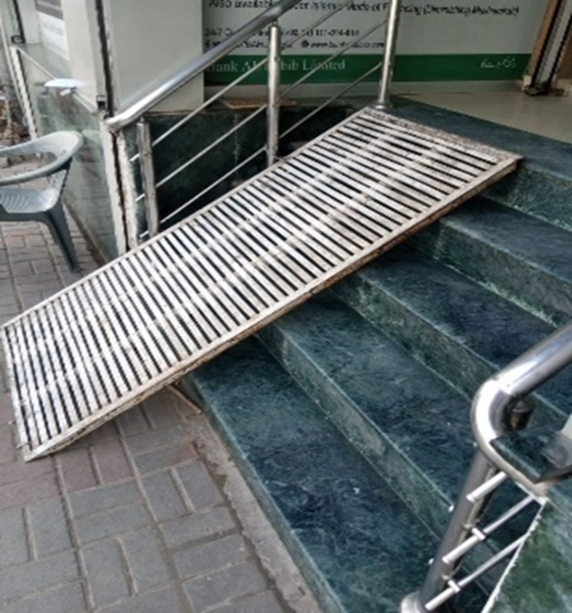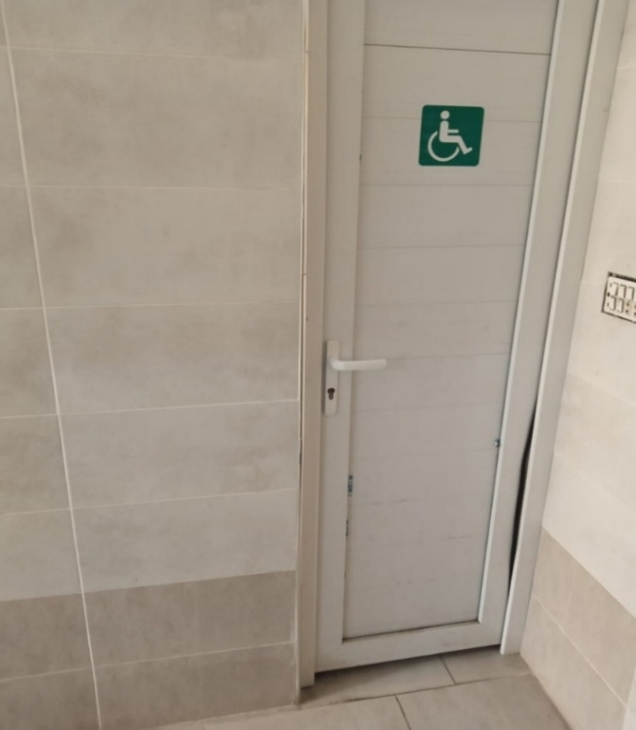
(The built ramps are not up to the mark, (The door is too narrow to enter with wheelchair)
and does not meet standard accessibility
requirements for the physical environment).

Recommendations:
The CRPD Committee recommends the State Party follow accessible guidelines and codes in all constructions and by all public and private institutes, to ensure enabling environment. The government offices and private institutes/ industries must ensure compliance with the accessibility guidelines and codes in infrastructure and working places/ stations to make these places accessible to all persons with disabilities.

Article 10 of CRPD. Right to life
Pakistan has reviewed the existing laws containing the death penalty specifically in the PPC and other special laws, to determine if the scope of death penalty can be reduced. Accordingly, the number of offences for which death penalty may be imposed was reduced. In addition, judicial safeguards are in place for restricting the scope of death penalty. The Safia Bano Case prohibits the death penalty for accused with psycho-social disabilities.

Recommendations:
The CRPD Committee recommends the State Party to ensure that no child with deformity or disability is aborted during pregnancy.

Article 11 of CRPD. Situations of risk and humanitarian emergencies
Pakistan is grappling with one of the most severe flood emergencies in recent history. Climate change is not only a threat to environment, but also the economic security of Pakistan. Without proper action, climate-induced disasters in Pakistan would become more intense. Pakistan has experienced significant temperature increases over the past few decades. Keeping in mind the impact of the climate change on Pakistan as well as significance and context of Article 11, it is decided to include this important issue in country situation analysis matrix of current alternative report.

Gaps in Implementation
The group participants hold the viewpoint that Federal Government provide no specific response or prioritization for PwDs, women, children and older Persons during emergencies. Persons with Disabilities are part of Protection working group and contingency planning, but they are not part of any implementation plan. There are some APPs related to early warning systems but the data on their usability is not available. Similarly, the respondent reported that there is an e-learning toolkit for DRR, which needs to be revised.

The legislation of Punjab clearly articulates to include Persons with disabilities in planning, but it is not implemented at district or sub-district (Tehsil) level. The Punjab Government has allocated substantial funds for assistive devices in their plans; however, no specific budget is allocated for the provision of assistive devices during disasters and emergencies. The participants reported that the government usually forces civil society organizations to paste Punjab government logo and stickers at relief activities to claim their active role and involvement in provision of relief goods and services.

In the GB area, although the policies exist at provincial level, their implementation at the local level is often fragmented, failing to fully leverage local knowledge and an integrated, bottom-up approach, as a result, communities (especially in Skardu) relying heavily on traditional coping mechanisms and informal social networks for rescue and relief during emergencies.

The participants of the group reported that systems for inclusive response (DIDRR) are weak in AJK. There is ambiguity of the mandate among various departments, which is the main challenge in the implementation of policies, in addition to lack of political commitment.

The early warning systems for disasters in Sindh are not in the accessible format for all Persons with disabilities. They also added that PDMA, DDMA DRR staff are not trained to manage Persons with disabilities during disasters. The assistive-devices, personal assistance and accessible toilets and other support services were not made available in relief camps during recent flooding in Sindh province.

In the province of Baluchistan, DRR is not disability inclusive during emergencies, no washroom was accessible for PWDs, no devices were given to Persons with Disabilities for evacuation and mobility at Camps during flooding at Naseer Abad. PDMA early warnings system is not fully inclusive for Persons with disabilities. Representatives of OPDs are not included in planning and implementation of DRR and DRM.

Recommendations:
The CRPD Committee recommends the State Party to ensure inclusive disaster response (gender sensitive and age-appropriate, especially ensuring protection and privacy of women with disabilities) at all levels (provincial, district, community), trained frontline DRR workers should serve as per humanitarian inclusion standards and inter agency guidelines including reporting and analysis. Dis-segregated data of Persons with Disabilities should be collected and should be properly utilized for planning and budgeting to implement and ensure protection of rights of PWDs. There is a need to develop and implement localized, context-specific DRR and DRM plans, incorporating indigenous knowledge to address the unique geographic and social conditions of communities like Skardu GB, AJK and parts of KPK and early warning system should be fully inclusive according to the diversified needs of PWDs.

Article 12 of CRPD. Equal recognition before the law
The judicial system is developed to promote legal support on non-discriminatory basis. However, the complaint redressal mechanism for any violation of stated right at district level is not developed.

Recommendations:
The CRPD Committee recommended the State Party introduce complaint redressal system which is easy to understand, and user friendly and followed by Persons with Disabilities.

Article 13 of CRPD. Access to justice
Structural and procedural barriers continue to restrict access to justice for persons with disabilities. Existing safeguards or accountability mechanisms are not very effectively functional.

There is a lack of available and accessible free legal support, especially for individuals with intellectual or psychosocial disabilities. Courtroom accessibility is low, and necessary, individualized legal accommodations are often unavailable. There is a shortage of professionals trained in disability rights, along with a lack of qualified sign language interpreters for administrative and judicial processes.

Not all political parties have aligned their manifestos with the rights of persons with disabilities under the CRPD. The proper forum to raise their voice does not exist at district level. The rights to protest and raise voices are limited and restricted under many security rules and regulations.

Recommendations:
The CRPD Committee recommends the State Party to strengthen implementation of the laws, establishing specific committees for rights at district level, and ensuring procedural accommodation in all judicial proceedings may ensure improved access to justice. Accessible courts should be established. E-portals within justice system at all levels of judiciary may be an option for submission of any complaints. Scale up of training for police, prison, and court officials.

Article 14 of CRPD. Liberty and security of a person
Government responses focus largely on mental health, rather than broader liberty and security concerns. Due to lack of awareness among family members and communities, many of the persons with especially those with psychosocial or intellectual disabilities, are often deprived of their liberty based on impairment, often restricted from making independent decisions, and face involuntary confinement. Few of the cases reported in media about the violence, including sexual and gender-based violence, against women and girls with disabilities, both in domestic settings and institutional settings. Proper data is not available at provincial and federal level. Laws ensuring liberty and security should be fully enforced in letter and spirit to protect Persons with Disabilities from abuse

Recommendations:
The CRPD Committee recommended the State party to establish robust, independent monitoring for all detention, correction, and care facilities to prevent arbitrary detention and abuse. Strengthening legal aid and support services for victims of violence (especially in rural areas), with a focus on accessible complaint mechanisms. Improve data collection on violence against Persons with Disabilities to inform policy makers.

Article 15 of CRPD. Freedom from torture or cruelty, inhuman or degrading treatment or punishment
Despite reporting complaints related to torture, inhuman or degrading treatment by Persons with Disabilities, their parents or caregivers and representatives of organizations of persons with disabilities, the State has not provided information or data on investigations, prosecutions, or outcomes.

Recommendations:
The CRPD Committee recommend the State party ensuring availability of data about addressing complaints related to torture, cruelty, inhuman or degrading treatment of Persons with Disabilities for monitoring and further collaboration to improve the situation.

Article 16 of CRPD. Freedom from exploitation, violence and abuse
Despite the existence of anti-rape laws and legislation on sexual harassment at the workplace, there is little to no evidence of effective compliance, enforcement, or disability-inclusive implementation for women with disabilities. Barriers include inaccessible reporting mechanisms, lack of reasonable accommodation during investigations, stigma, and absence of disaggregated data. So far, no progress is reported about the results or actions against 3,821 complaints/received for violence against persons with disabilities

Ensuring right to freedom from abuse and exploitation needs improvement. 3,821 complaints received by the state, for violence against persons with disabilities. However, there is no report about actions or results of these complaints.

Recommendations:
The CRPD Committee recommends the State Party to ensure registering each complaint, and to disseminate outcomes of the actions on violating the freedom of violence, exploitation and abuse.

Article 17 of CRPD. Protecting the integrity of the person
Pakistan has not taken sufficient legislative, administrative, or policy measures to ensure that persons with disabilities enjoy equal protection of their physical and mental integrity, as required under Article 17 of the UNCRPD. The absence of enforceable safeguards, accountability, and rights-based healthcare practices continues to expose persons with disabilities to abuse and violations.

Recommendations:
The CRPD Committee recommends to the State party urgent reforms to ensure free and informed consent, prevent abuse, and bring laws and practices into full compliance with the UNCRPD

Article 18 of CRPD. Liberty of movement and nationality
Access to citizenship documentation such as Computerized National Identity Card (CNIC) is challenging due to procedural barriers (disability certificate issuance processes) and lack of accessible information in rural areas, impeding the ability of persons with disabilities to exercise rights, including travel or accessing services.

Recommendations:
The CRPD Committee recommends to the State party that provincial councils may develop guidelines for simple procedures for getting medical assessments, disability certificates and then CNIC cards. Federal Government ICT model for issuance of CNIC may be adopted and implemented in all regions of Pakistan, to ensure swift and accessible services.

Article 19 of CRPD. Living independently and being included in the community
Community-based support systems remain underdeveloped. Independent living is critically important for persons with disabilities to exercise autonomy, dignity, and full participation in society. However, the lack of community-based services, personal assistance schemes, accessible housing, and support for decision-making significantly restricts the ability of persons with disabilities to live independently.
Recommendations:
The CRPD Committee recommends the State party to establish Assistive Technology or devices provision services through an accessible system by the Federal and provincial governments. This requires budget allocation for provision of assistive devices to all persons with disabilities. Such arrangements for provision of assistive devices must be ensured at district level with support of private sector. Expand social security schemes specific to persons/ women/children with disabilities across the country.

Article 20 of CRPD. Personal mobility
Physical barriers in infrastructure and transportation, and lack of mobility devices, significantly restrict personal mobility. Assistive technology/devices have heavy duties and lengthy process to follow. Driving license process is very difficult for Persons with Disabilities. Public transport systems are largely inaccessible due to lack of elevators, poor, and inaccessible, or non-existent signage and announcements. Transportation challenges are particularly acute in rural areas, where infrastructure for, and availability of, accessible transport is severely lacking. While the government has provided funding for rehabilitation and supported initiatives for assistive devices, accessibility and affordability of these devices remain challenging for many.

Recommendations:
The CRPD Committee recommends the State Party implement the existing legislation about accessible transport that may be ensured through federal and provincial councils, by establishing coordination mechanisms among the ministries and departments concerned. Availability of assistive technology may be ensured through allocation of budget by government under social protection schemes, and through engagement of private sector.

Article 21 of CRPD. Freedom of expression and opinion and access to information
Access to information via print and electronic media need improvement to make it accessible to all persons with disabilities (challenges with vision, hearing, etc.) Print and electronic media are largely inaccessible for persons with visual and hearing impairments.

Recommendations:
The CRPD Committee recommends the State Party ensure accessible adaptations to ensure access to persons with disabilities to all media platforms.

Article 22 of CRPD. Respect for privacy
Despite legal protection, societal attitudes and weak implementation often resulted in interference of privacy. For instance, in public and private offices, CCTV cameras are placed especially in retiring rooms for women that may breach the privacy of person with disability (especially women with visual impairment).

Recommendations:
The CRPD Committee recommends the State Party to organize more trainings of government officials related to privacy rights, and awareness raising sessions creating more empowerment-based approach to eliminate stigma among the person/women with disabilities

Article 23 of CRPD. Respect for home and family
Women and girls with disabilities face significant barriers in accessing sexual and reproductive health rights, including inaccessible health facilities, lack of information in accessible formats, discriminatory attitudes of healthcare providers, absence of informed consent practices, and exclusion from SRHR programs and policies. These gaps expose women with disabilities to heightened risks of abuse, forced decisions, and poor health outcomes.

Recommendations:
The CRPD Committee recommends the State Party launching an awareness campaign on electronic and social media about the existing legal protection laws related to PwDs, about respect for home and family. It is also recommended to stop forced marriages and force sterilization.

Article 24 of CRPD. Education
Currently, Pakistan has the world’s second-highest number of out-of-school children (OOSC) with an estimated 25.1 million children aged 5-16 not attending school, representing 35 per cent of the total population in this age group. Gender disparities further exacerbate these patterns, particularly in Sindh and Khyber Pakhtunkhwa, where the number of out-of-school girls exceeds that of boys, underscoring enduring structural and socio-cultural barriers to girls’ education.

Gaps in Implementation
Federal government is running two parallel systems of education, mainstream or inclusive education and special education and the same model is in practice at provincial level, where DGSE developed the special education institutes. The respondents in Islamabad group shared that some schools are administering IQ test of Children with Disabilities at the time of admission in schools, which is a form and example of systematic exclusion of children with disabilities for access to educational opportunities.

The government of Punjab is trying to promote inclusive education but so far, issues like teachers training, ensuring access in school buildings and transportation (especially for students coming from distant places and rural areas) and availability of special education schools at government as well as private schools are posing barriers in promoting inclusion,

Gilgit Baltistan Act for Persons with disabilities was passed during 2019, but the rules of business (defining how the act will be enforced) have been pending for approval since 2022. Therefore, the Act cannot be enforced without approval of Business Rules. There are limited schools offering education (special education) and they are in major cities only. Participants reported that school hostel for children with disabilities in GB is occupied by National Accountability Bureau (NAB office Gilgit)

Like federal government and other provincial governments, the government of AJK is trying to run two parallel systems to educate children with disabilities besides the gaps in resources and accessibility issues at educational institutions.

The development and approval of rules of business in KPK are creating a barrier to enforce the Disability Act 2018, including the right to education in inclusive setting, however, the special education centers are operational in some major cities of KPK developed by DGSE.

Inclusive education framework is acquired only by Sindh Government and Federal government, while rest of the provinces are in process of developing inclusive education curriculum and teachers training frameworks. Government has developed Sindh Persons with Disabilities Protection Authority (SPDPA) and its mechanisms exist at institutional or district level, but they are not consistently functional.
The implementation of the inclusive education policy guidelines is poor in the province of Sindh. For example, in accessible transportation systems and educational institutions, inconsistency in approval and dissemination of standardized Inclusive Education Framework for curriculum and lack of trained teachers on inclusive education.

In Baluchistan, educational institutions are grossly inaccessible. The Kumak Program has appointed only project director (PD) and the rest of the staff is to be hired despite allocation of funding, which is hampering the pace and progress of the program and resulting in the inefficient use of allocated funds.

Recommendations:
The CRPD Committee recommends the State Party to
- make serious efforts at federal as well as provincial governments to ensure education by overcoming system barriers to education, especially to address the exclusion of Children with Disabilities from the mainstream education system.
- consider inclusive education through government schools across board as OOSC in Punjab is 9.7 million children (27%), in Khyber Pakhtunkhwa, 4.5 million (34%) and in ICT 0.09 million (15%), Inclusive education must be promoted at village and community level, especially in rural areas, beside urban areas, to ensure inclusion. Teachers should be trained in Inclusive Education techniques and provided with incentives to meet the gap.
- improve inter-departmental coordination between education, SE&LD and DEPD is crucial to promote Inclusive education as In province of Sindh, OOSC is 7.4 million (44%), The Sindh Government should approve and disseminate a standardized Inclusive Education Teacher Training Manual for ECE–VIII.
- that special education schools should allow children without disabilities, (30% of the student enrollment) to test and promote inclusive education as in the province of Baluchistan, OOSC is 3.5 million (69%). Balochistan government should start online registration of PWDs, verification of SCNIC by means of barcode. Government of Baluchistan should collect reliable disaggregated data for Persons with disabilities, especially out of school children with disabilities.

Article 25 of CRPD. Health
“Nasheman” homes in Lahore, Bahawalpur, and Faisalabad, providing professional care, training, and rehabilitation (only 3 districts of Punjab out of 41 districts) cannot cover the entire population of the province. Similarly, no status was shared about the other provinces like Balochistan, AJK, GB area and KPK etc.

Recommendations:
The CRPD Committee recommends the State Party to introduce Health Card/health insurance (as during 2018-2022, Govt of Pakistan introduced “Sehat Card” provided free health care services up to one million Pak Rupees for medical treatment of diseases and surgeries in top hospitals across Pakistan) which should provide persons with disabilities free healthcare services across Pakistan in government as well as in private sector healthcare facilities. Similarly, Nasheman center models may be replicated in other districts. Tele-health services through government and private sector platforms may be made available free of cost or on low cost.

Article 26 of CRPD. Habilitation and rehabilitation
Mainly focus on medical rehabilitation. Inclusion process of Persons with Disabilities with other vulnerable groups in existing social protection schemes is weak. In many livelihood enhancement initiatives, persons with disabilities are not focused.

Recommendations:
The CRPD Committee recommends to the State Party that rehabilitation unit model of Government of Sindh may be replicated in other geographies across the country.

Article 27 of CRPD. Work and employment
Pakistan's population is over 241.5 million (males approx. 51.4% and females approx. 48.6) according to the official 2023 census report, making it the world's fifth-most populous country, experiencing significant growth with a large youth of youth (26%) between the 15-29 years and over half (53.8%) are in the working-age group (15-59). Keeping in mind the growing population pressure, and specifically youth population in working age group, Article 27, is considered as one of the key themes for situation analysis framework matrix to develop this alternative report to address this important aspect.

Gaps in Implementation
Although federal and provincial governments have overcome policy level barriers to protect the rights of Persons with disabilities. However, the infrastructure issues like accessibility, lack of opportunities for Persons with Disabilities to secure education and training for employment, attitude of the society and political will are still the barriers to overcome to secure the employability rights of Persons with disabilities. The participants of GB and AJK have the viewpoint that there is a lack of coordination between federal government and provincial government which is very important to share and exchange good practices to improve the services for Persons with disabilities.

The data shared by Punjab government (136,000 Persons with disabilities working in Punjab, out of which 12,000 Persons with Disabilities are working as peon) clearly indicates that the Persons with disabilities are appointed against grade 1 to Grade 4 Jobs

In KPK province, employment quota for Persons with disabilities for all sales up to grade 22, however, the instructions often highlight filling vacant posts in BS-15 and below through this quota as per notes of Establishment Division.

In the Baluchistan province, the department of social welfare (SWD) has been given the mandate to ensure the rights of Persons with Disabilities (as per disability Act 2017) but the department is overloaded with responsibility with limited staff. The SWD is managing child rights, social welfare, rights of Persons with disabilities and women rights, etc. apart from the social welfare component with limited staff. On the other hand, there is no formula to ensure 5% allocated employment quota for Persons with disabilities in public and private job opportunities. Government has formed disability committees which are inclusive of Persons with disabilities for policy dialogue and planning meetings, but the implementation is poor. Monitoring systems to track the implementation and progress needs massive improvement. For example, State Bank internship program offer is not accessible for Persons with disabilities as the bank building are not disabled friendly.

Recommendations:
The CRPD Committee recommends the State Party to
- equipped Persons with Disabilities with skills and educational qualifications to secure allocated quota reserved for Persons with disabilities in all provinces of Pakistan including federal capital. There is a need to revise criteria to hire PWDs.
- improve coordination between federal capital and provinces and at the same time between the departments within each province to share and exchange challenges to find solutions, getting updated ideas and good practices to secure the rights of the Persons with disabilities across Pakistan.
- Government of Sindh has strong legal foundations (including 5% quota in employment as well relaxation in age) but implementation is weak. Effective monitoring mechanisms are needed to push and track progress. Same is suggested for the government of Balochistan where employment quota is 5% for Persons with Disabilities with poor implementation.
- promote employment opportunities for Persons with disabilities, government bodies may provide tax rebate incentives, introduce mandatory inclusion plans, encourage public-private partnerships, besides serious efforts to build capacity of PWD to secure suitable and respectable job opportunities in public and private sector.

Article 28 of CRPD. Adequate standard of living and social Protection
Baitul Maal Pakistan (PBM) Punjab Baitul Maal (BPM), Department of Empowerment of persons with disabilities (DEPD- Sindh), Social welfare department (KPK) have allocated millions of rupees to provide assistive technology, financial assistance etc. to the persons with disabilities and their families.
However, there is a lack of focus on persons with disabilities in designing and planning development schemes such as Access to clean water and sanitation, appropriate and affordable devices and other assistance for disability-related needs. Assistance and respite care needs massive improvements.

Recommendations:
The CRPD Committee recommends the State Party that federal government in coordination with provincial governments may expand and scale up the development schemes and social protection programs across Pakistan to include large number of persons with disabilities in these programs.

Article 29 of CRPD. Participation in public and political life
To promote the full participation of Persons with Disabilities in national and local elections, the Election Commission of Pakistan (ECP) formulated and launched the Gender Mainstreaming and Social Inclusion Framework (GMSIF) 2024–2028, a five-year policy aimed at revising electoral laws, policies, and procedures. This framework focuses on enhancing voter registration and participation among vulnerable groups, including PWDs.
Similarly, Inclusive Voter Registration (INVR) program is in process at federal and provincial level to ensure voting rights of person with disabilities.

Despite significant improvement in gaining voting rights, there is a notable under-representation of persons with disabilities, particularly women, in political decision-making processes and public life. No representation in parliaments.

Recommendations:
The CRPD Committee recommends the State Party ensure accessible polling booths and ballot papers so that persons with disabilities can exercise their right to pollical participation. Similarly, reserve seats may be considered at national and provincial parliaments for persons with disabilities.

Article 30 of CRPD. Participation in Cultural life, recreation, leisure and sport
While Pakistan has enacted legislation, implementation on the ground for inclusive leisure remains weak. Inadequate design of recreational spaces, parks, and cultural centers limits independent access for Persons with Disabilities. Infrastructure barriers restrict the participation in cultural life, sports and leisure activities in most of the cities and in rural areas as well. Additionally, there is a lack of accessible formats (sign language, Braille) for media and cultural materials.

Recommendations:
The CRPD Committee recommends the State Party to enforce building codes to ensure all sports, tourism, and recreational facilities are accessible. Invest in skilled-based training and resources to allow Persons with Disabilities residing in rural areas to provide them the opportunity and utilize their creative and intellectual potential. Implement national campaigns to address stigma and promote social integration.

Article 31 of CRPD. Statistics and data collection
Disaggregated Census data was collected through Washington set of questions) and Pakistan Social and Living standard measurement survey is available at Pakistan Bureau of Statistics, but it is not utilized so far by Ministry of Planning and Development and other ministries for resource allocations for fulfilling the legal obligation as CRPD and National laws to improve the implementation status. Monitoring mechanisms requires strengthening for accountability and compliance of disaggregation of data through council.

Recommendations:
The CRPD Committee recommends the State Party to be more consistent in collecting disaggregated data, particularly relating to gender and specific types of disabilities, to inform policy makers, federal and provincial councils, that may enhance collaboration among different departments for sharing and utilization of data for planning and decision making.

Article 32 of CRPD. International cooperation
International cooperation and local implementation are hampered by fragmented coordination, slow action plan execution, and limited inclusion of disabled people's organizations (DPOs) in decision-making. Lacks forum (such as working group) of donors & UN agencies who have mandate or focus on Disability Inclusion, coordinated by government, resulted in the situation that their inputs often lack sustained, coordinated, and inclusive engagement, particularly in funding long-term disability-specific projects. Gaps persist in data collection, mainstreaming, and meaningful participation of Organizations of Persons with Disabilities (OPDs) in donor-funded programs.

Recommendations:
The CRPD Committee recommends the State Party to ensure the SDG coordination mechanism actively tracks CRPD implementation.

Article 33 of CRPD. National implementation and monitoring
The implementation of CRPD, its governance and monitoring are assigned to Ministry of Human Rights (M/o HR) at Federal Level. The M/o HR had developed a cell on CRPD where senior staff (Director, deputy directors) is constantly engaged in ensuing compliance with CRPD. At the same time disability councils

In connection with article 33(2) CRPD, an effective independent monitoring mechanism with inclusion of CBIDN and OPDs does not exist at Federal, Provincial and district levels.

Federal and provincial councils/ other forums facilitate the coordination among different departments and authorities for improving implementation however, the follow up on assuring compliance by all government departments and private organizations/ institutes is weak to some extent.

Effective monitoring system with inclusion of CBIDN and OPDs does not exist at Federal, Provincial and district levels.

3. Key Findings

3.1 Summary of Key Findings (Conclusions)
Government of Pakistan has made a steady progress during last 5-7 years, policy framework to ensure rights of the Persons with disabilities is in place, including rules of business and regulations for enforcement of the Acts, in most parts of the country has been developed and approved. The remaining two provinces (GB and KPK) will enforce the developed Disability Acts, once the rules of business are developed and approved.

Government (federal as well as provincial) is allocating substantial dedicated budgets for the welfare of marginalized communities including Persons with disabilities (men, women and children). The federal as well as provincial governments have taken several initiatives to ensure and facilitate the rights of the Persons with disabilities and providing range of services in the form of schemes and grants to improve education, ensure employment rights, provision of assistive devices, social protection networks and inclusion in disaster response. However, most of the stakeholders, especially representatives of OPDs hold the viewpoint that the implementation of rights, rules and regulations is limited to urban areas only and needs massive improvement to include Persons with Disabilities from rural and remote communities.

Government’s Initiatives are under way for developing monitoring as well as grievance redressal mechanism. The participants, including representatives of the government, shared that there is a lack of coordination across board between federal and provincial governments, different departments within the provinces, which should be improved.

The government (federal as well as provincial) have is on the way to achieve important milestones and made good progress in the selected Articles 11 (Situations of risk and humanitarian emergencies), Article 24, (Education), Article 27 (Work and Employment) and Article 33 (National Implementation and Monitoring) to ensure right of the Persons with disabilities through inclusive policies and practices.

Government in collaboration with non-state actors (INGOs, NGOs, OPDs and Donor agencies) is trying to translate and transform CRPD to change lives of Persons with Disabilities across Pakistan through different initiatives (projects, programs, grants and schemes, etc.) On the other hand, many international disability focused organizations which focus on single diversity/disability are now turning into cross-disability organizations. Similarly, the community based inclusive development approach is becoming the focus of the projects and programs in mainstream development organizations. Likewise, donor agencies are funding projects which are inclusive, gender sensitive and address pressing global issues like Climate Change (impact of interventions on environment, recycling of waste, low carbon footprints, etc.), inclusive DRM and DRR.

NGOs are collaborating resources and sharing and exchanging good practices and learnings, international good practices are implanting in Pakistan, like development of Independent Living Centers in line with Article-19 (living independently and being included in the community and Community Based Inclusive Development Network CBID-N to for advocacy and protection of the rights of PWDs). Similarly, efforts are on the way to disaggregated data collection.

Advocacy and campaigning efforts by the stakeholders have changed the culture of the development sector. Now development organizations (NGOs) are implementing project with inclusive development approach, focusing children, youth and women with disabilities as project KPIs.

CBID in collaborations with INGOs, OPD members organizations, sponsors have achieved most of the objectives set out in the strategic plan to ensure the rights of PWSs in line with UNCRPD, like formulation of Acts, rules of business and regulations. The illustration below shows the overall summary of achievements on part of provincial and federal government post ratification.

Fig. 6 (CRPD implementation)

(Figure showing milestones summary of development in implementing UNCRPD in Pakistan)

4. Recommendations
The CRPD Committee recommends the State Party to;

- Improve coordination between federal government/ministries and provincial governments for smooth implementation. The coordination mechanism may facilitate in execution and sharing of learning to scale up good practices of other provincial governments / departments ensuring rights of the Persons with Disabilities in line with CRPD and Government Acts.
- Enhance interdepartmental coordination within the province to deal with ambiguity in mandate, manage resources (human as well as financial) and improved services.
- Representation and participation of OPDs and Persons with Disabilities in Federal councils and Provincial Councils or Boards may be increased in coordination with CBID Network to improve the monitoring mechanism and thereby improving and facilitating the implementation of rights of persons with disabilities in all sectors.
- Federal and Provincial governments may frame the mechanism for ensuring compliance to accessibility design guidelines and codes (Accessibility code 2006) in by all builders (government and private contractors), housing schemes, public places, banks and infrastructure of government and private institutes, to ensure improved access of Persons with disabilities in every domain.
- Adoption and use of modern technology (including artificial intelligence) to ensure access to information, especially freely available software for reading, writing, and translation linked with windows.
- Promote screen reading software for usage by the population in rural communities
- Expand the skills-based training programs for Persons with Disabilities in rural areas with engagement of private sector to ensure their inclusion in the job market or self-enterprise to earn a respectful living.
- Effectively design and plan campaigning strategies through use of digital advocacy/ communication techniques and tools, for dissemination of information, creating awareness among the masses, changing attitudinal barriers, enhancing abilities and achievements of the Persons with Disabilities, with engagement of OPDs and private sector.
- Focus on inclusive education and developing skills of persons with disabilities for economic empowerment, provision of assistive devices, and financial support through social protection schemes. Good practicing models already existed in different provinces, may be expanded and scale-up in other regions with engagement of private sector.
- Provide incentives to the private sector employers for hiring Persons with disabilities and promoting public private partnership to improve job market.
- Develop a coordinated system for utilizing data on persons with disabilities, their services, resources of services at Federal, Provincial and District level through councils and concerned government departments.
- Similarly, the Ministry of Planning and Development may plan to utilize the Census 2023 data and PSLM national level data available at Pakistan Bureau of Statistics for planning and resource allocation in coordination with each service sector departments.
- Ensure UNCRPD implementation in a true letter and spirit, with all stakeholders’ engagement and participation in joint /collective monitoring mechanism.
- Develop a repository of all the acts, rules of business, regulations, grants and schemes for Persons with disabilities and older people, for mass level awareness, advocacy. This will be helpful in ensuring the rights of Persons with disabilities.
- Grievance redressal mechanisms should be an integral part of this repository for the protection of the violation of the rights. (for example, supreme court has given the ruling to hire 2% quota first and then remaining 98% in jobs but there is no public awareness about this ruling).

Annexure: Picture Gallery (Consultation Process)

Figure 1: Consultation at Islamabad (National, KPK, AJK, GB) Nov 13, 2025
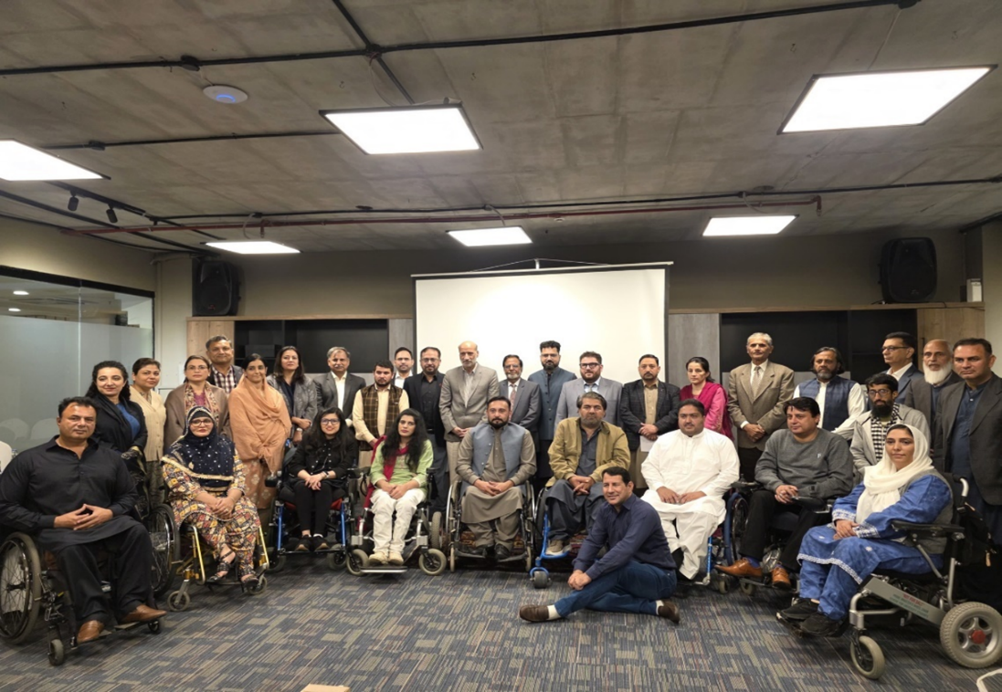
(Picture of Islamabad consultation workshop participants)

Figure 2: Consultation at Lahore (Punjab) on Nov 27, 2025
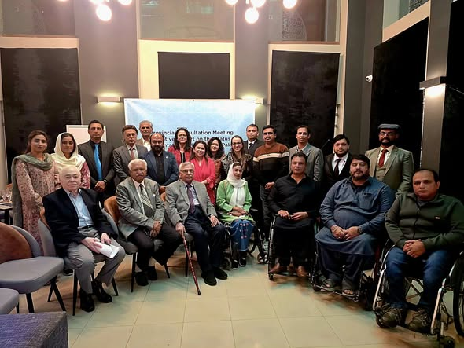
(Picture of the Lahore (Punjab) consultation workshop)

Figure 3: Consultation at Karachi (Sindh & Balochistan) on Dec. 10, 2025
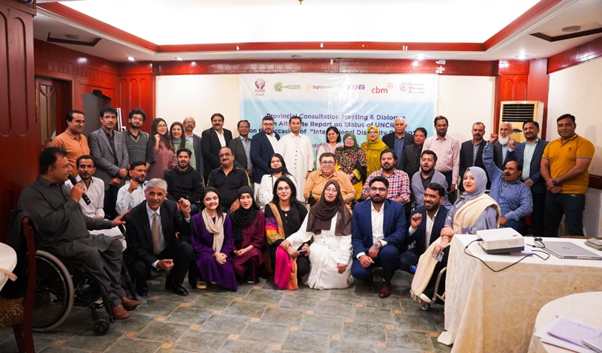
(Picture of the Karachi Consultation workshop)

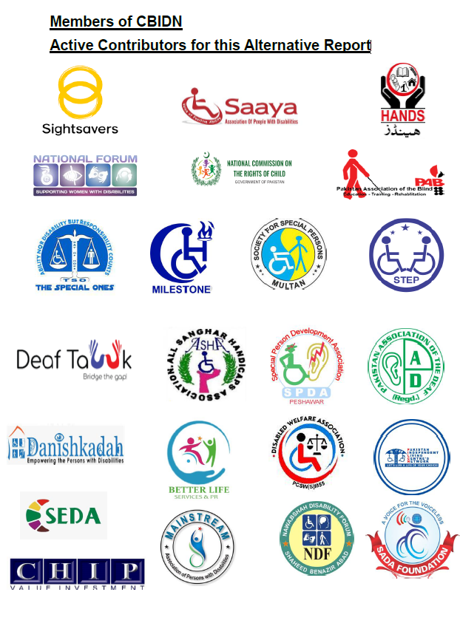

https://dgse.gov.pk/SiteImage/Downloads/pdfresizer.com-pdf-resize(1).pdf
https://www.unicef.org/pakistan/education

