

Table of Contents

A. INTRODUCTION 3
B. BACKGROUND, LEGAL FRAMEWORK AND CONTEXT 3
C. KEY ISSUES AND RECOMMENDATIONS 3
1. Discriminatory Legal Framework 3
2. Early and Child Marriage 5
3. Women’s Legal Capacity to Enter into Marriage 6
4. Divorce Rights 7
5. Custody and Guardianship of Children 8
6. Violence Against Women 9
7. Nationality 11

A. INTRODUCTION
Musawah, the global movement for equality and justice in the Muslim family, submits this Thematic Report on concerns for consideration by the CEDAW Committee in its review of the Kingdom of Bahrain, reporting before the 84th CEDAW Session in February 2023. This is the CEDAW Committee’s third engagement with Bahrain, which acceded to the Convention in 2002. Bahrain has expressed reservations, in relevant part, to Article 2, Article 9(2), Article 15(4), and Article 16 of the Convention.
In 2014 and 2008, Concluding Observations of the CEDAW Committee included for the State Party to: prohibit and sanction discrimination against women; criminalize violence against women and provide effective remedies and sanctions; and adopt a unified family law that provides for equality and effective access to justice in family issues. Recommendations were also made for the State to: withdraw or limit its reservations to the Convention; change widely shared stereotypical roles of women and men; set the minimum age of marriage at 18 years; and, adopt legislative measures to eliminate discriminatory economic consequences in divorce. However, it is noted that despite enacting a comprehensive Family Law in Bahrain in 2017, there has not been sufficient progress towards substantive implementation of these recommendations. Inequalities remain entrenched in the legal framework governing family relations in Bahrain.
We hope that the CEDAW committee will utilize this report as a key resource during its constructive engagement with the State Party and in follow-up activities on the Concluding Observations. Musawah would like to acknowledge the vital input and feedback from Harvard Law School’s International Human Rights Clinic, various national women’s rights advocates, and Bahraini lawyers into this Report.

B. BACKGROUND, LEGAL FRAMEWORK AND CONTEXT
Article 2 of the of the Constitution of Bahrain (2002) establishes Islam as the state religion of Bahrain and provides that Islamic Shari’a is “a principal source for legislation.” Article 18 declares all citizens “equal before the law in public rights and duties”. Article 5 commits the state to “guarantee[] reconciling the duties of women towards the family with their work in society, and their equality with men in the political, social, cultural, and economic spheres without breaching the provisions of [Shari’a].”
All matters relating to personal status, marriage, divorce, and custody and guardianship of children are governed by Law No. 19 of 2017 Promulgating the Family Law (“the Family Law”), which was the country’s first codification of a unified family law and followed decades of women’s advocacy efforts. The law includes some unified provisions that apply to all Muslims regardless of their sects, as well as provisions that specifically apply to adherents of the Sunni or Shia school of jurisprudence.
In addition to the 2017 Family Law, several other national laws in Bahrain relate to personal status and family. The 2015 Domestic Violence Act defines domestic violence as any act of abuse that occurs within the family by one of its members. The Bahraini Penal Code of 1976 (“the Penal Code”) also includes general criminal laws that are applicable to the domestic violence context, such as prohibitions on kidnapping, murder, rape, sexual assault, and battery. Bahraini nationality law is codified in the Nationality Act of 1963.

C. KEY ISSUES AND RECOMMENDATIONS

Discriminatory Legal Framework Articles 2, 16

Despite the constitutional guarantee that “there shall be no discrimination” based on gender, and despite the Committee’s requests that Bahrain implement legislation that specifically prohibits gender-based discrimination and adopts the Convention definition of discrimination, the Family Law continues to rely on an inherently discriminatory framework of “reciprocal” or “complementary” rights unique to each spouse. This framework reinforces numerous inequalities throughout the law governing marriage relations. For example, a husband is considered the head of the household by virtue of his role as the main provider for the family. Under Article 56(b), a woman can risk losing her right to financial maintenance if she is determined to be recalcitrant (nashez). A woman can be deemed nashez for pursuing a career outside of the home without her husband’s permission or for traveling outside of the country without her husband’s permission.

The operation of the Shari’a court system impacts and enables the inequality and discrimination in many of the family-related areas of concern. The Family Law provides Shari’a court judges with wide discretion to issue case-by-case rulings on family affairs according to their own interpretation and application of either Shia or Sunni jurisprudence.

In addition, because the Family Law includes sect-specific provisions that apply exclusively to Sunni or Shia courts, so the rights and guarantees afforded to a woman often significantly differ depending on whether her family is Sunni or Shia.

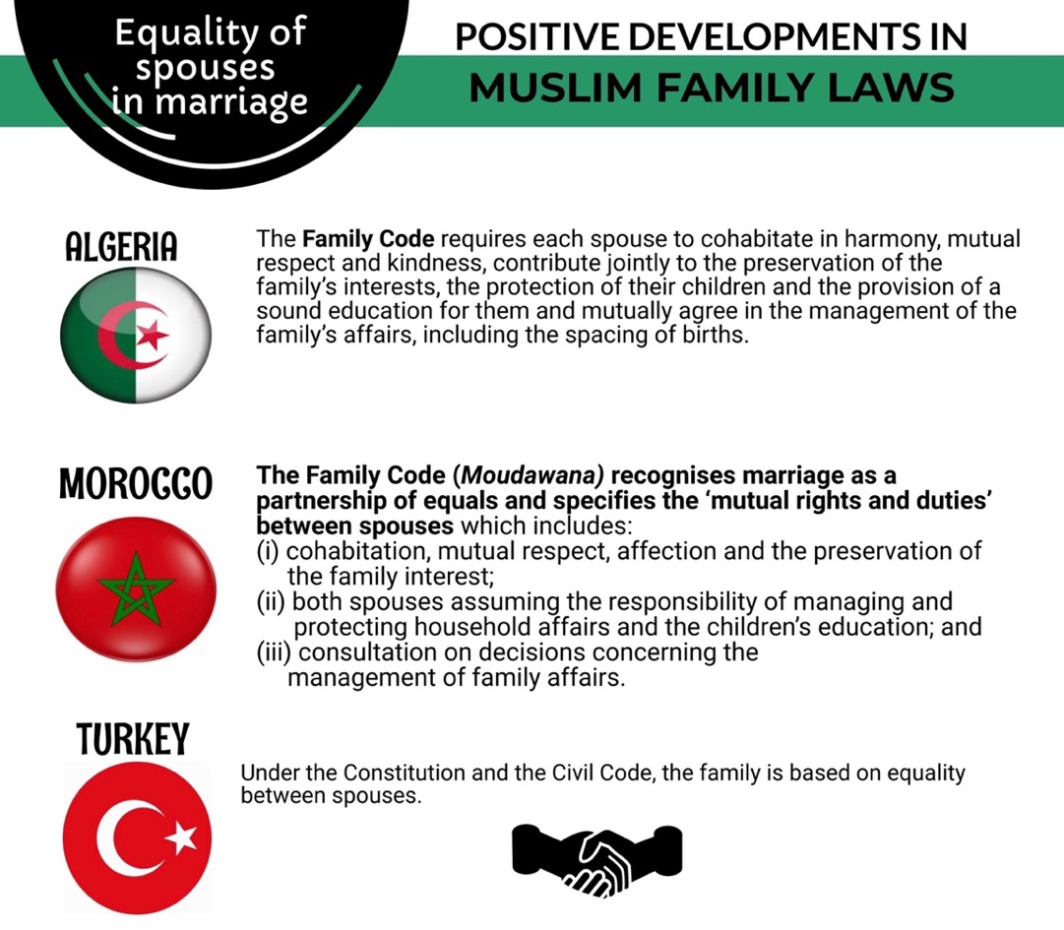

Early and Child Marriage Article 16

The Family Law of Bahrain permits parents to “marry off” girls under 16 years of age with permission of the Shari’a court and after “verifying the appropriateness of marriage.” There is no absolute legal minimum age for marriage in Bahrain. This stands in stark contrast to Bahrain’s own Child Law, which defines a child as any person below 18 years of age.

Young girls, in particular, are vulnerable to exploitation and child marriage. According to statistics published by the Bahraini Ministry of Justice and Islamic Affairs, over 11% of marriages contracted in Bahrain in 2020 involved young girls between 15-19 years old. Some of these young girls were married off to men as old as 50 years or more. According to official numbers, there have also been a number of cases where marriage of a child below 15 years old was recorded in 2019 and 2018.

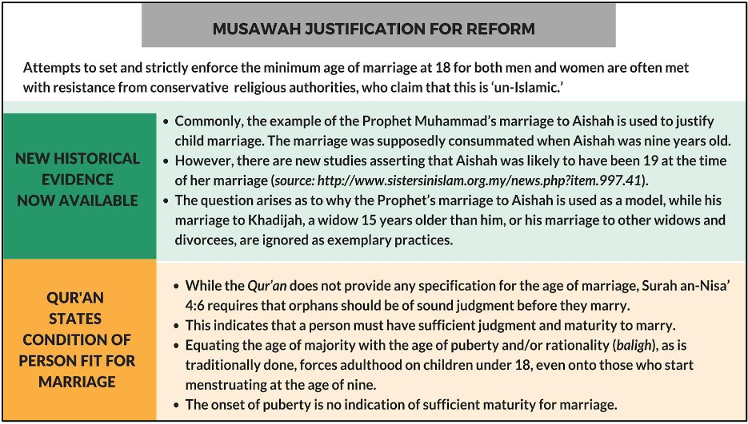

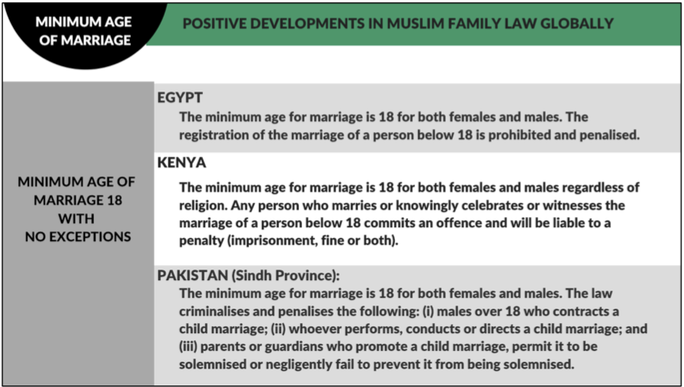

Women’s Legal Capacity to Enter into Marriage Article 16

The Bahraini Family Law of 2017 requires consent of both parties to a marriage. However, the law also requires that a previously unmarried woman, regardless of her age, obtain the permission of a male guardian (wali) in order to enter into marriage. The requirement is somewhat more flexible for a Shi’a woman, permitting her to contract her own marriage in the case of the absence of a father or paternal grandfather.

In the event the wali opposes the marriage, the prospective bride may seek the authorization of a judge to get married (known as an ‘adl case). However, this practice continues to limit a woman’s ability to enter into marriage on her own accord because it is often difficult socially and practically. It is not socially acceptable to get married without the family’s consent.

Divorce Rights Article 16

Women do not have equal rights to divorce. The Family Law 2017 grants a man an unrestricted right to divorce his wife unilaterally at any time, and without any reason, simply by uttering a divorce declaration (talaq), whereas a woman may only obtain divorce through courts (tatleeq) for specific limited grounds enumerated in the law, such as abuse, drug addiction, or extended abandonment by the husband.

Alternatively, if a woman elects to initiate a divorce for reasons not enumerated in the law, she must forfeit her financial rights or pay a sum of money to her husband in exchange for granting her a redemptive divorce (khul’). Khul’ is another area where the Family Law discriminates between Sunni and Shia women. Under the provision of the article applicable to Sunni marriages, both parties may mutually agree to terminate the marriage and if the husband refuses, then the judge may grant the dissolution. Whereas a Shi’a woman is entitled to request the dissolution of marriage by a payment of consideration and the consent of the husband. Shi’a law does not provide recourse for a woman if her husband refuses to consent to the dissolution.

In practice and across the board, while khul’ provides a relatively more accessible form of divorce for women, women nevertheless face difficulties in exercising their right to obtaining a khul’ divorce. It is common for some men to abuse the unrestricted powers granted to them by the law and to pressure women to pay large sums of money in exchange for granting them their “freedom.” Many women often find themselves forced to forfeit their financial rights in order to avoid lengthy disputes or delays in obtaining a divorce.

Financial rights after a divorce
There is no concept of shared matrimonial assets under Bahraini law. Following a divorce, a woman is entitled to limited financial rights, and these financial rights differ for Sunni and Shi’a women. For both, the limited post-divorce financial maintenance in the law does not justly account for a woman’s contribution to the marriage and the household and often leaves women with no means of subsistence following a divorce.

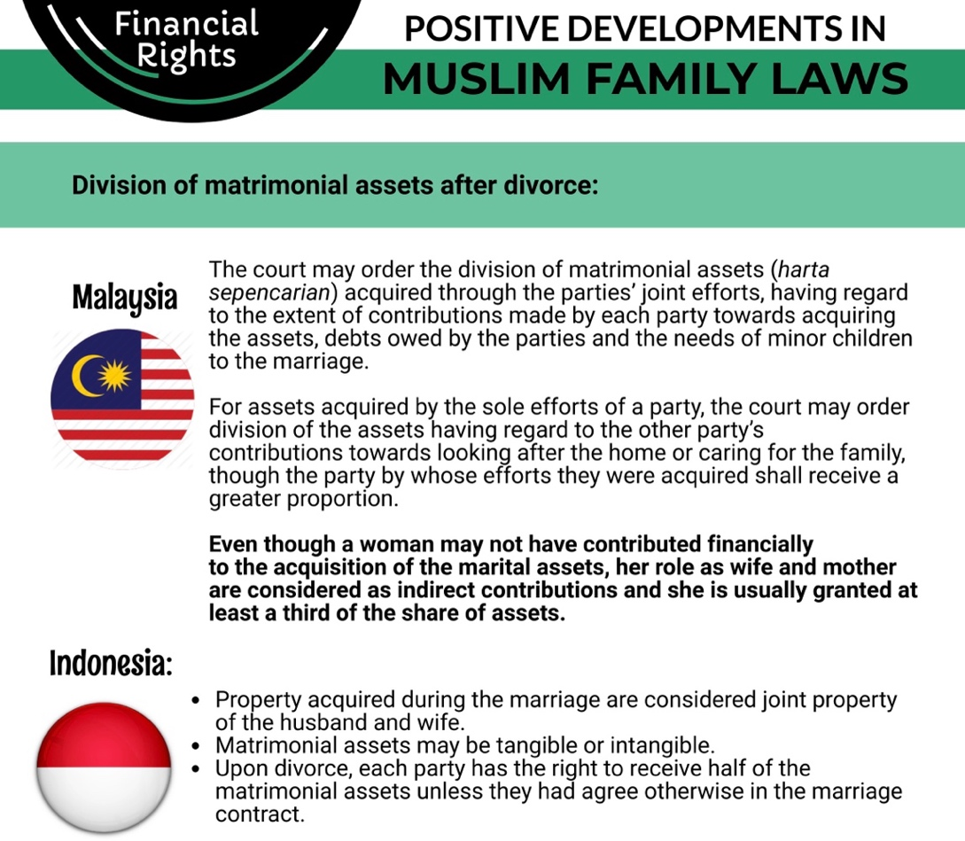

Custody and Guardianship of Children Article 16

Women are not entitled to equal custody and guardianship of their children. As a general rule, a mother has priority in the custody of her children until a child reaches a certain age, after which custody is transferred to the father. A woman’s custody rights are limited and conditional, and both legal and financial guardianship of the children remain the exclusive right of a father (or his male heirs) regardless of custody arrangements.
Custody of Children
A mother’s custody of her children is considered temporary, is subject to strict conditions of moral character and fitness and is restricted to physical care of the children. A Sunni woman loses custody of her sons when they turn fifteen (15) years old and her daughters at the time of the daughter’s marriage. However, Shi’a women lose custody of their children much earlier, at the age of seven for both sons and daughters. Both Sunni and Shi’a mothers automatically lose custody of their children if they remarry – unless a court determines otherwise – whereas a father does not lose custody if he remarries. The custodial rights of a mother are extremely limited; for example, she may not move the child outside of Bahrain without the explicit permission of the child’s guardian.

The Law provides a judge complete discretion to determine what is in “the best interests of the child” so long as it does not contradict the custody provisions articulated. Courts in Bahrain have repeatedly utilized the “best interests” analysis to deprive a mother of her custody rights. For instance, a Cassation Court ruling in 2019 held that a 15-year-old boy could not remain with his mother, even though that was his personal choice, because it was in the “best interests” of a boy his age to learn the moral of men from his father since he had outgrown the need of the service of women.
Guardianship of Children
A woman cannot be guardian of her children under Bahraini law. A father has priority right over the guardianship of the children. In case of the father’s death, guardianship passes to male relatives of the father. A father or guardian has exclusive power to make decisions regarding the child’s affairs, upbringing, and education regardless of who maintains custody. Whereas the mother, even as a custodian, cannot make even the simplest of decisions for the child without the guardian’s assent. For example, medical decisions, place of residence, schooling, and anything else related to caring for the child are the sole decisions of the guardian.

Bahrain’s Financial Guardianship Law governs guardianship over a minor’s financial assets and property. This law states that a guardian must be male, adult, sane, and of the same religion as the child. In theory, a woman can go to court to claim guardianship of her children but to date, there are no court cases where the guardianship of the child, either under the Family Law or the Financial Guardianship Law, was awarded to a woman.

Violence Against Women Article 16

In 2015, the Kingdom of Bahrain passed a Domestic Violence Act aimed at providing protection against various types of violence within the family and establishing protective and preventive measures for victims of domestic violence. The Act includes physical abuse, psychological abuse, sexual abuse, and “economic” abuse, and provides that victims have a right to request a protection order. It also states that the relevant Ministry shall provide shelters for victims, specialized trainings for law enforcement officers, judges, and prosecutors, and mechanisms to monitor incidents of domestic violence.

While passing this Act was a significant step forward, according to local activists in Bahrain, domestic violence remains prevalent. The Act’s provisions defining domestic violence have not been cited by family courts when issuing verdicts, according to a local activist, and it also has not been robustly enforced in practice. According to the U.S. State Department as of 2019, although the Act provides that police should be contacted about incidents of domestic violence and that the public prosecutor can investigate information it receives from police, in practice, victims of domestic violence “reported difficulty knowing whom to contact or how to proceed when filing a complaint.”

“Marry your Rapist” Provision in the Penal Code
The 1976 Penal Code criminalizes rape and sexual assault and sets forth applicable penalties. However, under Article 353 of the Penal Code, an offender is exempted from criminal prosecution for crimes of rape or sexual assault if he subsequently marries the victim, a legal reality that Bahrain does not dispute. Moreover, the Penal Code does not specifically criminalize marital rape.

Although Bahrain has informed the Committee that a bill that would repeal Article 353 has been proposed, Bahrain has declined the Committee’s request to provide a detailed update on the status of that bill and ongoing efforts to repeal Article 353.

Honor crimes in the Penal Code
Although Bahrain insisted to the Committee that “there is no such thing as honour crimes in Bahrain,” Penal Code Article 334 nevertheless permits mitigated penalties for any person who, upon discovering his or her spouse in the act of adultery, fatally assaults his or her spouse or the spouse’s partner. Meanwhile, under Article 16, “[n]othing is an offence which is done in exercise of a right justified by law or custom.”

Bahrain noted in its 2018 State Party report that a bill that would amend Articles 16 and 334 had been proposed. However, it did not address the Committee’s request for an update on the status of that bill in its response.

Nationality Article 9

According to statistics published by the Bahraini Ministry of Justice and Islamic Affairs, 5% of the 5,091 Bahraini women who were married in 2020 wed a foreign spouse.

Bahrain’s Nationality Law of 1963 imposes significant restrictions and additional conditions that limit Bahraini women’s ability to pass citizenship onto their children or onto their foreign spouses; Bahraini men are not subject to the same limitations.

The Nationality Act of 1963 provides that a child born to a Bahraini father automatically gains Bahraini citizenship at birth, regardless of birthplace, and regardless of the citizenship status of the mother. However, if a child is born to a Bahraini mother and a non-Bahraini father, the child is a Bahraini citizen at birth only if the identity of the father is unknown or paternity has not been legally established. In effect, this leaves children of Bahraini women married to foreign spouses at heightened risk of statelessness and deportation. In addition, the Nationality Act provides that a Bahraini man may confer Bahraini citizenship to his foreign wife upon request to the Bahraini government, whereas the Act does not specifically provide any parallel means through which a Bahraini woman may confer Bahraini citizenship to her foreign husband.

Bahrain has taken some positive steps to alleviate this suffering and unequal treatment. For example, under Act. No. 35 of 2009, the children of Bahraini women married to foreigners are subject to the same exemptions as Bahraini nationals from certain fees for government health and educational services and for residency. However, Bahrain has acknowledged that these measures are “temporary” pending a comprehensive amendment of the Nationality Act that grants legal equality to Bahraini women married to foreigners.

See Sandy Russell Jones, The Battle Over Family Law in Bahrain, in The Arab Revolts (David McMurray & Amanda Ufheil-Somers eds., 2013), 222
Law No. 19 of 2017 Promulgating the Family Law, Arts. 5, 38-49.
Domestic Violence Act No. 17 of 2015, Art. 1.
The Penal Code (1976), Arts. 321-322.
The Family Law (2017), Arts. 5, 38-40.
Id. at Art. 65(b).
Id. at Art. 3.
Id. at Art. 20.
Bahrain Child Law No. 37 of 2012, Art. 4.
Bahrain Information & eGovernment Authority, Marriage & Divorce 2020, Bahrain Open Data Portal (Feb. 23, 2021), https://www.data.gov.bh/en/ResourceCenter/DownloadFile?id=3556 (hereinafter Marriage & Divorce 2020), at Table 6.06.
Marriage & Divorce 2020, at Table 6.06; Marriage & Divorce 2019, at Table 6.06.
Marriage & Divorce 2020, at Tables 6.05, 6.06; Marriage & Divorce 2019, at Tables 6.05, 6.06; Bahrain Information & eGovernment Authority, Marriage & Divorce 2018, Bahrain Open Data Portal (Feb. 21, 2019), https://www.data.gov.bh/en/ResourceCenter/DownloadFile?id=2982.
The Family Law (2017), Art. 25.
Id. at Arts. 15, 28.
Id. at Art. 15(1)(d).
Dr. Dunya Ahmed, Women’s Rights in the Middle East and North Africa 2009 – Bahrain (Feb. 11, 2009).
The Family Law (2017), Arts. 81-82.
Id. at Arts. 97-112.
Id. at Arts. 95-96.
See The Family Law (2017), Art. 95(1)(a).
See id. at Art. 95(2)(a).
For instance, 2019 data indicates that about 25% of divorces in Bahrain were khul’ divorces specifically.
See Rania F. Al-Rabadi & Anas N. Al-Rabadi, Oriental Family Laws: Case Study Within a Gendered -Citizenship/Inequality Perspective: From Concept to Analytical Status, 17 J. Int’l Women’s Stds. 245, 252 (2016).
Harvard International Human Rights Clinic, Interview with anonymous Bahraini women’s rights advocate (Feb. 24, 2021).
The Family Law (2017), Art. 124.
Id.
Id. at Art. 127.
Id. at Art. 129-130.
Article 125(1), Bahrain Family Law
Cassation Court ruling, Cassation Court (Civil) Case No. 102 of Judicial Year 2018 (Holding: February 20, 2019).
Bahrain’s Financial Guardianship Law No. 7 of 1986.
Domestic Violence Act (2015).
See UNDP, Bahrain: Gender Justice & The Law (2018), p. 11; Bahrain State Party Report (2018), ¶¶ 94-100.
Domestic Violence Act (2015), Art. 1.
Bahrain State Party Report (2018), ¶¶ 95-96; UNDP, Bahrain: Gender Justice & The Law (2018), 15.
See Bahrain State Party Report (2018), ¶ 95.
U.S. Department of State, 2019 Country Reports on Human Rights Practices: Bahrain (hereinafter 2019 State Department Report), p. 26.
Harvard International Human Rights Clinic, Interview with anonymous Bahraini women’s rights advocate (Feb. 24, 2021).
2019 State Department Report, p. 26.
See Replies of Bahrain to the List of Issues and Questions in Relation to its Fourth Periodic Report, CEDAW/C/BHR/RQ/4, p. 9.
See Penal Code (1976), Arts. 344-353; UNDP, Bahrain: Gender Justice & The Law (2018), p. 9.
See Response to LOI, page 9.
Replies of Bahrain to the List of Issues and Questions in Relation to its Fourth Periodic Report, CEDAW/C/BHR/RQ/4, p. 9; see also Bahrain State Party Report (2018), ¶ 101.
Penal Code (1976), Art. 334.
Id. at Art. 16.
Replies of Bahrain to the List of Issues and Questions in Relation to its Fourth Periodic Report, CEDAW/C/BHR/RQ/4, p. 9; see also List of Issues and Questions in Relation to the Fourth Periodic Report of Bahrain, CEDAW/C/BHR/Q/4, ¶ 10.
Marriage & Divorce 2020, at Table 6.04.
Decree Law. No 12 amending the 1963 Nationality Act, Article (4).
Id.; see also UNDP, Bahrain: Gender Justice & The Law (2018), p. 18.
Nationality Act (1963), Art. 7.
See Bahrain State Report (2018), ¶ 159; see also UNDP, Bahrain: Gender Justice & The Law (2018), p. 18.
Bahrain State Report (2018), ¶ 160.

