European Union Agency for Fundamental Rights, selection of relevant and recent passages from published reports related to Italy
fra.europa.eu
21 November 2016, Vienna
References to Italy marked with bold
In the coming days there will be an overview available on FRA’s website on hate crime against migrants: http://fra.europa.eu/en/theme/asylum-migration-borders/overviews
Contents
Data Explorers, tools and themes 2
Jewish people’s experiences and perceptions of hate crime, discrimination and antisemitism 2
Roma survey data explorer 2
Local Engagement for Roma Inclusion (LERI) – Multi-Annual Roma Programme 2
Annual reports 2
Fundamental Rights Report 2016 (2016) 2
1. Racism, xenophobia and related intolerance 2
2. Roma integration 3
Fundamental rights: challenges and achievements in 2014 - Annual Report 2014 (2015) 4
1. Equality and non-discrimination 4
2. Racism, xenophobia and related intolerance 5
3. Roma integration 6
4. Asylum, borders, immigration and integration 7
Thematic reports 8
Ensuring justice for hate crime victims: professional perspectives (2016) 8
Severe labour exploitation: workers moving within or into the European Union States’ obligations and victims’ rights report (2015) 9
Antisemitism – Overview of data available in the European Union 2005–2015 14
EU-MIDIS, European Union Minorities and Discrimination Survey. Data in Focus Report. Minorities as Victims of Crime (2012) 20
Key migration issues: one year on from initial reporting 21

Data Explorers, tools and themes

Jewish people’s experiences and perceptions of hate crime, discrimination and antisemitism
http://fra.europa.eu/DVS/DVT/as2013.php

Roma survey data explorer
http://fra.europa.eu/en/publications-and-resources/data-and-maps/survey-data-explorer-results-2011-roma-survey

Local Engagement for Roma Inclusion (LERI) – Multi-Annual Roma Programme
http://fra.europa.eu/en/project/2015/local-engagement-roma-inclusion-leri-multi-annual-roma-programme

Annual reports

Fundamental Rights Report 2016 (2016)
http://fra.europa.eu/en/publication/2016/fundamental-rights-report-2016
- Racism, xenophobia and related intolerance
“In the Czech Republic, Denmark, France, Ireland, Italy, Luxembourg, the Netherlands, Spain and Sweden, national public campaigns and/or information websites were launched on living together without prejudice, racism and xenophobia; on increasing the reporting of racist and discriminatory incidents; and on victim support.” (page 81)
“FRA interviewed police and other law enforcement officers, public prosecutors and judges from criminal courts, experts working for victim support services, and representatives of civil society organisations. The results indicate that professionals believe that many police officers and judicial staff do not fully understand what hate crime constitutes and often lack the commitment necessary to identify hate crimes and prosecute and sentence offenders. Awareness-raising and specialised training for relevant staff can help address such a lack of understanding or commitment. This was provided in a number of Member States in 2015: in the Czech Republic, on victims of crime; in Bulgaria and Italy, on hate crime generally; on racist crime in Bulgaria, Cyprus and France; and on recognising and dealing with cyber-hate in Slovakia.” (page 82)
Promising Practice: “Developing an EU model of good practice to tackle hate crime
The project Good Practice Plus is developing an EU model of good practice to tackle racial and religious hate crime and hate speech and to promote effective reporting systems on hate crime. It promotes measures to build the capacity of law enforcement officials, prosecutors and personnel of victim support services; awareness-raising programmes; and efforts to empower ethnic minority communities. The project aims to improve the position of hate crime victims, provide them with support, and ensure access to justice for victims of racism and hate speech. The project is a partnership between the Northern Ireland Council for Ethnic Minorities, the Police Service of Northern Ireland, Migrant Centre NI and Finland’s Ministry of the Interior. Seven other countries are formally engaged with the project: Belgium, the Czech Republic, Estonia, Greece, Ireland, Italy, and the Netherlands. The European Commission co-founded the project. For more information, see: http://goodpracticeplus. squarespace.com/”
(page 82)
“The Italian Ministry of Labour and Social Policies adopted a National Plan against Racism, Xenophobia and Intolerance. It aims to monitor and support the implementation of the racial and employment equality directives by collecting data on labour discrimination, promoting diversity management policies, and taking measures to combat discrimination in the private sector.” (page 86)
- Roma integration
“Regarding Italy, ECRI urged full legal protection and the provision of decent accommodation in the case of any evictions. Forced evictions against Roma were also the subject of a European Parliament hearing on fighting racial discrimination in housing.” (page 100)
“The Commission’s 2015 report on the implementation of the EU Framework for NRISs recognised the key competences of local-level actors to address challenges – for example, in housing and education – but noted that “the involvement of local authorities in implementation varies widely.” The report also noted progress in drawing up, revising and planning local level action plans in Member States, such as Bulgaria, the Czech Republic, Greece, Hungary, Ireland, Italy, Poland, Romania, Slovenia, Spain and Sweden.” (page 102)
“The Council of Europe/European Commission Joint Programme ROMACT continued to be implemented in 2015 in five Member States (Bulgaria, Hungary, Italy, Romania and Slovakia), with the aim of building up the capacity of local authorities and improving their responsiveness and accountability towards marginalised Roma communities. The project also complements the Council of Europe/European Commission’s ROMED 2, which ran in parallel with ROMACT in 2015; it focuses on mediation and participation of Roma citizens in decision-making processes at local level in their municipalities through the development of Community Action Groups.” (pages 102–103)
“In several Member States, municipalities have put in place local action plans that target Roma specifically, but not exclusively, despite the absence of such a provision in the NRIS – for example, in the Czech Republic, Italy, Spain and the United Kingdom. […] Italy set up regional and local boards to implement the NRIS, as well as coordination bodies of regional and local authorities. Only half of the regions approved strategies and set up boards, whereas by 2015 most municipalities had developed local strategies, despite the lack of any formal obligation to do so.” (pages 104–105)
“In 22 municipalities included in FRA’s LERI research project, the project used different approaches to local engagement in 2015 by applying participatory action research methodology. In bringing together local stakeholders, including Roma, small-scale plans and actions are developed to cater to the real needs and specificities of the local communities. […]. In Bologna, Italy, the project strengthens the participation of Roma and Sinti groups in a local support group.” (page 105)
“Local action plans usually concern the four core thematic areas of the EU Framework on NRISs: education, employment, health and housing. Additionally, local action plans sometimes set out non-discrimination measures – for example, in Bulgaria, Italy, Romania, and Slovenia.” (page 106)
“In Italy, some local action plans include measurable objectives in terms of reducing school drop-outs, increasing Roma families’ access to social services, developing school projects and eliminating a specific number of camps by certain deadlines.” (page 106)
“Most Member States have monitoring processes in place at national level, under the responsibility of central state institutions such as ministries. This is the case in Croatia, Italy and the Netherlands, for example.” (page 107)
“Local and regional authorities are often represented on national monitoring committees – for example, through national associations of municipalities. This is the case in Bulgaria, Croatia, Ireland, Italy, the Netherlands and Romania.” (page 108)
Promising Practice: “Transferring local-level initiatives
The Roma Secretariat Foundation (Fundación Secretariado Gitano, FSG) (Spain) and Consorzio Nova Onlus (Italy) are implementing an ESF funded project that aims to develop and adapt the model of the ‘Acceder programme’ to the Italian context. The Acceder programme, implemented by FSG since 2000, aims to help the Roma population integrate into the job market. It is present in 14 Spanish regions and involves 51 employment mechanisms. Transferring it to the Italian context involves several phases, such as carrying out feasibility studies for selecting a pilot locality, drafting an implementation plan for the selected locality, and implementing pilot projects. Involving various relevant stakeholders – including Roma associations – in the design, assessment and implementation of the programme in Italy is instrumental for creating an effective mechanism. The added value rests in the fact that the same scheme can also be replicated in other Member States, together with any necessary adaptations. Doing so would maximise resources and expertise, and reinforce transnational cooperation between Member States on common issues. For more information, see FSG, ‘Transferencia Acceder a Italia’” (page 108)

Fundamental rights: challenges and achievements in 2014 - Annual Report 2014 (2015)
http://fra.europa.eu/sites/default/files/fra-annual-report-2014_en.pdf
- Equality and non-discrimination
“Not knowing where to turn to seek redress in cases of discrimination is, however, often the first barrier to being able to fully exercise the fundamental right to equal treatment. No single organisation or body is responsible for enabling people to seek redress. FRA, together with a group of national human rights bodies, therefore continued working in 2014 on a pilot online tool named ‘Clarity’ to help victims of discrimination and other fundamental rights violations gain better access to non-judicial remedies. The bodies involved represented Austria, Bulgaria, Cyprus, Finland, France, Greece, Hungary, Italy, Malta, Portugal, Romania, Slovakia, Spain and the United Kingdom (Northern Ireland).” (page 29)
“Member States also took steps to begin training staff involved in the management and control of ESIF on EU anti-discrimination law and policy, in line with the second conditionality [anti-discrimination: arrangements to train staff of the authorities involved in the management and control of ESIF in the fields of Union anti-discrimination law and policy]. This happened in Austria, Belgium, Bulgaria, Croatia, Cyprus, the Czech Republic, Denmark, Estonia, Finland, France, Germany, Hungary, Italy, Latvia, Lithuania, Luxembourg, Malta, the Netherlands, Poland, Romania, Slovakia, Slovenia, Spain and Sweden. The criteria to be met under this conditionality are having a plan in place, and the plan covering all relevant actors.” (page 31)
“Concerning the third conditionality [disability: arrangements in accordance with the institutional and legal framework of Member States to consult and involve bodies in charge of protecting the rights of persons with disabilities or representative organisations of persons with disabilities and other relevant stakeholders throughout the preparation and implementation of programmes], some Member States have consulted or plan to consult with bodies in charge of protection of rights of persons with disabilities or disabled persons organisations (DPOs). This was the case in Austria, Belgium, Bulgaria, Cyprus, Denmark, Estonia, France, Greece, Hungary, Ireland, Italy, Latvia, Lithuania, Luxembourg, Malta, the Netherlands, Poland, Portugal, Romania, Slovakia, Spain and Sweden. The criteria to be met under this conditionality include having a plan in place to involve such organisations, identifying relevant actors and their roles and facilitating their active involvement in the process.” (page 31)
“For the fourth conditionality [disability: arrangements to train staff of the authorities involved in the management and control of the ESIF in the fields of applicable Union and national disability law and policy, including accessibility and the practical application of the CRPD as reflected in Union and national legislation, as appropriate], Member States took steps to ensure that relevant staff will be trained on applicable EU and national disability law and policy, including accessibility and the implementation of the CRPD. This happened in Austria, Belgium, Bulgaria, the Czech Republic, Denmark, Estonia, Finland, France, Germany, Greece, Hungary, Italy, Latvia, Luxembourg, Malta, the Netherlands, Portugal, Romania, Slovenia, Slovakia and Spain. The criteria to be met under this conditionality are having a plan in place, and the plan covering all relevant actors.” (page 31)
“The other relevant conditionality Member States have to meet relates to arrangements to monitor the implementation of Article 9 of the CRPD on accessibility, in the context of disbursing structural and investment funds. Monitoring here relates to ensuring the suitability of the built environment, transport, information and communication technologies or public services. It also relates to the availability of redress mechanisms to challenge situations where structural funds would be used in a way prejudicial to accessibility. Austria, Belgium, Bulgaria, Denmark, France, Hungary, Italy, Latvia, Lithuania, Luxembourg, Malta, Poland, Romania, Slovakia, Sweden and the United Kingdom took steps towards meeting this conditionality. The criteria to be met under this conditionality are having in place monitoring, redress and enforcement mechanisms on accessibility in all its forms, and clear technical guidance being available.” (page 31)
“Country-specific recommendations (CSRs) made by the European Commission to Member States on how to boost growth and jobs creation could, where followed, play an important role here. Twelve Member States received recommendations relating to poverty and social inclusion for 2014–2015: Bulgaria, Croatia, Ireland, Italy, Hungary, Latvia, Lithuania, Poland, Portugal, Romania, Spain and the United Kingdom.” (page 32)
- Racism, xenophobia and related intolerance
“Complaints filed with the national equality bodies in a number of Member States, including Austria, Belgium, Croatia, the Czech Republic, Greece, Italy, Luxembourg, Spain and Sweden, show that race, ethnicity and skin colour remain amongst the most common grounds of reported discrimination.” (page 50)
“At the same time, research points to a trend in anti Muslim sentiments: according to the Pew Research Centre survey results, a median of 46 % (ranging from 26 % to 63 %) of respondents in France, Germany, Greece, Italy, Poland, Spain and the United Kingdom hold anti-Muslim views. The research also found that the majority population perceives Jews in a more positive way than Muslims.” (page 52)
Promising Practice: Tackling hate crime
“The Italian Observatory for Security against Acts of Discrimination (Osservatorio per la sicurezza contro gli atti discriminatori, OSCAD), established in September 2010, assists victims of crimes with a discriminatory motive to assert their right to equality before the law, and affords them protection against discrimination. A multi-agency body formed by the state police and the carabinieri, and housed in the Department of Public Security at the Ministry of the Interior, OSCAD works closely with civil society organisations such as LGBT rights organisations and Amnesty International Italy. Citizens, institutions and NGOs can report incidents to OSCAD, which then contacts relevant police services so that cases can be properly investigated. If the reported incidents are not of a criminal nature, they are referred to the national equality body, the National Office against Racial Discrimination (Ufficio Nazionale Antidiscriminazioni Razziali, UNAR). OSCAD is also tasked with preparing training materials on combating discrimination for the police forces. It also participates in training and information programmes with public and private institutions, as well as in the OSCE Training against Hate Crime for Law Enforcement programme. For more information, contact: oscad@dcpc.interno.it” (page 56)
“No trends [in data in recorded crimes motivated by antisemitism] could be identified between 2011 and 2013 because of a lack of published data, the low number of recorded crimes, or changes in recording systems or to the definitions used, for the following EU Member States: Bulgaria, Croatia, Cyprus, Denmark, Estonia, Greece, Italy, Latvia, Lithuania, Luxembourg, Malta, the Netherlands, Portugal, Romania, Slovakia and Slovenia.” (page 62)
- Roma integration
“A public opinion poll conducted by the Pew Research Centre in March–April 2014 in seven EU Member States shows that Roma are viewed unfavourably by a median average of about half of those surveyed (Spain 41 %, Germany 42 %, Poland 50 %, United Kingdom 50 %, Greece 53 %, France 66 %, Italy 85 %).” (page 73)
“Civil society organisations are part of working groups in Belgium, Italy and Slovakia” (page 74)
“In response to the request in the 2011 European Commission communication on the EU Framework for national Roma integration strategies and the 2013 Council recommendation on effective Roma integration measures in the Member States, FRA established a working party on Roma integration indicators, as a subgroup of the European Commission’s network of NRCPs. Since 2012, FRA has coordinated the working party in close cooperation with the Commission. The number of Member States participating in the working party grew from 13 in 2013 – Belgium, Bulgaria, the Czech Republic, Croatia, Finland, France, Hungary, Italy, the Netherlands, Romania, Slovakia, Spain and the United Kingdom – to 17 in 2014, with Austria, Greece, Ireland and Portugal joining. The objective of this group is to develop and pilot a rights-based framework of Roma integration indicators (presented in detail in FRA’s Annual report 2013) that can comprehensively document progress made in reference to fundamental rights standards. In 2014, the working party set out process indicators that can show progress in implementing the measures outlined in the Council recommendation, and four Member States piloted the indicators.” (page 75)
- Asylum, borders, immigration and integration
“In the central Mediterranean, irregular arrivals by sea increased substantially – 170,100 persons reached Italy alone. Most of them were people likely to be in need of protection fleeing countries such as Eritrea or Syria. The majority of them were rescued under the auspices of Mare Nostrum, a large rescue at sea operation Italy launched on 18 October 2013 in response to the tragedy near Lampedusa costing the lives of 365 persons. The military vessels deployed by Italy as part of the Mare Nostrum operation remained at sea until the end of 2014, although the operation scaled down after the start of the Frontex-coordinated Triton operation in November. Unlike Mare Nostrum, the main objective of Triton is border surveillance and not rescue at sea, although it also contributed to the detection and rescue of significant numbers of people in distress.” (page 86)
“The judgment on Sharifi and Others v. Italy and Greece condemned Italy for automatically returning persons arriving from Greece at Italian ports. The authorities violated their rights by handing these arrivals over to ferry captains, thus depriving them of access to the asylum procedure or any other remedy. In Tarakhel v. Switzerland, the ECtHR ruled that there would be a violation of Article 3 of the ECHR if a family with minor children who applied for international protection were returned to Italy under the Dublin Regulation without Switzerland having first obtained the Italian authorities’ guarantees that the applicants would be taken charge of in a manner adapted to the children’s ages and that the family would be kept together” (page 88)
“In another five Member States (Bulgaria, Cyprus, Greece, Italy and Portugal), the return monitoring system is still in a preparatory phase pending staff, funding, training and/or other action.” (page 89)
“Ten Member States (Croatia, Finland, France, Greece, Italy, the Netherlands, Poland, Portugal, Romania and Slovenia), amended their legislation to establish independent monitoring systems in 2014. […] Italy created a national monitoring authority for persons deprived of liberty; once established, it should also monitor forced returns.” (page 89)
“In 2014, however, five Member States (France – until May, Germany, Greece, Italy and Sweden) that lacked an operational monitoring system carried out by an independent authority (i.e. an authority different from the branch of government responsible for return), according to FRA’s assessment, organised 20 return operations. These operations concerned 1,089 of the 2,279 persons returned through Frontex-coordinated flights in 2014. In seven of these 20 operations, however, observers from other states were present.” (page 91)
“However, turning from policy to practice, fewer Member States adopted and implemented concrete measures, such as training for public officials and civil servants dealing with migrants. Austria, Croatia, the Czech Republic, Germany, Greece, Hungary, Ireland, Italy, Latvia, Malta, the Netherlands and Slovenia did so.” (page 96)
“Twelve EU Member States (Austria, Croatia, the Czech Republic, Denmark, Germany, Greece, Ireland, Italy, Latvia, Malta, the Netherlands and Slovenia), implement training programmes and capacity building for public administration. They offer these resources to civil servants dealing with migrants.” (page 96)
“In most cases, such curricular programmes provide information, knowledge and skills enabling pupils to live in community in modern ethnically diverse societies. However, in eight Member States (Belgium, Cyprus, Estonia, France, Greece, Hungary, Portugal and Slovakia), there are no such elements in the national curriculum. In Bulgaria, Italy and Romania, diversity is addressed in extracurricular activities.” (page 98)

Thematic reports

Ensuring justice for hate crime victims: professional perspectives (2016)
http://fra.europa.eu/en/publication/2016/ensuring-justice-hate-crime-victims-professional-perspectives
Quotes:
“The fact that homophobia and disability are not yet grounds covered by the law is a shortcoming in the legislation that should be overcome.” (Police officer, Italy), (page 19)

“It is more problematic if a politician makes a discriminatory statement rather than if a moron says the same thing in a pub”. (Police officer, Italy), (page 20)
“There are victims of first class and victims of second class: while crimes against Jews would not be tolerated, there is a sort of consensus for crimes against gypsies”. (Judge, Italy), (page 21)
“As a judge and a legal expert in the field, I look forward to the adoption of legal provisions regulating the web to enable police and the criminal justice system to better react to hate crime committed through the internet.” (Judge, Italy), (page 21)
“We are introducing, at the local level, police units which are directly in contact with foreign communities which have grown in number in recent years to help the communication between police and potential victims. This raises the number of complaints reported to the police.” (Police officer, Italy), (page 41)
“Frequently victims of hate crime who are third country nationals have a prejudice toward police forces because police officers in their former country are part of nondemocratic and repressive regimes.” (Police officer, Italy), (page 54)
“A number of interviewees (including from Italy, Poland and Slovenia) alluded to politicians contributing to the problem of hate crime with public racist or discriminatory statements.” (page 19)
“Similarly, the majority of interviewees in Italy claimed that politicians often make racist statements and that no action is taken against them, with only few incidences having led to criminal proceedings. Some interviewees from victim support services said that, in public discussions on measures in support of equal rights for gay couples, anti-LGBTI arguments are still frequently used, even by politicians and some institutional representatives, and that this reinforces intolerance against LGBTI persons.” (page 20)
“[I]n Italy, all interviewees pointed out that Roma and Sinti are the groups most exposed to public incitement to hostilities.” (page 21)
“However, it is worth mentioning that Greece, Romania and Italy recently enacted pertinent criminal law provisions [to criminalise the denial of the Holocaust and other war crimes].” (page 25)
“For example, in Italy, the Observatory for Security Against Discriminatory Acts (OSCAD) in 2010 established an online reporting system (by e-mail and fax) through which victims, organisations and institutions can report cases that occurred in the territory of the police. The grounds of discrimination covered are wider than those covered by existing legislation: race, ethnicity, nationality, religion, gender, age, language, disability, sexual orientation and sexual identity. The National Office against Racial Discrimination (UNAR) also established a reporting mechanism, which includes a website and a helpline. When UNAR receives information on a case of discrimination that constitutes a criminal offence, it has to refer it to the police.” (pages 43–44)
Additional Information regarding hate crime:
Italy was a member of the FRA Working Party on improving reporting and recording of hate crime in the EU (2014-2016) which was set up jointly with the Italian Presidency of the Council of the EU in 2014.
Italy is a member of the new FRA led Subgroup on methodologies on recording and collecting data on hate crime.

Severe labour exploitation: workers moving within or into the European Union States’ obligations and victims’ rights report (2015)
http://fra.europa.eu/en/publication/2015/severe-labour-exploitation-workers-moving-within-or-european-union
Quotes:
“[T]he primary aim is not to improve working conditions and the situation of exploited workers, but rather to sanction irregular work, so that worker protection is secondary.” (Lawyer, Italy), (page 53)
“[I]n agriculture […] and in manufacturing, textiles and clothing, there are situations that are particularly known, and clearly identified as labour exploitation, but [in these sectors] often [the police] do not intervene. I don’t know why, maybe for lack of a political will, or for the inability of institutions to react.” (Lawyer, Italy), (page 54)
“In fact, we favour irregular migrants, since in our opinion, they are regulars. It is the state that labelled them as irregulars, with reference to the residence permit.” (Representative of a victim support organisation, Italy), (page 81)
“[The] agent is torn between a law saying that [the] irregular migrant has to be prosecuted as such, and another law that protects the very same migrant as [a]victim of more serious crimes.” (Representative of police or law enforcement body, Italy), (page 86)
“These are lengthy, exhausting investigations which require strong coordination among police, carabinieri, labour inspectors. [There is] [l]ittle chance of success in trial as victims get expelled and who knows where they will be when trial finally starts. Why should a public prosecutor invest in something like that?” (Lawyer, Italy), (page 87)
“The criminal laws of Croatia, the Czech Republic, Estonia, Italy, Portugal and Slovakia protect all aliens (third-country nationals and EU citizens from other EU Member States) in an irregular situation of residence.” (page 38)
“On the other hand, in marked contrast to their initial tentativeness, probably stemming from these conceptual complexities, once the terms were clarified, respondents assessed the exploitation of workers from other countries in particularly exploitative employment relationships as in fact the most common form of severe labour exploitation. In 13 of the 21 EU Member States that were included in the fieldwork phase of the project – Austria, Croatia, Cyprus, France, Germany, Greece, Hungary, Italy, Lithuania, Malta, Poland, Portugal and Spain – it was perceived by experts as the most frequently occurring form of severe labour exploitation.” (page 39)
“Respondents in many countries – Austria, Bulgaria, France, Greece, Ireland, Italy, Malta, the Netherlands, Poland, Slovakia and Spain – identified working in an irregular situation as an important risk factor for exploitation.” (page 44)
“In contrast, in Italy and Poland agriculture is overwhelmingly considered the sector most prone to exploitation.” (pages 46–47)
“Many respondents – for instance from Italy, the Netherlands, Spain and the United Kingdom – spoke of the need for greater awareness-raising among the public to foster public debate on labour exploitation and encourage the reporting of situations of labour exploitation by citizens.” (page 51)
“Even where labour exploitation was widely covered in the national media – such as in Italy, following violent clashes between migrants working on fruit farms and local organised criminal gangs in Rosarno, Calabria – it was still not seen as a priority for the police or public institutions.” (page 54)
“In addition to common forms of support services, in a few countries – including Cyprus, Greece and Italy – trade unions play an important role supporting victims and providing legal counselling and legal aid.” (page 55)
“In Italy, training courses on how to work legally in agriculture are provided by cultural mediators targeting African migrants in Calabria.” (page 55)
“For instance, an employers’ organisation in Italy organised public meetings to discuss the main issues linked to the labour market, in particular relating to workers’ safety in the workplace. Support services also provide information material to make workers aware of the exploitative nature of their situation, and to help them find routes to the regularisation of their residence status.” (page 56)
“In Italy, inspections by the Provincial Labour Directorate focus on specific economic sectors, such as the tourism sector during the summer season. Inspections are also conducted as a result of tip-offs by workers, victims, trade unions, the consulates of victims’ countries or other concerned individuals.” (page 66)
“Interviewees in some Member States – France, Germany, Italy, Lithuania and Slovakia – highlighted limited coordination as one possible cause for the lack of effective monitoring, investigations and prosecutions. The experts suggested that too many different bodies are tasked with similar responsibilities, and that exchange and cooperation are not well institutionalised.” (page 66)
“Experts, for instance from Germany and Italy, criticised the fact that support services are not always inclusive of all groups of victims. Victim support often depends on the initiation of an investigation procedure and thus on the categorisation of an individual case of labour exploitation as a specific criminal act and, in particular, on the readiness of the victim to testify against the perpetrator.” (page 78)
“By far the most permits were issued in Italy; however, the precise number is not clear. A total of 147 residence permits were issued in Italy for victims of trafficking as a measure of ‘social protection’. In addition, 1.277 residence permits were issued for ‘humanitarian reasons’ (recipients included but were not limited to victims of trafficking).” (pages 78–79)
“Desk and field research carried out by FRA indicates that less than half of EU Member States have implemented Article 13 (4) of the Employer Sanctions Directive at the level of legislation; those that have done so include Germany, Greece, Hungary, Italy, Luxembourg, Slovakia, Slovenia, Spain and Sweden. However, even where legislation is in place, it is only rarely applied. In 2013, 28 residence permits were issued in Italy and four were issued in Germany on the basis of provisions implementing Article 13 (4) of the Employer Sanctions Directive, and in Slovakia the residence of one victim was ‘tolerated’. In all these cases, the victim’s residence was conditional on their willingness to cooperate with law enforcement authorities.” (page 79)
“In two thirds of the EU Member States in which fieldwork was carried out (Austria, Belgium, Croatia, Cyprus, Germany, Greece, Hungary, Ireland, Italy, Lithuania, Malta, Poland, Slovakia and Spain), experts view victim support services as lacking or ineffective in practice, with very few services dedicated to victims of labour exploitation specifically, and many services outright excluding them unless trafficking or violence is involved (as mentioned by five Austrian interviewees, for example).” (page 80 )
“Another difficulty, raised by interviewees in Germany and Italy, is the lack of a comprehensive and systematic approach, meaning that, rather than coordinating their efforts, every organisation tries to cope with the local circumstances and workers usually do not know in what areas the various services specialise.” (page 80)
“Offering accommodation to victims of severe labour exploitation is often difficult, as highlighted by respondents in France, Germany and Poland. In addition, in some Member States, such as Italy and the United Kingdom, government support for these services has been severely reduced. NGOs fill this gap in public services and organise themselves to provide support to victims, in particular to migrants in an irregular situation, who are afraid to turn to public institutions.” (page 81)
“In many countries – Finland, Germany, Greece, Italy, Portugal and Slovakia – investigation and prosecution of severe forms of labour exploitation of workers who have moved within or into the EU does not seem to be in the interest of the state, and it is left to individual complainants to step forward and initiate proceedings. In addition, law enforcement and prosecutors often rely to a large extent on the victim presenting the evidence, instead of using all measures at their disposal to gather evidence. Prosecutors rarely play a role in ensuring that the victim is aware of their right to claim compensation, that injuries and damages caused to victims are documented during the investigation or that compensation is claimed.” (page 84)
“Overall, research findings revealed a lack of competent partners who could be easily addressed and would be responsive to victims, their rights and their needs. Many respondents across countries and professional groups had little experience of exploited workers who had moved within or into the EU seeking to access justice. This is compounded by a lack of knowledge among stakeholders about the entitlements and rights of exploited workers, in particular those in an irregular situation or without written labour contracts, as expressed by experts in France, Italy, the Netherlands and the United Kingdom.” (page 84)
“From expert interviews conducted and case studies identified in Bulgaria, Cyprus, Greece, Italy, Lithuania, Slovakia and the United Kingdom, it appears that, in trying to access support services and justice, workers often face a lack of sensitivity on the part of authorities. Case studies indicate instances of victims being detained for immigration control reasons, of victims not reporting out of fear and distrust, and of authorities failing to identify a situation of exploitation and assist the victim. Experts reported that prejudice and insensitive treatment ranges from patronising victims to discriminatory attitudes, which perpetuate negative stereotypes and can result in victims being denied assistance and justice. Authorities need to establish trust and provide a sense of safety, security and protection for exploited workers who have moved within or into the EU.” (pages 84–85)
“In a case in Italy involving the exploitation of migrants from Ghana in agricultural work, the victims were encouraged to lodge complaints after political activists took an interest in their situation. As a result of their reporting the exploitation, they were detained for expulsion.” (page 86)
“Another weakness of investigations, highlighted by experts from Belgium, Germany and Italy in interviews, is that cases centre on the testimony of victims and witnesses. This presents risks, as victims and witnesses may withdraw their evidence or have to leave the country before the court case. Police and public prosecutors may also be discouraged from investing time and resources in the fight against severe labour exploitation because they believe success to be unlikely. This in turn may result in impunity for and encourage perpetrators.” (page 87)
“As experts from Italy, Slovakia and the United Kingdom pointed out, because of the focus of prosecutors on trafficking, labour exploitation is unlikely to trigger a response without clear indicators of trafficking, the assessment of which may differ from country to country, requiring for instance the involvement of organised crime, seizure of passports or evidence of physical harm. In many countries trafficking expertise is still focused in practice on detecting trafficking for sexual exploitation only, so labour trafficking may remain undetected even by specialist trafficking units.” (page 87)
“However, evidence from FRA’s research into severe labour exploitation of workers who have moved within or into the EU shows that referral mechanisms are often not in place for victims of labour trafficking, and even less so when it comes to other forms of severe labour exploitation. As a result, identification and recognition of victims of severe labour exploitation is not systematic in, for example, Germany, Italy and Slovakia.” (page 88)
“In Italy, the police resort to the protection offered under Article 18 of its Legislative Decree No. 286/98, which offers a permit for special humanitarian reasons, in particular to victims of trafficking for sexual exploitation. Some authorities do not realise that they have a responsibility to support victims. Also in Italy, some respondents considered that protection of a victim is only an indirect effect of activities carried out by the police, such as arrest of the employer or closure of the business, and does not constitute a separate obligation.” (page 88)
“As reported in Ireland, Italy and Spain, in some sectors businesses close and reopen under different names or declare bankruptcy to avoid paying wages or compensation.” (pages 88–89)
“The latest statistics published by Eurostat reveal that in Germany in 2012, 162 persons were prosecuted for trafficking, of which only 10 % faced prosecution for labour exploitation. The equivalent figure for France, the UK and Italy (in 2011) was 0 %.” (page 89)
“Judicial respondents in Italy reported that prosecuting the leaders of criminal organisations was worthwhile but that the statistically more frequent illegal gangmaster (caporalato) prosecutions were not useful in eliminating the phenomenon as a whole.” (page 89)
Breakdown of fieldwork in the EU Member States (interviews, focus groups and case studies)
 | Interviews | Focus groups | Case studies
Large Member States: France, Germany, Italy, Poland, Spain, and the United Kingdom | 40 interviews: four to seven interviews with representatives of groups M, P and J; six to eight interviews with representatives of group S, of which two or three interviews should be conducted with representatives of child welfare organisations; two to four interviews with representatives of groups L (at least one lawyer mainly working in the field of civil or labour law), R, W and E; one interview with a national coordinator (N). | Two focus group discussions | 15–18 case studies

Selected case studies:
Access to Justice - “Up to 30 men from Pakistan were exploited in several pizzerias in Bologna. They had entered Italy in an irregular manner. One of the victims decided to report the case to the police, as he knew about the social protection and residence permit avail- able under Article 18 of the Immigration Law. Six of the victims were then provided with assistance and the perpetrators were charged with forming a criminal organisation and engaging in irregular immigration and labour exploitation.” (page 26)
Migrants in irregular situations – “In Italy, a Bolivian woman in an irregular situation worked as a carer in a household, working long hours and receiving very little payment for her work. The employer used her irregular situation to intimidate her.” (page 53)

Antisemitism – Overview of data available in the European Union 2005–2015
Official data
The divisions for general investigations and special operations (Digos) collect data on antisemitic criminal conduct, which the Ministry of Interior communicated to FRA. These data show that the number of incidents of antisemitic criminal conduct recorded in Italy increased from 16 in 2010 to 58 in 2014.

Recorded incidents of antisemitic criminal conduct in Italy, 2010–2015
 | Cited persons | Arrested persons | Total
2010 | 9 | 0 | 16
2011 | 1 | 1 | 23
2012 | 20 | 6 | 28
2013 | 43 | 0 | 32
2014 | 23 | 0 | 58
2015 | not available | not available | not available
Source: Directorate of the Preventive Police, Divisions for general investigations and special operations (Digos)

Recorded incidents of antisemitic criminal conduct in Italy, 2011–2014

Note: The dotted linear regression line indicates the trend based on data for 2011–2014.
Source: Directorate of the Preventive Police, Divisions for general investigations and special operations (Digos)

Unofficial data
The Observatory of Contemporary Anti-Jewish Prejudice (L’Osservatorio sul pregiudizio antiebraico contemporaneo) records incidents of antisemitism in Italy, with a particular focus on the internet. As table 29 shows, the number of antisemitic incidents decreased from 86 incidents recorded in 2014 to 61 in 2015.
Recorded antisemitic incidents in Italy, 2005–2015
 | Recorded incidents
2005 | 49
2006 | 45
2007 | 45
2008 | 35
2009 | 47
2010 | 31
2011 | 58
2012 | 87
2013 | 49
2014 | 86
2015 | 61
Source: Observatory of Contemporary Anti-Jewish Prejudice

Recorded antisemitic incidents in Italy, 2005–2015

Note: The dotted linear regression line indicates the trend based on data for 2005–2015.
Source: Observatory of Contemporary Anti-Jewish Prejudice

Discrimination and hate crime against Jews in EU Member States: experiences and perceptions of antisemitism (2013)
http://fra.europa.eu/en/publication/2013/discrimination-and-hate-crime-against-jews-eu-member-states-experiences-and
Quotes:
“I think antisemitism in Italy is decreasing, albeit slowly.” (Man, 70–79 years old, Italy) (page 18)
“I often don’t say I’m Jewish, so I can really understand what people think of us. Antisemitism is very widespread in Italy, especially in public places and in the daily small talk among people.” (Man, 25–29 years old, Italy), (page 21)
“There are not only antisemitic insults or assaults. There are also looks/gazes or apparently less aggressive reprimands (this is the experience of my son at primary school and my son at high school) also from his teachers.” (Man, 50–54 years old, Italy), (page 34)
“Antisemitism due to prejudices against Israel is increasing, by identifying Jewish people with Israel in public opinion. This is more dangerous than the ‘traditional’ extreme right-wing antisemitism, because it is less visible but more deceitful and pervasive.” (Woman, 30–34 years old, Italy), (page 39)
“From my experience, I think most of the antisemitic incidents are verbal and they are due to ignorance and indifference more than to a real political-religious belief.” (Man, 45–49 years old, Italy), (page 48)
“Over 90 % of respondents in five countries (France, Hungary, Italy, Latvia and the United Kingdom) saw the state of the economy as ‘a very big’ or ‘a fairly big problem’.” (page 15)
“Respondents in Hungary and Italy alone considered government corruption to be among the top three problems in the country where they live (94 % of respondents voiced this opinion in both countries).” (page 16)
“The majority of the respondents in France (84 %), Belgium (74 %) and Hungary (72 %) consider expressions of hostility towards Jews in the street and other public spaces to be ‘a very big’ or ‘a fairly big problem’ in the country. In Sweden (51 %) and Germany (48 %), about half the respondents consider it a problem, while in Italy (30 %) or the United Kingdom (35 %) one third of the respondents do so.” (page 19)
“In the remaining countries surveyed, about one third of the respondents (Italy, 43 %; Germany, 33 %; the United Kingdom, 31 %; Sweden, 30 %) or less (Latvia, 23 %) consider the vandalism of Jewish buildings to be ‘a very big’ or ‘a fairly big problem’.” (page 19)
“About two thirds of the respondents in France, Hungary and Italy (69 %, 69 %, and 61 %, respectively) and half in Belgium (52 %) consider antisemitic graffiti to be ‘a very big’ or ‘a fairly big’ problem.” (page 19)
“More than 80 % of the respondents living in Belgium, France, Hungary and Italy are concerned by the level of antisemitism on the internet which they say has increased either a lot or a little.” (page 20)
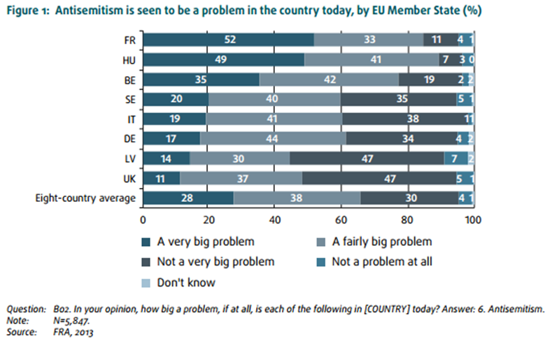
(page 20)
“Furthermore, fewer respondents from Sweden and the United Kingdom (53 % and 41 %, respectively) say that they have heard such statements [negative statements about Jews in the 12 months prior to the survey] in social situations than respondents from Belgium, France or Italy (58 %–59 %).” (page 25)
“While examining these results at country level, notable differences between EU Member States emerge. More respondents in Hungary, for example, tend to describe the person(s) involved in making negative comments about Jews as someone with a right-wing political view (79 %), while respondents in France (67 %) and Italy (62 %) were more likely than respondents from other countries to mention someone with a left-wing political view. […] Regarding Christian extremist views, relatively more respondents from Italy (36 %) and Hungary (32 %) than from the other EU Member States surveyed selected this category to describe the person(s) who made the negative statements listed.” (page 26)
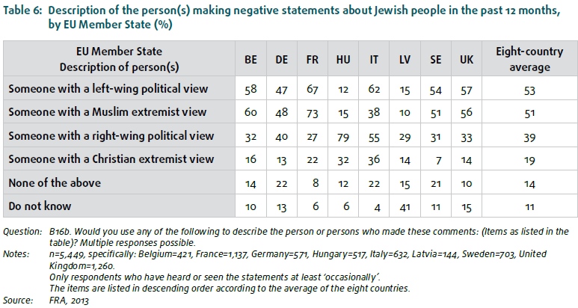
(page 27)
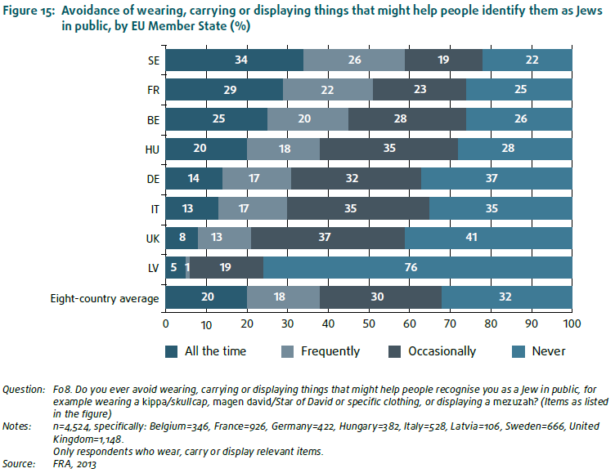
(page 36)
“The survey also asked respondents if they felt that they were held accountable for Israeli government actions. The majority of respondents in Belgium, Italy and France (around 60 %) said that people in the country blame or accuse them for anything done by the Israeli government, ‘frequently’ or ‘all the time’.” (page 39)
“On the other hand, about one in 10 respondents from France, Germany, Hungary and Italy have seen such offensive comments posted on the internet, including on social networking websites (10 %–15 %, depending on the EU Member State), or they have received offensive or threatening emails, text messages, letters or cards (11 %–12 %, depending on the country).” (page 44)
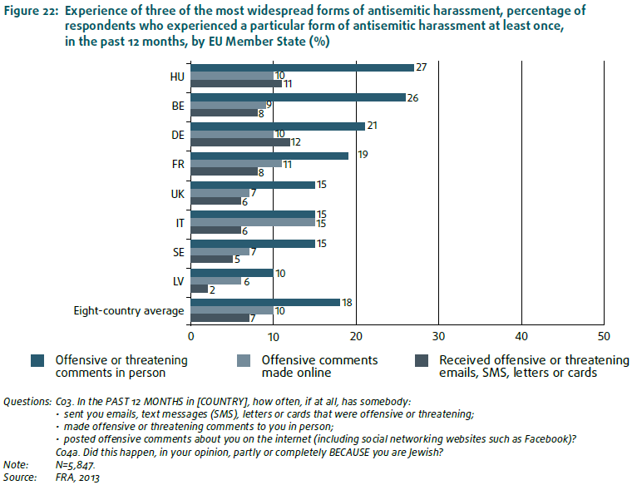
(page 45)
“Comparing the results between the EU Member States surveyed in terms of harassment incidents shows that in most countries around one quarter are reported to the police and/or to Jewish community organisations (percentages of the most serious incident of harassment: 22 %–24 % in Italy, France and Sweden.” (pages 49–50)
“When comparing the results of the general population survey Eurobarometer with the eight EU Member States covered by this FRA survey, the national prevalence in Eurobarometer for discrimination experienced on any ground is highest in Italy and Hungary with both at 23 %.” (page 54)
“In Sweden 27 % of respondents, in the United Kingdom 32 % and in Italy 41 % considered that their countries legislate against denying or trivialising the Holocaust.” (page 61)
“The FRA survey focused on exploring the impact of these discussions on Jewish people in the eight EU Member States covered. The survey asked the respondents about the extent to which they have heard it suggested that circumcision (brit mila) or traditional slaughter (shechita) should be banned, and whether it would constitute a problem for them as Jews. Respondents from the eight EU Member States surveyed differ in their awareness of such discussions. […] In the remaining countries – Belgium, France and Italy – 50 %–60 % of the respondents have heard of such proposals (Table 9).” (page 63)
“Over three quarters of respondents in France (88 %), Belgium (87 %), Italy (85 %) and the United Kingdom (80 %) and over two thirds in Germany (71 %) and Sweden (68 %) indicated that a prohibition against circumcision would be a very big or fairly big problem for them. About two thirds of respondents in France (70 %), Italy (70 %) and the United Kingdom (66 %) and half of the respondents in Belgium (59 %) and Germany (50 %) held the same position regarding prohibitions on traditional slaughter.” (page 63)

EU-MIDIS, European Union Minorities and Discrimination Survey. Data in Focus Report. Minorities as Victims of Crime (2012)
http://fra.europa.eu/sites/default/files/fra-2012-eu-midis-dif6_0.pdf
“In Italy, for example, the 12-month average victimisation rates were 36 % for North Africans and 22 % for Romanians, while in Spain the rates were 21 % for North Africans and 14 % for Romanians. The likelihood a respondent will be victimised over a 12-month period depends, therefore, on the aggregate group he or she belongs to and his or her country of residence.” (page 9)
“Roma and Sub-Saharan African respondents dominate the list of the 10 groups most affected by serious harassment. The only others who also make the ‘top 10’ list are North Africans in Italy and Turkish interviewees in Denmark.” (page10)
“The high number of incidents per 100 persons from a given group in the last 12 months, the incidence rate, could help explain how experiences of in-person crime become ‘normalised’ among some minority groups. Such ‘normality’ is suggested, for example, when incidence rates for assault or threat in the survey reach 74 for every 100 Somalis interviewed in Finland, and 44 for every North African interviewed in Italy.” (page 14)
“In Italy, the majority experienced a rate of victimisation of 3.2 % while North Africans registered 18.6 %, Romanians 13.4 % and Albanians 9.3 %. Some minority groups, in contrast, experienced comparable or lower rates of personal theft than the majority population.” (page 15)
“If we analyse the incidence rate, the results indicate that in the 18 EU Member States where comparisons can be made 25 of the 34 minority groups reported more incidents of assault or threat in a 12-month period than the majority population. […] The Roma in Greece, Hungary and Poland also had much higher incidence rates than the majority population, as did North Africans in Italy, with 41.7 per 100 against 1.6 for the majority population.” (page 15)

Key migration issues: one year on from initial reporting
http://fra.europa.eu/en/publication/2016/key-migration-issues-one-year-initial-reporting
“Despite EU Member States’ efforts in the past year to strengthen their guardianship systems and ensure the prompt appointment of guardians, significant delays remain in appointing guardians in most Member States; unaccompanied children have to wait for several months in Germany (up to five months1 ) and in Italy (up to eight months). In practice, authorities often start the asylum procedure without the presence of a guardian (Bulgaria, Greece and Italy).” (page 4)
“Provision of adequate and safe accommodation for unaccompanied children remains a challenge in several EU Member States (such as in Germany, Greece, Hungary, Italy and Sweden) despite the significant increase of specialised facilities for unaccompanied children in some Members States.” (page 6)
“Unaccompanied children are often transferred several times before they are placed in a specialised reception facility at municipal or local level (for example in Germany, Italy and Sweden). Italy, for example, has developed a two-pronged system for the reception of unaccompanied children: they are initially placed in first reception centres, then in second reception centres, both of which are specialised in accommodating them, and eventually they enter child protection facilities run by municipal authorities. Reports show that in the case of great numbers of migrants arriving, unaccompanied children might stay for several weeks in first reception centres or even in hotspots before they are placed in a dedicated facility.” (page 7)
“In Bulgaria, Italy and Hungary, legislation prohibits migration detention of unaccompanied children. In practice, however, children are detained for migration purposes in several EU Member States” (page 7)
“Several incidents of child abuse and sexual assaults have been reported in Germany, where similarly to Italy accommodation facilities do not have any systematic safety and protection measures in place and existing recommendations are only hardly followed.” (page 9)
“Applicants for international protection frequently use leaflets and factsheets (Germany, Italy and Sweden), as well as information websites in various languages.” (page 10)
“Many locations have observed an increase in negative reactions towards migrants over the past year, for example: […] and Italy observed stronger reluctance at local level, particularly in smaller municipalities, to receive refugees and asylum seekers.” (page 10)
“In Italy, problems with a lack of financial resources occur with respect to special reception centres (Centri di Accoglienza Straordinaria, CAS), which are managed at regional level as reported by the National Association of Italian Municipalities. Even more serious is the challenge related to the reception of children. Even though municipalities are supported by the central government’s fund targeted at the reception of children, the strong increase in numbers of children arriving in Italy and special needs of unaccompanied children caused a lack of resources.” (page 11)
“Incidents of police violence in Italy, applied to persuade persons to cooperate during identification, continue to be reported when implementing identification and receptions procedures, although no formal complaint has ever been filed. Despite establishing the hotspot system in Italy to cope with the high number of arrivals, transfers and relocation upon arrival and registration remain difficult as many of the arrivals continue to be disembarked in other locations than the formally established hotspots.” (page 13)

This information is going to be published in the upcoming report on 13 December 2016.
Osservatorio antisemitismo, Episodi di antisemtisimo in Italia.

