Annex 1
The court budget of the last 4 years, the percentage in the total State Budget
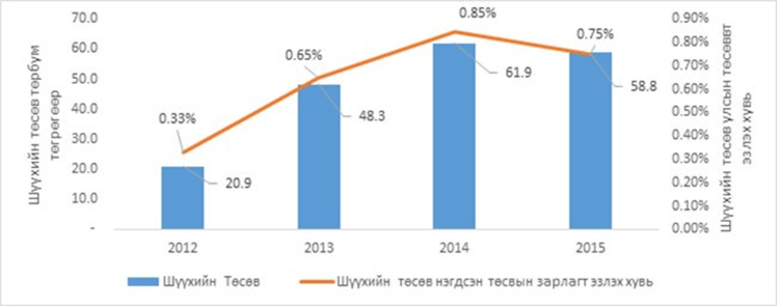
(Court budget in bln MNT, Percentage of the Court budget in the total State budget, court budget, percentage of the court budget in the state budget)

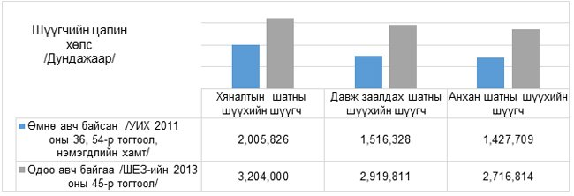
(Average salary of the judge, Previous salary /Parliament 2011, resolution 34, 56, with the bonuses/
Current salary /GCC 2013 resolution 45/ , Cassation or review court judge, Appellate court judge, First instance court judge )

