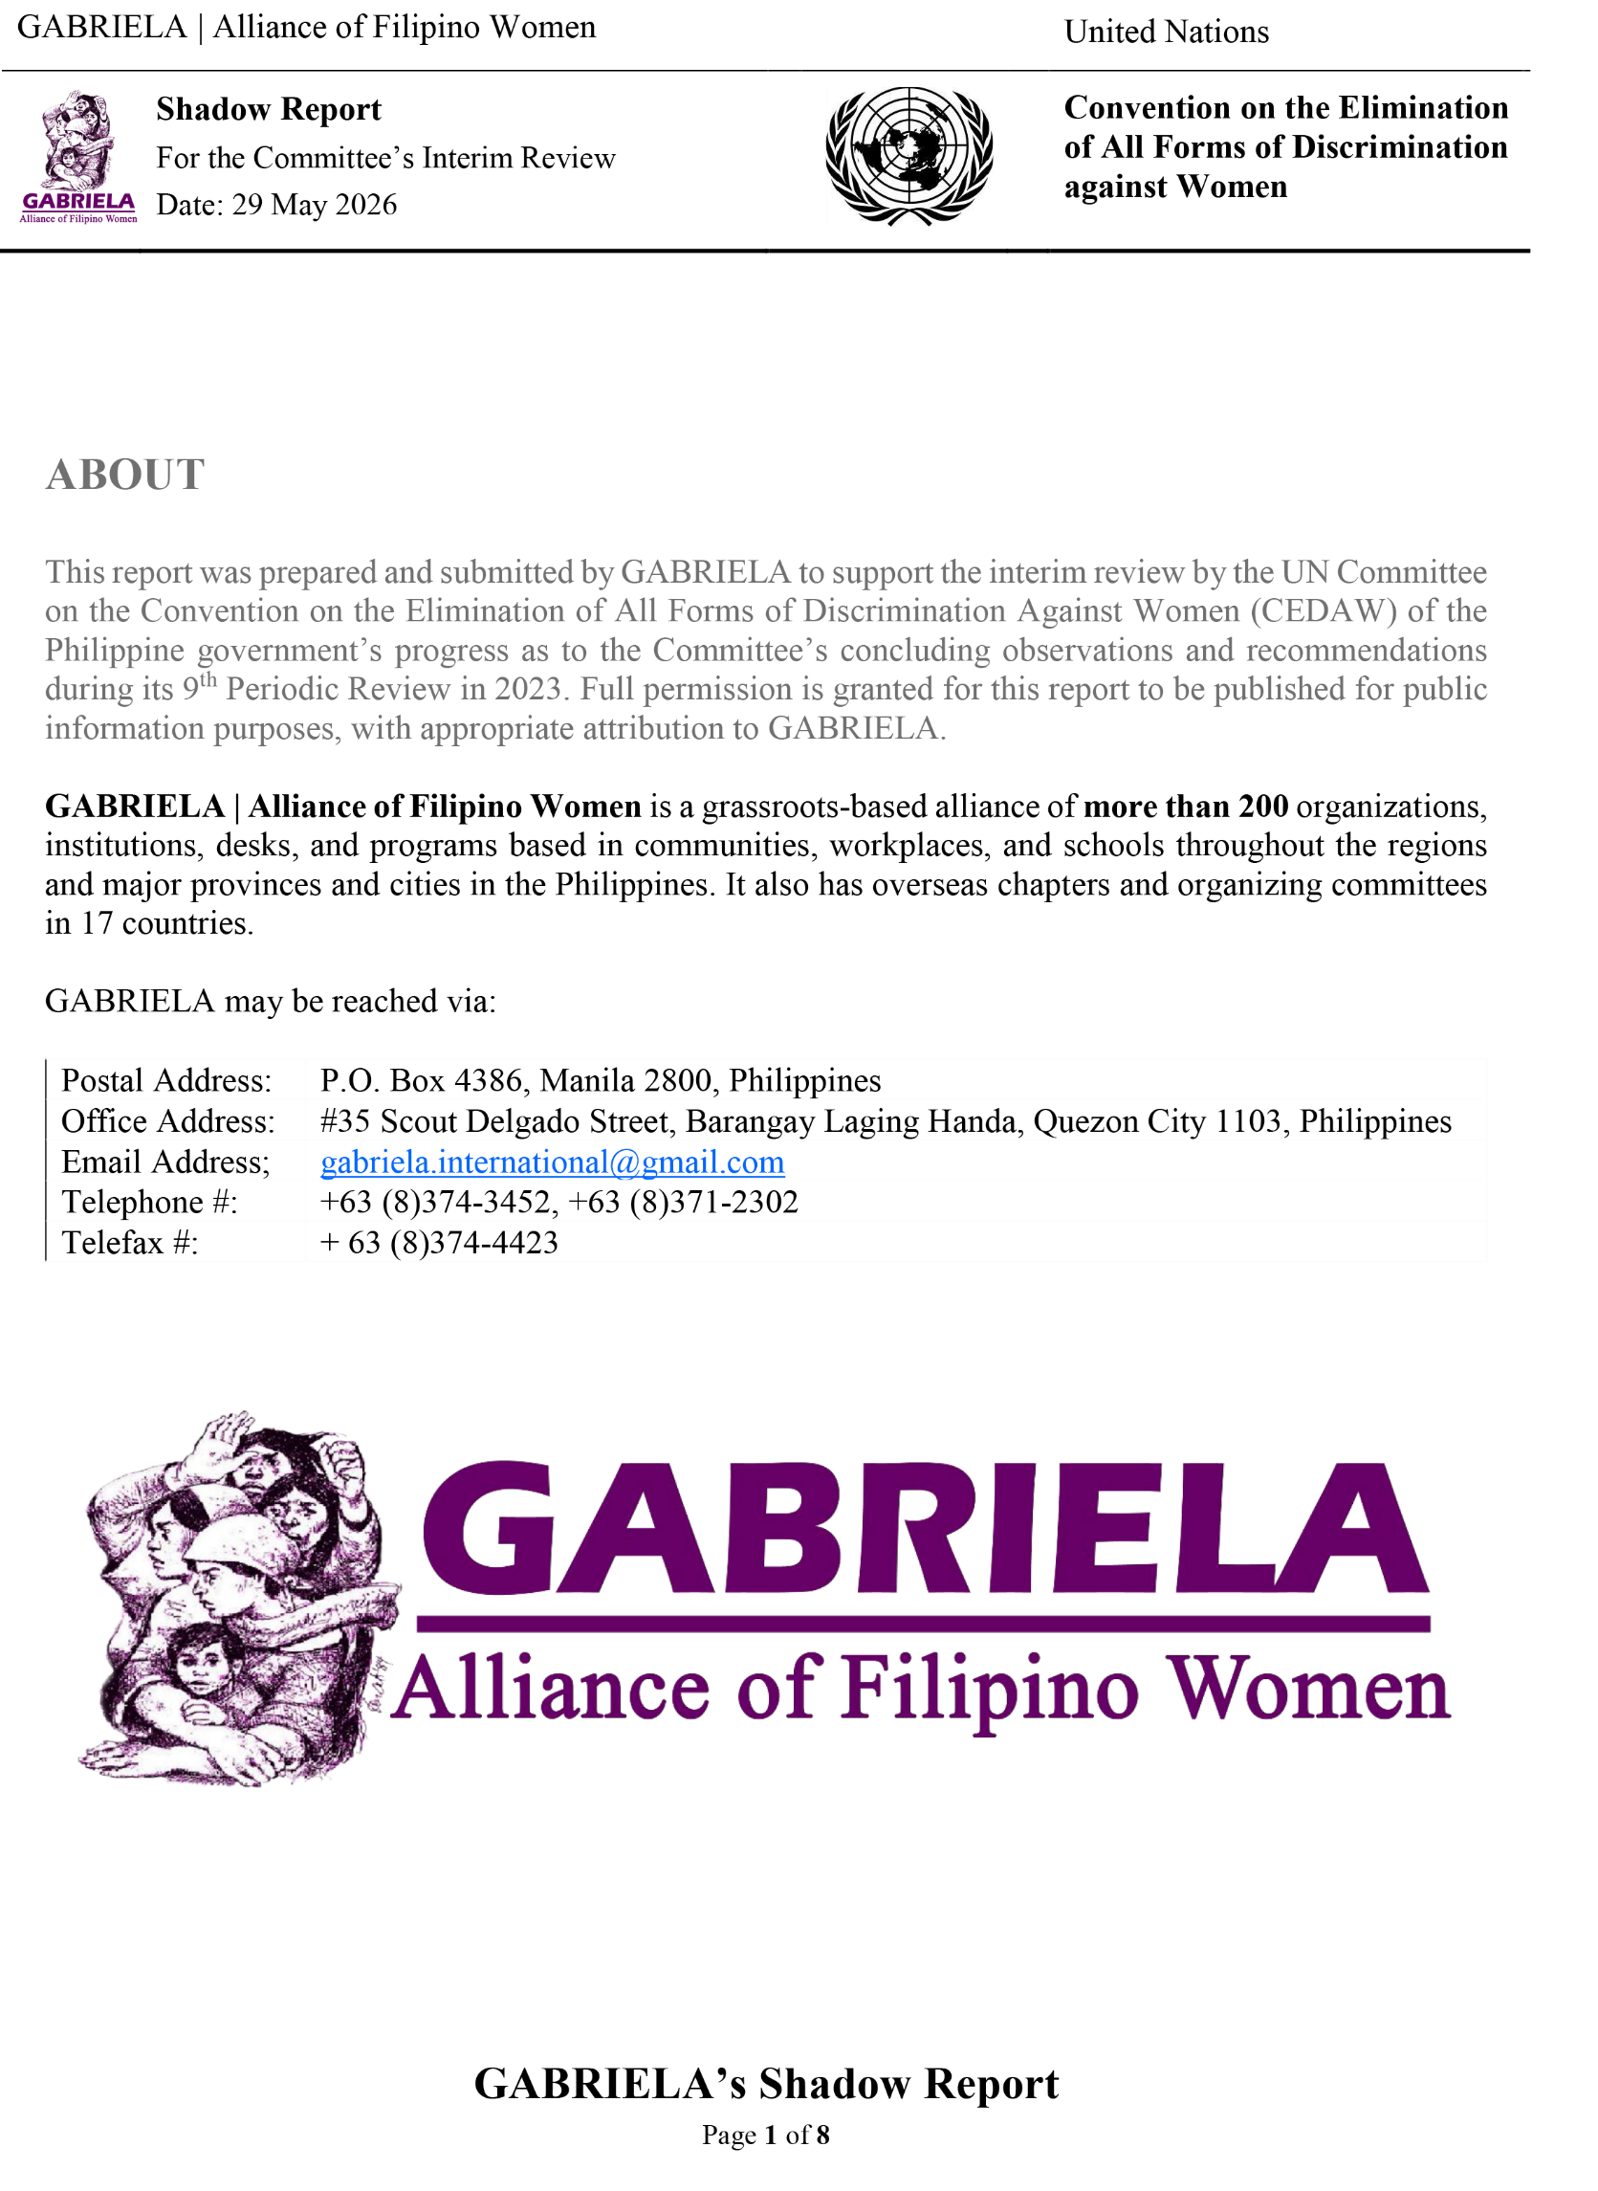

GABRIELA’s Shadow Report
May 29, 2026

On Recommendation No. 36 (2023, UN CEDAW Concluding Observations, 9th Periodic Review )
On Women Human Rights Defenders (WHRD) and Civil Society:
- Three years into the Marcos Jr. Administration and despite the government hosting the International Conference on Women, Peace and Security on October 28, 2024, women human rights defenders and other activists continue to be targeted by state forces.

Red-tagging and harassment of people’s organizations and their leaders have increased, especially under the government’s National Action Plan for Unity, Peace and Development decreed last May 2025. This program gives the NTF-ELCAC supervisory powers over all other executive agencies, framing peace and development as primarily a security question, and militarizing government services among the far-flung villages and urban poor communities.

Numerous organizations and personalities, including UN Special Rapporteurs on Freedom of Expression and Opinion0F and on Human Rights and Climate Change1F and several Filipino bishops, have called for dismantling this agency as a human rights violator, but the Marcos administration has instead given it more clout through Executive Order 37. This agency, using Duterte’s draconian Anti-Terrorism Law (R.A. 11479) and Anti-Terrorism Financing Law (R.A. 10168) as its weapons, has upped the tempo of terrorizing people’s organizations, many of which are led and run by women.

As a leading women’s organization, GABRIELA and its members face escalating government attacks due to their relentless advocacy for social justice and democratic rights. Under the Marcos administration, this state-sponsored vitriol has intensified as a panic response to widespread discontent fueled by the current economic crisis. These attacks directly violate Filipino women’s freedom of association, which is guaranteed by the Philippine Constitution, the Universal Declaration of Human Rights, and ILO Convention No. 87, among others.

- According to human rights group Karapatan, extrajudicial killings under the Marcos administration rose from 89 by the end of 2023 to 135 by the end of 2025, 23 of whom are women). Warlita Jimenez and Ali Jejhon Macalintal are only some of the most recent cases.
- WJ, a 55-year-old leader of a local farmers’ organization in Sitio Makilo, Barangay Camansi, Kabankalan City, Negros Occidental, was gunned down by two armed men wearing bonnets who barged into her house at 11:00 PM of December 23, 2025. She was the widow of Joseph Jimenez, a farmer-leader who was captured and summarily executed by the 15th Infantry Battalion of the Philippine Army (IBPA) on November 30, 2022.
- Suspected state agents shot and killed AJM inside an acupuncture clinic on June 23, 2025 before fleeing the scene on a motorcycle. Macalintal was a transgender woman and Moro activist, having previously served as the deputy secretary-general of the Karapatan-SOCCSKSARGEN chapter. She was also a radio broadcaster for RPN DXDX. In 2024, she feared for her safety, reporting the harassment and constant surveillance by state agents from Task Force Gensan who had inquired about her whereabouts from her cousin and neighbor. Macalintal confided to colleagues that she had been pressured to sign a document during a meeting with the task force, which led to more harassment until she was killed. She had specifically named several state agents, including Ssgt. Makoy Manalo, Ssgt. Pandian, Ssgt. Toledo, and Ssgt. Bong Dionisio, as her harassers and had warned her family to hold them accountable if anything happened to her.

- The reported 13 enforced disappearances from the start of the Marcos Administration until 2023 has now risen to 17—eight of whom are women.

In the 9th periodic review of the Philippines by the UN CEDAW, GABRIELA highlighted two particular cases of enforced disappearances in its shadow report involving three WHRDs but none of them have been surfaced to this day: EM1, MEP, and EM2—all of whom were granted a protection writ by the Supreme Court, but no progress has been made on locating them.

- State forces have consistently declared GABRIELA and its leaders and members as fronts, recruiters, or they themselves “cadres” of the CPP-NPA-NDF (Communist Party of the Philippines-New People’s Army-National Democratic Front of the Philippines). There has been no decline in government officials’ public pronouncements, media articles, facebook posts, and the like. WHRDs are subject to varied forms of harassment from state forces—ranging from tailing, surveillance, home and work visitations, and even judicial harassment. This takes a toll on the mental and physical health of WHRDs, and causes disruptions and, in some cases, total halting of their human rights work. They are constantly in fear for their safety and security.
- Former National Security Adviser Gen. HEJ. and Gen. EA, NTF-ELCAC co-vice chair and current security adviser pursued their judicial harassment of GABRIELA Chairperson GL and Vice Chairperson JMS; Karapatan National Council members ETL, CP, RC, GKD, Dr. EB, JMC, and Fr. WR; and Sr. EB of the Rural Missionaries of the Philippines (RMP) by appealing the perjury charges which had already been dismissed in 2023. The Court of Appeals again dismissed Esperon’s appeal in 2024.
- JS, Kasama-TK Deputy Secretary General – Harassed, red-tagged, placed under intense surveillance, slandered and vilified by personnel from the NTF-ELCAC, the 2nd Infantry Division of the Philippine Army, and the Philippine National Police (PNP) in Batangas. State forces have resorted to flying drones at her residence, and taking pictures of her wherever she went, held at gunpoint by elements of the 59th IBPA in one instance in March 2024.
- KD, Spokesperson of Free Tacloban 5 Network – Sister of woman political prisoner Marielle Domequil. She was called by the military to the barangay hall for a dialogue. She filed a complaint at the Commission on Human Rights Region 8 on August 7, 2025.
- AFDV, writer, poet, researcher, former political prisoner, and former Gabriela Deputy Secretary-General – Red-tagged by NTF-ELCAC agent JC in a Bombo Radio-Iloilo live interview on August 19, 2024. On November 7, 2025, two persons who refused to identify themselves insisted on talking with her at her residence, even giving a description of her face.
- July 28 to the second week of August 2025, leaders of GABRIELA and Gabriela Women’s Party in Cagayan province and Marikina City reported suffering various forms of harassment and threats, including interrogation, surveillance and unwanted visits in their homes, and being intimidated to “surrender” in exchange for “ayuda” (financial aid).
- On September 15, 2025, a Facebook post by GMA Super Radyo Iloilo cited Col. EL, Chief of the Public Affairs Office of the 3rd Infantry Division, Philippine Army who tagged Paghugpong sang mga Mangunguma sa Panay kag Guimaras (PAMANGGAS) as a “rebel group” and falsely claimed that its Chair LC was “at large.”
- MAV, Secretary General of KASAMA-Lupang Ramos, a local peasant organization advocating for genuine land reform – Red-tagged and threatened by several personnel of the Task Force Ugnay, including 2nd Lt. AKCG and Lt. VNA on August 11, 2025. V and two other residents are now facing trumped-up charges of grave threats and other cases filed by the women soldiers.
- PPJ, development worker for Paghidaet sa Kauswagan Development Group, Inc. – Approached at the bus terminal in Hinigaran town on October 23, 2025, at around 4:30 PM by two men in dark glasses who warned her something bad will happen if she did not stop her activities. Earlier in January 2025, she was arrested and detained for two months on trumped-up terrorism financing charges, which were quashed in May 2025.
- Arbitrary arrests and arrests on trumped-up charges continue, victimizing both women and their families. On January 23, 2026, at least six anti-mining protesters, including two elderly women, were arrested in Dupax del Norte, Nueva Vizcaya while forming a human barricade along the Keon Barangay Road to block the entry of Woggle Corp., an affiliate of FCF Minerals Corporation that has obtained a highly questionable exploration license for 3,100-hectares in Dupax del Norte. They have since been released.

Despite the release of a number of women political prisoners whose cases were dismissed because the charges were trumped-up in the first place, many continue to languish in jail. Community journalist FMC and development worker MD are still appealing their recent conviction for “terrorist financing.” In 2024, WHRDs MD, MTB, JD, FB, LR, JL, and EBM were arrested. As of the 2025 count, there were 137 women political prisoners. Another eight women political prisoners were added in the first quarter of 2026, including Dr. AMR, MAAS, TF, RFT, CG, and JP.
- Dr. AMR was a spokesperson of Save the Abra River Movement against large scale mining and a doctor among the underserved communities in the far-flung villages. She was working with Community Health Education Services and Training in the Cordillera Region (CHESTCORE) when she was arrested on March 11, 2026 in Barangay Baras-Baras, Tarlac City.
- JP is a member of Migrante, working for the rights of Filipino migrants. Her husband, Jory Porquia, Bayan Muna-Iloilo coordinator, was shot to death in April 2020 while working at a community pantry. Her son and labor organizer Lean Porquia is also relentlessly red-tagged and is facing a trumped-up charge of

- Up to at least 227 mass leaders and activists have been falsely charged with violating these two terror laws (R.A. 11479 and R.A. 10168), with 30 of them currently detained, including community journalist Frenchie Mae Cumpio, development worker Marielle Domequil and environmental activist Miguela Peniero.

Among the women who faced trumped-up charges of financing terrorism in 2024 and 2025 were CM, Kilusang Magbubukid ng Pilipinas national council member; AM, Regional Coordinator of Makabayan; Leyte Center for Development Executive Director JJ; staff workers of the Negros-based Paghidaet sa Kauswagan Development Group Inc. PJ; and activist AML (but already dismissed).

On December 26, 2025, LE, sister of Bloody Sunday Massacre victim AME, was charged with financing terrorism purportedly for providing pork adobo to the NPA. Her case has since been dismissed. Also dismissed was the terrorism financing case in August 2025 against Ilocos-based indigenous rights activist MZ. While most of these cases end up being dismissed, they nevertheless send warning messages and disrupt the work, and even punish these human rights defenders with a period of imprisonment while waiting for court decisions that are slow in coming.

Community Empowerment Resource Network (CERNET) won its case against the government’s terrorist financing charges, but 17 other NGOs still face the charges in court while their funds are frozen. Two bank accounts of rural women’s group Amihan remain frozen since last 05 May 2021 by the AMLC under AMLC Resolution No. TF-38, Series of 2021, based on alleged violations of the Terrorism Financing and Suppression Act of 2012. Bank accounts of the RMP in Mindanao also remain frozen.

- Women Deprived of Liberty: At end 2025, there are 137 women out of the 966 political prisoners as recorded by Karapatan.

These women political prisoner share the inhumane conditions of jail life with other PDLs, congested jails with almost no ventilation, very little and inedible food, lack of and even unclean water, poor healthcare, arbitrary rules and procedures that keep changing at the whim of prison officials.

As women, they face the added challenge of inadequate maternal and health care services. Not all prison facilities have resident doctors to conduct routine check-ups especially for pregnant women who compose about 4% of those incarcerated. Only 37 breastfeeding areas exist in the 84 BJMP jails for women. Newborns can only stay in prison with their mothers for 12 months, but many jails remove the babies from prison even before their first year. The future of their children particularly their new born is a constant worry but there are no counselling or mental health programs available to them.

Women PDLs who get sick never get adequate care. And it takes months before their request for consultation outside prison is granted. They say that sick women for example of breast cancer may die first before her outside appointment is granted.

On Recommendation No. 28 (2023, UN CEDAW Concluding Observations, 9th Periodic Review )
On Gender-Based Violence
- UN CEDAW commended the Philippines for the legislative reforms it has undertaken since 2016, particularly the passage of laws aimed at advancing women’s rights and protection. However, while the enactment of laws is significant, equal attention must be given to their effective implementation and enforcement.

Despite the existence of progressive legislation, implementation gaps remain substantial. Twenty-seven years after the passage of the Rape Victim Assistance and Protection Act (R.A. 8505), only a limited number of cities and provinces have established Rape Crisis Centers. Although the Anti-Sexual Harassment Law (R.A. 7877) and the Safe Spaces Law (R.A. 11313) mandates the creation of Committees on Decorum and Investigation (CODI) in workplaces and educational or training institutions, many institutions still do not have functioning CODIs. There is also little public information on whether any institution has been penalized for non-compliance.

Implementation challenges are likewise evident at the barangay level. While approximately 97 percent of barangays nationwide reportedly maintain anti-VAWC desks in compliance with the Anti-Violence against Women and their Children Act (R.A. 9262), many face operational difficulties. These include the replacement of trained personnel with unqualified staff after every barangay election, especially when new barangay captains assume office. In many rural barangays, anti-VAWC desks also lack basic resources such as dedicated communication equipment and secure filing cabinets for sensitive case records. At present, GABRIELA, in collaboration with women’s representation in Congress—the Gabriela Women's Party, is conducting a review of the implementation of R.A. 9262.

The persistence of these gaps underscores a critical reality: laws, regardless of how progressive they are, cannot protect women or eliminate violence if they are not effectively implemented.

According to the PNP Women and Children Protection Center, reported VAWC cases reached 13,211 in 2025 or an average of approximately three reported cases every two days. However, the PNP itself estimates that only one in ten cases is actually reported, suggesting that the true scale of violence is far greater.

In January 2026, GABRIELA raised alarm over what it described as a “horrifying escalation” of violent incidents occurring within homes and communities. These incidents included the fatal shooting of a woman by her live-in partner in Bacolod City, the fatal stabbing of a woman by her husband in San Jose, the rape of a 13-year-old girl by her stepfather in Pasig, and the molestation of a 15-year-old girl in Makati.

- Persistent sexist behavior among public officials remains a major concern. Last 2025 elections, at least four candidates, including a re-electionist governor, drew criticism from women’s groups for remarks considered sexist, derogatory, or discriminatory toward women. In 2026, two veteran lawmakers also made sexist remarks during committee hearings, one of which was televised nationwide. Since 2018, at least four municipal stations and one provincial station have posted online “rape prevention tips” that promoted victim-blaming rather than emphasizing that rape is a crime committed by perpetrators. When public officials and law enforcers express sexist attitudes, they reinforce victim-blaming, gender inequality, and violence against women and children.

More alarming is the direct involvement of law enforcers in cases of violence against women. From 2022 to 2025, the Center for Women's Resources monitored 40 cases of VAW allegedly perpetrated by men in uniform. These cases included domestic violence, sexual abuse, custodial rape, and sexual molestation committed during military operations. Such incidents undermine public trust in institutions mandated to protect women and children and highlight the urgent need for accountability, gender sensitivity training, and stronger oversight mechanisms within the security sector.

The government must strengthen efforts to fulfill the mandates of R.A. 7192, R.A. 9710, and R.A. 11313, particularly in promoting gender sensitivity among government officials and personnel, especially those tasked with protecting women and children.

- Poverty increases vulnerability of women and girls to VAWC, a fact supported by the National Demographic and Health Survey. Under the Marcos Jr. regime, the purchasing power of Filipinos further eroded—in 2022, the real value of a peso only amounted to Php0.87, decreasing to Php0.79 in March 2026 amid the oil shocks. According to IBON, 84% of Filipino families are highly vulnerable, living on tight, low-income budgets, and prone to inflationary shocks. In the first quarter 2026 SWS survey, about 52% of Filipino families have rated themselves as poor.

There is likewise a need to analyze how government economic policies are affecting the economic situation of majority of Filipinos. It could start with gathering initial studies that mostly show the negative impact of the government policies of liberalization, e.g., Rice Tarrification Law, deregulation, e.g. Oil Deregulation Law, and privatization, e.g. National Water Crisis Act.

GABRIELA’s RECOMMENDATIONS
GABRIELA hereby reiterates its recommendations Nos. 1 – 6 to the Philippine government as indicated in the 2023 GABRIELA Shadow Report, with three additional recommendations (Nos. 7 – 9) relevant to the issues and cases raised herein. GABRIELA also forwards the same recommendation to the UN CEDAW as expressed below in (II).

- Recommendations to the Philippine Government

  - Fulfil its obligation as a signatory to the Convention on the Elimination of Discrimination against Women and its local counterpart, the Magna Carta of Women, with the intention of allowing women to obtain economic and social security and to guarantee their rights against all forms of violence at the workplace and elsewhere.
  - Respect and fulfil the recommendations of UNHRC member-states to ensure the protection of the rights and well-being of Filipino women, including guarantees for marginalized women’s unimpeded access to the justice system.
  - Allow Special Procedures and mandate holders to conduct official visits in the Philippines to identify measures or mechanisms under international laws to facilitate transitional justice for victims of HRV.
  - Free all women political prisoners and drop all trumped-up charges against WHRDs and activists; Resume peace negotiations aimed at instituting much needed political and socio-economic reforms.
  - Repeal EO 70, s. 2018 and dismantle the NTF-ELCAC; Hold to account state forces for HRVs committed in the implementation of the said order from 2018 to present.
  - Repeal the Anti-Terror Law or amend it by striking down provisions that violate basic civil liberties and fundamental human rights.
  - Repeal the Anti-Terrorism Financing Law (R.A. 10168) or amend it by striking down provisions that violate basic civil liberties and fundamental human rights.
  - Repeal the National Action Plan for Unity, Peace, and Development (NAP-UPD) and adopt an action plan in accordance to international human rights and humanitarian laws. Resume peace talks and address the roots of armed conflict.
  - Ensure enabling laws, policies, and mechanisms by passage of new policies or amendments to exising ones in full accordance to the International Labour Organization’s Convention No. 190 on Violence and Harassment in the World of Work, which was ratified by the Philippine government in 2024.

- Recommendations to the CEDAW
For the UN CEDAW Committee to conduct an independent international investigation or a commission of inquiry on the grave and systemic violations of the Philippine government of its commitments to CEDAW, including General Recommendation 3 that provides that states who ratified CEDAW must “to ensure women’s human rights are protected before, during and after conflict.” Similarly, the CEDAW committee is urged to investigate state forces’ violations of Filipino women’s basic human rights and freedoms.

Gabriel Pabico Lalu, “Abolish the outdated NTF-Elcac – UN Special Rapporteur Khan2024,” Philippine Daily Inquirer, February 2, 2024, https://newsinfo.inquirer.net/1898263/un-special-rapporteur-khan-recommends-abolition-of-ntf-elcac.
Iya Gozum, “‘Disband NTF-ELCAC,’ UN special rapporteur urges PH gov’t,” Rappler, November 15, 2023, https://www.rappler.com/philippines/united-nations-special-rapporteur-urges-philippine-government-disband-ntf-elcac.
Michelle Abad, “LIST: 2025 candidates who have made public sexist remarks,” Rappler, April 8, 2025, https://www.rappler.com/philippines/elections/list-2025-candidates-made-public-sexist-remarks.
GABRIELA, “GABRIELA urges Supreme Court to sanction misogynist lawyer-candidate,” Facebook, April 7, 2025, https://www.facebook.com/gabriela.alliance/posts/pfbid0TnCMQyw3Ak67tqUq3PCvxBHRvVcgGkQb4XTaPrMq1AiaY8391GfGXfyuDfNkNMj7l.
Ibid., “GABRIELA slams PNP’s victim-blaming ‘Iwas Rape Tips,’ demands accountability from perpetrators in uniform,” Facebook, January 31, 2026, https://www.facebook.com/gabriela.alliance/posts/pfbid0215htbNHYDxwhn5Lum29Gq8UQR7apBBC9daPMnvnEKMQKfFKQKLLwty9kgx5HNZY7l.
Center for Women’s Resources, “Executive Summary,” in Ulat Lila: March 2026, (Center for Women’s Resources, 2026), 21.
Kurt dela Peña, “High inflation: Your P1 is now worth only 87 centavos,” Philippine Daily Inquirer, July 7, 2022, https://newsinfo.inquirer.net/1623432/high-inflation-your-p1-is-now-worth-only-87-centavos.
IBON Foundation, “Oil shocks risk further erosion of Filipinos’ purchasing power,” IBON.Org, March 10, 2026, https://www.ibon.org/oil-shocks-risk-further-erosion-of-filipinos-purchasing-power/.
Ibid., “Most Filipinos trapped in precarious work, face deeper crisis from oil price shocks,” IBON.Org, April 8, 2026, https://www.ibon.org/most-filipinos-trapped-in-precarious-work.
Social Weather Stations, “SOCIAL WEATHER REPORT | Self-Rated Poverty (SRP) at 52% on March 2026; Borderline at 13%, Not Poor at 35%,” SWS, May 8, 2026, https://sws.org.ph/social-weather-report-self-rated-poverty-srp-at-52-on-march-2026-borderline-at-13-not-poor-at-35.

