LIST OF ISSUES SUBMISSION ON FAMILY LAW AND
MUSLIM WOMEN’S RIGHTS IN

INDIA

94th CEDAW Pre-Session Working Group (PSWG)

Oct 2025

SUBMITTED BY:
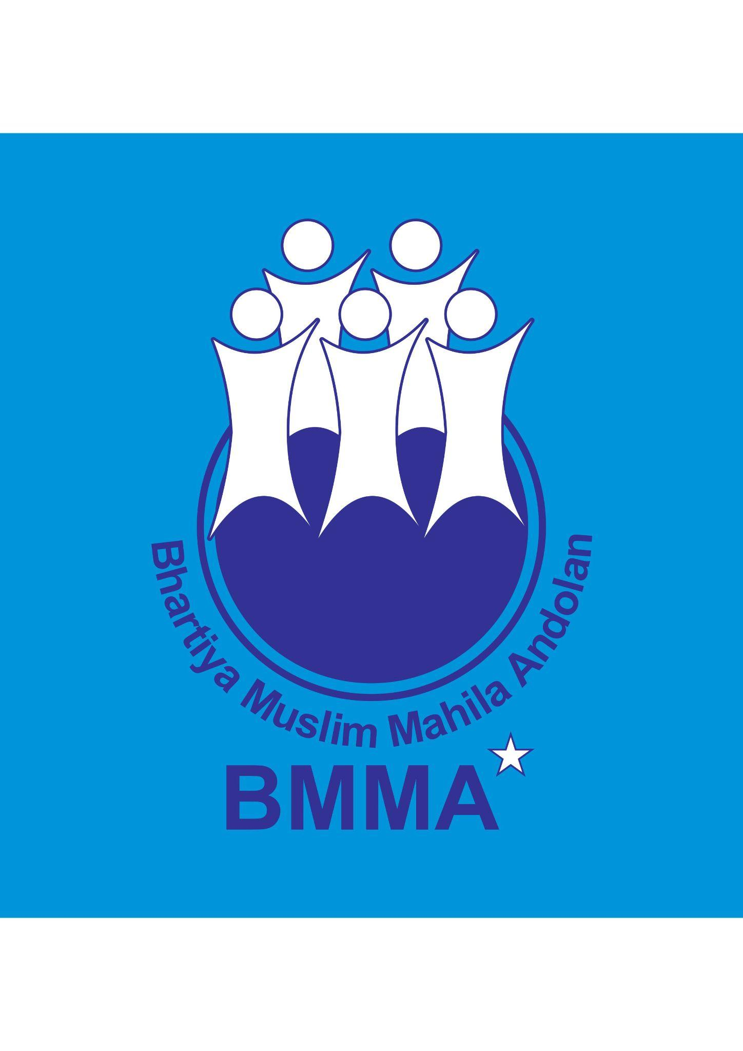  Bharatiya Muslim Mahila Andolan [BMMA]  Secretariat: 35/B, RHS, Goregoan, Mumbai, India  Email: noorjehan.sn1@gmail.com  Web: https://bmmaindia.wordpress.com/  Tel: +91 9833072690 | ​​    Musawah  15, Jalan Limau Purut, Bangsar Park, 59000 Kuala Lumpur, Malaysia  Tel: +603 2083 0202 Fax: +603 2202 0303  Email: musawah@musawah.org  Web: www.musawah.org



Global Campaign for Equality in Family Law
Web: www.equalfamilylaws.org
Table of Contents

A. Introduction 3
B. Legal Framework and India’s International Obligations 3
C. Key Issues 3
1. Comprehensive Codification of Muslim Family Law 3
2. Child Marriage 4
3. Polygamy 5
4. Financial Security during and after Marriage 5
5. Marriage Registration 6
6. Divorce 7
7. Custody and Guardianship of Children 7
8. Adoption 8
9. Inheritance and marital property rights 8
D. Suggested List of Questions 9

A. Introduction
This comprehensive shadow report, jointly submitted by Musawah (the global movement for equality and justice in the Muslim family), Bharatiya Muslim Mahila Andolan (BMMA), and the Global Campaign for Equality in Family Law. It highlights critical legal inequalities faced by Muslim women in India concerning personal status matters and family law.
Despite India's ratification of The Convention on the Elimination of All Forms of Discrimination against Women (CEDAW) in 1993, Muslim women continue to experience systemic discrimination through uncodified personal laws that violate their fundamental rights to equality, dignity, and non-discrimination. This report identifies nine key issue areas requiring urgent attention: comprehensive codification of Muslim family law, child marriage, polygamy, financial security, marriage registration, divorce procedures, child custody and guardianship, adoption, and inheritance rights.
Based on extensive field research and legal analysis, we provide concrete recommendations for legislative and policy reform to align India's legal framework with its constitutional and international human rights obligations. We urge the CEDAW Committee to pose our suggested questions to the Indian government during its 94th Pre-Sessional Working Group in October 2025.

B. Legal Framework and India’s International Obligations
India's commitment to gender equality is enshrined in its Constitution, particularly Articles 14 (right to equality), 15 (prohibition of discrimination), and 21 (right to life and personal liberty). The Directive Principle of State Policy under Article 44 calls for a Uniform Civil Code throughout India, aiming to secure equal rights for all citizens regardless of religion in matters of marriage, divorce, inheritance, and adoption. As a signatory to CEDAW, India has obligations to eliminate discrimination against women in all forms, including in family law matters. The persistent retention of uncodified and discriminatory aspects of Muslim personal law does not align with India's commitments under Articles 2(f), 5(a), 15, and 16 of CEDAW, which require states to modify or abolish discriminatory laws, customs, and practices.

C. Key Issues

Comprehensive Codification of Muslim Family Law

Barring four instances of codified laws, The Muslim Personal Law [Shariat] Application Act, 1937 The Dissolution of Muslim Marriage Act, 1939 The Muslim Women (Protection of Rights on Divorce) Act, 1986 and the Muslim Women (Protection of Rights on Marriage) Act, 2019, there is no codified family law for Indian Muslims.

Of these four laws, two pertain to divorce, one to post-divorce maintenance and one a general call for the application of ‘Shari’ah’. Other key issues issues like marriage, maintenance within marriage, age of marriage, mehr (dower), consent, polygamy, custody of children, adoption, guardianship, inheritance, halala, muta (temporary) marriage, and other issues are not covered by a statutory law. As a result Indian Muslims do not enjoy the protection of a comprehensively codified family law.

Conflicting court jurisdictions on crucial issues and lack of political will on the part of previous and current governments has ensured that Muslim women remain out of the ambit of legal protection despite 78 years of an independent Indian state.

In the absence of a comprehensive codified Muslim family law in India which grants Muslim women legislative and constitutional protection, BMMA’s advocacy has included preparing and submitting a draft law to various governments.

Child Marriage
The Prohibition of Child Marriage Act (PCMA) was passed in 2006 with the objective to prohibit child marriages, to provide relief to victims and enhance punishment for those who abet, promote or solemnize such marriages. Any marriage of a girl below 18 and of a boy below 21 is a child marriage which is illegal, an offense and punishable under the law. The offense is cognizable and non-bailable. The Protection of Children from Sexual Offences (POCSO) Act, 2012 penalizes penetrative sexual assault on a child by anyone related to the child through marriage, penalizes sexual acts with a girl below 18 years of age, with or without her consent
However in practice the PCMA and POCSO fail to protect the rights of Muslim girls. According to the Delhi/Punjab/Haryana High Court a Muslim girl was free to marry after attaining puberty, i.e. 15 years. But the Madras High Court and Gujarat High Court have given primacy to the PCMA. A judgment by the Supreme Court in a case in 2018, recognized attaining puberty as a condition for a valid Muslim marriage.
A national study by BMMA on Muslim women’s views on reforms of the Muslim Personal Law, revealed that 55% of the 4710 respondents were married before the age of 18 out of which 15% were below the age of 15. In another study in the state of Maharashtra, 333 out of 505 were married before the age of 18.
Source: BMMA India (2016). Seeking Justice Within Family - National Study on Muslim Women’s Views on Reforms in Muslim Personal Law https://wunrn.com/wp-content/uploads/BMMA-Seeking-Justice-Final.pdf

PCMA and POCSO are national and secular laws that fail to apply to all citizens of India. Despite the Supreme Court judgment restating PCMA’s secular nature, its provisions are still not being applied in cases of child marriage affecting Muslim women and girls. This gap needs urgent addressing because it has led to contradictory and inconsistent judgments in cases of child marriage in India.
Women’s rights groups have been calling for PCMA, 2006, and any amendment to it to state unequivocally that this law applies to the Muslim community as well. Only an explicit provision will ensure that Muslim women in India can benefit from the law and have access to protection from child marriage.
The PCMA and POSCO were enacted to protect the rights of all Indian children, but instead, it is being applied unevenly to children of different communities.

Polygamy
The Bharatiya Nyaya Sanhita (BNS) Section 82 (which replaced Indian Penal Code’s Section 494 in 2024) prohibits polygamy with up to a seven-year imprisonment (non-cognizable, bailable, compoundable). The Hindu Marriage Act also prohibits polygamy, but Muslim women are denied equal protection. Section 2 of the Muslim Personal Law (Shariat) Application Act, 1937 states that notwithstanding any custom or usage to the contrary, in questions of marriage where the parties are Muslims, the rule of the decision shall be the Muslim Personal Law.
A Supreme Court judgment looking at bigamous marriage in Khurshid Ahmed Khan vs state of UP and Orissa 9/2/2015, SC 1662/2015 argued that polygamy cannot be seen as an 'integral part of religion' and so does not receive constitutional protection under Article 25. It also argued that any law in favour of monogamy did not violate Article 25. Various High Courts have also made this case. Indian Constitution provides explicitly for equality and non-discrimination and protects personal laws insofar as they do not violate these essential articles.
However, in the absence of a codified law, in practice there are no conditions stipulated if polygamy is to happen. Legally/statutorily a man is not expected to inform his existing wife, nor take her permission before marrying another woman. Advocates argue that polygamy blatantly violates Article 14 of the Indian Constitution on equality, as the lived realities reveal the harms of polygamy.
According to BMMA’s survey findings, polygamy is practiced within the Muslim communities, and has social, psychological, physical and financial impacts on women and families. In the study 91.7% of participants surveyed did not want their husband to have another wife, 73% wanted their husband should be punished, 84% said it should be made illegal, 50% faced mental trauma such as depression, self blame, lack of sleep, aches and pains, suicidal tendencies etc.
Source: BMMA India (2016). Seeking Justice Within Family - National Study on Muslim Women’s Views on Reforms in Muslim Personal Law https://wunrn.com/wp-content/uploads/BMMA-Seeking-Justice-Final.pdf
Polygamy is restricted in other Muslim contexts, such as Algeria, Bahrain, Malaysia, and Morocco, and completely prohibited in Tunisia, Turkey, Kyrgyzstan , Tajikistan and Uzbekistan.

Financial Security during and after Marriage
Mehr - Dower: In Islamic tradition, Muslim women are entitled to receive mehr (dower) as a gift from the groom during the time of solemnization of the marriage, intended to contribute towards her financial security. However, in practice, and in the absence of a clear codified provision, a token amount of mehr is given to brides, or deferred to future events like divorce or widowhood. BMMA study reveals that 40% of the respondents received less than Rs. 1000 as mehr ($11). In practice, it is also common for the mehr to be returned to the husband if the wife initiates the divorce, even in instances where she has faced harm within marriage.
Maintenance: The law of maintenance within marriage in the Bharatiya Nagarik Suraksha Sanhita (BNSS) is covered under Section 144, which provides for maintenance to a person's wife, children, and parents who are unable to maintain themselves, replaced Section 125 of the previous Code of Criminal Procedure. However, Muslim communities are not subject to this provision. As a result there is no guideline, nor legislation governing the right of maintenance for Muslim women.
Post-divorce maintenance is governed by the Muslim Women (Protection of Rights on Divorce) Act, 1986. However, this too lacks clear guidelines on how maintenance is calculated, regulated and implemented.
As per BMMA’s national study, after divorce Muslim women are left in financially vulnerable situations, as many receive miniscule support from their ex-husbands or their in-laws. 95% of divorced women surveyed did not get any financial support from their former husbands. These figures also coincide with the figures for maintenance of children. 47% of women surveyed had to support their children and while 46% received the support of their parents to do so.
Source: BMMA India (2016). Seeking Justice Within Family - National Study on Muslim Women’s Views on Reforms in Muslim Personal Law https://wunrn.com/wp-content/uploads/BMMA-Seeking-Justice-Final.pdf

Marriage Registration
The registration of Muslim marriages is governed by The Muslim Personal Law (Shariat) Application Act, 1937. This act mandates that Muslim personal law (Islamic law/Shariah) applies to Muslims for their marriage and family matters, including marriage, succession, and inheritance for Muslims. However, to issue Muslim marriage certificates, different states have different guide lines. There are some states for which marriage registration is compulsory and for some it is not. These laws are not applicable in Goa state, where the Goa Civil Code is applicable for all persons irrespective of their religion. These laws are also not applicable to Muslims who have married under the Special Marriage Act, 1954. While other religious communities in India have codified laws, Muslim personal law is not codified in India. In practice, a system of private registration of marriages with qazis (Muslim judges) has always prevailed among the Indian Muslims.
A study by BMMA revealed that more than 47% of Muslim women do not have a marriage contract (nikahnama). Out of the 2219 respondents without a nikahnama, 1185 women (53%) did not know its whereabouts or whether it was made at all. Moreover, 835 responded that they had knowledge of the existence of a nikahnama, but were not given a copy of it, while 205 women stated that no nikahnama was made. Over 75% of women had not read the nikahnama before signing, reducing this critical document to a formality.
Source: BMMA India (2016). Seeking Justice Within Family - National Study on Muslim Women’s Views on Reforms in Muslim Personal Law https://wunrn.com/wp-content/uploads/BMMA-Seeking-Justice-Final.pdf
The lack of registration impedes access to passports and other citizenship documents. It is important that all Muslim marriages have a mandatorily registered nikahnama under the Shariat Application Act, 1937, or relevant state laws.

Divorce
While the Muslim Women (Protection of Rights on Marriage) Act, 2019 criminalized the practice of instant triple talaq (Talaq-e-Biddat), it did not establish a comprehensive civil procedure for how divorce should be conducted for Muslims in India. The Dissolution of Muslim Marriages Act, 1939 provides Muslim women with specific grounds to seek divorce through the courts but does not regulate men's divorce practices. As a result, a legal vacuum exists concerning the valid procedure for divorce.
According to the BMMA study, 93% of women surveyed wanted a compulsory six month arbitration period before a divorce is granted, as reconciliation is considered an important process in Islamic jurisprudence before any decision of divorce is taken. This and other recommendations addressing gaps and issues pertaining to divorce have been submitted by the BMMA to the government, however, no progress has been made to date.
Prevalence of halala - Halala is a practice in which a Muslim woman, after being divorced by her husband by triple talaq, is forced to marry another man, consummate the marriage, and get divorced again, before reconciling with her previous husband. This occurs in instances when ex-husband want to reconcile the marriage. In BMMA’s national survey, a minority of women were survivors of halala, which can be considered as rape and must be expressly banned.

Custody and Guardianship of Children
India lacks a unified codified law on child custody for Muslims. Custody matters, particularly upon divorce, are typically adjudicated by courts based on traditional Islamic legal principles (fiqh) and the secular Guardians and Wards Act, 1890.
Traditional uncodified interpretations often grant the mother the right to custody of young children, but this right is not absolute and can be lost under certain conditions, such as if the mother remarries a person not considered a mahram to the child.
The national study by the BMMA reinforced the known fact that after divorce, women retain custody of children. Out of the total 525 women who were divorced, 324 women retained the custody of their children.
For the future, respondents had clearly indicated that they would want to retain the custody of the children. Almost 89% of women wanted their children to remain with them. The study brought forth the view that 95.6% women think that if the custody of the child/children is with the mother, they should claim maintenance from their ex-husband. The study revealed that 4368 women (92.7%) agreed that while deciding the custody of the child, the consent and well being of the child should be taken into consideration.
Source: BMMA India (2016). Seeking Justice Within Family - National Study on Muslim Women’s Views on Reforms in Muslim Personal Law https://wunrn.com/wp-content/uploads/BMMA-Seeking-Justice-Final.pdf
According to a draft law submitted by the BMMA to the State, both parents are recognized as natural guardians of the child, with custody following divorce residing primarily with the mother until the child reaches 14 years of age, at which point the child's own decision takes precedence; an arbitrator intervenes if the child is unable to decide, guided solely by the principle of the child's best interest, physical safety, and emotional well-being, while ensuring fair visitation rights for the non-custodial parent and explicitly stipulating that a mother's custody is not lost due to remarriage or change of religion.

Adoption
In India, the secular Juvenile Justice (Care and Protection of Children) Act, 2015, provides a legal framework for adoption, applicable to all citizens irrespective of their religion. This Act allows Muslims to adopt children legally, overcoming the limitations of traditional Muslim law. However, there is a significant gap between legal possibility and community awareness.
Although adoption is not uncommon in the community, according to the study conducted by BMMA, 75.7% women were not aware of the fact that a Muslim couple cannot legally adopt a child. Almost the same number, 78.9%, were not aware of the reasons for adoption not being legal in Islam. Slightly less but a good number 66.2% are not aware that an adopted child cannot become a natural heir to one’s property. Another significant finding was that 83.3% wanted adoption to be made legal, which includes the notion that the adopted child should be treated as a natural heir to property. Close to 80% wanted their adopted child to inherit their property.
Source: BMMA India (2016). Seeking Justice Within Family - National Study on Muslim Women’s Views on Reforms in Muslim Personal Law https://wunrn.com/wp-content/uploads/BMMA-Seeking-Justice-Final.pdf
According to BMMA’s recommended draft law, the Juvenile Justice (Care and Protection of Children) Act must be made applicable to the Muslim community expressly through legislation.

Inheritance and Marital Property Rights
The Muslim Personal Law (Shariat) Application Act, 1937 mandates that inheritance among Muslims in India is governed by Islamic law. Under traditional interpretations of Shariah, female heirs, such as daughters, typically receive a share equal to half of that given to a male heir in the same category (e.g., a daughter receives half the share of a son). A wife is entitled to one-eighth of her deceased husband's estate if they have children.
According to the national study conducted by BMMA, of 4710 Muslim women from 10 states surveyed, a striking 82% reported owning no property whatsoever, underscoring the profound economic marginalization faced by the community.
Among the minority who did own property (850 women), the primary source of assets was inheritance from their husbands (520 women), while a very small number (78 women) had acquired property through their own means, highlighting the significant barriers to economic self-sufficiency without education and livelihood opportunities. Furthermore, only 240 women had received property from their parents, suggesting a potential pattern of parents neglecting to pass on any property to daughters. This widespread asset deprivation is further evidenced by the fact that nearly 84% of all respondents did not hold ownership rights to their current residence.
Of the 850 women who owned property, the vast majority possessed assets of relatively low value. Specifically, 373 women (43.9% of property owners) held property worth less than INR 500,000 (approx. USD 5,630). The distribution of higher-value assets was as follows: 136 women (2.9%) owned property valued between INR 500,000 and 1,000,000; 83 women (1.8%) held assets worth INR 1,000,000 to 2,000,000; 70 women (1.5%) owned property valued at INR 2,000,000 to 4,000,000; and 188 women (4%) possessed assets exceeding INR 4,000,000. This data confirms that among the minority of women who own property, most hold assets of modest value.
Source: BMMA India (2016). Seeking Justice Within Family - National Study on Muslim Women’s Views on Reforms in Muslim Personal Law https://wunrn.com/wp-content/uploads/BMMA-Seeking-Justice-Final.pdf
The BMMA's draft law proposes a reformed framework for inheritance based on principles of fairness and economic justice. This includes, among other matters, the equal right to inherit parental property, distinct and separate from other financial rights like dower, dowry or gifts received during her lifetime; and recognition of non-financial contributions like unpaid labour and care work in the distribution of marital property during marriage and/or at the time of divorce.

D. Suggested List of Questions

We recommend the CEDAW Committee to include the following questions in its List of Issues to State Party:
- Please detail the specific legislative and policy measures taken, along with a clear timeline, to abolish discriminatory practices such a polygamy, halala, and muta (temporary) marriage, and to ensure the uniform application of provisions from the Bharatiya Nyaya Sanhita (BNS) to all citizens, including Muslims.
- What concrete steps is the State party taking towards the comprehensive codification of Muslim family law to ensure equality for women and girls? Please provide a detailed timeline for this reform and specify how it will address discrimination in matters including, but not limited to, child marriage, mandatory marriage registration, polygamy, divorce procedures, halala, inheritance rights, marital property rights and child custody.

- Please provide details on how and when the government will address the llack of uniform application of the Prevention of Child Marriages Act (PCMA) to family laws, especially of the Muslim community and enact legislation to make it compulsory to register all marriages and ensure the PCMA is implemented without exception.

- Women’s rights organisations, including the Bharatiya Muslim Mahila Andolan (BMMA), have submitted a comprehensive draft for a codified Muslim family law to the PM Office as well as to its National Law and Women’s Commission on multiple occasions. What specific action has been taken to review and act upon these submissions, and how is the State party ensuring the meaningful participation of Muslim women’s groups in the drafting of any related legislation?

- If the State party is proceeding with a uniform family or civil code for all citizens, please explain how such a code would specifically prohibit discriminatory community practices like halala and muta (temporary) marriage, while explicitly protecting positive provisions available to Muslim women under religious principles, such as the right to mehr (dower) and khula (woman-initiated divorce). How will the Code guarantee that these rights are enforceable as statutory legal entitlements?

The Global Campaign for Equality in Family Law (GCEFL) was launched by eight women’s rights, human rights and faith based organisations in 2020, as a concerted and strategic global effort drawing attention to and calling for reform of discriminatory family laws as a fundamental women’s rights and human rights issue. The overarching goal of the GCEFL is equality for women and girls and other marginalised groups under law, policy, and practice in matters relating to families in all their diversity, regardless of religion and culture. More info: www.equalfamilylaws.org
For a detailed overview of legislative frameworks, available case law, policies, procedures and practices of Muslim family laws in India, see Musawah’s Country Table - India (2022). https://www.musawah.org/resources/country-table-india/
A practice in which a woman, after being divorced by her husband by triple talaq, marries another man, consummates the marriage, and gets divorced again
Mahapatra, D. (2019, September 11). SC to study if under‑18 Muslim girl can marry on attaining puberty. The Times of India. https://timesofindia.indiatimes.com/india/sc-to-study-if-under-18-muslim-girl-can-marry-on-attaining-puberty/articleshow/71072845.cms
Triple talaq, or instant triple divorce/Talaq-e-Biddat, is a practice where a husband divorces his wife by saying "talaq" (divorce) three times in one sitting, which results in an immediate and irrevocable divorce under some schools of thought in Islam.

