Assessment of Economic and Social Rights Fulfilment in the Netherlands
Submission from the Human Rights Measurement Initiative to the United Nations Committee on Economic, Social and Cultural Rights for the 78th Pre-Sessional Working Group, Geneva, September 2025.
I. Reporting Organisation
1. The Human Rights Measurement Initiative (HRMI) measures the human rights performance of countries, including the Netherlands. HRMI is an independent, not-for-profit NGO with its primary base of operations in New Zealand, and a second base in the United States of America at the University of Georgia’s Center for the Study of Global Issues (GLOBIS).
II. Assessment Methodology
2. HRMI uses the award-winning and peer-reviewed SERF Index methodology to measure the fulfilment of economic and social rights (ESRs).
3. This methodology uses bellwether indicator data from international organisations—such as the World Health Organization and UNICEF—and compares each country’s achievement to what other countries at the same level of income have achieved. In this way, HRMI measures progressive realisation of economic and social rights as defined in the International Covenant on Economic, Social and Cultural Rights (ICESCR). A country’s ‘income adjusted’ HRMI score is a measure of how well its government is converting its resources into good human rights outcomes for its people.
4. HRMI supplements these scores with qualitative information sourced by a confidential survey of on-the-ground human rights experts, such as NGO researchers, journalists, and human rights lawyers and advocates. For more details on HRMI’s methodology, please refer to the resources on our website.
5. All HRMI’s data are published annually on the Rights Tracker and are freely available for non-commercial use under a Creative Commons License. HRMI’s Rights Tracker is a certified Digital Public Good with the Digital Public Good Alliance.
III. Overview of Economic and Social Rights Fulfilment in the Netherlands
6. HRMI’s most recent ESR scores for the Netherlands measures its achievement as of 2022 and show significant room for improvement. They are shown in the graph below.
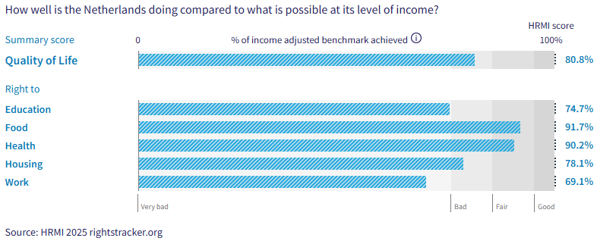
7. The Netherlands’ scores for 2022 are as follows:
- Overall Quality of Life score = 80.8% (in the ‘bad’ range)
- Right to education = 74.7% (‘very bad’)
- Right to food = 91.7% (‘fair’)
- Right to health = 90.2% (‘fair’)
- Right to housing = 78.1% (‘bad’)
- Right to work = 69.1% (‘very bad’)
8. The Netherlands scores 80.8% on overall ‘Quality of Life’ when scored against the ‘income adjusted’ benchmark. These scores take into account the Netherlands’ resources and how well it is using them to make sure that the ‘Quality of Life’ rights of its people are fulfilled.
9. This score tells us that the Netherlands is only doing 80.8% of what is possible to achieve currently with its existing level of resources. Some of these scores may seem positive; however, on an ‘income adjusted’ benchmark, any score less than 100% indicates that a country is underperforming, and not meeting its current obligations under international human rights law. Therefore, our assessment is that the Netherlands still has some way to go to meet its immediate economic and social rights obligations.
10. Compared with other high-income countries, the Netherlands is performing close to average on ‘Quality of Life’ rights.
IV. Right to Education
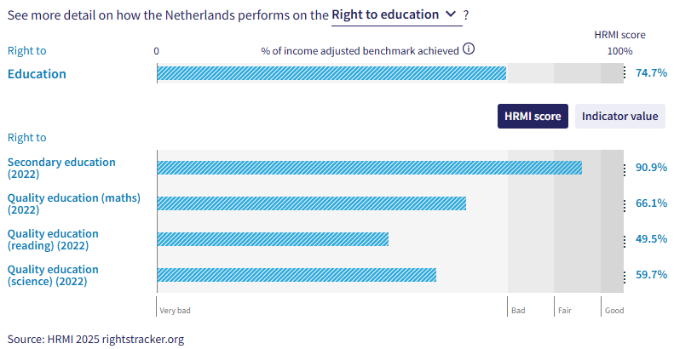
11. HRMI defines the right to education in accordance with ICESCR Article 13 and CESCR General Comments 11 and 13. For high-income countries such as the Netherlands, HRMI further breaks down the right to education into four areas of measurement: secondary school enrolment, quality of education for maths, quality of education for reading, and quality of education for science. This is measured using PISA score data from UNESCO and OECD databases. Our scores show significant challenges across all areas, as the scores lie within the ‘very bad’ and ‘fair’ ranges, with no score reaching the ‘good’ range.
12. The Netherlands’ score for secondary school education (adjusted for income) has been inconsistent, and fluctuated between 2000 and 2022. Currently, the Netherlands scores 90.9% on the right to secondary education is at 90.9%, with a marked decline from its 2021 score of 97.1%. According to the UNESCO database, 95% of children in the Netherlands who were of upper secondary school age were enrolled in school in 2022.
13. The Netherlands scores of 66.1% for quality maths education, 49.5% on quality reading education, and 59.7% on quality science education, and all these scores lie well within the ‘very bad’ range. Overtime trends for all these three areas show a concerning decline over the period 2003-2022. Especially with regard to the right to quality reading education, the Netherlands ranks sixth lowest among 29 high-income countries in Europe.
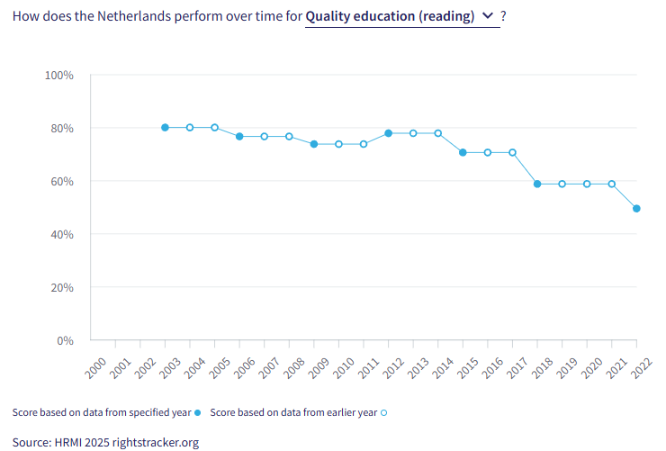
V. Right to Food
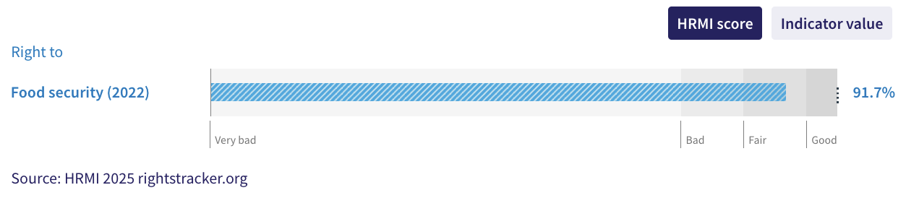
14. HRMI defines the right to food in accordance with ICESCR Article 11 and CESCR General Comment 12. For high-income countries such as the Netherlands, HRMI measures the percentage of individuals in the population who have not experienced food insecurity at moderate or severe levels during the reference period. This indicator value is measured on the Food Insecurity Experience Scale from FAOSTAT.
15. The Netherlands scores an ‘income adjusted’ HRMI score of 91.7% for the right to food, which falls in the ‘fair’ range. This means that the Netherlands is doing 91.7% of what is possible to achieve with its existing resources to ensure the right to food for its people. However, overtime trend shows that there has not been any significant improvement on this right since 2015. In fact, there seems to be a decline from the 2021 score of 94.1% to its current score.
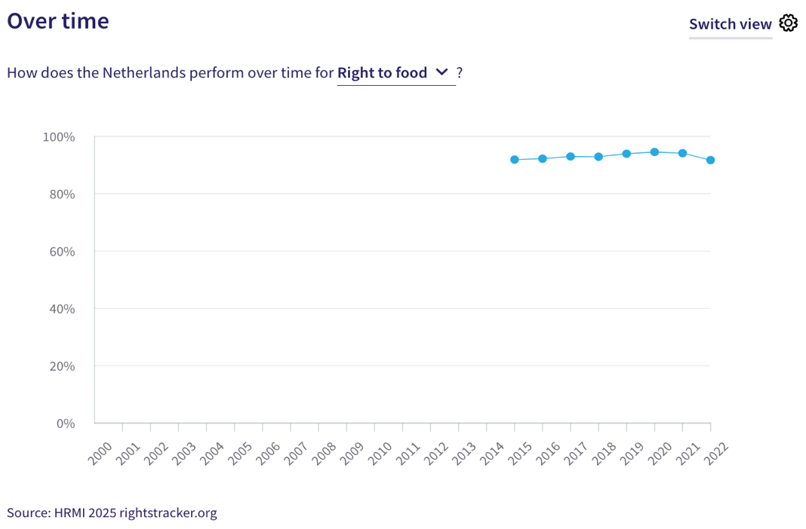
VI. Right to Health
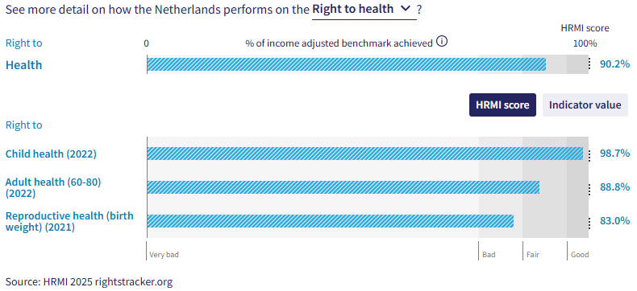
16. HRMI defines the right to health in accordance with ICESCR Article 12.1 and CESCR General Comment 14. For high-income countries such as the Netherlands, HRMI uses three indicators to measure the country’s achievements on the right to health: percentage of children surviving to age 5, senior (60-80 years old) survival rate, and percentage of babies who do not have a low birth weight. HRMI uses data from UN IGME, UNPD, the Max Planck Institute Mortality Database, OECD and World Bank World Development Indicators. The Netherlands has an ‘income adjusted’ score of 90.2% on this right, which means that it is achieving 90.2% of what is possible with its current income levels. While this score falls in the ‘fair’ range, it has largely stagnated over the recent years showing no significant improvement.
17. In the Netherlands, child health has improved steadily from 97% in 2000 to a peak HRMI score of 98.7% from 2014 onwards, and has remained consistent.
18. The score for adult health in the Netherlands saw steady progress over the 2000-2019 period, growing from 68.5% in 2000 to 89.8% in 2019. There was a notable drop in this score in 2020 and 2021, during the COVID-19 pandemic.
19. The Netherlands’ HRMI score for reproductive health —based on percentage of babies who do not have a low birth weight— has shown slow but steady progress from a score of 76.7% in 2000 to 83.0% in 2022. Despite this progress, this score lies in the ‘bad’ performance range.
VII. Right to Housing
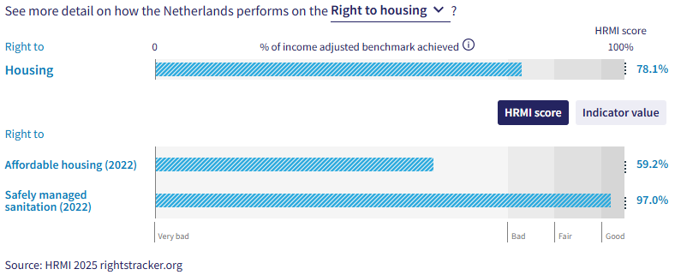
20. HRMI defines the right to housing in accordance with ICESCR Article 11.1 and CESCR General Comment 4. For high-income countries such as the Netherlands, HRMI measures this right using two indicators: affordable housing data from Eurostats, and data on access to safely managed sanitation from the WHO UNICEF Joint Monitoring Project (JMP). The Netherlands has an ‘income adjusted’ HRMI score of 78.1% on the right to housing, which means that it is achieving only 78.1% of what is possible to ensure this right for its people. This score falls in the ‘bad’ range. Compared to 28 other high-income countries in Europe, the Netherlands ranks 17th for the overall right to housing.
21. The Netherlands has a HRMI score of 59.2% for the right to affordable housing, which falls well within the ‘very bad’ range. From 2005 and 2022, this score has been volatile, with notable variations over time. However, it has declined steeply from 69.6% in 2020 to the current score of 59.2% in 2022. The Netherlands ranks 20th out of 29 high-income countries in Europe on the right to affordable housing.
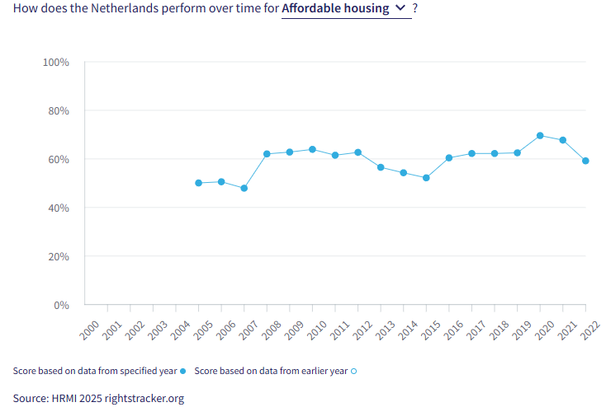
22. The Netherlands has had a consistent HRMI score over the 2000-2022 period on the right to safely managed sanitation, not declining or improving by more than 0.2% every year. The Netherlands’ current HRMI score for safely managed sanitation is 97.0%, and falls in the ‘good’ range. According to the WHO UNICEF Joint Monitoring Project (JMP), 97.5% of people in the Netherlands had access safely managed sanitation in 2022. In comparison with 31 high-income countries in Europe, the Netherlands ranks 7th for this right.
VIII. Right to Work
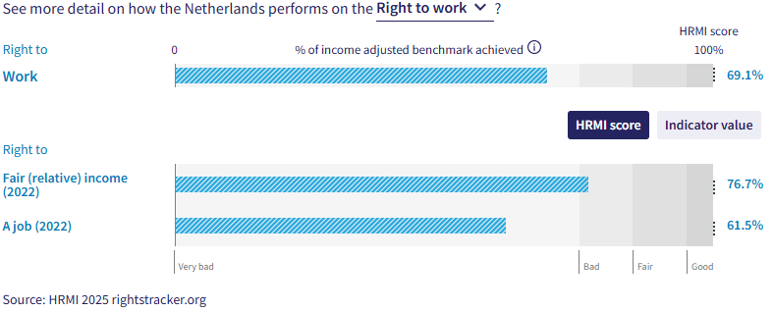
23. HRMI measures the right to work in accordance with ICESCR Articles 6 and 7. For high-income countries such as the Netherlands, HRMI measures the right to work by drawing on data from the Luxembourg Income Study, the OECD, and World Bank PovcalNet. The indicators used to construct the HRMI score for right to work for high-income countries are ‘how many people are not relatively poor’ and ‘the percentage of people who have not been unemployed long-term’. The Netherlands has an overall HRMI score of 69.1% for the right to work, which falls in the ‘very bad’ range. This score has seen some fluctuations over the past two decades; however, it has shown a fairly consistent rise from 2017 to 2022. Among 28 high-income countries in Europe, the Netherlands ranks 4th for the right to work.
24. The percentage of people who were not relatively poor in 2022 was 92.6%, translating into a HRMI score of 76.7%, which falls in the ‘bad’ range. There has been a considerable decline in this right over time between 2000 and 2021, with some recent recovery in 2022.
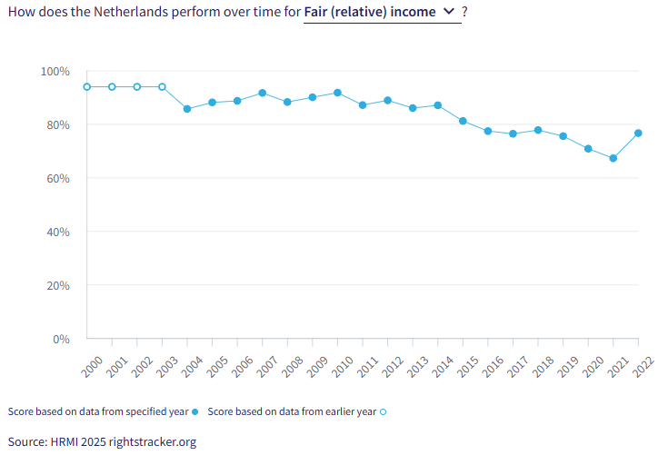
25. The Netherlands’ HRMI score for long-term employment lies in the ‘very bad’ range. Our scores and over time trends indicate that long-term employment is an aspect of the right to work that the Netherlands has struggled with between 2002 and 2022; however, it has shown a steady rise from 2016 to 2022. While the Netherlands still has a long way to go in ensuring the right to long-term employment for its people, this recent upward trend is promising.
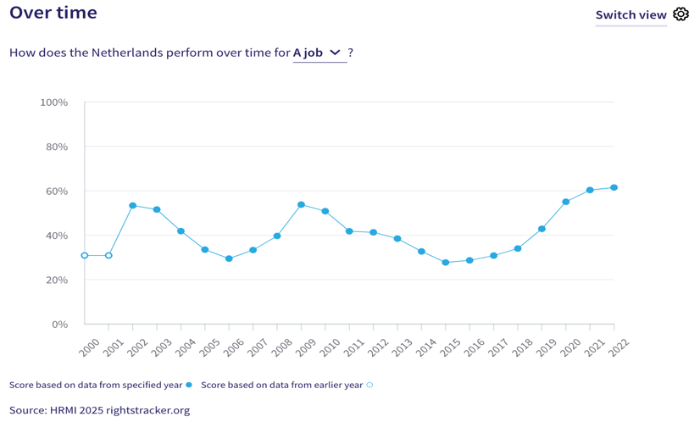
IX. Concluding Remarks
26. The Netherlands’ best ‘income adjusted’ HRMI scores are for the right to child health and for the right to safely managed sanitation, both of which fall in the ‘good’ range. Its most concerning scores are for the three areas of the right to education —quality maths education, quality reading education, and quality science education— as well as the right to affordable housing. These scores are not only in the ‘very bad’ range, but have also shown a decline in recent years.
27. Our analysis is that the Netherlands is not constrained by resources from making significant improvements in the areas with low scores. Rather, it has the income available, and can prioritise to put it to use to improve the economic and social rights of its people. We recommend that the Committee assure the State Party that it has the available resources to make progress, especially in the areas of quality education, employment, and affordable housing.
28. We also recommend the following questions:
- What steps will the State Party take to improve secondary school enrolment rates and quality education at all levels?
- What steps will the State take to improve housing affordability?
- What steps will the State take to improve long-term employment rates?
29. HRMI respectfully submits its data and findings on the fulfilment of economic and social rights in the Netherlands. We hope that this submission will serve as a useful resource to the Committee on Economic, Social and Cultural Rights for drafting specific and meaningful questions to the Netherlands during the CESCR’s 78th Pre-Sessional Working Group.

Visit HRMI’s website to learn more about our mission and work, https://humanrightsmeasurement.org/.
This content represents the opinions of the Human Rights Measurement Initiative. It carries no endorsement of the University of Georgia.
See HRMI’s methodology for measuring economic and social rights: https://humanrightsmeasurement.org/methodology and https://rightstracker.org/page/methodology.
Ibid.
HRMI 2025 Rights Tracker, https://rightstracker.org/
See Human Rights Measurement Initiative (HRMI) Digital Public Good Certificate, https://app.digitalpublicgoods.net/a/10388? The Digital Public Goods Alliance is endorsed by the UN Secretary General’s “Roadmap for Digital Cooperation,” https://www.un.org/en/content/digital-cooperationroadmap/assets/pdf/Roadmap_for_Digital_Cooperation_EN.pdf. It defines digital public goods as: “open source software, open data, open AI models, open standards and open content that adhere to privacy and other applicable laws and best practices, do no harm, and help attain the SDGs,” https://digitalpublicgoods.net/standard/.
HRMI 2025 Rights Tracker, https://rightstracker.org/country/NLD?as=hi&tab=report-esr&qolFdScore=hrmi
The labels on the country charts of good, fair, bad, and very bad are used to give a general indication of how to understand the scores. HRMI’s income adjusted Quality of Life scores can be broadly interpreted as showing the percentage of the country’s obligation it has met, compared to what the best performing countries have achieved at each income level. A country scoring below 75% with a label of “Very bad” is failing to put in place the kinds of structures and policies that help people claim the right concerned, but the structures and policies in place most likely prevent many people from claiming their rights. See HRMI’s methodology for measuring human rights, https://rightstracker.org/page/methodology.
HRMI 2025 Rights Tracker, https://rightstracker.org/country/NLD?tab=report-esr
HRMI 2025 Rights Tracker, https://rightstracker.org/country/NLD?as=hi&tab=report-esr&qolFdScore=hrmi
HRMI 2025 Rights Tracker, https://rightstracker.org/metric/education?tab=report-esr&qolFdScore=hrmi&as=hi&income=hi
HRMI 2025 Rights Tracker, https://rightstracker.org/country/NLD?tab=report-esr
Ibid.
HRMI 2025 Rights Tracker, https://rightstracker.org/metric/pisa-math?tab=report-esr&qolFdScore=indicator&sort=score&subregion=europe&income=hi
HRMI 2025 Rights Tracker, https://rightstracker.org/metric/pisa-reading?tab=report-esr&qolFdScore=indicator&sort=score&subregion=europe&income=hi
HRMI 2025 Rights Tracker, https://rightstracker.org/metric/pisa-science?tab=report-esr&qolFdScore=indicator&sort=score&subregion=europe&income=hi
HRMI 2025 Rights Tracker, https://rightstracker.org/country/NLD?tab=report-esr
HRMI 2025 Rights Tracker, https://rightstracker.org/metric/pisa-reading?tab=report-esr&qolFdScore=indicator&sort=score&subregion=europe&income=hi
HRMI 2025 Rights Tracker, https://rightstracker.org/country/NLD?tab=report-esr&qolFdScore=hrmi
HRMI 2025 Rights Tracker, https://rightstracker.org/metric/food?tab=report-esr&qolFdScore=indicator&sort=score&income=hi&as=hi
Ibid.
Ibid.
Ibid.
Ibid.
HRMI 2025 Rights Tracker, https://rightstracker.org/metric/housing?tab=report-esr&qolFdScore=indicator&sort=score&income=hi&subregion=europe&as=hi
HRMI 2025 Rights Tracker, https://rightstracker.org/country/NLD?tab=report-esr&qolFdScore=hrmi
HRMI 2025 Rights Tracker, https://rightstracker.org/metric/affordable-housing?subregion=europe&income=hi
HRMI 2025 Rights Tracker, https://rightstracker.org/metric/safe-sanitation?tab=report-esr&qolFdScore=indicator&sort=score&income=hi&subregion=europe
HRMI 2025 Rights Tracker, https://rightstracker.org/country/NLD?tab=report-esr&qolFdScore=hrmi
HRMI 2025 Rights Tracker, https://rightstracker.org/metric/work?tab=report-esr&qolFdScore=indicator&sort=score&income=hi&subregion=europe&as=hi
HRMI 2025 Rights Tracker, https://rightstracker.org/country/NLD?tab=report-esr&qolFdScore=hrmi
Ibid.

