Annexes
Annex 1: SDG 5 Indicators captured in the National Census and DHS
- Proportion of ever- partnered women and girls aged 15 and older subjected to violence by current or former intimate partner
- Proportion of ever- partnered women and girls aged 15 and older subjected to violence by persons other than an intimate partner
- Proportion of women aged 20-24 years who were married
- Proportion of time spent on unpaid domestic and care work by sex
- Proportion of women in managerial positions
- Proportion of women aged 15-49 years who make their own informed decisions regarding sexual relationship.
- Proportion of total agricultural land, by sex
- Share of women among owners or rights-bearers of agricultural land by type of tenure
- Proportion of individuals who own a mobile phone by sex.

Annex 2: Gender-specific Indicators captured in the NDS 2016-2035
The NDS prioritizes the following SDG gender-specific indicators:
- SDG 1 on poverty eradication;
- SDG 2 on agricultural productivity and incomes;
- SDG 3 on maternal mortality and sexual and reproductive health services;
- SDG 4 on formal and informal education;
- SDG 5 on gender equality;
- SDG 8 on employment and decent work;
- SDG 10 on inequality reduction;
- SDG 11 on safe transportation;
- SDG 13 on climate change; and
- SDG 16 on peaceful and inclusive societies.

Annex 3: Gender data and Statistics Trainings attended by SIG Officials
- a Regional Gender and Human Rights Statistics Reporting Workshop in Fiji in 2014 attended by 4 SIG GFPs and a rep from the NSO;

- in 2015, another workshop for all SIG GFPs on the use and dissemination of gender statistics, in Honiara;

- In May/June 2017, a Solomon Islands Delegation consisting of the Chair of the Public Service Commission, Permanent Secretary of the MPS, Director Women of the MWYCFA, SIG GFPs for MECDM, Ministry of Education Human Resources Development (MEHRD), MDPAC and the Training Manager of IPAM MPS, attended a regional workshop, ‘Strengthening the role of central agencies of governments in supporting mainstreaming gender across governments’ policies, programmes, and services’, which included the key objective of familiarising participants with gender statistics methods and tools and identifying implementation measures to sustain the production and use of gender statistics.

- in 2022, the ‘National Training: Producing and Using Gender Statistics to Monitor the SDGs and Implement the Pacific Roadmap in Solomon Islands’; and

- in 2024, a training on the Solomon Islands Equality Insights data by 4 SIG officials in Melbourne.

Annex 4: Disaster Management Operational Arrangement
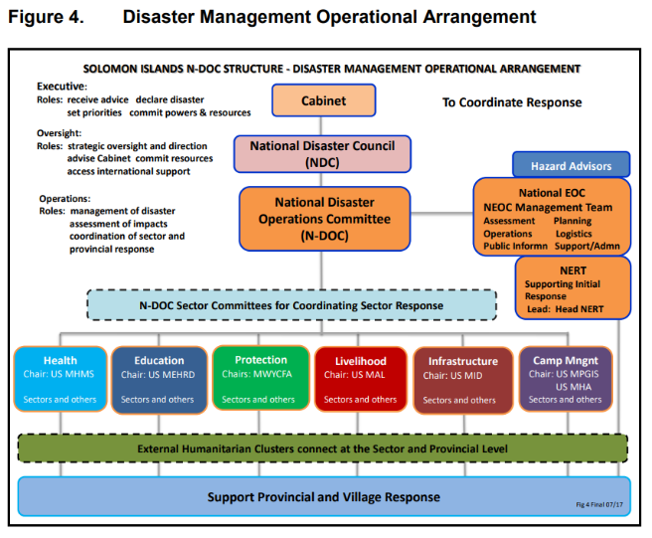
Annex 5: GBViE Preparedness and Response to COVID-19
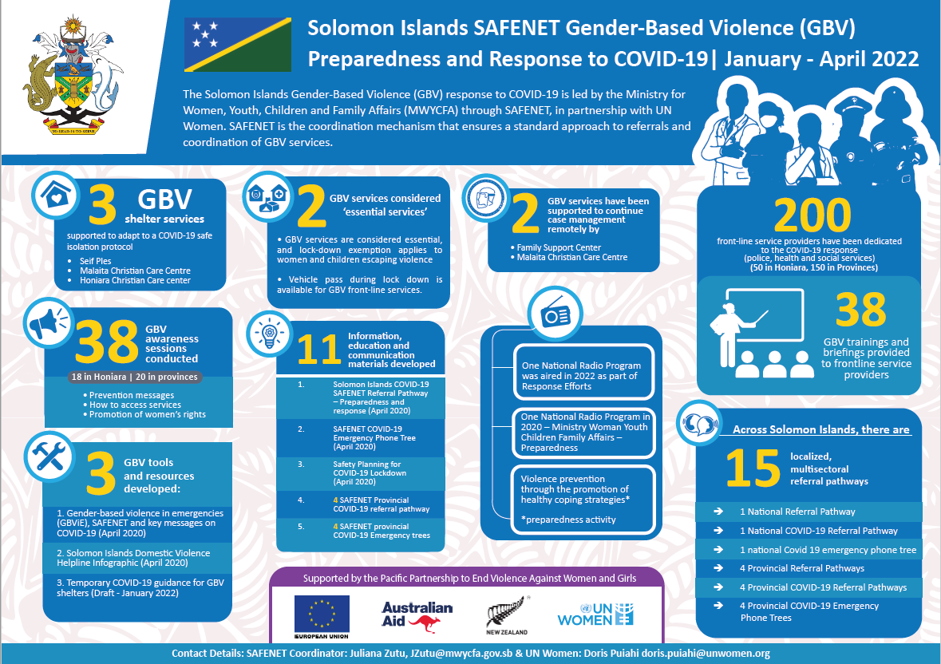

Annex 6: SI COVID-19 SAFENET Referral Pathway Preparedness and Response
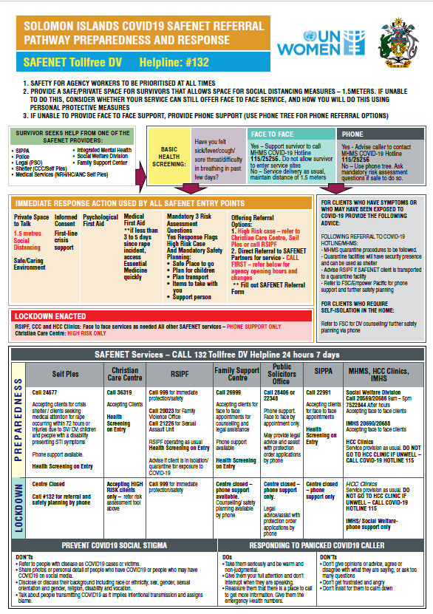

Annex 7: Police Trainings on the FPA 2014
Year | No. of Police Officers | Location
Apr 2016 – Apr 2017 | 650 officers (157 females, and 493 males) | Honiara and the Provinces
2018 -2019 | 25 Family Violence coordinator  150 frontline RSIPF officers | Honiara and the Provinces
2020 | 57 police officers (mostly shift officers and second in charge officers) | Honiara and Western province
2021 | 36 police officers (7 Henderson police, 4 Naha police and 25 White river police) | Honiara
2022 | 32 police officers | Western Province
2023 | 25 Family violence officers | 9 Provinces
2024 | 100 police officers | Malaita, Western and Isabel Provinces

Annex 8: SAFENET Response and Referral Network
No. | SAFENET Members | Type of Service they provide | Location
 | Ministry of Women Youth Children and Family Affairs | Coordination | Honiara
 | Ministry of Health and Medical Services (National Referral Hospital, Integrated Mental Health Services, Social Welfare Division, Reproductive Health) | Medical services, Mental Health Services, Welfare & Child protection services | Honiara and Provinces
 | Ministry of Commerce Immigration Labour and Industries (Immigration Division) | Human Trafficking related services | Honiara
 | Public Solicitors Office | Legal and Paralegal Services | Honiara and 4 Provinces
 | Office of the Director of Public Prosecutions | Legal Services
 | Honiara City Council (HCC Clinics, Women’s Division) | Medical Services, Psychological First Aid entry point | Honiara
 | Royal Solomon Islands Police Force (Family Violence Unit and Sexual Assault Unit, Seif Ples) | Security, Immediate Protection, Police Safety Notice (PSN), medical services and short-term accommodation
 | Family Support Center | Counselling Service, Legal Services, Case management (Hub center)
 | Christian Care Centre | Shelter, Pastoral and Spiritual Counselling | Honiara and 1 Province
 | Solomon Islands Planned Parenthood Association | Medical and Sexual and Reproductive Health
 | Homes of Peace and Empowerment (HOPE) Trust | Counselling and Case Management for Child Trafficking

Annex 9: WDD Establishment
No. | Established Position | Status
 | Director | Filled
 | GEWD Policy Coordinator | Vacant – recruitment in progress
 | WDD Training Coordinator | Filled
 | EVAWG Policy Coordinator | Vacant – temporary fill-in to be recruited
 | SAFENET Coordinator | Filled
 | WPS Coordinator | Vacant – recruitment in progress
 | Provincial Women’s Development Officer (Western and Choiseul) | Vacant – recruitment in progress
 | Provincial Women’s Development Officer (Central and Malaita) | Filled
 | Provincial Women’s Development Officer (RenBel and Guadalcanal) | Vacant – recruitment in progress
 | Provincial Women’s Development Officer (Isabel, Temotu and Makira) | Vacant – recruitment in progress
 | Externally Funded Positions
 | SAFENET Data Officer | Vacant – process of securing funding for recruitment
 | WIL TA | Vacant – recruitment in progress
 | WEE TA | Filled

Annex 10: TSM Awareness – Number of People Reached per Province
No | Province | Females | Males | Total
1 | Western | 2379 | 1210 | 3589
2 | Choiseul | 1536 | 719 | 2255
3 | Isabel | 1408 | 848 | 2256
4 | Renbel | 155 | 138 | 293
5 | Guadalcanal | 789 | 446 | 1235
6 | Central Islands | 1685 | 1214 | 2899
7 | Malaita | 683 | 463 | 1146
8 | Makira | 1682 | 1246 | 2928
9 | Temotu | 243 | 198 | 441
 | Totals | 10560 | 6482 | 17042

Annex 11: MWYCFA grants to CCC, MCCC and FSC
Year | Grantee | Amount (SBD)
2016 and 2017 | CCC and FSC | 150, 000 each
2018 | CCC | 150, 000
2018 | FSC | 250, 000
2019 | FSC | 132,478
2019 | CCC | 150,000
2019 | MCCC | 40, 926
2020 | FSC and CCC | 90,000 each
2021 | FSC | 132, 478
2021 | CCC | 60,000
2021 | MCCC | 40,926
2022-2023 | No requests for Grants
2024 | Requests for Grants has been received from CCC and FSC

Annex 12: Dual Citizenship Applications
Year | Total Applications Received | Total Number Of Female Applicants | Total Number Of Male Applicants
2020 | 101 | 35 | 66
2021 | 29 | 8 | 21
2022 | 55 | 22 | 33
2023 | 97 | 23 | 54

Annex 13: School Fees Limit Compliance
Education Level | Maximum Fee for Day Student |  | Maximum Fee for Boarding Student
Education Level | Urban School | Non-Urban School | Urban School | Non-Urban School
Primary | $1,200 | $250
Junior Secondary | $2,000 | $800 | $4,500 | $2,800
Senior Secondary | $4,000 | $3,000 | $9,000 | $7,200

Annex 14: Data on Post-Abortion Counselling
Location/Year | Post Abortion Counselling <25 years | Post Abortion Counselling >25 years
Honiara/2019-2022 | 68 clients | 83 Clients
Auki/2019-2022 | 1 client | 6 Client
Gizo/2019-2022 | 4 Client | 3 Client

