Annexes

Annex 1 for budget information

The table below represents the annual budgets allocations for education, health and social protection over the period 2014-2016.

Education | Health | Social Protection
2014: 22.81% | 2014: 1.97% | 2014: 3.72%
2015: 23.03% | 2015: 1.85% | 2015: 3.57%
2016: 31.05% | 2016: 1.41% | 2016: 4.19%
2017: 29.56% | 2017: 1.62% | 2017: 3.9%

Table 12.1: Annual Budgeted Apparatus Expenditures of the Government by Ministry/Department (x SRD. 1 Million), 2017 - 2021
Ministry | Year
Ministry | 2017 | 2018 # | 2019 # | 2020# | 2021*
General Affairs | 111.0 | 119.0 | 154.0 | 257.0 | 275.0
Finance and Planning | 92.0 | 104.0 | 103.0 | 145.0 | 157.0
Economic Affairs Entrepreneurship, Technological Affairs and Entrepreneurship / | 33.0 | 31.0 | 38.0 | 51.0 | 48.0
Agriculture, Animal Husbandry & Fishery | 55.0 | 56.0 | 69.0 | 97.0 | 100.0
Natural Resources | 54.0 | 62.0 | 55.0 | 58.0 | 111.0
Justice and Police | 369.0 | 369.0 | 458.0 | 815.0 | 853.0
Home affairs | 96.0 | 97.0 | 128.0 | 243.0 | 281.0
Regional Development and Sport | 180.0 | 187.0 | 223.0 | 386.0 | 360.0
Sports Affairs | 29.0 | 34.0 | 37.0 | 39.0 | 46.0
Public Works | 71.0 | 70.0 | 91.0 | 151.0 | 127.0
Education and Science | 1,051.0 | 1,127.0 | 1,476.0 | 1,195.0 | 1,091.0
Culture | 12.0 | 12.0 | 15.0 | 22.0 | 16.0
Environmental and Sanitary Services | 51.0 | 50.0 | 62.0 | 101.0 | 125.0
Social Affairs and Housing | 119.0 | 127.0 | 160.0 | 198.0 | 191.0
Public Health | 44.0 | 49.0 | 64.0 | 68.0 | 73.0
Defense | 262.0 | 273.0 | 328.0 | 461.0 | 448.0
Labour, Employment and Youth affairs | 25.0 | 23.0 | 33.0 | 45.0 | 50.0
Foreign Affairs, International Business & International Cooperation | 102.0 | 97.0 | 150.0 | 170.0 | 265.0
Transport, Communication & Tourism | 49.0 | 49.0 | 60.0 | 91.0 | 100.0
Spatial Planning together with Land Policy and Forest Management | 27.0 | 28.0 | 35.0 | 47.0 | 41.0
Environment |  |  |  |  | 11.0
Totaal/Total | 2,832.0 | 2,964.0 | 3,739.0 | 4,696.0 | 4,861.0
Human Resource Management (HRM) |  |  | 17.0 | 56.0 | 70.0
The National Assembly | . | . | . | . | .
General Management |  |  |  |  | 23.0
Covid-19 Emergency Fund |  |  |  | 600.0
Source: Ministry of Finance

Annex 2 The table below shows the annual number of persons with disabilities registered by district over the period 2016 - 2020 that received financial support.

District | Years
 | 2017 | 2018 | 2019 | 2020
Paramaribo | 4,941 | 4,229 | 3,904 | 4,263
Wanica | 3,776 | 3,384 | 3,123 | 3,346
Nickerie | 783 | 754 | 643 | 691
Coronie | 78 | 81 | 51 | 50
Saramacca | 420 | 334 | 305 | 332
Commewijne | 1,052 | 857 | 618 | 614
Marowijne | 731 | 655 | 616 | 688
Para | 1,010 | 872 | 834 | 929
Total | 12,791 | 11,166 | 10,094 | 10,913
- Number of Persons per December each year/ Remarks: In a family only one person
is entitled to financial support. However, several persons per household may be entitled.
Source: Ministry of Social Affairs and Housing

Annex 3. The table below shows adolescents who considered attempting suicide by age group and sex (%), 2016
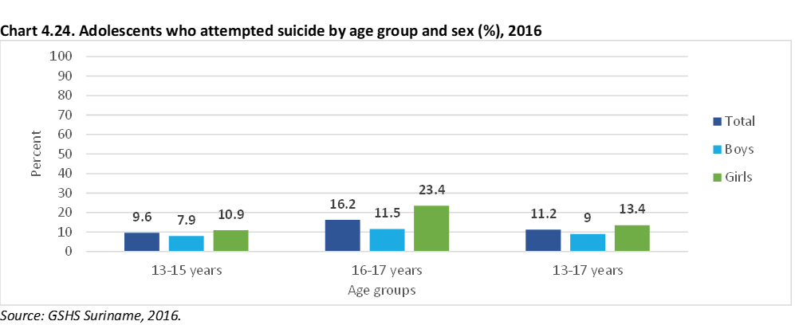

Source: SITAN May 2021

Annex 4 Chart below reflects the adolescents (ages 11-18) who experienced violence in the home (%), 2017
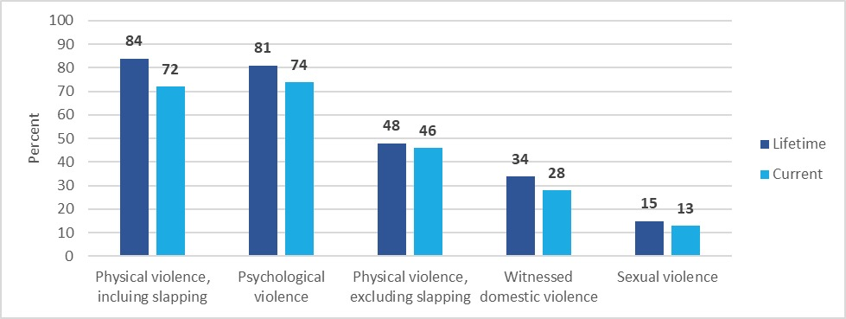

Annex 5 The chart below shows the proportion of mothers who reported their children experienced violence in the home (%)
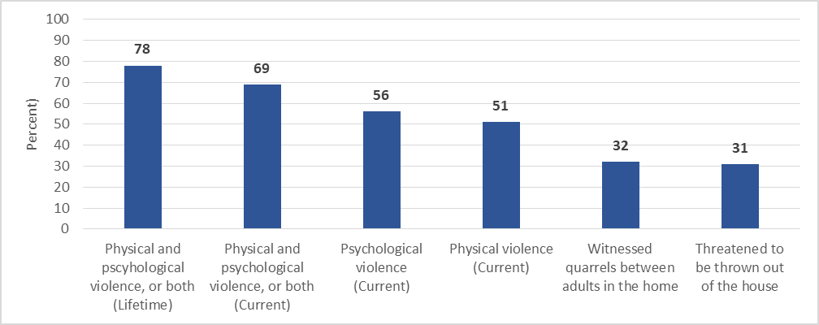
Source: SITAN May 2021

Annex 6 The number of students who experienced violence, in the past year

Forms of violence in the past 12 months | % | total number
All types of violence
Violence exclusive “tapping” | 81.3 | 49.736
Violence inclusive “tapping” | 87.6 | 53.591
Sexual violence
Sexual violence by adults and children | 13.1 | 8.014
Sexual violence by adults | 10.3 | 6.301
Sexual violence by children | 6.6 | 4.037
Sexual violence within the family | 8.2 | 5.017
Sexual violence outside the family | 8.6 | 5.261
Psychological abuse | 73.9 | 45.209
Witnessing violence between parents/adults | 27.5 | 16.680
Physical violence
Physical violence by adults and children including "tapping" | 72.4 | 44.292
Physical violence by adults inclusive “tapping" | 71.3 | 43.169
Physical violence by adults and children exclusive "tapping" | 45.9 | 28.080
Physical violence by adults exclusive “tapping" | 43.4 | 26.550
Physical violence by children | 11.8 | 7.218
Source: student survey (Terborg,2018)

Annex 7 physical violence within the home

Hypotheses | Actual | High Frequency
my mother/father/other adult has given me a slap. | 63.4 | 39.2
my mother/father/other adult has “spanked" me with a belt, stick or another object | 34.9 | 35.8
my mother/father/other adult has kicked me, clapped me, shook me hard | 20.9 | 35.7
my mother/father/other adult has wounded me as punishment | 8.7 | 35.3
children with whom I live have beaten me hard, kicked me | 9.1 | 37
children with whom I live have physically injured me | 5.4 | 37.9
Source: student survey (Terborg, 2018)

Annex 8 The table below is the annual number of children for whom the Government paid Child Benefit by District from 2016 – 2020

District | Years
 | 2016 | 2017 | 2018 | 2019 | 2020
Paramaribo | 31,429 | 32,233 | 32,798 | 33,383 | 33,796
Wanica | 19,702 | 20,177 | 20,276 | 20,614 | 21,003
Nickerie | 4,890 | 4,797 | 4,735 | 4,641 | 4,557
Coronie | 202 | 172 | 175 | 179 | 175
Saramacca | 1,980 | 2,001 | 2,036 | 2,045 | 2,030
Commewijne | 4,368 | 4,354 | 4,420 | 4,454 | 4,506
Marowijne | 3,287 | 3,029 | 2,995 | 2,952 | 2,813
Para | 5,733 | 5,761 | 5,917 | 5,870 | 5,975
Brokopondo | 3,882 | 3,853 | 3,912 | 3,860 | 3,987
Sipaliwini | 13,394 | 13,142 | 12,943 | 12,535 | 12,349
Totaal / Total | 88,867 | 89,519 | 90,207 | 90,533 | 91,191
Source: ABS Statistical yearbook 2019-2020, table 10.2, data from the Ministry of Social Affairs and Housing

Annex 9 for the total of facilities

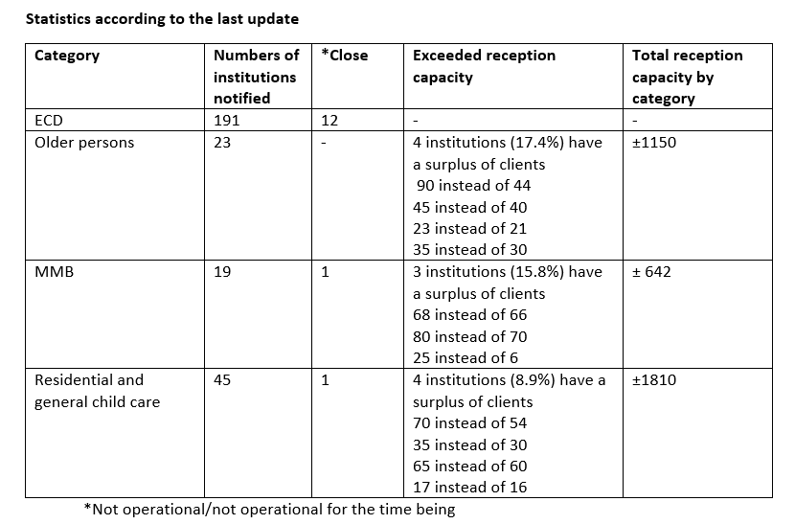

Annex 10 Overview of Schools of Special Education (SO) and Continued Special Education Schools (VSO)

Overview of Schools of Special Education (SO) and Continued Special Education Schools (VSO).

Nr | School | Number of school rooms | Number of teachers | Number of students
 | SO Flora | 09 | 14 | 60
 | SO Jankilaan | 07 | 10 | 42
 | SO Livorno | 10 | 13 | 87
 | SO Maretraite | 15 | 18 | 88
 | SO Fajalobi | 03 | 03 | 27
 | VSO Fajalobi | 05 | 16 | 30
 | SO Lelydorp | 06 | 07 | 83
 | VSO Lelydorp | 08 | 17 | 30
 | SO W.H.C. Monkou | 03 | 05 | 39
 | VSO klasje W.H.C. Monkou | 04 | 06 | 12
 | SO Welgedacht C. | 09 | 05 | 67
 | VSO Welgedacht C |  | 03 | 42
 | VSO Flora | 14 | 19 | 63
 | VSO Emma | 08 | 17 | 52
 | SO Tambaredjo | 05 | 10 | 33
 | VSO klasje Tamb | 06 | 01 | 06
 | Grietjebie | 07 | 08 | 47
 | L.J. Gruntjes | 03 | 05 | 08
 | Hubstina | 03 | 03 | 13
 | Jenny Muller | 03 | 06 | 13
 | Jules Fernandes | 10 | 12 | 70
 | De Bloementuin mlk | 09 | 08 | 60
 | Louis Braille | 04 | 06 | 09
 | SO Mytyl | 07 | 14 | 46
 | VSO Mytyl | 03 | 03 | 25
 | SO Montresor | 02 | 05 | 34
 | Ilse Labadie | 08 | 08 | 37
 | Stizona | 10 | 15 | 58
 | T.J.G. | 01 (loods) | 09 | 15
 | S.O.G.K. | 05 | 13 | 75

Annex 11 Statistics applications Refugees, Asylum seekers 2018

Applications received from Refugees/Asylum seekers in the period
January - December 2018
Country | TOTAL NUMBER OF APPLICATIONS SUBMITTED | MALE | FEMALE | CHILD | REFUGEE | ASYLUM SEEKER | TOTAL NUMBER OF PERSONS
CUBA | 9 | 7 | 2 | 1 | 3 | 6 | 10
DOM. REP | 1 | 0 | 1 | 1 | 0 | 1 | 2
NIGERIA | 1 | 1 | 0 | 0 | 1 | 0 | 1
JAMAICA | 2 | 2 | 0 | 0 | 2 | 0 | 2
VENEZUELA | 4 | 0 | 4 | 7 | 0 | 4 | 11
TOTAL | 17 | 10 | 7 | 9 | 6 | 11 | 26

Applications received from Refugees/Asylum seekers in the period
January - December 2019
Country | TOTAL NUMBER OF APPLICATIONS SUBMITTED | MALE | FEMALE | CHILD | REFUGEE | ASYLUM SEEKER | TOTAL NUMBER OF PERSONS
CUBA | 23 | 15 | 8 | 0 | 2 | 21 | 23
DOM. REP | 2 | 0 | 2 | 0 | 0 | 2 | 2
VENEZUELA | 9 | 5 | 4 | 0 | 1 | 9 | 9
NIGERIA | 2 | 2 | 0 | 0 | 1 | 2 | 2
TOTAAL | 36 | 22 | 14 | 0 | 4 | 34 | 36

Applications received from Refugees/Asylum seekers in the period
January- December 2020
COUNTRY | TOTAL NUMBER OF APPLICATIONS SUBMITTED | MALE | FEMALE | CHILD | REFUGEE | ASYLUM SEEKER | TOTAL NUMBER OF PERSONS
CUBA | 43 | 29 | 20 | 8 | 1 | 42 | 57
VENEZUELA | 6 | 1 | 5 | 8 | 0 | 6 | 14
CONGO | 1 |  | 1 | 0 |  | 1 | 1
NIGERIA | 1 | 1 |  | 0 |  | 1 | 1
TOTAAL | 51 | 31 | 20 | 16 | 1 | 50 | 73

Applications received from Refugees/Asylum seekers in the period
July - December 2020
 | Country |  | Total number of applications submitted |  | Male | Female |  | Child |  | Refugee |  | Asylum seeker |  | Total number of persons |  |  | Double submission
 | Cuba |  | 43 |  | 32 | 11 |  | 1 |  | 0 |  | 43 |  | 44 |  |  | 1
 | Nigeria |  | 0 |  | 0 | 0 |  | 0 |  | 0 |  | 0 |  | 0 |  |  | 0
 | Venezuela |  | 3 |  | 0 | 3 |  | 0 |  | 0 |  | 3 |  | 3 |  |  | 0
 | Total |  | 46 |  | 32 | 14 |  | 1 |  | 0 |  | 47 |  | 47 |  |  | 1

Naturalisation applications received from January - December 2019

CODE | JAN | FEB | MAR | A  P  R  I  L | M  A  Y | J  U  N  E | J  U  L  I | AUG | S  E  P | O  C  T | N  O  V | D  E  C | TOTAL
OPTIE 18-YEAR OLDS (ART 5 WNI) | 3 | 11 | 8 | 6 | 7 | 2 | 5 | 3 | 4 | 3 | 5 | 2 | 59
DECLARATION CITIZENSHIP regarding MINORS (ART 21, Law on Nationality and Residence,  /WNI)  CERTIFICATE OF RESIDENCY FOR MINORS (ART. 21 WNI) | 24 | 15 | 23 | 28 | 25 | 23 | 33 | 31 | 16 | 23 | 35 | 11 | 287
TOTAL | 27 | 26 | 31 | 34 | 32 | 25 | 38 | 34 | 20 | 26 | 40 | 13 | 346
Applications for naturalisation received from January - December 2019

CODE | J  AN | F  EB | MA  R | A  P  R  IL | M  AY | J  U  NE | J  UL  Y | A  UG | S  E  PT | O  CT | N  OV | D  EC | T  O  T  A  L
OPTIE 18-JARIGEN (ART 5 WNI) | 6 | 6 | 5 | 3 | 4 | 0 | 0 | 2 | 6 | 4 | 3 | 6 | 45
DECLARATION CITIZENSHIP regarding MINORS (ART 21 WNI) | 21 | 16 | 14 | 5 | 10 | 0 | 4 | 8 | 10 | 16 | 15 | 6 | 125
TOTAL | 27 | 22 | 19 | 8 | 14 | 0 | 4 | 10 | 16 | 20 | 18 | 12 | 170

Applications for naturalisation received from January – March 2021

CODE | JAN | FEB | MAR | TOTAL
OPTIE 18-YEAR OLDS (ART 5 WNI) | 3 | 8 | 2 | 13
DECLARATION CITIZENSHIP regarding MINORS (ART 21 WNI) | 7 | 5 | 10 | 22
TOTAL | 10 | 13 | 12 | 35
.
Applications for naturalisation received from April- June 2021

CODE | APRIL | MAY | JUNE | TOTAL
OPTIE 18-YEAR OLDS (ART 5 WNI) | 2 | 0 | 0 | 2
DECLARATION CITIZENSHIP regarding MINORS (ART 21 WNI) | 14 | 8 | 2 | 24
TOTAL | 16 | 8 | 2 | 26
.

Applications for naturalisation received from April – June 2021

CODE | APRIL | MAY | JUNE | TOTAL
OPTIE 18-YEAR OLDS (ART 5 WNI) | 2 | 0 | 0 | 2
DECLARATION CITIZENSHIP regarding MINORS (ART 21 WNI) | 14 | 8 | 2 | 24
TOTAL | 16 | 8 | 2 | 26
.

Annex 12 for the statistics on the number of youth TIP victims from 2015 -2021
Number of Youth TIP Victims from 2015 to 2021
Year 2015
Number of victims | Gender |  | Age | Ethnicity | Nationality
2 | Male | Female
 |  | 1 | 13 | Creole | Surinamese
 |  | 1 | 13 | Creole | Surinamese
Year 2016
Number of victims | Gender
2 | Male | Female
 | 1 | 0 | 16 | Creole | Surinamese
 | 0 | 1 | 16 | Creole | Surinamese
Year 2017
Number of victims
4 | Male | Female
 | 0 | 1 | 16 | Creole | Surina mese
 | 0 | 1 | 17 | Mixed ethnicity | Surina mese
 | 0 | 1 | 15 | Hindustani | Surina mese
 | 0 | 1 | 19 | Indigenous | Surinamese
Year 2018
Number of victims | Male | Female
1 | 0 | 1 | 17 | Mixed ethnicity | Surina mese
Year 2019
Number of victims | Male | Female
3 | 0 | 1 | 15 | Javanese | Surina mese
 | 0 | 1 | 15 | Maroon | Surina mese
 | 0 | 1 | 14 | Creole | Surina mese
Year 2020
Number of victims | Male | Female
1 | 0 | 1 | 16 | Javanese | Surinamese
Year 2021
Number of victims | Male | Female
4 |  | 1 | 16 | Maroon | Surinamese
 |  | 1 | 13 | Creole | Surinamese
 |  | 1 | 15 | Creole | Surinamese
 |  | 1 | 19 |  | Cuba n

Annex 13 Data Children in conflict with the law

Overview of arrests by judicial record (2010-2020)

The table below shows the number of recidivists from 2010-2020. The judicial past of the juvenile offenders is presented both in numbers and percentages. In addition, the percentage course of the statistics, in terms of increase and decrease, will be compared from 2011 to 2020.

Table Overview judicial past 2010-2020

Year | First Offenders | % | Recidivists | % | Total
2010 | 206 | 83% | 43 | 17% | 249
2011 | 253 | 82% | 57 | 18% | 310
2012 | 246 | 77% | 75 | 23% | 321
2013 | 282 | 83% | 59 | 17% | 341
2014 | 303 | 80% | 80 | 20% | 383
2015 | 233 | 72% | 91 | 28% | 324
2016 | 284 | 76% | 87 | 24% | 371
2017 | 280 | 74% | 98 | 26% | 378
2018 | 233 | 66% | 118 | 34% | 351
2019 | 177 | 66% | 91 | 34% | 268
2020 | 152 | 74% | 54 | 26% | 206²

Figure Penalty imposed

It is worth mentioning that out of the group of 159 juveniles who appeared in court, 34% (54) were given a sentence in 2020, namely:
- 12 % a suspended sentence
- 14 % an unconditional sentence
- 4% a combined penalty (with a conditional part)
- 4% imprisonment

 | 12yrs | 13yrs | 14yrs | 15yrs | 16yrs | 17yrs | 18yrs | Total
January | 0 | 0 | 2 | 1 | 5 | 9 | 13 | 30
February | 2 | 0 | 1 | 2 | 10 | 7 | 10 | 32
March | 1 | 2 | 3 | 3 | 2 | 8 | 3 | 22
April | 2 | 0 | 1 | 4 | 7 | 6 | 4 | 24
May | 0 | 0 | 1 | 1 | 3 | 9 | 3 | 17
June | 0 | 0 | 0 | 3 | 4 | 0 | 4 | 11
July | 0 | 0 | 1 | 3 | 3 | 7 | 2 | 16
August | 2 | 0 | 3 | 4 | 4 | 7 | 1 | 21
September | 0 | 0 | 1 | 0 | 1 | 5 | 4 | 11
October | 1 | 2 | 1 | 3 | 10 | 5 | 2 | 24
November | 1 | 0 | 3 | 3 | 10 | 4 | 0 | 21
December | 1 | 2 | 1 | 2 | 2 | 6 | 0 | 14
Total | 10 | 6 | 18 | 29 | 61 | 73 | 46 | 243

Figure Age groups of delinquents

Offences committed in 2020
In 2020, juveniles committed various offences. Qualified theft and robbery are still the most common offences among youths (35%). See Table 12 and Figure 10. Other common offences are
Assault (8%)
Aggravated assault (7%)
Theft with violence (6%)
Public violence (5%)
Rape (4%)

Table Overview of offences committed

# | Offence | Jan | Feb | Mar | Apr | May | Jun | Jul | Aug | Sept | Oct | Nov | Dec | Total
1 | Theft | 6 | 11 | 3 | 9 | 5 | 2 | 3 | 5 | 2 | 5 | 10 | 11 | 72
2 | Embezzlement | 0 | 0 | 0 | 0 | 1 | 1 | 0 | 0 | 0 | 0 | 0 | 0 | 2
3 | Qualified theft | 10 | 16 | 9 | 10 | 6 | 6 | 6 | 11 | 8 | 11 | 10 | 5 | 108
4 | Theft with violence | 2 | 2 | 0 | 6 | 0 | 0 | 3 | 4 | 0 | 8 | 2 | 2 | 29
5 | Fencing | 1 | 2 | 0 | 1 | 0 | 2 | 0 | 5 | 0 | 4 | 2 | 3 | 20
6 | Destruction/ damage of goods | 0 | 2 | 3 | 1 | 1 | 1 | 1 | 5 | 0 | 1 | 4 | 1 | 20
7 | Actual sexual assault | 3 | 0 | 7 | 1 | 0 | 1 | 0 | 0 | 2 | 2 | 2 | 2 | 20
8 | Rape | 3 | 0 | 7 | 2 | 0 | 1 | 1 | 0 | 2 | 1 | 2 | 3 | 22
9 | Fornication with unconscious or impotent persons | 2 | 1 | 4 | 2 | 0 | 0 | 1 | 0 | 1 | 2 | 1 | 0 | 14
10 | Rape of girl under 12 years | 1 | 0 | 0 | 1 | 0 | 0 | 1 | 0 | 1 | 0 | 2 | 3 | 9
11 | Rape of girl under 14 years | 0 | 1 | 3 | 0 | 1 | 0 | 1 | 0 | 1 | 1 | 3 | 2 | 13
12 | Intercourse with unconscious or impotent persons | 0 | 0 | 4 | 2 | 0 | 0 | 0 | 0 | 2 | 0 | 2 | 1 | 11
13 | Abduction | 0 | 0 | 0 | 0 | 1 | 0 | 0 | 0 | 0 | 0 | 1 | 0 | 2
14 | Abduction of a minor | 0 | 0 | 0 | 0 | 0 | 1 | 0 | 0 | 0 | 0 | 1 | 0 | 2
15 | Pornography | 0 | 0 | 0 | 0 | 0 | 0 | 0 | 0 | 0 | 0 | 1 | 0 | 1

# | Offence | Jan | Feb | Mar | Apr | May | Jun | Jul | Aug | Sept | Oct | Nov | Dec | Total
16 | Abuse of authority | 0 | 1 | 0 | 1 | 0 | 0 | 0 | 0 | 0 | 0 | 0 | 0 | 2
17 | Threat of crime | 4 | 1 | 1 | 2 | 0 | 1 | 1 | 1 | 0 | 0 | 1 | 0 | 12
18 | Abuse | 14 | 5 | 2 | 2 | 3 | 2 | 3 | 2 | 1 | 4 | 2 | 1 | 41
19 | Aggravated assault | 7 | 5 | 1 | 4 | 3 | 1 | 3 | 2 | 2 | 5 | 1 | 2 | 36
20 | Premeditated assault | 1 | 1 | 0 | 0 | 1 | 0 | 0 | 0 | 0 | 0 | 0 | 0 | 3
21 | Aggravated assault with premeditation | 1 | 2 | 0 | 2 | 0 | 0 | 0 | 1 | 0 | 0 | 1 | 0 | 7
22 | Aggravated assault with terrorist intent | 0 | 0 | 0 | 0 | 0 | 0 | 0 | 0 | 0 | 0 | 0 | 1 | 1
23 | Public assault | 6 | 1 | 1 | 2 | 0 | 1 | 3 | 2 | 2 | 7 | 0 | 1 | 26
24 | Crimes against personal liberty | 0 | 0 | 0 | 0 | 0 | 0 | 1 | 0 | 0 | 0 | 0 | 0 | 1
25 | Obstruction | 0 | 0 | 0 | 0 | 0 | 0 | 0 | 0 | 0 | 1 | 0 | 1 | 2
26 | Murder | 0 | 0 | 0 | 0 | 0 | 0 | 0 | 1 | 0 | 5 | 1 | 1 | 8
27 | Homicide | 4 | 2 | 1 | 0 | 2 | 0 | 0 | 6 | 1 | 1 | 1 | 1 | 19
28 | Traffic offence | 0 | 0 | 1 | 0 | 0 | 0 | 0 | 0 | 0 | 0 | 0 | 1 | 2
29 | Violation of the Narcotics Act | 1 | 1 | 0 | 0 | 0 | 0 | 0 | 0 | 0 | 0 | 1 | 1 | 4
30 | Participation in a criminal organisation | 2 | 0 | 0 | 0 | 0 | 0 | 0 | 0 | 0 | 0 | 0 | 0 | 2
31 | Fraud | 0 | 0 | 0 | 0 | 0 | 1 | 0 | 0 | 0 | 0 | 0 | 0 | 1
32 | Intentional deprivation of liberty | 0 | 0 | 3 | 0 | 0 | 0 | 0 | 0 | 0 | 0 | 0 | 0 | 3
33 | Withdrawal of legal authority | 0 | 0 | 0 | 0 | 0 | 0 | 0 | 0 | 0 | 0 | 1 | 0 | 1
34 | Violation of the Firearms Act | 0 | 0 | 0 | 0 | 0 | 0 | 0 | 0 | 0 | 0 | 0 | 2 | 2
 | Total | 68 | 54 | 50 | 48 | 24 | 21 | 28 | 45 | 25 | 58 | 52 | 45 | 518



Figure Number of youth arrests in the year 2018

Year | First  Offender | % | Recidivists | % | Total
2009 | 270 | 81% | 66 | 19% | 336
2010 | 206 | 83% | 43 | 17% | 249
2011 | 253 | 82% | 57 | 18% | 310
2012 | 246 | 77% | 75 | 23% | 321
2013 | 282 | 83% | 59 | 17% | 341
2014 | 303 | 80% | 80 | 20% | 383
2015 | 233 | 72% | 91 | 28% | 324
2016 | 284 | 76% | 87 | 24% | 371
2017 | 280 | 74% | 98 | 26% | 378
2018 | 233 | 66% | 118 | 34% | 351

Age | 10yrs | 11yrs | 12yrs | 13yrs | 14yrs | 15yrs | 16yrs | 17yrs | Total
January | 1 | 2 | 2 | 8 | 11 | 3 | 7 | 13 | 47
February |  | 0 | 1 | 6 | 4 | 5 | 10 | 13 | 39
March |  | 1 | 1 | 2 | 3 | 4 | 16 | 16 | 43
April |  | 0 | 0 | 1 | 4 | 8 | 8 | 5 | 26
May |  | 0 | 2 | 4 | 3 | 7 | 12 | 10 | 38
June |  | 0 | 2 | 5 | 2 | 2 | 14 | 9 | 34
July |  | 0 | 1 | 5 | 5 | 7 | 12 | 8 | 38
August |  | 0 | 3 | 2 | 1 | 5 | 10 | 11 | 32
September |  | 1 | 0 | 3 | 4 | 4 | 12 | 12 | 36
October |  |  |  | 2 | 4 | 5 | 8 | 11 | 30
November |  |  |  | 1 | 4 | 3 | 12 | 6 | 26
December |  |  |  |  | 3 | 3 | 2 | 8 | 16
Total | 1 | 4 | 12 | 39 | 48 | 56 | 123 | 122 | 405

Figure Number of arrests based on age in the year 2018

Figure Age groups of delinquents

Figure Types of offences

.

Type of Crime/Offences | Boys | Girls
Theft | 2
Qualified theft | 15
Theft with violence (robbery) | 11 | 1
Sex offence (moral offence) | 4
Destruction/damage of goods | 1
Public violence | 2
Causing fire, explosion and flood | 1
Murder |  | 1
Total | 36 | 2

