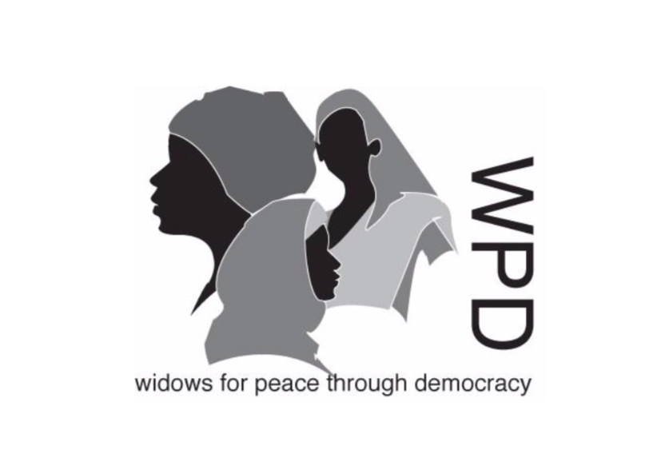

DISCRIMINATION REGARDING WIDOWHOOD IN YEMEN
ISSUES REQUIRING ADDRESSING IN THE CONTEXT OF CEDAW

Margaret Owen, WPD (Widows for Peace through Democracy) President
Heather Rainey WPD Research Assistant, Intern

WPD has complied this report in the hope that it can assist the Committee as it examines the Government of Yemen’s report on its implementation and compliance with the articles of the CEDAW
The status of widows and half widows (wives of the disappeared) is often disregarded in conflict and post-conflict scenarios. Few FACs even know how many widows there are, nor what either their needs or social roles are.
However, there is clear evidence that in these environments widows and their children experience high levels of discrimination resulting in extreme poverty, marginalisation and vulnerability to violence in many shapes and forms.

In Yemen, the ongoing conflict has caused a shocking humanitarian crisis, in which unemployment, corruption, displacement, collapse of essential services and institutions, severe food shortages impact so cruelly upon the civilian populations but especially on the lives of widows, their children and other dependents.
Their young sons at risk of abduction for recruitment into child soldiery, their daughters into the clutches of traffickers, for child marriage, that may be temporary, or into prostitution.
In 2020 there was understood to be 4 million IDP’s who were four times more at risk than the general population, 41% of these people are women, with a further 19% being children (UNHCR, 2020). Among these, are a significant number of widows, who are subject to a disproportionate amount of human rights abuse, violence and disease, their young children suffering and dying from malnutrition.
However, there is a paucity of reliable data on widowhood, ages, needs, roles or situation, and there are no official Government statistics on widowhood.

The on-going conflict has meant that poverty levels have risen from around 50% to between 71-78% from pre-crisis levels (World bank, 2021) Widows are among the poorest of the population.
WPD hopes this submission will aid the Committee in its consideration of Yemen’s State Report during its 80th Session
We suggest the following questions:
- Will the Government gather statistics on widowhood, and register their widows, so they can be given social protection and protection from violence regardless of the perpetrator?
- What means have the Government taken to criminalise all forms of violence against widows, including physical, sexual, psychological and economic?
- What means have the Government taken to eliminate child marriage, and protect the daughters of widows from being forced into such liaisons?
- What means have the Government taken to ensure that the children of widows continue in education?
- Will the Government repeal Article 12 of the 1994 Crime and Penalty Law that states that the value of the life of a woman or a girl is half that of a man and a boy?
- Will the Government amend Article 31 of the 1994 Act that states “women are sisters of men and have rights and duties defined by Sharia law” as this defines widows as second class citizens?
- Will the Government now implement its laws, so that they do not discriminate against widows. In particular, ensuring they have a legal right to inherit land, property and other assets?

WPD thanks the Committee for inviting it to submit this report. Please contact us if you require any further information.
WPD (Widows for Peace through Democracy)
Telephone: 0044(0)2076039733
Email: margaretowen001@gmail.com
Heather.rainey33@gmail.com

