SADA
SOUTH AFRICAN DISABILITY ALLIANCE
Annexure A - SADA Profile
- Establishment of the South African Disability Alliance (SADA)
On 15 November 2007 the South African disability sector formally established the South African Disability Alliance based on considerations in terms of the real experiences of South Africans with disabilities:
- South Africans with disabilities of all ages have the right to equal access to and enjoyment of all the rights and freedoms available to and an improvement in the quality of life comparable to that of society in general.
- Physical, social and economic barriers in society continue to prevent or limit the access of persons with disabilities to or enjoyment of these rights, freedoms and quality of life.
- Persons with disabilities have taken it upon themselves to strive for the goal of removing these barriers through various interventions by the State and other organs of society (including through legislation, government policy and the provision of services and other measures).
- Persons with disabilities, organised under the auspices of the disability rights movement in South Africa, assert our right to represent ourselves and play a leadership role in all matters directly affecting us, inspired by the slogan “nothing about us without us”.
- Organs of civil society (particularly within the disability sector, but also in society in general) have made a significant contribution by providing valuable services and initiating various programmes and projects aimed at improving the quality of life of South Africans with disabilities.
- A need was identified to improve collaboration between all key role-players (in government, civil society, business and labour) whose role is essential for the improvement of the quality of life and attainment of the goal of access to and enjoyment of all the rights and freedom and a quality of life generally available to society at large.
- While the terms “disabled people” and “persons with disabilities” were used interchangeably in South Africa at the time, the SADA preferred the latter given the struggle of persons with disabilities to be recognised as people first.
- Purpose and objectives of SADA
SADA exists as a consultative forum of member organisation on issues of mutual concern and interest. In line with the goal of the advancement of the rights and freedoms of persons with disabilities in South Africa and the improvement of their quality of life, SADA provides a platform for seeking consensus and reaching common positions on issues relating to:

- Key policy and legislative issues relating to disability at national, regional (African) and international levels;
- Public perceptions of disability and persons with disabilities;
- Norms and standards of services and service delivery to persons with disabilities;
- Representing a unified voice as the disability sector without restricting differing views;
- Joint strategies and inclusive positions on cross-cutting issues affecting persons with disabilities;
- Self-representation by persons with disabilities;
- Advocating and lobbying on issues affecting persons with disabilities; and
- Leadership for persons with disabilities in South Africa on issues affecting us.
SADA furthermore promotes collaboration in terms of joint initiatives, campaigns, programmes and projects between role-players in the disability sector and the disability sector and other societal and governmental role-players, including:
- The development, implementation, monitoring and evaluation of policy, legislation and other instruments affecting persons with disabilities at the national, regional and international level;
- Participating in research projects and initiatives;
- Public education and awareness; and
- Funding for the disability sector.
- SADA membership
SADA recognises both full and associate membership:
- Full membership is conferred on organisation operating in at least 50% of South African provinces with a core focus and function in the field of disability. Such members are required to be apolitical (not aligned to any particular political party).
- Organisations failing to meet the criteria for full membership may be granted associate membership, provided that the organisation has a direct interest in the field of disability beyond a commercial interest.
Membership is limited to organisations and excludes individuals. All members must be registered as non-profit organisations with the NPO Directorate of the National Department of Social Development, a non-profit company with the Registrar of Companies at the Department of Trade and Industry or a professional body.

Full members of SADA
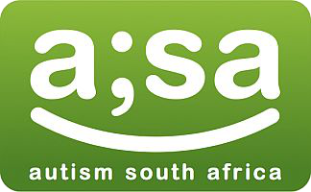  Autism South Africa |  |   Blind SA |  | 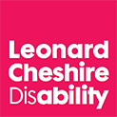  Cheshire Homes South Africa
  Deaf Federation of South Africa (DeafSA) |  | Disabled Children’s Action Group (DICAG) |  | 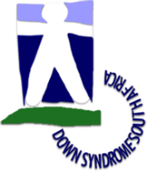  Down Syndrome South Africa (DSSA)
  Epilepsy South Africa |  | 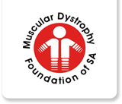  Muscular Dystrophy Foundation of SA (MDSA) |  |   National Association of Persons with Cerebral Palsy (NAPCP)
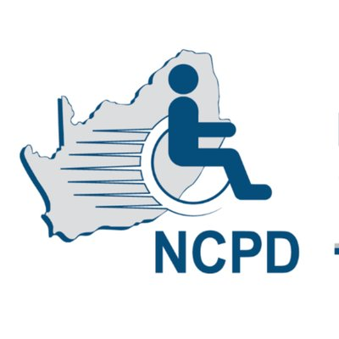  National Council for and of Persons with Disabilities (NCPD) |  | 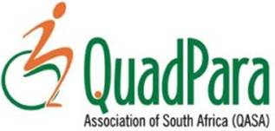  QuadPara Association of South Africa (QASA) |  |   South African Federation for Mental Health (SAFMH)
 | 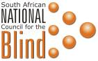  South African National Council for the Blind (SANCB) |  |   South African National Deaf Association (SANDA)

Associate members of SADA
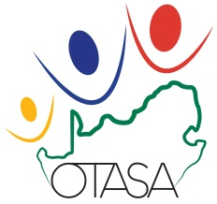  Occupational Therapy Association of South Africa (OTASA) | 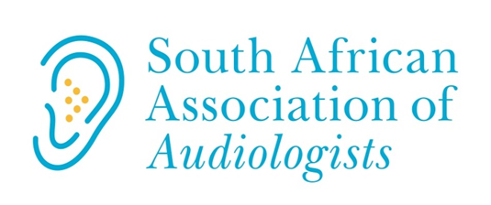  South African Association of Audiologists (SAAA) | 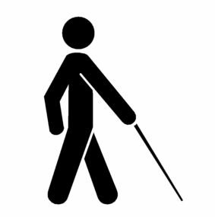  South African National Association of Blind and Partially Sighted Persons (SANABP)
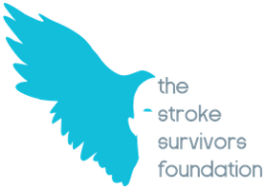
New members of SADA
An application for membership by the South African Stroke Survivors Foundation is currently under consideration.
- Values and principles of SADA
SADA exists to serve the common good of member organisations which implies a relationship of mutual and reciprocal respect and responsibility. The fundamental responsibility of SADA is to endorse, practise and require a commitment from member organisations to the following core values:
- Fidelity to purpose: All SADA resources, energies and activities must be devoted to promoting the purpose of SADA and not to any specific organisational, personal or private objective to the detriment of SADA. Any change of purpose must result from a formal decision to this effect, following a broad process of consultation and must be formalised by amendment of the official terms of reference.
- Altruism and benevolence: The actions and decisions of SADA must be motivated by reasons consistent with its purpose.
- Integrity: SADA and its member organisation subscribes to the highest standards of integrity.
- Optimising resources: SADA is placed in a position of trust by being in possession of funds and resources provided to advance its purpose and reach its objectives.
- Conflicts of interest and self-dealing: It is recognised that conflicts of interest cannot always be avoided. In the event of a conflict of interest, the affected person/member organisation (i) must disclose the interest and its general nature before the matter is considered at a meeting; (ii) must disclose to the meeting any material information relating to the matter and known to him/her; (iii) may disclose any observations or pertinent insights relating to the matter if requested to do so by the other member organisations; (iv) if present at the meeting, must leave the meeting immediately after any disclosures contemplated in these terms of reference; (v) must not take part in the consideration of the matter (except to the extent contemplated above); (vi) while absent from the meeting is to be regarded as present at the meeting for the purpose of determining a quorum and is not to be regarded as being present at the meeting for the purpose of determining whether a resolution has sufficient support to be adopted; and (vii) must not execute any document on behalf of SADA in relation to the matter unless specifically requested or directed to do so by the meeting.

- Equality and non-discrimination: SADA subscribes to the principles of equality and non-discrimination as described in the South African Constitution and the UNCRPD.
- Self-representation and human rights: SADA supports the right of persons with disabilities to represent themselves (or if they are unable to, be represented by a person of trust) in all matters affecting them, as well as the promotion of equal opportunities and inclusion of persons with disabilities in all aspects of society and particularly activities and initiatives of SADA.
- Democracy and empowerment: SADA will demonstrate a clear commitment to democratic process and decision-making which shall be informed by knowledge, research and a participative process allowing for wide-ranging consultation and feedback. Member organisation shall be shown respect and given the opportunity to evaluate all activities of SADA.
- Independence and impartiality: All member organisations must be treated equally and fairly, without special favour or prejudice. Where it is necessary, because of limited resources, to choose between particular member organisations or communities, the basis for choice must be such as to avoid the reality or possible perception of unfair discrimination. This is particularly important as members of the Executive Committee are identified with one member organisation or group rather than with another. A commitment to independence includes a duty to make choices and arrive at decision at arm’s length without being dictated to by any particular member organisation, constituency or interest group. Similarly, SADA will always act independently and take particular care to avoid the perception of political preference or patronage.

ANNEXURE B
RECOMMENDATIONS MADE BY THE HEALTH OMBUD IN TERMS OF THE ESIDIMENI TRAGEDY
- The Gauteng Mental Health Marathon Project must be de-established.
- The Premier of the Gauteng Province must, in the light of the findings herein, consider the suitability of MEC Qedani Dorothy Mahlangu to continue in her current role as MEC for Health.
- Disciplinary proceedings must be instituted against Dr Tiego Ephraim Selebano for gross misconduct and/or incompetence in compliance with the Disciplinary Code and Procedure applicable to SMS members in the Public Service. In the light of Dr Selebano’s conduct during the course of the investigation, which includes tampering with evidence, it is recommended that the Premier should consider suspending him pending his disciplinary hearing, subject to compliance with the Disciplinary Code and Procedure applicable to SMS members in the Public Service.
- Disciplinary proceedings must be instituted against Dr Makgabo Manamela for gross misconduct and/or incompetence in compliance with Disciplinary Code and Procedure applicable to SMS members in the public service. In the light of Dr Makgabo Manamela’s conduct during the course of the investigation, which includes tampering with evidence, it is recommended that consideration be given to suspending her pending her disciplinary hearing, subject to compliance with the Disciplinary Code and Procedure applicable to SMS members in the public service.
- The findings against Drs M Manamela and TE Selebano must be reported to their respective professional bodies for appropriate remedial action with regard professional and ethical conduct.
- Corrective disciplinary action must be taken against members of the GDoMH: Ms S Mashile (Deputy Director); Mr F Thobane (Deputy Director); Ms H Jacobus (Deputy Director); Ms S Sennelo (Deputy Director); Dr S Lenkwane, (Deputy Director); Mr M Pitsi (Chief Director); Ms D Masondo (Chair MHRB), Ms M Nyatlo (CEO of CCRC), Ms M Malaza (Acting CEO of CCRC) in compliance with the Disciplinary Code and Procedures applicable to them, for failing to exercise their Fiduciary duties and responsibilities. They allowed fear to cloud and override their fiduciary responsibilities and thus failed to report this matter earlier to relevant authorities. Fiduciary responsibility is essential for good corporate governance.
- All the remedial actions recommended above must be instituted within 45 days and progress be reported to the Chief Executive Officer of the Office of Health Standards Compliance within 90 days.
- The Ombud fully supports the ongoing SAPS and Forensic investigations underway. The findings and outcomes of these investigations must be shared with appropriate agencies so that appropriate action where deemed justified can be taken.
- The National Minister of Health should request the SAHRC to undertake a systematic and systemic review of human rights compliance and possible violations nationally related to Mental Health.

- Appropriate legal proceedings should be instituted or administrative action taken against the NGOs that were found to have been operating unlawfully and where MHCUs died.
- In light of the findings in the report, the NDoH must review all 27 NGOs involved in the Gauteng Marathon project; those that do not meet health care standards should be de-registered, closed down and their licenses revoked in compliance with the law.
- The National Minister of Health must with immediate effect appoint a task team to review the licensing regulations and procedures to ensure they comply with the National Health Act, the Mental Health Care Act 2002 and Norms and Standards. The newly established process must ensure that NGO certification is done through the OHSC. This newly established licensing process should form the first line of protection for the mentally ill. Currently, this does not seem to be the case.
- All patients from LE currently placed in unlawful NGOs, must be urgently removed and placed in appropriate Health Establishments within the Province where competencies to take care of their specialized needs are constantly available, this must be done within 45 days to reduce risk and save life; simultaneously, a full assessment and costing must be undertaken.
- There is an urgent need to review the NHA 2003 and the MHCA 2002 to harmonise and bring alignment to different spheres of government. Centralisation of certain functions and powers of the MHCA must revert back to the National Health Minister. While Schedule 4, Part A of the Constitution and Sections 3 subsection 2; section 21, subsection l , section 25, subsection 1 and 2, sections 48 and 49 and section 90 of the National Health Act. No. 61, 2003, recognize and define Health as a concurrent competence between the National and Provincial government spheres the findings and lessons of this investigation merits such a review. Furthermore, projects of high impact on the quality and reputation of the national health system and whose outcomes undermine human dignity, human well-being and human life must not be permitted nor be undertaken without the expressed permission of the National Health Minister or his/her nominee.
- Projects such as the GMMP must not in future be undertaken without a clear policy framework, without guidelines and without oversight mechanisms and permission from the National Health Minister; where such policy framework exists the National Health Minister must ensure proper oversight and compliance.
- This investigation has clearly shown that for deinstitutionalisation to be undertaken properly, the primary and specialist multidisciplinary teams that are community based mental health care services must be focused upon, must be resourced and must be developed before the process is started. It will most probably require more financial and human resource investment initially for deinstitutionalization to take root. Sufficient budget should be allocated for the implementation.

- The National Minister of Health must lead and facilitate a process jointly with the Premier of the Province to contact all affected individuals and families and enter into an Alternative Dispute Resolution process. This recommendation is based on the ‘low trust’, anger, frustration, loss of confidence’ in the current leadership of the GDoH by many stakeholders. The National Department of Health must respond humanely and in the best interest of affected individuals, families, relatives and the nation. The process must incorporate and respect the diverse cultures and traditions of those concerned. The response must include an unconditional apology to families and relatives of deceased and live patients who were subjected to this avoidable trauma; and as a result of the emotional and psychological trauma the relatives have endured, psychological counselling and support must be provided immediately. The outcome of such process should determine the way forward such as mechanisms of redress and compensation. A credible prominent South African with an established track record should lead such a process.
- The Gauteng Mental Health Review Board was found to be moribund, ineffective and without authority and without independence. As a structure its terms of reference must be clearly defined and strengthened in line with the National Health Act and the Mental Health Care Act 2002 and its independence and authority re-established.
Recommendations to the GDoH
- The development of information systems with patient registers and a data base by which to make evidence-based decisions, monitor and evaluate health care delivery must be a priority for the GDoH; this recommendation is strongly endorsed by StatsSA;
- Exemplary adherence to the MHCA and its related regulations by the GDoH and the MHRB;
- District health services must be capacitated to ensure adherence to regulations and to provide clinical and rehabilitative support to the NGOs in each district;
- The strengthening of Primary Health Care Services and District Hospitals;
- If deinstitutionalisation of MHCUs is to be implemented in South Africa, it has to be done with the provision of structured community mental health care services, as recommended by the MH Policy and articulated by Prof Freeman’s document, with the adequate planning and allocation of designated resources;
- Specialist run community/ psychiatric services, as described in the MH Policy, must be included in the proposed NHI structure and funding in order to address the needs of people with severe psychiatric disability/who require specialist level care close to their homes;
- GDoH must develop a capacity programme for all newly established NGOs within 45 days (submit such to the OHSC within 90 days).

Annexure C: Case study based on an email from a parent of a child with disabilities
“Ben is a 16 year old boy child with a rare disease - Dellaman's syndrome. It affects 1 in 200 million individuals worldwide, but the prevalence in South Africa is unknown.
In addition, he has severe uncontrolled seizures, right hemisphere brain damage, cerebral palsy and a mild intellectual disability. A survivor of an in-utero stroke, recurring tumours and sight in only one eye, Ben is seen by practitioners in the public health system once every three months. There is no case management or a dedicated specialist/doctor. His medication prescriptions are inconsistent and he is victimized in the community as well.
Ben lives with me (a single mom) and three siblings who are all under the age of 15 years. They have to help me shoulder the responsibility of taking care of Ben, neglecting their own needs to do so.
Besides having to deal daily with Ben’s recurrent seizures, threats of recurring tumours, a child who is 16 years old with functioning at the level of a seven- or eight-year old, providing food and having to work, I am constantly trying to fight a system that is extremely unsupportive of his unique health care needs.
I am not able to afford medical aid and as a result Ben attends Baragwanath Hospital. However, due to the constant rotation of doctors there is no consistent care for him, leading to poor management of his epilepsy. He also has poor access to much needed neurological scans. Even when a small Non-Governmental Organisation (Care4u2) tried to assist there were long delays and a waiting list in the private sector.
Care4u2's occupational therapist approached the Department of Social Development to request social work intervention because he needs specialised after care. While a social worker was sent to assess his needs nothing fruitful came from it. I have being reaching out to numerous organisations, as well as Carte Blanche, Doctors Without Borders, local newspapers and radio stations (to name a few) but this produced nothing fruitful it.
Recently (due to Ben’s seizures and consistent hospital admissions) my previous employer bullied me into resigning. As a result I was evicted from my flat and had to seek a place of shelter for myself and kids with a neighbour. By the grace of God I am again employed for three months now and barely surviving, having to pay off a deposit for a small flat I managed to secure and the daily challenge to feed and clothe my kids.
This is just the tip of the iceberg. I am drained, unsupported and barely keeping my wits together while also witnessing my son’s health deteriorating. On 27 May 2017 I shared Ben’s story (his challenges) in Huisgenoot. I challenged the public health system who only support tailor-made cases of individuals with disabilities, but again received no feedback or assistance.

Ben does not fit into the current health system offerings which is why everyone is finding it hard to support him. His multiple disabilities and behavioural challenges make him a target in his current community as well. I humbly ask that everyone reading this e-mail with the compassion and love of God please help to assist myself and kids should you be in a position to do so.”
The mother lists Ben’s needs which include:
- A full-time live-in carer as he attends the Gateway School for learners with special educational needs in Roodepoort, Johannesburg and is alone at home with his younger siblings during afternoons leaving them to cope with his seizures;
- Reliable hospital transport for emergency treatment;
- Daily needs (utilities, food, clothing);
- Medical assistance, including ongoing neurological evaluation and assistance (as he experiences three to four seizure nightly despite medication), epilepsy management, therapy (occupational, physical, psychological and behavioural), paediatric care, maxilla-facial surgery, dentistry, medication (not provided by government hospitals), medical aid;
- Family counselling;
- Financial stability (e.g. employment with improved remuneration for the mother);
- Nutritional assistance, including epilepsy dietary requirements and vitamin supplements; and
- Activities for brain stimulation.

Clause 2 of the Terms of Reference of the South African Disability Alliance (SADA) adopted in April 2016.
Clause 3 of the Terms of Reference of the South African Disability Alliance (SADA) adopted in April 2016.
Clause 6 of the Terms of Reference of the South African Disability Alliance (SADA) adopted in April 2016.
MEC: Member of the Executive Council (i.e. a provincial “minister”.
GDoMH: Gauteng Directorate of Mental Health.
SAPS: South African Police Service
SAHRC: South African Human Rights Commission
NGO: Non-Governmental Organisation.
MHCU: Mental Health Care User.
NDoH: National Department of Health.
OHSC: Office of Health Standards Compliance.
LE: Life Esidimeni.
NHA: National Health Act.
MHCA: Mental Health Care Act.
GMMP: Gauteng Mental Health Marathon Project.
GDoH: Gauteng Department of Health.
StatsSA: Statistics South Africa.
MHRB: Mental Health Review Board.
MH Policy: Mental Health Policy.
Name changed to protect the privacy of the individual and his family.
The Chris Hani Baragwanath Hospital in Soweto, Gauteng is the third largest hospital in the world with some 3,200 beds and about 6,760 staff members. It is one of 40 provincial hospitals in Gauteng, financed and run by the Gauteng Provincial Health Authorities.
Carte Blanche is an investigative television series with a focus on socio-economic issues aired on the DSTV (a commercial cable station).
Huisgenoot is a weekly Afrikaans-language general interest family magazine with the highest circulation figures of any South African magazine (followed by its English-language sister magazine – You.

