Intersex Genital Mutilation
Human Rights Violations Of Children
With Variations Of Reproductive Anatomy

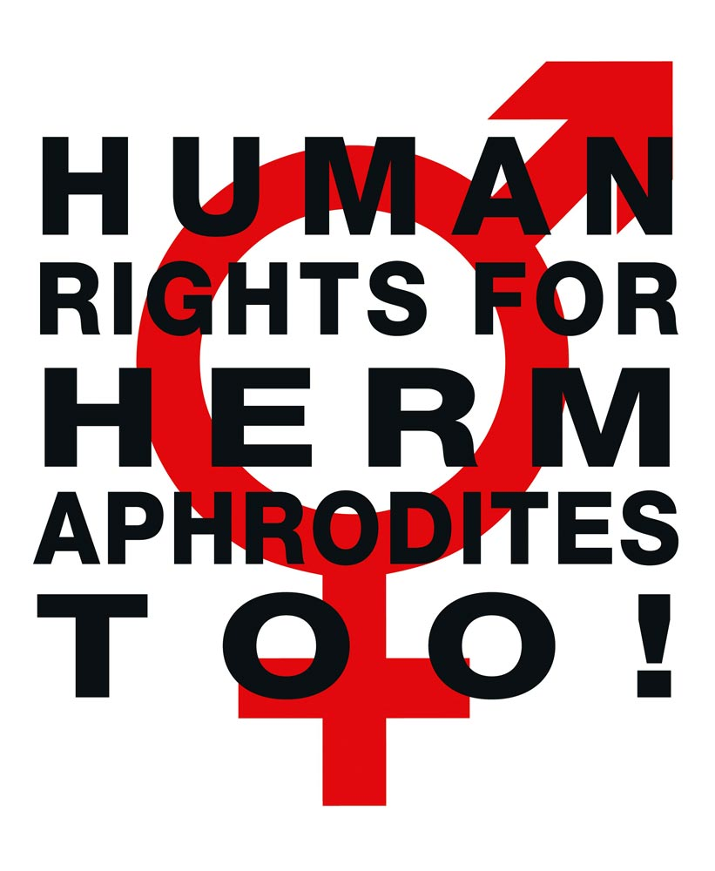

NGO Report (for Session)
to the 2nd and 3rd Periodic Report of Austria on the
Convention on the Rights of Persons with Disabilities
(CRPD)
Compiled by:

StopIGM.org / Zwischengeschlecht.org (International Intersex Human Rights NGO)
Markus Bauer, Daniela Truffer
Zwischengeschlecht.org
P.O.Box 1318
CH-8031 Zurich
info_at_zwischengeschlecht.org
https://Zwischengeschlecht.org/
https://StopIGM.org

August 2023

This NGO Report online:
DOCX: https://intersex.shadowreport.org/public/2023-CRPD-Austria-NGO-Intersex-StopIGM.docx
PDF: https://intersex.shadowreport.org/public/2023-CRPD-Austria-NGO-Intersex-StopIGM.pdf

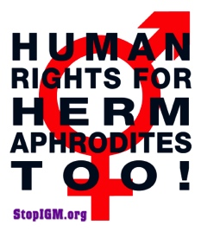

Executive Summary
All typical forms of IGM practices are still widespread in Austria today, facilitated and paid for by the State party via the public health care system, and practiced with impunity. Survivors of IGM continue to be denied access to justice and reparations due to lack of effective legal prohibition and the statutes of limitations.
Austria is thus in breach of its obligations to (a) take effective legislative, administrative, judicial or other measures to prevent involuntary, non-urgent genital surgery and other harmful medical treatment of intersex children, (b) to ensure access to justice, redress, compensation and rehabilitation for victims, and c) to provide families with intersex children with adequate psychosocial and peer support (art. 17).
CAT and CRC have already considered IGM in Austria as constituting inhuman treatment and a harmful practice. Nonetheless, to this day the Austrian Government fails to act.
This Committee has repeatedly recognised IGM as a serious violation in Concluding observations, LOIs and General Comments. IGM practices in Austria constitute the same or similar violations as those previously specified and addressed by CRPD.
In total, UN treaty bodies CRPD, CRC, CEDAW, CAT and CCPR have so far issued 83 Concluding Observations recognising IGM as a serious violation of non-derogable human rights, typically obliging State parties to enact legislation to (a) end the practice and (b) ensure redress and compensation, plus (c) access to free counselling. Also, the UN Special Rapporteurs on Torture (SRT) and on Health (SRH), the UN High Commissioner for Human Rights (UNHCHR), the World Health Organisation (WHO), the Inter-American Commission on Human Rights (IACHR), the African Commission on Human and Peoples’ Rights (ACHPR) and the Council of Europe (COE) recognise IGM as a serious violation of non-derogable human rights.
Intersex people are born with Variations of Reproductive Anatomy, including atypical genitals, atypical sex hormone producing organs, atypical response to sex hormones, atypical genetic make-up, atypical secondary sex markers. While intersex people may face several problems, in the “developed world” the most pressing are the ongoing Intersex Genital Mutilations, which present a distinct and unique issue constituting significant human rights violations.
IGM practices include non-consensual, medically unnecessary, irreversible, cosmetic genital surgeries, and/or other harmful medical procedures that would not be considered for “normal” children, without evidence of benefit for the children concerned. Typical forms of IGM include “masculinising” and “feminising”, “corrective” genital surgery, sterilising procedures, imposition of hormones, forced genital exams, vaginal dilations, medical display, involuntary human experimentation and denial of needed health care.
IGM practices cause known lifelong severe physical and mental pain and suffering, including loss or impairment of sexual sensation, painful scarring, painful intercourse, incontinence, urethral strictures, impairment or loss of reproductive capabilities, lifelong dependency of artificial hormones, significantly elevated rates of self-harming behaviour and suicidal tendencies, lifelong mental suffering and trauma, increased sexual anxieties, and less sexual activity.
For 30 years, intersex people have denounced IGM as harmful and traumatising, as western genital mutilation, as child sexual abuse and torture, and called for remedies.
This Thematic NGO Report was compiled by the international intersex NGO Zwischengeschlecht.org / StopIGM.org. It contains Suggested Recommendations (p. 17).
NGO Report (for Session) to the 2nd and 3rd Periodic Report of Austria
on the Convention on the Rights of Persons with Disabilities (CRPD)

Table of Contents

IGM Practices in Austria

Executive Summary 3
A. Introduction 5
1. Intersex, IGM and Human Rights in Austria 5
2. About the Rapporteurs 5
3. Methodology 6
B. Precedents: Concl Obs, UPR, LOIPR, State Party Report 7
1. Previous Concluding Observations 7
a) Inhuman Treatment: CAT 2015 (CAT/C/AUT/CO/6, paras 44–45) 7
b) Harmful Practices: CRC 2020 (CRC/C/AUT/CO/5-6, para 27(a)-(b)) 7
2. Universal Periodical Review (UPR) 8
a) 2021 3rd Cycle Recommendations supported by Austria (A/HRC/47/12) 8
3. Current 2nd and 3rd CRPD Cycle: LOIPR and State Party Report 8
a) 2018 List of Issues (LOIPR) (CRPD/C/AUT/QPR/2-3, para 32-33) 8
b) 2023 State Party Report under LOIPR (CRPD/C/AUT/2-3, para 221) 8
C. IGM in Austria: State-sponsored and pervasive, Gov fails to act 9
1. Austria’s commitment to “protect intersex children”, “ensure accountability” 9
a) UNHRC45 Statement, 01.10.2020 9
b) UNHRC48 Statement, 04.10.2021 9
2. Most Common IGM Forms advocated and perpetrated by Austria 9
a) IGM 3 – Sterilising Procedures: Castration / “Gonadectomy” / Hysterectomy 10
b) IGM 2 – “Feminising Procedures”: Clitoris Amputation/“Reduction”, “Vaginoplasty” 10
c) IGM 1 – “Masculinising Surgery”: Hypospadias “Repair” 12
3. Ministerial “DSD Guidelines” allowing IGM doctors to continue with impunity 14
4. Legal prohibition of IGM stalled by Coalition Government 15
D. Suggested Recommendations 17
Annexe 1 – Intersex as “Invalidity”: Historical Medical Examples 18
1916–1950s: “Intersex = bastardisation” caused by “racial mixing” 18
Baltimore and Zurich 1950: Start of systematic “genital corrections” 19

A. Introduction

1. Intersex, IGM and Human Rights in Austria
Austria has been reviewed by CAT (2015) and CRC (2020) with both Committees recognising IGM in Austria as constituting a harmful practice and cruel, inhuman or degrading treatment or torture.
IGM practices were mentioned in the LOIPR (para 32). In its State Party Report the Austrian Government indirectly admitted that “[s]erious interventions” continue to be performed on intersex children too young to give informed consent, however, the State Party typically tried to evade the actual topic at hand by repeatedly shifting the focus to “gender” issues and “establish[ing] a specific gender” instead (see also our NGO Report for LOIPR, p. 9). What’s more, the State Party conveniently failed to give any answers at all regarding whether intersex children are still considered and treated as “abnormal” children with disabilities (see Annexe 1, p. 18, and NGO Report for LOIPR, p. 7), as well as regarding the Committee’s question on data on IGM practices (para 221).
To this day, Austria continues to deny the serious nature of the violations constituted by IGM practices, and refuses to take effective legislative, administrative, judicial or other measures, including prohibition under Criminal Law, to protect intersex children from harmful practices and cruel, inhuman or degrading treatment.
This NGO Report demonstrates that the persisting harmful medical practice on intersex persons in Austria – advocated, facilitated and paid for by the State party, and practiced with impunity –, as well as the ongoing denial of access to justice and reparations for IGM survivors, constitute serious breaches of Austria’s obligations under the Convention.

2. About the Rapporteurs
This NGO report has been prepared by the international intersex NGO StopIGM.org / Zwischengeschlecht.org:
- StopIGM.org / Zwischengeschlecht.org is an international intersex human rights NGO based in Switzerland, working to end IGM practices and other human rights violations perpetrated on intersex people, according to its motto, “Human Rights for Hermaphrodites, too!” According to its charter, StopIGM.org works to support persons concerned seeking redress and justice and regularly reports to relevant UN treaty bodies, often in collaboration with local intersex advocates and NGOs, substantially contributing to the so far 83 Treaty body Concluding Observations recognising IGM as a serious human rights violation.
StopIGM.org has been active in Austria since 2011, documenting the ongoing practice, publicly confronting individual perpetrators and hospitals, has been consulted by the CRC NHRI Child and Youth Advocates Austria (KIJOE), supporting IGM survivors to testify at the UN, and has previously reported on IGM in Austria to CAT in 2015 (in collaboration with VIMÖ – Verein Intergeschlechtlicher Menschen Österreich), to CRPD and CEDAW in 2018, and to CRC in 2019.
The Rapporteurs would like to acknowledge the work of pioneering Austrian intersex advocate and IGM survivor Alex Jürgen. And we would like to acknowledge the work of the Austrian Intersex NGO VIMÖ – Verein Intergeschlechtlicher Menschen Österreich, and the work of the Austrian NGO Plattform Intersex.

3. Methodology
This thematic NGO report is an update to the 2018 CRPD NGO Report for LOIPR by the same Rapporteurs.

B. Precedents: Concl Obs, UPR, LOIPR, State Party Report
1. Previous Concluding Observations
a) Inhuman Treatment: CAT 2015 (CAT/C/AUT/CO/6, paras 44–45)
Intersex persons
44. The Committee appreciates the assurances provided by the delegation that surgical interventions on intersex children are carried out only when necessary, following medical and psychological opinions. It remains concerned, however, about reports of cases of unnecessary surgery and other medical treatment with lifelong consequences to which intersex children have been subjected without their informed consent. The Committee is further concerned at the lack of legal provisions providing redress and rehabilitation in such cases (arts. 14 and 16).
45. The State party should:
(a) Take the legislative, administrative and other measures necessary to guarantee the respect for the physical integrity and autonomy of intersex persons and to ensure that no one is subjected during infancy or childhood to non-urgent medical or surgical procedures intended to decide the sex of the child;
(b) Guarantee impartial counselling services for all intersex children and their parents, so as to inform them of the consequences of unnecessary and non-urgent surgery and other medical treatment to decide on the sex of the child and the possibility of postponing any decision on such treatment or surgery until the persons concerned can decide by themselves;
(c) Guarantee that full, free and informed consent is ensured in connection with medical and surgical treatments for intersex persons and that non-urgent, irreversible medical interventions are postponed until a child is sufficiently mature to participate in decision-making and give effective consent;
(d) Undertake investigation of instances of surgical interventions or other medical procedures performed on intersex persons without effective consent and ensure that the persons concerned are adequately compensated.

b) Harmful Practices: CRC 2020 (CRC/C/AUT/CO/5-6, para 27(a)-(b))
Harmful practices
27. With reference to joint general recommendation No. 31 of the Committee on the Elimination of Discrimination against Women/general comment No. 18 of the Committee on the Rights of the Child (2014) on harmful practices and recalling the concluding observations of the Committee against Torture (CAT/C/AUT/CO/6 para. 45) the Committee recommends that the State party:
(a) Prohibit the performance of unnecessary medical or surgical treatment on intersex children where those procedures may be safely deferred until children are able to provide their informed consent;
(b) Gather data with a view to understanding the extent of these harmful practices so that children at risk can be more easily identified and their abuse prevented;
2. Universal Periodical Review (UPR)
a) 2021 3rd Cycle Recommendations supported by Austria (A/HRC/47/12)
139.128 Strengthen the legislative framework to expressly prohibit any practice that modifies a person’s sexual characteristics without well-founded medical reasons or without the full consent of that person (Uruguay);
139.130 End harmful practices, including forced and coercive medical interventions, to ensure the bodily integrity of children with intersex variations (Iceland);
139.131 Prohibit any practice that modifies a person’s sex characteristics without irrefutable medical reasons and the full and informed consent of the person affected (Malta);

3. Current 2nd and 3rd CRPD Cycle: LOIPR and State Party Report
a) 2018 List of Issues (LOIPR) (CRPD/C/AUT/QPR/2-3, para 32-33)
Freedom from torture or cruel, inhuman or degrading treatment or punishment (art. 15)
[...]
32. Please indicate whether intersex children are treated as children with disabilities and if surgery continues to be performed on these children in the State party. If so, please provide data on the number of children who have undergone surgery since the the review of the initial report.
33. Please provide information on measures taken to implement the recommendations relating to persons with disabilities made by the Committee against Torture in 2015 (CAT/C/AUT/CO/6).

b) 2023 State Party Report under LOIPR (CRPD/C/AUT/2-3, para 221)
Reply to paragraph 32 of the list of issues prior to reporting
221. Divergences in the development of gender are based on a multitude of different causes, due to which a person cannot be genetically and/or anatomically clearly identified as being female or male. These persons are supported by multi-disciplinary teams at specialised facilities. Serious interventions in order to establish a specific gender are, as far as possible, delayed until the person affected has reached an age when their understanding of and insight into the situation are well developed.

C. IGM in Austria: State-sponsored and pervasive, Gov fails to act
1. Austria’s commitment to “protect intersex children from violence and harmful practices”, “investigate abuses”, “ensure accountability” and “access to remedy”
a) UNHRC45 Statement, 01.10.2020
On occasion of the 45th Session of the Human Rights Council the State party initiated a public “Joint Statement led by Austria on the Rights of Intersex Persons” calling to “protect […] intersex adults and children […] so that they live free from violence and harmful practices. Governments should investigate human rights violations and abuses against intersex people, ensure accountability, […] and provide victims with access to remedy.”
b) UNHRC48 Statement, 04.10.2021
On occasion of the 48th Session of the Human Rights Council the State party supported a public follow-up statement reiterating the call to end harmful practices and ensure access to justice:
“Intersex persons also need to be protected from violence and States must ensure accountability for these acts. […]
Furthermore, there is also a need to take measures to protect the autonomy of intersex children and adults and their rights to health and to physical and mental integrity so that they live free from violence and harmful practices. Medically unnecessary surgeries, hormonal treatments and other invasive or irreversible non-vital medical procedures without their free, prior, full and informed consent are harmful to the full enjoyment of the human rights of intersex persons.
We call on all member states to take measures to combat violence and discrimination against intersex persons, develop policies in close consultations with those affected, ensure accountability, reverse discriminatory laws and provide victims with access to remedy.”
2. Most Common IGM Forms advocated and perpetrated by Austria
Despite Austria’s repeated pledges to end IGM, to this day, in Austria all forms of IGM practices remain widespread and ongoing, persistently advocated, prescribed and perpetrated by the state funded University Hospitals, and paid for by the State via the public health system.

Currently practiced forms of IGM in Austria include:
a) IGM 3 – Sterilising Procedures:
Castration / “Gonadectomy” / Hysterectomy /
Removal of “Discordant Reproductive Structures” / (Secondary) Sterilisation
Plus arbitrary imposition of hormones
The Austrian Urological Society (Österreichische Gesellschaft für Urologie und Andrologie, ÖGU) endorses the 2023 Guidelines of the European Association of Urology (EAU), which include the current ESPU/EAU “Paediatric Urology” Guidelines 2023 of the European Society for Paediatric Urology (ESPU) and the European Association of Urology (EAU), chaired by Innsbruck paediatric urology head surgeon Prof Dr Christian Radmayr, which stress:
“The issue of whether gonads should be removed and the timining [sic] of such surgery remains controversial and has been altogether questioned in some forms of DSD. Patients with, for example, CAIS benefit from the presence of testicles and the resultant aromatisation of the naturally occuring testosterone to oestrogens. The risk of malignant gonadal transformation in this subcategory is low (1.5%) with cases of malignancy first appearing after the second decade of life, thus allowing for the safe deferal of gonadectomy until after puberty [1248, 1249].”
Further, regarding “whether and when to pursue gonadal or genital surgery”, the Guidelines refer to the “ESPU/SPU standpoint on the surgical management of Disorders of Sex Development (DSD)”, which advocates “gonadectomies”:
“Testes are either brought down in boys or removed if dysgenetic with tumour risk or in complete androgen insensitivity syndrome or 5 alpha reductase deficiency. Testicular prostheses can be inserted at puberty at the patient’s request.”
b) IGM 2 – “Feminising Procedures”: Clitoris Amputation/“Reduction”,
“Vaginoplasty”, “Labiaplasty”, Dilation
The Austrian Urological Society (Österreichische Gesellschaft für Urologie und Andrologie, ÖGU) endorses the 2023 Guidelines of the European Association of Urology (EAU), which include the current ESPU/EAU “Paediatric Urology” Guidelines 2023 of the European Society for Paediatric Urology (ESPU) and the European Association of Urology (EAU), chaired by Innsbruck paediatric urology head surgeon Prof Dr Christian Radmayr. In chapter 3.17 “Disorders of sex development”, despite admitting that “Surgery that alters appearance is not urgent” and that “adverse outcomes have led to recommendations to delay unnecessary [clitoral] surgery to an age when the patient can give informed consent”, the ESPU/EAU Guidelines nonetheless explicitly refuse to postpone non-emergency surgery, but in contrary insist to continue with non-emergency genital surgery (including partial clitoris amputation) on young children based on “social and emotional conditions” and substituted decision-making by “parents and caregivers implicitly act[ing] in the best interest of their children” and making “well-informed decisions […] on their behalf”, and further explicitly refusing “prohibition regulations” of unnecessary early surgery, referring to the 2018 ESPU Open Letter to the Council of Europe (COE), which further invokes parents’ “social, and cultural considerations” as justifications for early surgery (p. 2).
Notably, some Austrian IGM doctors publicly claim to have abandoned IGM 2 (however, they conveniently continue to refuse to disclose relevant statistics, same as the State Party Report), for example in an October 2019 news report based on an interview with Vienna IGM doctor Stefan Riedl:
“In the past, interventions were carried out as soon as possible, today a reconsideration has taken place in medicine and irreversible interventions are avoided as far as possible, according to medical experts last week at the European Congress for Paediatric Endocrinology in Vienna. […]
‘In all other cases [i.e. IGM 2] – based on the right to physical integrity – the patient is allowed as much time as possible until puberty or later,’ explains Riedl. If the prospective teenager is not yet sure of his or her gender identity when puberty sets in, it is also possible to delay puberty by administering hormone blockers.”
However, such unsubstantiated claims fly in the face of recent statistics presented by another Vienna IGM doctor at the September 2019 “European Congress for Paediatric Endocrinology” in Vienna mentioned in above quote (i.e. the 58th Annual Meeting of the European Society for Paediatric Endocrinology ESPE):
“Genital surgery has been performed in 251 (76%). Clitoral surgery been performed in 231 (92%), vaginal surgery in 204 (81%) and a combination of clitoral and vaginal surgery had been performed in 186 (74%). Of the 251 who had surgery, 18 (7%) had vaginal but no clitoral surgery whilst 42 (17%) had clitoral but no vaginal surgery. Mean age at first surgery was 2.5 years (0-15), with clitoral surgery and vaginal surgery at 2.6 years (range) and 3.2 years (range), respectively. […] The Chicago Consensus Statement on DSD (comparison of data before and after 2006) did not have any significant influence on the timing or probability of surgery.”
What’s more, Riedl’s unsubstantiated claims fly in the face of a survey presented by Riedl himself and fellow Vienna IGM doctor Alexander Springer, documenting preference for early “clitoral surgery” by IGM doctors much in line with above ESPE statistics:
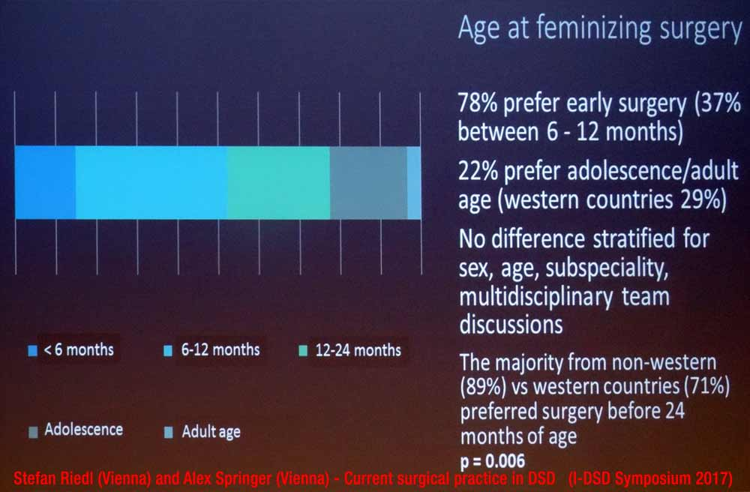
c) IGM 1 – “Masculinising Surgery”: Hypospadias “Repair”
The Austrian Urological Society (Österreichische Gesellschaft für Urologie und Andrologie, ÖGU) endorses the 2023 Guidelines of the European Association of Urology (EAU), which include the current ESPU/EAU “Paediatric Urology” Guidelines 2023 of the European Society for Paediatric Urology (ESPU) and the European Association of Urology (EAU), chaired by Innsbruck paediatric urology head surgeon Prof Dr Christian Radmayr. In chapter 3.6 “Hypospadias”, the ESPU/EAU Guidelines’ section 3.6.5.3 “Age at surgery” explicitly promotes, “The age at surgery for primary hypospadias repair is usually 6-18 (24) months.” – despite admitting to the “risk of complications” and “aesthetic[…]” and “cosmetic” justifications.
To this day, Austrian University Clinics still promote “early surgical correction” “around the 1st year of life”.
In addition, a 2019 medical article by IGM doctors from the Departments of Pediatric Surgery and Urology of the Medical University Vienna promotes even more experimental “surgical techniques”, and further offers revealing insights on the frequency of IGM 1 and the harmful consequences:
“Materials and Methods: This is a consecutive single team (2 surgeons) retrospective series. Between 2014 and 2017, 250 patients underwent hypospadias repair […]. Median age at first stage was 1.5 (0.5–22.1) years […].
Results: The total complication rate was 22.9%. […]”
This continued preference for “early surgical correction” is also in line with a previous survey presented by partly the same Vienna IGM doctors:
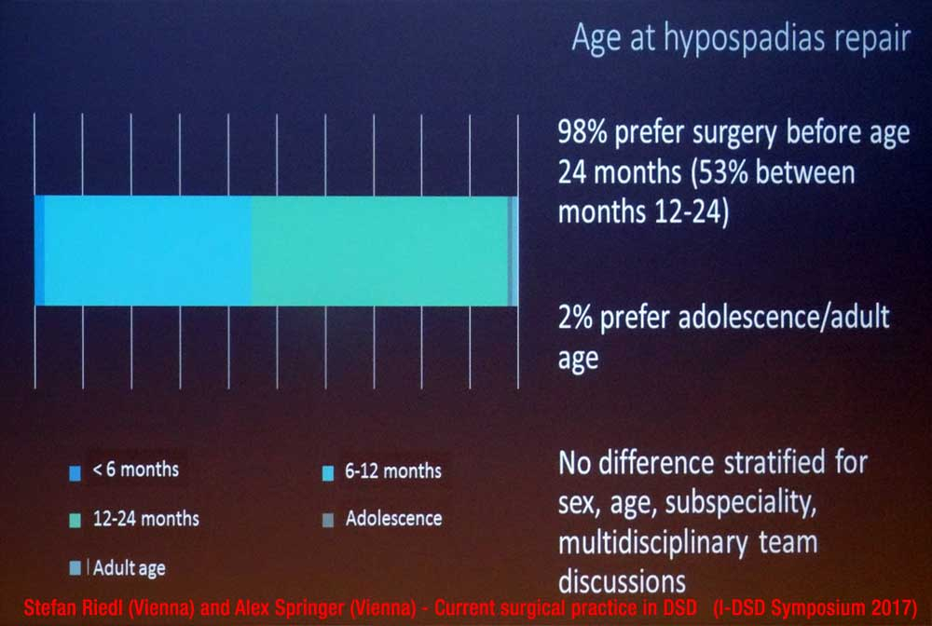
And it is further confirmed in the October 2019 news report based on an interview again with Vienna IGM doctor Stefan Riedl:
“certain cases are treated early – in addition to medically necessary hormone treatment, these include hypospadias repair or the removal of functionless gonads”
3. Ministerial “DSD Guidelines” allowing IGM doctors to continue with impunity
As documented in our Report for LOIPR (p. 10), an alarming new trend is the increasing misrepresentation of IGM as “health-care issue” instead of a serious violation of non-derogable human rights, and the promotion of “self-regulation” of IGM by the current perpetrators (i.e. IGM doctors, Health Ministries and other related actors and bodies) – instead of effective measures to finally end IGM practices.
Unfortunately, this has now also been the case in Austria:
Without public announcement, in September 2019 the Ministry of Health published on its homepage a longwinded, 95-page “Medical DSD Guideline”. While its title “Recommendations on variations of sex development” clearly alludes to the vastly superior (and much more to the point) 2012 Swiss Bioethic Recommendations which support prohibition of IGM under criminal law and to address obstacles to access to justice, namely the statutes of limitations, and further the Ministry has to be commended to have also consulted with Austrian intersex advocates, unfortunately, it has to be clearly said that in the end the Ministry sided with the IGM doctors and failed to support the demands of intersex people.
Tellingly, while the “Guideline” contains a 9-page section “5 Legal basis for variations of sex development” (p. 20-28) which even mentions the “prohibition of torture (Art. 3 ECHR)” (p. 20) and “the possible [!] right to redress after interventions that have subsequently turned out to be severely traumatising and restricting the quality of life” (p. 19), it conveniently fails to refer to the 2015 CAT Concluding Observations to Austria on intersex and IGM (CAT/C/AUT/CO/6, paras 44-45), let alone to the Convention on the Rights of the Child, and/or protection from harmful practices.
What’s more, the “Guideline” again repeats the already above mentioned, unsubstantiated claims of “considerable change” in the medical practice “in recent decades” (p. 23).
Accordingly, Austrian intersex advocates have clearly and officially “criticise[d] double standards” of the “Guideline”:
“A definite refusal of non-consensual and medically unnecessary treatments is missing here [i.e. within the “Guideline”] and there [i.e. in recent unsubstantiated public claims of “change” by IGM doctors, see above], and so these continue to be carried out.”
Namely, Platform Intersex Austria (PIÖ) legal expert Eva Matt further observed:
“The problem is that the various contributions in the paper partly contradict each other strongly. In everyday medical practice, very different therapy plans can be justified by this paper. There is no legal security for the physical autonomy of intersex people.”
And Association of intersex people Austria (VIMÖ) member Tinou Ponzer stated:
“For twenty years, medical guidelines have spoken of a restrictive approach to surgery and of involving self-help groups. Unfortunately, in the peer support we have to find out again and again that this is not yet the case in practice in 2019.”
Nonetheless, it has to be expected that Austrian Government representatives will still claim “we have now this wonderful new Guideline and everything is well” – while at the same time refusing to disclose data on the actual current practice in Austria (as evidenced in the State Party Report), let alone to finally take effective measures against harmful practices on intersex children, namely by criminalising the practice and to address obstacles to access to justice and redress, namely the statutes of limitations (see below).
4. Legal prohibition of IGM stalled by Coalition Government
On 09.06.2021, the Equal Treatment Committee of Austria’s Parliament unanimously adopted the Motion for a Resolution 1594/A(E) “Protection of intersex children and adolescents from medically unnecessary treatment of their sexual characteristics”, further calling on the Government to disclose data on surgery and other treatments on intersex children to the Parliament. On 16.06.2021, the National Council supported the Motion (183/E XXVII. GP). Both steps have been warmly welcomed by Austrian intersex NGO VIMÖ and allies.
These preliminary steps to prohibit IGM practices were also duly noted by Austrian IGM doctors.
However, to this day no corresponding Draft Law has materialised. Also, so far the Government failed to disclose the demanded data on surgery on intersex children (same as in the State Party Report). According to media reports, a Bill has been drafted, but has been stalled for more than half a year now within the Coalition Government.
In order to urge the Government to finally put forward a Draft Law, on 17.05.2023 the intersex NGO VIMÖ submitted an Open Letter co-signed by 73 Austrian NGOs.
In addition, on 14.06.2023 the Austrian intersex NGO VIMÖ submitted a Petition with currently 7’482 signatories to the Austrian Government on occasion of a peaceful protest, again urging the Government to advance a Draft Law.
However, so far, still no Draft Law has materialised.
There we would like to again urge the Committee to address IGM practices in Austria in the forthcoming 29th Session, and to sternly remind Austria of its obligations under the Convention to adequately protect intersex children against IGM practices and inhuman treatment (see next page).

D. Suggested Recommendations

The Rapporteurs respectfully suggest that, with respect to the treatment of intersex persons in Austria, the Committee includes the following measures in their recommendations to the Austrian Government:

Intersex Genital Mutilation
While welcoming Parliamentary Motions to protect intersex children, the Committee remains seriously concerned about cases of medically unnecessary and irreversible surgery and other treatment on intersex children without their informed consent, which can cause severe suffering, and the lack of legal protections, redress and compensation in such cases.
The Committee recommends that the State party (Articles 15 and 17):
Adopt clear legislative provisions that explicitly prohibit the performance of unnecessary and irreversible medical interventions, including surgical, hormonal or other medical procedures, on intersex infants and children; provide adequate counselling and support for families of intersex children; extend the statute of limitations to enable criminal and civil remedies; and provide health care and psychosocial support to intersex persons who have been subjected to intersex genital mutilation.
Systematically collect data on the number of irreversible surgical and other procedures that are performed on intersex children, disaggregated by age, type of intervention, and geographic location.
Annexe 1 – Intersex as “Invalidity”: Historical Medical Examples

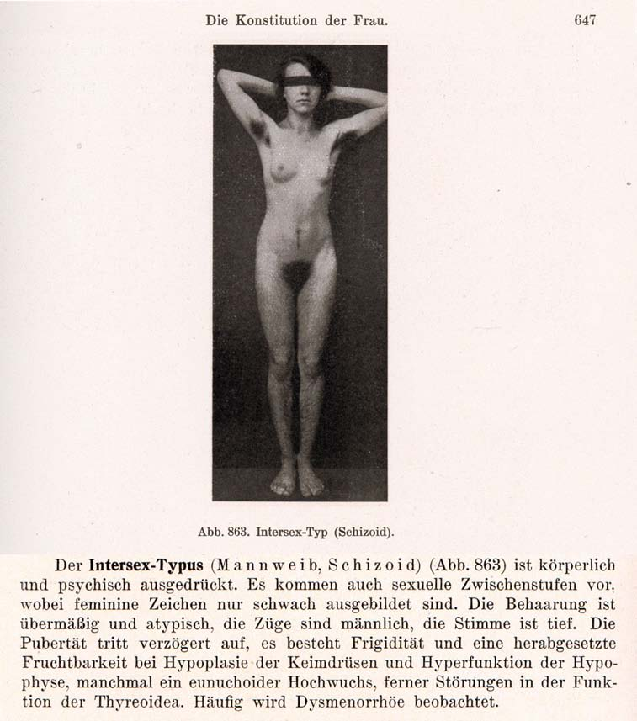
1916–1950s: “Intersex = bastardisation” caused by “racial mixing”;
racist gynaecological diagnosis “intersexual constitution”
The German geneticist Richard Goldschmidt (1878–1958) coined the terms “Intersex” and “Intersexuality” when publicising his experiments of crossbreeding “different geographic races” of gypsy moths, claiming to be able to produce “hermaphroditic” a.k.a. “intersex” specimens of any grade and shape at will, and thereafter extrapolating his findings to humans. Of Jewish descent, in 1936 Goldschmidt was forced to resign as director of the “Kaiser-Wilhelm-Institut für Biologie” in Berlin and emigrated to the United States. Despite Goldschmidt downplaying the “racial” background of his findings since the early 1930’s and later renouncing the underlying genetic theories altogether, the term “Intersex” and its “racial” implications prevailed. In 1924 the gynaecologists Paul Mathes (1871-1923, Austria) and Hans Guggisberg (180-1977, Switzerland) introduced the derived diagnosis “Intersexual Constitution” into human medicine, allegedly caused by “racial mixing”, “most frequent in Jews” and associated with “biological inferiority”, mental illnesses (see above “schizoid”), “hypertrophied clitoris” and a strict verdict “not fit for marriage.” It proved particularly popular among prominent eugenicists and Nazi doctors, including Fritz Lenz, Hans Naujoks, Lothar Gottlieb Tirala, Robert Stigler, Wilhelm Weibel, Walther Stoeckel, and kept being used in medical publications until the 1950s.
Sources: Wilhelm Weibel: Lehrbuch der Frauenheilkunde, 7th ed., Berlin/Wien 1944 p. 647 (photo), 648 (text).
Richard Goldschmidt: “Die biologischen Grundlagen der konträren Sexualität und des Hermaphroditismus beim Menschen”, in: Archiv für Rassen- und Gesellschaftsbiologie 12, 1916.
Paul Mathes, Hans Guggisberg: “Die Konstitutionstypen des Weibes, insbesondere der intersexuelle Typus”, in: Josef Halban, Ludwig Seitz: Biologie und Pathologie des Weibes. Bd.3, 1924.
Helga Satzinger: Racial Purity, Stable Genes, and Sex Difference: Gender in the Making of Genetic Concepts by Richard Goldschmidt and Fritz Lenz, 1916 to 1936. In: Heim et al. (ed.), The Kaiser Wilhelm Society under National Socialism, 2009.
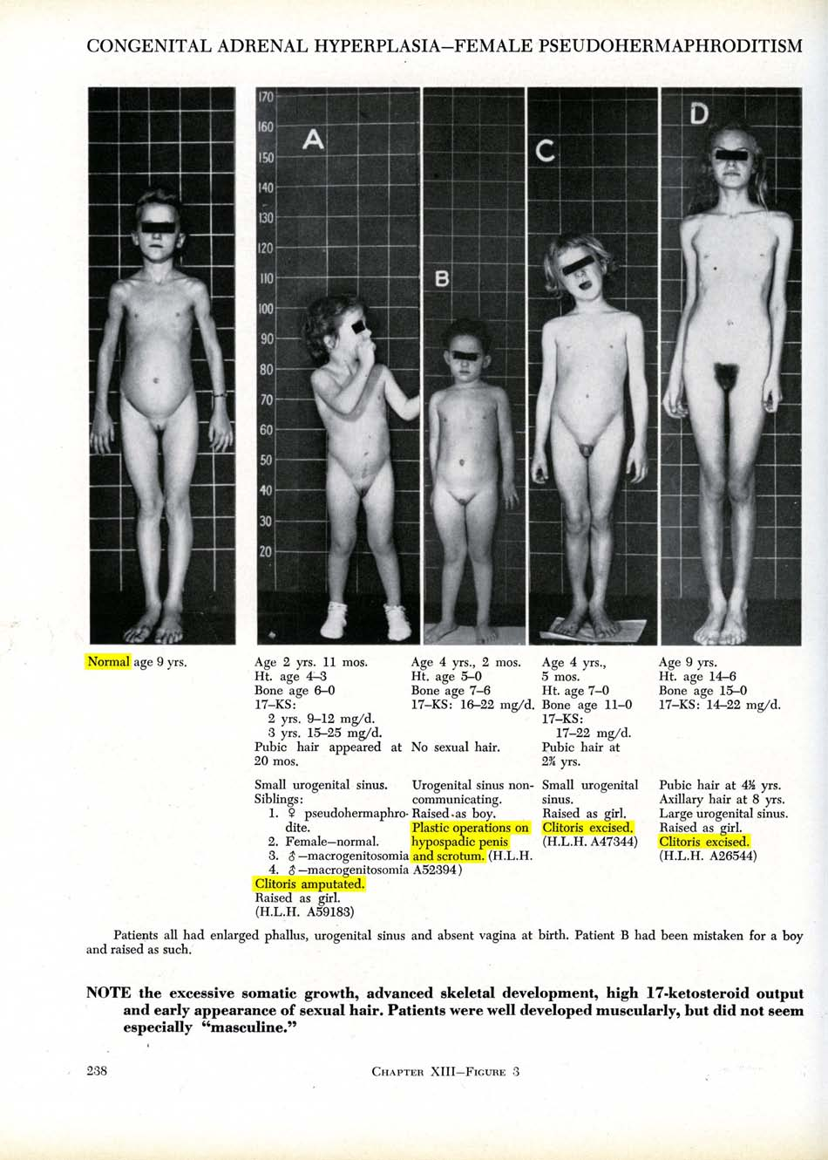
Baltimore and Zurich 1950: Start of systematic “genital corrections”
Lawson Wilkins (1894-1963), “The Father of Pediatric Endocrinology”, and teacher of the famous Swiss paediatric endocrinologist Andrea Prader in 1950, who then introduced the practice in Europe, was also the “inventor” of systematic cosmetic genital surgeries on children. As Wilkins’s monograph illustrates, in 1950 at Johns Hopkins in Baltimore, any child diagnosed “not normal” was submitted to drastic “genital corrections”, either “feminising” or “masculinising”. Often the psychologist John Money gets erroneously credited as having “invented” the systematic mutilations, however, it was Wilkins (and Prader) who started systematic surgeries; Money “only” delivered a “scientific rationale” five years after the fact.
Sources: Lawson Wilkins: The Diagnosis and Treatment of Endocrine Disorders in Childhood and Adolescence. Springfield, 1950.
Alison Redick: American History XY: The Medical Treatment of Intersex, 1916-1955, Dissertation 2004

https://Zwischengeschlecht.org/ English homepage: https://StopIGM.org
https://zwischengeschlecht.org/post/Statuten
https://intersex.shadowreport.org
https://stopigm.org/post/IAD-2016-Soon-20-UN-Reprimands-for-Intersex-Genital-Mutilations
https://www.interfaceproject.org/alex-jurgen
https://www.berlinale.de/external/programme/archive/pdf/20060735.pdf
https://www.austrianfilms.com/news/bodytintenfischalarm_ein_gespraech_mit_elisabeth_scharang_und_alex_juergenbody
http://www.m-media.or.at/gesellschaft/alex-jurgen-mein-korper-wurde-gebastelt/2013/11/05/index.html
https://www.tagblatt-wienerzeitung.at/nachrichten/chronik/oesterreich/700353_Ich-haette-gerne-wieder-was-sie-mir-weggeschnitten-haben.html
https://vimoe.at/
https://www.plattform-intersex.at/
https://intersex.shadowreport.org/public/2018-CRPD-LOIPR-Austria-NGO-Zwischengeschlecht-Intersex-IGM.pdf
Statement initiated by Austria (and supported by 34 other States) during the 45th Session of the Human Rights Council on 1 October 2020, https://www.dfat.gov.au/international-relations/themes/human-rights/hrc-statements/45th-session-human-rights-council/joint-statement-led-austria-rights-intersex-persons
Statement supported by Austria (and 52 other States) during the 48th Session of the Human Rights Council on 4 October 2021, https://www.bmeia.gv.at/oev-genf/speeches/alle/2021/10/united-nations-human-rights-council-48th-session-joint-statement-on-the-human-rights-of-intersex-persons/
For general information, see 2016 CEDAW NGO Report France, p. 47. https://intersex.shadowreport.org/public/2016-CEDAW-France-NGO-Zwischengeschlecht-Intersex-IGM.pdf
https://uroweb.org/guidelines/endorsement/
https://d56bochluxqnz.cloudfront.net/documents/full-guideline/EAU-Guidelines-on-Paediatric-Urology-2023.pdf
Ibid., p. 94
Ibid., p. 93
P. Mouriquand, A. Caldamone, P. Malone, J.D. Frank, P. Hoebeke, “The ESPU/SPU standpoint on the surgical management of Disorders of Sex Development (DSD)”, Journal of Pediatric Urology vol. 10, no. 1 (2014), p. 8-10, http://www.jpurol.com/article/S1477-5131(13)00313-6/pdf
For general information, see 2016 CEDAW NGO Report France, p. 48. https://intersex.shadowreport.org/public/2016-CEDAW-France-NGO-Zwischengeschlecht-Intersex-IGM.pdf
https://uroweb.org/guidelines/endorsement/
https://d56bochluxqnz.cloudfront.net/documents/full-guideline/EAU-Guidelines-on-Paediatric-Urology-2023.pdf
Ibid., p. 89
Ibid., p. 93
Ibid., p. 93
Ibid., p. 93
Ibid., p. 94
https://www.espu.org/images/documents/ESPU_Open_Letter_to_COE_2018-01-26.pdf
Der Standard (21.09.2019), “Geschlechterentwicklung: Was Ärzte tun, wenn ein Neugeborenes weder Mädchen noch Bub ist” (“Sex development: What doctors do when a newborn is neither a girl nor a boy”), https://www.derstandard.at/story/2000108887801/was-aerzte-tun-wenn-ein-neugeborenes-weder-maedchen-noch-bub
Doris Hebenstreit (Department of Urology, Hanusch Krankenhaus, Vienna), Faisal Ahmed, on behalf of the contributing centres within the I-DSD registry and I-CAH registry, Alexander Springer (Medical University Vienna), Christoph Krall, Nils Krone, Niels Birkebaek, Tatjana Milenkovic, Birgit Koehler, Christa Flueck, Ruth Krone, Antonio Balsamo, Rodolfo Rey, Carlo Acerini, Alya Guven, Tulay Guran, Feyza Darendeliler, Sabah Alvi, Marta Korbonits, Walter Bonfig, Eduardo Correa Costa, Richard Ross, Violeta Iotova, Daniel Konrad, Jillian Bryce, Hedi Claahsen van der Grinten, Liat de Vries, “Contemporary surgical approach in CAH 46XX – Results from the I-DSD/I-CAH Registries”, presentation at ESPE 2019, see Abstract Book, p. 96, https://www.karger.com/Article/Pdf/501868
Photo of presentation slide: Stefan Riedl (Vienna) and Alex[ander] Springer (Vienna) -Current surgical practice in DSD: results of the COST/DSDnet surgery survey, presentation at 6th I-DSD Symposium Copenhagen, 29.06.2017, see programme p. 5, https://web.archive.org/web/20191214214059/https://www.gla.ac.uk/media/Media_533778_smxx.pdf
For general information, see 2016 CEDAW NGO Report France, p. 48-49, https://intersex.shadowreport.org/public/2016-CEDAW-France-NGO-Zwischengeschlecht-Intersex-IGM.pdf
https://uroweb.org/guidelines/endorsement/
https://d56bochluxqnz.cloudfront.net/documents/full-guideline/EAU-Guidelines-on-Paediatric-Urology-2023.pdf
Ibid., p. 27
Ibid., p. 29
Ibid., p. 28
Ibid., p. 28
Vienna University Hospital for Paediatric and Adolescent Surgery, under “Paediatric Urology”, https://www.meduniwien.ac.at/hp/chirurgie/kinderchirurgie/patientinneninformationen/leistungen/
Ursula Tonnhofer, Manuela Hiess, Martin Metzelder, Doris Hebenstreit, and Alexander Springer (2019), “Midline Incision of a Graft in Staged Hypospadias Repair–Feasible and Durable?”, Frontiers in Pediatrics, 2019; 7: 60, p. 1, https://www.ncbi.nlm.nih.gov/pmc/articles/PMC6423900/pdf/fped-07-00060.pdf
Photo of presentation slide: Stefan Riedl (Vienna) and Alex[ander] Springer (Vienna) -Current surgical practice in DSD: results of the COST/DSDnet surgery survey, presentation at 6th I-DSD Symposium Copenhagen, 29.06.2017, see programme p. 5, https://web.archive.org/web/20191214214059/https://www.gla.ac.uk/media/Media_533778_smxx.pdf
Der Standard (21.09.2019), “Geschlechterentwicklung: Was Ärzte tun, wenn ein Neugeborenes weder Mädchen noch Bub ist” (“Sex development: What doctors do when a newborn is neither a girl nor a boy”), https://www.derstandard.at/story/2000108887801/was-aerzte-tun-wenn-ein-neugeborenes-weder-maedchen-noch-bub
Federal Ministry of Labour, Social Affairs, Health and Consumer Protection (2019), “Empfehlungen zu Varianten der Geschlechtsentwicklung” (“Recommendations on variations of sex development”), https://www.sozialministerium.at/dam/jcr:3e0dc44d-0464-42ed-ad1d-c3562ec8c873/empfehlungen_varianten_der_geschlechtsentwicklung.pdf
Swiss National Advisory Commission on Biomedical Ethics (NEK-CNE) (2012), Zum Umgang mit Varianten der Geschlechtsentwicklung. Ethische Fragen zur “Intersexualität” (“On the management of varations of sex development. Ethical issues relating to “intersex”), English version see https://www.nek-cne.admin.ch/inhalte/Themen/Stellungnahmen/en/NEK_Intersexualitaet_En.pdf
Ibid., see Recommendation 12, p. 19
“In recent decades, opinions about what is medically indicated in the case of a Variation of sex development and what is in the best interest of the child have changed considerably.”
Association of intersex people Austria (VIMÖ) (07.10.2019), Press release: “Gesundheitsministerium veröffentlicht Empfehlungen zu Varianten der Geschlechtsentwicklung” (“Ministry of Health publishes recommendations on variations of sex development”), https://www.ots.at/presseaussendung/OTS_20191007_OTS0140/gesundheitsministerium-veroeffentlicht-empfehlungen-zu-varianten-der-geschlechtsentwicklung
Ibid.
Ibid.
https://www.parlament.gv.at/dokument/XXVII/I/896/fnameorig_982576.html
https://www.parlament.gv.at/aktuelles/pk/jahr_2021/pk0692#XXVII_A_01594
https://www.parlament.gv.at/gegenstand/XXVII/A/1594
https://www.parlament.gv.at/dokument/XXVII/A/1594/imfname_971331.pdf
https://www.parlament.gv.at/gegenstand/XXVII/E/183
https://www.parlament.gv.at/dokument/XXVII/E/183/fnameorig_984853.html
https://vimoe.at/2021/06/09/juni-2021-parlament-fordert-regierung-auf-intergeschlechtliche-kinder-zu-schuetzen/
https://www.ots.at/presseaussendung/OTS_20210609_OTS0130/hosi-salzburg-genitalverstuemmelung-an-intergeschlechtlichen-menschen-stoppen
Springer A (2022), “56.9 Intersex-Gesetz in Österreich” (“Intersex Law in Austria”), presentation at 63rd Annual Meeting of the Austrian Society of Surgery, Eur Surg (2022) 54 :S1–S139, p. S90 (p. 90 in PDF), https://link.springer.com/content/pdf/10.1007/s10353-022-00763-x.pdf
“According to the answer to a parliamentary question by Justice Minister Alma Zadic (Greens) from April, a corresponding bill has been in political coordination since autumn 2022 and lies with the coalition partner ÖVP.”, news ORF.at (2023), “Gesetz zum Schutz intergeschlechtlicher Kinder gefordert” (“Law for the protection of intersex children called for”), 17.05.2023, https://orf.at/stories/3317021/
https://vimoe.at/2023/05/17/mai-2023-offener-brief-an-ministerinnen-zum-schutz-intergeschlechtlicher-kinder-und-jugendlicher/
https://vimoe.at/wp-content/uploads/2023/06/OffenerBriefMai2023.pdf
https://mein.aufstehn.at/petitions/schutzen-sie-intergeschlechtliche-kinder-und-jugendliche?source=homepage&utm_medium=promotion&utm_source=homepage
https://vimoe.at/2023/06/09/juni-2023-uebergabe-der-petition-am-14-06-2023-um-815-uhr-vor-dem-parlament/
https://vimoe.at/2023/06/14/juni-2023-vimoe-an-oevp-und-gruene-schuetzen-sie-endlich-intergeschlechtliche-kinder-und-jugendliche/

