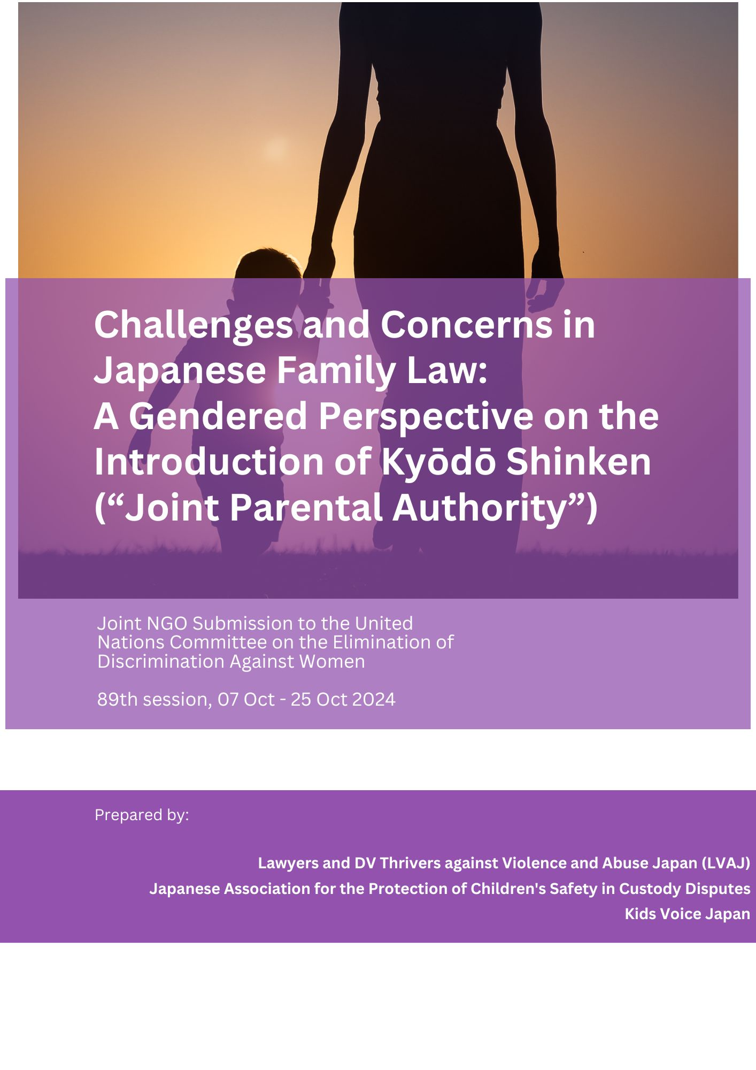

Contents

Introduction 3
1. Problems with the Introduction of a Kyōdō Shinken (“Joint Parental Authority”) after Divorce 3
2. Potential Serious Effects 4
3. Recommendations for the Japanese Government 4
4. Background 6
4-1 Gender Inequality, the Predominant Parenting Responsibilities of Women, Poverty among Single Mothers in Japan 6
4-3 International Misconceptions of the introduction of Japan’s Kyōdō Shinken (“Joint Parental Authority”) Law 7
4-4 Misconceptions about the Japanese Family Law System in the International Media 9
5. Recommendations Sought 10
5-1 Conducting a Survey on Post-Separation Abuse 11
5-2 Transition to Tandoku Shinken (“Sole Parental Authority”) Post-Divorce in Kyōdō Shinken (“Joint Parental Authority”) Cases 11
5-3 Thorough Investigation of the Legislative Process of the Amended Family Law 12
5-4 Measures Against DV 13
5-5 Urgent Measures to Ensure the Safety of DV Victims in Judicial Procedures and Prevent Coerced Agreements 15
5-6 Judicial Response to DV: Enhancing Training and Resources in Family Courts 16
5-7 Enhancing Law Enforcement and Judicial Intervention in DV Cases to Ensure Victim Safety 18
5-8 Equitable Property Division in Divorce Proceedings 19

Introduction
We present this argument to the 89th session of CEDAW, highlighting the current challenges faced by women in Japanese society, particularly in relation to domestic violence (DV) in intimate relationships and Japan's policy on post-divorce child rearing. In 2024, Japan amended its Family Law to introduce a system for kyōdō shinken (“joint parental authority”) post-divorce, is set to come into effect within two years.
We express grave concerns about this family law amendment, particularly regarding its potentially severe negative impact on mothers, who are predominantly the primary caregivers, and the majority of children they raise. Our concerns are grounded in the context of Japan's significant gender disparities, the challenging circumstances faced by women, and the insufficient measures against domestic violence and abuse. These points align with the issues highlighted by CEDAW, and we assess the amendment from the dual perspectives of promoting children’s healthy upbringing and realizing their best interests, as well as advancing gender equality. Terminology defined:
- Shinken (“parental authority”): Shinken encompasses a broad spectrum of parental rights and duties regarding childcare, education, legal representation, and the right to determine the child's place of residence and permit work.
- Kango (“custody”): This refers to the responsibility to raise the child.
As detailed below, a significant misunderstanding within the international community regarding the Japanese family law system arises from the mistranslation and misinterpretation of these terms and their associated legal concepts. We strongly urge CEDAW to consider recommendations based on an accurate understanding of shinken, kango, and parent-child visitation.
1. Problems with the Introduction of a Kyōdō Shinken (“Joint Parental Authority”) after Divorce
In 2024, Japan amended the Family Law provisions in the Civil Code to include a post-divorce kyōdō shinken (“joint parental authority) system and will come into effect within two years. This legal reform uses the term Shinken (“parental authority”), which covers a very wide range of powers, including the rights and duties of custody and education (Civil Code, Article 820), the right to designate residence (Article 822) permission of the work (Article 823), property management and representation (Article 824).
With the introduction of the legislation, if the parents have joint parental authority after divorce, they must make many important decisions concerning the child—such as residence, choice of school, and medical treatment—jointly. Although in “urgent cases” and “day-to-day care and education,” a parent with joint parental authority can decide independently, we are deeply concerned that the vagueness of the provisions regarding joint decision-making may lead to deadlocks in decision-making or provoke harassment by a former spouse.
The 2024 amendment to include kyōdō shinken (“joint parental authority”), resulted from strong lobbying and public opinion building. Although there is a legal procedure to allow visitation between non-resident parents and their children after divorce, such lobbying to promote kyōdō shinken was carried out primarily by groups consisting mainly of non-resident parents, including those who, for one reason or another, are restricted by the courts from interacting with their children and used the revision as a means to restore contact. Despite the fact that in many Western countries post-divorce parenting laws have recently been reconsidered due to concerns about the safety of children and resident parents, Japan revised its law to introduce kyōdō shinken.

2. Potential Serious Effects
The introduction of the kyōdō shinken (“joint parental authority”) system could have several severe consequences:
(1) Post-Separation Abuse May Worsen and Increase Dramatically: The application of kyōdō shinken in cases involving DV, power imbalances, or other forms of abuse could escalate tensions and conflict between non-resident parents, exacerbating existing abuse.
(2) Inappropriate Application of Kyōdō Shinken: The system may be applied in cases where it is not appropriate, such as relationships with unequal power dynamics, various forms of DV and abuse, forcing one party into unwanted choices.
(3) Barriers to Separation or Escape: Victims of DV and abuse may find it increasingly difficult to separate from or escape their abusers.
(4) Increase in Harassment through Legal Complaints: There could be a rise in unjustifiable complaints and lawsuits used as a form of harassment, causing further damage due to the courts' lack of understanding of DV and abuse.

3. Recommendations for the Japanese Government
(1) Research the Actual Situation of Post-Separation Abuse (PSA): The Japanese government should conduct a thorough investigation into the reality of PSA and develop measures based on the findings.
(2) Facilitate Transition to Tandoku Shinken (“sole parental authority”): Measures should be taken to ensure a smooth transition to tandoku shinken in cases where kyōdō shinken(“joint parental authority”) is inappropriate.
(3) Expand Support for DV Victims: the court's decisions should prioritize the safety and well-being of the child and the resident parent above all else. Legal frameworks must ensure that any contact or visitation arrangements do not expose victims to further harm or coercion. Additionally, public measures to support the safe implementation of visitation rights should be expanded.
(4) Strengthen Measures Against DV
a. Promptly Amend the Law: The law should be amended to make DV a criminal offense or impose more severe penalties for criminal cases involving DV.
b. Enhance Victim Protection in Shelters: Improve the protection of victims in shelters.
c. Support Victims After Leaving Shelters: Provide financial and social support to help victims rebuild their lives.
d. Support NGOs: Provide financial assistance to NGOs that support DV victims.
(5) Strengthen Law Enforcement and Judicial Intervention in DV Cases:
a. Introduce Emergency Protection Orders: Implement measures such as emergency protection orders to enable immediate responses to report of DV.
b. Establish Guidelines for Protection Orders: Create operational guidelines for issuing protection orders without court hearings and promote their use.
(6) Improve Property Division Practices: Amend laws and court practices to ensure a fair division of property, especially in cases of unequal earning power between spouses. Current practices often disadvantage lower-earning spouses, typically wives, and require substantial improvement to align with CEDAW General Recommendation No. 29.
(7) Enhance Court Procedures: Specific improvements should be made to ensure the safety of DV victims in court proceedings and prevent them from being coerced into unwanted agreements.
a. Specialized Training: Provide specialized training on DV for judges, family court investigating officers, and mediators.
b. Assign Specialized Advisors: Assign specialized advisors on divorce, custody, and DV protection orders in family courts.

4. Background

4-1 Gender Inequality, the Predominant Parenting Responsibilities of Women, Poverty among Single Mothers in Japan
The low status of women in the family is tied to the broader socio-economic inequality of women in Japanese society. For example, only 10.3% of the House of Representatives members are women, and only 8.3% of company executives are women. Men overwhelmingly hold leadership roles, and the wage level of female workers is 74.8 when the male level is set at 100.
Consequently, in Japan, child-rearing responsibilities disproportionately fall on women, many of whom leave the workforce or reduce their work hours after childbirth, leaving them financially dependent on their husband’s income. In cases of divorce, especially within the first five years of marriage, which represent a significant proportion of divorce cases, women continue to assume the child-rearing responsibilities. However, the employment environment for women remains challenging, leading to severe economic hardships for many single mothers. Despite this, only 28% of non-resident parents (mostly fathers) pay child support, resulting in a high rate of poverty among single-mother households. Moreover, despite strong demand from those affected for the introduction of a system to enforce the automatic or compulsory collection of child support—similar to tax deductions—this measure was not implemented in the recent family law reform.
4-2 Unique Characteristics of Japan's Family Law System and Social Structure Surrounding Marriage
We believe that the revised Family Law will pose serious problems in divorces involving power imbalances between spouses, including cases of DV. To understand why, it is essential to consider the distinct characteristics of the Japanese family system and its societal context, which differ significantly from those in other countries.
a. In Japan, marriage does not require any religious significance or ceremony; it is established through a notification to the ward office under the Family Registration Law (Civil Code Article 739).
b. In most cases, divorces do not require court involvement. Couples can dissolve their marriage through a "divorce by mutual consent," simply by filling out the necessary information and notifying the administrative authorities. This type of divorce accounts for about 90% of all divorces, with no grounds for divorce required. Matters related to child custody, including child support and visitation, are left to the parties' discretion without any official evaluation, including judicial authorities.
c. The vast majority of parents in Japan choose legal marriage, with births outside of wedlock accounting for only about 2.4% of all births.

4-3 International Misconceptions of the introduction of Japan’s Kyōdō Shinken (“Joint Parental Authority”) Law
We believe that the 2024 amendment to the Civil Code will have a significant impact, particularly on victims of DV and their children. However, when promoting the introduction of kyōdō Shinken after divorce in Japan, some have mistakenly used the slogan “Europe and the US have kyōdō shinken, Japan does not.” This is a misleading explanation based on evaluations and assumptions about the Japanese system that are shaped by their own countries' family systems. It is essential to correct these misunderstandings.
(1) Even before the amended law comes into effect, Japan's rate of joint parental authority is actually higher than in many other countries. Although it is often said by people from other countries that “Japan does not have a joint parental authority system,” this is misleading because nearly all parents with children in Japan are married. Even after accounting for divorces, 75% of Japanese couples remain married until their children reach adulthood. In comparison, the combined rate of joint parental authority (or “custody”, depending on the country’s system) during marriage, non-marital cohabitation, and post-divorce in the United States is at most 58%, and 72% in France. Therefore, the need to emphasize the introduction of post-divorce joint parental authority in Japan appears less compelling.
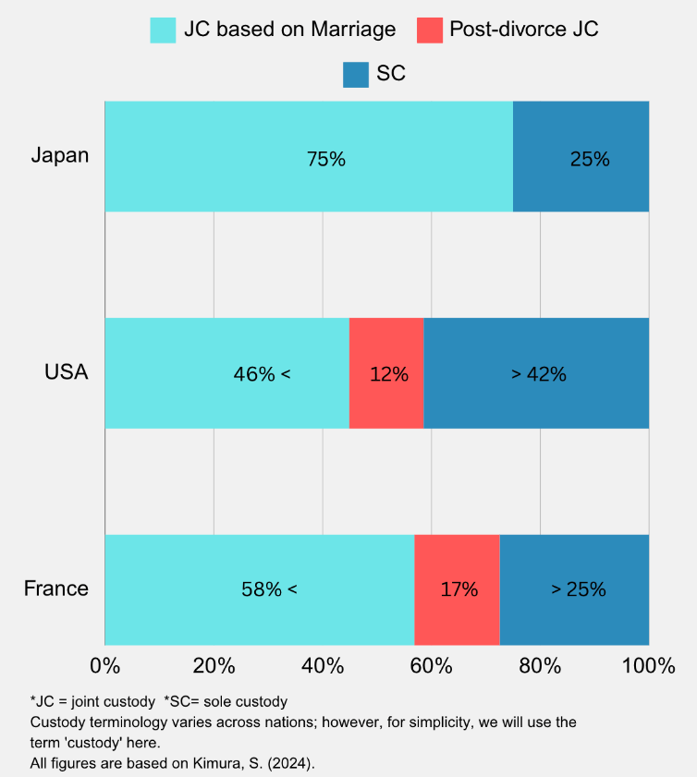
(2) Joint Custody in Japan and Other Countries: Joint custody, which has been adopted in many Western countries, is already possible in Japan, even before any legal amendments. Under the current system, kyōdō shinken (“joint parental authority”) is maintained during marriage, while tandoku shinken (“sole parental authority”) is assigned to one parent after divorce. This is because in Japan, even under the sole tandoku shinken system, Japanese law (Civil Code Article 766) allows custody arrangements to be determined through mutual agreement (Article 766 of the Civil Code). In practice, the non-resident parent (the parent without shinken or “parental authority”) inherently retains certain rights, including visitation, and may continue to participate in the child's upbringing. These rights allow the non-resident parent to remain involved in child-rearing responsibilities through mutual agreement.
For example, if the mother becomes the resident parent (the parent with shinken) after a divorce, the parents can agree to co-parent the child with the father, who does not have shinken. This arrangement is effectively equivalent to full joint custody in Western countries. Agreements can include terms on visitation and other involvement, thereby allowing both parents to share the responsibility for the child's upbringing. Strictly speaking, Japan differs from many other countries where joint parenting agreements made after divorce can be enforced by the court as a legally binding obligation. However, as mentioned above, this difference is largely due to Japan's exceptionally high rate of joint parental authority within legal marriages, as well as its unique legal framework and social structure. Despite these differences, a considerable number of divorced couples in Japan do engage in joint parenting.
The legal relationship between the non-resident parent and the child inherently continues, with the non-resident parent maintaining obligations like financial support, while both the parent and child retain mutual inheritance rights. In this sense, the current Japanese system of shared Kango (“custody”) arrangements is not fundamentally different from the shared parental responsibility model in Western countries, where one parent primarily cares for the child as the resident parent, while the other fulfills their parenting responsibilities as the non-resident parent. .

4-4 Misconceptions about the Japanese Family Law System in the International Media
Many reports, particularly from Western media, often reflect misunderstanding of Japan’s family law system. The Japanese government should correct these misunderstandings by providing accurate explanations of Japan's parent-child legal structures to foreign countries.
One of the most prevalent and significant misconceptions is that ‘under the tandoku shinken (“sole parental authority”) system in Japan, a non-resident parent can never see the child again after the divorce’. However, since the 2011 amendment of the Civil Code, there have been explicit provisions for visitation, and a legal process exists for non-resident parent to seek visitation without requiring the resident parent’s consent. Some foreign parents who publicly claim that their children have been taken to Japan and that they cannot see them have not even applied for mediation or trial for visitation through the Japanese legal system.
Another major misconception is the belief that ‘under sole parental authority system in Japan, the parent who most recently had the physical custody is almost always awarded sole parental authority by the court’. However, in practice, the family court evaluates the child’s caregiving history since birth and, in principle, appoints the primary caregiver as the resident parent. Given that women typically shoulder the bulk of child-rearing responsibilities in Japan, mothers who have been the primary caregivers are frequently awarded physical custody and sole parental authority when they leave the home with the children. Some foreign media outlets have mischaracterized this process as a ‘whoever leaves with the child wins’ scenario, which misrepresents the legal reasoning behind these decisions.
Western countries often criticize Japan’s sole parental authority system, particularly in relation to post-divorce parenting, citing it as a major issue. In connection with the Hague Abduction Convention, it has also been pointed out that Japan's sole parental authority system is a root cause of parental child abduction following divorce. The Western countries and international organisations have urged that Japan's sole parental authority system be changed and that a joint custody system be introduced. However, it is crucial to understand that kyōdō shinken (“joint parental authority”), as outlined in the upcoming legal reforms in Japan, differs from the concept of joint custody as applied in other countries.
Foreign governments and media outlets have called for reforms to Japan’s Family Law, often based on a misinterpretations of the country's legal and social realities. For example, during discussions preceding the 80th session of the UN Committee on the Rights of the Child in 2019, several committee members mistakenly asserted that Japan does not recognize shared custody, leading to the recommendation that Japan “Revise the legislation regulating parent-child relations after divorce in order to allow for shared custody of children (…) and ensure that the right of the child to maintain personal relations and direct contact with his or her non-resident parent can be exercised on a regular basis.” These recommendations were made despite Japan’s existing legal system, which already allows for visitation and interaction between non-resident parents and children. The Japanese government bears responsibility for not adequately addressing these misperceptions. We strongly urge CEDAW to carefully consider its recommendations based on a correct understanding of Japan’s unique social structure and family law system concerning parental authority and parent-child interactions.

5. Recommendations Sought

5-1 Conducting a Survey on Post-Separation Abuse
Japan should conduct a comprehensive, nationwide survey to assess the prevalence of post-separation abuse (PSA) and take immediate action to address this issue.
Reasons:
With the introduction of the post-divorce kyōdō shinken system in 2026, there are concerns that the rate of PSA will increase. Despite these concerns, Japan currently lacks an official survey on PSA. According to a survey conducted through an internet research company, 58% of 1,000 divorced respondents with children reported experiencing PSA. This included 35.3% for emotional abuse, 21.7% for financial abuse, and 15.4% for visitation-related abuse. Among the 582 respondents who had suffered PSA, as many as 431 (74.1%) indicated that the abuse occurred in the presence of their children.
Additionally,
In the in cases where divorce was caused by DV or child abuse, 53.7% of the respondents reported emotional abuse, 31.6% financially abuse, 19.4% visitation-related abuse. Furthermore, in cases where DV was the cause of divorce, incidents of sexual abuse were 4.7 times higher compared to cases where DV was not a factor. Until now, when kyōdō shinken (“joint parental authority”) system after divorce did not exist, the legal abuse was 5%, but concerns have arisen that this number could rise following the system’s implementation in 2026.
Women, particularly ex-wives, in Japan often have low incomes, with nearly half of single-parent households living in relative poverty4. Attending court-mandated mediation can impose a significant financial burden, potentially jeopardizing the livelihood of single mothers. Therefore, with the introduction of the post-divorce kyōdō shinken system, the government must introduce concrete measures, such as financial compensation for time taken off work to attend mediation and establish legal frameworks to prevent mediation applications that could lead to post-separation legal abuse.

5-2 Transition to Tandoku Shinken (“Sole Parental Authority”) Post-Divorce in Kyōdō Shinken (“Joint Parental Authority”) Cases
In introducing a post-divorce kyōdō shinken system, there should be policies in place that enable a smooth transition to tandoku shinken in the event that kyōdō shinken is no longer appropriate.
Reason:
In Japan, 90% of all divorces are settled through “mutual consent”, without the involvement of courts nor lawyers. As the result, parties who lack legal knowledge may agree to kyōdō shinken without fully understanding its implications, or they may feel pressured into accepting it. Additionally, relationships between parents can deteriorate after a divorce, making kyōdō shinken inappropriate. In cases where kyōdō shinken should not have been agreed upon or circumstances post-divorce make it unsuitable, there are concerns that the children in vulnerable positions may suffer. In such cases, it is crucial to implement measures that facilitate a swift transition to sole custody.

5-3 Thorough Investigation of the Legislative Process of the Amended Family Law
The Legislative Council for the amendment of the law introducing kyōdō shinken (“joint parental authority”) did not allow victims of DV and abused children to participate as members in the legislative process. Only representatives of non-resident parents were included. This issue warrants thorough investigation and the reasons for this exclusion should be publicly disclosed.
Reasons:
(1) In the discussions of the government's legislative council, which proposed the framework of the bill and preceded its proposal to the Diet, victims of DV, abused children and their parents concerned about the introduction of kyōdō shinken were only heard as witnesses and were not allowed to participate as committee members. However, representatives of non-resident parents' organisations advocating for the introduction of kyōdō shinken were included and actively lobbied for its introduction.
(2) Despite opposition from representatives of DV survivor support groups and researchers with expertise in supporting DV victims, their dissenting opinions were ignored, and the draft proposal was submitted to the government. It was highly unusual for a draft proposal to be passed without unanimous agreement.
(3) In 2023, public comments were solicited on the draft, and approximately 8,000 individual opinions were submitted, with two-thirds opposing the introduction of kyōdō shinken. However, the Ministry of Justice has not published the details.

5-4 Measures Against DV
In Japan, victims of DV and other forms of violence against women are not uniformly able to access necessary support across all regions. To ensure that all victims receive specialized and comprehensive assistance, the following measures should be implemented promptly.
(1) Immediate improvements should be made to rectify situations where public emergency shelters deny admission for various reasons. The Japanese government should clarify what steps it is taking to address this issue.
(2) Measures should be taken immediately to improve the current lack of post- emergency evacuation support for the daily lives, housing, employment, and recovery of parents and children.
(3) As done in many other countries, support activities should be enhanced by engaging NGOs to provide victim assistance.
Reasons:
(1) Challenges in Shelter and Support Services for DV Victims in Japan:
In Japan, support for victims of violence against women, including DV, is highly fragmented.
Under the relevant regulations, prefectural women's counseling centers are responsible for providing emergency shelter and specialized consultations, but there have been criticisms about the accessibility of emergency shelters. Shelters have high vacancy rates and substantial regional disparities (an average occupancy rate of 14,1%, with some prefectures as low as 2%. The average duration of temporary protection is 17.1 days). Moreover, emergency shelters are designed for short stays of around two weeks, and with very few victims moving on to longer-term facilities.
Criticisms of Protection in Public Shelters include:
a. One notable issue is the practice in some localities where, except for infants and young children, mothers and children fleeing from DV are sheltered separately. This separation is due to the handling agencies for child abuse and women's support being distinct, and the foundational laws being different, which complicates intervention efforts in families where DV and child abuse coexist. This has led to serious incidents, including child deaths (e.g. Meguro case in 2018, Noda case in 2019).
b. There are numerous reports that women's support centres are not actively providing temporary shelter to victims.
Examples include:
- Refusing to take the victims into shelters on the grounds that ‘the victim is not in danger because offender is in custody’, or that they ‘do not provide temporary protection because a protection order has been issued’.
- Declining to take the victims into shelters on the grounds that “there is no urgency” in cases of psychological DV or, cases of severe physical violence in the past.
- Denying shelters to victims on the grounds that ‘the victim has not yet made up her mind’, although the victims should be carefully assisted in making their own decisions.
- Refusing protection because the victims had some cash or savings. Instances have occurred where protection was denied to victims possessing amounts such as ¥80,000 (€512), ¥100,000 (€640), ¥200,000 (€1,280), ¥500,000 (€3,200), or even a pension and savings up to ¥1 million (€6,400).
- Denying entry to victims because they are mentally ill, elderly, or disabled.
The regional disparities and reluctance to provide shelter stem in part from the fact that until 2023, the only legal basis for shelters and consultation services was the Anti-Prostitution Law. The idea stems from a restrictive framework that fails to support all victims of domestic violence, instead focusing only on those women who, due to financial constraints, are deemed at risk of turning to prostitution under the provisions of the Anti-Prostitution Law. The shelters were not administered under principles of human rights or gender equality, and the budget allocated was minimal. With the introduction of the new law (Support for Women’s Welfare Act) in April 2024, the philosophy of human rights protection has finally been raised, but changing established local practices has been challenging. Another reason is the lack of adequate employment conditions to employ trained professional social workers, which has left them with low competence and awareness.
(2) Lack of Long-Term Support: Although women's centres are tasked with initial emergency evacuation, there has historically been no public institution specialising in medium- to long-term support following an initial crisis. Although municipalities are expected to fulfill this role, the specifics and responsibilities of the support provided remain vague.
(3) Potential for Improvement Through NGO Collaboration: On the other hand, there are more than 100 NGO shelter organisations with the enthusiasm, philosophy, experience and expertise to provide comprehensive support. However, due to limited commissioning and financial support from the national and local governments, they are compelled to work on a volunteer basis, keeping each organization's scale small.
Overall, the current situation in Japan significantly deviates from the standards set by the Istanbul Convention, which advocates for professional and comprehensive support for all victims.

5-5 Urgent Measures to Ensure the Safety of DV Victims in Judicial Procedures and Prevent Coerced Agreements
Reasons:
Recommendation 35 of CEDAW mandates that gender-based violence against women not be forcibly subjected to mediation or other out-of-court dispute resolution procedures (IV D). However, as described below, the procedures in Japanese courts currently do not sufficiently meet this requirement.
(1) As a matter of principle, divorce proceedings in family courts in Japan must first go through mediation, rather than suddenly initiating divorce proceedings (principle of mediation first). Even if the party requests that the mediation be closed quickly because it is a DV case, there is no guarantee that their request will be granted, and there is a risk that they will be forced to attend mediation proceedings several times.
(2) Attending mediation sessions at the family court building can pose risks; perpetrators might ambush and harm the victim. For instance, in March 2019, a man undergoing divorce mediation ambushed and fatally stabbed his wife outside the entrance of the Tokyo Family Court building, targeting the time when she was scheduled to attend the mediation.
(3) During divorce mediation, even in cases involving DV, courts often enforce a pro-contact culture, asserting that it is in the child’s best interest to maintain contact with the non-resident parent. Consequently, DV victims may face further harm as they are criticized for fearing their abusers. Furthermore, there is a concern that in the future, the court may promote kyōdō shinken (“joint parental authority”) after divorce for such cases.
Therefore, it is advisable to consider introducing a system that allows divorce litigation without prior mediation for cases declared to involve DV and expand legal aid to improve access to legal representation for victims.

5-6 Judicial Response to DV: Enhancing Training and Resources in Family Courts
At the very least, judges who issue DV protection orders, along with family court judges, family court investigating officers, and mediators, should receive specialized training in DV issues to ensure that DV cases are handled appropriately and to prevent secondary victimization in Japanese courts. Additionally, family courts should employ specialized consultants to assist with divorces, custody issues, and DV protection orders.
Reasons:
In Japan, there are very few judges, mediators, family court investigating officers and lawyers who understand the characteristics of DV, such as ‘domination and control.’ Therefore, even though the DV Act also covers psychological, sexual, and economic violence, DV victims are often at risk of secondary victimization in court because anything other than physical violence is frequently not recognized as DV. One reason for this is that law school curricula and training institutions do not include courses on DV, abuse, or sexual violence. Another reason is the lack of specialized judicial institutions to handle DV protection orders and abuse cases.
(1) Statements Highlighting Judicial Officials' Lack of Understanding of DV, as Reported by Victims Who Have Experienced the Court Process:
- “The child needs his father, so visits must be allowed.”
- “The relationship between parent and child has nothing to do with DV against you.”
- “If you let the children see their father, he will be more willing to pay child support.”
- “The court acknowledges that the child has been sexually abused, but it cannot be proven that the father was the perpetrator. Overnight visits should still be allowed.”
Furthermore, misconceptions about post-separation DV or PSA persist, such as the belief that “physical distance prevents DV,” leading to negligence in addressing malicious litigation. This puts DV victims and abused children at risk, especially when courts enforce “Indirect Compulsory Payment/Fine” to compel compliance with court-ordered visitations. Additionally, harassment of lawyers and supporters by perpetrators has become increasingly frequent.
(2) Statements by Politicians showing lack of understanding of DV
Alarmingly, in Japan, there have been campaigns by groups advocating for kyōdō shinken (“joint parental authority”) and perpetrators of DV, labeling DV victims who flee with their children as "kidnappers." This situation indicates a profound lack of understanding of the nature of DV across society. Such propaganda, often spread by influential politicians (specific examples below), has had a chilling effect on DV victims, potentially deterring them from seeking safety. It is not a coincidence that these politicians have forcefully pushed through legal reforms to introduce kyōdō shinken.
Given the intensification of unfounded claims and lawsuits by the perpetrators, courts must reject such claims and make correct judgments based on a proper understanding of DV to protect the safety of the victims.
Examples of Politicians' Profound Ignorance of DV:
a. A, a Member of the House of Representatives: He stated, “It is necessary to establish a system as soon as possible to judge whether DV is really bearable or unbearable.” His comments suggest that victims should endure DV and not flee with their children. On an Australian TV program, he remarked, ‘In many cases, the police don't act because, in Japan, it is quite normal for parents to kidnap their children and leave home.’ This spreads inaccurate information about Japanese society and the legal system.
b. B, a Member of the House of Representatives:
He tweeted, “If the level of emotional abuse is such that living together becomes impossible, feel free to divorce. Just don't call it DV.” This statement downplays emotional abuse and discourages victims who feel overwhelmed by emotional abuse from labeling their situation as DV, thus potentially deterring victims from escaping with their children.
c. C, a Member of the House of Councilors: She repeatedly used the term “kidnapping of one's own child” in the Diet to aggressively criticize DV victims who flee with their children. Using her knowledge of the location of DV shelters gained from her time as governor of Shiga Prefecture, she exposed information on YouTube videos that led to the identification of shelter locations.
d. D, a Member of the House of Representatives: He stated in the Diet, “I think it would be healthier to have a society where it is harder to get divorced unless there is DV or child abuse,” implying that making divorce more difficult without clear evidence of abuse or DV could be beneficial.
These statements and some media reports that support them discourage DV victims from seeking refuge away from their abusers, leading to an escalation of DV and further deepening and prolongation of the harm, which we strongly condemn.

5-7 Enhancing Law Enforcement and Judicial Intervention in DV Cases to Ensure Victim Safety
(1) Immediate Response Measures: Japan should introduce immediate response measures, such as temporary emergency protection orders, when police receive DV reports to ensure the safety of the victims. This includes measures that allow for quick consultation and action following a report.
(2) Guidelines for Protection Orders: Current Japanese DV Act should establish guidelines for issuing of protection orders without a court hearing to allow for swift responses.
Reasons:
According to the Istanbul Convention, which advocates the introduction of emergency prohibition orders (Article 52) and has been ratified/adopted by 39 countries, many nations have implemented such measures to secure the safety of victims. However, in Japan, there is virtually no system in place for police or other authorities to issue provisional emergency protection orders immediately. Under the current DV Act, although courts can issue ordinary protection orders (which take about 12 days to process) immediately and without a hearing if necessary, there are no guidelines on when these should be issued without a hearing, resulting in a lack of utilisation.
Furthermore, under the current Japanese DV Act, third parties such medical personnel can report physical DV incidents to a DV centre when discovered. However, guidelines on how police or DV Counselling and Support Centres should respond to reports of intimate partner or spousal DV are lacking, thereby rendering this reporting system ineffective.

5-8 Equitable Property Division in Divorce Proceedings
In light of CEDAW General Recommendation No. 29, legislative amendments and operational changes should be considered to ensure a substantially fair division of property between spouses with economic disparities at the time of divorce.
Reasons:
The current practice of property division in Japanese family courts is as follows: properties each spouse owns at the time of separation (often considered the time the property was jointly accumulated) are added together, and each spouse receives half.
While this rule appears fair at first glance, it often results in substantial inequality for the wife after divorce. This is because the strong gender division of labour within marriages in Japan mean that husbands often bear the financial responsibilities, leaving wives economically vulnerable post-divorce.
This division of property, combined with the rarity of alimony awards, means that if an individual has lost earning power during the marriage through unemployment or job change, they receive no compensation upon divorce. With the introduction of the kyōdō shinken (“joint parental authority”) system in 2026, concerns have been raised that resident parent may receive reduced child support or face difficulties obtaining social security benefits.
The introduction of the post-divorce kyōdō shinken system, in a society where alimony is rare and the economic roles within marriage are heavily gendered, is likely to exacerbate economic hardships, particularly for women. To prevent such outcomes, it is imperative that Japan urgently reconsider the equity of property division during divorce.

CEDAW/C/JP/QPR/9, No.9, “Gender-based violence against women” and No. 25, “Marriage and family relations.”
In Western countries, there has been a shift from “Parental Authority and Parental Right” to “Parental Custody” and then to “Parental Responsibility”, and then to “Joint Custody.” The transition has been from “Joint Custody” to “Shared Parental Responsibility.”
Gender Equality Bureau, Cabinet Office, Government of Japan. White Paper on Gender Equality. 2024. p.110, 122, 127.
Ministry of Health, Labor and Welfare, Government of Japan. Nationwide Survey on Single parent household. P.60
Ministry of Health, Labor and Welfare, Government of Japan. Comprehensive Survey of Living Conditions. 2018 Average Annual Household Income: - Households with children: €47,600 (7,459,000 JPY) - Single-mother households: €19,500 (3,060,000 JPY) Current living conditions (2019 survey, single-mother respondents): - 'Very difficult': 41.9% - 'Somewhat difficult': 44.8%
Vital Statistics and OECD Family Database, 2020. OECD average: 41.9%
Kimura, Sota (2024). “Kyōdō Shinken after Non-Marital Relationships or Divorce and the Child’s Best Interests”, Gendai Shisō, 52(5), 53–59.
Ministry of Justice, Government of Japan. Summary of Survey Results on Divorce by Mutual Consent. moj.go.jp/content/001346482.pdf Out of 1,000 individuals who divorced by mutual consent: - 71% had some form of agreement regarding visitation (Q41). - Among these, 68.3% agreed to meet regularly with their child(ren), and an additional 17.6% agreed to overnight stays (Q44).
Ogawa, Tomiyuki. “The current situation and legal systems in Japan and overseas (such as in the United States, the United Kingdom, Australia, etc.).”Visitation and Kyōdō Shinken (“Joint Parental Authority”) , edited by Takashi Kumagami and Harumi Okamura, Akashi Shoten, 31 Jan. 2023, p. 56.
Ogawa, p. 60-63.
Japanese Association for the Protection of Children's Safety in Custody Disputes. Survey on post-separation abuse and Kyōdō Shinken legislation. papermark.io/view/cm0gcmvxv0002rj95b8p298hv
Senda, Yuki. “Discussion about Domestic Violence (DV) on the first meeting of the Family Law Subcommittee of the Legislative Council.” Journal of Musashi University Comprehensive Research Organization. 2022. P33-39.
Takeuchi, Tsutomu. Response in the House of Councillors Judiciary Committee, May 9, 2024. National Diet of Japan Proceedings Database. kokkai.ndl.go.jp/#/detail?minId=121315206X01020240509&spkNum=7&current=5
“Public Comments on ‘Kyōdō Shinken’ Reviewed without Full Disclosure, Raising Doubts about Its Predetermined Implementation.” Seikatsu News Commons, s-newscommons.com/article/303
Ministry of Health, Labor and Welfare, Government of Japan. 29 Mar. 2023. The basic policy on measures to Support for Women Facing Difficulties.
The All Japan Women's Shelter Network gathered insights from 81 survivors and 92 supporters in 2020, along with data previously submitted by various support organizations. nwsnet.or.jp/archives/582
Istanbul Convention, Article 20 (General Support Services), Article 23 (Shelters).

