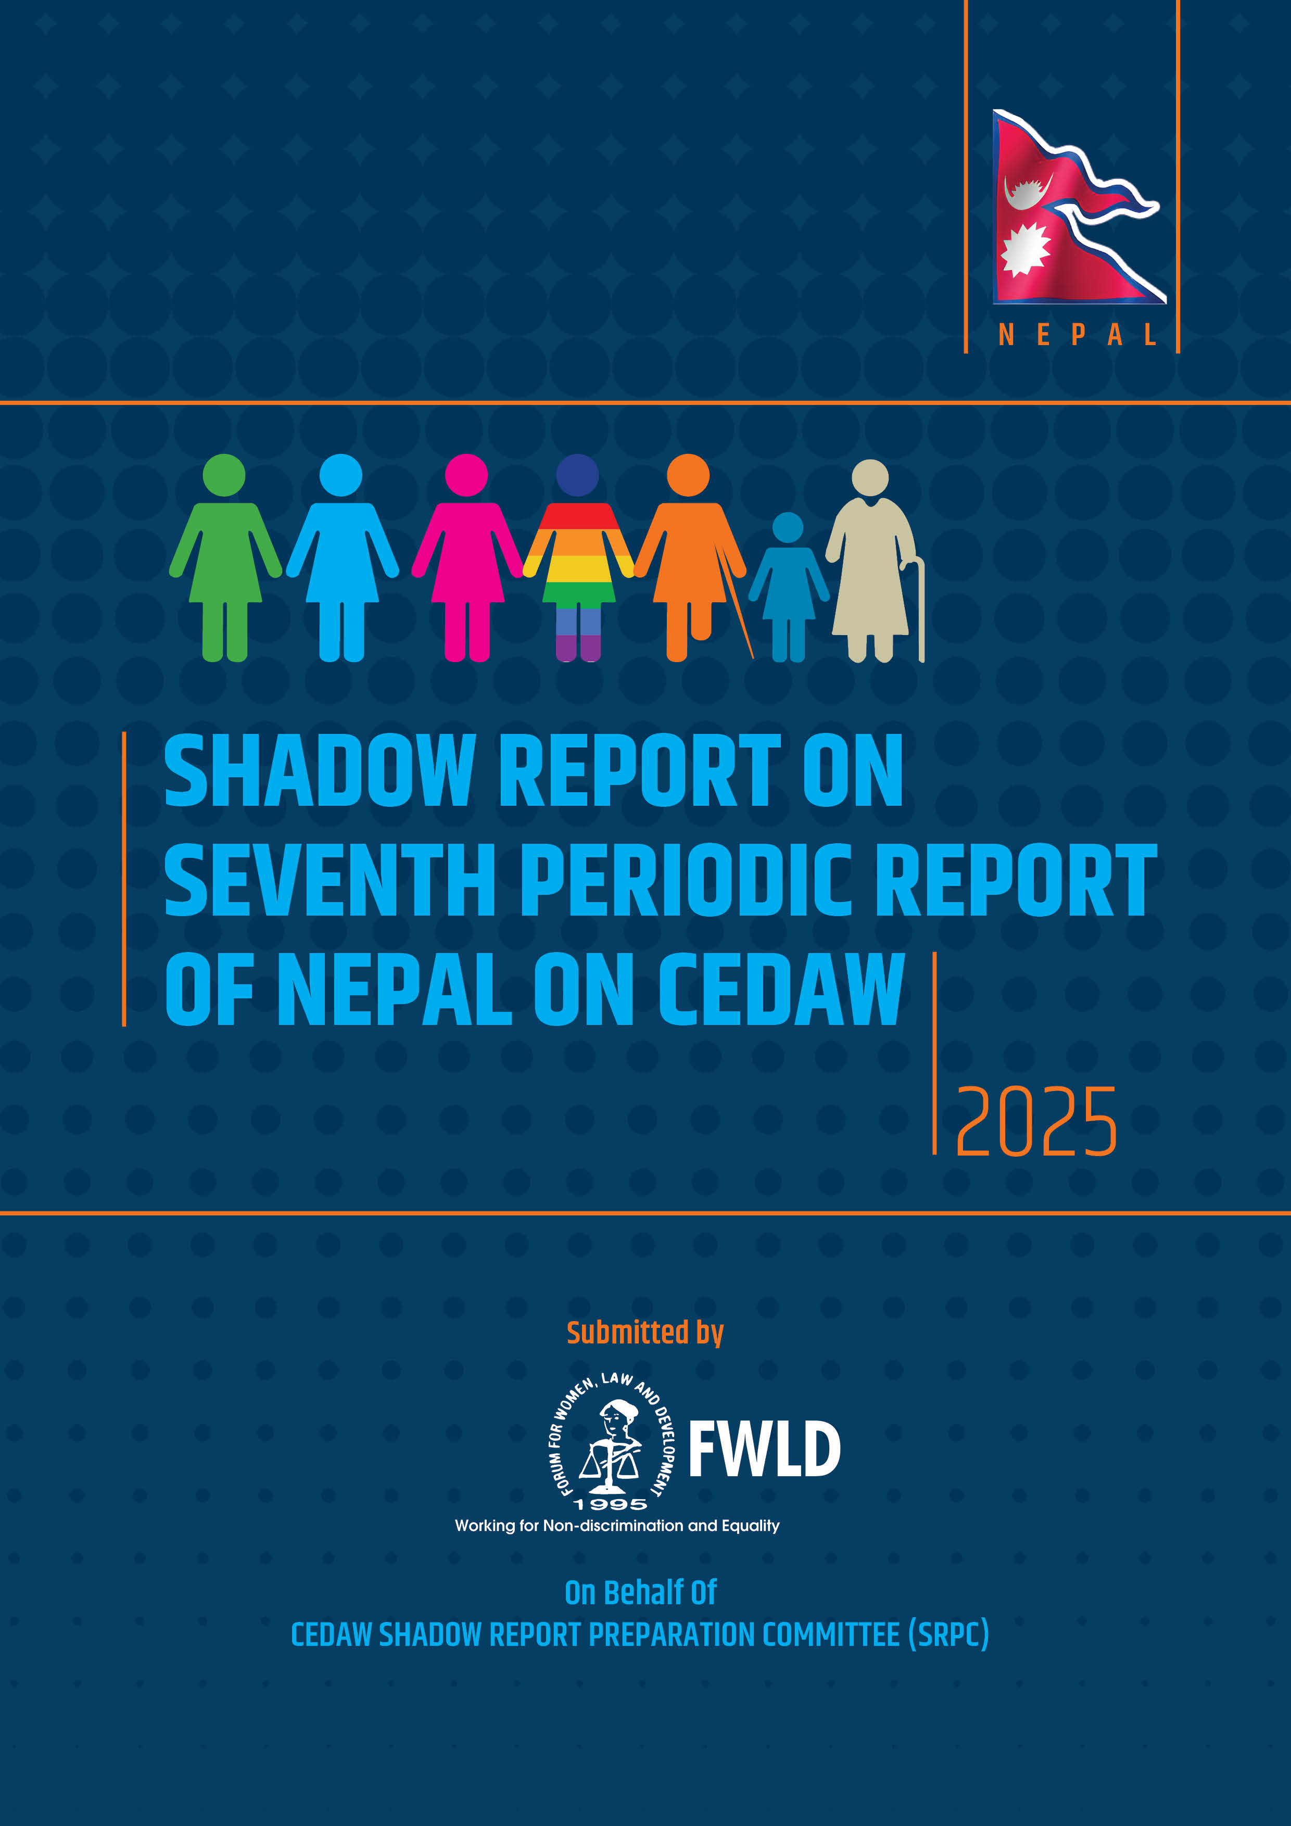
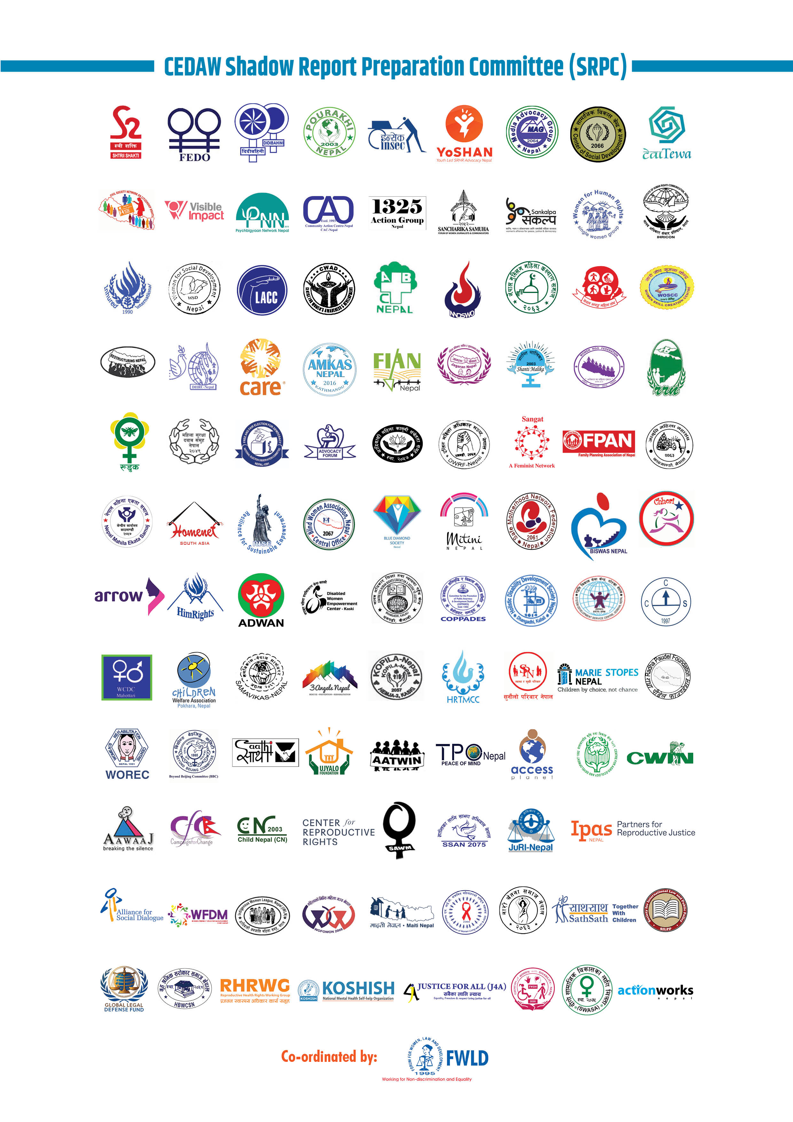
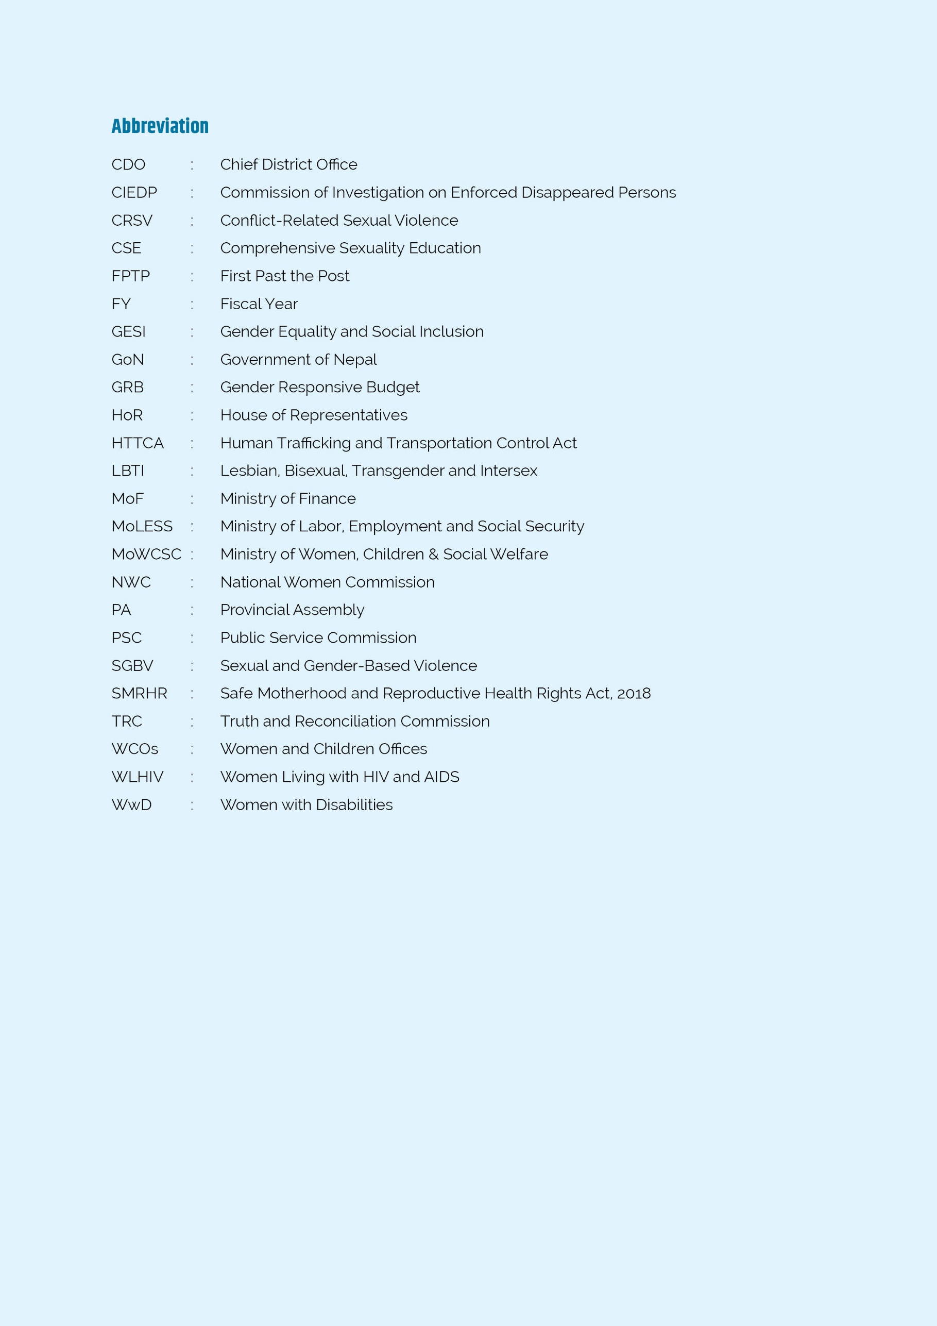
Introduction and Report Preparation Process
The report is a coalition submission of CEDAW Shadow Report Preparation Committee (SRPC), comprising 106 civil society organizations. Forum for Women, Law and Development (FWLD) is the coordinator of SRPC and it has been consistently engaging in treaty monitoring mechanisms for promoting accountability of the Government towards advancing gender equality and the empowerment of women and girls. FWLD has been coordinating and preparing all civil society’s CEDAW Shadow Reports submission since Nepal’s initial report in 1999 to sixth periodic report reviewed in 2018, and also facilitated the committees for the formulation of List of Issues by submitting Civil Society’s Submission for List of Issues and making oral statement to the committee regarding 7th Periodic Report of Nepal during 89th Pre-sessional Working Group.
The process of drafting this report entailed seven provincial and one national level consultations with relevant stakeholders (maintaining intersectionality), and article-wise discussions with specialized organizations/agencies. Also, FWLD in coordination with National Women Commission (NWC), organized interactions in the presence of Minister of Foreign Affairs, relevant ministries and Chief Secretary of the Government of Nepal, as well as with media on CEDAW Committee’s LOIs.
The drafting process in general indicates that at the normative level, Nepal is progressing towards gender equality and women’s empowerment, nevertheless, systemic discrimination against women across multiple critical areas persists exacerbating issues of intersectionality and leaving marginalized groups vulnerable to discrimination. This submission encompasses pertinent issues related to all 16 articles of CEDAW Convention, and appeals for the enactment of robust anti-discrimination laws, amendments to existing laws that perpetuate inequality, effective policy implementation, strengthening institutional frameworks, enhancing women's representation in leadership roles across all sectors, and dedicated resources to promote substantive equality and equitable treatment of women and marginalized populations.

Article 1
Discrimination against Women

Critical areas of concern

- Nepal lacks a specific legislation on anti-discrimination and thus, does not define “discrimination against women”.
- Absence of legal remedies for discrimination left critical issues specifically intersectionality within women unaddressed; like discrimination against Women with Disabilities (WwD), and Lesbian, Bisexual, Transgender and Intersex (LBTI) in lack of inclusive and universal design of shelter homes particularly during disaster.

Implementation of Concluding Observations

- Non-enactment of Anti-discrimination legislation, addressing discrimination lacking intersectionality approach.

Recommendation
- Enact specific and robust anti-discrimination law defining “discrimination against women”, and reform existing discriminatory laws.
- Address intersectional and compounded discrimination against women, including WwD, Dalit women, single women, women from religious minorities, LBTI, Indigenous women, Madhesi women, senior citizen women and women in humanitarian crisis.

Article 2
State Obligations

Critical Areas of Concern
- Section 160 of National Criminal Code, 2017, (Criminal Code) prohibits and punishes only public authorities for discrimination against citizens based on various grounds.
- Lack of universal design and reasonable accommodation limited right to justice of WwD.
- Lack of gender-matching identity documents caused LBTI to face discrimination or denial of relief distribution during disaster.
- No gender audit for gender perspective impact assessment in law-making process.

Implementation of Concluding Observations
- No significant process made in incorporating international human rights principles.

Recommendations
- Take effective measures to punish and compensate discrimination by all including in private sphere and individual.
- Conduct comprehensive gender audits and ensure public participation during the law-making processes.

Article 3
Advancement of Women Through National Machinery

Critical Areas of Concern
- In fiscal year (FY) 2024/25, only 0.09% of the national budget was allocated to Ministry of Women, Children and Senior Citizens (MoWCSC) and 0.05 % to Goal 5 on ‘Gender Equality’ of Sustainable Development Goals (SDG).
- National Women Commission (NWC) requires no minimum academic qualification for commissionersand also lacks intersectionality in their appointment; affecting effective delivery of NWC mandate. Also, NWC’s allocated budget is declining; and NWC is yet to establish provincial offices.
- Nepal Police’s Women, Children and Senior Citizens Service centers lacks adequate women officers, and gender sensitive and responsive infrastructure affecting safe, confidential, and respectful environments for reporting of SGBV cases.
- Upon federalism, all district level Women and Children Offices (WCOs) under MoWCSC, a focal institution for advancing women and children’s rights has been dissolved; Separate sections or divisions working on women’s issues formed at local levels lacks functionality resulting into limited mandate and insufficient human resources. Also, previous women development officers (who were female) serving WCOs, are discriminated in participating in the Public Service Commission’s (PSC) examination, and are limited to one post promotion only.
- Ministry of Finance (MoF) has formulated Model Guideline for Gender-Responsive Budget (GRB) for province and local levels but it is not mandatory for them. Also, the GRB guidelines fails to acknowledge the diversity of women in caste, class, religion, disability and sexuality.
- Truth and Reconciliation Commission (TRC) and Commission on Investigation of Enforced Disappearances (CIEDP) still does not have executive chairpersons and members making it dysfunctional, and has impeded justice for conflict related sexual violence (CRSV). Also, despite estimated 1500 CRSV victims, they are deprived of justice due to limited statute of limitations in sexual violence cases.

Implementation of Concluding Observations
- By adopting local and provincial Gender Equality and Social Inclusion (GESI) policies, Government of Nepal is implementing National Gender Equality Policy; and by localizing strategies, National Action Plan (NAP-II), 2022 on UNSCR 1325 and 1820, however, it is not effective at local level due to lack of awareness and ownership.

Recommendations
- Strengthen MoWCSC, and NWC by allocating sufficient human and financial resources; appoint NWC’s commissioners with expertise on women human rights issues ensuring intersectionality; and establish NWC at provincial level with monitoring structures.
- Ensure that Nepal Police’s Women, Children and Senior Citizen Service Centers is headed by women officer and their services are survivor-centric and gender-responsive.
- Allocate sufficient human and financial resources to sections/divisions working on women’s issues at local levels.
- Ensure equal opportunity for WCOs to participate in PSC.
- Implement GRB guidelines maintaining intersectionality within women in local and provincial governments.
- Appoint Chairperson and members in TRC and CIEDP, and implement NAP-II through gender sensitive approach.
- Amend TRC Act, 2014 stating removal of statute of time limitation in CRSV and provide appropriate reparation to survivors.

Article 4
Special Measures for Substantive Equality

Critical Areas of Concern
- The 2023 Global Gender Gap Report reflected decline in Nepal's gender parity score, from 0.692 in 2022 to 0.659 in 2023. Thus, Nepal’s rank fell from 96th to 116th among 146 nations, urging targeted initiatives to achieve gender equality.
- Despite constitutional requirement of implementing special opportunity provision under Fundamental Rights of women by enacting legislation with 3 years of its promulgation, no initiative have been taken.
- Temporary special measures adopted by GoN, is neither target-based nor time-bound and lack phase out policy, basing on impact assessment.
- Non-acknowledgement of Intersectionality within women has caused lesser representations of women from marginalized groups, including Dalit, Madhesi, indigenous communities, religious minorities, LBTI, geographically disadvantaged locations, WwD and women in humanitarian crisis in all sectors.

Implementation of Concluding Observations
- Special Opportunity Act, anticipated to include provisions relating special measures in fields of health, education, employment, and social security, is yet to be enacted.

Recommendations
- Ensure proportional participation of women in all mechanisms, including in meaningful and decision-making roles, in all sectors through appropriate special measures.
- Enact legislation with immediate effect to implement constitutional provision on special opportunity.
- Introduce a long-term comprehensive plan to enhance capacity of women acknowledging their diversity, and aiming to advance situation of marginalized groups, including Dalit, Madhesi, indigenous communities, religious minorities, LBTI, women from geographically disadvantaged areas, women in humanitarian crisis and WwD.
- Introduce targeted, time-bound temporary special measures for women, that accommodate intersectional lens along with a phase-out policy, where applicable.

Article 5
Sex Roles and Stereotypes

Critical Areas of Concern
- Despite increasing the statute of limitation in cases of sexual violence, the prevailing provision fails to completely remove it impeding access to justice for survivors.
- Despite criminalization of marital rape, the penal provision differentiates marital rape with lesser punishment. Furthermore, it gives discretionary power to court in sentencing with no minimum range, leading to inconsistent and lenient punishments.
- The technology-facilitated SGBV is not included under legal provisions addressing different forms of SGBV. The Electronic Transactions Act, 2008 is insufficient to address all forms of cybercrimes.
- Though the right of victim with compensation and social rehabilitation is ensured, the provisions are scattered across various laws leaving it as a discretion of the authority.
- Law does not prohibit social rites and rituals constituting gender-based discrimination. For instance, women are still barred from entering the temple as in Dholamandali Temple.

Implementation of Concluding Observations
- Only 21 government-supported safe houses are inadequate for the victims of GBV, and they lack universal design and reasonable accommodation, as well as social rehabilitation and family reintegration services.
- Despite criminalizing Chhaupadi, and dismantling 8,550 chhau goths in two months, the practice is still prevalent.
- Nepal lacks legal prohibition of medical procedures to determine gender identity to intersex children before they reach the legal age of consent.

Recommendations
- Amend Section 165(1) of Criminal Code to explicitly criminalize social rites rituals, and harmful traditional practices that constitute gender-based discrimination.
- Enact comprehensive law addressing cybercrime and include technology-facilitated GBV in specialized SGBV laws.
- Increase punishment and ensure mandatory minimum sentence for marital rape.
- Enact legislation prohibiting medical procedures to determine gender identity to intersex children before they reach the age of consent.
- Completely remove the statute of limitations on rape.
- Enact Umbrella Law to support victims/survivors of SGBV, addressing different areas such as rescue, compensation, interim relief, treatment, psychosocial counseling, legal counseling, safe house, social rehabilitation, and livelihood opportunities.
- Increase number and quality of safe houses that provide comprehensive social rehabilitation and family reintegration services, ensuring their accessibility to SGBV victims/survivors, including WwD and children of survivors. Establish at least one local transit home for immediate support.

Article 6
Trafficking and Exploitation of Prostitution

Critical Areas of Concern
- Despite ratifying Palermo Protocol, Human Trafficking and Transportation (Control) Act 2007 (HTTCA) and various national laws, are yet to be amended. Definition of Prostitution as Human Trafficking discourages victims from reporting due to stigmatization.
- Only Lumbini Province and some local levels have formulated anti-trafficking laws whereas Bagmati Province has formulated policy.
- While sex workers are not criminalized, they are prosecuted for violation of public morality offense.

- MoWCSC has national and district coordination committees to combat human trafficking, but provincial and local committees are not mandated under HTTCA.

Implementation of Concluding Observations
- A bill to amend HTTCA is under consideration in the Cabinet.
- Nepal has not yet formulated a comprehensive policy to protect sex workers from violence and exploitation and lacks effective monitoring mechanisms with an exit plan.
- Reports indicate harassment and extortion by police to sex workers.

Recommendations
- Amend HTTCA in compliance with the Palermo Protocol, including the definition of ‘human trafficking’ and not interconnecting trafficking with sex work.
- Operationalize NCCHT and DCCHT and form provincial and local level committees.
- Formulate a comprehensive policy to protect sex workers with effective monitoring, and accessible exit plans with alternative livelihoods.

Article 7
Participation in Political and Public Life

Critical Areas of Concern
- Despite 51.1% of total population, male voters (89,92,010) outnumbered women voters (87,41,530); also, women’s voting decision is generally not autonomous.
- In House of Representatives (HoR) and Provincial Assembly (PA), only legally mandated proportion of women are represented, however, representation by First Past the Post (FPTP) is minimum in comparison to by Proportional representation (PR):
Women representation in Federal Election 2022 and Provincial Election 2022
 | Women Candidates | By FPTP | By PR | Total | Total %
HoR | 235/2414 (9.74%) | 9(9.89%) | 82 (90.10%) | 91 | 33.09%
PA | 280/2946 (9.5%) | 14 (7%) | 186 (93%) | 200 | 36.36%
Source: Election Commission Nepal, 2022
- 40.96% of those elected at local level were women but their representation is limited to non-decision-making positions:
 | Local Level Election 2017 |  | Local Level Election 2022
 | Female | Male | Female | Male
Women Ward-Chairperson | 0.9% | 99.1% | 1.05% | 98.95%
Women Mayor/Chairperson | 2.39% | 97.61% | 3.45% | 96.55%
Source: Election Commission Nepal, 2022
- One Dalit women member in ward committees is legally mandated but 170 seats for them were vacant in 2022 Local Level Election reflecting their challenges in participating in political and public life.
- The Local Level Election Act, 2017 requires one of the two candidates for chairperson or vice-chairperson, mayor/deputy-mayor to be woman. However, this provision is applicable only when a party fields candidates for both positions, thus in alliance politics, parties shared a position among themselves and fielded a male candidate resulted in decrease by 20%.
- Despite 0.01003% of the population of sexual and gender minorities and constitutional recognition, they are not recognized as ‘minorities’ depriving them of ‘minorities quotas’.
- No representation of WwD in Federal Parliament, 1 (0.18%) in PA and only 6 in local level.
- Only 43 (10.69%) out of 402 judges are women (2 out of 17 (current) in Supreme Court, 23 in High Court, and 18 in District Court)
- Constitution allows president and vice-president to be ‘from different communities or sex’, resulting males in both.
- Report indicates, in the same pace, it will take 136 years for 50% of women representation proportionate to the population in civil services.
 | Women | Total | % of women
Council of Ministers | 3 | 25 | 12
MoF | 22 | 107 | 20.56%
Ministry of Labor, Employment and Social Security | 24 | 79 | 30.37%
Ministry of Education, Science and Technology | 40 | 118 | 33.89%
Civil Service | 23,840 | 86,277 | 27.6%

- 8 out of 77 districts have women Chief District Officers(CDO).
- Only 11% of police officers,76% of armed Police Force, and 9.4% of Nepali Army are female.
- There is negligible women representation in office bearers with almost zero in president in political party.
- In the likelihood of winning elections through extravagant spending, women and LBTI’s lack of access to wealth impacts their campaigns as well as their ability to successfully run for the candidacy.

Implementation of Concluding Observations
- The zipper/slide system was not introduced in 2022 election.

Recommendations
- Introduce a long-term comprehensive plan to strengthen the capacity of women and increase women's participation (candidacy as well as elected) at all levels; Conduct women and intersectionality targeted voter’s education for meaningful exercise of their voting rights; Regulate Political financing to ensure men and women compete on equal footing.
- Amend Articles 84, 176, and 222 of Constitution ensuring at least 33% of women candidacy in FPTP in HoR and PA by political parties. Also, at local level, out of their total candidates they should ensure at least 33% of women in Mayor/Chairperson/Ward-chairpersons’ positions. If the political parties give candidacy for only one position, they should give candidacy to women.
- Ensure at least 5% representation of WwD in the Federal Parliament, PA, and in local governments.
- Include ‘LBTI Community’ under ‘minorities’ in Article 306(1) of Constitution.
- Adopt a comprehensive and long-term plan to inculcate principle of inclusion in judiciary ensuring the appointment of women in judges and decision-making positions.
- Guarantee women representation in president or vice-president.
- Ensure at least one-third representation of women in officer-bearers’ positions and any other committees in Political Parties Act, 2017.

Article 8
Participation of Women in the International Forum

Critical Areas of Concern
- Women representation in international forums or delegation is relatively low. Only 1 woman (10%) out of 10 members went to Inter-Parliamentary Union, 1 woman (25%) out of 4 joined 16th Ministerial Meeting of the Asia Cooperation Dialogue (ACD), Doha.
- Only 68 (23.29%) out of 292 posts in diplomatic services are occupied by women.
- 5(15.15%) out of 33 ambassadors are women.

Recommendation
- Ensure women representation in ambassadors, and international delegations based on proportional representation.

Article 9
Nationality

Critical Areas of Concern
- Articles 11(2), 11(5), and 11(7) of the Constitution undermine Nepali women’s independent identity as mothers in transferring citizenship to their children.
- Article 11(3) requires children of parents who obtained Nepali citizenship by birth to have both a Nepali father and mother to obtain their citizenship. While Nepali men can confer citizenship to their foreign women spouses easily, Nepali women is denied the same right, leaving children of such mothers in stateless situation, unlike those of Nepali fathers.
- There is no provision to grant citizenship to the spouses other than foreign women, excluding Nepali women or LBTI to confer citizenship to their foreign spouses on equal grounds.
- To secure citizenship for children with unidentified fathers, Section 8(1) (a1) of the Nepal Citizenship Act, 2006 requires mothers to self-declare the fact along with a penal implication, including imprisonment (Section 21(3c)), if later found false. However, similar requirement doesn’t exist for a Nepali father.
- Medical examination in practice for revising sex in citizenship certificates or to obtain citizenship under the “other” category creates barriers, limiting their ability to obtain citizenship in alignment with their gender identity.
- Although Section 8(1)(a) of the Citizenship Act, 2006, which previously restricted Nepali women, married to foreign men before obtaining citizenship, from applying Nepali citizenship, was repealed in 2023, in practice women is such circumstances continue to face challenges in acquiring citizenship.
- Children of Nepali migrant women or trafficking survivors born abroad are denied citizenship certificates, as Article 11(5) of the Constitution conditioned birth in Nepal and permanent domicile if the father is unidentified, resulting hundreds of children born in foreign lands at risk of statelessness.
- Despite constitution and legal reformations, the delayed amendment of Citizenship Certificate Distribution Guidelines, 2006 has hindered the implementation of legal reformation.
- Non-implementation of court decisions for granting citizenship, coupled with persistent discrimination perpetuated by authorities’ patriarchal mindset continue to hinder women from exercising equal citizenship rights in practice.
- A police report is mandatory in cases where the father is missing or unidentified, however, no such document is required for father to register birth of his child.
- 26% of children under five years of age do not have birth registration certificates. Insufficient application of universal right to birth registration excludes children, whose parents lack legal identity documents, particularly children of stateless persons, refugees, migrants or sex workers, from being registered at birth.
- Despite Supreme Court’s order, the absence of national refugee legislation disproportionately affects refugee women and girls. Tibetan long-stayer refugee women lack registration and identity documentation, and birth registration for their children, leaving them vulnerable and without access to basic services. Bhutanese refugee, relatively better documented also face suspended birth registration for their children since January 2024 due to unresolved technical issues by GoN leading to Bhutanese children without necessary legal recognition. Moreover, births of children born to Nepali women married to refugee men remain unregistered, as their fathers are foreign national (refugee).

Implementation of Concluding Observations
- The Nepal Citizenship (First Amendment) Act, 2022 is amended in line with the Constitutional provisions.
- National ID and Civil Registration Act, 2020 and Regulation, 2021 came into force, allowing for the registration of births through mother or father.
- Non-establishment of complaint mechanism for denial of citizenship application.

Recommendations
- Repeal Articles 11(5) and 11(7) of the Constitution, to enable Nepali women to transfer citizenship to their children on equal grounds.
- Amend Article 11(3) of the Constitution to replace "Father and Mother" with "Father or Mother".
- Amend Article 11(6) to ensure equal right to Nepali women to confer citizenship to their foreign spouses, on equal footing with men.
- Remove the self-declaration condition and penalties for Nepali mothers to transfer citizenship to their children with unidentified fathers.
- Expedite the amendment of Citizenship Certificate Distribution Guidelines 2006.
- Ensure the rights of LBTI to obtain their citizenship certificate recognizing their gender identity without medical examination.
- Implement court decisions on granting citizenship on equal grounds by Nepali women.
- Guarantee universal birth registration for all children, including those of stateless persons, refugees, migrants, and sex workers.
- Ensure birth registration and legal recognition for children of refugee women and Nepali women married to refugees, regardless of parental nationality, to support their rights, and access to basic services.
- Ratify the 1954 Convention Relating to the Status of Stateless Persons and the 1961 Convention on the Reduction of Statelessness.

Article 10
Education

Critical Areas of Concern
- Higher education participation remains unequal (women 57.7%, men 75.6%) due to poverty, hunger, and social barriers. Challenges include high dropout (8.7% in secondary schools), grade repetition (9% in primary), and absenteeism. Female literacy rate improved to 69% by 2021 but remains behind male (84%).
- The Technical and Vocational Education and Training Strategic Plan (TSSP) 2023–2032 promotes GESI through scholarships and incentives, targeting disparities and expanding opportunities for vulnerable groups by 2030, but marginalized groups, including Dalits, sexual minorities, and low-income families, face significant inequalities, with only 12% achieving literacy milestones compared to 65% from affluent families.
- There is 54.1% female representation in primary schools, 43.2% in combined primary and lower secondary levels, but only 19% in secondary schools. Women dominate Early Childhood Development (ECD) programs. There is low representation of women and marginalized in secondary education, and remain underrepresented in School Management Committees across all levels.
- Only 20.01% of Ministry of Education’s budget is gender-responsive despite 10-12% of budget in education in last decade and 10.95% in the latest, limiting progress on free, compulsory education and gender equality.
- Educational institutions lack universal design and reasonable accommodations in infrastructure, creating barriers for students, particularly girls with disabilities.

Implementation of Concluding Observations
- Appointed trained health workers (nurses) in schools.
- Ineffective complaint mechanism against acts of bullying, harassment, or SGBV in educational institutions.

Recommendations
- Increase budget allocation and strengthen actions to ensure universal access to education and to meet SDG Target 4.5, eliminating gender disparities in education.
- Expand technical and vocational education training (TVET) programs covering more girls and women, equipping them with market-relevant skills.
- Develop infrastructures with universal design and reasonable accommodation ensuring safe and inclusive education environments.

Article 11
Employment

Critical Areas of Concerns

- Despite 98 days fully paid maternity leave in other Acts, Labour Act, 2017 provides 98 days maternity leave with only 60 days fully paid.
- The National Statistics Office in 2021 indicates higher share of women worker in any sector but their monthly income is less than men with the biggest pay gap in “technicians and associated professionals” category where the monthly salaries for men and women are NRs. 24,000 and NRs. 22,500 respectively, and in “agriculture, forestry and fisheries workers” category, NRs. 12,167/month and NRs. 11,406/month for male and female respectively.
- Sexual Harassment at Workplace (Prevention) Act, 2014 exclude informal sectors in the definition of “workplace” and, CDO, complaint hearing body is administrative and lacks legal expertise.
- 95% of the labour permits are granted to men, however, women leaving through irregular channels are estimated to be as high as 12% of the total workforce abroad, which exposes them to occupational health hazards, with heightened health risks.
- Despite the retirement age of 58 years in Labour Laws, Nepal Airlines Corporation discriminates flight attendants and hostesses which is largely women with retirement age of 40 and additionally, with most appointments, contractual. .
- Refugees women are at greater risk of becoming victims of un-paid labour due to lack of identity documents or regular permits to work in either formal and informal sectors.

Recommendations
- Effectively Implement 98 days fully paid maternity leave provision.
- Enforce “Equal Pay and Equal Social Security for Equal Work” provision.
- Amend Sexual Harassment at Workplace (Prevention) Act, 2014 to include informal sectors (including domestic workers, home workers and adult entertainment workers) and to provide jurisdiction to respective district court instead of CDO.
- Ratify ILO Convention concerning Occupational Safety and Health (Convention No. 155), ILO Convention on Home Work (Convention No. 177), ILO Convention concerning Decent Work for Domestic Workers (Convention No. 189), ILO Convention on Violence and Harassment (Convention No. 190), and International Convention on the Protection of the Rights of All Migrant Workers and Members of their Families, 1990.
Article 12
Women and Health

Critical Areas of Concern
- The Safe Motherhood and Reproductive Health Rights Act, 2018 (SMRHR Act) fails to fully decriminalize abortion and continue provisions related to prosecution of women and girls for undertaking abortion beyond legal conditions. It also denies termination of pregnancy beyond 28 weeks of gestation even to save a woman's life, and includes miscarriage under the definition of induced abortion. 15 women were prosecuted out of 31 cases of “abortion” registered last FY.
- While Safe Abortion Service Program Management Guidelines, 2021 has provisions on expanding safe abortion services through self-managed abortion and telemedicine, it is yet to be implemented.
- Although Comprehensive Sexuality Education (CSE) is integrated into national curriculum, the subject containing CSE contents are optional for Grades 9/10, making it optional for schools as well as students effectively reducing the extent of CSE provided through school education.
- The risk of mental health problems is higher amongst women, including single women, women affected by domestic violence and SGBV, WwD, pregnant women and in postpartum phase etc.
- There are instances of women undergoing unsafe delivery on road without any skilled attendance, and mistreatment during child birth and postnatal period in health institutions, however, no concrete actions has been taken to uphold dignity during pregnancy and child birth.
- Infertility among Nepali married couples ranges between 12% to 15%, but Nepal do not have adequate legal framework to regulate it.
- The Disaster Risk Reduction and Management Cycle fails to integrate sexual and reproductive health (SRH) services as essential services, to address vulnerability of women and adolescent girls, LBTI, WwD and other marginalized communities.
- Intersex girls and adolescent, and Women Living with HIV and AIDS (WLHIV) cannot access necessary health services due to exclusion, stigma, discrimination and abuse.

Recommendations
- Fully decriminalize abortion.
- Implement provisions relating self-manage and telemedicine abortion.
- Mandate subjects containing CSE contents as compulsory in school.
- Implement National Mental Health Policy 2017 ensuring access to comprehensive services for women and adolescent girls suffering mental health issues.
- Address barriers faced by women to access safe and institutional deliveries upholding dignity during pregnancy and child birth.
- Adopt adequate legal framework to regulate issue of infertility and AR.
- Ensure SRH services as essential services, including during disaster and humanitarian crisis.
- Ensure effective implementation of SMRHR Act enabling equal access and treatment of intersex girl and adolescent, and WLHIV in health services.

Article 13
Economic and Social Benefits

Critical Areas of Concern
- Women's rights to economy and social benefits are held back by poor access to information, patriarchal mindset, lack of proper institutional mechanism and gender discrimination.
- Absence of civil documents, such as citizenship, marriage certificate etc. limits access of women to government social and economic benefits. Married women are required to submit their spouses and family members citizenship documents to seek their citizenship, rendering them vulnerable.
- Despite increment in women-headed households by 15% (2001-2021), it is mostly due to widowhood or being wives of migrant workers indicating high risk of poverty and social exclusion, as women's workload grows when men are absent.
- Despite government’s declaration, the Social Security Fund (SSF) scheme could not cover the informal sector workers, where about two-thirds are women as compared to men. Until August 2024, only 451 informal workers were registered under the scheme.
- Women and Dalit farmers are discriminated due to patriarchal mindset, socio-cultural beliefs and religious practices, gender- and caste-based discrimination limiting access to social networks, and opportunities.
- Despite tax exemption and rebate in joint ownership of spouses, the total household ownership was only 23.8% in the names of women, which is a 1.1% surge as compared to the 2011 census. Also, though women's access to legal land ownership has improved, they lack full control over their property.
- Despite financial opportunities’ avilability to marginalized groups through Micro-Finance Institutions, and 98% borrowers being women, women’s financial literacy rate is only 38.6% compared to male (56.5) %.

Implementation of Concluding Observations
- In December 2024, the National Planning Commission implemented the Integrated National Social Protection Framework to increase access to social security programs for disadvantaged and at-risk communities, especially those from marginalized groups, particularly in rural areas or from vulnerable backgrounds.

Recommendations
- Launch community outreach programs to raise awareness of legal rights and promote the effective implementation of women's rights, laws and policies at all levels.
- Expand the reach of SSF in informal sectors, covering domestic workers, home workers, and adult entertainment sector.
- Establish and utilize Single Women Protection Fund to protect and uplift single women through skill-based livelihood opportunities.
- Introduce women entrepreneurship and financial literacy programs to empower financial independency and decision-making powers of women.
- Launch targeted packages for financial security of women headed households.

Article 14
Rural Women

Critical Areas of Concern
- Rural WwD face compounded challenges, including discrimination, limited access to information, lack of disability friendly infrastructure, employment opportunities, legal recognition, and essential services, such as sign language for accessible communication.
- Due to unpaid household and caregiving duties, rural women's economic contributions often go unrecognized despite their majority.
- Despite impacting in all dimensions of society, Climate change differentially affected rural women and adolescent girls as the changes in temperature, rainfall patterns resulting in flash floods and landslides and droughts has caused limited access to maternal health care, unintended pregnancy, and maternal and neonatal mortality.
- Extreme weather events severely affecting crop yields as well as limited access to resources and decision-making power in household expenditure causes rural women to face greater difficulty in coping with food insecurity.
- Despite efforts to improve internet access in community schools, a digital divide persists, particularly for adolescent girls, who are a larger portion of students in rural areas. Although digitalization offers new opportunities, these are not fully utilized to reach both in-school and out-of-school girls and young women.
Implementation of Concluding Observations
- Constitution is yet to be amended to explicitly recognize the rights of tribal women, including right to self-determination.
Recommendations
- Develop infrastructures with universal design and reasonable accommodation ensuring access of rural WwD.
- Establish a national framework that systematically measure economic value of unpaid domestic and care work, ensuring its integration into national plans and economic planning.
- Ensure meaningful participation of rural women in disaster risk reduction planning, response, and recovery efforts at all levels promoting gender-responsive practices, innovations, and climate financing mechanisms.
- Develop and implement targeted digital literacy in schools and community centers, and provide digital devices to adolescent girls in rural areas through government-subsidized programs, and partnerships with development partners.

Article 15
Equality Before Law

Critical Areas of Concern
- Association of Nepali women’s residence and surname with their husband denies their independent identity; also, women cannot confer their surname to their children.
- WwD, especially visually impaired are rendered eligible to have insurance policy and ATM cards due to the requirement of the accompany of a guardian to hold legal ownership of any property.
- Infrastructures and banking facilities are not disability-friendly.
- Section 47(e) of the Motor Vehicles and Transportation Management Act, 1993 deprives a deaf person from acquiring individual/professional driving license and thus, denies them from such employment opportunities.

Implementation of concluding observations
- National Census 2021 recognized the population of gender and sexual minorities and incorporated their data (2928) in its findings for the first time.

Recommendations
- Amend Sections 111(5), 81(2), and Section 87 of Civil Code recognizing women’s independent identity by allowing them to self-declare their residence and surname, and to confer their surname to their children.
- Ensure banking and financial facilities with Universal design and reasonable accommodation.
- Amend laws to provide driving license to deaf people.

Article 16
Marriage and Family Relation

Critical Areas of Concern
- 2021 National Census indicates high prevalence of child marriage, with 22.3% of individuals marrying between 15 and 17 and 0.3% marrying before the age of 10; however, there is severe underreporting with only 52 officially reported cases during FY 2023/24. Criminal Code criminalizes child marriage prohibiting act of entering as well as arranging such marriages below age of 20, thus, prosecuting children also; Consequently, 9 children aged 17-18, 10 aged 15-16, and 1 aged 11-14 were prosecuted.
- National Civil Code (Civil Code) automatically considers a woman married to father of her child, violating her right to consent to choose her spouse.
- Civil Code requires property jointly held by spouses to be partitioned before divorce. However, it unfairly deprives wives from partition share or alimony if she is the cause of divorce.
- Civil Code allows a widow to receive share of her husband’s property; however, if she remarries, she has to transfer the share to her children from the previous marriage, and can retain only if she has no children.
- Married daughters remain excluded from the status of coparceners in their paternal property in practice.
- Civil Code defines marriage as union between man and woman failing to recognize same sex marriage and marriage of people been identified as “others”.
- Civil Code conditioned mothers on their child custodial rights upon remarriage, while fathers face no such restriction.
- The legal definition of 'family' does not acknowledge transgender and intersex members, not recognizing them as equal coparceners in partition property or heirs in succession matters.

Implementation of Concluding Observations
- Interim order of Supreme Court authorized temporary registration of same-sex marriages; accordingly, the local government offices have registered such marriages. However, the legal provisions are yet to be reformed.

Recommendations
- Amend laws so that the children subjected to child marriage be exempted from criminal prosecution.
- Repeal provision that establishes marriage ipso facto solely due to the birth of a child out of sexual relationship between a man and a woman.
- Orient justice actors and stakeholders ensuring women's ancestral property rights.
- Ensure equitable treatment for both spouses regarding property partition and spousal support in divorce proceedings, regardless of the cause of divorce.
- Repeal legal provision ensuring widow’s right to remarriage by keeping the share of her deceased husband’s property.
- Ensure equal child custodial rights for mothers and fathers, regardless of their marital status or subsequent relationships.
- Enact legislation to recognize same-sex marriage and of people having identified as “others”.
- Reform laws with inclusive terminologies such as “children”, “spouse”, and “parents” instead of “son and daughter”, “husband and wife”, and “father and mother”.

https://www.recordnepal.com/womens-representation-and-intersectional-uninclusion
Persons with disabilities and climate change in Nepal: Humanitarian impacts and pathways for inclusive climate action, 2023, p. 30, Protection and Risk Reduction Division, Link : https://www.preventionweb.net/media/88891/download?startDownload=20250102
Elaborated in Articles 9, 11, 15 and 16.
https://nfdn.org.np/ne/research-report
Article 20, Constitution of Nepal.
https://www.unv.org/Success-stories/v4action-nepal-volunteers-curb-misinformation-about-covid-19
https://asiapacific.unwomen.org/sites/default/files/Field%20Office%20ESEAsia/Docs/Publications/2020/03/np-Mapping-progress-on-womens-rights.pdf
https://www.mof.gov. np/public/site/publication-detail/3359
Article 252(6), Constitution of Nepal.
https://nwc.gov.np/en/
Federal budget of Nepal for the fiscal year 2024/25
Article 254, Constitution of Nepal. .
https://www.adb.org/sites/default/files/project-documents/55092/55092-001-rrp-en.pdf
Section 7(14), Civil Service Act, 1993.
https://kathmandupost.com/columns/2024/05/07/devising-a-gender-responsive-budget
https://www.researchgate.net/publication/358912577_Nepal's_Gender_Policies_Achievements_and_Challenges
https://kathmandupost.com/national/2024/12/17/transitional-justice-delayed-as-selection-panel-misses-deadline
https://kathmandupost.com/national/2023/04/29/absence-of-law-is-denying-conflict-victims-of-sexual-violence-access-to-justice-report
https://saathi.org.np/wp-content/uploads/2024/04/TJ-In-Nepal-Stumbling-Blocks-And-Way-Forward.pdf
https://widgets.weforum.org/GGGR/edition-23-ranking/pdf/2023/gggr_index_2023_098_NPL.pdf
Constitution of Nepal, Article 38(5).
Department of National Personnel Records (Civil) 2023/24.
https://hr.parliament.gov.np/uploads/attachments/ky1remr5lbxneoih.pdf
https://globalpressjournal.com/asia/nepal/petitions-fasting-women-nepal-press-end-rape-charge-limits/
Section 219(4), Criminal Code
“Supreme Court reduced the Illam Appeal Court’s eight-year sentence to just two months” https://myrepublica.nagariknetwork.com/news/analyzing-sc-s-decision-on-marital-rape
https://njanepal.org.np/public/reports/22071352423-Final%20A%20Study%20on%20Cyber%20Crime%20Cases%20in%20Nepal,%202022.pdf
Constitution of Nepal, Article 21.
Section 165(1), Criminal Code
https://myrepublica.nagariknetwork.com/news/dhading-s-centuries-old-temple-where-women-are-still-barred
Nepal's Seventh Periodic Report on CEDAW.
https://saathi.org.np/wp-content/uploads/2023/02/Detailed-mapping-of-Women-Shelters.pdf
Section 168(3), Criminal Code
Nepal Seventh Periodic Report on CEDAW.
https://kathmandupost.com/sudurpaschim-province/2024/08/28/menstruation-taboo-is-keeping-many-achham-girls-and-female-teachers-from-school; https://www.tandfonline.com/doi/full/10.1080/26410397.2019.1684231?scroll=top&needAccess=true
https://stopigm.org/Intersex-Genital-Mutilations-in-Nepali-Hospitals-Pt-2/
Foreign Employment Act 2007, Organized Crime (Prevention) Act 2014, Immigration Act 1992, Extradition Act 2014, Legal Aid Act 1997, Labor Act 2017, Mutual Legal Assitance Act 2014, Passport Act 2019, Child Labor (Prohibition and Regulation) Act 2000, Assets and Goods related to Offence (Freeze, Control and Confiscation) Act 2014, the Children Act (2018), and the Criminal Code. 2017.
https://fwld.org/wp-content/uploads/2021/12/Legal-gap-analysis-trafficking.pdf
Sanfebagar Municipality, Shivapuri Rural Municipality, Bhadrapur Municipality, Dipayal Silgadhi Municipality, Mangalsen Municipality, Bannigadhi Jaygadh Rural Municipality, Kamal Bazaar Municipality and Turmakhand Rural Municipality
https://www.faith.org.np/digital-booklet/
Section 118, Criminal Code
Namely NCCHT- National Committee to Combat Human Trafficking, DCCHT- District Committees to Combat Human Trafficking
https://www.faith.org.np/digital-booklet/
Population | National Population and and Housing Census 2021 Results
Election Commission Nepal, 2022
https://www.womenforpolitics.com/post/women-voters-in-nepal-what-do-we-need-to-know-about-women-voters
Election Commission Nepal, 2022.
Local Level Election Act, 2017, Section 17(4).
https://kathmandupost.com/politics/2022/04/04/alliance-politics-may-trim-women-s-representation-in-local- governments
https://www.govlab.com.np/public/storage/policy-brief/610339394.pdf
Constitution of Nepal, Articles 18 and 42.
https://censusnepal.cbs.gov.np/results/population#disability
https://english.ratopati.com/story/37458
https://risingnepaldaily.com/news/12056
Judicial Council 2024.
Joint Report Published by 6 Constitutional Bodies, 2023.
https://www.opmcm.gov.np/en/cabinet/
https://mof.gov.np/site/page/11
https://moless.gov.np/our-team/
Ministry of Education, Science and Technology
https://www.mof.gov.np/site/publication-detail/3344
https://ekantipur.com/en/ feature/2024/08/12/24-thousand-women-employees-in-civil-service-20-08.html
Nepal Police, 2024.
https://risingnepaldaily.com/news/49203#:~:text=Presently%2C%20women%20make%20up%2011.78,policies%20intr oduced%20by%20the%20constitution
https://www.democracyresource.org/wp-content/uploads/2023/07/DRCN_Women_Candidacy_in_First-Past-the-Post_Electoral_System_in_Parliamentary_Elections_in_Nepal_July-2023_English-1.pdf
Does money play a bigger role in Nepali elections? | Nepalnews
https://www.democracyresource.org/wp-content/uploads/2024/10/DRCN_Womens-Political-Participation-in-Federal-Nepal-Achievements-and-Barriers-_English_2024.pdf
https://ekantipur.com/en/news/2024/03/31/the-parliament-objected-to-the-non-participation-of-women-in-the-ipu-under-the-leadership-of-the-speaker-06-51.html
Press Release on 6th Ministerial Meeting of the Asia Cooperation Dialogue (ACD) - Embassy of Nepal - Doha, Qatar,
https://mofa.gov.np/the-ministry/organizational-structure/
Ministry of Foreign Affairs, 2024.
Ibid, Article 11(6).
Article 11(6), Constitution of Nepal; Section 5(1), Nepal Citizenship Act, 2006
Sukumaya Lama vs. Prime Minister and Council of Ministers et.al. Writ no. 069-WS-0013 filed on July 22, 2012(sub-judice).
Returnee Women Migrants and her child source from Pourakhi Nepal Shelter
Nepal Citizenship (First Amendment) Act, 2022 and Nepal Citizenship (Third Amendment) Regulation, 2022
https://theannapurnaexpress.com/story/47046/?mibextid=xfxF2i
Krishtina Maharjan v. Ministry of Home Affairs et al., Writ No. 078-WO-0853, decided August 8, 2023 (pending implementation); Sanumaiya Chhetri v. Ministry of Home Affairs et al., Writ No. 077-WO-1106, decided January 8, 2023 (pending implementation).
No. 5 of Annex 10, the National ID and Civil Registration Regulation, 2021
https://censusnepal.cbs.gov.np/results/population#birth_reg
Mahmood Rashid vs. the Ministry of Home Affairs et.al. Writ no. 0040 of 2064 BS (2007).
The Government of Nepal Ministry of home Affairs (NUCRA), REFUGEES IN NEPAL: A SHORT GLIMPSE, October 2019.
UNHCR Nepal Factsheet November 2024.
Consultations with Refugee Women for Shadow Report Preparation in Jhapa and Kaski dated on 28 December 2024 by FWLD.
National Planning Commission, 15th Plan – Approach Paper (BS 2076/77 – 2080/81)
https://girlseducationchallenge.org/countries/country/nepal
https://countryeconomy.com/demography/literacy-rate/nepal
https://planipolis.iiep.unesco.org/sites/default/files/ressources/nepal_TVET Sector Strategic Plan_2023-2032.pdf
https://www.unicef.org/nepal/education
Ministry of Women, Children and Senior Citizens (MoWCSC). (2021). A progressive journey to gender equality and women’s empowerment: Achievement of Nepal (p. 29).
https://edusanjal.com/news/education-budget-percentage-lowest-10-years/
Labour Act, 2017, Section 45 (3).
https://kathmandupost.com/money/2021/06/16/wage-gap-between-men-and-women-persists-report-says
Sexual Harassment in Workplace (Prevention) Act, 2014, Section 14.
https://apwld.org/wp-content/uploads/2022/01/AMKAS-NEPAL-final.pdf
https://www.mdpi.com/2071-1050/16/17/7568
https://thehimalayantimes.com/kathmandu/nac-cabin-crew-protest-against-management-over-discrimination
https://migrants-refugees.va/country-profile/nepal/
https://www.nepalpolice.gov.np/media/filer_public/1e/7c/1e7ccd75-4f92-4937-a15a-5dd7c2d4061d/fy_2080-81_annual_infographics_-_ne.pdf
https://fwd.gov.np/wp-content/uploads/2021/12/Safe-Abortion-Services_Nepal.-Final-one-.pdf
https://education-profiles.org/central-and-southern-asia/nepal/~comprehensive-sexuality-education.
https://link.springer.com/chapter/10.1007/978-981-99-9153-2_6; https://reachalliance.org/wp-content/uploads/2023/11/Nepal-Final.pdf.
https://thehimalayantimes.com/nepal/bajura-mothers-delivering-babies-on-remote-roads-due-to-lack-of-access-to-maternal-health-services.
https://bmcpregnancychildbirth.biomedcentral.com/articles/10.1186/s12884-022-04639-6
https://kathmandupost.com/columns/2022/08/06/mind-the-legal-gap
https://ekantipur.com/en/feature/2024/11/16/expensive-technology-and-lack-of-laws-hinder-the-treatment-of-infertility-11-37.html.
http://stop.genitalmutilation.org/post/Denial-of-Needed-Health-Care-Intersex-in-Nepal-Pt-3
https://www.ncasc.gov.np/uploads/frontend/publication/65cc592a1f61c.pdf
https://genderequalitystrategy.undp.org
https://risingnepaldaily.com/news/43347
https://upr-info.org/sites/default/files/documents/2015-10/js9_upr23_npl_e_main.pdf
Gender-Equality-Report-1715242038.pdf https://mowcsc.gov.np/en/gender-equality
Gender-Equality-Report-1715242038.pdf https://mowcsc.gov.np/en/gender-equality
https://newbusinessage.com/article/government-fails-to-include-informal-sector-workers-in-social-security-fund
https://kathmandupost.com/columns/2023/09/23/breaking-the-barriers-in-agriculture
Gender-Equality-Report-1715242038.pdf https://mowcsc.gov.np/en/gender-equality
National Census Report, 2021.
https://www.fig.net/resources/proceedings/fig_proceedings/fig2020/papers/ts04d/TS04D_chhatkuli_shrestha_et_al_106 29_abs.pdf
https://www.nrb.org.np/contents/uploads/2023/11/final-2080_7_15_final_Edited.pdf
https://www.nrb.org.np/contents/uploads/2022/12/Baseline-Survey-on-Financial-Literacy-in-Nepal-including-Financial-Inclusion-Indicators.pdf
https://socialprotection-pfm.org/partner-countries/nepal/
file:///E:/Nabin+Maharjan,+Saroj+Acharya+&+Sandhya+Thapa+51-66.pdf
https://purakasia.org/inclusive-nepal/disability-and-the-poor-implementation-of-inclusive-policies/
https://nepaleconomicforum.org/rural-womens-financial-exclusion-in-nepal-impacts-on-entrepreneurship-and-development/
Perception-of-Climate-Change-Vulnerability-and-its-Impact-on-Sexual-and-Reproductive-Health-andRights-in-Khutiya-and-Banganga-River-Basins.pdf
https://www.npc.gov.np/images/category/Food_Security_Atlas_2019.pdf
https://www.researchgate.net/publication/371575436_Addressing_the_Digital_Divide_Access_and_Use_of_Technolog y_in_Education
National Civil Code, 2017, Section 81(2), Section 87
National Civil Code, 2017, Section 111(5).
https://myrepublica.nagariknetwork.com/news/male-female-ratio-at-birth-widening/?categoryId=opinion
https://www.nepalpolice.gov.np/media/filer_public/57/33/5733d531-91bb-4450-8fb2-d2dd21d9022e/fy_2080-81_annual_infographics_-_en.pdf
Section 173, Criminal Code
https://www.nepalpolice.gov.np/media/filer_public/57/33/5733d531-91bb-4450-8fb2-d2dd21d9022e/fy_2080-81_annual_infographics_-_en.pdf
Section 74, Civil Code
Ibid, Section 99(3).
Ibid, Section 99(6).
Ibid, Section 214(1).
Ibid, Section 214(2)
Dang District Court in 11th July 2023 held that partition right of married daughter is not an absolute right and held that it is a relative right, consequently denying them their partition right in ancestral property (Case Number: 079-CP-0304), High Court Patan (Case Number: 080-DP-0703, Decision Date: 2 February, 2024)
Section 67, Civil Code
Mitini Nepal and FWLD vs. Office of Prime Minister and Council of Ministers (Constitutional Bench, The Supreme Court, Nepal)
Section 115 (b), Civil Code
Non-Resident Nepali Act, 2008, Section 2(f), Act relating to the Children, 2018, Section 2(h).
Section 205, Civil Code
Ibid., Section 239.
https://www.ilgaasia.org/news/NepalSeminalCourtRulingPR2024

