Report of the Civil Alliance for Rights and Feminism ( CARF) in Yemen on the Implementation of the Convention on the Elimination of all Forms of Discrimination against Women (CEDAW)

October 2020

Index of Contents
Introduction ……………………….………………………………………..……................................3
General Context ………………………………………………………………………..……………..4
The Transitional Peace Process …………………………………………………….…………………5
The Constitutional Frame …………………………………………...……………..……….………... 6
Access To Justice ……………………………………………………........................………….…. 6-7
The National mechanism for women's development……..………….…................,.............................8
Special temporary arrangements ……………………….…...................................,..............................9
Stereotypes and harmful practices …………………………………………….…,…………….…9-10
Participating in political and public life ………………………………………………………….10-11
Woman participation in judiciary ……………………….……………………...….… ……………..12
Woman participation in security appointments……………………….........................................….. 12
Nationality………………………………………….……………..……………..…………………...13
Education …………………………………………..…………………….……...………………..13-14
Employment ……………………………………..……………………………..............................14-15
Health care ………………………….………………………………………………………….…15-16
Purposes of the development plan 2003……………..…………………….………………………...17
Rural woman ………………………………………………………….…………........................... ..17
The deprived groups of women ……………………………………………………..………….……18
Marriage and family ties ………………….…………………………….......................................… 19

Introduction
This report is the first for the Civil Alliance for Rights and Feminism on how successful Yemen's implementation CEDAW.

The circumstances surrounding the preparation of the report in the context of armed conflict, as in the face of escalating rates of violence and discrimination against women do demands the state to fulfill the implementation of the Convention by eliminating discrimination against women in the implementation of its obligation as required, as well as to pay due attention to the protection of women as per the general recommendations of the convention's committee No. (19,28,30), with a consistency of comprehensive approach to implementing the convention and the international humanitarian law with regard to the agenda of the UN Security Council, particularly the Resolution No.1325 and the decisions in relation.

In the preparation of report, depended on an action plan, implementing a training course for the members of the Alliance regarding the convention and preparing report, collect and analyze information, appoint a Report Drafting Committee, organizing a workshop for discussing and enriching the draft, and to ratifying of the final edition of the report by the participating organizations.

The report has faced a number of difficulties, especially under lack of knowledge of many parties about it, and to the complications in collecting data and information from the relevant authorities.

The Alliance appreciates and thanks the High Commissioner for Human Rights and Friedrich Ebert Stiftung - Yemen Office, for their cooperation in providing the necessary support to complete and submit the report.

Maha Awadh
Wogood for Human Security
Alliance Coordinator
Yemen- Aden

1. The General Context
Since September 2014, armed conflicts are taking place in Yemen ,During the period from 2014 until the end of 2019, four rounds of political negotiations and consultations took place between the conflict parties in Yemen under auspices of the United Nations with a special representative for Yemen, but those negotiations did not achieve any progress or achievement regarding peace process, as the UN has established a number of supervisory, political, security, and military committees including a Commission of Pacification, as it was agreed on a set of confidence-building measures,, but the work of these committees remains stalled.
The security situation in Yemen has worsened throughout the period from 2014 till 2020, and with a disparity between one governorate and another. And, Yemen continued being under the economic blockade, deterioration of the security situation, legal marginalization, destruction of infrastructure especially all types of service sectors, the absence of the political will in woman's issues, practices of restricting freedom of expression and mobility, the increase religious extremism, and the huge deterioration of the economic and social situation, and on despite the international and regional declaration to support Yemen with billions of dollars in order to improve the economic and social situation, the impact of these sums has not been shown on these conditions in general or on the performance of weak and corrupt institutions.
Throughout the Yemeni governorates, women suffer due to the deterioration of the legal protection system including the judiciary and security services, which became composed of a number of armed groups that are unqualified and untrained that affiliate to different parties, as the number of violence cases against women increased during the war, especially sexual violations and harassment.
In general, no strategy has been adopted to protect women and girls during conflict or in responding to the collapse of the peace process, with a wide range, affective and painful violations amounting to killing, injury, kidnapping, arrest, rape, forced displacement, and domestic violence, early and forced marriage, in addition to threats to activists and defenders who play a prominent role and demanded better protection of rights and protested against poor conditions.

Recommendations:
1. Obligating all parties to the conflict to protect woman and implement Security Council resolutions related to the protection of women from all forms of violence acts during armed conflicts, especially sexual ones.
2. Bind the state to enact laws that protect women during and after conflicts and align them with CEDAW agreement as well as establishing a mechanism for its implementation.
3. The state's review of the policies and procedures that cause gender-based discrimination and violence and apply principles of due diligence to protect women and girls, as to develop programs to get implemented by law enforcement agencies and those providing legal and social services.

2. The Transitional Peace Process
- The years of war has changed the structures of state institutions as it no longer reflected an interest in gender equality, and caused to the continuous deterioration of women's human rights.
Steps taken to adopt a national action plan to implement resolution 1325 and the other subsequent resolutions on women, peace and security.
The Ministry of Social Affairs and Labor led the process of preparing the National Action Plan on Women, Peace and Security (2020-2022) in implementation of Security Council Resolution No. 1325 and its subsequent resolutions. The steps taken writing an initial draft by the technical team followed by the issuance of Council of Ministers' resolution No. (106) for the year 2018, according to which a National Committee was formed to discuss the draft, held only one discussion workshop in Aden, as the resolution of the Council of Ministers No. (75) of 2019 was issued regarding approval of the National Action Plan for Women, Peace and Security.
- Civil society organizations, including feminist organizations in the initial leadership of advocacy and awareness in disseminating of Resolution No. 1325, and agenda of woman, peace and security, conducting consultations, dialogue sessions. The results that emerged in additional proposals were identified on several important and feasible issues in designing the National Plan.

Recommendations
- Re-formulating the National Action Plan to enhance the obligations' implementation of the Convention on the Elimination of all Discrimination against Woman and the Declaration of Beijing, peace and Security resolutions.
- Adopting broad participation approach from the national and local actors, civil society organizations, feminist organizations, academic institutions, and others.
- Including the National Action Plan with the specified budget.

3. The Constitutional Framework
The Constitution Drafting Committee was formed of 17 members, with participation of 4 women and to 13 men, i.e. the proportion of women is 23.5% specialized in the legal field, social and political sciences and gender. However, the constitution's draft did not identify or prohibit all forms of discrimination on the basis of gender, as it reflected ambiguity regarding the women's rights, and makes a room for retrogressive interpretation, along with a clear defect in the texts related to women which relates to the variation from one text to another. for example, the Article (135) in the section of rights and freedoms does stipulates all rights and freedoms are guaranteed in a manner that does not violate peremptory provisions in the Islamic law.
On the other hand, this reflects the withdrawal of the Constitution Drafting Committee from what was approved in the outcomes of the National Dialogue from the Rights and Freedoms Team. Accordingly, the draft constitution is a continuation of the distinction between men and women that is reflected in the Crime and Penal Law No. (12) for the year 1994 in Article (42), which defines the blood money (Deyah) of a woman as half of the blood money of a man, and in many of the provisions of the current Personal Status Law.
Recommendations:
- Re-writing constitution's articles regarding women, focusing on understanding the variables of women's needs for protection.
- Women experts from constitutional jurisprudence, politicians, civil society organizations and feminist organizations shall be added to the constitutional committee.

4. Access To Justice
- Women face difficulties in their access to justice, such as legal illiteracy among litigating women, the longtime of litigation procedures before all types of courts, as well as lack of instructions on litigation in courts which assist women in understanding procedures, in addition to the financial cost.
- Civil and feminist organizations provide legal aid to women held in prisons with support of international NGOs, but due to war conditions and transformation of organizations' programs from development to relief side, this activity stopped during the years 2015-2016, and had partially returned in some governorates such as Aden and Taiz.

Table No. (1) Shows the number of women imprisoned in the central prisons of the Yemeni governorates
Governorate | Number of detainees | Number of prisoners | Number of children accompanying their mothers
Amanat Al-Asimah |  | 152 | 14 girls ، 14 boys
Aden | 4 | 23 | 2
Taiz |  | 25
Ibb |  | 41 | 6
Mukala |  | 13 | 3 boys and 2 girls
Sayoun |  | 6
Marib |  | 11 | 4 boys
Hodeida |  | 86 | 7 boys
Source – private
Amanat Al-Asimah comes at top of list of women imprisoned with a number of "152", followed by Al-Hodeida with "86" women imprisoned. Most of the women detainees and prisoners in those prisons are still under investigation, although most of them have been present for more than two years without trial, and most of them were arrested on immoral and difficult-to-prove charges, including the charge of the so-called shameful act and adultery, in addition to charges of prostitution and intelligence for parties to the conflict, as well as the arrest of women participating in protests, activists in humanitarian and development work, or the women whose male relatives are participating in war or economic exploitation. and most women's sections in the prisons of Yemen do lack all necessary medical care and treatments while a number of pregnant women are within the prisoners, as some of them in the final months of pregnancy and some have gave birth. Children who accompany their mothers in prison are deprived of right to education and vaccination from the spreading diseases, in addition to basic need for food and hygiene, in breach of law.

Recommendations:
- Activating the judicial aid mechanism for women in the Ministry of Justice for the benefit of indigents, victims of violence and women in detention.
- Ensure the right to integrated health and food care for women detainees and prisoners, especially pregnant and lactating women.
- Provide suitable and serviced shelters for released women whose families refuse to return to their homes.
- Provide female cadres when investigating imprisoned women.
- Opening reserve sites at the level of all governorates.

5-National Machinery For The Advancement Of Women
5.1 The National Committee for Women:
It has continued its work until the end of 2016, after which the reality of the National Committee changed by placing it under the administration of the de facto authority in Sana'a, but despite the legitimate government's restructuring of its governmental institutions and bodies, it did not work to reinstate the Supreme Council for Women, similarly, the National Committee for Women.
5.2 The National Human Rights Institution:
The government has not made steps to establish an independent national body for the promotion and protection of human rights in accordance with the Paris Principles.
5.3 The National Committee to Investigate Human Rights Violations:
This committee was established as a temporary national mechanism to investigate violations related to international humanitarian law and human rights law in accordance with Republican Decree No. 140 of 2012 and its amendments. The Decree obligated the committee to work with the international covenants such the Agreement on the Elimination of All Forms of Discrimination against Women, and giving a minimum of 30% to women from the composition of the committee. Currently, the committee consists of 9 personalities, including 4 women, but the committee needs a strategy to integrate gender.

Recommendations:
- The necessity to work restore the governmental institutional framework for the Supreme Council for Women and the National Committee for Women.
- Working to establish an independent national human rights body in accordance with the Paris Principles, and defining the mechanism and criteria for selecting members, taking into account the gender in the national institution and the extent of its independence.
- Developing a strategy for gender mainstreaming in the work of the National Committee to Investigate Human Rights Violations.

6. Temporary special measures
- There are no temporary special measures, and the feminist movement is working to push for positive discrimination that helps women to participate effectively in political life, but despite the fact that the outcomes of the dialogue conference stipulated that the participation of women not be less than 30%, we see that appointments since 2014 contradict this as it only 3 women ministers were appointed in the Competencies Government in 2014, and this represents 7%, and only two women ministers were appointed in the 2015 government, as well as the 2018 government, 6.8%.

Recommendations:
- Emphasizing the importance of implementing the quota system for achieving women's participation in peace negotiations, the political process, conflict resolution, national reconciliation, and reconstruction and construction efforts.

7. Stereotypes and harmful practices:
- Yemen does not have an appropriate legal framework prohibiting and preventing gender-based violence. The government failed to pass a domestic violence bill that was introduced in 2008.
- The societal environment puts pressure on the necessary protection opportunities for women and their ability to obtain them, including the process of reporting domestic violence.
- A number of Yemeni women live under the burden of honor-based violence in a traditional cultural context that is seen as a matter of discipline and that it is usually a domestic matter of the family, and there are no official statistics on the prevalence of this violence.
- The Humanitarian Needs Report for 2018 said that (60,000) women are at risk of sexual violence, including rape. This is due to displacement movements, increased poverty rates, the collapse of the protection system and the rule of law, According to the United Nations Office for the Coordination of Humanitarian Affairs, recorded incidents of gender-based violence increased by 63% in the first quarter of 2016 compared to the first quarter of 2015. It also increased by 36% during the year 2017, and the report stated for the year 2018 that 12.9 million people need protection, and that nearly 3 million women are exposed to the risks of gender-based violence.
- Violence also prevails in the public space where it was reported that 90% of all women are subjected to sexual harassment in the street, and it increased during the conflict as the majority of it is by the host community (or the host family), or in camps for the displaced, and by armed individuals belonging to one of the parties, The risk of violence based on women from the marginalized category is multiplied as they face seduction and sexual violence.
- Forced marriages have increased since 2014-2019, and have increased in prevalence due to the war, the impact of the economic situation.
Recommendations:
- Criminalize domestic violence, committed by the husband or relatives, and do not pardon the punishment when the victim’s guardians concede.
- Establishing a mechanism to document the spread of honor-based violence.
- Ensuring the provision of shelters at the level of all governorates with integrated services.
Activate the hotline for guidance on gender-based violence.
- Forming committees to protect women in all governorates.

8. Participation in political and public life
Given the process of negotiations that took place after the war, Security Council Resolution 2216 was unresponsive to gender, the participation of women in the third round of negotiations in Kuwait in 2016 was limited to the participation of 3 women by 10%.
A table showing the percentage of women compared to the percentage of men in the discussion sessions
Negotiations courses | women percentage in the govt. delegation | men percentage in the govt. delegation | Women percentage in Ansar Allah group “Houthis”. delegation | Men percentage in Ansar Allah group “Houthis”. delegation
Geneva Jun. 2015 | 0% | 100% | 6,25% | 93,75%
Geneva Dec.2015 | 8,33% | 91,67% | 8,33% | 91,67
Kuwait Aug. 2016 | 10% | 90% | 6,25% | 93,75%
Geneva Sep. 2018 | 14,2% | 85,8% | 0% | 100%
Stockholm Dec. 2018 | 14,2% | 85,8% | 0% | 100%
The Kingdom of Saudi Arabia sponsored discussions between the government and the transitional that led to the conclusion of Riyadh agreement, on 6th November, 2019. Discussions were limited to the conflicting political parties, and the delegations were made up of 100% of men.
8-1 Participation of women in the committees emanating from the peace talks
After the peace talks in Stockholm 2018, it was agreed to form 3 committees, namely the prisoner exchange committee, Taiz Committee and Hodeida Redeployment Committee. All these committees were composed of individuals belonging to the conflicting parties, and there is no representation of Yemeni women in them.
8-2 Participation of women in security and military committees:
Women were not represented on the membership of any of the supervisory, security and military committees that were formed from the first round of the Geneva negotiations "1" 2016 until the Stockholm Agreement 2019.
8-3 Participation of women in local peace building:
Women and feminist organizations have played a major role in promoting local peace, as the Association of Abducted Mothers has contributed to the release of 336 detainees and enforced disappearances. Women have participated in Humanity Relief Efforts by mapping the internally displaced and war-affected families, smuggling food and medicine to the besieged areas, and providing first aid and psychosocial support.
8-4 Participation of women in parties:
There is no update in party data for women.
8-5 Participation of women in the diplomatic corps:
The data showed that the representation of women at the level of the high diplomatic corps is very small, as at the present time there are only 3 female ambassadors, and as for the data provided by the Ministry of Foreign Affairs it also includes Women ambassadors who retired.

Current Position | Males | Females | Total | Women Percentage
Minister | 4 | - | 4 | -
Ambassador | 168 | 11 | 179 | %6.1
Minister Plenipotentiary | 70 | 6 | 76 | %7.0
Counselor | 53 | 3 | 56 | %5.4
First secretary | 123 | 25 | 148 | %16.9
Second secretary | 74 | 17 | 91 | %18.7
Third secretary | 104 | 27 | 131 | %20.6
Cultural attaché | 53 | 12 | 65 | %18.5
Administrator | 170 | 25 | 195 | %12.8
Total | 819 | 126 | 945 | %13.3
The Source: Ministry of Foreign Affairs 2018

Recommendations:
- Effective implementation of the minimum quota of 30% for women in the public and political spheres and peace negotiations, and all peace committees and political processes for the transitional period and future governments.
- Take measures to ensure that the peace agenda responds to gender, and in formal consultation with women in the negotiation process, including rural women and conflict survivors, to ensure that their priorities are addressed in any political settlement.
8-6 The participation of women in the judiciary:
- There is a slight improvement in the participation of Yemeni women in the judiciary, especially since the middle of the year 2017, where there is currently one female judge in the Supreme Court, which is matched by a number of "42" judges. To the number of “2” female judges in the appellate courts with the rank of chief of division, namely the second civil division and the second personal division, and three female judges were appointed in the presidency of the primary courts “taxes, juvenile and elementary”, and the number of women working in the judiciary is 36, compared to “310” Among the men are judges and "42" a member on behalf of women compared to the number of "466" on behalf of the male member.
- It was accepted to join the Higher Institute of the Judiciary, "36" females, compared to "300" males.
Recommendations:
- Redeveloping the judicial work in many scientific, practical, and other fields.
- Developing the field of judicial studies and research.
- Raising the capabilities of women working in the judiciary.
- Involving women judges in decision-making positions in the Supreme Judicial Council, with a representation rate of no less than 30%.
- Involving the judge woman in the specialized courts in a manner consistent with her competence and capabilities.

8-7 Women Participation in the Security Corps:
The current number of women working in security sector reflects the image of the low presence of women in the most important security and law enforcement institution where there are 14 women of officer rank, 5 of captain rank, 6 of lieutenant rank, and 94 women of assistant rank. During the past three years, 453 new women have been enrolled in the women's police, 500 women are employed in the Ministry of Interior, and 2 women currently hold general positions in the departments of women, child protection, and information management as the highest position in Security body.
Recommendations:
- Incorporation of gender within the security sector reform that must be taken into account in the peace agreement and preparing for the transitional phase.
- Enhancing the capabilities of women in the security field with training and qualification in the specialized security and military fields.
9. Nationality
- Although Law No. 6 of 1990 was amended by Law No. 25 of 2010 regarding nationality, which includes the right to grant a Yemeni mother the nationality to her children from a foreign husband, there still a number of obstacles that this group of women face. A committee was formed to receive and decide applications related to citizenship, during which only five to six cases were received and processed, and then the work of this committee stopped.
- The legal distinction between women and men in the issue of equal acquisition of nationality on the basis of marriage.

Recommendations
- Extending the period in which the Yemeni women has the validity to pass on nationality to her children retroactively.
- Amending the Nationality Law to ensure equality between men and women regarding the ability to pass on their nationality to their husbands.

10. Education
The war had harmful effects on the education process in Yemen, and according to the UNESCO report for the year 2017, there are about two million children out of school, i.e. (27%) of children of school age (with a large disparity between boys and girls, social status and geographical location), as more than 1,600 schools have become unusable due to the destruction caused by the military operations, or because being used as buildings hosting internally-displaced persons or occupied by armed men for military purposes.
The displaced families have difficulties in getting their children to school due to various reasons, including lack of documents, limited capacity in the classroom. The Office of the United Nations High Commission for Human Rights has included internally displaced persons in the list of people who are likely to have difficulties in obtaining an education as they accounted for (29%). This has caused financial deficit (26% for both boys and girls), and children dropping out of work (25% for boys and 12% for girls), and the long distance of schools from population centers of the displaced persons (12% boys and 17% girls), as well as safety and security factors (12% for boys and 13% for girls ).

Recommendations:
- Rebuilding and recreating the appropriate school environment.
- Providing poor families with school supplies and uniforms.
- Encouraging and caring for people with special needs and providing them with all facilities in schools.

11. Employment
11.1 Unemployment:
Statistics of the Central Agency in 2013-2014 showed that the percentage of men outside the labor market is (34.6%) of the total men aged 15 years and over, as the (women) is 94.0% (of the total number of women) aged 15 years and over. In the same year, the Central Department clarified that the gender gap between women and men outside the labor market is about 172 - % (and the parity index) is about 272%, meaning that every 100 men outside the labor market are met by about 272 women outside it.
The current conflict has devastated the Yemeni economy, leaving millions of Yemenis unable to afford basic necessities; the economic downturn has pushed into a lack of livelihoods, as the Yemeni economy has shrunk by an estimated 50%, female employment has shrunk by 28%, and nationwide, there has been 43% of lower employment of women in Sana'a in the private sector, while in Aden, the number of working women has already increased by 11%, as the projects owned by women, 42% of companies owned by women have almost closed due to material damage, as well as loss of capital and lack of electricity and fuel .
11.2 The arbitrary exclusion of women after the war:
Since the year 2015, many female employees have been dismissed from their government positions, especially those who were in the ranks of a general manager / director of department / head of department, as well as many school administrators and military employees, arguing that they are loyal to the previous regime and were subjected to job abuse as most of them were replaced by men and a small number of women. The ministries and facilities that reported these as we were informed are (Ministry of Finance / Central Bank / Aden Ports / Civil Service / Ministry of Social Affairs / secondary schools in the districts of Crater / district of Sheikh Othman).
All of the jobs that were approved, especially in the sovereign facilities, are the jobs that were not subject to formal procedures and direct supervision by the service office and the labor office, where 85% of these jobs were dedicated for male employees. There are 137 jobs across the Ministry of Civil Service, 75% of which were for male, and although it is an official job, it was not subject to the procedures and conditions of preference for public employment.

Recommendations:
- Micro-economic initiatives aiming at bringing women into the workforce must be accompanied by long-term efforts to address the social and economic structures and cultural stigmas that have restricted women's participation in the workforce.

- Carrying out studies to ascertain the extent of the changes driven by conflicts in the workforce of women, and to define new dynamics for women participating in different governorates, and the different demographics and levels of education.

12. Health and health care
The conflict in Yemen has led to an unprecedented deterioration of health situation, and the UNFPA response report, 2018, indicated that 16.4 million people lack basic health services, as 75,000 pregnant women are at risk of complications, and 1.1 million pregnant women suffer from malnutrition Severe.
Many health workers are still unaware that a woman has the right to access health care. They still demands the husband’s consent, especially in conducting childbirth operations despite the wife’s approval and urgent need to perform the procedure in obstructed deliveries and caesarean sections. In 2019, the maternal mortality rate in Yemen reached 385/10000 of live births according to the United Nations estimation, and the under-five years-children mortality rate is 42/1000 of births according to the estimation of the Inter-Agency Standing Committee.
There are new infected persons due to the security situation and the displacement of many residents. According to WHO reports for the year 2009, the NACP's information indicates that the prevalence rate does not exceed 0.02%. Due to the armed conflict, many residents have been displaced, and new cases have appeared in the governorates hosting the displaced persons, like the governorate of Ma'rib, where the reports of the years 2018-2019 indicate that (45) cases are recorded annually, while the reports for the past years did not exceed (2) cases. The number of registered cases in Yemen reached 5730 for 2011, as 2,471 of them were under care.
Number of cases enrolled in treatment centers for 2019
Governorate | No. of cases under care | No. of cases under treatment
Sana'a | 2272 | 1772
Hodeida | 442 | 269
Mukalla | 171 | 119
Taiz | 259 | 169
Aden | 496 | 337

Drug policy:
- Those involved in treatment for HIV / AIDS indicate that the stock of medicines in treatment sites is only enough for 6 months due to the difficulty of transferring them from the recipient of the grant (the International Organization for Migration) from the sponsoring body to the Global Fund to Fight AIDS, Tuberculosis and Malaria.
- Those infected with HIV also indicate the lack of PCR (viral blood load) and CD4 (body immunity) checks, despite the availability of devices.
Recommendations:
- Paying more attention to sexual and reproductive health programs while providing support to offer efficient reproductive health services, whether in the field of maternity / family planning/ education.

- Raising awareness about sexually transmitted diseases, especially HIV / AIDS infection, in light of the spread of drugs and poverty, which lead young people, especially girls, to work as prostitutes.
- Supporting civil society organizations to activate their role in raising awareness and providing preventive intervention programs for the most vulnerable groups (gay / prostitutes / drug users) after stopping the programs due to changing the grant to an emergency grant.
- Intensifying work with health staffs to stop requesting husbands’ consent to conduct childbirth operations.
- Dealing with the living persons with AIDS, and the most vulnerable groups to HIV / AIDS without discrimination.
- Activating the PCR and CD4 unit, since the devices are available in the 5 governorates of Aden / Sana'a / Al Hodeida / Hadramout / Taiz, as a result of the lack of operational solutions from the IOM recipient of the grant.

13. The goals of the 2030 Development Plan
Yemen is facing the largest humanitarian crisis in the world. The indicators of poverty and unemployment have risen and expanded. Yemen does not have 2030 Development Plan

Recommendations
- Combining the emergency humanitarian aid, development and human rights approaches to address gender inequalities.
- Coordinating efforts to adopt strategies that allow affected individuals and communities to regain their autonomy, to feed themselves with dignity and human rights, while paying particular attention to the right to development.

14. Rural women
It is worth noting that, before the crisis, less than 1% of the agricultural land was owned by women. Also, on average, female agricultural workers earn 30% less than men working in the same field³⁸.
After the war of 2015, the agricultural sector was affected, as are many sectors. Making farmers decide to abandon their farms, in 2015. About 40% of farmers have given up their farmland, which has increased the loss of livelihoods.

Recommendations:

- Treating the immediate causes of food insecurity and malnutrition by ensuring adequate access to food and ensuring standards of life.
- Promoting the rights of rural women, including participation in decision-making and access to services, goods and resources.

15. Disadvantaged groups of women
15.1 Marginalized Women's Status:
- The percentage of literate marginalized women is notably low, and their access to education is significantly deteriorated. Due to the very low level of education and craft capabilities and skills, many of them work in street sweeping and cleaning. And a large number of them work in begging as a profession which exposes them to the risk of sexual harassment and rape, especially girls.
- Marginalized women receive less nutrition and health care, they are more vulnerable to diseases because of working in garbage and in hard work, as well as because of malnutrition.
- Marginalized women do not participate in elections effectively because of the high illiteracy rate and poor cultural awareness, as they do not come forward to stand for election.
- A high percentage of marginalized women do not have ID cards that recognize ensure their right to citizenship.
- Marginalized women do not have the right to personal security, as their privacy is exposed to many violations and violence, such as rape and unfair justice due to bias towards perpetrators who are mostly from tribes.
- Marginalized women are exposed to the denial of access to care provided by the Social Welfare Fund.

Recommendations:
- Promote the marginalized women conditions and rights, and enable them to participate in all aspects of political and economic life.

15-2 Displaced Women:
The war has increased the prevalence of some forms of violence and abuse, as displaced women and girls are exposed to violence by the host community as well as by the displaced themselves, including abuse, verbal and sexual harassment, discrimination in treatment, cursing and insults. Reports also indicated the prevalence of sexual violence and child marriage among the displaced families, especially the marginalized ones. All of the previous do take place under the absence of all kinds of services provided to victims of violations, especially in cases of physical abuse, sexual harassment and threats, as well as under a culture of defect that prevents people to reporting crimes of sexual violence which leads to this violence against the displaced.

Recommendations:

- Promoting the access of displaced women to protection services, and activating the case management for the competent authorities to provide psychological and social support.

16. Marriage and family relations
- Yemeni legislation does not impose a minimum age for marriage. In fact, women have no freedom to choose a husband with her full and absolute will, since they must consult her guardian to complete the marriage.
- It is not permissible for a woman to sign marriage contract by herself if she chooses her husband.
- During the armed conflict "2015-2019", a number of heads of families have giving away their daughters in marriage as a kind of adjustment to the economic conditions. As the reports indicated that Yemeni families resorted to selling their girls to marriage and were often minors, and confirmed that Yemeni girls are sold as brides after smuggling them across the border into the Sultanate of Oman.
Rights during marriage and its dissolution:
- Generally, Yemeni women suffer from difficulties in gaining access to justice in all types of cases, especially in cases related to personal status (marriage / annulment / alimony / custody).These cases remain pending in the courts for a very long time because the judiciary is not convinced of allegations demanding the wife to the dissolution and the conditions and proof attached thereto.
- Extending alimony cases that must be decided upon as a matter of urgency in accordance with the Civil Procedure and Implementation Law, which opposes the law, in addition to the difficulty of implementing the judgments after their issuance by following the introductions and implementation procedures.
- Society and family practice psychological violence against the wife who demands the dissolution of marriage and blames her for not continuing under a fake social framework, and sometimes, she is subjected to physical violence and marital rape, but there are no protection mechanisms or monitoring and documentation of such cases.
- The phenomenon of males depriving females from the legal inheritance established in the Personal Status Law continues in several regions of Yemen, especially all mountainous and coastal rural areas.
- Courts and civil society institutions working in the women's field suffer from the arbitrariness of authorities and their bias towards men in matters of personal status, especially because of the absence of protection mechanisms guaranteeing the right of women.
Recommendations:
- Developing the legal and social protection system by aligning formal and traditional legal systems with international human rights standards and strengthening them in protecting the rights of women and girls to equality in the family.

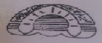
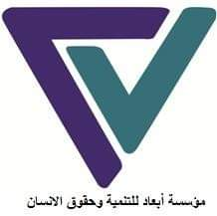
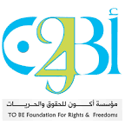
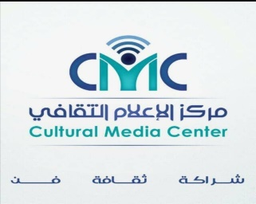
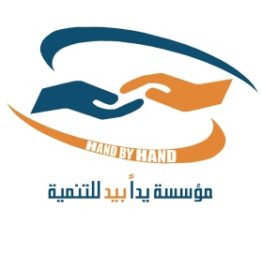
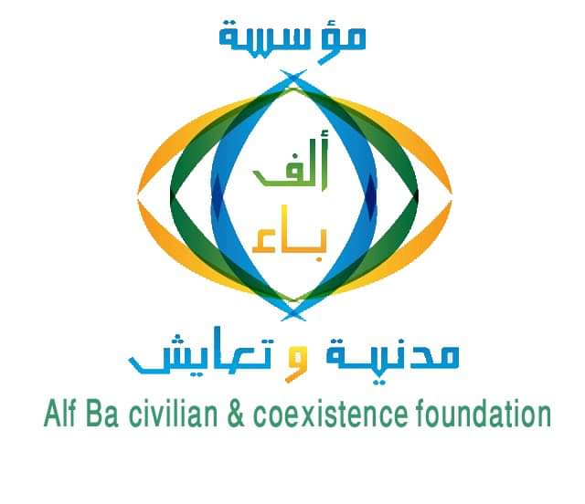
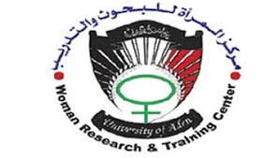

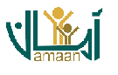
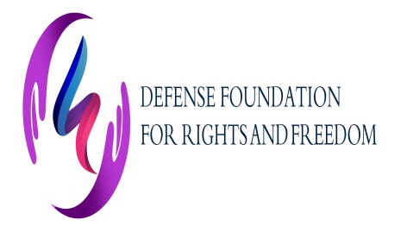
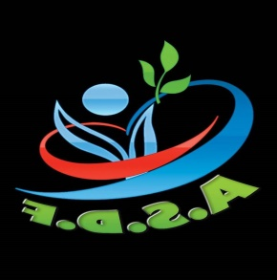
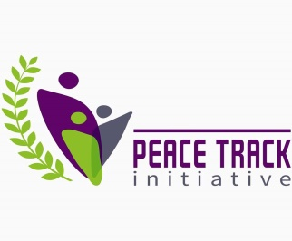
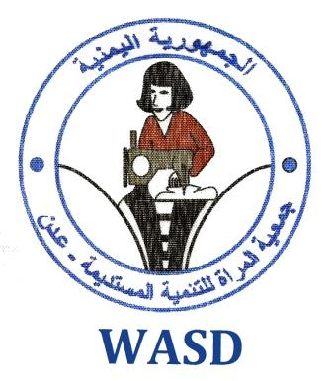
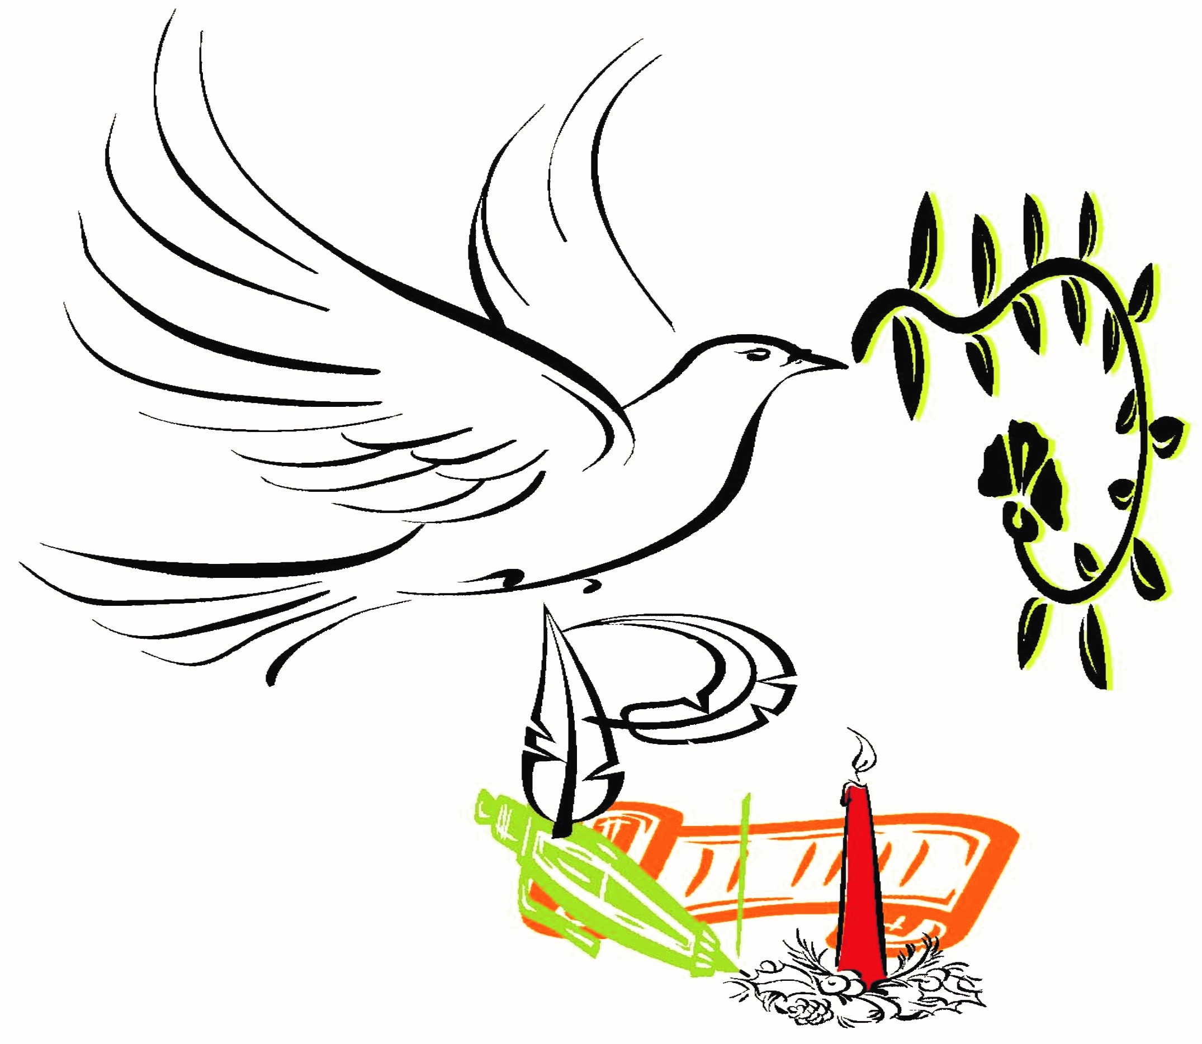
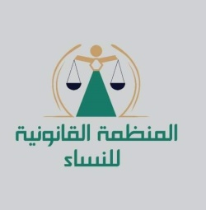
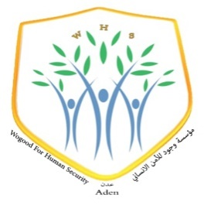
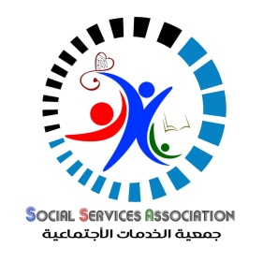
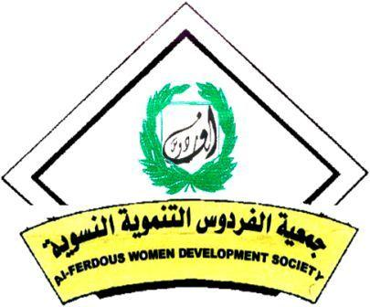

Work List of "Reporting By Civil Society Organization to SEDAW 2020
entity | e-mail | Name |  | No.
Alliance members
Women's Legal | ekramaidros@yahoo.com |  | Ekram Al-Edroos |  | 1
Wogood for Human Security | ansamhaidarah@gmail.com |  | Ansam Haidarah |  | 2
Peace Track Initiative | ngamal@peacetrackinitiative.org |  | Nadia Gamal |  | 3
Women of the most vulnerable | Ssaued599@gmail.com |  | Samera Saeed |  | 4
Arman | foundationarman@gmail.com |  | Naseem Ahmed |  | 5
AL-fardous women development Society | sameeranasr@gmail.com |  | Sameera Nasr |  | 6
Yemen Women Union | Nadiaaanadiaaa77@gmail.com |  | Nadia Al-Akbree |  | 7
Women Research &|Training | d-huda-alawi@yahoo.com |  | Huda Alwai |  | 8
Women Aden | _ |  | Amal Abdulkadeer |  | 9
Women for Sustainable Development | wasdyemen@yahoo.com |  | Salwa Othman |  | 10
Alf. Ba Civil & coexistence | Bahiah.c.c@gmail.com |  | Bahia Al-sakaf |  | 11
To Be for Rights and Freedom | foundation.tobe@gmail.com |  | Laila Al-shabebi |  | 12
Aba'd for development & Human Rights | jiabzm@yahoo.com |  | Jiab Gaber |  | 13
Cultural Media ‎ | Wedad7772@gimil.com |  | Wedad abdo |  | 14
Advisory | eshraqh1@gmail.com |  | Ashraq almqtary |  | 15
Wogood for Human Security | mahaawedh@gmail.com |  | Maha Awadh |  | 16
Social Services | ssa_2004@hotmail.com |  | Rasena Yaseen |  | 17
Social Relief & Rights | Afraa2008@gmail.com |  | Afra Hariri |  | 18
Peace Track Initiative | nisma.Mansour@peacetrackinitiative.org |  | Nasmh Mansour |  | 19
Aden for Monitoring Studies | Aden.cmst@gmail.com |  | Qasem Dawood |  | 20
Women center | Zahra.sos@hotmail.com |  | Zahra Saleh |  | 21
Ministry of Health | Dr.nasrindakik@gmil.com |  | D / Nasrin dAkik |  | 22
Ministry of Interior | _ |  | Alia Saleh |  | 23
Mothers of Abductees & Detainees | amataslam@gimil.com |  | Amah alsalam Al-Hajj |  | 24
Adra organization | _ |  | Nusseibah Ahmed |  | 25
Adra organization | _ |  | Sahar Noureddine |  | 26
Affairs Of Yemen Returnees Home | nalgabriy@gmail.com |  | Shada Al Jabri |  | 27
Women & Child Rights Department | _ |  | Mona Saleh |  | 28
Defence for Rights & Freedoms | a.ziad31@yahoo.com |  | Ziad Mohammed |  | 29
National Forum for Human Rights | _ |  | Khaled Ayesh |  | 30
UN Women | Aber.noman@unnwomen.org |  | Abeer Noman |  | 31
Female police | Ndyta080@gmail.com |  | Nadia Obaid |  | 32
Ministry of Education | _ |  | Ibtisam Qasim |  | 33
Ministry of Justice | manalsl1967@gmail.com |  | Dr. Manal Suleiman |  | 34
Central Statistical | Cso.aden@gmail.com |  | Wael Ali |  | 35
Aden for Studies, Monitoring & Training | arwaam@hotmail.com |  | Arwa Al-Muflehi |  | 36
Tagdid | abeefahim@outlook.com |  | Abeer Fahim |  | 37
Social Affairs | _ |  | Fatima yaslam |  | 38
Ministry of Media | Fardaos.67@gmail.com |  | Firdous Mahmoud |  | 39
Literacy and Adult Education | Nabilah79@yahoo.com |  | Nabila Ahmed |  | 40
Department of Graduate Studies Women's | DR.asmaahmed@gmail.com |  | Dr. Asma Al-Rimi |  | 41
Aden University | Nadia.sallam@gmil.com |  | Dr. Nadia Haider |  | 42
Cultural Media | samahdma@hotmail.com |  | Samah Emdad |  | 43

Republican Decree Law No. (48) of 1991 regarding the organization of prisons, amended by Law No. (26) of 2003, in Articles 23, 24 and 25 of Chapter Five regarding the health care of prisoners
https://www.wilpf.org/portfolio-items/yemeni-women-map-the-road-to-peace/
The Status of Yemeni Women: From Aspiration to Realizing Opportunities, World Bank, May 2014
Care and others. Gender Analysis and Conflict in Yemen, 2016, p. 25, available at: https://www.carenederland.org/wp-content/uploads/care/uploads/2016/11/Yemen-gender-conflict-analysis-201016- en.pdf. P. 24
The OCHA Report 2017 Overview: Yemen, 2016, p. 11, available at: http://reliefweb.int/sites/reliefweb.int/files/resources/YEMEN%202017%20HNO_Final.pdf
Care and others., Gender Analysis and Conflict in Yemen, 2016, p. 25,
Report of a survey monitoring cases of violations, gender-based violence and harm to women, prepared by Women National Committee July 2016.
Joint Paper 1, Report on the Universal Periodic Review in Yemen, 2013, p. 2, see the following link: https://uprdoc.ohchr.org/uprweb/downloadfile.aspx?filename=519&file=EnglishTranslation
Special reference
Internal Displacement Monitoring Center, Global Report on Internal Displacement, 2016, pp. 25-26. P. 39. Save the Children, Yemen’s Forgotten Children: The Urgent Case for Funding Education and Child Protection, 2017, p. 2, available at: https://www.savethechildren.org.uk/sites/default/files/documents/Yemen-Brief-FundingEducationChildProtection-April2017.pdf
Ibid., P.40.
UN Office for the Coordination of Humanitarian Affairs, Humanitarian Needs Overview: Yemen, 4 December 2017, p.3,
The previous reference
https://carpo-bonn.org/wp-content/uploads/2018/10/Rethinking-Yemen%E2%80%99s-Economy-policy-brief-8.pdf
Ministry of Civil Service
https://reliefweb.int/sites/reliefweb.int/files/resources/bn-missiles-food-security-yemen-201217-en.pdf
Report of a survey monitoring cases of violations, gender-based violence and harm to women, prepared by the National Committee for Women, July 2016.
Internal Displacement Monitoring Center, World Report on Internal Displacement, 2016, pp. 25-26. 2016, http://www.internal-displacement.org/assets/publications/2016/2016-global-report-internal-displacement-IDMC.pdf
Ibid.P, 9
Report of National Women's Committee, July 2016
Internal Displacement Monitoring Center, Global Report on Internal Displacement, 2016, pp. 25-26.
Law No. 20 of 1992 (Personal Status Law), Article 40 (2).
50Study of knowledge and attitudes of issues of gender-based violence and reproductive health in the governorates (Ibb, Hadhramaut, Al Hudaydah, Abyan, Lahj) - Preparation of Sabriet al-Taur, Tariq al-Kibsi, Chapter Three: Patterns and Determinants of Violence (Early Marriage), December 2013
Al Shaibany, S. and Al Wasmi, N., “Child marriage on the rise as conflict in Yemen continues”, The National, 17 April 2018, available at: https://www.thenational.ae/world/mena/child -marriage-on-the-rise-as-conflict-in-yemen-continues-1.722499.
Article 239 of the Law

