Alternative Report to the Committee on the Elimination of Racial Discrimination (CERD)  REVIEW OF THE PERIODIC REPORT OF  THE ISLAMIC REPUBLIC OF IRAN  Impact Iran  Kurdistan Human Rights Network  ARTICLE 19  Ensemble contre la peine de mort  Rasank  Ahwaz Human Rights Organization  Balochistan Human Rights Group  Kurdistan Human Rights Association - Geneva  All Human Rights for All in Iran  Siamak Pourzand Foundation  PEN America  Kurdpa Human Rights Organization  113th Session of the Committee on the Elimination of Racial  Discrimination (CERD) Geneva, 5 to 23 August 2024  Contact: Roozbeh Mirebrahimi - roozbeh@impactiran.org | 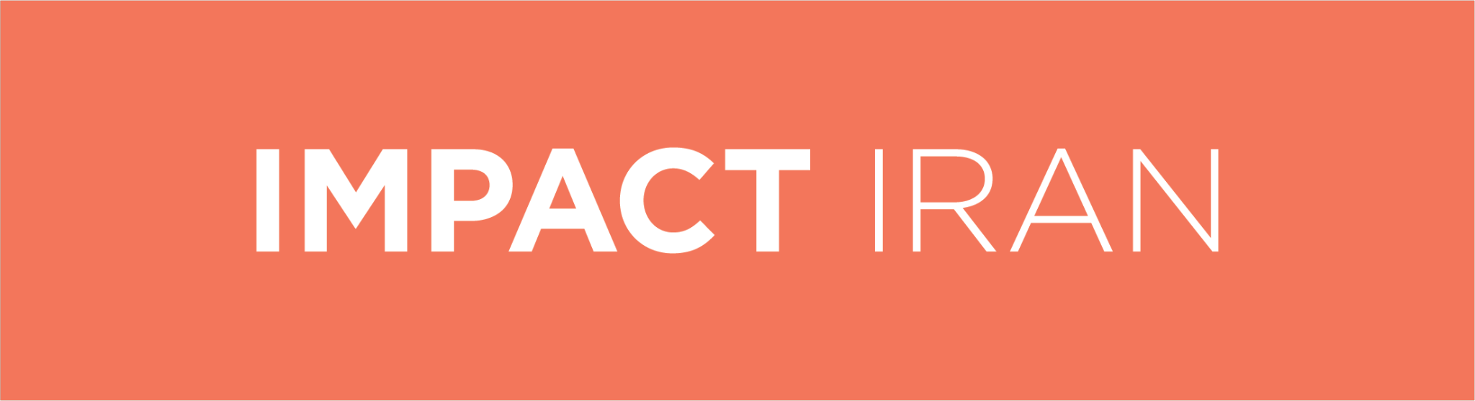  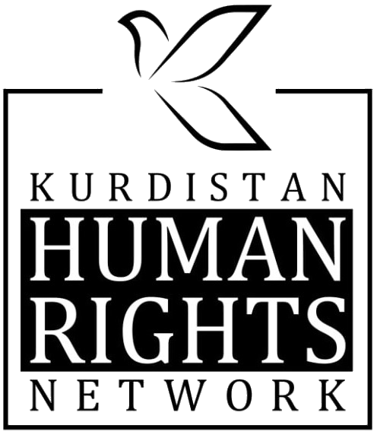  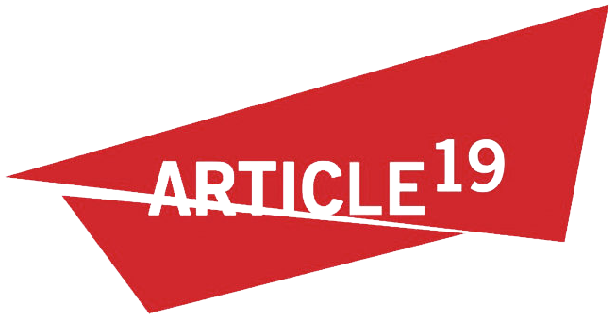  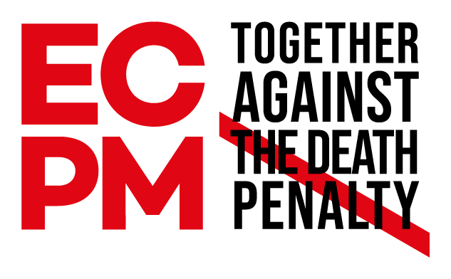  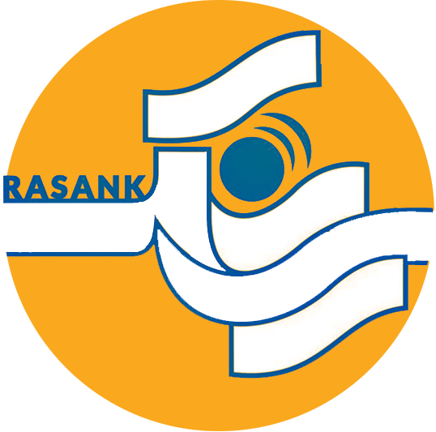  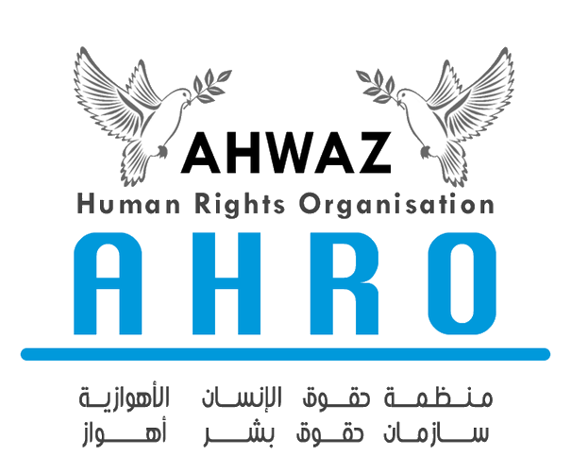  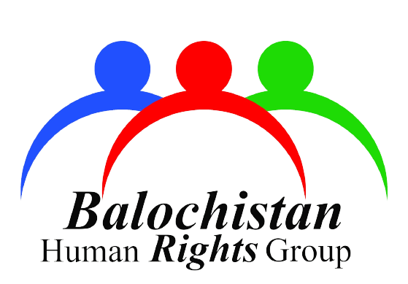  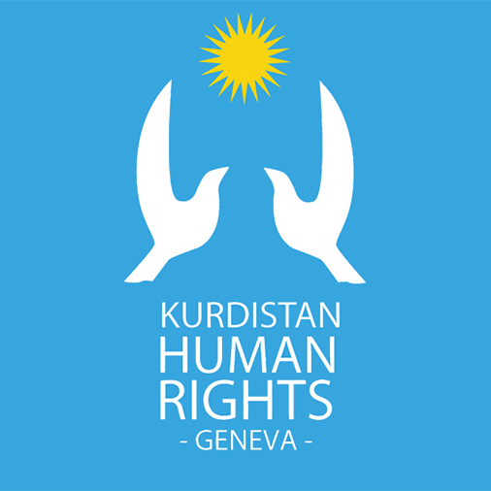  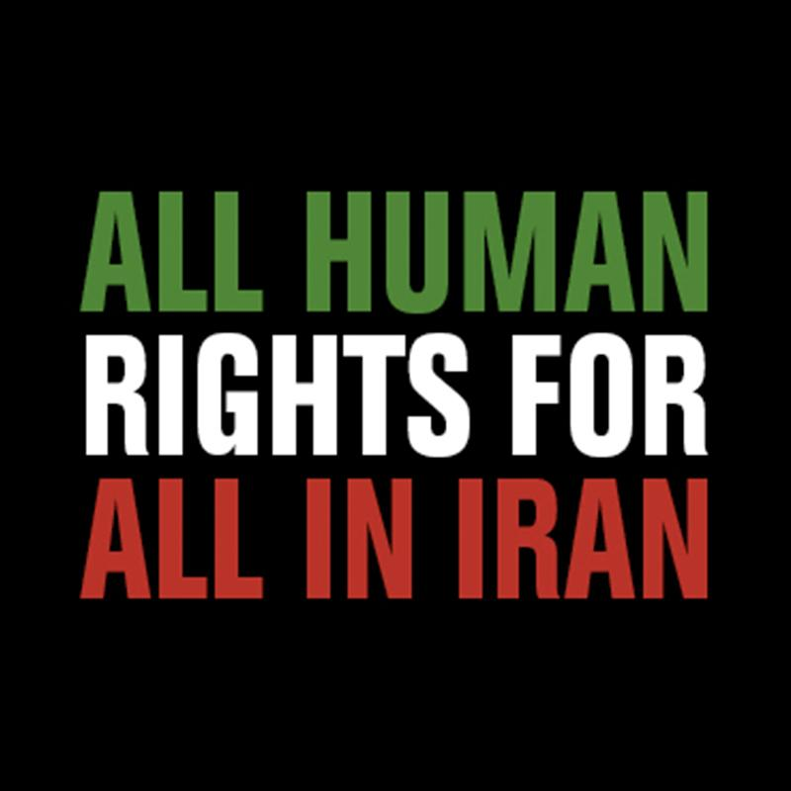  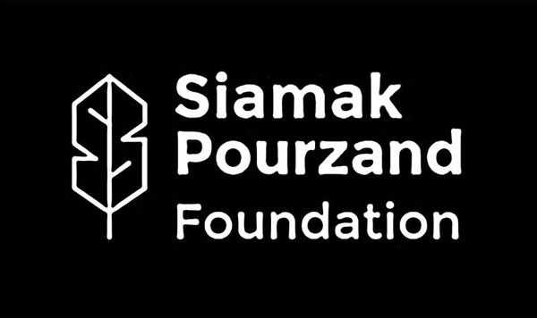  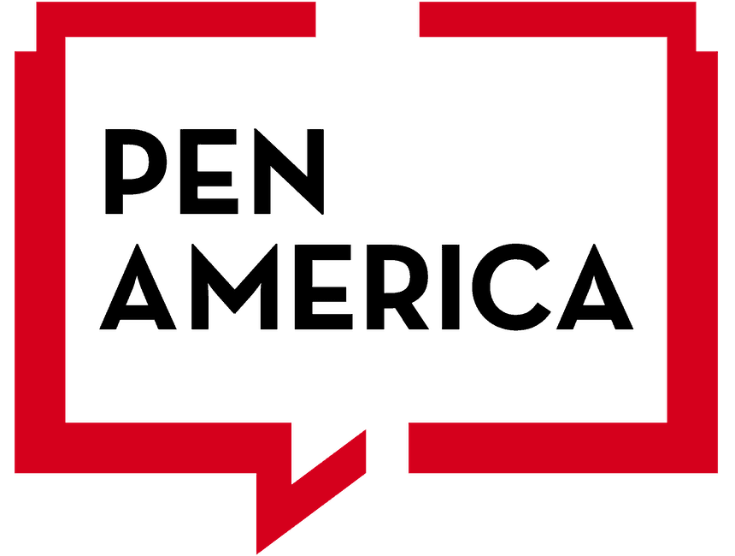  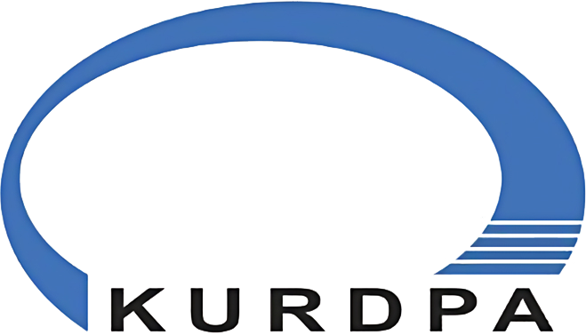

1. Introduction
- The situation of ethnic minorities in Iran has significantly worsened since the last review by this Committee. Human rights violations have escalated, compounding repression and marginalization. The violent state crackdown of nationwide protests in 2019 and 2022 saw a disproportionate impact on ethnic minorities, who were subjected to gross violations of human rights and crimes under international law, including the crimes against humanity, in 2022, of murder, torture, imprisonment, enforced disappearances, and rape and sexual violence, highlighting the targeted suppression and persecution of these groups.
- Systemic rights violations against minority groups in Iran emanate in the first place from laws that effectively sanction discrimination. They further arise from pervasive institutional, political and social practices aimed at systematically marginalizing and suppressing minorities, and curbing their political, linguistic, and cultural presence in Iranian society. In flagrant breach of the principles of equality and non-discrimination, which are central to human rights, state policies intentionally and severely deprive various minority groups of their fundamental rights on the basis of their actual or perceived ethnic origin or religion or belief. These laws and practices do not merely result in discrimination by happenstance; rather, they demonstrate a deliberate plan and intent by the state to marginalize and suppress ethnic minorities, curtailing their development and forcing assimilation into the dominant cultural paradigm.
- This submission relies on a range of evidence and sources to establish the ongoing persecution of ethnic minorities, including Kurds, Baluch, Ahwazi Arabs, Azerbaijani Turks, Turkmen, who may also belong to religious minority communities, including Sunni Muslims, Sufis, Yarsan, Bahá'ís or Christians. They include testimonies from victims and witnesses; laws, decrees, and rulings; court documents; official statements and state propaganda promoting hatred against targeted groups; media articles and reports by human rights organisations documenting patterns of discriminatory policies and practices as well as human rights violation and crimes under international law such as torture, enforced disappearances, sexual and gender-based violence, and extrajudicial executions.
- The cumulative impact of discriminatory actions by the State has been devastating for ethnic minority groups in Iran. These communities have faced extensive socio-economic disenfranchisement, with restricted access to education, healthcare, and employment opportunities, severely limiting their ability to thrive. The suppression of cultural and religious practices has eroded their traditional identities and heritage, causing significant psychological and emotional trauma. Politically, these groups are largely excluded from meaningful participation, eradicating any platform for advocacy or reform. As a result, ethnic minorities in Iran endure systematic marginalization, where their voices are silenced, and their potential is systematically undermined. This pervasive and intentional suppression has fostered an environment of fear further hindering the ability of these communities to freely exercise their human rights.

2. Overview of Ethnic Diversity in Iran
- Iran is a mosaic of diverse ethnic, linguistic, and religious groups. With a population exceeding 82 million, the Iranian government does not publish data on language or ethnicity, making it difficult to accurately assess the country's demographic composition. The UN Committee on the Elimination of Racial Discrimination urged Iran in 2003 (and again in 2010) to provide information on its ethnic makeup, emphasizing the principle of self-identification. However, the government has consistently ignored these requests, including in its latest submission in February 2022.
- Despite the lack of official data, statements from Iranian officials have highlighted Iran’s linguistic and ethnic diversity. In 2009, then-Minister of Education Hamid Reza Haji Babai revealed that 70% of Iranian students were bilingual, with many children not using Farsi as their primary language even after first grade. Additionally, reports from NGOs and UN experts indicate that Iran's population includes various ethnic groups such as Persians, Azerbaijani Turks, Kurds, Lurs, Baluch, Ahwazi Arabs, Turkmens, Armenians, Assyrians, and the Afro-Iranian minority.
- The Iranian government often asserts that Kurds, Baluch, Azerbaijani Turks, Turkmens, Ahwazi Arabs, Lurs, and Persians are "ethnic groups" rather than minorities and dismisses terms like "Ahwazi Arab ethnic minority" as fabricated. This distinction between ethnic groups and minorities is politically and socially significant. Ethnic groups, as the government describes, include distinct communities sharing a common language, culture, and heritage, such as Persians, Kurds, Baluch, and Azerbaijani Turks. By referring to these communities as "ethnic groups" rather than "minorities," the government suggests inclusivity within a unified Iranian identity, often downplaying their distinct characteristics of culture, religion and/or language and challenges and opportunities. Labeling these groups simply as ethnicities allows the government to overlook the unique issues they face, such as cultural erasure, unequal access to resources, and political marginalization. This semantic distinction serves as a tool for the state to minimize their grievances and demands for greater autonomy, cultural recognition, and equal rights, thereby maintaining the status quo and centralizing power.

3. Intersectional discrimination: Women and girls belonging to ethnic minorities
- Intersectional discrimination involves overlapping social identities and systems of oppression, recognizing that individuals face unique challenges due to multiple factors like ethnicity, religion, gender, or socioeconomic status. In Iran, intersectional discrimination is particularly severe for women and girls of ethnic minority backgrounds, heightening their marginalization and vulnerability.
- From birth, their gender, ethnic background, and religion set them apart, leading to lifelong struggles. As children, women and girls face societal expectations and limited opportunities. Girls belonging to ethnic minorities in Iran are more likely to live in poverty and lack basic amenities due to chronic underdevelopment in minority-populated provinces, often resulting from systemic neglect and government policies that fail to address their needs. Schools in minority-populated provinces are often underfunded, with few resources and poorly trained teachers. Other barriers include inadequate educational facilities in minority areas, cultural biases favoring male education, and state neglect in addressing gender disparities. Consequently, these girls often drop out of school early or never attend, limiting their future opportunities and perpetuating cycles of poverty and discrimination. Intersecting and compound discrimination exacerbate minority women’s precarious positions, creating a vicious cycle of further marginalization and socio-economic and political exclusion.
- Poverty is commonly understood as being one of the key drivers of child marriage. Official data shows that child marriages are increasing each year, especially in minority provinces. These areas have the highest rates of child marriage, significantly impacting the lives of women and girls. Child marriage is a key driver of school dropouts. One survey conducted in 2016 revealed that about 37.5% of married children, boys and girls, were illiterate. Authorities reported that only 40% to 50% of girls in minority-populated border provinces complete high school, and NGOs, highlight that the number of female-headed households, many led by girls under 18, in Sistan and Baluchistan Province (Iran’s poorest province) is growing.
- Iranian laws not only enable impunity for perpetrators of sexual and gender-based violence, but, in some cases, sanction them, thus deepening discrimination against women and girls. The Penal Code, for instance, allows male guardians significant control over women’s lives. Marital rape is not criminalised and violence against women falls under the general assault provisions meaning domestic and other forms of violence against women are not adequately criminalised. Generally, witnesses must corroborate the victim's testimony, an almost impossible demand in private settings. This legal framework enables abusers and discourages survivors from seeking justice, knowing the law may not support them.
- Because of their gender and ethnic identities, women belonging to minority groups face frequent and severe encounters with the state's oppressive laws. The so-called morality police, and other policing authorities, scrutinize them not only as women but also as members of ethnic and religious minorities, subjecting them to harsh punishments. The death of Kurdish Iranian Jina Mahsa Amini while in the custody of the morality police on 16 September 2022, for allegedly not wearing the “proper hijab,” exemplifies the systematic violence and persecution faced by women and girls belonging to minorities in Iran. A year after her death, on 1 October 2023, Armita Garawand, who was also Kurdish Iranian, was hospitalized with a brain injury following an encounter with the morality police in Tehran’s subway, reportedly for not wearing a hijab. Her family reported state pressure to refrain from speaking about her situation and prevention from burying her in her home city of Kermanshah.
- Socio-economic sanctions against women who do not abide by the compulsory veiling laws and policies further compounds the economic hardship women from minorities face. The pending “Hijab and Chastity Bill,” foresees the de facto economic paralysis of women who do not abide by the states’ discriminatory dress requirements. As currently proposed, the draft compels women and girls to adhere to mandatory veiling, or see themselves facing severe repercussions, ranging from being denied employment opportunities, access to public services such as education and healthcare, and essential commodities, to passport confiscations, exorbitant fines, and incarceration. Many aspects of the bill depriving women and girls of basic rights and services have already been and continue to be implemented through other laws and state policies. Given the precarious economic situations in which many women belonging to minorities find themselves, these sanctions have a disproportionate impact on these segments of the population. Minority women and girls who do not comply with Iran’s repressive dress laws and/or protest against them, thereby exercising their rights to freedom of expression, religion and belief and equality face arrest, detention, judicial prosecution and punishments, and violence from security forces.
- Discrimination limits minority women’s job opportunities, restricting access to decent, higher-paying work. Women from minority backgrounds face additional obstacles due to marginalization and exclusion that limit their mobility and autonomy. These barriers perpetuate economic disparities, putting many women belonging to minorities at greater risk of poverty.

4. Freedom from discrimination in the enjoyment of civil, and political rights

4.1. The Right to Life

a. The use of the death penalty against ethnic minorities
- International monitors report that ethnic minorities in Iran are disproportionately sentenced to death and executed. According to KMMK-G data, from 1 January to 29 May 2024, authorities executed at least 285 individuals, including 82 Kurds and 36 Baluch. In 2023, although Baluch individuals made up only an estimated 2% of Iran's population, they accounted for 20% of at least 830 executions, a disproportionate rate also reported in previous years. Human rights organizations also consistently report that Ahwazi Arabs are more likely to receive death sentences compared to members of the Persian communities.
- In Iran, most executions of ethnic minorities are related to drug offenses, which do not amount to “the most serious crimes”, defined under international law as crimes resulting directly and intentionally in death. Impoverished and marginalized communities are disproportionately represented among those sentenced to death for such crimes. Authorities rarely announce these executions publicly and often carry them out in secrecy, making reporting difficult and in turn severely hindering accountability. From 2017 to 2023, only 3% of drug-related executions documented by NGO, Iran Human Rights (“IHRNGO”) were reported by official sources, compared to 20% for all executions. Despite the lack of transparency and public acknowledgment, the impact is significant, instilling fear within the families, friends, and communities of the victims, effectively communicating a message of intimidation.
- Furthermore, targeting the most marginalized members of society, including impoverished ethnic minorities, incurs minimal political costs for the Iranian government. These groups often lack the resources and influence to resist or attract significant international attention. By focusing repressive measures on communities with limited protection and opportunities for advocacy, the authorities minimize the risk of backlash or international condemnation. Consequently, the suffering of the most vulnerable often goes unnoticed and unresolved, perpetuating cycles of disadvantage and oppression.
- Political dissidents from these communities also face heightened risk as the state often resorts to the death penalty to quash dissent and maintain control. A significant proportion of those executed for their political beliefs or group affiliations belong to ethnic minorities. According to IHRNGO and Ensemble Contre la Peine de Mort (“ECPM”), between 2010 and 2023, 154 individuals were executed on political and national security charges. Of these, 49% were Kurdish, 45% Baluchi, and 24% Ahwazi Arab. In 2019, the UN Special Rapporteur on human rights in Iran highlighted that Kurdish political prisoners charged with national security offenses constitute nearly half of the total number of political prisoners in the country and faced disproportionately high rates of death sentences and executions.
- The UN Special Rapporteur on Iran has stated that "the serious shortcomings in the legal framework and justice system, together with systemic violations of due process and fair trial, render most, if not all, executions in the Islamic Republic of Iran arbitrary deprivation of life." Judicial proceedings, including those leading to the pronouncement and implementation of death sentences, systematically violate due process and fair trial guarantees. Defendants are regularly subjected to torture and ill-treatment, and coerced into making confessions, while denied access to independent lawyers of their choice and effective legal assistance.
- The impact on minorities is thus compounded given that death sentences are meted out by a judicial system that disproportionately targets minorities. Reports indicate that ethnic minorities such as Kurds, Baluch, and Ahwazi Arabs are often charged with vaguely worded and broadly defined capital offenses such as "enmity against God" or "spreading corruption on earth," charges that are frequently used by the State to suppress dissent and eliminate real or perceived political opposition.
- The UN High Commissioner for Human Rights has highlighted the use of the death penalty as a tool of political repression stating, “criminal proceedings and the death penalty are being weaponized by the Iranian Government to punish individuals participating in protests and to strike fear into the population so as to stamp out dissent [...]”. According to the UN Special Rapporteur on Iran, “the judiciary acts as a repressive organ instead of an independent body towards which individuals can seek recourse.”
- Rights monitors have identified recurring patterns of the use of the death penalty disproportionately and systematically targeting ethnic minorities, particularly following periods of protests in minority-populated provinces. Judicial proceedings leading to the pronouncement and implementation of these death sentences systematically disregard basic due process and fair trial standards. Over the years, reports have documented the State's systemic failure to take accountability measures as well as its deliberate efforts to prevent timely, independent reporting of these executions while silencing justice-seeking families. In the context of a domestic legal framework that fails to protect the rights of ethnic minorities, coupled with institutionalized discrimination and historic impunity, the sheer scale of executions and the cross-country prevalence of these recurring patterns suggest a deliberate and organized effort by the Government to intimidate and repress ethnic minority communities through the imposition of the death penalty, among other actions described throughout this report. These discriminatory practices are exacerbated by a political climate that views ethnic minorities with suspicion and as threats to national unity. The state's emphasis on maintaining a homogeneous national identity results in policies and legislation that favor the majority while penalizing those who deviate from this framework. This perpetuates a cycle of fear and control, silencing ethnic minorities and further marginalizing their communities, thereby reinforcing the entrenched power dynamics that uphold the current political structure.

b. Extrajudicial killings of fuel and border couriers
- According to KMMK-G, at least 42 Kulbar (border couriers) were killed between January and May 2024. KHRN reported 184 injuries among Kulbaran caused by security officers during the same period. Over the past 12 years (2011-2023), KURDPA reported that at least 74% of Kulbars who died while working were either killed or wounded by direct fire from the border security forces of the Islamic Republic of Iran.
- Border couriers, called “Kulbaran'' in Kurdish and “Soukhtbars” in Baluchi, operate in economically marginalized border provinces such as Kurdistan, Kermanshah, Sistan and Baluchistan, and Western Azerbaijan. These couriers often fall victim to extrajudicial killings by Iran’s border agents. They also navigate perilous routes strewn with landmines under harsh weather conditions.
- Civil society organizations consistently report that Iranian border guards deliberately shoot to kill border couriers, based on first-hand accounts and detailed reports of fatal injuries sustained by victims. Many report that security forces frequently fire live ammunition at border couriers in the Kurdish and Baluch-populated regions, resulting in numerous deaths and severe injuries. The UN Special Rapporteur on Iran regularly describes these deaths as "indiscriminate" and "extrajudicial" killings. On 5 March, 2021, the United Nations High Commissioner for Human Rights condemned the use of lethal force by the Islamic Revolutionary Guard Corps (IRGC) and state security forces against unarmed border couriers and protesters from the Baluch minority.
- In July 2020, the UN Special Rapporteur on Iran reported that cases of violence against Kulbaran "are often either dismissed by the courts or closed without conviction or compensation for the victims and their families."
- Iranian legislation governing the use of firearms by state officials and law enforcement, the 1995 Law on the Use of Firearms by Armed Forces in Necessary Instances, contravenes international law as it does not incorporate the principles of legality, precaution, necessity, proportionality, non-discrimination and accountability. It further provides for the use of firearms in a range of circumstances which do not involve protection of life or prevention of serious injury in the face of an imminent threat. . Under Article 3 of the Law, law enforcement officers are allowed to use firearms, among others, for preventing and stopping people who intend to enter or exit from illegal borders and do not pay attention to the warnings of border guards. The Law is thus permissive in its language and fails to promote restraint or prevent the abusive use of lethal force, enabling border guards to use lethal force against border couriers and effectively shielding them and other state agents from prosecution when they unlawfully use lethal force.

c. Other threats to physical and mental integrity
- According to Iranian government statistics, more than 20 million landmines were planted in the minority-populated provinces of Western Azerbaijan, Ilam, Kurdistan, Kermanshah, and Khuzestan during the eight-year Iran-Iraq War (1980-1988). These landmines severely alter the daily lives of the residents of these regions, particularly affecting farmers, nomads, shepherds, and traders. KMMK-G data reveals that from 2015 to May 2020, landmines and unexploded remnants of the Iran-Iraq War resulted in the deaths of 60 civilians and injuries to 173 others. Alarmingly, over 40% of these landmine victims were children. Both the Committee on the Rights of the Child and the UN Special Rapporteur on Iran have urged Iran to clear its territory of landmines and other remnants of the War without delay. Despite Iran’s claims that these provinces are free of landmines, incidents continue to be reported. According to KMMK-G, between January and May 2024, landmine explosions injured 23 Kurdish individuals and killed five in the provinces of Kermanshah, Ilam, Kurdistan, and Western Azerbaijan. Impact Iran Coalition members also report that new landmines have appeared in those locations more recently.

4.2. Freedom of opinion, expression, and peaceful assembly
- Iran remains one of the most restrictive countries in the world regarding freedom of expression. In 2023, it ranked 147th out of 161 countries in ARTICLE 19’s Global Expression Report, and 177 out of 180 in Reporters without Borders’ Press Freedom Index. Reports from the UN and civil society indicate that the systemic and systematic repression of freedom of expression in Iran disproportionately affects ethnic minorities.
- Article 24 of Iran’s Constitution claims to protect freedom of expression, but its exception for content "harmful to the principles of Islam or the rights of the public" allows for widespread censorship. This vague provision enables laws that suppress free expression, particularly targeting minorities and their advocates. As a result, minorities face legal obstacles and punitive actions, hindering their ability to voice grievances and seek justice.
- Iran’s Islamic Penal Code continues to criminalize protected acts and conduct. Its vaguely worded national security offenses, which breach the principle of legality and legal precision, grant authorities broad interpretive powers, thus further criminalizing peaceful activism and cultural activities by ethnic minorities. This ambiguity enables the labeling of minority protests as “secessionist” or “terrorist,” justifying harsh restrictions, increased security measures, and unnecessary and disproportionate use, including of lethal force,, as witnessed during the 2022 protests. Expression of ethnic consciousness and activities to promote the human rights of members of ethnic minorities, or peaceful acts that draw attention to the government’s failure to respect the rights of minorities, have historically been seen by the Iranian authorities as indicators of hostility and support for “separatism” and as such a challenge to its national security. Authorities arrest, convict and sentence ethnic minorities under vague charges such as "gathering and colluding to commit crimes against national security" (Article 610 of the Islamic Penal Code) and "spreading propaganda against the system" (Article 500), or the capital offense of “sowing corruption on earth,” (Article 286). National security laws effectively ban political groups advocating for minority rights.
- These laws, criticized by UN experts for being vague and overly broad, grant Iranian authorities considerable leeway to silence free expression, suppress dissent, and discriminate against ethnic minorities. Activists are subjected to severe penalties, including long prison sentences, flogging, which constitutes torture, and even capital punishment, following unfair trials lacking due process. This further entrenches systemic injustices and fosters a climate of fear, obstructing meaningful progress toward inclusivity and equity within Iranian society.
- In January 2021, the Parliament added two supplementary provisions to the Islamic Penal Code, seemingly attempting to address this shortcoming by criminalizing “insulting legally-recognized religions, Islamic branches, and Iranian ethnicities”. These supplementary Articles further restrict free expression in Iran and aggravate an already extremely restrictive legal framework that authorities rely on to silence Iran’s minorities. The enactment of these amendments has raised significant concerns among human rights organizations, as they further extend the reach of state surveillance and control over personal beliefs and cultural expressions. Critics argue that rather than promoting tolerance and protection, these amendments provide new tools for authorities to target dissidents and minority groups under the pretext of preserving national harmony. This legal tightening complicates the already precarious situation for ethnic minorities, limiting their ability to freely express their cultural, religious, and linguistic identities without fear of reprisal.

a. Patterns of state violence targeting specifically members of ethnic minorities participating in protests
- Documented patterns of state repression of dissent, in particular in the context of successive protests that have engulfed the country over the past few years, reveal that authorities disproportionately use unnecessary and unlawful force, including lethal force, to suppress protests and dissent in provinces with significant ethnic minority populations, such as Kurdistan, Kermanshah, West Azerbaijan, Sistan and Baluchistan, and Khuzestan. The state’s unlawful use of lethal force, including firearms such as military grade assault rifles and metal pellets during protests has resulted in the killing of minorities, including minority children as well as severe, painful and irreversible injuries - including permanent disabilities such as the total loss of vision. Recent notable incidents include:
- November 2019: On 14 November 2019, the Government announced a 50% increase in subsidized fuel prices and its rationing, leading to nationwide protests amid economic hardship. The state responded with unnecessary, disproportionate and unlawful use of force, including lethal force, disproportionately affecting minority provinces. The UN Special Rapporteur on Iran expressed concern over “the Government’s excessive use of force,” reporting high death tolls in Khuzestan and Kermanshah Provinces. Numerous activists from ethnic minorities, including Kurds and Azerbaijani-Turks, were reportedly arrested following the protests.
- July 2021: On 15 July 2021, protests erupted in at least 26 cities in Khuzestan province, predominantly populated by Ahwazi Arabs, over water shortages and grievances regarding basic human rights and governance. The protests, known as “the Uprising of the Thirsty,” spread nationwide and were met with unlawful use of force, including lethal force. Similarly, the UN Special Rapporteur on Iran reported widespread use of unlawful force against protesters, many of whom belong to the Ahwazi Arab minority. The UN Special Rapporteur on Iran reported unlawful use of force against protesters, many of whom were Ahwazi Arabs.
- September 2022: On 16 September 2022, 22-year-old Kurdish woman Jina Amini—known by her government-registered name Mahsa Amini—died in custody after being arrested by Iran’s “morality police” for allegedly not wearing the “proper” hijab. Authorities labeled protesters in ethnic regions as separatists, justifying the use of military forces and violent repression. The Independent International Fact-Finding Mission on Iran (FFMI) referred to a credible figure of at least 551 deaths, including 68 children, and thousands of arrests since September 2022, predominantly affecting minority groups like Baluch and Kurds. Nearly half of all protester deaths occurred in minority-populated regions. Violent crackdown by state forces peaked during the “Bloody Friday” on 30 September 30 2022, in Zahedan, Sistan and Baluchistan where security forces killed between 82 to 103 people, including at least 13 children, and injured approximately 350 protesters and bystanders. The FFMI found that “[w]hile military grade weapons were used across the country… security forces displayed a particularly militarized response to protests that took place in minority regions, as compared to the means and methods used… to repress the protests elsewhere.” The FFMI found that “security forces used military-grade weaponry, such as AK-47s and automatic and semi-automatic and heavy machine-guns, as well as armoured vehicles, and helicopters more regularly in these regions.” It further stated that investigations into use of force incidents in minority-populated areas revealed that “assault rifles were routinely fired on semi-automatic or automatic rounds meaning the weapons fired several bullets or ammunition rapidly at a time. Security forces also deployed such weaponry at a higher rate than they did in other regions or deployed them immediately or almost immediately after the start of the protests.” The FFMI also pointed to incidents where security forces chased and/or targeted persons who were not protesting or when there were no protests taking place at the time, stating that “[s]uch incidents of targeted killing appear to have aimed at creating a general atmosphere of fear in minority populated cities that became epicentres of protests.”

b. Disproportionate representation of members of ethnic minorities in arrests and detention statistics
- The systemic discrimination against ethnic minorities in Iran results in over-policing, ethnic profiling, and biased sentencing, leading to high incarceration rates and disproportionate representation among those sentenced to death. As of June 2024, the Iran Prison Atlas database, managed by the NGO United for Iran, documented 1,306 verified cases of political prisoners in Iran. Among them, at least 42% (561) were Kurdish and 16% (219) were Baluch. Given that Kurds and Baluch are estimated to comprise 10% and 2% of the Iranian population respectively, this data highlights the disproportionate detention rates for these ethnic minorities related to protests and free expression.
- The Kurdistan Human Rights Association - Geneva (“KMMK-G”) reported the arrests of at least 329 Kurdish individuals between January and May 2024. Many of these ethnic minority members faced charges and convictions for national security-related offenses, such as “propaganda against the system,” “insulting the Supreme Leader,” leading “illegal gatherings,” and affiliation with opposition groups or activities tied to ethnic cultural expressions, including Nowruz celebrations.

4.3. Administration of Justice
- For decades, human rights organizations and UN experts have documented and reported a crisis of grossly unfair trials and due process violations in Iran. Violations of fair trial rights, committed on a large scale and systematic manner, include denial of the right to access a lawyer of one's choice following arrest and hasty proceedings sometimes lasting only a few minutes, held behind closed doors, and often leading to severe and irreversible punishments, including death sentences. Courts frequently rely on forced confessions obtained through torture and ill-treatment, often when detainees are held in prolonged solitary confinement, to convict and sentence defendants. Reports also document inhumane detention conditions including overcrowded prisons, inadequate food and water, poor hygiene and denial of access to adequate medical care. Additionally, there is an absence of genuine appeal processes in both law and practice.
- As detailed below, ethnic minorities are at risk of further violations within the justice system due to institutionalized and pervasive discrimination based on their ethnic and religious identities. The disproportionate execution rates of ethnic minorities is emblematic of the systemic discrimination they face within the judiciary.
- Members of ethnic minorities are disproportionately targeted with national security-related charges for peacefully exercising their freedom of expression and association. Under Iranian law, individuals facing such charges must select their legal counsel from a limited list approved by the Head of the Judiciary, meaning they are deprived of the right to access an independent lawyer of their choice during the investigations. Moreover, national security offenses fall under the jurisdiction of Revolutionary Courts. As human rights organizations and UN experts and bodies have persistently highlighted, fair trial violations are further exacerbated during proceedings before Revolutionary Courts given the application of procedures pertaining to national security offenses including additional restrictions regarding access to a lawyer, casefile material and written copies of judgments. Revolutionary Courts are disproportionately used to try human rights defenders, as well as members of ethnic, religious, and linguistic minorities. In 2023, more than 500 death sentences were issued by Revolutionary Courts.
- Human rights organizations also argue that many ethnic minorities are unaware of their rights under Iranian and international law, facilitating abuses by security forces and violations of their right to a fair trial and due process. Access to justice for ethnic minorities is further undermined by the lack of special measures to ensure equal access. Interrogations and court proceedings are conducted in Farsi, without interpretation for those not proficient in the language. At the end of interrogations, the accused must sign statements translated into Farsi, which they cannot read, placing them at a serious risk of self-incrimination. Additionally, the vulnerability of ethnic minorities to poverty makes it extremely difficult for them to afford legal assistance in turn further placing them at risk of torture and ill-treatment and coerced confessions.
- Ethnic minorities are not only disproportionately at risk of being caught in the State’s machinery of repression, but, in a landscape of structural and historic impunity, have a further diminished chance of access to truth, justice and reparation. In its March 2024 report, the FFMI noted that "[t]he lack of accountability for human rights violations in minority-populated areas has been the norm rather than the exception.” It further found that state authorities systematically denied killings committed by their security forces, particularly in minority-populated regions, attributing them to “opposition groups,” “terrorists,” and “unknown elements.”
- The lack of identity documents also obstructs access to justice for ethnic minorities. Courts often require a DNA test to verify identity, which can be prohibitively expensive for those in severe poverty. The absence of ID documents in regions like Sistan and Baluchistan means that even the deaths of some undocumented victims, including children, remain unacknowledged. Families intending to pursue justice face significant challenges in verifying both their identity and the victim’s identity.

4.4. Participation in Political & Public Life
- Although ethnic minorities comprise a substantial portion of the population in various regions, their participation in political processes, where citizens influence government actions, decisions, and the distribution of power, remains extremely limited.
- This underrepresentation is pronounced at the provincial level. Provinces with significant ethnic minority populations, such as Kurdistan, Sistan and Baluchistan, and West Azerbaijan, encounter challenges due to centralized control and the appointment of provincial governors by the central government. These appointments often fail to reflect the demographic composition of the provinces, resulting in a disparity between the ethnic makeup of the population and their political representation. At the county level, official data from 2021 reveals that less than 1% of the 324 counties situated across Iran's 31 provinces are represented by individuals from ethnic minority communities. This limited representation at the county level reflects broader systemic issues within Iran's political framework that hinder minority participation in local governance.
- Minorities also face significant challenges in accessing public life, even at more local levels. They remain underrepresented across the 1,800 to 2,700 districts that comprise the country's provinces, including areas with substantial minority populations. As the most localized form of governance beyond the city level, these municipalities are uniquely positioned to understand and address the specific needs and concerns of their communities. In theory, if these bodies act independently and democratically, their closer proximity to the population enables them to serve as the front-line entities for facilitating the inclusion of local voices, particularly those of ethnic minorities, in decision-making processes. However, systemic discrimination and policy constraints often undermine this ideal, resulting in the underrepresentation of ethnic minorities within these local structures.
- In September 2017, protests erupted in Ahvaz amid suspicions of electoral fraud when only three out of 13 district seats were won by Ahwazi Arab candidates. The Ahwazi Arab community, a significant portion of the population in Ahvaz Province, reportedly perceived the outcome as intentional exclusion from municipal decision-making processes. These protests highlighted broader issues of political marginalization and the barriers ethnic minorities encounter in their efforts to achieve fair representation and participation in public life.
- Ethnic minorities are also underrepresented in national institutions, including the 290-seat Iranian Parliament (Majlis). The parliamentary election law bans candidates affiliated with parties deemed illegal or those convicted of actions against the Islamic Republic—charges often levied against ethnic minority advocates for their peaceful activities. The structure of the Iranian Parliament, like other national offices, does not proportionately reflect the country's diverse population.
- Iran's legislative framework significantly restricts the political opportunities for ethnic minorities to compete for and secure representation within political institutions at all levels. The Constitution enforces stringent criteria for high-ranking positions, requiring adherence to Shi’a Islam as well as belief and adherence to the principle of the “absolute rule of the Islamic jurist”. Consequently, Kurds, Turkmen, and Baluch—who are predominantly Sunni—as well as other religious minorities, are effectively barred from occupying roles such as the President, Supreme Leader, and members of the Guardian and Expediency Councils. Additionally, the parliamentary election law prohibits candidates affiliated with parties deemed illegal or those convicted of actions against the Islamic Republic—charges often directed at ethnic minority advocates for their peaceful activities. The Government bars ethnic minorities from creating political parties or advocacy groups, and minority rights activists, including cultural rights defenders and environmental rights defenders, are regularly harassed and accused of promoting separatism or terrorism. Minority activists are frequently arrested, detained, and sentenced based on real or perceived political affiliations deemed a threat to the Islamic Republic, preventing them from running for office.
- Gozinesh, meaning "selection" or "choice," is a vetting process in Iran for public sector jobs, education, and some private sector roles. This process enforces ideological alignment, thereby excluding individuals on the basis of - among others - their religious and political beliefs. This further marginalizes ethnic minorities and hinder their socioeconomic mobility by excluding those who do not conform to state-sanctioned ideologies, thus perpetuating systemic discrimination and oppression. Furthermore, the Guardian Council routinely disqualifies ethnic minority candidates in Iran. These exclusionary practices marginalizes minority voices and perpetuates systemic inequities, undermining the democratic process and fostering disenfranchisement.
- Socioeconomic disparities in minority-populated provinces, including economic hardship, high illiteracy, poor healthcare, and limited native language services, also hinder political participation. These barriers deepen marginalization, preventing ethnic minorities from gaining political influence and achieving fair representation. As long as biases in political, legal, and administrative frameworks persist, inclusive governance remains a challenge.
- State surveillance and restrictions also limit the participation of members belonging to ethnic minorities in public life. NGOs and community groups must navigate a challenging registration process and face constant surveillance to ensure they do not engage in activities deemed against national interests. Additionally, legislation exists that restricts the ability to gather and organize, requiring permits for public meetings and making it difficult for these groups to operate freely. Governmental control extends to cultural expressions as well. Festivals, educational programs, and local initiatives often face bureaucratic hurdles or outright bans if they are perceived to promote ethnic identity over national unity. These cultural celebrations, crucial for maintaining ethnic identity and solidarity, are thus targeted through stringent regulations, limiting the ability of minorities to express and preserve their unique cultural heritages openly.

5. Freedom from discrimination in the enjoyment of economic, social and cultural rights
- The laws and practices that exclude minorities from political life in Iran have far-reaching consequences beyond mere political underrepresentation. They contribute to a broader climate of economic and social marginalization for ethnic minorities. Politically, these exclusionary practices disempower minority communities, preventing them from effectively advocating for their rights and interests. This disenfranchisement results in unresponsive governance and policies that fail to address the unique challenges these communities face.

5.1. Poverty and persistent structural discrimination and marginalization of ethnic minorities as human rights issues
- Economically, denying ethnic minorities the right to fully participate in decision-making processes, especially in poverty-reduction strategies, hinders poverty alleviation and worsens socioeconomic disparities. Discriminatory measures such as gozinesh limit their socioeconomic mobility, restricting access to quality education and economic opportunities. Minority groups in Iran, facing structural marginalization, are generally among the poorest. Compared to the general population, they experience higher poverty levels and have less access to education, employment, healthcare, and basic services. They often live in inadequate housing and rely on poorly resourced schools, health facilities, and public goods. Systemic discrimination creates a complex web of human rights violations affecting almost all aspects of their lives, with intergenerational impacts resulting in long-lasting debilitating effects.
- The World Bank noted in April 2024 that despite a general decline in poverty across Iran, significant regional disparities persist, particularly in rural and southeastern areas. Minority populated provinces in Iran, such as Sistan and Baluchistan, Khuzestan, Kurdistan, Ilam, Kermanshah, and West Azerbaijan, endure the highest poverty rates, far above the national average. While the national poverty average rate is estimated at 30%, it is reported to be higher than 50% in Sistan and Baluchistan. According to the UN Special Rapporteur on Iran, Sistan and Baluchistan is the most underdeveloped area, with the highest rates of poverty, infant and child mortality, and the lowest life expectancy and literacy rates. An estimated two-thirds of the province lacks access to clean water. The southeastern provinces, especially Sistan and Baluchistan, face severe poverty, with rates significantly above the national average.In 2020, 32% of poor households in Iran were in the southeastern and northwestern regions, which house only 20% of the total population. Conversely, only 24% of the poor live in the Tehran metro area and the central region, which accommodate 40% of the population.
- Moreover, the oil-rich province of Khuzestan, primarily inhabited by Ahwazi Arabs, shows some of the lowest socio-economic indicators in Iran and reportedly one of the highest suicide rates due to dire social and economic conditions. Poverty rates in West Azerbaijan have also more than tripled from 13.6% in 2011 to 44% in 2020.
- These conditions have triggered protests in Iran since at least 2017, highlighting severe economic and environmental crises that disproportionately impact peripheral regions and marginalized communities. Demonstrations often focus on acute water shortages, unemployment, and poor living conditions. Despite the peaceful nature of many protests, demands for change by minority communities are met with extensive state violence and repression. Security forces frequently respond with unlawful force, including live ammunition, birdshot and other metal pellets, tear gas, as well as mass arrests. The government's harsh crackdown seeks to silence dissent and maintain control, yet it also underscores the deep-rooted grievances driving minority communities to demand their rights and seek justice
- Socio-economic challenges are worsened by the fact that many minority members lack birth certificates, blocking access to basic services like healthcare, social welfare, and education. This deepens their marginalization. Many Baluchi people are without birth certificates, risking statelessness. In 2017, a parliament member estimated that up to 36,000 children in the province lacked identification and were deprived of education. Although some children attend school with special cards, many remain excluded. The lack of documentation bars them from schools, essential health services, social security benefits, and employment opportunities, further entrenching their marginalization.

5.2. The Right to Employment
- Minority-populated provinces in Iran experience significantly higher unemployment and corresponding poverty rates compared to the national average of 8.2% in 2024. For instance, in early 2024, the unemployment rate was 13.5% in Sistan and Baluchistan, with unemployment rates in some parts of the province reaching a staggering 60%. In Kurdistan, the unemployment rate was documented to be 9.7% in early 2024, reflecting deeper structural issues within the region. Khuzestan, predominantly inhabited by Ahwazi Arabs, stands as another glaring example. Despite contributing approximately 15% of the country’s gross domestic product and possessing a significant portion of Iran’s oil and gas reserves (80% and 60%, respectively), Khuzestan has one of the highest unemployment rates. The disproportionate unemployment among Ahwazi Arabs starkly contrasts with the region’s resource wealth. This skewed distribution underscores systemic inequalities in employment opportunities for ethnic minorities.
- Members of ethnic minorities are disproportionately affected by economic fluctuations and corresponding employment rates due to laws, policies, and practices that directly and indirectly hinder their access to employment, including gozinesh practices. Furthermore, ethnic minorities often encounter inferior working conditions and workplace discrimination. Numerous cases documented by Baloch Campaign Activists highlight Baluch Iranians enduring low wages, unsafe or unsanitary working conditions, delayed salary payments, lack of insurance and benefits, and threats or dismissals related to union activities and participation in protests against work conditions.
- High poverty and unemployment rates in minority provinces severely limit livelihood opportunities, compelling ethnic and religious minorities to engage in hazardous and high-risk economic activities like cross-border couriering. This exposes them to the risk of being shot at by Iranian border security forces, aggravating their already precarious socio-economic conditions. These violations underscore the urgent need for systemic structural reforms to ensure equitable access to employment and uphold the economic rights of all ethnic minorities in Iran.
- In addition, the severe environmental and water crisis in minority-populated provinces has greatly impacted farming and agricultural activities, upon which many rely for their livelihoods. Agricultural laborers are disproportionately affected by persistent droughts, driving them further into poverty and extreme poverty. The depletion of water resources has led to reduced crop yields and the abandonment of arable land, exacerbating food insecurity in these regions. Farmers often have little choice but to migrate to urban areas in search of menial jobs, further straining already limited urban resources and services. This cyclical pattern of environmental degradation and economic hardship highlights the urgent need for comprehensive policies addressing climate resilience and sustainable water management to safeguard the future of these vulnerable communities.

5.3. The Right to Education
- The impact of governmental policies on minority groups extends significantly into the realm of education and cultural expression, specifically through the restriction of access to mother tongue language education and the promotion of their cultural languages. Although Iran is home to a diverse array of ethnic groups and languages, the state imposes stringent limitations on the use of non-Farsi languages in educational and public spheres.
- In 2021, Zahra Mohammadi, a teacher of Kurdish language and literature who offered private lessons to children in Kurdistan Province and established the Nozhin Cultural Association, was sentenced to 10 years in prison due to her activities. This punitive measure, widely criticized, highlighted the state's repressive stance against cultural education initiatives in minority regions. In November 2022, the UN Working Group on Arbitrary Detention concluded that Mohammadi’s detention was arbitrary. Although she was released in February 2023, the plight of her colleagues reveals ongoing judicial harassment.
- In April 2024, four Kurdish human rights defenderswere each sentenced to 10 years of imprisonment. They were convicted of "forming groups and association with the intention of disturbing national security" based on their peaceful efforts to advance socio-cultural rights through the Nozhin association, highlighting the severe challenges faced by advocates of minority education in Iran.
- Under Article 15 of Iran's Constitution, Farsi/Persian is designated as the sole official language of the country. While this article permits the use of regional and tribal languages in the press and mass media, it limits the presence of these languages in educational settings to literature classes only.
- In the public education system, there are no elementary, middle, or high schools that teach minority languages such as Turkish, Baluchi, or Kurdish. Instead, the Ministry of Education has reportedly issued statements forbidding the use of Baluchi, Kurdish, and Turkish languages inside public schools. Minority languages such as Kurdish, Arabic, Baluchi, and Turkic are often excluded from school curricula, forcing children from these communities to receive education predominantly in Farsi.
- In theory, education in minority languages is available only through private classes, limiting accessibility and affordability. Private teachers must obtain a state license to teach Kurdish, for example. If classes do not fully comply with stringent government conditions, and in some cases, even if they do, teachers face prosecution and prison sentences. Additionally, these classes are often subject to surveillance and interference from security forces, creating an atmosphere of intimidation and fear. The high costs associated with private education further exacerbate the divide, making it accessible only to those who can afford it, thereby perpetuating educational inequality.
- Access to education in mother-tongue languages is crucial for improving educational outcomes for students from minority communities. ​​Education in a minority’s mother tongue is essential to ensure inclusive quality education, reduce dropout rates; leads to better academic results as well as improved levels of literacy and fluency and greater family and community involvement.
- Conversely, the lack of mother-tongue education can lead to higher dropout rates and lower academic achievement among minority students. In some minority provinces, literacy rates are well below reported estimates of the national average. The exclusion of minority languages from education impacts long-term educational and professional prospects, perpetuating socio-economic marginalization and making it harder to escape poverty and underrepresentation.
- In May 2019, Iran’s Ministry of Education announced that five- and six-year-old children must take proficiency tests in Farsi. Children who fail would be barred from regular schools and placed in special education schools, labeled as “slow learners”, or hard of hearing. This policy has faced criticism for equating language proficiency with cognitive ability, risking the stigmatization and marginalization of students who may not speak Farsi as their first language, denying them equal access to quality education. Opponents argue that placing these children in special education based solely on Farsi proficiency undermines their academic potential and institutionalizes discrimination against minority language speakers.
- In 2015, the government announced the introduction of a university program in Kurdish language and literature at the University of Kurdistan in Sanandaj, aiming to provide access to cultural education. A similar degree for Azerbaijani Turkish literature was also established for this purpose. Additionally, Baluchi language courses were introduced at the University of Sistan and Baluchistan. Since August 2016, participants in the national university entrance examinations have been permitted to select Kurdish and Turkish languages as their majors at the bachelor's level. However, as highlighted by the Committee on the Rights of the Child during the 2016 review of Iran, the lack of access to mother tongue education in primary and secondary schools presents a significant obstacle for those aspiring to pursue university-level minority language courses. If children are unable to progress to university due to inadequate primary and secondary education, they will miss out on the benefits of mother tongue education initiatives at the higher education level.
- The Government has taken extensive measures to ensure the exclusive use of Farsi across public institutions at all levels. It has mobilized ministries and public bodies and established multiple mechanisms to report violations of Farsi language use. In March 2018, a lawsuit was filed against the Ministry of Education, and two years later, in March 2020, the Court of Administrative Justice ruled that the state must produce and prepare textbooks for teaching ethnic language literature through secondary school. However, there is no evidence that this ruling has been implemented. In March 2022, the Minister of Culture and Islamic Guidance emphasized, “Where information and culture building are not effective, we will use police forces to preserve language and literature.”
- In practice, state measures extend beyond educational settings, generating conditions that effectively criminalize the use of languages other than Farsi in public and some private spaces. Public celebrations of linguistic and cultural heritage are frequently suppressed. Publications in minority languages often encounter censorship, limiting the availability of cultural literature and media in native languages. Reportedly, between 2023 and 2024, authorities denied the publication of books in Turkish and seized books from Turkish-Azerbaijani publishers even though they had received publication permits.
- Cultural festivals, traditional performances, and literary events face administrative obstacles and are sometimes outright banned. One cultural event organized to exhibit Turkish-Farsi books, although initially permitted by the municipal authorities, was later canceled because a Turkish word appeared on the banner announcing the event. Such censorship underscores the systematic efforts to suppress the cultural and linguistic expressions of the Azerbaijani community, denying them their fundamental rights to freedom of expression and cultural preservation.
- Policies that restrict the broadcasting of radio and television programs in minority languages further diminish the presence of these languages in the public domain. Such limitations impede the transmission of cultural narratives, traditions, and knowledge, depriving minority communities of a vital platform to express and preserve their linguistic heritage.

5.4. The Right to Adequate Housing
- In his 2005 country visit report to the UN Commission on Human Rights, the UN Special Rapporteur on adequate housing highlighted the highly unsatisfactory living conditions in impoverished neighborhoods in Kermanshah and Khuzestan, predominantly inhabited by Kurds, Arabs, and Muslim Sufis. Particularly severe conditions were observed in areas such as Ghal'e Channan and Akhar Asfalt in Ahvaz, where insufficient basic services adversely impacted public health and contributed to significant security issues. Many poor neighborhoods were unpaved, open-air sewage was frequently observed, and uncollected garbage obstructed streets, hindering traffic and emergency access.
- The government's rapid expansion of sugar cane fields through large-scale land confiscation or purchase forced the displacement of many farmers in Khuzestan. The Rapporteur also noted that the affected population had no legal recourse to challenge the legitimacy of the expropriation orders. Existing legal remedies only allowed them to contest the compensation for their land, which was usually much lower than market value. The affected population was not consulted before or during the expropriation process. Existing legal remedies only allowed them to contest the compensation for their land, which was usually much lower than market value. The affected population was not consulted before or during the expropriation process. This lack of consultation and inadequate compensation exacerbated the sense of injustice and disempowerment among the affected communities. Moreover, unrest erupted in Khuzestan during the UN special procedure visit sparked by revelations in a document allegedly outlining plans to alter Khuzestan's demographics by relocating Ahwazi Arabs. Initially peaceful, the demonstrations escalated, and the government's harsh response led to numerous fatalities and injuries.
- While numerous reports and recommendations have been made over the years, tangible measures to improve housing conditions in these marginalized communities remain scarce in the 20 years since the special procedure visit. Since the April 2005 protests, security forces have annually repressed gatherings commemorating those killed during the protests. In 2010, the Ahwaz Human Rights Organization reported that the Government had been implementing policies to encourage the settlement of non-Ahwazi Arabs into confiscated lands, conducting forced evictions, and destroying housing of local Ahwazi Arabs. Impact Iran coalition members report that the absence of redress for these past acts and the ensuing socio-economic impacts persist today.
- In 2016, farmers in Jofair protested the confiscation and transfer of their farming lands to non-local companies. In his January 2021 report, the Special Rapporteur on Iran expressed concern over reports of forced evictions in ethnic minority areas. In his January 2021 report, the Special Rapporteur on Iran stated that he was “concerned at reports of forced evictions in ethnic minority areas.” The Balochistan Human Rights Group also reported that between 2022 and 2023 the government-mandated destruction of residences and forced evictions in Sistan and Baluchistan.

5.5. The Right to a Healthy Environment
- The environmental crisis in Iran disproportionately affects poor, vulnerable, and marginalized groups, particularly in minority-populated provinces such as Sistan and Baluchistan and Khuzestan. Many of these environmental injustices are deeply rooted in systemic issues like racism, discrimination, colonialism, patriarchy, impunity, and political systems that routinely overlook human rights. The UN Special Rapporteur on contemporary forms of racism asserts that zones rendered dangerous and uninhabitable due to environmental degradation are primarily inhabited by those subject to historical and ongoing racial and ethnic subordination.
- In provinces like Sistan and Baluchistan and Khuzestan, a severe environmental and water crisis exacerbates already challenging socio-economic conditions. Experts attribute land degradation, air pollution, and water scarcity in these regions to detrimental government policies, including drainage network extensions, water redirection, and dam construction. In January 2022, a group of UN Special Procedures raised concerns about the significant impacts of the water crisis in Khuzestan on ecosystems and biodiversity resulting from altered river flows due to dam operations. This situation has led to inadequate access to safe drinking water and sanitation. Additionally, toxic emissions from petrochemical industries have further degraded air quality.
- The deterioration of environmental conditions represents a violation of the right to a healthy environment and threatens rights to life, health, water, and food. The expansion of oil extraction, agro-farming such as sugar cane cultivation, and water diversion projects have dried the once wetland-rich regions of Khuzestan, contributing to frequent dust storms. Ahvaz, the provincial capital, suffers from alarmingly high levels of air pollution. In 2013, the annual concentration of particulate matter (PM2.5) in Ahvaz reached 197,061 µg/m3, significantly surpassing the WHO's recommended maximum of 5 µg/m3. This extreme pollution has direct adverse effects on respiratory health.
- Decades of dam construction and water diversion have resulted in severe water shortages in Khuzestan, impacting health, agriculture, livelihoods, and biodiversity. Approximately 700 villages lack access to tap water and depend on tanker deliveries. In Sistan and Baluchistan, residents are often forced to collect water from unsafe pits, leading to tragic drownings, including among children. These water diversion projects have devastated many Ahwazi Arab farmers and fishermen, deepening economic hardships and poverty.
- The dire environmental situation in Khuzestan and Sistan and Baluchistan has triggered protests against government water policies and broader socio-economic neglect of minority-populated provinces. These protests are heavily repressed. In July 2021, protests in Khuzestan over water access were met with unlawful and excessive use of force by security forces, who reportedly fired live ammunition and metal pellets, killing and injuring several people. Protests over government mismanagement, environmental, and water issues have been regular in the region since the 2000s and are consistently met with the use of unlawful and sometimes lethal force by the authorities and security forces and disregard from State officials.

A/HRC/55/67
CERD/C/63/CO/610 December 2003
CERD/C/IRN/CO/18-19 September 2010
CERD/C/IRN/20-27 February 2022
Iranian Students News Agency, “Deputy Minister of Education announced: 100 hours of Farsi language training for bilingual children in preschool”, October 2009 (Farsi).
A/HRC/55/CRP.1 para 100; Minority Rights Group “Country Profile: Iran.”
Reply to communication IRN 9/2023 by the Islamic Republic of Iran 2050/1724288
All Human Rights for All in Iran, Siamak Pourzand Foundation, Impact Iran, “Joint Submission to the Committee on Civil and Political Rights” September 2023.
A/74/273, para 43.
Fardaye Eghtesad, “Which are the most deprived provinces of Iran?” January 2023.
Deutsche Welle, “Government statistics: 93 thousand women are heads of households in Sistan and Baluchistan“ 11 October 2021.
All Human Rights for All in Iran, Siamak Pourzand Foundation, Impact Iran, “Joint Submission to the Committee on Civil and Political Rights” September 2023.
Kurdistan Human Rights Association - Geneva, “Annual Report on the Situation of Human Rights in Kurdistan of Iran for the period: 1st January to 31st December, 2023.”
ARTICLE 19, Iran: Siege on women and girls intensifies as authorities deceive the world, 12 April 2023; Amnesty International, Iran: International community must stand with women and girls suffering intensifying oppression, 26 July 2023; also A/HRC/55/CRP.1, Section VIII.
Between November 2022 and November 2023, Kurdistan Human Rights Network (KHRN) documented the cases of 57 Kurdish women who have been administratively sanctioned, arrested, detained, sentenced due to their political engagement, human rights activism, their membership in unions, or participation in protests. The vast majority of charges held against these women were national security-related, with sentences ranging from heavy fines to years of imprisonment and lashes. At least 5 of these women suffered from physical and psychological violence from authorities during arrests and detention.
​​A/HRC/35/10.
OHCHR, “UN experts urge Iran to respect international law and stop horrific executions of protesters,” 23 January 2024; OHCHR, “UN experts urge Iran to stop “horrific wave” of executions,” 19 May 2023; OHCHR, “Iran: UN experts alarmed over execution of Baloch minority prisoners,” 04 February 2021.
​​The Association with Human Rights in Kurdistan - Geneva (KMMK-G) details death penalty sentences and executions targeting members of ethnic minorities.
Iran Human Rights NGO (“IHRNGO”), Ensemble Contre la Peine de Mort (“ECPM”) “Annual report on the death penalty in Iran” 5 March 2024
General comment No. 36 on article 6 of the International Covenant on Civil and Political Rights, on the right to life, Para 39.
Impact Iran members data: Abdorrahman Boroumand Center (ABC), Baloch Campaign Activists, Balochistan Human Rights Group (BHRG), Iran Human Rights NGO (IHR), Ensemble Contre la Peine de Mort (ECPM), The Association with Human Rights in Kurdistan - Geneva (KMMK-G), KURDPA. The Iranian Government does not publish official statistics of capital offenses carried out in various provinces of the country.
Iran Human Rights NGO (“IHRNGO”), Ensemble Contre la Peine de Mort (“ECPM”) “Annual report on the death penalty in Iran” 17 March 2024
A/74/188, para. 87
A/HRC/49/75 para. 6
OHCHR, “Respect lives, voices of Iranians and listen to grievances, pleads UN Human Rights Chief,” 10 January 2023.
A/HRC/49/75.
Siamak Pourzand Foundation “Direct shootings at Kolbaran; Death for a Bite of Bread” 8 June 2024 (Farsi); Siamak Pourzand Foundation & Aron AmirAsgari, “Examining the Factors of Systematic Discrimination and Exploitation of Kolbars in Kurdish Inhabited Areas of Iran” 14 May 2024 (Farsi).
Based on data collected by Impact Iran coalition members, Ahwaz Human Right Organization (AHRO), Baloch Campaign Activists, Balochistan Human Rights Group (BHRG), The Kurdistan Human Rights Association - Geneva (KMMK-G), Kurdistan Human Rights Network (KHRN), KURDPA, Rasank, Siamak Pourzand Foundation; See also IRN 9/2021.
A/HRC/31/69, A/HRC/34/65.
A/HRC/43/61
OHCHR, Press briefing notes on Iran, 05 March 2021
A/75/213
IRN 9/2021; A/HRC/55/CRP.1, para 458.
Siamak Pourzand Foundation “Direct shootings at Kolbaran; Death for a Bite of Bread” 8 June 2024 (Farsi).
The Association with Human Rights in Kurdistan - Geneva (KMMK-G) details deaths and injuries caused by landmines in Iran.
Article 19, “The Global Expression Report 2023,” 05 July 2023.
Reporters without Border “Country fact-file: Iran.”
ECPM and IHR NGO, “The death penalty in law and in practice,” 2023.
Article 19, “Iran: New Penal Code provisions as tools for further attacks on the rights to freedom of expression, religion, and belief”, 6 July 2022.
Amnesty International “IRAN: DETAILS OF 321 DEATHS IN CRACKDOWN ON NOVEMBER 2019 PROTESTS” 29 July 2022.
A/HRC/43/61
IRN 37/2021
Article19, “Iran: Bullets, detention and shutdowns: the authorities’ response to protests in Khuzestan” 28 July 2021.
A/HRC/49/75
A/HRC/55/CRP.1 paras 98, 1092, 1764, 1925.
United 4 Iran, Iran Prison Atlas.
A/HRC/55/CRP.1 para 1024 and Iran Human Rights Documentation Center “Bloody Friday in Zahedan” 19 October 2022
A/HRC/55/CRP.1 para 1066.
A/HRC/55/CRP.1 para 1066.
A/HRC/55/CRP.1 para 1068.
A/HRC/55/CRP.1 para 1069.
United 4 Iran, Iran Prison Atlas.
The Association with Human Rights in Kurdistan - Geneva (KMMK-G) details recent arrests, detention and sentences targeting members of ethnic minorities.
See also Kurdistan Human Rights Network (KHRN) details of recent arrests, detention and sentences targeting members of ethnic minorities in January 2024, February 2024, March 2024, April 2024, May 2024, June 2024.
Article 48 Code of Criminal Procedure, 2015.
Human Rights Committee, Concluding observations on the fourth periodic report of the Islamic Republic of Iran, CCPR/C/IRN/CO/4, 23 November 2023, Para 41; Report of the Special Rapporteur on the situation of human rights in the Islamic Republic of Iran, A/HRC/49/75, 13 January 2022, paras 55 & 56.
A/HRC/55/CRP.1, para 154-155; 170; 834.
See further, Impact Iran IRIX Database https://impactiran.uwazi.io/en/entity/zx9ajn4ijz, https://impactiran.uwazi.io/en/entity/qpbnjnwcvp?page=1 , https://impactiran.uwazi.io/en/entity/lgfrl3giey?page=2, https://impactiran.uwazi.io/en/entity/nj61io20sg?page=3, https://impactiran.uwazi.io/en/entity/mjo3xkhwv98?page=5
Iran Human Rights (“IHRNGO”), Ensemble Contre la Peine de Mort (“ECPM”), Annual Report on the Death Penalty in Iran 2023”.
Association for the Human Rights of the Azerbaijani People in Iran 2023 Annual report.
A/HRC/55/CRP.1 para 1075
A/HRC/55/CRP.1 para 1076.
A/HRC/55/CRP.1 para 1077-1078.
Reports of KURDPA and Kurdistan Human Rights Network (KHRN) show that in recent years, while few members of the Kurdish minority were appointed as governors, including in the provinces of Kermanshah, West Azerbaijan, and Kurdistan, none of them were Sunni Muslim.
Note 3 and 4 of Article 30 of the Parliament Election Laws.
BBC Persian, “Arab party banned in Khuzestan”, 4 November 2006. Amnesty International, “Iran: Sweeping Arrests of Ahwazi Arab Activists”, 28 April 2015; Amnesty International, “Iran: Hundreds Arrested in Vicious Crackdown on Ahwazi Arabs”, 2 November 2018.
IRN 3/2024 ; See also regular reporting from Impact Iran coalition members, Ahwaz Human Right Organization (AHRO), Baloch Campaign Activists, Balochistan Human Rights Group (BHRG), The Kurdistan Human Rights Association - Geneva (KMMK-G), Kurdistan Human Rights Network (KHRN), KURDPA, Rasank.
A/72/502 ; A/HRC/32/31
World Bank Group, “Poverty and Equity Briefs” Spring 2024 Edition.
Fardaye Eghtesad, “Which are the most deprived provinces of Iran?” January 2023.
A/HRC/22/56.
World Bank Group, “Poverty and Equity Briefs” Spring 2024 Edition.
World Bank Group, “Iran Poverty Diagnostic”, November 2023.
A/74/188; Iran Human Rights Documentation Center, “Extreme Inequality: The Human Rights Situation of Iran’s Baluch Minority”,10 July 2019.
Iran Human Rights Documentation Center, “Extreme Inequality: The Human Rights Situation of Iran’s Baluch Minority”,10 July 2019.
Radio Farda, “Half The Girls Living In Border Areas Drop Out Of School”, 09 September 2024; A/74/188, para. 85.
A/HRC/55/CRP.1 para 1005
asriran.com/003zkr ; https://www.rokna.net/fa/tiny/news-993067 ​; https://www.eghtesadnews.com/fa/tiny/news-635558 ; asriran.com/003fuV
Iran Statistical Yearbook 2021-2022 (1400), 29 April 2023, p. 850 (Farsi).
Islamic Republic News Agency, “82 per cent of country’s oil and gas reserves are in Khuzestan”, 8 November 2022 (Farsi).
Ravinaft, “Non-native employment and lack of local recruitment in Khuzestan oil industry”, November 2023 (Farsi); Mehr News “The non-native managers of Khuzestan brought 40 to 50 people with them” October 2021
Baloch Activists Campaign 2023 report.
Siamak Pourzand Foundation “Direct shootings at Kolbaran; Death for a Bite of Bread” 8 June 2024 (Farsi); Siamak Pourzand Foundation & HRO, “Investigating the factors of systematic discrimination and exploitation of Kolbers in Kurdish regions of Iran” 14 May 2024 (Farsi).
IRN 32 2021; IRN 37/2021; Balochistan Human Rights Group, “Water Crisis in Balochistan: A Human Rights Emergency” 10 June 2024.
A/HRC/WGAD/2022/82.
Kurdistan Human RIghts Network.
Fars News, “The plan to teach local and ethnic languages ​​in schools is against national security/ higher authorities should intervene,” December 2021.
A/HRC/43/47 para. 50
Hamshahri Online, “Provinces above average literacy,” January 2021.
Iranian Students’ News Agency, “The introduction of "Persian Language Proficiency Test" to measure the health of new students is on the agenda” 8 June 2018 (Farsi).
IRIB News Agency, “The Minister of Culture and Islamic Guidance thanks national media for protecting the Persian Language” March 2021 (Farsi); IranWire “The Minister of Culture and Islamic Guidance: We use the Police so that the Persian Language is not harmed,” 17 March 2021 (Farsi).
See here the Court of Administrative Justice ruling.
Baydaq News’ post on X, 8 March 2022.
Kurdistan Human Rights Association - Geneva, “Annual Report on the Situation of Human Rights in Kurdistan of Iran for the period: 1st January to 31st December, 2023.”
Yazeco, “The breath of Turkish publishers and books fell under the blade of audits,” September 2023 (Farsi); Ana, “Turkish books in queue for license/publishers: no specific framework announced” May 2024 (Farsi); Axar, “Islamic Guidance prevents the publication of Turkish books in Iran”, May 2024 (Farsi)
IranWire, “The guidance department canceled the Turkish-Farsi book exhibition permit in Marand” December 2021.
There is no reliable public data on confiscated or purchased lands by the government. Human rights organizations report that in the 1990s the government’s development plans led to the confiscation of over 120,000 hectares and displacement of many farmers and agricultural workers. Amnesty International, “Land confiscation and population transfer: Appeal case”, 17 May 2006.
E/CN.4/2006/41/Add.2 para 79.
Detailed data of deaths, arrests and detentions in relation to the April 2005 protests collected, gathered and analyzed by Ahwaz Human Rights Organization.
Young Journalist Club, “Ahvaz representative’s criticism of the authorities regarding the confiscation of agricultural lands”, 12 April 2016 (Farsi); “Confiscation of agricultural lands in two Arab villages”, Gooya News, 8 April 2012 (Farsi); Tabnak, “They bought our land under the condition of employment, but they hired non-local forces”, 2 December 2017 (Farsi).
Detailed data of deaths, arrests and detentions in relation to the April 2005 protests collected, gathered and analyzed by Ahwaz Human Rights Organization.
Ahwaz Human Rights Organization, “Submission to the UN Office of the High Commissioner for Human Rights Universal Periodic Review: 7th Session of the UPR Working Group”, February 2010
The Islamic Republic News Agency “The farmers of Jafir demand the transfer of lands to the natives of the region”, 12 March 2016.
Balochistan Human Rights Group Annual Report 2022-2023.
A/HRC/49/53
OHCHR, “The global climate crisis is a racial justice crisis: UN expert” 31 October 2022; A/77/2990.
AL IRN 32 2021; AL IRN 37/2021; Balochistan Human Rights Group, “Water Crisis in Balochistan: A Human Rights Emergency” 10 June 2024.
IRN 37/2021.
WHO Air Quality Database updated in April 2022.
Baloch Campaign Activists 2023 report.
Unrepresented Nations and Peoples Organization (UNPO) & Ahwaz Human Right Organization (AHRO) “Ahwaz: UNPO and AHRO Submit Joint Report to UN on Ahwazi Water Protests and Iranian Dam Building Practices” 1st December 2021.
IRN 32/2021; IRN 37/2021.
Article19, “Iran: Bullets, detention and shutdowns: the authorities’ response to protests in Khuzestan”, 28 July 2021.

