The Seventh Periodic Report of the Government of Finland on the implementation of the International Covenant on Economic, Social and Cultural Rights

Annex

Table 1

Table 2

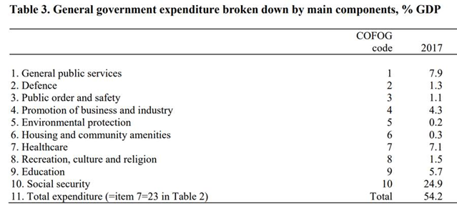

Table 3

DISCRIMINATION CASES IN 2014-2018

SUPERVISORY AUTHORITIES | 2014 | 2015 | 2016 | 2017 | 2018
Non-Discrimination Ombudsman (Ombusman for Minorities until 31.12.2014) | 287 | 496 | 877 | 1056 | 924
OSH Authorities (the figures for 2014-2016 include only those of AVI Southern Finland) | 120 | 135 | 109 | 197 | 200
National Non-Discrimination and Equality Tribunal (National Discrimination Tribunal until 31.12.2014) | 20 | 40 | 67 | 70 | 113
Ombudsman for Equality | 317 | 274 | 262 | 388 | 442
DISTRICT COURTS
Ethnic agitation | 2 | 1 | 5 | 14 | 33
Discrimination | 10 | 6 | 16 | 9 | 12
Work discrimination | 27 | 23 | 13 | 18 | 9
Equality Act | 18 | 21 | 25 | 14 | 10
Non-Discrimination Act | 0 | 4 | 14 | 25 | 11
COURTS OF APPEAL
Ethnic agitation | 2 | 0 | 0 | 4 | 3
Discrimination | 1 | 3 | 3 | 2 | 2
Work discrimination | 11 | 7 | 9 | 6 | 4
Equality Act | 9 | 6 | 10 | 6 | 2
Non-Discrimination Act | 0 | 0 | 3 | 2 | 23

Table 4
Unemployed jobseekers with Finnish background
January February March April May June July August September October November December

Table 5
Young unemployed jobseekers with foreign background
January February March April May June July August September October November December

Table 6
Persons under 25 years of age whose unemployment exceeds three months

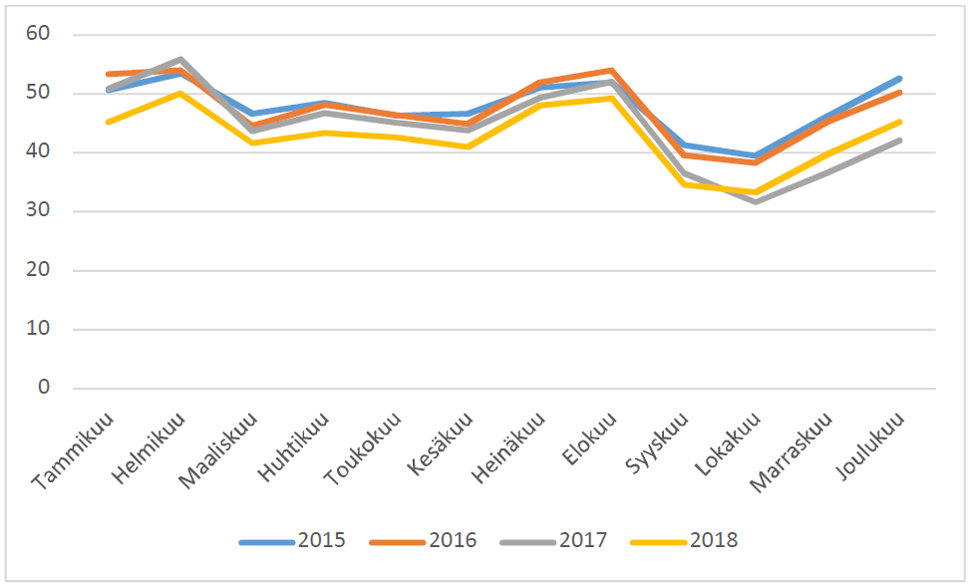
January February March April May June July August September October November December

