COMMITTEE ON THE ELIMINATION OF DISCRIMINATION
AGAINST WOMEN (CEDAW)

Copenhagen, January 24^{th,} 2021
Gender Equality for Everyone
National Governments has legal obligations in accordance with the United Nation Convention on the Rights of the Child articles 2, 3 and 7 and the European Human Rights Convention articles 6, 8, 14 and 17.
It is a human right for children to know and be cared for by their parents. It is a human right to receive respect for family life. It is a human right to be protected against discrimination. It is a human right to have a fair trial of civil rights within reasonable time. This applies for all citizens.
Every Government has today the opportunity to secure equal rights for women and men, boys and girls in society and the society will benefit from this. It is the future welfare model for any society.
However, we must address the gender equality issue for both women mainly in the work life, but also for men and children in family life to keep a positive balance and respect in society of gender equality, public health, and human rights.
We today face a new challenge which is gender equality in gender equality. Everything is not about women – or men. Gender equality and human rights in society applies for everyone
In the Nordic society shared parenting is today the norm in daily life. However, children and parents are still for historical reasons – like in many other European and International countries - living in a shared parenting world with single parenting law.

This is where we find the real reason for the discrimination against women and men, boys, and girls in the Nordic society and Denmark – and the largest potential for success.
We need to address both the work and family life challenge and the gender equality challenge for both women and men, boys, and girls to protect the role models and to create the right effect and balance in society.
In 2017 the ‘World's first gender equality catalog for children and fathers’ was there for created with 12 themes and 348 items related to gender discrimination against children and fathers. This for the benefit of everyone in society.
The 2021 version will soon be launched and documents that more items have been added than solved. This despite clear documentation of human rights violations.
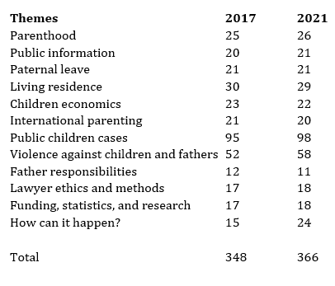
The catalog clearly documents a governmental responsibility for change in family law in Denmark and in all Nordic countries as well as most European and International national governments. This has also be stated by the Council of Europe in the resolution 2079 on Gender Equality and the Role of fathers.
We therefore need to express our regrets over this disappointing development in general. In many societies there are widespread efforts to promote gender equality and human rights, but the rights of children and fathers have gone the opposite way. Governments and authorities should rectify this without delay for the benefit of everyone.
In our opinion current supreme court and human rights judgments especially in the Nordic countries shows a clear responsiveness and understanding that the balance in due regard between the child, mother and father must be maintained without habitual prejudice.
Let us mention a few examples.
Public information about children
All fathers in society has experienced that public information is not sent to both parents and that fathers often do not receive the information about their children. They do not receive this in connection with daily life, paternity leave, health research, surveys, schools, and institutions or even children cases. They are most often not aware of this or the information they do not receive before it is too late. It can be about ordinary things or can be profoundly serious.
In connection with the public information with free digitalized mail there is a simple explanation to why the mail often is not sent to both parents. Most or probably all countries cannot make a list of all children in relation to legal custody and information rights.
This is because key data about fathers is often missing in the central registration and the mailing is therefore not automated for both parents.
This means great costs for society in manual workflows in a shared parenting society at schools, municipalities, hospitals and for the state. In addition to the loss of knowledge, human errors this also will cause a decline in citizen satisfaction and respect for gender equality.
If all local authorities, vendors, and IT systems have to provide their own data instead of retrieving data easily about the father and mother somewhere central, there will be many human mistakes. Shared information for parents will not happen in many situations due to the lack of time and resources.
In addition, exclusion rules can be regarded as sexist against fathers, since it is public employees with often outdated education and cultural understanding about women and men, with a significant over-representation of women, that assess if a father, for example, should have digital information about the child.
Paternity leave
In relation to parental leave, there has still been no extension of the leave period for fathers and children to 50/50 arrangements or 3 months in Denmark compared with most other Nordic countries, not even after the adopted by the EU agreement for a minimum of 2 months.
Only in Sweden and Iceland we have seen positive changes in the law and welfare benefits with 50/50 percent arrangements. This is indeed incredibly positive and a benefit for the children, gender equality and society.
And yes, fathers can look after the children and the fathers that has 3 or even 12-month paternity leave today decided by the parents themselves loves it.
They have the same positive and stress full experiences as we traditionally know it from the mothers. This is one of the best Nordic experiences we have today in shared parenting and gender equality
It is by no means correct for any Government to claim that children and fathers have a free choice. This can be documented in studies with fathers on leave, which documents that legal rights, family economics and information are key problems unless the paternity leave is earmarked for the children and fathers. This effect both women and men, boys and girls in society.
In most Governmental law there is also no legal rights for children and fathers in two home families making everything even more impossible and frustrating for the good and responsible fathers that agree on gender equality in work and family life. It means that in practice, the father and child is left without rights, since they may experience marriage/partnership dissolution, if they demand their rights. A clear discrimination issue related to modern family forms.
Politicians and the principal authorities are often not aware that the parental leave legislation that provides children and fathers a possible right, yields to the family law.
Children and fathers can often be given an opportunity, agreement, and right to paternity leave which cannot be practiced, because the family law does not deal with leave for two home families. Although two home family life is almost the norm today in the Nordic countries. The Family law is based on traditional family forms causing major problems for children and fathers in society with clear violation of human rights obligations.
In addition, some countries respect single mums or two women living together, but not single men and two men that desire a child. This is also a clear violation although we most respect the right of the child to know and be cared for by their parents.
The experiences in the other Nordic countries demonstrates, that earmarked paternity leave works and is a major success when used. It is not yet introduced by law in many countries including Denmark.

Residential and non-residential parent
The most severe and discriminatory gender problem in the Nordic society today is the residential and non-residential legal discrimination, which was introduced when joint custody became the norm for fathers. The concept has in practice put the joint custody out of power.
One must of course not divide such a large part of the population (33%-50% of all children and their fathers), as is the case today, that live in two home families with different rights as a basic assumption.
Millions of children, parents, and grandparents are affected and stand with different legal rights and experience discrimination daily in society. It can have profoundly serious consequences for the children and children’s mental health later in life.
The Nordic research is clear today that children living with shared parenting and equal parenting arrangements offering new opportunities for both women and men in work and family life is in the best interest of the children.
This is not only due to great parents, but also due to more quality time with both parents, more social resources with grandparents and other family members as well as a better and more clear identity with the father and mother is our experiences from daily life today.
It is in most Nordic countries except for some situations in Sweden the residential and non-residential legal concept that decide public welfare benefits for children.
This for example social grants, free court proceedings and for that matter au-pair arrangements, only awarded to the residential parent and not based on actual needs or equal opportunities.
National statistics documents that the residential parents are still the mother like it was in the 1980ies. This although fathers are using much more time with the children and today can be primary care takers with women working and having a career. There is a clear discrimination in the family court system because of discrimination in family law and practice by government.
It is not uncommon that a non-residential parent for example in equal parenting time arrangements earns the least today and may become unemployed or ill. Here the same rules do not apply for welfare benefits to citizens based on the residential and non-residential legal concept, against all common sense and fairness as well as being a clear violation of basic human rights in the modern society. It is serious discrimination of citizens, which creates social vulnerability for children and fathers as well as instability in society.
For many years, the seriousness has been pointed out for changing Governments.
Children and gender equality
If we analyze the reasons for lacking results we come to some interesting findings. Because within children and gender equality, as in the case of the main actors in the UN Cedaw examination of Denmark, we find that women are in power and not men. The men seem to be discriminated.

This could be the reason for the lack of respect of the important gender equality mission for everyone. This is not a disrespect of women, but a question about the professionalism and seriousness related to gender equality and discrimination debate in many countries today including Denmark and positive results.
In the figure below we find the main actors within children and gender equality legislation and debates in Denmark.
The key question is if this is gender equality for everyone and if this will create the right balance in society? Will this address the challenge of family law for children and fathers, which today is the main challenge in many countries for gender equality.
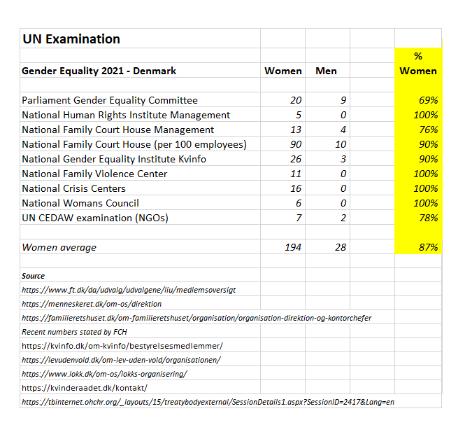

Recommendation
For the creation of gender equality, we need a new modern family law and practice that complies with fundamental human rights. It is all about understanding the issue, willingness, and accountability – and gender equality in gender equality – by most governments, ministries, officials, politicians, and institutions.
We have created 3 principles and 10 basic rules, which can be used by every governments to towards gender equality and the UN Global Goals in the best interest of women and men, boys and girls in society.
The 3 basic principles and 10 rules are based on several years of analysis of children and family legislation and gender equality approaches from a leadership perspective.
The 3 basic principles:
A) All children and parents must be equal as the basic assumption
B) The parents shall have a free choice to create their own arrangements
C) A family court with children experts shall make decisions in case of concern in the best interest of the children
The 10 rules for a new family law:
§1 All children have a life-long right to know and be cared for by their parents
§2 All parents have the right to the same public information about the child
§3 All children have the right to equal parental leave with each parent
§4 All parents have joint legal custody
§5 All children that are not living together with both parents have residentials address at both parents and equal parenting time.
§6 All parents share the income and cost of the child unless there is not equal or almost equal parenting time. Then one parent is financially responsible alone based on a standard child allowance from the other parent.
§7 If a parent moves more than 80 kilometers away from the child's place of residence, the other parent as the basic assumption has the living address of the child and the parent that moves away is responsible for transportation of the child.
§8 The parents can make another agreement on parenting time and child finances if agreed.
§9 If there is concern for the child by a parent or authority, the case is handled by a family court with children experts and a certified contact person is appointed for the child.
§10 The family court can make decisions based on equality, documentation and the best interests of the child. All allegations of criminal offenses are handled by the police. Gender or any type of discrimination related to children is regarded as psychological violence.
Let us start today by creating a modern family law in the best interest of children for gender equality in society.
In the Nordic countries families live in daily life with shared parenting like in no other countries or regions, but where are the shared parenting law that will facilitate the gender equality for everyone, like never seen before in a positive and respectful manor for everyone.
We cannot allow discrimination in general or gender discrimination in particular, against any citizens, such as the case is today.

The key challenge is to create gender equality in gender equality for equal opportunities and personal freedom in work and family life. This for the benefit and in respect of women and men, boys, and girls in society.
Yours Sincerely
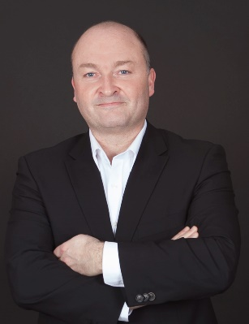
Jesper Lohse, MBA & Nordic Father
info@worldparents.org

Appendix
A) The World’s first gender equality caralog for children and fathers – version 2021 (will soon be available)
B) The World’s first gender equality catalog for children and fathers – version 2017

C) Council of Europe in the resolution 2079 on Gender Equality and the Role of fathers

