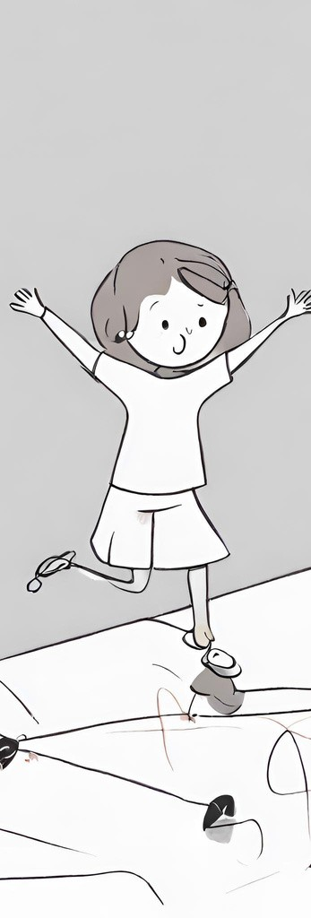

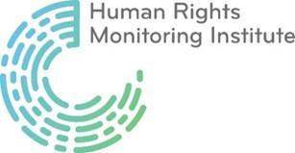

ALTERNATIVE
REPORT
Submitted by the Human Rights Monitoring Institute
to the UN Committee on the Rights of the Child’s 95th session on the occasion of the review of Lithuania’s combined 5th and 6th periodic reports under the UN Convention of the Rights of the Child

Author: Greta Baltikauskaitė OCTOBER 2023

INTRODUCTION
- HRMI is a non-governmental, non-profit Lithuania-based human rights organisation. Since its establishment in 2003, HRMI has been advocating for full compliance of national laws and policies with international human rights obligations and working to ensure that rights are effective in practice. HRMI conducts research, monitoring, evidence-based advocacy and awareness raising in various human rights areas, including the rights of the children.
- Violence against children is a matter of profound significance, impacting the well-being and future prospects of the youngest and most vulnerable members of our society. This report endeavours to provide an objective and informed analysis of the current state of affairs, encompassing the various forms of violence inflicted upon children and their far-reaching consequences. It is our hope that the findings contained herein will serve as a foundation for informed policy decisions and initiatives aimed at safeguarding the rights and dignity of Lithuanian children. Through the medium of this report, our intention is to draw attention to the noteworthy advancements made in Lithuania in recent years, particularly in the realm of fortifying safeguards against all manifestations of child abuse.
- This report is structured in the following way: 1) Legislation on the child’s right to protection from all forms of violence; 2) Strategic documents on combating violence against children; 3) Overview of statistics on violence against children; 4) Helping children who have experienced/are experiencing violence; 5) Recommendations.
LEGISLATION ON THE CHILD'S RIGHT TO PROTECTION FROM ALL FORMS OF VIOLENCE
In 2020, substantial modifications to the Framework Law on the Protection of the Rights of the Child were enacted, ushering in a paradigm shift in the approach to child welfare. These amendments have ushered in a comprehensive evaluation of the child's circumstances, with a particular emphasis on attending to the child's needs and the well-being of the family unit. Furthermore, they have facilitated the provision of suitable support, all with the overarching objective of safeguarding the child's welfare, particularly in non-urgent cases.
Child protection experts conduct individual child assessments, exploring various potential scenarios. Upon receiving a report and assessing the child's safety, if no risk is evident, the specialists conclude their review. If, however, challenges within the family necessitate specific services, the family is referred to the municipality for a needs assessment. This initiates a case management process wherein the municipality collaborates with parents to enhance the child's family situation. When a tangible risk to the child's safety, health, or life emerges post-assessment, child protection measures are invoked. These may involve relying on relatives, close associates, or placing the child with one of their parents in a crisis centre, known as temporary child care.
Child protection experts conduct a comprehensive evaluation of the child's circumstances in adherence to the Child Situation Assessment Procedure, which was enacted on the 1st of January 2020. This process encompasses the completion of a Child Situation Assessment Questionnaire. The assessment unfolds through a methodical screening procedure. Initially, it entails an appraisal to ascertain the existence of justifiable grounds for establishing the child's imperative requirement for safeguarding, as delineated by the enumerated risk factors.

Simultaneously, due diligence is given to the evaluation of the family's inherent strengths, which may serve to mitigate the identified risk factors. If no exigency for protection is ascertained, the focus shifts to an examination of those risk factors that may indicate a need for family or child-centric services. If no such indicators are manifest, the assessment is formally concluded. Throughout the evaluation process, families are afforded the opportunity to articulate their specific requirements for assistance and services, which fall within the purview of responsibility of the local municipalities.

In 2022, Lithuania ratified the Optional Protocol to the United Nations Convention on the Rights of the Child on a communications procedure. This legal step enabled an individual complaint procedure, which enables children to lodge a complaint with the United Nations when their rights are violated and the legal system of the country where the child lives is not able to resolve the problem.

Amendments to the Law on State Guaranteed Legal Aid of the Republic of Lithuania were adopted in 2023 and will enter into force in 2024, which provide that children who may have suffered sexual violence will be assigned a specialized advocate providing state-guaranteed secondary legal aid. An exception would only apply if the child's parents have concluded a legal services contract with a lawyer of their choice.

A draft amendment to Article 95 of the Criminal Code of the Republic of Lithuania was also launched in 2023 to introduce a longer statute of limitations for sexual offences against children. The statute of limitations would run from the time of the alleged commission of the offence, but an additional provision would be introduced to the effect that it cannot expire before the victim reaches the age of 35 as a minor.
STRATEGIC DOCUMENTS ON COMBATING VIOLENCE AGAINST CHILDREN
The Ministry of Social Security and Labour of the Republic (- MSSL) of Lithuania has adopted the Action Plan for Child Welfare 2022-2026, which provides for the further development of measures to protect children from all forms of violence and to provide the necessary comprehensive assistance to child victims of violence.

MSSL of Lithuania has also adopted an Action Plan for the Prevention of Domestic Violence and Provision of Assistance to Victims for 2022-2023. It pointed out that the professional competence of state and municipal employees and other persons working in the field of prevention of domestic violence and violence against children and providing assistance to victims of violence was insufficient. In view of this problem, it was decided to initiate training for professionals working in the field of child welfare so that they would be able to identify domestic violence against children and to assist them in a way that goes beyond the prevention.
OVERVIEW OF STATISTICS ON VIOLENCE AGAINST CHILDREN
In the context of children's rights violations and domestic violence, it is imperative to recognize that these transgressions often remain concealed, making it challenging to ascertain their precise prevalence. Children subjected to violence frequently grapple with fear or a lack of awareness regarding avenues for seeking assistance. In some cases, children may not comprehend that they are enduring sexual abuse, making it challenging for them to report these violations of their rights. Additionally, children with developmental disabilities, who struggle to report victimisation, may be at a higher risk of being targeted by abusers. The psychologist at Lithuania's center for child victims of sexual abuse reports that there is a rising trend in the number of children who have experienced sexual violence. This increase is attributed to a greater willingness to seek assistance and an improved awareness of the issue.

It's worth noting that the issue extends beyond children's inability to identify acts of violence. Even some adults mistakenly view physical punishment as a legitimate method of education, and actions like shaking a child or twisting their ear are often not recognized as forms of violence against them. The study's findings suggest that if the public had a clearer understanding of what constitutes violence and were more willing to report it, we could uncover more instances of child abuse. When asked if they would report a potential violation of a child's rights, only 16 percent confirmed that they would "definitely report," while 4 percent said they would "definitely not report."

There is a significant need to change society's attitudes towards children, their upbringing and violence. As mentioned in the report, some view violence as a means of upbringing.

One significant aspect of the societal attitude problem is the persistent misconception among some adults that physical punishment is a legitimate means of educating or disciplining children. This misguided belief can lead to instances of child abuse and violence being rationalized, downplayed, or even endorsed as a form of discipline. Such attitudes can perpetuate harmful behaviours and prevent the recognition of the seriousness of these acts. This lack of recognition hinders the ability to identify and address child abuse effectively. It suggests a need for education and awareness campaigns to help individuals, particularly adults, understand what constitutes violence and its harmful impact on children.

Despite the importance of identifying and reporting instances of child abuse, the findings suggest that a significant portion of the public is not willing to report potential violations of a child's rights. This reluctance to report can result from various factors, including fear of retaliation, lack of knowledge about reporting mechanisms, or societal indifference to the issue.

The State Child Rights Protection and Adoption Service underscores that there has been a consistent annual increase in the number of reports they receive. In 2020, they received 39,430 reports, in 2021, the number rose to 40,493, and in 2022, it exceeded 44,500.
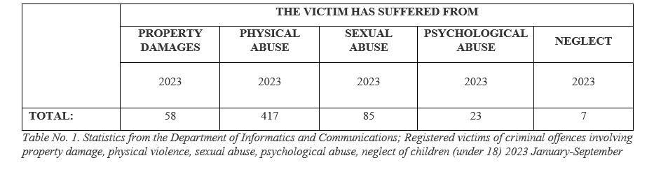

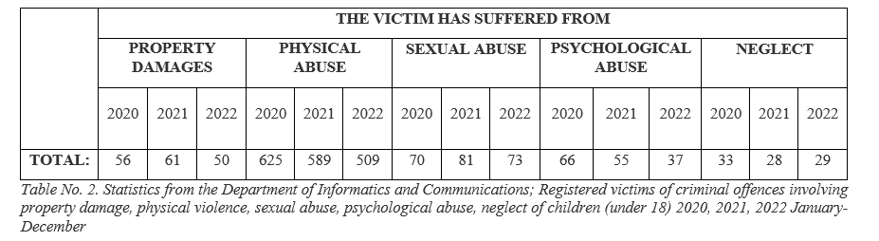
In 2022, 8 out of 10 domestic violence victims were women, and 1 in 10 were children under 18. A total of 6,119 domestic violence crimes were reported, with 64.2% occurring in urban areas and 35.8% in rural areas. Among adult victims, 78.8% were women, and 80.6% of them experienced intimate partner violence. Furthermore, 10.3% of victims were children under 18, and 90.8% of them were victimised by their parents or adoptive parents.
Potential violations of children's rights between 2022 and 2023
- Statistics of the Child Rights Protection and Adoption Service:
  - In 2022, the number of reports received by the State Service for Protection of Children's Rights and Adoption under the SADM on possible violations of children's rights will be 45 758.
  - In 2022, 3 228 cases of possible violence against a child have been recorded (2 866 children may have been subjected to violence in 2022). Child Rights Services received 2,216 reports of physical violence (1,347 boys, 869 girls), 300 reports of sexual violence (44 boys, 256 girls), 291 reports of psychological violence (132 boys, 159 girls) and 421 reports of neglect (201 boys, 220 girls).
  - During January-August 2023, the number of reports received by the State Office for Protection of Child Rights and Adoption under the MSSL on possible violations of the rights of the child was 36 522.
- State Child Rights Protection and Adoption Service under the MSSL. "Strengthening the forces to combat sexual violence against children":
  - In the first half of this year (2023), 2,072 reports of possible violence against children were received. Of these, 1 578 were for physical violence, 201 for sexual violence, 197 for psychological violence and 96 for neglect.
In 2022, child rights services received a staggering 45,000 reports concerning potential violations of children's rights. This marks a significant increase of 13 percent compared to the previous year, 2021. On average, they received 126 reports of potential child rights violations per day in 2022, compared to 111 in 2021 and 108 in 2020.

The director of the State Child Rights Protection and Adoption Service has reported that they received more than 105 reports of potential sexual violence against children in the first quarter of 2023. These numbers have been on the rise in recent years. In 2022, approximately 300 cases of potential sexual violence against children were reported.

Determining whether the increase in public awareness of violence against children has led to a rise in reported cases or if there is indeed a surge in actual incidents remains a complex challenge. However, the statistics presented in the report unquestionably demonstrate a significant uptick in such cases. It is important to highlight that in 2021, the Ombudsman for Children emphasised the glaring absence of essential services to support children facing domestic violence.

This deficiency primarily revolves around the shortage of qualified professionals, including psychologists, psychiatrists, and psychotherapists, along with the limited availability of services for those residing in rural areas. Moreover, numerous municipalities in different regions appear to be unwilling or unable to comprehensively address the critical need for providing assistance to affected children and their families. They often attribute this shortfall to a lack of specialised personnel.

Furthermore, a significant gap exists in terms of equipping parents with the necessary skills to handle children exhibiting behavioural problems. It is widely acknowledged that instances of violence against children often result from parents struggling to manage their child's inappropriate behaviour or episodes of aggression, resorting to physical punishment as a misguided means of control.
HELPING CHILDREN WHO HAVE EXPERIENCED/ARE EXPERIENCING VIOLENCE
Comprehensive assistance for children in Lithuania is mainly provided by non-governmental organisations and funded by the MSSL through calls for proposals. When assessing the mechanism of allocating funding to organisations providing assistance, it should be noted that the project-based funding model is not the most appropriate one to ensure sustainable and long-term provision of complex assistance to children.
Moreover, the funding allocated to provider organisations is not sufficient to ensure that comprehensive assistance is available to all child victims of violence. The right to free and accessible comprehensive assistance for children is guaranteed by Article 20(2) of the Framework Law on the Protection of the Rights of the Child, which stipulates that a child who is a victim of any form of violence has the right to receive assistance that is in accordance with the child's needs and in the child's best interests, and that the State is therefore under an obligation to ensure the availability of such assistance.

In 2021, an Educational Centre was established at the Child Victims of Sexual Abuse Support Centre (hereinafter "the Support Centre"), which carry out preventive activities for children and educational activities for relatives of children and professionals working with children and families. The Help Centre, which has been in operation since 3 June 2016, is the only specialised centre in Lithuania that brings together under one roof all the services necessary for investigating cases of sexual violence against children. The Help Centre provides free, short-term, comprehensive support to child victims of sexual abuse and their families.

The comprehensive family services are provided within the framework of the Comprehensive Family Services Project, funded by the EU Structural Funds under the 2014-2020 Operational Programme for Investment of the European Union Funds, and contribute to the protection of children against violence. For example, services such as positive parenting training, psychosocial support, family mediation, etc. are provided to all families. From the start of the implementation of this measure until June 2022, 90,000 beneficiaries have received services under this measure (the target was 30,000 beneficiaries). The amount of funds committed and used by the deadline was €33 million. The measure is planned to continue in the period 2023-2029 (planned funding from the European Union's Structural Funds - over € 60 million). This contributes to the prevention of violence against children by helping families to properly care for, positively nurture and educate their children from birth, to create an environment conducive to children's development, and to respond to the child's needs, thus avoiding neglect and social exclusion.

The Child Support Center has undertaken the project funded by the MSSL of the Republic of Lithuania. The program begins with a thorough individual assessment of each child who has experienced violence. Following this assessment, a comprehensive support plan is prepared, with a strong focus on helping the child and their family members overcome the emotional and psychological trauma resulting from these experiences.

From 2006 to the end of 2021, the Center has provided vital assistance to 1,793 children who have been impacted by violence, dedicating an impressive 28,685 hours to this cause. In the year 2022, the Center extended comprehensive assistance to 126 children who had experienced violence, benefiting 182 of their family members. In 2023, the Child Support Center remains committed to delivering complex assistance to 60 children who have endured violence, ensuring that 120 of their family members also receive this support.

According to the Specialised Comprehensive Assistance Centre, 121 people under the age of 17 were subjected to violence and received assistance in 2022.

As stated by the MSSL of the Republic of Lithuania, in 2022, in order to ensure the availability of assistance and services for children victims of violence, by funding projects of non-governmental organisations, complex assistance with 1374 children.

Insufficient and unchanging financial support for children's welfare in Lithuania underscores several critical issues with significant ramifications for the welfare of children. The consistent allocation of funding at the same level over consecutive years indicates a deficiency in prioritising child well-being. Given the limited resources dedicated to addressing domestic violence, especially concerning children, the capacity to assist a maximum number of child victims is constrained. Additionally, it is worth emphasising that a substantial concentration of organisations operates within urban areas, rendering access to remote regions more challenging. Consequently, a greater allocation of resources is imperative to facilitate the implementation of measures and the generation of employment opportunities for professionals capable of enhancing support provisions.
RECOMMENDATIONS
- Public opinion surveys indicate that certain parts of society still accept violence against children, particularly in the form of punishment. There is a clear need for a widespread and targeted public education effort to inform people about the harm caused to children by violence and corporal punishment. Our recommendation is to launch an extensive public education campaign to raise awareness about the harmful impact of violence and corporal punishment on children, emphasising the promotion of positive parenting techniques and employing a systematic, multi-level approach rooted in internationally recognized models of child violence prevention.
- Insufficient financial resources designated for addressing child violence in Lithuania are a significant challenge. The annual budget for children's aid remains the same and is relatively small. Additionally, there's a notable lack of support for child victims, with only a slight increase in funding planned for 2026. It's important to highlight that there is a shortage of qualified professionals in the regional areas, making it difficult to provide necessary assistance to children. Our recommendation is to prioritise increasing the annual budget for children's aid in Lithuania, with an immediate focus on bolstering resources to address violence against children. This will enable the enhancement of support structures and the recruitment of qualified professionals to better assist child victims.

Protecting-children-from-violence: what-changes-in-2020 https://www.teise.pro/index.php/2020/01/05/vaiku-apsauga-nuo-smurto-kas-keiciasi-2020-metais/
Ibid, 1.
Lithuania deposits its instruments of ratification of the Optional Protocol to the Convention on the Rights of the Child on a communications procedure https://uk.mfa.lt/default/lt/naujienos/lietuva-deponavo-vaiko-teisiu-konvencijos-fakultatyvaus-protokolo-del-pranesimu-proceduros-ratifikacinius-rastus
Law No VIII-1591 of the Republic of Lithuania on State Guaranteed Legal Aid No VIII-1591 of the Republic of Lithuania amending Articles 4, 6, 7, 8, 9, 10, 11, 12, 13, 14, 15, 17, 18, 19, 20, 21, 22, 23, 24, 25, 29, 31, 32 of the Law on State Guaranteed Legal Aid, and the Annex https://e-seimas.lrs.lt/portal/legalAct/lt/TAD/67bcd4e1173811eea9b3de7dd350a34e?jfwid=-6arlcywg4
Government approves longer statute of limitations for sexual offences against children https://www.lrt.lt/naujienos/lietuvoje/2/2056745/vyriausybe-pritare-ilgesniam-senaties-terminui-del-seksualiniu-nusikaltimu-pries-vaikus
On the adoption of the Action Plan for Child Welfare 2022-2026 https://e-seimas.lrs.lt/portal/legalAct/lt/TAD/27ba5da17d5511ecb2fe9975f8a9e52e/asr
On the adoption of the Action Plan for the Prevention of Domestic Violence and Provision of Assistance to Victims 2022-2023 https://e-seimas.lrs.lt/portal/legalAct/lt/TAD/2d979e12b9d011ec9f0095b4d96fd400/asr
Psychologist on child sexual abuse: victims don't always realise they are being abused
Child abuse survey: some people justify corporal punishment or ear plugging
More than 3,000 cases of violence against children a year: who to report and how to spot it? https://www.lrt.lt/naujienos/lietuvoje/2/1857164/lrt-trumpai-per-metus-daugiau-nei-3-tukst-smurto-pries-vaikus-atveju-kam-butina-pranesti-ir-kaip-tai-atpazinti
Domestic violence https://osp.stat.gov.lt/informaciniai-pranesimai?articleId=10572074
Activity Reports https://vaikoteises.lrv.lt/lt/administracine-informacija/ataskaitos/menesio-veiklos-ataskaitos
Strengthening the fight against sexual violence against children https://vaikoteises.lrv.lt/lt/naujienos/stiprinamos-pajegos-kovai-su-seksualiniu-smurtu-pries-vaikus
Half of Lithuanians still don't know if hitting a child is wrong
Skuodiene: more than 105 reports of possible sexual violence against children received by April
Research and summaries http://vtaki.lt/lt/teisine-informacija/vaiko-teisiu-padeties-vertinimas/atlikti-tyrimai-ir-apibendrinimai
Written communication with the Ministry of Social Security and Labour, 2022 October 14th
Children Support Centre https://pvc.lt/projektai/kompleksine-pagalba-nuo-smurto-nukentejusiems-vaikams-smurto-liudininkams-ir-ju-seimoms/
Reports on the activities of the Specialised Centre for Complex Assistance https://www.specializuotospagalboscentras.lt/veiklos-ataskaitos/
Ministry of Social Security and Labour of the Republic of Lithuania 2022 Activity Report https://socmin.lrv.lt/uploads/socmin/documents/files/veikla/planavimo-dokumentai/2023/2023-03-20%20SADM%202022%20m_%20veiklos%20ataskaita_teikti.pdf

