Briefing Note to the CRC Committee, prior to the Publication of the List of Issues for Japan

Japan’s current climate policy violates the obligations of the State under the Convention on the Rights of the Child as it permits the excessive emission of greenhouse gases resulting in the increase of adverse climate-induced impacts on the rights of children both in Japan abroad.
The Committee on the Rights of the Child should ask Japan to:
- provide information regarding how the current climate mitigation policy of Japan is compatible with its obligation to protect the rights of children, ie. ‘, in particular the rights to health, food and an adequate standard of living, both in Japan and abroad.
Additionally, Japan continues to fund extensively the development of coal-fired energy in third countries, disregarding the adverse implications of this policy for the rights of children in communities located in proximity to these power plants as demonstrated by many scientific and medical studies.
The Committee on the Rights of the Child should also ask Japan to:
- provide information indicating how children’s rights, and in particular their right to health, are protected in the context of Japan’s policy to provide financial support for coal-fired power plants in third countries, given the known scientific and medical evidence about the adverse health impacts on children living in proximity to coal-fired power plants.
Climate change impacts on the rights of children, including adverse impacts in Japan
The current and anticipated impacts of climate change constitute one of the most significant global threats for the enjoyment of human rights – especially those protected under the Convention on the Rights of the Child. As noted by the Human Rights Council, children are among the most vulnerable to climate change. The Committee on the Rights of the Child (CRC) has highlighted previously that climate change results in adverse impacts on many of the rights protected by the Convention on the Rights of the Child, including the rights to education, to the highest attainable standard of health, safe and drinkable water and sanitation, food and nutrition security (CRC article 24), adequate housing and adequate standard of living (CRC article 27). The magnitude of these impacts will keep increasing as temperatures continue to rise.
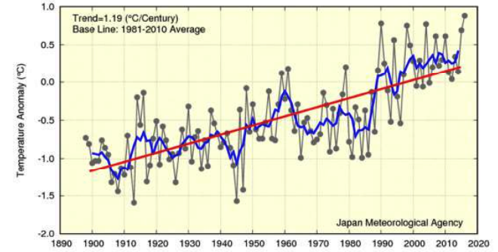
Figure 1: Annual surface temperature anomalies from 1898 to 2016 in Japan (source: Japanese Meteorological Agency, “Climate Change Monitoring Report” 2016).
In Japan, the mean air temperature rose by about 1˚C in the 20th century, and the Japan Meteorological Agency (JMA) is now virtually certain that a long-term trend in the frequency of extremely high monthly temperatures has increased as shown in the graphic above. The mean surface temperature in Japan during 2016 is estimated to have been 0.88˚C above the annual average from 1981 to 2010, which is the highest since 1898. Without mitigation efforts to decrease a long-term trend of extremely high temperatures due to climate change, vulnerable groups like children will continue to experience adverse impacts on their health.
The children of Japan are also particularly at risk for developing asthma and other respiratory diseases from Asian dust exposure, the volume and impact of which has increased in Japan due to climate change. Initial research suggests that Asian dust causes a 50-fold increase in particulates outdoors and 20-fold increase in particulates indoors compared to average everyday conditions, likely contributing to the development of asthma and other respiratory diseases.
- Climate mitigation policy of Japan and adverse impacts on the rights of children
Under the Paris Climate Agreement, States committed to limit the increase of global average temperature to well below 2ºC above pre-industrial levels and to pursue efforts to limit the temperature increase to 1.5ºC. States recognised that keeping global temperature increase to below this threshold would ‘significantly reduce the risks and impacts of climate change’.
Consistent with these obligations, States must ensure that they reduce emissions of greenhouse gases so as to avoid a level of climate change that threatens the enjoyment of human rights, including the rights of children. The Intergovernmental Panel on Climate Change (IPCC) has highlighted that keeping to a 2°C temperature target requires industrialised countries to reduce their emissions by 2020 by 25% to 40% below 1990 levels. All parties to the UN Framework Convention on Climate Change (UNFCCC) have committed to acting in accordance with this finding both through the adoption of the report of the IPCC as well as through several decisions under the UNFCCC. As an industrialised country, Japan is therefore required — at a minimum — to reduce its emissions by 25% to 40% below 1990 levels by 2020.
However, Japan’s total emissions have increased from 1,274 million tonnes CO2-eq in 1990 to 1,325 million tonnes CO2-eq in 2015, which is the equivalent of an increase in emissions by 4.0% between 1990 and 2015. Between 2010 and 2020, total GHG emissions (excluding land use, land use change and forestry) are projected to increase by 7.3% according to data provided by the Japanese government.
Moreover, as stated in Japan’s Nationally Determined Contribution, the Japanese Government only intends to reduce greenhouse gas emissions by 26% below 2013 levels by 2030, equivalent to 18% below 1990 levels by 2030. This illustrates an enormous gap between Japan’s current commitments and the reductions necessary to avoid a dangerous level of climate change.
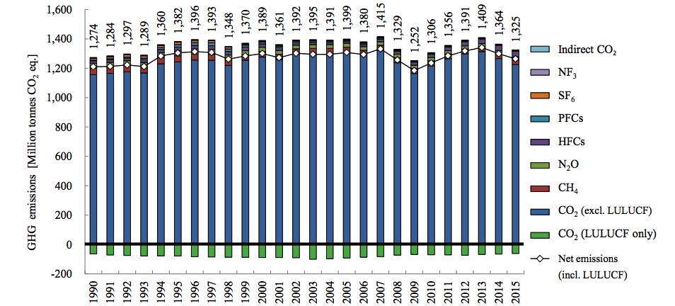
Figure 2: Trends in greenhouse gases emissions and removals (source: Japanese Government, “7th National Communication under the UN Framework Convention on Climate Change”, 2017)
International studies assessing the adequacy of national climate policies consistently describe the emissions reductions by Japan and its climate change targets as “highly insufficient” or “very low”. Further, if all countries adopted Japan’s low level of ambition in reducing emissions, average global temperature increase would likely exceed 3°C to 4°C in the 21st century. This would have catastrophic implications for the enjoyment of human rights around the world and be particularly dangerous for children.
In its report from the Day of General Discussion held in 2016 on Children’s Rights and the Environment, the CRC endorsed several recommendations to States, including the need for urgent and aggressive reductions in greenhouse gases, guided by the best available science. The CRC further committed to consistently link Concluding Observations on environmental issues to existing legal frameworks including States’ commitments under the UNFCCC.
The upcoming review of Japan’s obligations under the Convention on the Rights of the Child offers an opportunity for the CRC to ask Japan to provide further information regarding whether its climate mitigation policy complies with the legal obligations of the country to protect the rights of the child as provided under the Convention on the Rights of the Child and in accordance with internationally agreed environmental standards.
- Financing of coal power plants oversees and adverse impacts for children in local communities
In a 2016 report on energy and air pollution, the International Energy Agency estimated that coal is responsible for the largest share of air pollution in the power sector worldwide - leading to respiratory illnesses and premature deaths, with children being among those most particularly exposed.
The impacts of coal on the health of children is particularly grave. A report focusing on coal-fired energy production in India (which is a significant recipient of Japanese financing for coal projects) found that it was responsible for ‘hundreds of thousands of lives [lost]…and millions of asthma attacks, heart attacks, hospitalisations’ and that the ‘adverse impacts are especially severe for children’.
Since at least 2007, Japan has provided the largest share among OECD countries of overseas financing for the construction of coal-fired power plants in third countries. From 2003 to 2016, the Japan Bank for International Cooperation (JBIC) – which is owned 100% by the State – invested in 24 coal-fired thermal power plant projects, including 6 in India, 5 in Indonesia, 5 in Vietnam 2 in Morocco.
The vast majority of Japan’s financial support is provided through export credits and loan guarantees through the JBIC and the Nippon Export and Investment Insurance. This financial support results in Japanese companies benefiting economically from these investments while communities in the developing countries hosting these projects suffer from their environmental and social externalities. Additionally, coal-fired power plants financed by Japan overseas are less efficient than the worldwide average as the best technologies available are not systematically used in these projects, thus resulting in further impacts on vulnerable populations in the host countries through greater atmospheric pollution.
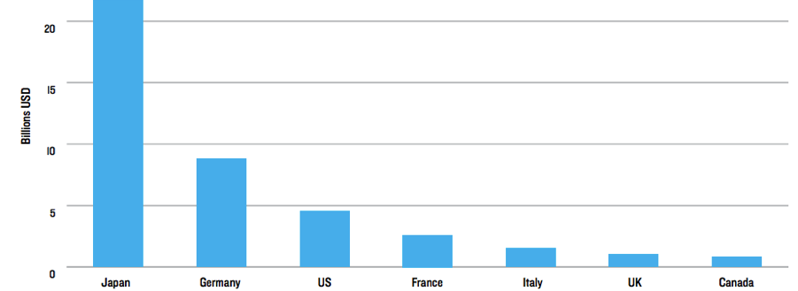
Figure 3: Coal finance by G7 Country between 2007-2015 (source: NRDC, “Swept under the rug: how G7 nations conceal public financing for coal around the world”, 2016)
In recent years, the majority of other industrialized countries have shown signs of phasing out their public financing of overseas coal projects. On the other hand, Japan continues to finance coal in several countries. The country is also considering providing funding for new projects. Given that the lifespan of new coal-fired power plants is several decades, these new project will result in long term adverse impacts for local communities in the regions where they are built and will generate emissions of greenhouse gases for several decades.
Local communities have protested the constructions of these projects in many countries and have challenged these projects in courts, denouncing the impacts of these projects on their health and livelihoods. Research conducted in relation to several of the power plants funded by JBIC has highlighted the high impacts of coal fired-power plants on the health of local residents and stressed that the health of local children would be particularly exposed.
In this context, we urge the Committee on the Rights of the Child to also ask Japan to provide information indicating how children rights, and in particular their right to health (article 24 of the CRC), are protected in the context of Japan’s policy to provide financial support for coal-fired power plants in third countries.
This short briefing note was prepared by the Center for International Environmental Law (CIEL) and the Global Initiative for Economic, Social and Cultural Rights (GI-ESCR). Please do not hesitate to contact us for any additional information: Sébastien Duyck sduyck@ciel.org (+41786966362)

See CRC Concluding Observations on Haiti (2016) and on the United Kingdom (2016) for precedents of recommendations by the CRC in relation to the mitigation policy of individual states.
Office of the High Commissioner for Human Rights, Analytical Study on ‘Climate change and the full and effective enjoyment of the rights of the child’, UN Doc. A/HRC/35/13.
Human Rights Council Resolution 32/33 (2016) and Resolution 35/20 (2017).
See CRC Concluding Observations on Tuvalu (2013), Saint Lucia (2014), Jamaica (2015) and Kenya (2016).
Japan Meteorological Agency, “Climate Change Monitoring Report 2016,” October 2017. http://www.jma.go.jp/jma/en/NMHS/ccmr/ccmr2016_low.pdf. Long-term trends of extremely high temperature events are derived from analysis of temperature records from 15 observation stations. These results have at a 99% confidence level.
Japan Environment and Children’s Study (JECS), “Birth cohort study on the effects of desert dust exposure on children’s health.” 23 June 2014. http://bmjopen.bmj.com/content/4/6/e004863.JECS evaluates the impacts of various environmental factors on children’s health and development across 15 regions of Japan.
According to JECS, Asian dust is a regional form of desert dust from China and Mongolia which is transported to Japan during Asian dust season. Desert dust is compromised of minerals, microbial agents, and anthropogenic atmosphere pollutants.
Paris Agreement, Article 2.1.a.
Ibid.
Fourth Assessment Report of the Intergovernmental Panel on Climate Change (AR4), Box 13.7.
E.g.: Bali Action Plan (Decision 1/CP.13, 2007); Decision 1/CP.16 (2010); Decision 1/CMP.6 (2010); Decision 1/CMP.7 (2011); Decision 1/CMP.8 (2012); Decision 1/CP.19 (2013); Decision 1/CP.20 (2014); Decision 1/CP.21 (2015).
When indicating the volume of all greenhouse gases taken together, including CO2 (carbon dioxide), the notation CO2-eq which stands for ‘CO2 equivalent’ is often used. To express the total effect of all greenhouse-gas emissions, an accounting unit is used in which the effects of all greenhouse gases are converted into the heating potential of CO2.
Ministry of the Environment, Greenhouse Gas Inventory Office of Japan, “National Greenhouse Gas Inventory Report of Japan”, 2017, E.S.2.1 (http://www-gio.nies.go.jp/aboutghg/nir/2017/NIR-JPN-2017-v3.1_web.pdf)
https://cop23.unfccc.int/sites/default/files/resource/docs/2016/trr/jpn.pdf, p. 15.
Japan national emission reduction commitment under the Paris Climate Agreement (“Nationally Determined Contribution”) http://www4.unfccc.int/submissions/INDC/Published%20Documents/Japan/1/20150717_Japan%27s%20INDC.pdf. Japan ratified the Paris Agreement on 8 November 2016.
Climate Action Tracker, Japan (last updated 6 November 2017).
Ibid.
See the Climate Change Performance Index : https://www.climate-change-performance-index.org/
Climate Action Tracker, Japan (last updated 6 November 2017) http://climateactiontracker.org/countries/japan.html
Report by the Committee on the Rights of the Child of the 2016 Day of General Discussion: Children’s Rights and the Environment, at 29, 32 and 36.
International Energy Agency, World Energy Outlook Special Report 2016, available at https://www.iea.org/newsroom/news/2016/november/world-energy-outlook-2016.html, page 57.
Conservation Action Trust, UrbanEmissions.info, Greenpeace India, ‘Coal Kills: An Assessment of Death and Disease caused by India’s Dirtiest Energy Source’ (March 2013) http://www.greenpeace.org//india/en/publications/Coal-Kills/; see, also, Dejusticia, Business and Human Rights Resource Centre, Digging Deeper: The Human Rights Impacts of Coal in the Global South (2015) available at http://docs.wixstatic.com/ugd/c04a21_55722707895847839433655205a851ff.pdf
Swept under the rug: how G7 nations conceal public financing for coal around the world”, NRDC (2016), available at https://www.nrdc.org/sites/default/files/swept-under-rug-coal-financing-report.pdf
See http://sekitan.jp/jbic/wp-content/uploads/2014/01/factsheet-en.pdf
Dejusticia, Business and Human Rights Resource Centre, Digging Deeper: The Human Rights Impacts of Coal in the Global South (2015) available at http://docs.wixstatic.com/ugd/c04a21_55722707895847839433655205a851ff.pdf
Dirty Coal Breaking the Myth About Japanese-Funded Coal Plants, Kiko Network (2015), available at http://sekitan.jp/jbic/wp-content/uploads/2015/04/Dirty-Coal-JBIC.pdf.
See for instance the beginning of the construction work for the Bangladeshi Matarbari power plant in January 2018.
See for instance information related to recent local opposition to Japanese-funded coal power plants based on health and environmental concerns in Vietnam (http://www.mekongwatch.org/PDF/V_Coal-NGOstatementENG_20170414.pdf), in India (http://www.thehindu.com/todays-paper/tp-national/tp-karnataka/kudgi-plant-krrs-hasiru-sene-to-lead-protest/article6692153.ece), or in Indonesia (https://medium.com/economic-policy/despite-protests-japan-gives-lifeline-to-dangerous-fossil-fuel-projects-d3ce94714fe7).
See for instance the research conducted by the Harvard University in relation to the health costs of coal burning in Indonesia, cited in Human Cost of Coal Power – How coal-fired power plants threaten the health of Indonesians, Greenpease South-East Asia (2015), available at http://www.greenpeace.org/seasia/id/PageFiles/695938/full-report-human-cost-of-coal-power.pdf

