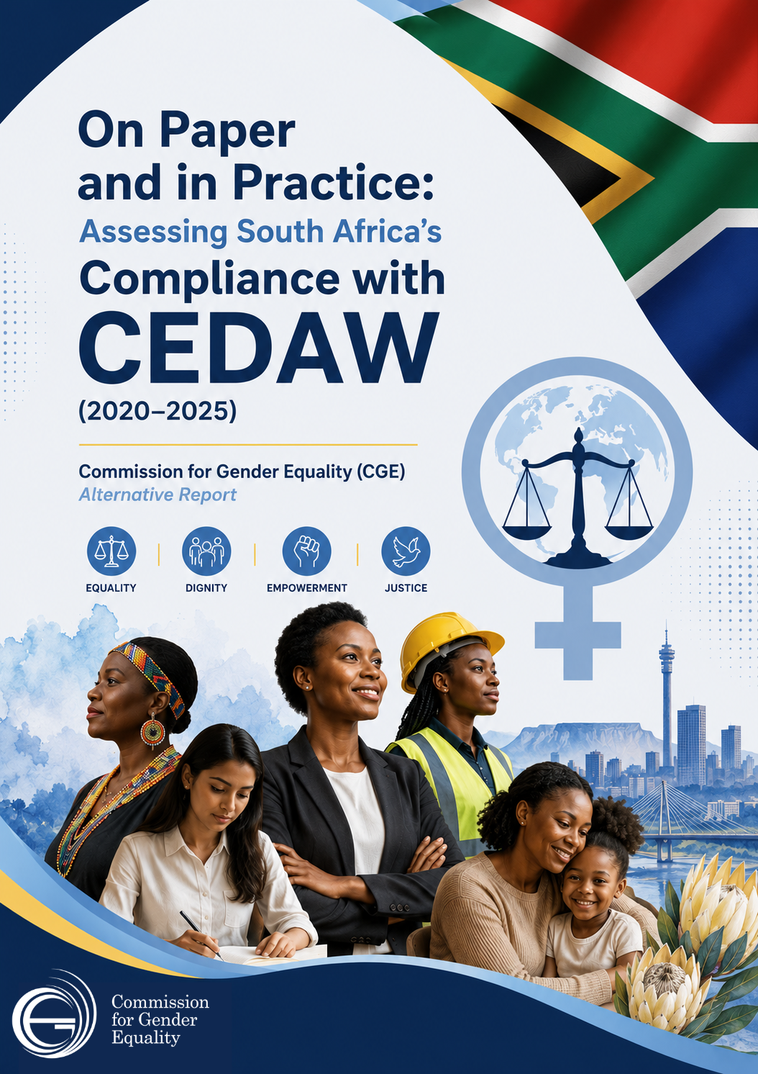

On Paper and in Practice: Assessing South Africa’s Compliance with CEDAW (2020–2025)
Commission for Gender Equality (CGE) Alternative Report
1. Introduction
The Commission for Gender Equality (CGE), established under Section 181 of the Constitution of South Africa and guided by the mandate as articulated under Section 187 of the Constitution and the CGE Act No. 39 of 1996. The CGE is mandated to advance, monitor, and safeguard gender equality in the country. Central to this mandate is the responsibility to evaluate South Africa’s adherence to international human rights obligations, particularly the Convention on the Elimination of All Forms of Discrimination Against Women (CEDAW).
This Alternative Report offers an independent assessment of South Africa’s implementation of CEDAW between 2020 and 2025. It builds on earlier CGE reporting cycles, including the baseline report of 2015 and subsequent reviews aligned with State periodic reports. The report specifically examines progress from the fifth periodic report presented to the CEDAW Committee in 2021, taking into account recommendations issued during the 1839th and 1840th sessions (CEDAW/C/SR.1839; CEDAW/C/SR.1840).
While South Africa has made notable advances in advocating for promotion of gender equality through legislative and policy reforms, significant challenges persist in translating these commitments into tangible outcomes. This report therefore focuses not only on legal and institutional developments but also on implementation gaps that continue to shape women’s lived realities in South Africa.

2. Background and CEDAW Context
CEDAW, adopted in 1979 by the United Nations General Assembly, is widely regarded as the international bill of rights for women. It is rooted in three core principles: substantive equality, non-discrimination, and State obligation. South Africa ratified the Convention in 1995, marking a crucial commitment to gender equality in the post-apartheid era.
The reporting process under CEDAW provides an opportunity for States to assess their progress, such as identifying shortcomings, and developing strategies to meet their obligations. South Africa has submitted periodic reports since 1998, and the combined up to the fourth reports presented in 2011 and its fifth report presented in November 2021.
The CEDAW Committee acknowledged South Africa’s progress in adopting key legislative and policy measures, including the Recognition of Customary Marriages Amendment Act (2021), the Employment Equity Act amendments, and the Prevention and Combating of Trafficking in Persons Act (2013). Complementary policy frameworks such as the National Strategic Plan on Gender-Based Violence and Femicide (NSP-GBVF) (2020–2030), National Action Plan on Women, Peace and Security (2021-2025) and the National Policy on the Prevention and Management of Learner Pregnancy (2021) demonstrate further commitment.
However, the Committee during the previous country reporting issued a list of Concluding Observation which highlighted persistent implementation challenges, including inadequate resources, weak institutional coordination, and insufficient monitoring mechanisms.

3. Aim and Objectives
The primary aim of this report is to assess South Africa’s compliance with CEDAW implementation between 2020 and 2025. The analysis focuses on legislative reforms, policy developments, and practical measures implemented to promote gender equality.
The secondary objectives include:
- Assessing progress regarding country compliance on the implementation of specific CEDAW provisions during the reporting period.
- Evaluating implementation of the Committee’s recommendations following the fifth periodic report.
- Identifying structural, institutional, and socio-economic barriers that hinder effective implementation.
- Proposing strategic interventions to strengthen compliance and gender transformation.
4. Methodology
The report adopts a qualitative research approach, drawing on secondary data from policy documents, government reports, and institutional records. Content analysis and thematic analysis were used to systematically review data, identify patterns, and assess alignment with CEDAW obligations (Busetto et al., 2020; Cypress, 2015; Krippendorff, 2018).
This methodological approach allows for a comprehensive understanding of both progress and persistent challenges across multiple sectors.

5. Progress on concluding observations and recommendations from 1839th and 1840th Session
Overall Findings
The report concludes that South Africa has made notable progress in legal and policy development, particularly in strengthening frameworks aimed at gender equality, gender-based violence, and women’s empowerment.
However, it highlights a significant gap between policy and implementation. Key systemic challenges include:
- Chronic underfunding and underutilisation of budgets.
- Weak monitoring and evaluation systems.
- Poor coordination across institutions.
- Limited access to services, especially in rural and marginalised communities.
- Inadequate data collection, especially gender-disaggregated statistics.
Overall, while the legislative framework aligns with international standards, practical enforcement remains insufficient, limiting meaningful transformation in women’s lives.
South Africa has shown a significant improvement in the indicators it reports regarding the SDGs. This progress is evident in the Baseline Report and the first and second Voluntary National Review (VNR) reporting cycles, which have indicated that progress increased from 64% in 2019 to 72% in 2023.
Additionally, there has been an increase in the availability of gender-disaggregated data across various indicators for the 17 SDGs. The SDGs Country Report of 2023 reveals positive trends in 33% of the targets, with the main contributions coming from economic (11.2%), environmental (10.1%), and social (9.5%) goals, while the remaining 2.4% is attributed to the governance sector. Furthermore, 23% of the targets have shown no noticeable change in the data, 11% have demonstrated no progress, and 33% of the SDG targets lack sufficient or new data to effectively track their progress.
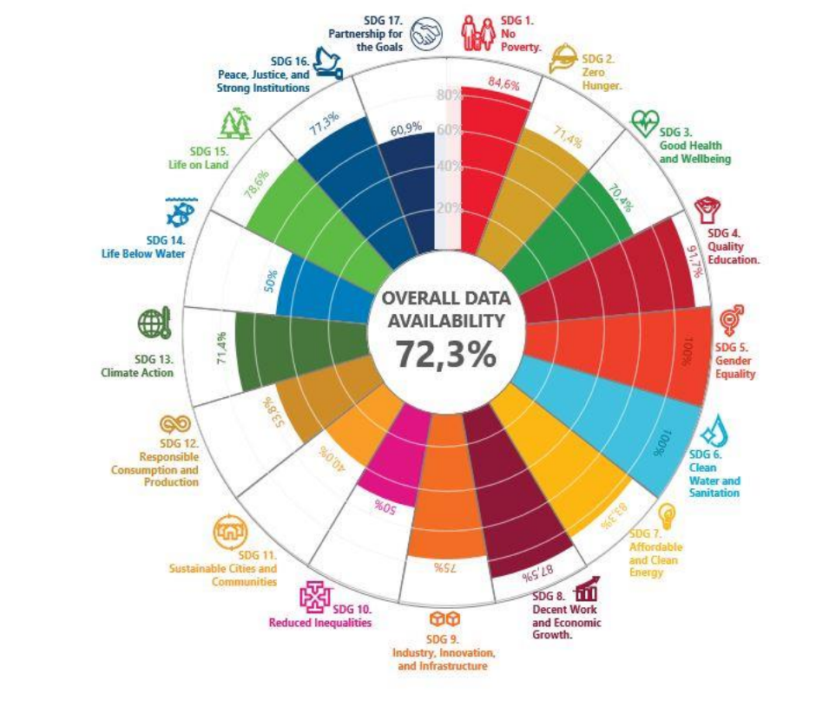
Source: South Africa SDG Report (2023)
6. Legislative and Policy Framework
South Africa’s constitutional framework provides a strong foundation for gender equality. Section 9 of the Bill of Rights prohibits discrimination on the basis of gender, sex, and other grounds, while Section 39(3) ensures that customary law must align with constitutional principles.
The Promotion of Equality and Prevention of Unfair Discrimination Act (PEPUDA) remains central to anti-discrimination efforts. Amendments and ongoing legislative reviews aim to broaden definitions of discrimination and strengthen enforcement mechanisms. Similarly, the Employment Equity Act seeks to address workplace inequality through affirmative action measures and gender targets.
Despite these frameworks, enforcement remains inconsistent. Equality courts, established under PEPUDA, are underutilised, with low case volumes indicating limited awareness and accessibility. Furthermore, Legal Aid South Africa lacks gender-disaggregated data, limiting the ability to assess women’s access to justice.
The delayed finalisation of the Women’s Empowerment and Gender Equality (WEGE) Bill represents a significant gap, especially regarding the promotion of gender equality in the country. The absence of comprehensive legislation continues to impede gender transformation in both public and private sectors.
6. Governance, Parliament, and Oversight
Parliament, particularly the Portfolio Committee on Women, Youth, and Persons with Disabilities, plays a crucial oversight role in ensuring compliance with the implementation of CEDAW. The Committee monitors strategic plans, budgets, and policy implementation, including the NSP-GBVF. Commission for Gender Equality is an independent Constitutional body mandated to monitor and evaluate compliance by state and other entities regarding implementation of gender transformational prescripts in the country.
While oversight mechanisms have improved, their impact remains limited. Legislative efforts have not fully translated into systemic change, particularly in addressing gender inequality in economic and political spheres.
7. Gender-Based Violence and Femicide
Gender-based violence (GBV) remains one of the most critical challenges facing South Africa. The NSP-GBVF represents a comprehensive framework with six pillars addressing prevention, protection, accountability, and support services.
Significant progress includes:
- Expansion of Thuthuzela Care Centres (from 55 to 64 between 2020 and 2024)
- Establishment of over 1,000 victim-friendly rooms in police stations
- Training initiatives for justice system personnel
However, implementation gaps remain severe. Only 52.1% of allocated GBVF funding was utilised between 2020 and 2023 (CGE, 2023), reflecting inefficiencies and lack of urgency.
The National Council on GBVF, legislated in 2024, has been enacted, but not yet operationalised, hence creating a leadership void. The process of establishing the GBVF Council, which is a multi-sector structure to oversee and coordinate the work related to fighting the scourge of GBVF in the country is now underway. Government should expedite the NCGBVF establishment (HSRC, 2024).
Prevalence data from the Human Sciences Research Council (2024) underscores the magnitude of the crisis:
- 33.1% of women have experienced physical violence
- 9.8% have experienced sexual violence
- 35.5% have experienced either form
These figures highlight the gap between policy commitments and lived realities.
8. International Representation and Political Participation
Women’s political participation has improved over time but remains uneven. Representation in the National Assembly declined from 46% in 2019 to 43% in 2024 (IEC, 2024). At local government level, women occupy only 37% of councilor positions. International representation has regressed as it constitutes 40% vacancies which affects the 43% representation that was achieved post 2019 administration (IEC, 2024).
Voluntary party quotas, such as those adopted by the ANC and EFF, have contributed to progress. However, the absence of mandatory quotas limits broader gains. Women, particularly from marginalised groups, continue to face barriers, including violence, discrimination, and lack of access to economic resources.
In the public sector, disparities are more pronounced. African women hold only 6.7% of top management positions, reflecting systemic inequalities (Employment Equity Report, 2023/2024). In 2024, women held 36% of board positions in the JSE Top 40 and 23% of executive positions demonstrating large margin regarding women’s participation in leadership positions (Just Share, 2023).

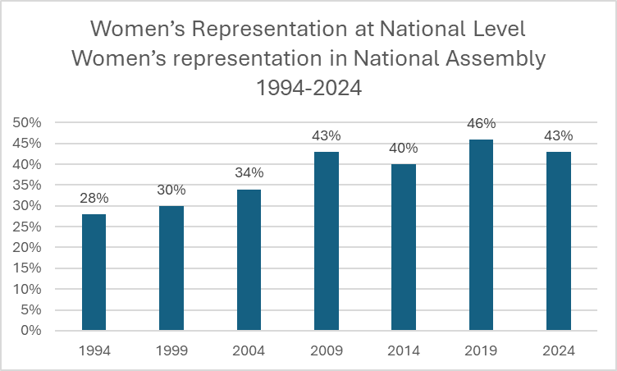
Representation of women in the National Assembly

Source: CGE, 2024
Women in Politics in South Africa | 2004 | 2009 | 2014 | 2019 | 2024
Women MPs in the National Assembly (NA) | 33% | 43% | 40% | 46% | 43%
Women MPs in NCOP | 41% | 30% | 28% | 36% | 44,4%
Women MPLs | 30% | 41% | 37% | 46% | 38%
Women in Cabinet | 42% | 41% | 41% | 50% | 44%
Women deputy ministers | 60% | 39% | 44% | 46% | 39,5%
Women premiers | 44% | 55% | 22% | 22% | 22%
Women voters | 55% | 55% | 56% | 55% | 55%
Source: IEC, 2024

9. Education
Education remains a critical area of progress and concern. The Basic Education Laws Amendment Act (BELA) (2024) and the National Policy on Learner Pregnancy (2021) aim to improve access and retention for girls.
Female enrolment has remained relatively stable at around 49.5%, with higher participation in senior grades. However, dropout rates among girls are influenced by financial constraints, care work responsibilities, and teenage pregnancy.
Gender disparities persist in STEM fields, despite targeted initiatives such as the 10,000 Girls in STEM programme. Literacy rates also reflect inequality, with women consistently exhibiting higher illiteracy rates than men (Stats SA, 2022).
Closure to public schools due to cost cutting and school safety remain a concern, particularly in rural areas where inadequate transport exposes girls to violence and harassment.
Percentage distribution of female learners in ordinary schools by grade in 2024
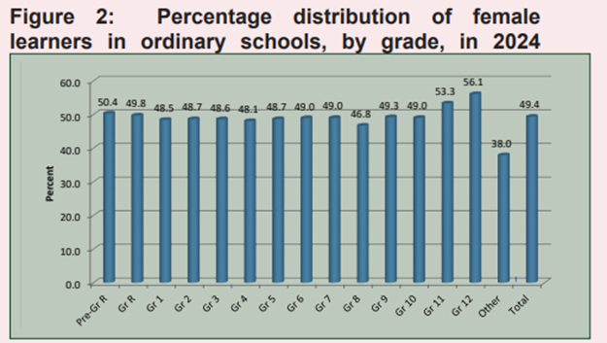
Source: DBE, 2024
National budget allocation for the Department of Basic Education
Year | Budget allocation (R billion)
2020/2021 | 25.3
2021/2022 | 27.6
2022/2023 | 29.1
2023/2024 | 30.5
2024/2025 | 32.3
Source: National Treasury
According to the table above, the trajectory of budget allocation does not demonstrate budget reduction. It is important for the state party to provide the rationale for closing public schools especially in rural areas.
Percentage (%) distribution of main reasons given by persons aged 7 to 18 years for not attending an educational institution by sex, 2023
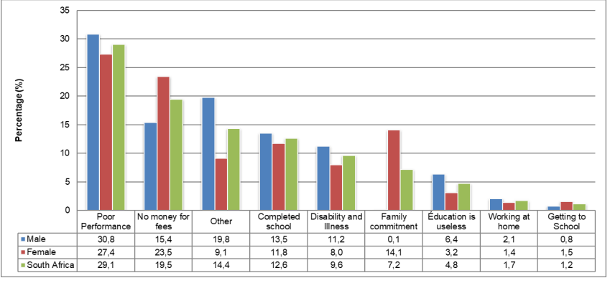
Source: Stats SA GHS (2023)
The table above presents the sex disaggregated data on the main reasons given by persons aged 7 to 18 years for not attending school.
10. Employment and Economic Empowerment
Despite progressive legislation, gender inequalities in employment persist. Women occupy only 24.9% of top management positions and earn between 23% and 35% less than men (Department of Labour, 2024; Buthelezi, 2023).
The Employment Equity Amendment Act (2023) introduces stronger compliance mechanisms, including mandatory targets. However, enforcement remains weak, particularly in informal sectors dominated by women.
Women face disproportionate unemployment rates, particularly Black women, whose unemployment exceeds 38.6% (Stats SA, 2025). Informal employment and care work responsibilities limit economic participation.
Although initiatives such as the Isivande Women’s Fund and SEDFA aim to support women entrepreneurs, access to funding remains a significant barrier, especially in rural areas.
11. Health and Reproductive Rights
South Africa has a strong legal framework for women’s health, including the National Health Act and the Choice on Termination of Pregnancy Act (1996). These laws provide access to reproductive health services, including termination of pregnancy.
However, access remains uneven, particularly in rural areas and marginalised communities, where facilities and trained personnel are limited. Stigma against gender-diverse communities and conscientious objection among healthcare providers further restrict access.
In 2021, the CGE found limited or no monitoring by the National Department of Health (NDOH) on termination of pregnancy (TOP) services across provinces, as the National Department of Health could not provide relevant information. Each province appears to manage termination of pregnancy services independently, leading to discrepancies in reporting. Some provinces lack access to services, especially for second-trimester procedures. There is also an unwillingness of healthcare professionals to provide termination of pregnancy services due to conscientious objection, which is a significant barrier.
HIV prevalence among young women remains high, with rates reaching 21.6% among pregnant women aged 15–24. Reports of forced sterilisation among women living with HIV highlight ongoing violations of reproductive rights.
Maternal health services have been significantly improved, with over 500 obstetric care facilities available nationwide. The maternal mortality ratio has decreased to 138 deaths per 100,000 live births, but rural areas continue to experience higher mortality rates, with a 10% higher rate of maternal deaths compared to urban centres. The government’s Maternal Support Services (MSS) programme has been instrumental in reducing maternal mortality, particularly through efforts to ensure skilled birth attendants and access to emergency obstetric care. Additionally, 92% of births are attended by skilled health personnel in urban areas, although the percentage drops to 85% in rural areas.
In 2023/2024, the CGE undertook an investigation into maternal and neonatal healthcare within the Eastern Cape province. Despite governmental efforts that aim to promote gender equality and improve women’s health, some provinces, particularly the Eastern Cape, face significant challenges in delivering adequate and quality healthcare services for women, which has resulted in high maternal and neonatal mortality rates.

12. Nationality and Citizenship
Amendments to the Citizenship Act (2023) have strengthened gender equality by allowing women to confer nationality on their children. Birth registration rates have improved, particularly for children of South African mothers and foreign fathers.
However, migrant and refugee women continue to face bureaucratic barriers, increasing the risk of statelessness. Inconsistent implementation across regions and lack of awareness remain key challenges.
13. Rural Women and Structural Inequality
Rural women face compounded disadvantages, including limited access to land, limited access to credit, resources, and economic opportunities. Only 18% of redistributed land is held by women, reflecting persistent structural inequalities.
Women also bear the burden of unpaid labour, contributing significantly to agriculture without formal recognition or compensation. Food security programmes reach only a fraction of female-headed and child headed households, further exacerbating vulnerability.
Women constituted a majority of beneficiaries, particularly in the Child Support Grant (CSG), with over 50% being mothers aged 18 to 35. In rural areas, half (47.2%) of women received grants compared to a quarter (23.1%) of women in urban areas (Stats SA, 2022). Women make up most of the grant recipients, especially the Child Support Grant, as women are the primary caregivers for the whole family, including the elderly. It is more evident in the rural areas than the urban areas that women are the primary grant recipients. In 2023, almost half (42,3%) of households nationally were headed by women, and just more than half (57,7%) were headed by men. Moreover, female headed households are prevalent in rural areas (47,6%), particularly in the Eastern Cape (48,8%) and Limpopo (47,0%) (GHS, 2023). As women make up most low-income earners and caregivers, women carry more responsibilities for collective household needs such as food, health, and education, and women spend a greater share of their already lower income on these needs.
South Africa’s Constitution (1996) guarantees equality and non-discrimination, ensuring that rural women have equal access to land and property rights (Republic of South Africa, 1996). However, despite key legal instruments such as the Communal Land Rights Act of 2004 and the Land Reform Programme, rural women continue to face systemic barriers to land ownership and tenure security. Customary land tenure systems continue to favour men’s ownership, systematically excluding women from land control (Masuku, Mthembu & Mlambo, 2023).
14. Conclusion
The review indicates that the country has made significant progress in various domains towards fulfilling its obligations under CEDAW. Notably, in the areas of policy and legislative reform, substantial advancements have been achieved throughout the reporting period from 2020 to 2025. The advancements include the implementation of progressive laws that aim to enhance gender equality and protect women's rights.
Additionally, a series of institutional reforms have been initiated, along with the development of comprehensive strategies and programmes. These initiatives focus not only on preventing discrimination and violence against women but also on providing support services for victims and survivors of GBV.
The findings indeed indicate that South Africa has made positive strides in addressing the crucial issues raised by the CEDAW Committee during the last reporting session. It is worth noting, however, that while significant advancements have been documented in terms of legislation and policy updates, as well as the establishment of various institutional mechanisms, much of this progress appears to exist primarily on paper. Many of these institutions, such as the Department of Health and other relevant agencies, remain inadequately resourced in terms of funding, personnel, and training, which hampers their ability to effectively implement the initiatives they were designed to support.
The three legislative frameworks established to tackle gender-based violence and femicide represent a significant step forward in South Africa’s commitment to this crucial issue. However, despite their promise, gender-based violence and femicide initiatives continue to face substantial challenges. They are often underfunded, resulting in inadequate resources for effective implementation. Coordination among various stakeholders, including government agencies, the private sector, non-governmental organisations, and community organisations, remains insufficient, which hampers the overall effectiveness of these initiatives. Furthermore, the execution of programmes designed to combat gender-based violence and femicide often lacks consistency and rigour, leaving many victims without the support they require.
This situation highlights a crucial critique that while South Africa may be making notable progress in developing legislation and policy frameworks on paper, the actual implementation of these measures falls significantly short, reflecting a worrying gap between intention and action in addressing gender inequality in the country.

References
Department of Employment and Labour. (2024). Department launches a game-changer in inspection and enforcement of NMW. Retrieved from https://www.labour.gov.za/department-of-employment-and-labour-launches-a-game-changer-in-inspection-and-enforcement-of-nmw
End GBVF Collective. (n.d.). NSP implementation collective. Retrieved from https://gbvf.org.za/nsp-implementation-collaborative/
Masuku, M. M., Mthembu, Z., & Mlambo, V. H. (2023). Gendered effects of land access and ownership on food security in rural settings in South Africa. Frontiers in sustainable food systems, 7, 1158946.
Murray, R. (2022). The impact of CEDAW Article 11 on women's employment rights. International Journal of Discrimination and the Law, 22(1), 5-20.
Neves, D., & Du Toit, A. (2023). Rural livelihoods and women's access to resources in South Africa. Development Studies Quarterly, 25(2), 74-95.
Olivier, T. (2020). The economic dependence of rural women in South Africa: A gendered analysis of social policies. Social Policy Review, 38(3), 98-113.
Pillay, S., & Pillay, R. (2021). Unpaid work and rural women: Economic implications and policy solutions. Rural Economy Policy Review, 19(4), 175-190.
Republic of South Africa. (1996). Commission for Gender Equality Act No. 39 of 1996. Government Printer
Republic of South Africa. (1996). Constitution of the Republic of South Africa. Government Printer.
Republic of South Africa. (2020). Employment Equity Amendment Act No. 47 of 2020. Government Printer
Stats SA. (2022). Unemployment rates in rural and urban South Africa: A comparative analysis. Statistics South Africa.

