To: The United Nations Committee on Economic, Social and Cultural Rights

Subject: Submission in relation to the fifth periodic report of Rwanda
This letter highlights concerns in Rwanda regarding the rights of domestic workers and people who use drugs. The below observations are being submitted by HDI Rwanda.
Health Development Initiative - Rwanda (HDI) is an independent, non-governmental, non-profit organization based in Rwanda. It strives to improve both the quality and accessibility of healthcare for all Rwandans regardless of their socio-economic status. HDI has been operating and advocating for vulnerable groups in Rwanda for the last 20 years.
Over the last two decades of operation, HDI has been noticing Rwanda’s significant strides in improving economic, social, and cultural rights, particularly in areas such as health service decentralization. However, legal, structural, and social barriers continue to hinder the full realization of these rights, especially for domestic workers and people who use drugs.

Rwanda continues to urbanize rapidly, the demand for domestic workers has grown significantly, shaped by shifting socio-economic dynamics. Many families in urban areas, balancing dual-income jobs, increasingly rely on domestic help to manage their households. This trend has led to a notable expansion of the informal sector, with domestic work becoming a critical source of income, especially for women migrating from rural communities to the cities.

With this urbanization growth, there is increased exposure to drugs and a higher likelihood of substance abuse in Rwanda. The youth constitute the majority of the population and are known to be more susceptible to experimenting with drugs due to peer pressure, curiosity, lack of recreational alternatives, and unemployment. The government has recognized the issue of excessive drug use and has initiated the TUNYWE LESS, loosely translated as let’s drink less, campaign to address alcohol consumption. While this is a positive step, it primarily focuses on alcohol and does not fully address the needs of other groups, such as individuals who use drugs, who have a higher incidence of HIV.

To effectively address these issues, the Government of Rwanda should consider alternative approaches with a particular focus on the needs of domestic workers and people who use drugs.

- Domestic workers

1.1 Context

[1] According to the United Nations Women report, unpaid domestic work is valued at 10 to 39% of Gross Domestic Product (GDP), indicating the economic importance of this labor, much of which is informal. Rwanda's informal sector is a significant component of its economy, estimated to account for approximately 31.4% of the GDP.

[2] A 2021 report by the National Institute of Statistics of Rwanda (NISR) confirms that women make up a significant majority in this sector. Additionally, a published study by HDI revealed that 73.8% of domestic workers were female in a sample of 884 workers in Kigali.
1.2 Legal framework
[3] The Constitution of Rwanda recognizes that everyone has the right to free choice of employment and that all individuals, without any form of discrimination, have the right to equal pay for equal work.
[4] The Law Nº 66/2018 of 30/08/2018 regulating labour in Rwanda which is in force since August 2018 recognizes the protection of informal sector workers including domestic workers in the issues relating to social security, the trade union organizations and those relating to health and safety at workplace
[5] Article 6 (1) of Law regulating labour prohibits forms of work including those cause physical harmful to the child. Additionally, the Ministerial Instructions N^{O} 01/2017 of relating to prevention and fight against child labour provide for preventive measures and sanctions for those who exploit children.

[6] Article 21 of the Constitution of Rwanda which stipulates that every Rwandan has the right to good health.

1.3 Areas of Concern

[7] Despite the existence of a progressive legal framework, working conditions affect the right to health for domestic workers as a recent study conducted in Kigali by HDI revealed that one in three domestic workers were unaware of their HIV status. This can be attributed to several factors: lack of targeted HIV programming, long working hours, leaving little time to seek healthcare, as well as the lack of health insurance coverage, among others. These findings highlight issues related to both the accessibility and quality of healthcare services.
[8] Regarding the right to work, recent evidence from a study conducted by HDI found that 1 in 8 domestic workers were under 18, violating one of the provisions of the Law Nº 66/2018 regulating labour in Rwanda which prohibits the worst of forms of employment for children.
[9] Additionally, nearly half of the domestic workers reported experiencing some form of workplace violence, with 1 in 6 enduring both physical and emotional abuse. These experiences were linked to severe mental health challenges, with 50.1% of workers facing psychological distress and 32.9% showing suicidal behaviors.
[10] The above-mentioned study noted that perpetrators of violence often prevent domestic workers from seeking help, trapping them in a state of severe mental distress. This underscores the urgent need for review of the current labor laws that safeguard this group from exploitation.

- Criminalization of Drug use and its consequences on the right to health
2.1 Context
[12] Although Rwanda has made commendable strides in addressing public health challenges, particularly in combating HIV/AIDS and communicable diseases like tuberculosis, its legal and policy framework on drug use remains heavily focused on criminalization and punitive measures. This approach risks undermining access to essential health services for people who use drugs.
[13] In response to the growing substance abuse problem, the Iwawa Rehabilitation Center was established to provide rehabilitation services, vocational training, and reintegration support for youth with drug-related issues. Since its inception in 2010, the center has successfully graduated 12,293 individuals, reflecting a commitment to addressing the complex challenges posed by substance abuse in Rwanda.
2.2 Legal framework
[14] The Law N0 68/2018 of 30/08/2018 relating to offences and penalties in general outlines various drug-related offenses, including the use, possession, and trafficking of illicit drugs with the ultimate goal of controlling drug use.
[15] Additionally, the Law N°03/2012 of 15/02/2012 governing narcotic drugs, psychotropic substances and precursors in Rwanda. This law provides a comprehensive framework for regulating narcotic drugs, psychotropic substances, and their precursors in Rwanda. It defines various controlled substances, establishes rules for their importation, production, distribution, and use, and outlines penalties for drug-related offenses, including possession, trafficking, and manufacturing.
2.3. Strategy
[16] The National HIV/AIDS Strategic Plan 2018–2024 highlights people who inject drugs (PWID) as a key population at increased risk of HIV infection due to several high-risk behaviors and social factors. PWIDs face heightened vulnerability because injection drug use often involves sharing contaminated needles, a primary driver of HIV transmission.
2.3 Areas of concern
[17] Article 263 of Law No 68/2018 of 30/08/2018 aims to control drug use and trafficking but inadvertently criminalizes individuals who use drugs, creating significant barriers to healthcare access and discouraging those in need from seeking help due to fear of legal repercussions. While we commend the recognition of people who inject drugs (PWID) in the HIV/AIDS strategic plan, the broader category of people who use drugs (PWUD) receives limited attention, leaving critical gaps in addressing drug-related harms.
[18] Despite existing government efforts, such as drug prevention campaigns, repression of drug trafficking, and rehabilitation centers, the country lacks comprehensive harm reduction services, including needle exchange programs, opioid substitution therapy (OST), and access to HIV prevention and care.
[19] The current legal framework, which penalizes drug users with imprisonment, limits their ability to access healthcare and perpetuates stigma and discrimination. This, in turn, hampers the delivery of critical services, including HIV testing, antiretroviral treatment (ART), and condom distribution.
[20] Furthermore, while Rwanda’s HIV/AIDS National Strategic Plan identifies PWID as a key population, there are no dedicated interventions or a comprehensive harm reduction package to meet their specific needs. Key gaps include a lack of comprehensive data on drug use, the absence of a national harm reduction policy, and insufficient healthcare access for PWUD.
- Recommendations
In light of the above, HDI calls on the Committee to recommend the Government of Rwanda to:
- Develop and implement rights awareness programs targeting domestic workers, employers, and the broader community.
- Establish safe reporting systems for domestic workers to report workplace violence, ensuring timely resolution and appropriate support.
- Ratify and domesticate the ILO Convention on Domestic Workers (C189) to enhance legal protection and enforcement.
- Promote mobile health services and outreach initiatives to provide confidential and accessible health care for domestic workers.
- Strengthen enforcement of regulations prohibiting the employment of minors as domestic workers.
- Amend Article 263 of Law No 68/2018 to decriminalize drug use and shift towards a health-centered approach.
- Develop a national harm reduction policy with a comprehensive, evidence-based package tailored to the needs of people who use drugs.
- Conduct research to inform drug-related programming and policy reforms based on current needs.
- Provide specialized training for law enforcement agents, health care providers, and key stakeholders involved in the national drug response.
- Implement community awareness programs to reduce stigma against people who use drugs.
We hope that this information is useful during the Council's review of Rwanda. If you would like further information, please do not hesitate to contact the undersigned.
Email: kagaba@hdirwanda.org
Phone Number: 0788305117

Sincerely,
Dr Aflodis Kagaba
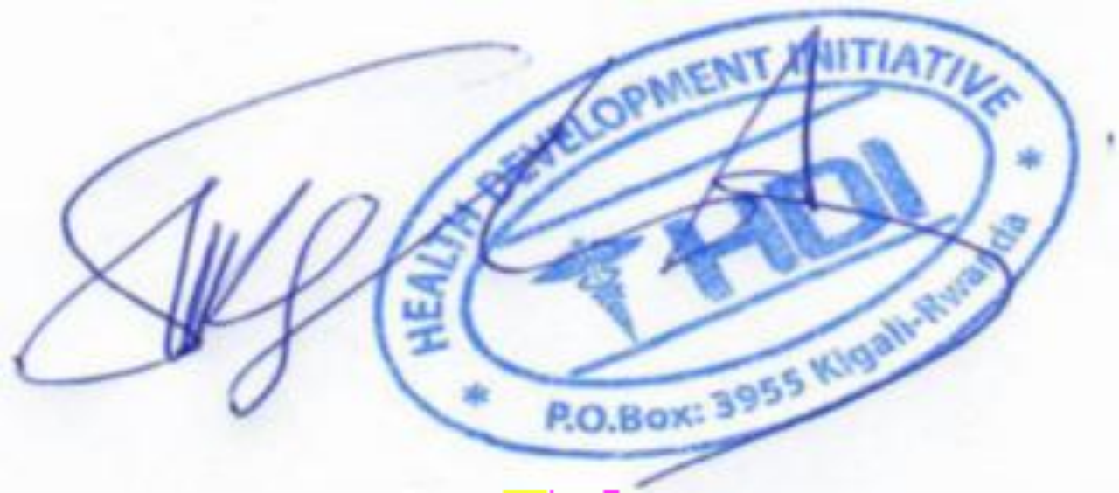
Executive Director

Ministry of health, Tunywe Less: curbing the rise in alcohol consumption among the youth, https://www.moh.gov.rw/news-detail/tunywe-less-curbing-the-rise-in-alcohol-consumption-among-young-people-in-rwanda, 2024
Assessment of gaps in laws & policies related to unpaid care work in Rwanda, Donnah Kamashazi, https://africa.unwomen.org/sites/default/files/2023-05/Final%20Report-Assessment%20of%20gaps%20in%20laws%20and%20policies%20related%20to%20unpaid%20care%20work%20in%20Rwanda.pdf
As note 1
Gender Statistics profile report- Nyaruguru & Ruhango District, https://www.statistics.gov.rw/statistical-publications/subject/gender#:~:text=Women%20make%20up%20majority%20among,gender%20equality%20and%20development%20issue, 2023
Unveiling the burden: prevalence and predictors of psychological distress among domestic workers in Kigali-Rwanda, HDI-Rwanda https://pmc.ncbi.nlm.nih.gov/articles/PMC11589022/, 2024
Articles 30, 31 and 32 of the Constitution
Injection drug use practices and HIV infection among people who inject drugs in Kigali, Rwanda: a cross-sectional study, https://harmreductionjournal.biomedcentral.com/articles/10.1186/s12954-021-00579-0, 2021
Drugs and Substance Abuse Amongst Adolescents - A pilot Study in 7 Districts, https://rbc.gov.rw/publichealthbulletin/img/rphb_issues/a9e93b3756891b9d0d4354a68740f3e61682073176.pdf, 2023
Rwanda Public Health Bulletin, https://rbc.gov.rw/publichealthbulletin/img/rphb_issues/RPHB%204%20(1)%20V5.pdf, 2023
As note 9

