BRIEFING ON KYRGYZSTAN FOR THE COMMITTEE ON THE RIGHTS OF THE CHILD, SESSION 94 PRE-SESSIONAL WORKING GROUP- February 2023
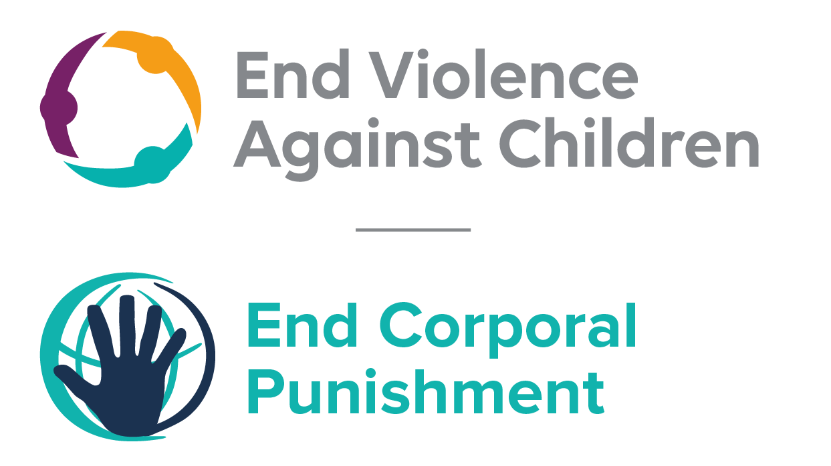
The Global Partnership to End Violence Against Children, October 2022

This briefing describes the legality of corporal punishment of children in Kyrgyzstan. In light of the Committee’s General Comment No. 8 on “The rights of the child to protection from corporal punishment of children and other cruel or degrading forms of punishment”, its repeated recommendations on the issue and the importance of eradicating this form of violence given by the UN Secretary General’s Study on Violence against Children. Considering the recommendations to prohibit all corporal punishment made during the Universal Periodic Review in 2010, 2015 and 2020, as well as the global commitment to ending all violence against children in the context of the 2030 Agenda for Sustainable Development, we hope the Committee will:
• in its List of Issues Prior to Reporting for Kyrgyzstan, raise the issue of corporal punishment of children, in particular asking what progress is being made towards the adoption of the new Child Code to explicitly prohibit corporal punishment of children in all settings; and,
• in its concluding observations on the fifth-sixth report of Kyrgyzstan, recommend that a legislation is enacted as a matter of priority to explicitly prohibit corporal punishment of children, in all settings including the home and repeal all provisions allowing the use corporal punishment by adults.

Kyrgyzstan’s commitment to prohibiting corporal punishment
Kyrgyzstan expressed its commitment to prohibiting corporal punishment in all settings by clearly accepting the recommendation to do so made during the Universal Periodic Review of Kyrgyzstan in 2015 and 2020. A draft Child Code which would prohibit all corporal punishment of children is yet to be signed by the President.

Summary of necessary legal reform to achieve full prohibition
Prohibition is still to be achieved in the home, alternative care settings and day care.
There appears to be no confirmation in legislation of a “right” of parents and other to impose corporal punishment on children, such as a right to inflict “reasonable chastisement” or a “power to correct”. However, the near universal acceptance of a certain degree of violence in the name of discipline necessitate clarity in law that all forms of corporal punishment are prohibited, without exception.
Alternative care settings – Prohibition should be enacted in legislation applicable to all alternative care settings, including foster care, placed of safety, emergency care, etc.
Day care – Corporal punishment should be prohibited in all early childhood care (nurseries, preschools, crèches, family centres, etc) and all-day care for older children (day centres, after-school childcare, childminding, etc.).

- Current legality of corporal punishment in Kyrgyzstan
  - Home: Corporal punishment is lawful in the home. There is no clear prohibition in law of all forms of corporal punishment in childrearing. The Code on Children 2012 includes as one of the basic principles of child protection “ensuring protection of the child from all forms of violence” (art. 4, unofficial translation); it defines violence/abuse as “any action in relation to the child which violates or endangers its physical or mental development” (art. 5). Article 7 states that the child has the rights to “care from parents and persons replacing them” and to “respect for his/her human dignity”. Article 16(1) states: “Every child has the right to honour and dignity, and security of the person. The state provides personal security of the child, and protects him/her from physical and mental, sexual violence, cruel, brutal, inhuman or degrading treatment….” The Code does not explicitly prohibit all corporal punishment, however light, in childrearing.
  - The Family Code 2003 states in article 59(2) (unofficial translation): “… The child has the right to education by the parents, ensuring its interests, full development, and respect for human dignity….” Article 61(2) protects the child from abuse by parents; article 70 states: “In the exercise of parental rights, parents have no right to harm the physical and mental health of children, their moral development. The methods of raising children should exclude neglectful, cruel or degrading treatment, abuse or exploitation of children.” But the Code does not explicitly prohibit all corporal punishment, however light, in childrearing.
  - The Law on the Protection and Protection from Family Violence 2017 (Law No. 63 of 27 April 2017) repealed the Law on Social Legal Protection from Violence in the Family 2003. We have been unable to examine the Law on the Protection and Protection from Family Violence 2017 but there are no indications that it addressed corporal punishment of children. The 2003 Law did not explicitly state that violent punishment in the guise of “discipline” was prohibited. In reporting to the Committee on the Rights of the Child, the Government had acknowledged the inadequacy of this Law in protecting children from violence. However, under examination by the Human Rights Committee in 2014, the Government stated that corporal punishment is prohibited under the Criminal Code. In fact, there is no explicit prohibition of corporal punishment in the Criminal Code 2014.
  - During the Universal Periodic Review in 2010, the Government accepted the recommendation to protect children by law from corporal punishment in any setting, but also stated that the law already prohibits corporal punishment. However, following the second cycle review of Kyrgyzstan in 2015, the Government clearly accepted the recommendation to prohibit corporal punishment in all settings including the home, indicating its commitment to law reform to achieve prohibition. During the third cycle review of Kyrgyzstan in 2020, the Government supported the recommendation to prohibit corporal punishment in all settings.
  - A draft Child Code aiming to prohibit corporal punishment of children in all settings was under discussion. Article 5 of the draft Code lays out key principles, including a “ban on corporal punishment and other acts degrading the human dignity of the child everywhere in all forms and manifestations” (unofficial translation). Corporal punishment is defined in article 6 as “any punishment of a child with the use of physical force and the intention to inflict physical pain on him to any degree” (unofficial translation). Another Bill amending the Code of misdemeanours makes corporal punishment an offence punishable by a fine or “public works”. Both texts were introduced to Parliament in December 2019. In July 2021, the Child Code aiming to prohibit corporal punishment in all settings was adopted by the Parliament. It will come into force after it is signed by the President. As of October 2022, new Child Code had not been signed by the President. We have yet to examine it.
  - Alternative care settings: Corporal punishment is unlawful in residential institutions. In clause 31 of Regulation No. 489 “On the state children’s home (residential institutions) of the system of the Ministry of Education, Science and Culture of the Kyrgyz Republic” 1998, corporal punishment is not included as a permitted measure of discipline. There is no explicit prohibition of corporal punishment in foster care and other alternative care settings, though children are protected from some corporal punishment under the protection from “cruel, brutal, inhuman or degrading treatment” in article 16 of the Code on Children 2012.

  - Day care: There is no explicit prohibition of corporal punishment in day care settings, though children are protected from “cruel, brutal, inhuman or degrading treatment” in article 16 of the Code on Children 2012. The Law on Preschool Education 2009 states that children in preschool education have “the right guaranteed by the state … to be protected from all forms of exploitation and actions that are harmful to their health, as well as physical and psychological abuse, humiliation of dignity” (art. 18, unofficial translation), but it does not explicitly prohibit all corporal punishment.

  - Schools: Corporal punishment is unlawful in schools, though there appears to be no explicit prohibition. The Law on Education 2003 states in article 29 (unofficial translation): “… Teachers shall … not apply methods of physical and moral abuse in relation to students.” The Law on the Status of the Teacher 2001 states in article 15: “The teacher shall … respect the honour and dignity of pupils.” Article 16 of the Code on Children 2012 protects children from “cruel, brutal, inhuman or degrading treatment”.

  - Penal institutions: Corporal punishment is considered unlawful as a disciplinary measure in penal institutions but it is not explicitly prohibited. There is no provision for corporal punishment among the permitted disciplinary measures in the Criminal and Executive Code 1999 (arts. 39-15 and 87), but the Law on Bodies and Organisation of Criminal and Executive (Penitentiary) System 2003 states in article 28 that staff may use physical force if nonviolent methods are ineffective. Article 16 of the Code on Children 2012 protects children from “cruel, brutal, inhuman or degrading treatment”.

  - Sentence for crime: Corporal punishment is unlawful as a sentence for crime. It is not among permitted sentences for offenders under 18 in article 78 of the Criminal Code 1997. The Code on Children 2012 includes among the principles underpinning juvenile justice “prohibition and prevention of all forms of violence in case of administration of law concerning children in conflict with the law” and “prohibition of torture, cruel, inhuman or humiliating treatment or punishment of the minor” (art. 90). The cases of crimes committed by children are often heard in aksakal (traditional village) courts. Corporal punishment is not included in the measures available to these courts under articles 28 and 29 of the Law on Courts of Aksalals 2002; article 28 also states that the court has no right to impose punishments degrading to human dignity.

Recommendations by human rights treaty bodies and during the UPR

  - CRC: On three occasions, the Committee on the Rights of the Child has recommended to Kyrgyzstan that legislation be enacted to explicitly prohibit corporal punishment in all settings: in its concluding observations on the state party’s initial report in 2000, on the second report in 2004, and on the third-fourth report in 2014.

  - CAT: In its 2013 concluding observations on the state party’s second report, the Committee Against Torture recommended that legislation be enacted to explicitly prohibit corporal punishment in all settings.

  - HRC: On two occasions, the Human Rights Committee recommended that the Government prohibit corporal punishment in all settings: in its concluding observations on the state party’s initial report in 2000 and on the second report in 2014.
2.4 UPR: At the first cycle of the Universal Periodic Review of Kyrgyzstan in 2010, recommendations to adopt legislation explicitly prohibiting corporal punishment were issued and accepted by the Government. Recommendations to prohibit all corporal punishment made in the second cycle UPR in 2015 and third cycle UPR in 2020 were also accepted.

6 June 2012, CRC/C/KGZ/3-4, Third/fourth report, para. 72
14 March 2014, CCPR/C/SR.3039, Summary record of 3039th meeting, para. 14
16 June 2010, A/HRC/15/2, Report of the working group, paras. 53 and 76(56)
9 April 2015, A/HRC/29/4, Report of the working group, para. 117(78)
27 August 2020/A/HRC/44/4/Add.1, Report of the working group, para. 65
[2019], CRC/KGZ/5-6, Fifth/sixth report, pages 8-10; information provided by UNICEF Kyrgyzstan (December 2019)
Information provided by UNICEF Kyrgyzstan (July 2021)
9 August 2000, CRC/C/15/Add.127, Concluding observations on initial report, paras. 33, 34, 39 and 40
3 November 2004, CRC/C/15/Add.244, Concluding observations on second report, paras. 37, 38, 43, 44, 45 and 46
7 July 2014, CRC/C/KGZ/CO/3-4, Concluding observations on third/fourth report, paras. 32 and 33
20 December 2013, CAT/C/KGZ/CO/2, Concluding observations on second report, para. 21
24 July 2000, CCPR/CO/69/KGZ, Concluding observations on initial report, para. 19
23 April 2014, CCPR/C/KGZ/CO/2, Concluding observations on second report, para. 21
16 June 2010, A/HRC/15/2, Report of the working group, paras. 76(56) and 76(57)
9 April 2015, A/HRC/29/4, Report of the working group, para. 117(78)
27 August 2020/A/HRC/44/4/Add.1, Report of the working group, para. 65

