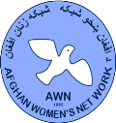
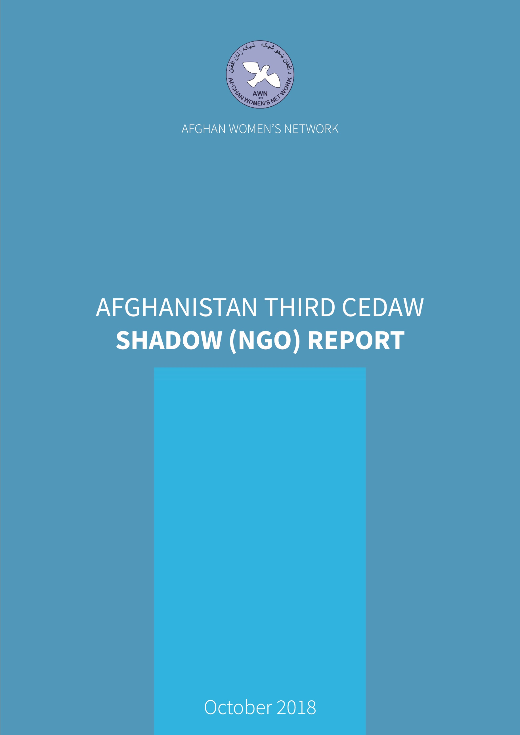

EXECUTIVE SUMMARY

1

There is no doubt that women in Afghanistan have made significant social and economic progress in the years since the combined Initial and Second CEDAW Report was issued. Women’s literacy rates have risen, women are now actively involved than ever before in the public domain, including in the civil service, diplomatic positions, the private sector, medical, legal, teaching professions, arts, sports, and many other areas and more women enjoy better access to maternal health care services. It remains a concern, however, that Afghanistan’s maternal mortality ratio is the highest in South Asia, at 390/100,000 live births and the adolescent birthrate (ages 15-19) is 74 per 1,000 births.

However, the number of women in the civil service (2016-17) remains low, with the figures as follows: MOJ 8%, MOD 8.5%, MOI 0.8%, Ministry of Counter Narcotics 6.1% and the MORR 10.1%. Likewise, participation of women in the police force and justice system remains low.

There has been significant progress in relation to reform of gender discriminatory laws including the EVAW Law, Anti-Harassment Law, and the NAP on UNSCR 1325. A start has been made in spreading awareness of gender and women’s rights issues (e.g. women’s rights in Islam and in civil law) among some sections of the population. The struggle for civic and human rights for women and indeed, all of Afghan society, still has a long way to go. Despite some positive developments, women remain culturally constrained in terms of decision-making. Early marriage & forced marriage remained common practices. Women face ongoing exclusion from political participation and endure gender-based violence and social marginalization.

VAWG remains a serious problem, both perpetrators and victims of violence continue to see domestic violence as a private matter, finding it both socially unacceptable and logistically difficult to involve the police. Women’s access to the formal justice system is complex, expensive and time-consuming, especially in rural areas. Informal justice (i.e. the local Jirgas with only male members) is deeply patriarchal and is based on social attitudes that are deeply inimical to women’s well-being. One study estimates that 150 cases of honor killing occur annually in Afghanistan, based on statistics kept over the past five years. Fewer than half of them are formally reported, however, and very few ends in convictions. Based on 2016 data, incidents of VAW lacked investigation, arrest and prosecution of perpetrators.

In December 2015, the AIHRC issued a report documenting the widespread use of so-called virginity examinations on female detainees. Afghan police and prosecutors routinely order such tests on women in their custody and use the results to charge women with “morality crimes.”

There is still a disproportionately low number of women elected to seats in the Parliament and the situation at the provincial and district levels is even worse. In 2017 some women Cabinet members and provincial Governors were replaced by male counterparts. In most provinces, women are never consulted on important provincial discussions and decisions.

An influx of returning refugees and the large number of internally displaced Afghans has brought with its problems for women and girls, in addition to the stresses of poverty, relocation and establishing livelihoods faced by entire families. Early marriage is adopted by some families as a negative coping strategy. The situation also leaves girls and women vulnerable to human trafficking. Many returning refugees and migrants, most from Pakistan, joined the ranks of the IDPs”.
2

The MoWA – has fallen short of achieving its stated goals of protecting women from violence and abuse, empowering women and creating an enabling environment for women in all decision-making bodies. Som e of the reasons for this was the overlap of functions and lack of cooperation between government Ministries, lack of gender-related specialist capacity, and a ‘welfare’ approach to women’s empowerment.

Ratification of the Optional Protocol to the Convention on the Elimination of All Forms of Discrimination against Women (OP-CEDAW) was strongly urged by AWN and other women’s groups but has not yet been accomplished. There is a need to emphasize again the necessary institutionalization of the education of women, men and law enforcement officials on gender-related matters. The 2017 Human Rights Watch report notes that, “A long-promised plan by the Afghan government to implement UNSCR 1325, which calls for women’s equal participation in issues surrounding peace and security, was further delayed during the year.

In addition to the specific recommendations outlined under each Article discussed in this Shadow Report, the report offers a number of cross-cutting recommendations that are crucial to the implementation of CEDAW in Afghanistan.

Recommendation Priority 1: The international community should put diplomatic pressure on the Afghan Government to ensure that women’s rights are effectively incorporated into the education system and geared towards changing social norms on women’s rights, ending VAW, and women rights in Islam (e.g. inheritance, divorce, women`s right to education). School curricula require a thorough revision from a gender perspective. Introducing innovative gender mainstreaming programmes in the curriculum of the schools and universities should redefine the roles of men and women, including women as leaders, and the rights of boys and girls, such that traditional views that promote gender inequality and violence are disrupted. The curriculum needs to include a gender-sensitive framework for teachers, parents and students to comprehend the meaning of gender equality.

Recommendation Priority 2: Involve religious scholars in promoting CEDAW provisions. Recognizing that Afghanistan is a religious society and religious scholars are part of the formal government structures, the role of mullahs and clergy should be increased in promoting awareness of VAW and should start actively preaching that any form of violence against women and children is unacceptable in both civil and religious law. Such engagement should be one of the implementation indicators to be reported in the next periodic report on implementation of CEDAW. Similarly, madrassas and other religious schools should be registered with the government and with specific curricula include courses on VAW and make it explicit that no form of violence is acceptable in either civil or religious law.
3
Recommendation Priority 3: Ensure that the laws provide for accountability of state and non-state actors who commit or are complicit in the commission of violence against women, through a range of punitive, preventive, and restorative measures. Initiate a law that will hold the State accountable for failing to take all reasonable steps to prevent, protect, and fulfil the rights of women and girls.

Recommendation Priority 4: The allocation of sufficient budget should be undertaken to effectively implement the mandate of MoWA. MoWA should strongly advocate for the allocation of appropriate funds and promotion of departments of gender to directorates and clearly defined strategies, policies and plans should be developed to ensure implementation of NPP-WEE.

Recommendation Priority 5: Timely and accurate reporting of VAWG cases should be done so that immediate attention and assistance is provided to victims. It is important to develop a standard operating procedure that will capture victim identification and referral to rehabilitation centres. Creation of specific anti-drug programs especially for women that includes eradication of sources of narcotics should immediately be prioritized and undertaken. Importantly, specific hospitals should be designated to provide treatment for addicted women and ensure allocation of resources and funds for appropriate and proper provision of care and rehabilitation for anti-trafficking victims including shelter.

Priority Recommendation 6: Salary standardization to address gaps in pay scale between men and women should be developed and implemented. The principle of reward and recognition should be implemented regardless of gender and improved mechanisms to receive and review complaints of gender and sexual-based violence should be implemented. The government should provide support for women at markets to sell their handicraft, link them to international markets and facilitate the ground to women who have started their business at district level.

Introduction

The Afghan Women’s Network was established in 1995, following the UN Fourth World Conference on Women in Beijing China. AWN is a non-partisan and non-profit network; whose members are women's organizations and agencies working for women’s rights. AWN has an active and considerable presence in Kabul, Herat, Balkh, Kandahar, Bamyan, Paktia, Nangarhar and Kunduz provinces, and is also active through its members in other provinces of Afghanistan. AWN members include 3,700 individuals and 145 organizations.

This shadow report addresses areas of concern raised by the Committee on the Elimination of Discrimination against Women in the Concluding Observations on the combined Initial and Second periodic reports on Afghanistan.

Constitutional, Political, and Legal Structure

Legal framework for the protection of Human Rights at the national level: Afghanistan is a signatory to the UN Declaration of Human Rights, the cornerstone of the Afghan legal framework is the 2004 Constitution, the statutory principles of which are based primarily on principles of Islam (Shari’a). The citizens of Afghanistan, man and woman, have equal rights and duties before the law.” Other laws that promotes gender equality and women’s rights include the 1977 Afghan Civil Code, the 2009 (EVAW Law), as well as international treaties to which Afghanistan is a State party.

Law on Elimination of Violence against Women (2009): EVAW Law identifies 22 acts of violence against women, including rape, forced prostitution, forced marriage, abuse, humiliation or intimidation, harassment or persecution and forced drug addiction among others.
4

Despite the existence of the EVAW Law, VAW remains a major issue in Afghanistan, as do forced marriages, early child marriages, the practice of Baad and Badal and so-called “honor killings”. High illiteracy rates, low levels of legal awareness particularly among women, misinterpretation of Sharia, and low awareness about human rights and women’s rights, and children’s rights within Afghan communities are the key underlying causes for continued traditional harmful practices in the provinces. The EVAW Commissions in Kabul and the provinces are still technically and financially dependent on UN Women and are not able to lead their own initiatives. The lack of proper data collection and a database to keep track of VAW cases, the prosecution process, as well as the final decisions and support constitute massive gaps in the delivery of justice.

Reporting Process on EVAW Law

The Civil Code (1977): A clear definition of marriage was included in the Civil Code (1977) which defines marriage as a contract that legalizes sexual contact between a man and a woman. Likewise, it defines the minimum age of marriage for men as 18 and for women as 16. The rights of married women are also outlined in the Civil Code which clearly defines the payment of support and economic rights paid by the groom to the wife.

Family Law: The Afghan Family Law is generally considered to be progressive from a gender perspective in that it provides some important protections to women in terms of child custody, inheritance and divorce rights and this is governed by the Civil Code 1977. However, the Family Law has several outstanding weaknesses and has not been sent to Parliament for approval by MoJ. The MoJ argues that the Articles of this Law should be reviewed and analyzed by experts from other Muslim countries. Recently, social gatherings at which people gave their recommendations, were run at the zonal level but the status of this law has remained the same.

Penal Code: On March 4, 2017; HE, President Ashraf Ghani endorsed Afghanistan's new Penal Code in Decree No. 256. This Code has been drafted by the Criminal Law Reform Working Group (CLRWG) between 2012 and 2016. The new Penal Code compiles all criminal provisions from other laws into a single document and modernizes and clarifies offenses and punishments. The new Code added effectiveness in preventing, reducing, deterring, and fairly punishing criminal behaviors. The revisions also ensure conformity with the standards and norms under the international treaties and conventions to which Afghanistan is a signatory, including CEDAW.

Despite the on-going efforts made by Afghan CSOs and the Government, the elimination of VAW remains a dream. Virginity testing is one of the unethical practices that violates women’s rights. In Afghanistan, the bloodied sheets from the first night of girls’ wedding is considered as proof of virginity in many rural and urban areas. Over the years, many Afghan girls have been killed, detained and punished for lacking an intact hymen. At best, they are called impure. The Virginity Test has recently been banned in the Penal Code, and a huge number of CSOs, including AWN and AIHRC, have lobbied to ban compulsory tests. Fortunately, the Penal Code now condemns and prohibits virginity tests.

The Anti-Harassment Law: In November 2016, a Law was passed by the Parliament to protect women and children against harassment. While the move was considered commendable, a petition for amendment has recently been submitted by the Women’s Commission in the Lower House and by CSOs to the President to further review the Law. According to the team of lawyers leading the petition, the focus should not only be on imposing punishment but also on ensuring that protective measures are in place with increased social awareness of the law.
5

The Treaty-Specific Document

ARTICLE ONE: DEFINITION OF DISCRIMINATION

Article 22 of the Constitution of Afghanistan (2004) stipulates that “Any kind of discrimination and distinction between citizens of Afghanistan shall be forbidden”, it further states that “the citizens of Afghanistan, man and woman, have equal rights and duties before the law.” As such, all Afghan citizens are equal. The Constitution recognizes inequality or discrimination based on gender and/or religious affiliation and the state is required to act upon any unequal treatment that may arise. Across the country, local practices have been discriminatory, particularly in areas where knowledge of the law is limited. Male elders are accustomed to relying on the interpretation of Sharia law and tribal customers, which discriminate against women. Male domination has hindered women’s access to justice and their rights.

ARTICLE TWO: INFORMATION ON IMPLEMENTATION OF THE CONVENTION

Measures have been undertaken by the Government of Afghanistan to promote and strengthen women’s rights. These are reflected in its legislation, policies, institution-building and operations.

Although AWN recognizes the efforts of GoIRA in implementing measures to address discrimination, the extent and effectiveness of the implementation appear to have been minimal. One indicator of this is the Gender Inequality Index (GII) introduced in the 2010 Human Development Report, which shows that in 2015 Afghanistan had a GII value of 0.667, making it 154th out of 159 countries and 168th out of 189 countries for which there was complete data in the 2017 Index. The GII reflects gender-based inequalities in three dimensions: reproductive health, empowerment, and economic activity. The GII for Afghanistan reflects the loss in human development due to inequality between female and male achievements.

Recommendation: AWN calls on the Government to strictly implement of the Convention as approved in the budget.

ARTICLE THREE: IMPLEMENTATION OF THE CONVENTION THROUGH ALL AVAILABLE MEANS

Women’s advocacy groups recognize the efforts of the government to work with the local courts to encourage them to interpret laws so that they do not discriminate against women. A deeper understanding and awareness of the EVAW law and its implementation, as conveyed through discussions with community members and FRU reports, has resulted in (i) more women gaining access and legal assistance and (ii) cases being resolved according to the EVAW Law. The EVAW law has also strengthened the rights of women to employment by criminalizing any interference on rights of women to work. However, while provisions for equal work are in place, there is no mention of equal pay for equal work. Efforts have been made to recruit additional women police officers. As of September 2015, a total of 2,834 female police officers had been recruited and trained; however, this is only 2% of the total police force. A hindering factor is the prevailing cultural prohibitions and male domination which prevents women from working outside the home and thus making recruitment and retention difficult.
6

ARTICLE FOUR: AFFIRMATIVE ACTIONS

The Afghanistan Peace and Reintegration Program is started in 2010, for the promotion of peace, reconciliation and security in Afghan communities. The most significant development in the peace process was the joint participation of the GoIRA together with the civil society leaders, the Taliban Political Commission based in Doha, Qatar, other Taliban representatives and members of the international community, in 2015-2016. A strict monitoring should be undertaken to ensure effective implementation of the peace process and any related programs. The CSOs support a peace process that does not compromise democratic achievements. Based on the Afghan civil society position paper for the London Conference on Afghanistan in December 2014, civil society strongly proposes that government should take strong and comprehensive measures to address all forms of discrimination and the root causes of violence against women in any possible deal.
7

The National Machinery for the Advancement of Women: The women’s advocacy organizations believe that the Ministry is faced with a multitude of challenges as a result of the country’s socio-cultural and political discourse. Strategic, organizational and operational gaps exist within the Ministry, limiting its capacity to effectively carry out its functions. Gender concerns are not effectively addressed due to a lack of gender training among its staff. The budgeting process lacks transparency and is not adequate to cover its operational requirements. Faced with an increasingly contentious political discourse, this can be a challenge. While technical and financial assistance has been provided in the past by donor agencies to MoWA, efforts need to be exerted to strengthen and capacitate the Ministry as an implementing arm of the Government with regard its gender-related policies.

Recommendations to build the efficiency of the MoWA

- The allocation of sufficient budget should be undertaken to effectively implement its mandate. Being the lead agency in women’s affairs, MoWA should strongly advocate for the allocation of appropriate funds and promotion of departments of gender to directorates.
- A sufficient number of competent and gender-sensitive trained staff should be appointed to ensure effective implementation of plans.
- Clearly defined strategies, policies and plans should be developed to ensure implementation of NPP-WEE.
- Sustained conduct of advocacy and education campaigns are needed to make women aware of their rights including addressing family violence.

The Afghanistan Independent Human Rights Commission: There is a call to review the founding law of the AIHRC. The Article 11 requires Commissioners to have a good reputation, public trust, independence, and commitment to human rights. However, it does not include or define the selection process for candidates. AWN and women’s advocacy groups fear that the Commission lacks a clear, transparent, and participatory selection process that is based on merit. AIHRC’s selection of Commissioners has been based on the appointment of the President. To maintain its independence, the President should not have the authority to remove them from office once appointed. The Civil Society and Human Rights Network, together with ANNI have made strong representation to the President to take appropriate action to correct this discrepancy in the law.35

Recommendations to enhance the operational efficiency of the AIHRC

- The AIHRC should encourage the formation of a multi-sectoral consultative committee composed of CSOs, international community members and selected official in Government that will look into the appointment of AIHRC Commissioners.
- Enforce a clear selection process that is based on merit, public trust and commitment to human rights; and strongly encourage the active participation of CSOs in the process.
- Enforce the agreed TOR and the Paris Principles.
- AIHRC should review its processes and mechanisms to include transparency and accountability and regularly monitor the implementation of its plans and activities.

ARTICLE FIVE: ELIMINATION OF STEREOTYPES
8
“Moral crimes” and so-called “honor killings”: The practice of arresting and prosecuting runaway women and girls for “moral crimes” and charging them with the aggravating intention to commit zina (adultery and fornication) or pre-emptive zina is generally deplored, however it is accepted under current practice. Women involved in moral crimes (both as defendants and victims) are often denigrated and/or treated with contempt. With the law opened to a wide range of interpretation, the tendency of women’s rights to be violated is inevitable.

There is a need to expand the ruling on abolishing “running away” to also include “attempted zina”. While there has been a decrease in “running away” charges, research done by Human Rights Watch (in 2016) showed that arrest, conviction and prosecution is done under the classification of “attempted zina”, a charge deemed justified by judges, prosecutors, and police.38 The law should provide for state accountability for investigating, prosecuting, and convicting victims of rape for zina and entitle women to remedies as a result of the same. The State should also be held accountable for committing acts which denigrate the women and failing to take adequate steps to avoid “re-victimization”.

ARTICLE SIX: TRAFFICKING IN WOMEN AND GIRLS: Since the Anti-Human Trafficking and Abduction Laws were passed in 2008, AWN and other civil-society advocacy groups have acknowledged the value of the initiatives undertaken by the Ministry of Justice. One of these was recruiting an NGO to mount a public awareness program in 20 provinces. A short-term shelter in Kabul was reopened for trafficking victims, including 15 Child Protections Units. This led to preventing the recruitment of more than 300 trafficked children into the Afghan security forces in 2016. According to the 2017 Trafficking in Persons Report of the US Department of State, the GoIRA has not yet met the minimum standards on key areas.

There is inadequate effort to protect victims. Comprehensive victim identification and assistance statistics have not been compiled to allow systematic identification of victims and their transfers or referrals to protective services. While the MOLSAMD reported that it had created a referral system, it was not known whether this was used or disseminated for proper monitoring of victims.

Recommendations to the GoIRA for effective implementation of the law

- Timely and accurate reporting of cases, by age and gender, should be done so that immediate attention and assistance are provided. It is important to develop a Standard Operating Procedure that will capture victim identification and referral to appropriate rehabilitation centres.
- Creation of specific anti-drug programs especially for women that includes eradication of sources of narcotics should immediately be prioritized and undertaken. Importantly, specific hospitals should be designated to provide treatment for addicted women.
- Appropriate and effective monitoring of cases need to be regularly enforced and act to eliminate administrative corruption which is presently prevalent.
- Capacitate anti-trafficking enforcers and prosecutors in the provincial and local levels on the proper definition of human trafficking, as well as identification, protection, and law enforcement strategies.
- Ensure allocation of resources and funds for appropriate and proper provision of care and rehabilitation for anti-trafficking victims including shelter.
- Put in place measures to ensure that victims of prostitution and trafficking are not investigated, prosecuted, and punished for zina.

ARTICLE SEVEN: POLITICAL AND SOCIAL RIGHTS OF WOMEN
Upholding women’s rights achievements: It is important to recognize the continuous efforts exerted by the government in the implementation of the EVAW law. It is also important to note that during the Afghan solar year 1393, the total number of cases registered by the MoI, MoWA, DoWAs and the Attorney General’s Office is 5,720. of the total, 79% or 4,541 are cases of VAW while the remaining 21% are civil cases concerning disputes related to divorce, separation, and annulment of engagement, alimony and child custody.
9

Overall cases registered by MoWA, the Police and the courts, by category of violence
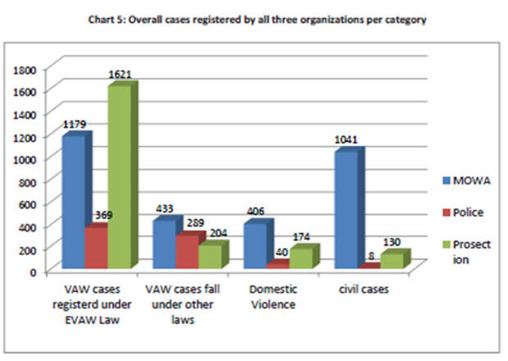

A review of EVAW over three years (1391, 1392, and 1393) shows an increase of 27% in the number of registered cases from 4,505 in 1391 to a total of 5,720 in 1393. On the other hand, the number of complaints due to acts of violence criminalized under the EVAW law has dropped by 11% (from 3,396 in 1391 to 3,038 in 1393).

Comparative analysis of registered cases, 1391 to 1393

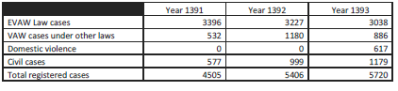
Members of Parliament opposed to the landmark 2009 (EVAW) law with continued efforts to weaken the Law by amending it to remove provisions regulating the minimum age of marriage, prescribing punishments for domestic assault and providing for women’s shelters. As of November 2016, the draft amendments were being considered by the Parliamentary Commission on Women, Civil Society and Human Rights.

There is a need to strongly advocate increasing the participation of women in the National Assembly and to open opportunities for women to assume high-level government seats. Strengthening women’s participation will promote a strong voice and unified stand among women, thus allowing them to support and/or resist gender-related provisions that will affect women. Afghanistan’s culture of male domination and discriminatory tradition has discouraged women from participating in decision making, whether in public, political or professional life. The total number of civil service employees in 2016-2017 is 399,574 of which 77.5% were male with only 22.5% female. This is a 0.3 percent decrease compared to last year.
10

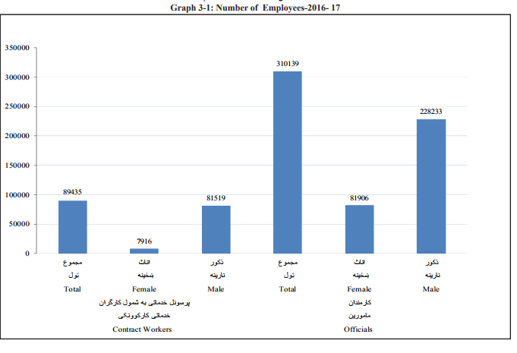
Source: Central Statistics Organization, Islamic Republic of Afghanistan

Total reported number of officials based on the graph above is 310,139 of which only 26 percent is female and 74 percent male. This reflects the impact of male domination on women’s participation in public offices.

Recommendations to empower women to participate in political and public life are as follows:

- Strongly uphold women’s meaningful presence in the National Assembly and in the Provincial Councils as stated in the Electoral Law. The state should ensure appointment of qualified women who can assume authority and effectively participate in decision making.
- Strongly advocate increasing and active participation of women by providing opportunities for women to assume high-level government seats at the central and local governments.
- Develop and implement financial and technical support programs that will create women’s economic self-sufficiency which will eventually lead to women’s increased participation in the private sector.
- Provide full support in the implementation of the NPP-WEE which aims to create an enabling environment for women.
- Fully enforce the current platform for political participation as well as political cooperation among women that strongly advocate and encourage women’s participation.
- Provide capacity building programs and encourage education among women to increase their self-confidence and encourage them to take part in decision making.
- The need to improve the mechanism for the investigation, prosecution and punishment of traffickers as well as the support services, for the victims is greatly emphasized. Active collaboration between the police, judicial and legal sectors in terms of investigation, interrogation, prosecution and punishment should be undertaken with the full enforcement of the law without exceptions.

Participation of women in the peace process and its impact on women’s rights

Although the Government of Afghanistan has recently taken steps to increase the number of women in the HPC, the number remains low (12/19%) compared to that of men. Women’s advocacy groups believe that deep rooted patriarchal attitudes on not allowing women to express themselves, men’s negative opinions and lack of trust in women within and outside government has contributed to a lack of women’s participation in the HPC. Although some women have been put in high level positions, they have not been able to represent women’s voices and interests. Male counterparts prohibit women’s participation in peace talks in parts of the country due to insecurity, hence making women only a symbolic part of the peace talks.
11

Women’s NGOs and advocacy groups have been effective in influencing the HPC to allow more women to sit as members in the High Peace Council. The Afghan CSOs are lobbying the government and the international community to ensure protection of their rights and to allow them to contribute to reconciliation efforts.

Recommendations to strengthen women’s participation in the peace negotiations

- Strict monitoring of the implementation of the Gender Policy for the High Peace Council (HPC) should be undertaken. The Gender Policy was issued by the HPC’s Joint Secretariat to establish a gender balance in the composition of peace and reintegration institutions; however, this has not been strictly followed.
- Curriculum enhancement should be done in Higher Education to include Peace and Conflict Management courses. Increased knowledge of women will strengthen their capability to actively participate in pre and post peace processes including debate, facilitation, mediation, dialogue and negotiation and quality peace agreements implementation.
- Peace Committees should be organized at the district levels, thereby allowing greater opportunities for women to participate and raise their voices in the peace process. Currently, it is at both the central and provincial levels, but is relatively weak at the provincial level.
- A new policy or amendment of the law that will require strict participation of women in the High Peace Council should be created.
- Sufficient budget allocation should be appropriated for women’s participation in peace negotiations.

ARTICLE NINE: NATIONALITY

The amended draft of the Census Law was approved, authorizing the printing of the word “Afghan” on the electronic identity card as the “nationality and ethnicity” of the holder during the first quarter of 2017. With the issuance of the national identification card (Tazkira), it not only proves a person’s identity but also facilitates the holder’s right to education, ownership of land and property, participation in political processes and other liberties and entitlements under the law. By law, all adult Afghans, regardless of sex and age, are entitled to receive a Tazkira. However, although women have the legal right to hold a Tazkira, cultural and other challenges hinder their access.

Many men do not allow female family members to obtain identity documentation. In more remote areas, men find it shameful for female family members to obtain these documents. And some women also lack knowledge of the existence of and their right to a national identity card. One recent study found that, “Afghan women are often unable to obtain basic legal documents such as national ID cards and marriage certificates, which makes it difficult to seek help from the courts when they are in trouble.

ARTICLE TEN: EDUCATION:

High illiteracy rates among women and low enrolment at the secondary level coupled with high dropout rates continue to be prevalent. The fear of crimes, lack of security, lack of female teachers in the villages and rural areas are major contributing factors. Most of the primary, secondary/high schools for girls are located far from the villages. The fear of girls being in an accident or victimized in a sexual assault has caused families to deter girls from going to school when they reach the age of 12 or 13.
12

However, recent changes have been noted and families are now open in allowing their girls to go to school. Based on the Afghanistan Statistical Yearbook 2016-2017, total number of female new students reached 11,934 in 2016 compared to 11,853 in 2015. Likewise, 2015 saw a 6.4 percent increase in the number of new female students from 11,135 in 2014 to 11,853 in 2015. The greatest increases in female enrolment are in urban centres. To address the decrease in enrolment and corresponding increase in drop-out, the following actions are recommended:

- Establish more primary schools at the rural levels with utmost importance.
- Formulate programs that will encourage parents and families to participate in parents’ councils at the school
- Improve benefits for teachers such as facilities for nursing teachers and increases in salaries.
- Improve mechanisms to receive and review complaints of gender and sexual-based violence.
- Provide literacy classes to women and girls who are not able to attend formal classes due to a variety of obstacles such as poverty and/or insecurity.
- The State party needs to ensure the safety and security of teachers free from harassment as well as provide appropriate privileges such as increase in salary and job security.

ARTICLE ELEVEN: EMPLOYMENT

Low labour force participation characterizes the labour market of Afghanistan. With men having higher participation, at 80.5%, women show very low engagement in economic activity at 26.7%. This shows that the labour and economic potential of Afghanistan is not fully maximized with a high dependency level amongst family members. Based on the ALCS 2016-2017 Mid-term Results-Highlights April-September 2016, Afghanistan has a relatively low employment-to-population ratio.

With agriculture as the backbone of the rural economy, women play a critical role, accounting for nearly 43% of the sector’s labour force. However, despite playing a vital role in agriculture, they are engaged in the lower levels of the value chain and labour-intensive activities such as performing irrigation, weeding, harvesting, and minimal processing. Men, on the other hand, are engaged in the upper level of the value chain. Further, women working on the farm are either paid a very low wage or none. This basically reflects the social and cultural norms in Afghanistan in relation to gender indifference. However, women are not given equal work opportunities in terms of position, promotion and wages.

Recommendations to ensure that women are given equal work opportunities in terms of position, promotion, and wages are presented below:

- Develop and undertake programs that will allow and encourage women to take higher education that will encourage them to pursue higher positions and other opportunities.
- Salary standardization to address gaps in pay scale between men and women should be developed and implemented.
- The principle of reward and recognition should be implemented regardless of gender.
- Implement improved mechanisms to receive and review complaints of gender and sexual-based violence.

ARTICLE TWELVE: HEALTH:

Participation of women professionals in the health sector has been decreasing. Out of Afghanistan’s 5,858 doctors, only 22% are women, and women comprise 21% of the country’s 5,599 nurses. While 11,037 women community health workers provide essential basic health services and education to women around Afghanistan, only 3% of 958 community health supervisors are women and 53% of rural clinics have a female physician.
13

Fewer women are joining the health services due to lack of security, education and qualified skills. The lack of job opportunities in the health sector due to the smaller number of local clinics in the villages has also contributed to the decrease. Likewise, families who do not allow family members to serve in distant neighbourhoods or districts coupled with a male dominated society are known to be contributing factors. To maintain a gender balance in the health sector, there is a need to increase educational and employment opportunities for women, such as community health education and setting up family health and protection centres in remote areas. A special facility should be set up by the government to attend to mentally affected women that will provide shelter and appropriate treatment.

ARTICLE FOURTEEN: RURAL WOMEN:

AWN commends the MOWA and the Ministry of Agriculture, Irrigation, and Livestock for taking an active part in presenting their rural development plans to the relevant communities. Part of the development plan is the provision of credit facilities. It is also worth noting that the Ministry of Finance signed in July 12, 2017 a financing package of $482.3 million in grants with the World Bank of which $5 million (1.04%) is to support the Women’s Economic Empowerment National Priority Program (WEE-NPP) Support Project.

The MRRD and MOEC are commended for actively earmarking a budget for the implementation of the rural development plan. This has been presented to the communities especially the rural women, it is important to note the plans of the MOWA, the Ministry of Agriculture, Irrigation and Livestock and the Ministry of Economy to organize women into credit cooperatives. It is also important to note the need to create an oversight multi-sectoral committee to monitor project implementation and thereby to ensure that project objectives are achieved and that the results are attained.

ARTICLE FIFTEEN: EQUALITY BEFORE THE LAW

Legal complaint mechanisms: Despite the efforts to implement the formal justice system, this has not been fully achieved. Strong interference from influencers and powerful people has contributed to corruption within the system. Bribes are required for cases to proceed. Incompetent staff, the culture of male domination and women’s lack of knowledge of their rights have further contributed to the failed implementation of the formal justice system.

The informal justice system is most often resorted to by most of the people accessing justice. While this is a recognized venue for justice, it is flawed with cultural biases by male elders against women. The Civil Dispute Resolution Act (2015) was drafted by the MOJ to formalize the Jirgas and Shuras. The implementation of this law will dig a well for Afghan women at large, since women do not have the right to participate in the local Jirgas/Shuras and decisions are issued in their absence. It is also the case that most of the decisions are not taken in favour of women and their consent to the decisions is not deemed important for the member of the Jirga/Shura. At meanwhile, protocols should be established to recognize and strengthen the role of legal aid providers as a necessary cog in the justice machinery, without which, many women would have suffered from a miscarriage of justice, unfair trial, or heightened re-victimization during the justice process.

cInternally Displaced Persons and Refugees:
In just three years, the number of IDPs has increased to 1.2 million - AWN notes that, due to a lack of capacity and expertise within the MORR, the Ministry has not effectively implemented the new National IDP Policy that was launched in 2014. According to Amnesty International, Afghan IDPs continue to lack adequate shelter, food, water, health care and opportunities to pursue education and employment. As noted above, women and girls who are displaced from their homes are often vulnerable to sexual and physical violence and to exploitation by human traffickers.
14

Aside from the lack of capacity, the Ministry is beset with corruption and faces waning international interest. The 2014 IDP Policy spells out the rights of IDPs and a concrete Action Plan for implementation but it has not lived up to its promise and, so far, has shown few benefits for those displaced. Efforts should be undertaken to capacitate MORR and establish a sustainable and gender-sensitive mechanism that will ensure that the policy is implemented and that the IDPs are equally provided with better access to basic needs and opportunities. Women refugees and displaced persons should be provided with information about the program and how access it.

Policy Brief: Beyond Numbers and Participation- Afghan Women Must Make Decisions, AWN, 2017
Afghanistan Living Conditions Survey Mid-Term Result Highlight 2016-2017
Afghanistan. UNDP Human Development Report 2016.
Central Statistics Organization, Afghanistan. 2016-2017.
New York Times. May 3, 2014.
https://www.rferl.org/a/afghanistan-virginity-tests-human-rights-violation/27582267.html
https://www.independent.co.uk/news/world/middle-east/afghanistan-female-governor-replaced-by-man-masooma-muradi-daikundi- sexism-resistance-gender-a7972166.html
https://www.pajhwok.com/en/opinions/problems-and-issues-curriculum-development-afghanistan
AWN Profile
EVAW Law report final March 2014
Baad and Badal are ttraditional practices of “giving” a usually young female family member ” to settle a dispute.
Derived from the religious precepts of Islam, particularly the Quran and the Hadith.
http://www.musawah.org/sites/default/files/Afghanistan-report%20for%20Home%20Truths.pdf
A virginity test is to determine whether a female has been subjected to sexual intercourse
Agency Coordinating Body for Afghan Relief and Development. Medica Afghanistan: Our First Anti-Harassment Law and why it should be amended. September 3, 2017
Country Reports on Human Rights Practices for 2016 United States Department of State • Bureau of Democracy, Human Rights and Labor.
Progress Report on Women’s Status and Empowerment and National Action Plan (NAP 1325)
Afghanistan UNDP Human Development Report 2016
Afghanistan 2016 Human Rights Report
Afghanistan peace and Reintegration Programme (UNDP Support) 2015 Second Quarter Project Progress Report.
ANNI is a network of human rights organizations and defenders engaged with national human right institutions (NHRIs) in Asia advocating for the effective work and functioning of these bodies for the promotion and protection of human rights.
Based on the Global Alliance of National Human Rights Institutions, Afghanistan’s Independent Human Rights Commission is compliant with the Paris Principles.
The law criminalizes the use of threat or force or other types of coercion or deceit for the purpose of exploitation..
http://moj.gov.af/en/news/300852.
Notes were taken from the 2017 Trafficking in Persons Report of the US Department of State.
Third Report on EVAW Law in Afghanistan in March 2014 – March 2015).
Afghanistan 2016 Human Rights Report
Human Rights Watch. Events 2016 Afghanistan.
The Peace Process & Afghanistan’s Women. Part 2 of a 4 Part-Series on Peace and Reintegration in Afghanistan by Stefanie Nijssen.
New Afghan ID Cards to Include Both Nationality, Ethnicity. March 2, 2017. TOLOnews.
Commissioned by the Norwegian Refugee Council and funded by the European Commission, SIDA, UNHCR and Danida.
Without IDs, Afghan Women Remain Invisible in the Justice System. March 9, 2017.https://www.newsdeeply.com
National Strategy on Women in Agriculture 2015-2020.
The Ministry of Public Health and UN Partners call for greater efforts to step up gender equality: more women needed in all roles in the health sector. UNFPA Afghanistan. March 9, 2016
Amnesty International, number of people internally displace by conflict doubled to 1.2 million in just three years. May 31, 2016
http://morr.gov.af/Content/files/National%20IDP%20Policy%20-%20FINAL%20-%20English(1).pdf)

