JOINT CONTRIBUTION TO THE FOLLOW-UP PROCEDURE ON THE 2021 CONCLUDING OBSERVATIONS OF THE UN COMMITTEE ON THE ELIMINATION OF ALL FORMS OF DISCRIMINATION AGAINST WOMEN - CEDAW COMMITTEE -

Ecuador 2024

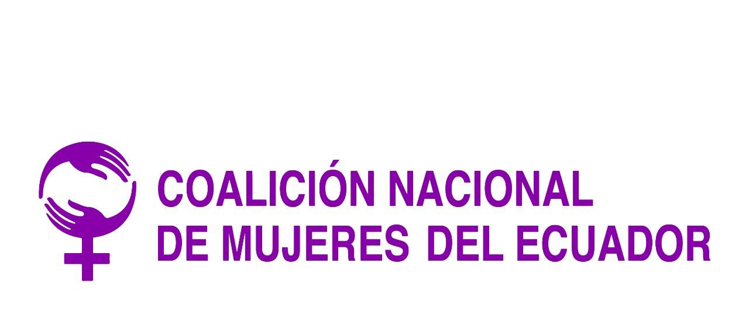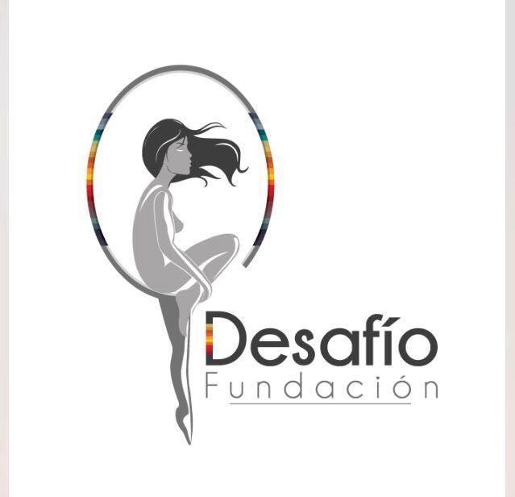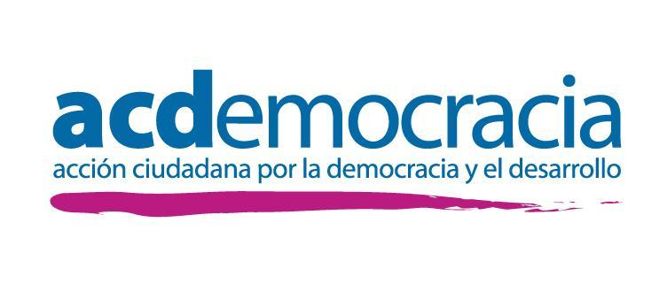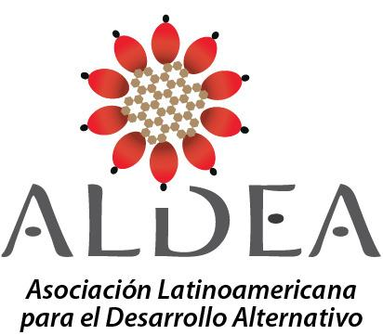
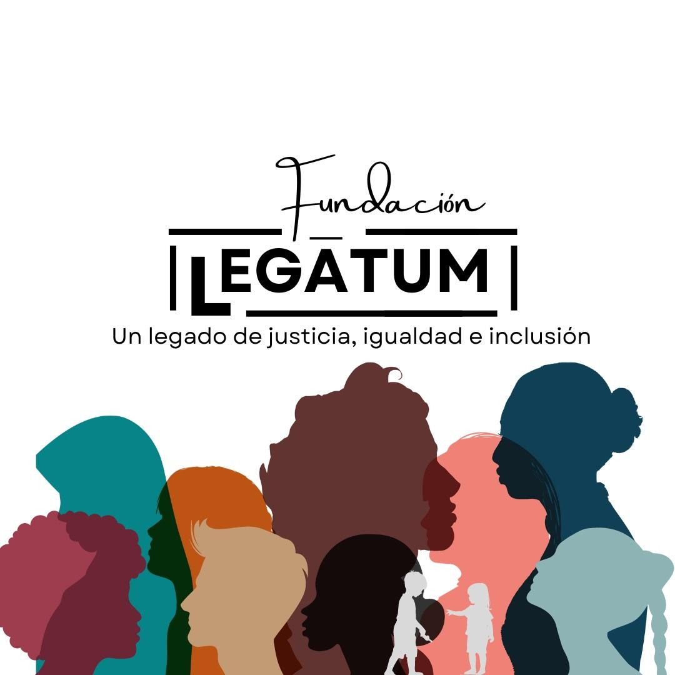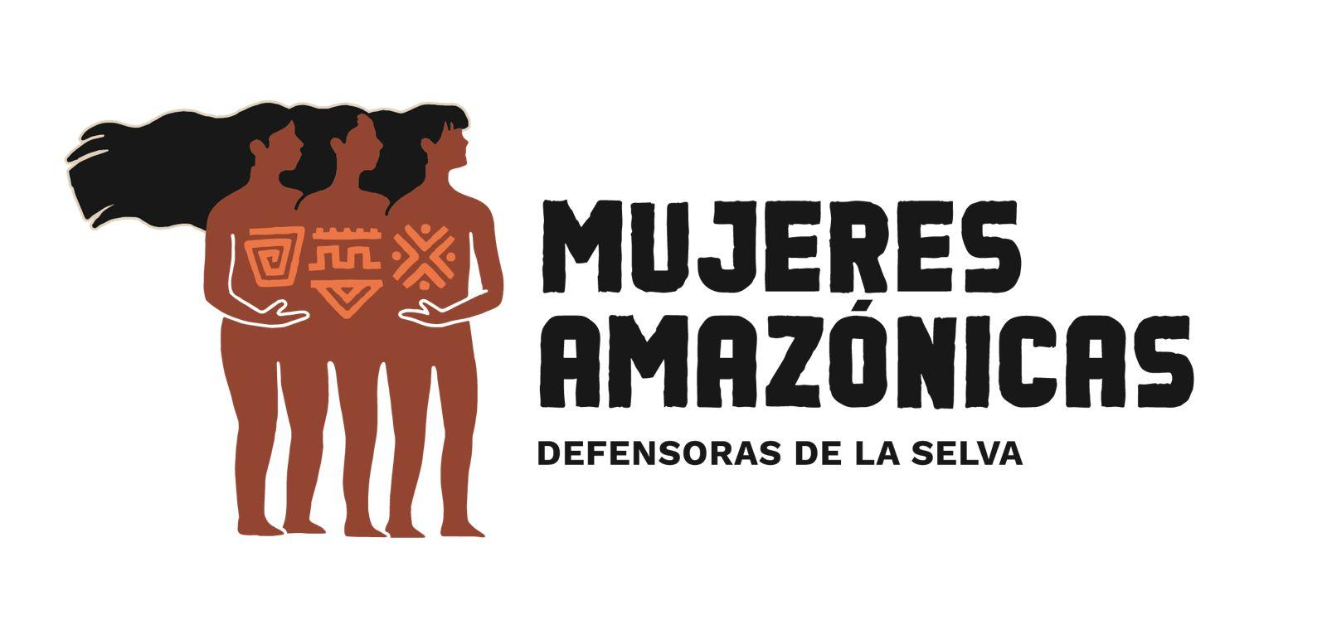

Introduction

- In accordance with the procedures within the CEDAW Committee and the request for a written report within two years on the steps taken to implement the recommendations contained in paragraphs 22 a), 22 d), 28 c) and 34 a) of these concluding observations, survivors of violence, women's organizations of Ecuadorian civil society and legal professionals, allow us to provide updated information based on the monitoring of state actions and the daily work of diverse women in the field.
- We kindly request the members of the Committee that speak Spanish to refer to the Spanish version of this document.
22 (a):
STRUCTURAL VIOLENCE & FEMICIDES
- The current situation of structural violence in Ecuador shows that the VaW law is not being implemented. Besides the declaration of "non-international armed conflict" puts girls, women and elderly women in the country at a greater risk, especially those belonging to vulnerable groups, such as Afro-descendant women, in regions where violence has been exacerbated.
- The last three years have been the most violent years for girls, adolescents, women and elderly women in the country. From the data collected by Alianza Feminista para el Mapeo de los Feminicidios en el Ecuador, it can be seen how more than 800 women have had their lives violently taken from them.
- The State has done little to prevent and eradicate violence and the figures of the deadly escalation of violence prove it. Budget cuts, weak institutions and lack of political will are factors that have had an impact on the exposed results that profoundly affect the rights of women and girls to a life free of violence.
- Civil society has made a complementary effort to register all violent deaths that have characteristics of femicidal violence, and has denounced new forms and more violent conditions in which femicides are perpetrated. To this end, civil society records and generates maps of femicides in the Country that are published periodically.

Data collected by civil society organizations

FEMICIDES | CIVIL SOCIETY
YEAR 2022 | 332
YEAR 2023 | 302 cases  + 4 cases of women missing in previous years but found in 2023.  (Data still under review as of January 10, 2024)
Source: ALDEA Foundation. www.fundacionaldea.org

- As for the Ecuadorian State, it has created an online platform -femicidiosEC, Judiciary Council- to make visible all violent deaths of women in Ecuador. This platform classifies cases into murders, femicides, homicides, robbery with death, rape with death, contract killings, abandonment of person and kidnapping, i.e. femicide cases are substantially reduced and do not name all those that occur..

State`s data
NUMBER OF FEMICIDES AND OTHER FORMS OF VIOLENT DEATHS AND NEWS OF THE CRIME
 | Year 2021  226 cases in total  (61 femicides) | Year 2022  424 cases in total  (89 femicides) | Year 2023  583 cases in total  (102 femicides) | TOTAL
Source: FemicidiosEC. Juditiary Council 2023
- The province of Guayas is the one that has experienced the highest increase in femicides and violent deaths of women from 2021 to 2023, followed by Manabí and Los Ríos, Pichincha and El Oro. Pichincha is the province with the largest population in the country, followed by Guayas. The levels of insecurity due to criminal violence, contract killings and machismo violence are expressed more strongly in the province of Guayas.
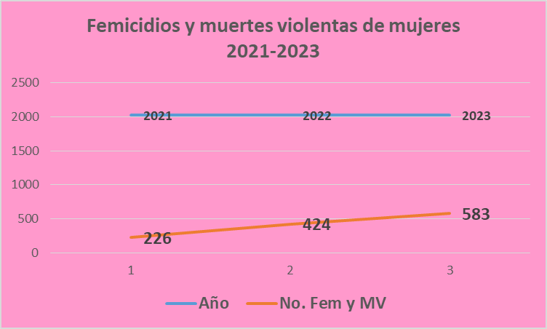
FUENTE: FemicidiosEC Consejo de la Judicatura, 2023, Elaboración propia.
- From January 1, 2021 to December 31, 2021 226 femicides and violent deaths were registered. From January 1, 2022 to December 31, 2022, 424 femicides and violent deaths of women were registered; and from January 1, 2023 to December 31, 2023, 583 femicides and violent deaths of women were registered.
- Civil society organizations question the State for its weak response to the escalation of machismo violence against women, girls and adolescents, and warn of a greater escalation, especially taking into account the context of criminal systems that are changing the social dynamics of the country in general, but also the ways in which violence against women is presented, specifically.
- Female bodies are being used as spoils of war between criminal gangs, to mark territories of death/ confrontations or to send sobering messages to the neighborhood or community. Likewise, these deaths of women - slaughtered, with their throats slit, whose bodies are "dumped" in public spaces as waste - show a growing message of misogyny and hatred towards female bodies.
Low prosecution and conviction rates in cases of violence

- Facing this reality, the responses from government institutions are scarce and access to justice, security or protection for victims does not materialize. In fact, during 2023, civil society has reported that only taking into consideration the data of 2023, at least 36 victims of femicide had a history of violence - in some cases they even went to the care and protection services - or even had a help ticket (boleta de auxilio).
- The Ecuadorian justice system is going through a crisis unparalleled in the history of the country, a crisis that is evident both in the administrative area, since there is a lack of the most elementary things, such as paper and ink for printers, reagents for evidence in cases of sexual abuse and specialized personnel: experts, psychologists, forensic doctors, among other needs; as well as in the jurisdictional area in which serious cases of corruption are noticed, such as, for example, the denaturalization of jurisdictional guarantees, actions through which people linked to organized crime groups are favored and even sentenced femicides and sexual aggressors have been left free.
- This reality has been confirmed by the World Justice Project (WJP), which recently published a report in which it defines the progress or setbacks of 142 countries in the rule of law, analyzing eight factors. In terms of the absence of corruption in the Ecuadorian justice system, our country is ranked 105th, which implies a very high level of corruption, comparable to the situation in countries such as Iran, Zambia and Albania.
- Through an operation called METÁSTASIS, carried out on December, 2023, by the Attorney General's Office, the infiltration of organized crime groups and drug trafficking in the administration of justice, in the Police, in the Executive Function was evidenced; in this operation 31 people were arrested, including judges, prosecutors, police, prison guides and lawyers in free practice, who were part of a corruption network that received money in exchange for issuing appeals or sentences in favor of these groups.
- Survivors of violence and their families are condemned to impunity and lack of redress, hence the importance of working and demanding profound changes, purification and training processes.

N.S.G’s case, member of the Kichwa people of Sarayaku and the Amazonian Women's Collective

- An emblematic case is that of N.S.G who in 2015 filed the first complaint against her ex-partner for physical aggression, blows to the face and body At that time, the person in charge of summoning the defendant "was unable to find him", even though he had all the information on where to locate him, and the case was filed. In 2020, he filed a second complaint for psychological violence, including a death threat with a shotgun pointed at his head. In turn, her ex-partner filed complaints against her for the alleged crime of psychological violence, this time acting as the victim, with the purpose of subduing, intimidating, threatening her, and continuing to exert control. He has also used her son as a means to continue violating her, repeatedly misusing the judicial system by filing lawsuits against her in family and visitation matters.
- In March 2022, interposed a third complaint. The aggressor had been failing to comply with the protective measures (injunctive relief) ordered in favor of N.S.G since 2020.
- One of the causes that have unjustifiably delayed the process is that for more than four occasions there have been excuses by the Prosecutors and that her case is in charge of the Unit of Citizen Patrimony, Rapid Solutions and Transit 2, of the Prosecutor's Office of Pastaza, without capacity or experience in gender violence. Four years after the complaint was filed, she is in the evaluation and preparatory stage of the trial, which was scheduled for Friday, January 5, 2024, however, the competent judge postponed the hearing for February 14, without any reason, adding another unjustified delay.
- The case of N.S.G demonstrates the reality of many other women -especially those who have fewer resources and fewer real possibilities of access to justice-. It also shows how violence remains invisible and women continue to be re-victimized, even by the institutions created to guarantee these rights and the rights of all, despite filing the corresponding complaints and providing the necessary evidence. It also shows that:
- There are not enough prosecutors and personnel specialized in gender violence, and those that exist have more than 3000 processes per year.
- The aggressors use the same system to continue controlling, manipulating, violating and intimidating the victims, with the purpose that their victims are exhausted and retract the complaint.
- The distress tickets do not serve their purpose of providing protection to the victims. Women die with distress tickets in their wallets.
- Racism and silence from civil society, local media and even organizations that call themselves "feminist" opt for silence if the aggressor is from a family with economic and political influence.
- Re-victimization is present in all public institutions given the lack of expertise, experience and training in gender and the excessively slow processes.
- In spite of the support of international cooperation, the Unified Registry of Violence (RUV) is a pending debt. The State must fulfill its commitment to implement this instrument in its entirety, providing the necessary budget for its operation.
- Regarding care and protection services, there is no effective mechanism for referral and counter-referral of cases. The lead entity -Ministry of Women and Human Rights- does not manage to integrate all services into a national network, as services offered by local governments, for example, are left out. Thus, there are no specific guidelines for the authorities on what they must do to open victim care and protection services, on the quality of the approach, minimum standards or others. In addition, when new authorities take office in mayors' or prefectures' offices, services are left to the free will of the new authority if he or she continues with sufficient support and budgets. This results in services being closed or opened according to political expediency and not according to the demand for services in that locality. For this reason, local ordinances are needed that are aligned with the competencies that the LOIPEVM provides for the GADs.
- There are few care and shelter services for adolescents and they do not meet the demand in the face of the increase in sexual violence against minors. This favors revictimization and lack of protection, as some of the victims are reintegrated into society.

In this context, as organizations we highlight:
- Regarding femi(ni)cides, the Ministry of Women and Human Rights should activate the National System for the Prevention and Eradication of Violence against Women and direct greater efforts to strengthen its prevention policy, at all levels of government; with actions of education, communication and social networks on a permanent basis; with the necessary budget. Training must be permanent, since the current is not enough to achieve a change in socio-cultural patterns.
- At the same time, it is necessary to continue coordinating with civil society so that the data on femicides and violent deaths of women are compatible.
- The State must design and implement prevention, care, protection and reparation policies for the victims of violence and for the families of femicide victims in all territories, whether urban, marginal urban, rural or geographically distant.
- Even though on November, 2022 the Ministry of Women and Human Rights was created. However, it was done under the same structure and budget of the Secretariat of Human Rights (Art.1), therefore it represents only a change of name and unfortunately, it is a weak institution, without territorial deconcentration, nor sufficient personnel in its "Specialized Centers", to face the incessant increase of the scourge of violence against women.
It is worth mentioning that in these centers, called Centros Violeta (Violeta Centers), ISO standards are applied, these standards are focused on processes and not on people. A comprehensive reparation is defined by the victim, not by a standard quality process. These centers provide guidance and psychological and social support, but do not provide sponsorship, which means that the civil society organizations are the ones that take them on, increasing their workload, but without increasing their budget.
- The Ministry of Women and Human Rights, as the competent entity in the area of violence against women, should issue a national regulation with clear guidelines for cantonal and provincial governments on the opening of care services, both external and sheltered, for women victims of violence. These guidelines should have minimum standards for the opening of services that guarantee quality approaches, basic minimum infrastructure and local ordinances that can sustain the services, regardless of the authority in charge.
- The National Plan for the Prevention and Eradication of Violence against Women, elaborated with the participation of civil society in 2020, has 143 indicators aligned with the competencies of the National System for the Prevention and Eradication of Violence, however, to date this plan has not achieved inter-institutional coordination and has not been able to comply with its actions of prevention, attention and reparation to women victims of violence at a national and decentralized level. This Plan has not been properly socialized and disseminated at the national level among the competent authorities; in the Amazonian provinces, for example, its existence is unknown among the same governmental entities.
- The National System for the Prevention and Eradication of Violence against Women had 27 inter-institutional articulation meetings by 2021 and 10 by 2023, i.e. This system, as evidenced by the National Assembly that monitors the implementation of the Law for the Prevention of Violence against Women, has a weak implementation, and requires political clarity and commitment. The lives of women and girls in the country depend on its functioning.
- This system continues to be written on paper and declarations that have no concrete impact on women's lives. It has been designed on the basis of meetings and reports, but there are no mechanisms for monitoring due process or sanctions, when the norm is not applied, or for following up on cases.
- The National Equality Agendas developed by the National Equality Councils are not binding for the Government Planning Secretariat. These instruments should be binding and cross-cutting for national and decentralized government institutions.ersales para las instituciones del gobierno nacional y desconcentrado.
- With the change of government, due process and monitoring of cases of violence and femicide must be ensured and that both the Annual Planning and the General State Budget take into account gender-based violence as a priority. We also call for the approval of the bill for the Integral and Transformative Accompaniment and Reparation for family members of victims of femicide and other violent deaths of women.
28 (c) :
- It is brought to your attention that data from the Ministry of Education indicate that 4.1% of children and adolescents (NNA) dropped out of school/college and there was a decrease of 3% of students enrolled for the year 2023-2024.
- Approximately 38,238 children have not been enrolled in school in the highlands and the Amazon. The most important causes are poverty, lack of interest and migration. A fundamental aspect to consider is the insecurity in many areas of the country. As a consequence of this reality, according to a FORBES report, 1,326 adolescents between 12 and 17 years old have been arrested in the first semester of 2023 for crimes of robbery, possession of weapons and drug trafficking, according to information provided by the National Police.
- School dropout is the reflection of a deep social crisis. It is a structural problem that cannot be solved only by the Ministry of Education, but by the entire structure of the State. Children and adolescents have no future and feel that they have been abandoned by the State. Particular responsibility lies in the areas of finance, education, health, labor, and security.
- In the case of the province of Esmeraldas, according to data from the Ministry of Education, in the last five years, 28 thousand children and adolescents have dropped out of the education system due to impoverishment, high rates of violence and natural disasters. In other words, we are talking about forced school dropouts.
34 (a):
- In its follow-up report, the State makes "special mention" of the decriminalization of abortion in cases of rape for all women, through the LORIVE (R.O. No. 53, Second Supplement, 29-04-2022), and calls it a "milestone in guaranteeing women's reproductive rights in Ecuador". In this regard, it is worth remembering that the United Nations Special Procedures emphasized how this law was approved in regressive terms.
- By 2024 in Ecuador, although there has been progress with respect to the legal framework for the exercise of SRRR, setbacks are evident:
Developments
- Ecuador, through the Constitutional Court, has decriminalized abortion in cases of rape, but this minimal progress is not accompanied by a public policy that allows victims to access services and health care providers are not aware of the procedure, so we can say that in this area there is a stagnation of the right to make a decision regarding the continuation of a forced pregnancy resulting from rape.
Deadlocks
- The stagnation translates into the fact that the law regulating the voluntary interruption of pregnancy resulting from rape was drafted by former President Lasso, who, being an extreme conservative, vetoed practically the entire law approved in the national assembly, introduced articles of protection to the embryo or fetus and permissiveness for conscientious objection (among other violations) in private sector institutions. Although this law has been challenged through unconstitutionality lawsuits, what is in force are temporary precautionary measures that have partially resolved the obstacles of the law imposed by the former President.
- There is no information and/or dissemination in any area to ensure that the victims and the population in general know that there is the possibility of deciding on an abortion in case of rape, therefore, there is a violation of the right to information.
Challenges
- The Constitutional Court must resolve the various claims of unconstitutionality so that pregnant victims of sexual violence can count on an expeditious and accessible law.
- The health system must have clear health regulations and modern medications that allow for safe and risk-free abortions, especially considering that the current time limits for abortion allow only up to 12 weeks, which would be a medical abortion. The gold standard according to WHO is for countries to have a National Drug List: Misoprostol and Mifepristone available in both the public and private sectors.
- Ecuador should include Comprehensive Sexual Education in the educational curriculum, as misinformation and silence are risk factors for all types of violence, including sexual violence.
Threats
- A proposal for a Gestational Mourning Law is currently being processed in the National Assembly, which aims to give legal status to the embryo and fetus, which would strongly affect the progress achieved, even with the risk of eliminating the legal grounds for abortion in force in Ecuador. This proposal should be shelved.

https://www.forbes.com.ec/columnistas/desercion-escolar-problema-aumento-n41308
www.fundacionaldea.org/mapas.
Dos femicidas en libertad por medidas cautelares en Cuenca - El Comercio
A great concern is that femicides are released after a short time in prison. Sentences that take years to reach are erased in an instant by figures such as habeas corpus, with no legal grounds to grant them.
Restrictions on government power; absence of corruption; open government; fundamental rights; order and security; regulatory enforcement; civil justice; and criminal justice.
See Investigation report on sexual violence against minors, submitted by the Ombudsman's Office (CASO-DPE-1701-170122-300-2023-000005) Available at: https://repositorio.dpe.gob.ec/handle/39000/3549).

