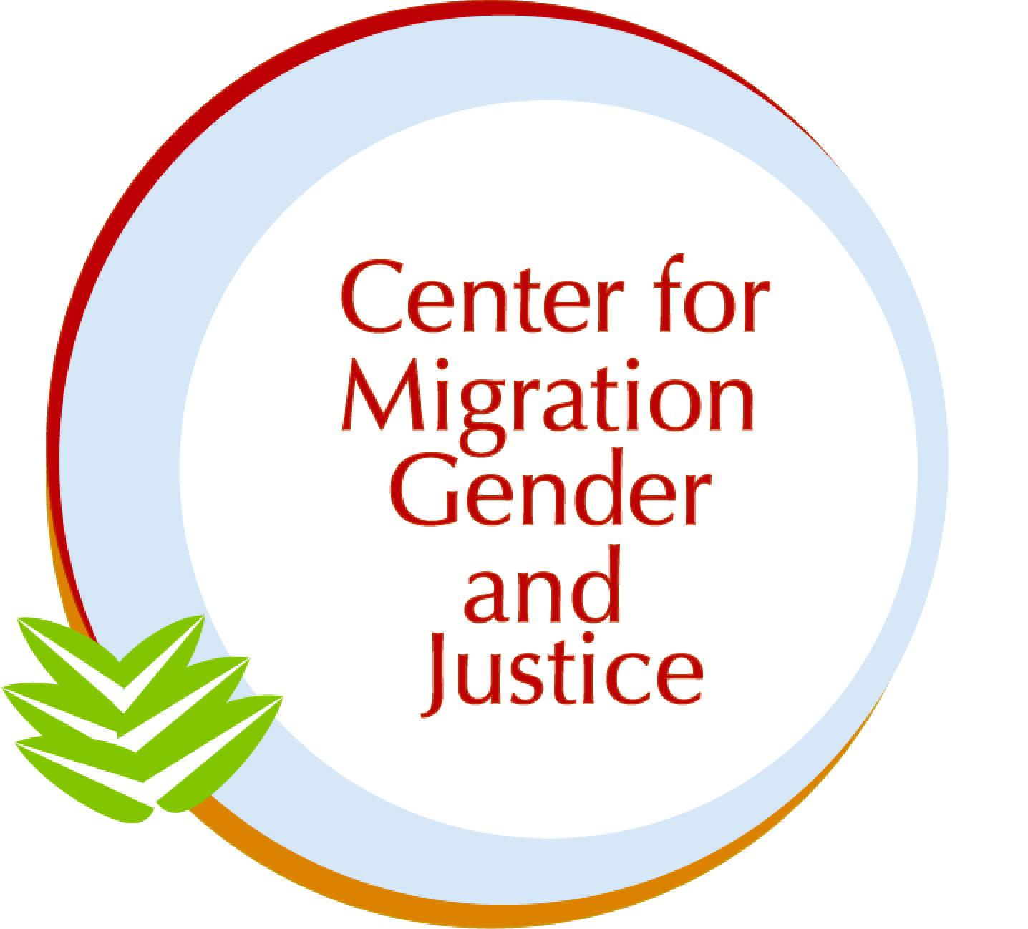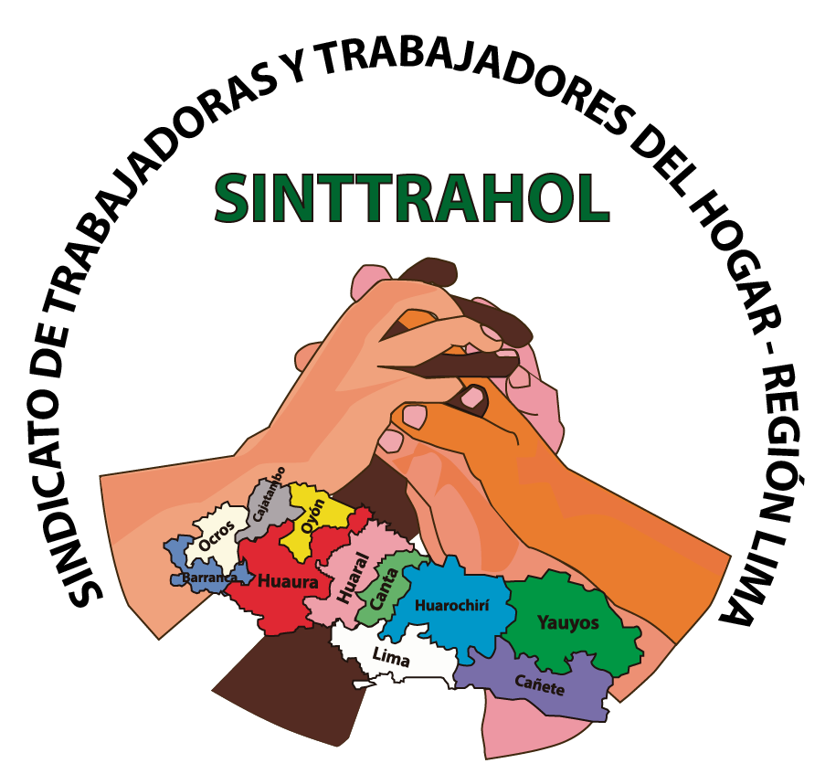

Submission to the Committee on Migrant Workers (CMW)

SHADOW REPORT: Peru

November 1, 2024

Authors: Mehar Allidina and Dr. Lara-Zuzan Golesorkhi

The Center for Migration, Gender and Justice is a migrant- and women-led non-profit, non-governmental organization that addresses human rights at the intersection of migration and gender through research, advocacy, and education. Within our areas of expertise, this report speaks to Peru’s implementation of the Convention on the Protection of the Rights of All Migrant Workers and Members of Their Families in light of the Committee’s 39th session (2-13 December 2024). Throughout the report, the names of any alleged victims, witnesses, and perpetrators have been anonymized, and no photographs of alleged victims, witnesses, or perpetrators have been included.

In this report, we employ a working definition of migrant as a person who moves away from their place of usual residence, whether within a country or across an international border, temporarily or permanently, and for a variety of reasons. The term includes a number of legal statuses of persons. We identify the specific legal status when necessary and/or to amplify particular experiences.

Migration and Gender in Peru’s Second Report:

Historically, Peru has been a country of emigration but has recently become a transit- and destination country for migrants in the region. Between 1990 and 2022, 3,490,519 Peruvian nationals emigrated from the country (52% women, 48% men), most of them aged between 20 and 39 years old (Integral Human Development, n.d.). The main countries of destination included the US (30.2%), Spain (15.6%) and Argentina (13.5%). Between 2010 and 2022, 216,808 Peruvians returned to the country, averaging 16,678 returns each year. Of those that returned, 51.5% were women and 48.5% were men.

As a transit country, Peru has seen migrants from Cuba and Haiti with onward mobility to Brazil, Chile, or Ecuador; as a destination country, Peru has hosted more than 1.5 million migrants from Venezuela since 2017, out of which 50.6% are women and 49.4% are men (Ibid.; IOM, 2023). More specifically, between August 2013 and March 2024, the National Migration Office recorded 39,197,701 migrants in the country (86.8% Venezuelan, 3.3% Colombian, and 1.1% Ecuadorian). Regarding migrant workers, the National Migration Office reported 436,599 entries from 2015 to 2023, and the Ministry of Labor and Employment Promotion reported 72,028 migrant worker contracts in 2023, again most of them signed with Venezuelans (CMW/C/PER/2).

Peru has enacted policies to protect migrant workers and their families, assuring equal rights such as Law No. 31047 on Domestic Workers and Decision No. 545 (Andean Instrument on Labour Migration), the latter which promotes equality, non-discrimination, and social security for Andean workers. In 2017, the Supreme Decree No. 015-2017-RE was passed under the National Migration Policy (2017-2025). The Decree aims at “promoting the integration of foreigners into Peruvian society, guaranteeing the protection, care and defense of their human rights and cultural identity” (Dedios and Ruiz, 2022). Furthermore, the Temporary State Permit and Law No. 1350 (Immigration Law) offer important frameworks for migrant workers’ rights, especially as it pertains to accessing services under Peruvian law.

Outside of the Convention on the Protection of the Rights of All Migrant Workers and Members of Their Families, Peru has ratified the following international agreements that are relevant to migrant workers: Protocol to Prevent, Suppress, and Punish Trafficking in Persons Especially in Women and Children, ILO Migrant Workers (Supplementary Provisions) Convention, Ibero-American Multilateral Agreement on Social Security, Convention on the Elimination of All Forms of Discrimination against Women (CEDAW), ILO Convention 189 (Domestic Workers Convention), and ILO Convention 190 (Violence and Harassment Convention). Additionally, Peru has also implemented the Global Compact for Safe, Orderly, and Regular Migration (GCM) which holds important provisions for migrant workers such as Objective 6 (facilitating fair and ethical recruitment and safeguarding conditions that ensure decent work), Objective 10 (prevent, combat, and eradicate trafficking in persons in the context of international migration), and Objective 15 (provide access to basic services for migrants).

Despite these legal-institutional frameworks in place, the intersection of migration and gender largely remains overlooked in the state party report as it pertains to labor protections of women, girls, LGBTQIA+, and gender-diverse migrants.

Based on an analysis using our Gender-Migration Index (GMI), a guidance tool for gender-responsiveness and migration-inclusion in policy, we find there is moderate mention of, engagement with, and commitment to gender dynamics in CMW/C/PER/2. The 39-page-long document refers to women, girls, gender and gender-based considerations 42 times in total with a complete absence of reference to LGBTQIA+ and gender diverse migrants.

For example, while the state party report acknowledges principles of equality and non-discrimination regarding migrant workers, the report does not adequately address risks of sexual harassment in the workplace, wage gaps, or the risks of sexual and labor exploitation. This is of particular concern in policy areas such as domestic work, trafficking, and health.

In Peru, there are around 420,000 domestic workers (as of 2021), the vast majority (95%) of them are women (EUROsociAL+, 2021). Domestic work is characterized by high levels of informality that result in many of the workers lacking access to social security and receiving low wages. Gendered labor protection challenges also exist in the context of trafficking. Between 2021 and 2022, most trafficking victims were of Venezuelan nationality, yet limited access to services for LGBTQIA+ survivors have been reported (US Department of State, 2024). This is happening despite Peru having criminalized sex and labor trafficking in Article 129 of its Penal Code. In terms of health, the provision of sexual and reproductive health services accessible to migrant women persists as an issue given documentation requirements. Based on a survey focusing on the Venezuelan population in the country, 73% lack any type of health insurance and 55.8% reported lack of healthcare being their biggest challenge (UNHCR, 2024).

Based on the information provided, we recommend that the Committee ask the Government of Peru the following questions and that these enquiries are included in the Concluding Observations:

- How does Peru plan to streamline provisions of the GCM in areas such as domestic work, trafficking, and health into national policies and programs?

- What mechanisms are in place to provide health resources and sources for those in irregular status and/or informal labor precarity that lack documentation?

- Considering the absence of legal protections for LGBTQIA+ and gender diverse migrant workers, what steps is Peru taking to address discrimination based on sexual orientation and gender identity, in line with Article 7 (non-discrimination) of the Convention on the Protection of the Rights of All Migrant Workers and Members of Their Families?

Domestic Work

The state party report highlights the adoption of Law No. 31047 on Domestic Workers. The Law grants migrants legally present in Peru the same rights and obligations as national domestic workers in line with principles of equality and non-discrimination (CMW/C/PER/2). Yet, it is also noted that in regards to labor inspections conducted between 2013 and 2023, only “22 inspection orders were executed and finalized” in the case of domestic workers (p. 21). This must be reconciled against gendered labor protection challenges that present themselves in labor sectors such as this one.

For instance, Peru’s Ministry of Labor regularly conducts inspections to ensure compliance with laws governing migrant workers’ employment conditions. These inspections cover aspects including remuneration and the provision of social assistance. As has been reported, in some instances, only verbal contracts have been issued to domestic workers which make it harder to verify and regulate working conditions and wages (IDWF, 2024). This has informed the prevalence of low wages with domestic workers often earning a monthly income that is below the legal minimum and has heightened vulnerabilities to labor exploitation all in the absence of accessing social assistance (EUROsociAL+, 2021). These gendered labor protection challenges continue albeit Law No. 30709 (Equal Pay Law) being in place which prohibits discriminatory remunerations or salaries based on gender.

Additionally, domestic workers who experience sexual violence face stigmatization and tend to refrain from reporting cases of assault due to limited information about their rights and legal processes for obtaining justice (IDWF, 2024). On this account, Peru’s recent ratification of ILO Convention 189 (Domestic Workers Convention) and ILO Convention 190 (Violence and Harassment Convention) present positive developments along with the existence of Law No. 30364 (Law to Prevent, Punish, and Eradicate Violence against Women and Members of the Family Group) that offers legal protections against violence and discrimination. Inquiries around the implementation of these frameworks deserve more attention.

Based on the information provided, we recommend that the Committee ask the Government of Peru the following questions and that these enquiries are included in the Concluding Observations:

- How does Peru plan to improve its inspection procedures regarding the remuneration and the provision of social assistance for domestic workers? Are there any plans to increase the frequency and regularity of said inspections, especially given the country’s ratification of ILO C189?

- What steps has Peru taken in the implementation of ILO C190 in terms of the prevention, mitigation, and response of violence and harassment perpetrated against domestic workers?

- Are there any good practices to be reported from the Action Plan for Compliance with the Rights of Domestic Workers (2019-2021) and are there any intentions to expand this Action Plan aligned with the enforcement of Law No. 31047 on Domestic Workers? What specific measures were taken as part of the Action Plan that ensure the rights of migrant workers in the informal sector as per Article 25 of the Convention on the Protection of the Rights of All Migrant Workers and Members of Their Families which guarantees equal treatment in terms of working conditions?

Trafficking

Trafficking forms a fundamental aspect in the state party report, reflecting numerous initiatives and policies that address trafficking offenses. Of specific note is the adoption of a protocol for the care of victims of trafficking and migrant smuggling, and the granting of special resident status by the National Migration Authority if the trafficking offense was committed in Peru (CMW/C/PER/2). Despite these existing measures and Decree No. 1350 (Migration Decree) classifying victims of trafficking as “vulnerable persons,” there remains an absence of recognizing specific forms of trafficking that are relevant in the migration context and that carry gendered implications, namely sexual and labor exploitation.

As per Peru’s Penal Code, sexual and labor trafficking is criminalized with a penalty of 8 to 15 years of imprisonment and includes slavery as well as forced labor and sexual exploitation in its provision. According to the US Department of State, in 2023, 1,275 cases of trafficking were investigated out of which 590 were suspected of sex trafficking, 519 of labor trafficking, and 166 cases were unspecified. Data disaggregated by gender and migration status remains largely missing and so does funding towards survivor protection for which the government has heavily relied on civil society in terms of resources and services.

Similarly, while the Ministry of Women and Vulnerable Populations has a network of 429 emergency centers through which trafficking survivors can access legal, social, and psychological help, there appears to be no tracking of the number of individuals assisted at these centers because in most cases, it is required to legally file a complaint in order to avail services rendered. This poses a challenge for migrants in irregular status and/or in informal labor precarity given the pervasive fear of consequences for one’s migration status and/or potential for retaliation. According to a recent survey on living conditions of Venezuelans in Peru, 80% work in the informal and unregulated labor sector (UNHCR, 2023).

These ongoing issues regarding sexual and labor exploitation in relation to trafficking occur in light of Peru having ratified the Protocol to Prevent, Suppress, and Punish Trafficking in Persons Especially in Women and Children, having implemented the GCM, and having signed bilateral agreements with Argentina, Chile, Bolivia, Colombia, and Ecuador to increase international efforts in combating the trafficking of persons such as by organizing specialized training protocols for police officers throughout the country.

Based on the information provided, we recommend that the Committee ask the Government of Peru the following questions and that these enquiries are included in the Concluding Observations:

- What measures is Peru taking to enhance data collection as it pertains to trafficking as well as sexual and labor exploitation that is disaggregated by gender and migration status?

- How is Peru planning to address the prevalence of sexual and labor exploitation in the context of trafficking? More specifically, in what ways are concerns about irregular migration status/informal labor precarity overcome in the provision of services and resources for trafficking survivors?

- How does Peru intend to improve equitable access to resources and services for LGBTQIA+ and gender diverse trafficking survivors?

Health

A connected area of concern to both, domestic work and trafficking, is health. In the state party report, Peru emphasizes its universal health coverage established through Emergency Decree No. 017-2019 which “authorizes any person residing in the country who does not have health insurance to join the comprehensive health insurance system and to receive free coverage under the Basic Health Insurance Plan” (CMW/C/PER/2, p. 4). However, access to this system is conditioned by having a valid foreigner’s card or resident status.

This again, brings challenges to those in irregular status and/or in informal labor precarity such as domestic workers and trafficking survivors. For example, as testimony from our partners at SINTTRAHOL, a union of domestic workers based in Lima, shows, out of 380,000 domestic workers, only 90,000 have health insurance and pension provisions which means that the majority is not registered in the national health system. These workers are prone to diseases such as bone pain, muscle pain, and allergies, and may also suffer from deteriorating mental health given the strenuous working conditions.

Further so, although the state party report notes that sexual and reproductive health services are provided across the country through the health centers of the Ministry of Health and the regional governments, and that these services are free of charge and not contingent on an individual’s nationality, almost 7 out of 10 migrants from Venezuela are not registered in the national health system due to obstacles like bureaucratic constraints in obtaining a foreigner’s card, out-of-pocket costs, and delays in issuing documents (Dedios and Ruiz, 2022). Important to highlight here is that Peru currently faces the highest maternal mortality rate in Latin America and migrant women without legal documents are more reluctant to use health services in Peru, further exacerbating the issue.

Based on the information provided, we recommend that the Committee ask the Government of Peru the following questions and that these enquiries are included in the Concluding Observations:

- How does Peru plan to minimize the bureaucratic obstacles and out-of-pocket costs associated with access to healthcare of those in irregular status and/or in informal labor precarity that do not have a valid foreigner’s card or resident status?

- What mechanisms are in place to address the high levels of maternal mortality of women in Peru, including migrant women?

- How does Peru intend to enhance collaborations with unions like SINTTRAHOL to address health and other needs of domestic workers in respect to the country’s ratification of ILO C189?

References

CMW/C/Per. 2024. International Convention on the Protection of the Rights of All Migrant Workers and
Members of Their Families Committee for the Protection of the Rights of All Migrant Workers and
Members of Their Families.

Eurosocial. (2021). “EUROsociAL+ Contribuye a La Formalización de Las Personas Trabajadoras Del
Hogar En Perú.” Retrieved from https://eurosocial.eu/en/actualidad/eurosocial-contribuye-a-la-formalizacion-de-las-personas-trabajadoras-del-hogar-en-peru/

International Domestic Workers Federation. (2024). “Enough Violence and Harassment against
Domestic Workers in Peru! - International Domestic Workers Federation.” Retrieved from
https://idwfed.org/calls-to-action/latin-america-calls-to-action/enough-violence-and-harassment-a
gainst-domestic-workers-in-peru/

Integral Human Development. (n.d.). “Migrants & Refugees Section - Peru.” Retrieved from
https://migrants-refugees.va/country-profile/peru/.

International Organization for Migration. (2023). Migration Trends in the Americas. Retrieved from
https://americas.iom.int/sites/g/files/tmzbdl2601/files/documents/2024-07/en_tendencias_marzo_junio_2023_vf_.pdf.

UNHCR (2024). Annual Results Report 2023 Peru. Retrieved from https://reporting.unhcr.org/sites/default/files/2024-06/AME%20-%20Peru%20ARR%202023.pdf.

United States Department of State. (2024). 2024 Trafficking in Persons Report: Peru. Retrieved from https://www.state.gov/reports/2024-trafficking-in-persons-report/peru/.

Dedios, María, and Felipe Ruiz. (2022). Recent Migration to Peru: The Current Situation, Policy
Responses and Opportunities. United Nations Development Programme. Retrieved from
https://www.undp.org/sites/g/files/zskgke326/files/2022-10/PNUDLAC-working-paper-35-Peru-EN.pdf

