SANCRC secretariat
Save the Children South Africa
Emmanuel Modikwane
Programme Manager: Child Rights Governance
Telephone number: +27 (0)124307775
Email: Emmanuel@savethechildren.org.za
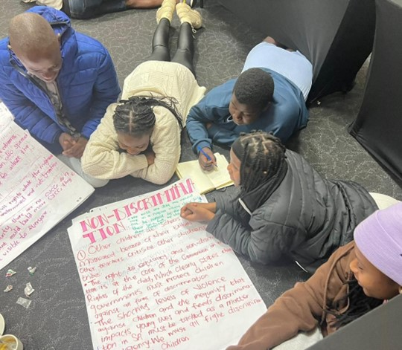

Children's Written Inputs on 3rd to 6th Periodic Report by South Africa (August 2023)

Contact Details:
SANCRC Secretariat
Save the Children South Africa
Emmanuel Modikwane
Programme Manager: Child Rights Governance
Telephone number: +27 (0)124307775
Email: Emmanuel@savethechildren.org.za
n's written inputs on 3rd to 6th Periodic report by South Africa

Table of Contents
Table of Figures 2
Introduction 3
New developments 4
Border Management 4
Online Child Sexual Exploitation and Abuse 5
COVID-19 5
Child participation and National Plan of Action for Children: 6
General measures of implementation 7
Legislation 7
Allocation of resources 9
Data collection 10
Dissemination, awareness-raising and training 11
Child rights and business 12
General principles 15
Non-discrimination 15
Best interest of the child 15
Respect for views of the children 16
Civil rights and freedoms 17
Birth registration, statelessness, & nationality 17
Access to appropriate information 18
Violence against children 18
Freedom of children from all forms of exploitation and GBV 18
Family environment and alternative care 19
Children with disabilities 19
Basic health and welfare 20
Adolescent health 20
Impact of climate change on the rights of the child and environmental health 21
Education, leisure and cultural activities 21
Special protection measures 23
Asylum- seeking, refugee and migrant children 23
Economic exploitation 24
Conclusion 26

Table of Figures
Figure 1: "We are not even sure if the government is listening to us when we speak to them." 8
Figure 2: “A bonded society - the picture shows a clean sky and happy people which we do not have anymore because the environment is polluted. This shows a world where children get to raise their voices and be heard." 13
Figure 3: Verbal abuse children still face in their homes 19
Figure 4: Verbal abuse from teachers in schools 23
Figure 5: We are concerned about how poverty leads to child labour 25
Figure 6: Child Labour 26

Introduction
Through the South African National Child Rights Coalition (SANCRC), Save the Children South Africa (SCSA) facilitated a 2-day consultation workshop in Benoni, Gauteng with 23 local children (12 female, 11 male), aged between 14 and 16 years old. The objective of the workshop was to provide children with a platform to comment on the South Africa periodic report in continuation of the work that was done in the children’s submission to the Committee to inform the List of Issues Prior to Reporting. The consulted children are SCSA project participants from the Limpopo and Gauteng provinces and are actively involved in two areas of SCSA programming (Child Rights Governance; Migration and Displacement) in these provinces.
Prior to the workshop, the children were provided with a child-friendly version of the State report that was developed by SCSA’s Research team. The 14-page document summarized the State report in language appropriate for 14 to 16 year olds, with child-friendly explanations of terms and concepts to assist in the children’s understanding of the matters discussed in the report.
Following a refresher session on the UNCRC, periodic reports and the purpose of the day, the children worked in groups of 4 to comment on sections of the State report. The children were encouraged to include their own experiences and those of other children in their communities in their analysis and comments on the State report, as well as to use resources available (e.g., internet on their cell phones) to research and review the current state of the country. Each group then presented its inputs to the larger group for open discussion of the topic and inclusion of inputs from the rest of the children.
As such the following report details the thoughts of the children that were consulted on the realities of children’s rights and how the UNCRC is being implemented in the country in relation to the South African Government’s (SAG) periodic report to the Committee. Apart from facilitating the consultation, Save the Children provided support in the reporting process by collating the children’s inputs from the consultation into this report. The children were further engaged by reviewing and making corrections to the drafted report in order to validate SCSA’s synthesis of their inputs through the Young People who were previously consulted for the List of Issues Prior to Reporting. The report had comments, reviewed and signed off by 86 (46 Females, 42 Males) across the country.
In addition to the workshop, Save the Children further sought out inputs from the ambassadors of the Nelson Mandela Children Parliament particular to children’s participation in South Africa. The parliamentarians, aged between 14 and 16 years old, shared their inputs during the week of the Nelson Mandela Children’s Parliament sitting, which was held on 14 July 2023 in Bisho, Eastern Cape.
The structure followed for the report mirrors the State report by the clusters of rights in the UNCRC. The children consulted opted to submit both written inputs as well as to share their thoughts through drawings, both of which are included in the report. In addition to making comments on the new developments as included in the State’s report, the children commented on the following clusters:
- General measures of implementation
  - Laws, allocation of resources
  - Data collection
  - Dissemination, awareness-raising and training
  - Child rights and business
- General principles
  - Non-discrimination
  - best interest of the child
  - Respect for the views
- Civil rights and freedoms
  - Birth registration, statelessness, and nationality
  - Access to appropriate information
- Violence against children
  - Freedom of children from all forms of exploitation
- Family environment and alternative care
  - Children with disabilities
- Basic health and welfare
  - Adolescent health
  - Impact of climate change on the rights of the child
- Education, leisure and cultural activities
- Special protection measures
  - Asylum-seeking, refugee and migrant children
  - Economic exploitation
The report then concludes with a summary of key issues discussed and includes recommendations to the Committee for the State.

New developments

Border Management
Item 11. South Africa is developing new legislation to establish a Border Management Authority, for the integrated management of borders and modernisation of the country’s border management capability using advanced technology at all ports of entry. The Border Management Authority will bring together relevant state agencies to protect the territorial integrity of the country, including prevention and detection of cross border crimes as well as detect use of fraudulent travel documents, and smuggling of persons and goods, through deployment of multi-disciplinary teams with capability to detect and identify possible victims of trafficking and related offences.

As children in South Africa, we support the decision to update the border management system and advise that the SAG needs to hire people to people who are dedicated to do their jobs right. The border system needs to be stronger and more modern (with the right equipment) to make sure we protect our borders, and we need to learn from other countries that are doing this well. we need police to be more visible and patrol our borders more. Border patrol needs to be paid fairly for their jobs, so they do not take bribes.

Online Child Sexual Exploitation and Abuse
Item 19. Government strengthened partnership with key stakeholders such as the Films and Publications Board (FPB), UNICEF and CSOs whereby all cases of Online Child Sexual Exploitation and Abuse (OCSEA) are reported to the FPB and removed from social media.
Social media apps such as TikTok, Twitter and Instagram have harmful content to children that is easily accessible. With such content being so easily accessible, children are impacted by the negative effects of pornographic content as well as content can be triggering and detrimental to child mental wellbeing such as online bullying content.

More needs to be done to make sure children cannot access harmful content, by urging social media companies to make harmful content less accessible to children. Government needs to monitor these companies to make sure this is followed and updated regularly as needed.
Educating all children of the dangers of online spaces and how to use the internet safely is important to help combat and prevent OCSEA.

COVID-19
Item 36. The COVID-19 pandemic negatively impacted the sector thereby affecting the lives of children, families and communities. The pandemic increased vulnerabilities of children manifesting in the increase of cases of child abandonment, orphanhood, poverty because of increased job losses and unemployment, mortality, poor health, family stress, domestic violence, and others. The introduction of lockdown in March 2020 resulted in the immediate temporary closure of all ECD programmes and partial care facilities. School closures led to disruptions in schooling and school-feeding schemes.
Treatment of communities, including children, by the SA National Defence Force (SANDF) during the COVID-19 lockdown to ensure that people stayed in their homes during the hard lockdown and curfew was unnecessarily aggressive. Many reports show that SANDF soldiers abused the law by using violent ways to carry out their orders under the lockdown levels which resulted in the serious harm and even deaths of community members, which also affected the lives of the children who depend on them. Given the above, we express concern for future emergencies when public servants, like the military, must be deployed to protect all who live in this country.

We acknowledge the steps government took to protect its citizens from COVID-19, however we do note that, on the ground, most communities did not benefit from efforts that were supposed to lessen the effects of the pandemic, like the high unemployment rates, on households. Food distributions were not being implemented in all communities, meaning children in many households continued to go without food needed to survive.

During the pandemic, education stopped for all school-going children which left many children with no way of learning and is still having effects on us to this day. Understanding that a hard lockdown was needed to reduce the spread of COVID-19 and save many lives, we believe the government’s COVID-19 response did not prioritise children’s rights to an education. The closing of schools also showed just how deep inequality is in South Africa. While some children were able to stay up to date with their learning by using online platforms and resources from their schools, many more children from public, no-fee paying schools did not have the resources to learn online from home. The Department of Basic Education did not respond quickly enough to provide educational resources and as a result, we are still trying to catch-up to the learning time we lost. Funding needs to be provided so public schools are equipped with the resources needed to meet children’s educational needs in the 21st century as well as prepare them for future emergencies that may threaten our right to education.

The COVID-19 pandemic changed our lives forever causing and leaving traumatic effects to our mental health. We believe that the SAG did not do enough to help us deal with the emotional and mental health issues that the pandemic caused us, with its response focusing heavily on addressing physical needs while neglecting the mental health of children experiencing trauma. Access to mental health support during and even after the pandemic has not been made available for children to access, even though we continue to experience the effects of the pandemic.

Child participation and National Plan of Action for Children:
Item 38. The NPAC further makes provision for Government to support child participation initiatives. Currently the draft child rights advocacy strategy puts children as an important constituency for consultation on matters pertaining to their rights, programmes, and services.
We do not see efforts to raise awareness and educate the public, especially children, about all national plans and strategies for child rights and development, including the NPAC. Rural areas are the most constantly excluded from public education as these communities are left out of knowing what government has planned for children in the coming years. Without knowledge and full understanding of these plans, children cannot be active in supporting the call to action by monitoring government’s implementation of these plans. This major gap in our participation does not communicate that the government regards children’s participation as important in decision-making.
It is our view that children’s participation is not at the level that it should be in a country that ratified the UNCRC more than 30 years ago. We still face the issue of not being given feedback on what resulted from our participation after we have been consulted by government and other duty bearers. We want to be involved in decision-making processes where adults make decisions that affect us.

General measures of implementation

Legislation
Item 41. The Social Assistance Amendment Act (Act No. 16 of 2020) was enacted to provide for additional payments linked to cash-transfers including payment of benefits to child headed households. This Act came into operation on the first of June 2022 and will improve the social assistance programme to benefit orphans and vulnerable children.

Item 44. In the beginning of 2022, the President signed into Law the following three legislations to strengthen the fight against Gender-Based Violence.
- The Criminal Law (Sexual Offences and Related Matters) Amendment Act.
- Domestic Violence Amendment Act.
- The Criminal and Related Matters Amendment Act.

Item 45. The Customary Initiation Act (Act no.2 of 2021) came into operation in September 2021 to, amongst others, provide for the effective regulation of customary initiation practices.

Social assistance amendment act: Even though more money is being given to child headed households, the money is still not enough to sustain these households for the month.
The Gender-Based Violence (GBV) laws are welcomed as we hope to see these laws contribute to the much-needed reduction of GBV in the country and seeing more justice for those affected by these crimes. We do note, with concern, that these laws have a strong focus on the adults involved in GBV matters, especially women. VAC specifically is often grouped with GBV and overlooked as a national concern. Even though these two issues are strongly linked according to research, we as children believe that these are still issues that need their own attention in the legal and budgeting frameworks to be fully addressed. We request this so the addressing of children specific issues can be prioritised.
The Limpopo and Eastern Cape provinces are where most illegal initiation schools operate and record many deaths of boys and men yearly. Though the Customary Initiation Act has been in effect since 2021, children in these provinces are still being taken through this cultural practice by unqualified individuals from unregistered initiation schools. This means that although the law may be in place, adherence to the law is still a problem that needs the intervention and supervision of the Department of Cooperative Governance and Traditional Affairs and the SAPS.
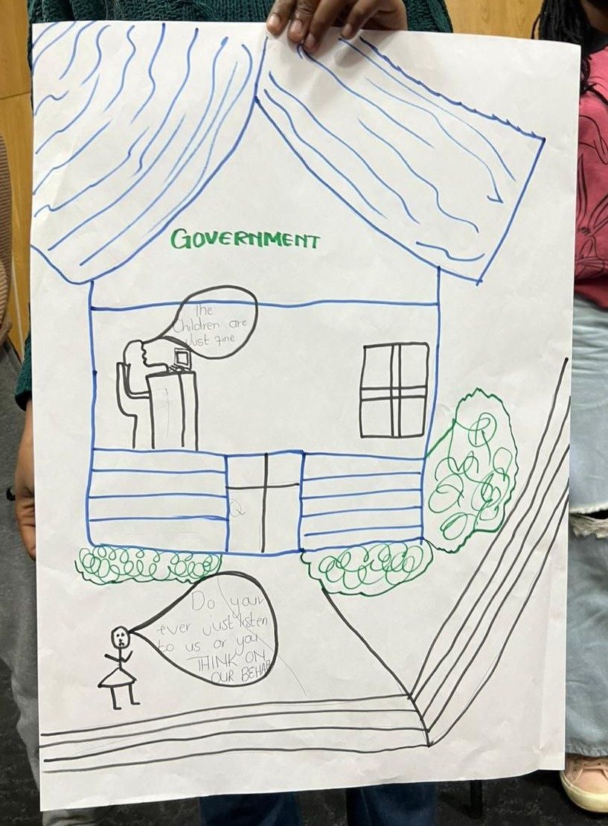
Figure 1: "We are not even sure if the government is listening to us when we speak to them."

Allocation of resources
Item 54. Regarding the eradication of corruption and ensuring a transparent, accountable and participatory budgeting process, in particular by involving children, Government introduced several initiatives to prevent and root it out:
- The National Development Plan (NDP) 2030, in Chapter 14, proposed various measures to fight corruption, which include: holding leaders to account for the use of public funds, putting in place a legislative framework to fight corruption, and establishment of institutions dedicated to fighting corruption.
- Government is developing a National Anti-Corruption Strategy (NACS) in line with international standards, focused on societal behaviour change and it will contribute towards achieving the NDP goal of a resilient anti-corruption system for South Africa.
- The President, during the State of the Nation Address, emphasised the importance of dealing with corruption and indicated that discussions are underway with the judiciary for the creation of special court rolls against corruption cases, amongst others.
Although anti-corruption plans are in place, but we on a daily basis still see the effects of corruption because South Africa continues to be a highly corrupt country. A result of corruption is that children’s issues do not receive the budget that should be allocated to address children’s needs.
“A basketball court in my community was supposed to be fixed but money that is supposed to be used to service the community is not used for the right thing by the municipality.”

“During COVID, money that was supposed to be used to get PPE for people disappeared.”

Although the government has created anti-corruption plans to stop corruption, we as children have not seen any change in the rife corruption that is happening in all levels of government. For example, the SAPS is very corrupt as it is common for people to have to bribe officers in order to close cases or are expected to pay officers to receive the help that they need. Officers often do not do their jobs, and nothing happens to them when this is reported.
“There are no actions taken [against corruption] leading to more injustices happening within the country.”
Item 55. In addition to the measures outlined in paragraph 22, additional measures were taken to ensure that children are not affected by regressive measures taken in response to COVID-19:
- The Care Dependency Grants for children with disabilities which were about to lapse during the pandemic did not lapse and Government continued to pay these grants throughout the pandemic from March 2020 to March 2021.

We acknowledge and appreciate the increase in the Care Dependency grant during the pandemic. This helped to support many families as so many people were unemployed at the time.
Such increases need to continue for all other grants, as South Africa still experiences the effects of the pandemic. Grants need to be raised so grantees can support themselves, especially with the increase of food prices.

Data collection
In our research on child specific data such a VAC, we looked for data on children specifically, but we found it very difficult to find. We believe that this is because data on adults like GVB statistics is seen as more important. The data we can find such as crime statistics on murder, rape, assault often combines children’s statistics with the adult statistics so we cannot see how many child victims are being affected.
In particular, sexual offences against boys are not being researched enough and so not much data is not available on these offences.
What also influences the availability of data on child victims is the treatment of children by police officers when children try to report crimes that have happened. Officers of the South African Police Service (SAPS) do not take children seriously when they are reporting cases and children are even victimised by the very police officers that are supposed to protect them. This has led to children not wanting to report crimes to the police and so the statistics on the abuse of children does not show what is actually happening in our country.

We recommend that the SAG makes sure that all police stations are safe, child friendly spaces and that cases reported by children are taken seriously and dealt with in a child friendly manner by all SAPS officers.

Dissemination, awareness-raising and training
Item 58. Government is implementing awareness-raising programmes and campaigns targeting children and the broader community on various areas relating to the Convention through media platforms, in schools and communities to educate, raise awareness and strengthen the protection and promotion of the rights of children such as:
- Annual commemoration of the National Child Protection Week (CPW) is aimed at raising awareness on the rights of children.
- Implementation of 365 days Child Protection Programme of Action in line with outcome three of the National Development Plan.
- Provision of systemic road safety awareness lessons through Life Orientation, as part of the curriculum offering for all learners across the grades.
- School campaigns to educate learners about the legal implications of sexual offences and their rights, as well as available victim-support services in the criminal justice system.
- School-based crime awareness engagements like bullying, cyber bullying, substance and drug abuse, dangerous weapons, sexual offenses, xenophobia, occult-related crimes and gangsterism and the necessity to report all forms of child abuse.
Laws, policies and plans that are developed by government on all social issues may be in place, but we are not aware of them as children and the public in general. Pamphlets, brochures and other ways of educating the public are good ways to reach communities that do not have access to technologies, however, more diverse ways to educate everyone need to be implemented by the government, including making information available in all languages, having accessibility for people with disabilities, and making sure that all information is distributed with child friendly documents as well.
“I as a child cannot protect myself if I am not educated about trafficking, child pornography and other forms of harm that children can be in. South Africa has a problem of educating its citizens.”

We acknowledge the effort that government has made to educate the public on important issues as mentioned in the report. However, we have found that the education of children on these issues, mostly, not being done by the government. We have also found that the government’s efforts to raise awareness does not happen regularly enough to have a long-lasting impact and they are not happening in all schools and communities. It is only when CSOs take the time to educate us on our rights, how to hold government accountable and how to advocate for change, do we get the knowledge and support needed to truly participate as children. We want the government to work more with organisations in South African communities to reach more children, for longer, and educate them on these topics.

Sidebar: The children’s feelings about the report process
At the end of day 1 of the consultations with the contributing children, the children were asked to reflect on how they felt about the work they had done to comment on the SAG’s report and their contributions to the reporting process in general. A key takeaway from the children’s reflections was that being involved in this process brought to light new and very important information about their rights and the SAG’s responsibilities to uphold the values of the UNCRC in all levels of government. The children are of the view that such information should be made available to all children within the South African borders by the SAG.
This further supports the children’s claims that children in South Africa are not being sufficiently, if at all, educated about their rights, how to vocalise what they or other children experience and how to engage in the accountability processes that children have the right to contribute to. The children’s statements communicate the SAG’s inaction to prioritise the empowerment of children in South Africa which would ensure that children are involved in decision-making processes that affect their lives and wellbeing. That responsibility has been left solely to civil society to action, as mentioned by the children themselves, with limited resources.

Child rights and business
Item 67. Government places specific focus on strengthening regulatory framework and intergovernmental cooperation between spheres of Government responsible for ensuring clean air in the priority areas. Government is developing priority area regulations which will support the priority area air quality management plans implementation efforts.
Recent events in South Africa has shown that climate change is having a major impact in SA. Particularly the province of KZN has been subject to a number of natural disasters that have impacted the lives of thousands of people, children included.
Businesses pollute communities and environment which goes against the right to clean and safe environments. Businesses are contributing to climate change and children are not aware. Children are not being made aware of the effects of companies like mining. Laws that are meant to protect the environment are not being followed by businesses and nothing is being done about that. Corruption in government is a major reason that allows businesses to not follow these laws. Government officials allow companies that are harmful to the environment to practice without first understanding how the companies will impact the environment and nearby communities. We believe that there is more focus on bringing more money into the country for selfish reasons than making sure that the impact of these businesses doesn’t risk the lives of South African communities, especially children.
We acknowledge the Environmental Management Act (Act no. 107 of 1998) which puts into law ways to keep businesses from harming the environment and the communities around them. we do think that the government should do more to educate people, including children about climate change, what contributes to it and what we can do to help prevent it. We want a campaign to educate children about the effects on the environment and what can be done about the harm that is being done to the environment.

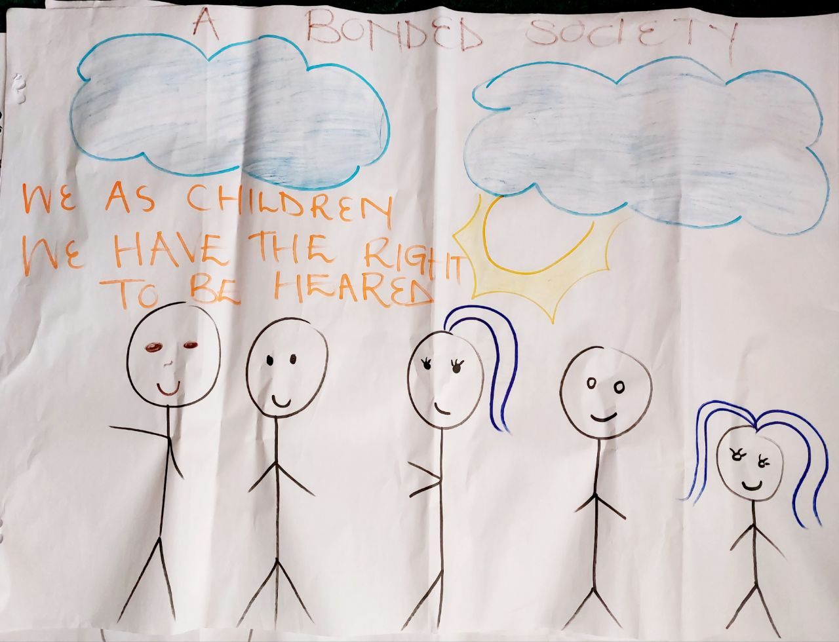
Figure 2: “A bonded society - the picture shows a clean sky and happy people which we do not have anymore because the environment is polluted. This shows a world where children get to raise their voices and be heard."

Harm to the environment is not only being done by businesses, but also people from vulnerable communities themselves. Illegal operations take advantage of the vulnerabilities of people living in poverty by putting their lives at risk to make money. An example of this from recent years and that South Africa is battling with is the illegal mining that is happening in many parts of the country. Illegal mining is harming the environment, destroying infrastructure and threatens the lives of many families and children. The problem is getting worse and needs serious intervention by the Government.
“The gas leak in Boksburg because of the Zama Zamas [illegal miners] is hurting the environment. If the government was inspecting such businesses, this heartbreaking event could have been prevented.”

Alcohol consumption by children is extremely high in South Africa. The recent Enyobeni Tavern tragedy where 21 children died at a tavern in the Eastern Cape, is just one example where children drinking alcohol is being normalised in communities and children are harmed as a result. Alexandra township in Gauteng has more than 15 formal and informal taverns. How these businesses operate is not being routinely checked by SAPS and so many of them sell alcohol to children in South African communities. The problem of adolescent substance use is being encouraged by both formal and informal businesses. This is only possible because regulations on the selling of alcohol are not being enforced by law enforcement. Due to the high corruption in the country, law enforcement itself accepts bribes from local taverns to continue selling alcohol to children and allowing them into their establishment. Communities cannot protect their children by reporting these businesses because their complaints are not taken seriously and cases are overlooked by law enforcement.
The advertisement of alcohol on all forms of media - TVs, radios and social media - is encourages and glamorises the consumption of alcohol and this is promoted at times when children are most actively engaging these types of media which is harmful for children to constantly view. We recommend that government create alcohol reduction campaigns with children in and out of school. The minimum drinking age should be increased to 21 years of age to protect children from the effects of alcohol on children directly and our communities as a whole. The monitoring of taverns needs to be strengthened and harsh penalties need to be enforced for businesses that do not comply with the regulations.
To address an important factor that contributes to adolescent substance use, we recommend that access to safe and child-friendly recreational areas be made available to children in all communities for children to have safe ways of entertaining themselves and engage with other children outside of school. Currently, most communities do not have access to these facilities and the only way for parents to provide entertainment for their children is if they pay for most programmes, which most families cannot afford.

General principles

Non-discrimination
Item 83. Furthermore, the Protocol on Discrimination on the Prevention, Elimination and Management of Unfair Discrimination in Schools is being developed to assist schools with the processes and measures they should undertake in preventing and managing unfair discrimination.
Item 90. To eliminate in practice, exclusion and discrimination against children, Government remains committed to ensuring that children, regardless of their race, nationality, ethnicity or legal status (citizenship or not) have access to all available basic services in the country.
Tribalism, which happens in both schools and communities, contributes to the discrimination of children. Tensions between different cultural groups lead to violence and exclusionary practices that affect children. This takes place mostly in non-urban areas affecting children of these communities. Our government and the SAPS need to intervene in these acts of violence that come from this form of discrimination. The people of these communities need to be educated on the devastating impacts of tribal discrimination against others and how this affects children. School campaigns, in all schools, can also contribute as a solution to stopping discrimination. All these efforts to educate the public need to be budgeted for by government.
Migrant children and their families continue to be discriminated against because they do not have documentation and because many still have negative feelings towards people who are not South African. Police services refuse to help migrant families when they are in need because they are undocumented.

Best interest of the child
Item 108. The National School Nutrition Programme, (NSNP), which derives its mandate from the Constitution, 1996, ensures implementation of the right to basic nutrition and the right to have access to food.
Efforts to reduce the nutrition needs of children through the National School Nutrition Programme in schools are acknowledged but the reality is that in many cases not enough food is being provided for the children who should benefit from the programme. Fights in schools have happened between learners as a result of food running out and not being able to cover all students that are supposed to benefit from the National School Nutrition Programme. In some cases, what prevents the NSNP from happening successfully is the need for more cooks to be added to school staff to cater for the needs of the school. In many of our schools, there may only be 4 or 5 cooks in a school that has to prepare meals for around 800+ learners.
Other issues that children experience with the National School Nutrition Programme are that:
- The NSNP does not take into accounts the dietary requirements of children. Some children cannot eat certain foods but have to because it is the only food available, and they come from homes that cannot feed them. this needs to be taken into consideration.
- The quality of the food is sometimes not up to standard because of the unclean areas where the food is prepared. Schools need to be trained on food safety, hygiene and sanitary standards to ensure that the food prepared is acceptable. Funding is also needed for these schools, so they have the materials needed to maintain sanitary cooking areas.

Respect for views of the children
Item 113. To address traditional attitudes and practices of caregivers and professionals working with children, regarding child participation, Government capacitates professionals in various disciplines on matters relating to the rights of children. The list of trainings provided to professionals is provided in paragraph 60.
Item 114. To promote meaningful participation of children in the family and community, Government adopted the Child Participation Framework which ensures strengthening of child participation as mandated by the Constitution.
Even though the SAG is training professionals and caregivers on child rights, the reality is that children’s views are not being respected and taken seriously in practice. Children are not being consulted in local government processes. We believe that this is because of personal beliefs that adults, professionals or the adults in our homes or schools, still hold and are not willing to put aside for our benefit.
South Africa has adopted and launched the Child Participation framework in 2018. In the 5 years since the framework’s adoption, most people, more importantly children, have still not been informed of or trained on the framework. We believe that it is for this reason that children still struggle to form a meaningful part of the public decision-making processes that affect them, either in local government or national government sittings. Meaningful child participation in the country is still a challenge. Children are not involved in policy development, law reform or any other matters affecting children unless the government or some other duty-bearers want to use children for public appeal without any real, long-term commitment to the participation of children in public discussion and decision-making. We recommend that all structures working with children be given full capacity especially on involving children and respecting their views. We are never consulted in the planning and design stages of programmes except when adults want us to participate in temporary engagements.
"During child protection week, we are being called to take part in the programme that we don’t even know. We are just told what to say and mostly it will be the room full of adults”.

- Nelson Mandela Children’s Parliamentarian

Civil rights and freedoms

Birth registration, statelessness, & nationality
Item 129. Furthermore, the SAHRC published a position paper in 2019 on access to services for undocumented children. The position paper contains progressive recommendations and government departments provide regular feedback on efforts to improve access to services by undocumented children.
Migrant children are still not being treated like South African children. They do not enjoy the same rights as children who are born in South Africa. They continue to be discriminated against in their school and in their communities. People in communities need to be educated on migrant issues, how the child protection system works and the presence of CYCCs for migrant children and other vulnerable children. The Department of Home Affairs is not carrying out its duty to protect all children as the department takes too long to process documentation for undocumented children leaving them stateless. There are not enough CYCCs to house children in need of care. More need to be built.

Even though all children are supposed to receive all basic services even though they do not have documentation, in certain communities that may only have one clinic, documentation is still required from children who do not have to receive the needed medical assistance making the only healthcare facility not accessible by undocumented children. Government needs to make sure these services are accessible to these children.

Access to appropriate information
Item 132. In terms of measures to improve digital inclusion for children and promote equality of access and affordability of online services and connectivity, the State of ICT Report published by the Department of Communications and Digital Technologies identified access to connectivity as a basic need because it determines access to education, health, and work, which are fundamental for our survival. Further, the Department adopted the National Digital & Future Skills Strategy which seeks to improve digital inclusion to populations at risk of exclusion such as children in rural areas and youth who are out of work. Furthermore, various cities, as part of their Smart City Initiatives have set up “hot spots” in schools, community libraries and parks to offer free access to Internet to children and community members.
South Africa has a great digital divide that means a large number of the population still do not have access to technology due to poor or a lack of infrastructure, mainly in townships and rural areas. As the SAG reported, this is a basic need which means that a majority of the country does not have access to important information that affect their lives. Many do not even know it exists. We acknowledge the SAG’s efforts to give access by creating hotspots and providing resources to schools. Government should make sure there are ways to distribute information to these communities while they do not have digital access. Resources must be made available in schools and libraries.

Violence against children

Freedom of children from all forms of exploitation and GBV
Item 134. Government adopted the National Child Care and Protection Policy in 2019 to expressively prohibit corporal punishment of children in all settings including the home environment and to promote positive parenting practices and programmes. Furthermore, the Constitutional Court decision [2019] ZACC 34 in the matter between Freedom of Religion South Africa v Minister of Justice and Constitutional Development and Others declared "reasonable and moderate chastisement" of children as a form of physical discipline by their parents to be unconstitutional. This Judgement is law in the country.
Not all schools are following the banning of corporal punishment. Even though the National Child Care and Protection Policy has been adopted by the SAG, the practice in schools and in homes has not changed since. We believe this is because the government is not monitoring the implementation of the ban on corporal punishment in these spaces. Children must know where and how to report when corporal punishment is being used to discipline them and we need to be assured that we will not be victimised for reporting. The DBE needs to have staff on the ground who inspect schools randomly to ensure they are following the National Child Care and Protection Policy, including in private schools.

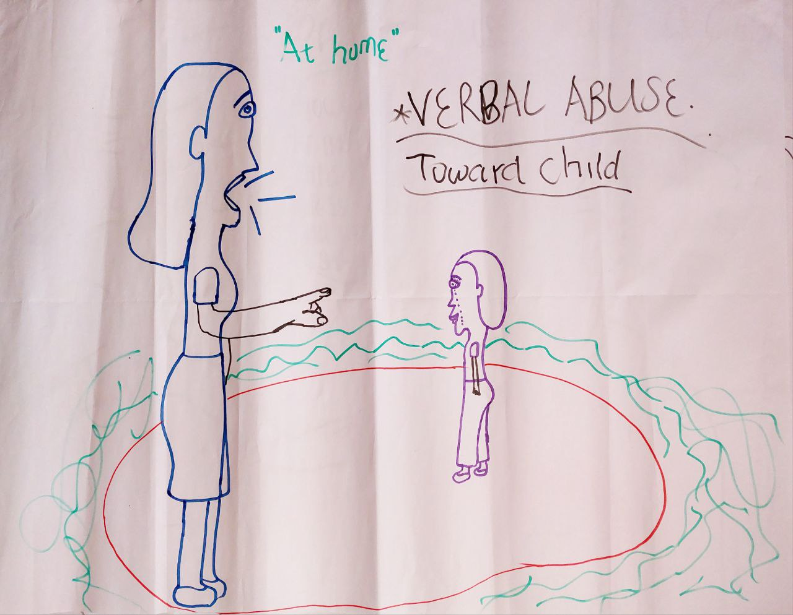
Figure 3: Verbal abuse children still face in their homes.

Family environment and alternative care

Children with disabilities
Item 173. The State is committed to providing children with disabilities rehabilitation and reasonable accommodation for full inclusion in all areas of public life. Section 42 (8) of the Children's Act, makes an unequivocal recognition of the special needs of children with disabilities, and requires that the 'children's court hearings must, as far as is practicable, be held in a room which is furnished and designed in a manner aimed at putting children at ease, and accessible to disabled persons.
Children with disabilities are not being accommodated in public life enough, especially those who live in townships and rural areas. Many are unable to learn due to the lack of resources and accessibility in both special and mainstream schools to allow for them to enjoy school activities just as all other children do.
Many children with disabilities are unable to access health services because of the lack of trained professionals to assist them in healthcare facilities such as local clinic. Local facilities are often understaffed and do not have the needed resources to assist in providing health services to children with disabilities (e.g., wheelchairs, sign language interpreters)

The SAG needs to fund public facilities such as schools and healthcare facilities in rural areas to ensure children with disabilities receive the services they need and can have the same enjoyment of the basic human rights that they are entitled to.

Basic health and welfare

Adolescent health
Item 193. Health Care Workers, especially Professional Nurses, are trained on Adolescent and Youth Friendly Services (AYFS).
Item 194. The department of health, in partnership with its stakeholders, provide training on the National Adolescent and Youth Health Policy 2017, to all partners working with young people, since 2017.
The existence of a National Adolescent and Youth Health Policy and training of health workers is a positive step towards providing adolescents with services and care, however, adolescents in many communities are still not able to access health facilities that address their needs. Most local clinics are overwhelmed with the need from the community, while being understaffed and while not having the resources needed to provide all services needed to everyone (e.g., lacking medications, medical instruments, etc). Clinics, and the Healthcare workers would provide the services, are not child friendly even though the policy says they need to provide youth friendly services. These issues as well as personal beliefs that adults still have about children and how we should be treated, continue to be the biggest barriers that make healthcare facilities inaccessible to teenagers.

“My sister that went to the clinic to test for pregnancy and was treated unfairly at the clinics by the nurses. They did not consider how she was feeling psychologically about the pregnancy and were asking her questions about why she was sexually active. Healthcare workers do not do their work in a child friendly way.”

Boy children need more education on teenage pregnancy so they can also prevent it better. Most efforts to educate adolescents about teenage pregnancy are directed at girl children and not both genders. Campaigns in communities are needed to educate both boys and girls about teenage pregnancy and how to prevent it. Contraceptives need to be made more available. Teenage pregnancies as a result of abuse by family members and community members are still a big problem in communities.

Impact of climate change on the rights of the child and environmental health
Item 216. To ensure that rights of children and our vulnerable poor are protected from the impacts of climate change, the following initiatives were developed/implemented:
- National Climate Change Response (NCCRP): policy which seeks to ensure management of Climate Change impacts through interventions that build and sustain social, economic & environmental resilience and emergency response capacity to reduce vulnerability.
- Draft Climate Change Bill acknowledges that climate change poses an “urgent threat to human societies and the environment”, and requires an effective, progressive, and coordinated response. It indicates that all affected parties must address all priority sectors; and identify and map risks and ‘vulnerabilities’ across the areas, ecosystems, communities and households likely to be affected.

South Africa has always had an issue of unsafe infrastructure, especially in non-urban areas which has been a threat to many children’s wellbeing. Infrastructure continues to not be safe for children’s use and this has increased with the devastating effects of climate change in recent years. When crises like the 2022 KZN floods or the 2023 tornadoes in KZN happen, the fixing of infrastructure are not prioritised so they can be safe to use again. As a result, children are left with no choice but to use dangerous infrastructure to function in their everyday lives, for example, to get to school every day. Local and national government needs to better anticipate these emergencies and have improved responses that prioritise the wellbeing of children affected. Response times also need to be improved when these catastrophic events happen, to ensure that children are not left at risk of further harm as a result.

Climate change is getting worse while we see no change in what government is doing to stop it. More and more children are being affected.

Education, leisure and cultural activities

Item 233. To improve access to enrolment and quality of early childcare and education, including strengthening support for parents and caregivers, Government continues to subsidise ECD programmes countrywide at R17 for 264 days. Financial assistance is also provided to registered or conditionally registered ECD programmes that will supplement the costs associated with providing quality ECD services.
Subsidies for ECDs are not enough to cover the needs of the children. At R17 per child, it is too little to cover the educational and nutritional needs for the children. The children from these centres are still facing malnutrition and not enough is being done to combat this.

ECDs are too expensive, making it difficult for parents to pay for their children to enrol. This is especially true for parents in low-income communities who are unable to afford the many expenses involved for their children to attend ECD – they need to pay fees and they need to pay for transport to the schools. As a result, many children lose out on an ECD education which is very important for their learning. We recommend government fully support ECDs financially including providing food and paying ECD practitioners fairly.

Item 237. Efforts continue to be strengthened to provide access to free and quality basic education for all children, through provision of funding to the no-fee schools which provide much-needed relief for households, that removes the need for parents to pay fees at such schools.

We acknowledge the free basic education that is being provided, but we make note that the quality of the education received at no-fee schools is not to the standard that allows children to become fully ready for life after school. Resources in these schools are lacking which stands in the way of children from receiving a full education. There are big differences between provincial infrastructure and resourcing (e.g., Gauteng schools are much more resourced than Limpopo or Eastern cape schools). There are schools in the Eastern Cape where children do not have classrooms, are still using pit toilets and do not have textbooks for learning. Resourcing of schools is not being monitored which is affecting the quality of education that children can receive. Children are forced to share books for example in order to do their schoolwork. We demand ongoing monitoring of the budgets allocated to education in individual provinces.
Though nutrition programs have been implemented to prevent early school leaving and exclusion, ongoing corporal punishment in schools pushes learners to leave school early. The government has not done enough to address this. Verbal abuse form teachers that learners face in schools make it an environment where children cannot learn. Positive discipline teaching is not being done in schools. Teachers need psychosocial support to be able to do their jobs well and treat us well in school. Teachers need counselling help as much as learners do. Schools take advantage of the fact that children do not know their rights, where to report corporal punishment and that corporal punishment has been banned in all settings. Children need to be educated and the ban needs to be enforced in schools with regular check-ins to make sure that schools are following the law.

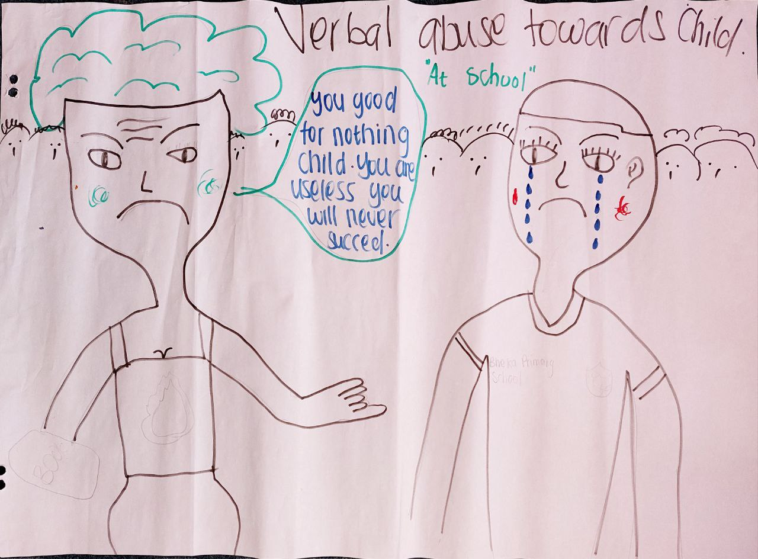
Figure 4: Verbal abuse from teachers in schools

Sanitary dignity programmes are not being carried out in all schools. Boys are also in need of products for sanitation purposes especially those that come from impoverished homes. Things such as roll-on and other toiletries are needed for boys as much as sanitary pads are for girls. Sanitary programmes need to broaden to include boys and be mandatory in all schools.

Special protection measures

Asylum- seeking, refugee and migrant children
Item 257. The Refugee Act provides for entitlement and protection of asylum seekers and refugees. Accordingly, asylum seekers and refugees have full legal protection, which includes rights set-out in Chapter two of the Constitution. Illegal foreign children have rights to basic education as a court concluded that Section 39 and 42 of the Immigration Act 13 of 2002 do not prohibit them into school and do not prohibit provision of basic education to them.
Migrant children are disadvantaged because proper data is not being collected on them this is because they do not have documentation. Police services refuse to help migrant families when they are in need because they are undocumented.
Apart from school, children without documentation are not able to enjoy extra-mural activities within their schools. This keeps them from enjoying activities the same as other children.

The children of the asylum seekers who have been camping outside of UNHCR offices in Pretoria since 2019 are not receiving their entitled rights. Living on the streets puts them at risk of physical harm and all the children are not going to school. The SAG needs to work with the UN to resolve this issue so the rights and needs of these children and their families are met.

Economic exploitation
Item 263. The country enhanced efforts aimed at improving the monitoring and enforcement of laws and policies on child labour by collaborating and building monitoring alliances with different stakeholders including NGOs in acting against child labour. This involves conducting advocacy sessions to raise awareness on what child labour is, the content of the national legislation and what activities are considered hazardous and constitute worst forms of child labour. These measures aimed at reporting, prosecuting transgressors are followed within the prescripts of the legislative framework around the protection of children.
Informal businesses, like community tuckshops (spaza shops) or car washes, exploit vulnerable children, especially migrant children, for cheap labour. Child labour continues in this way because informal businesses are not monitored for child labour as formal businesses are. We believe that a way to resolve this is by having local municipalities monitoring and enforcing their by-laws. The municipality must work hand-in-hand with its community to be informed of the businesses that are not following the by-laws. All communities need to be educated on the child labour laws and how they can report this practice to their local municipality.

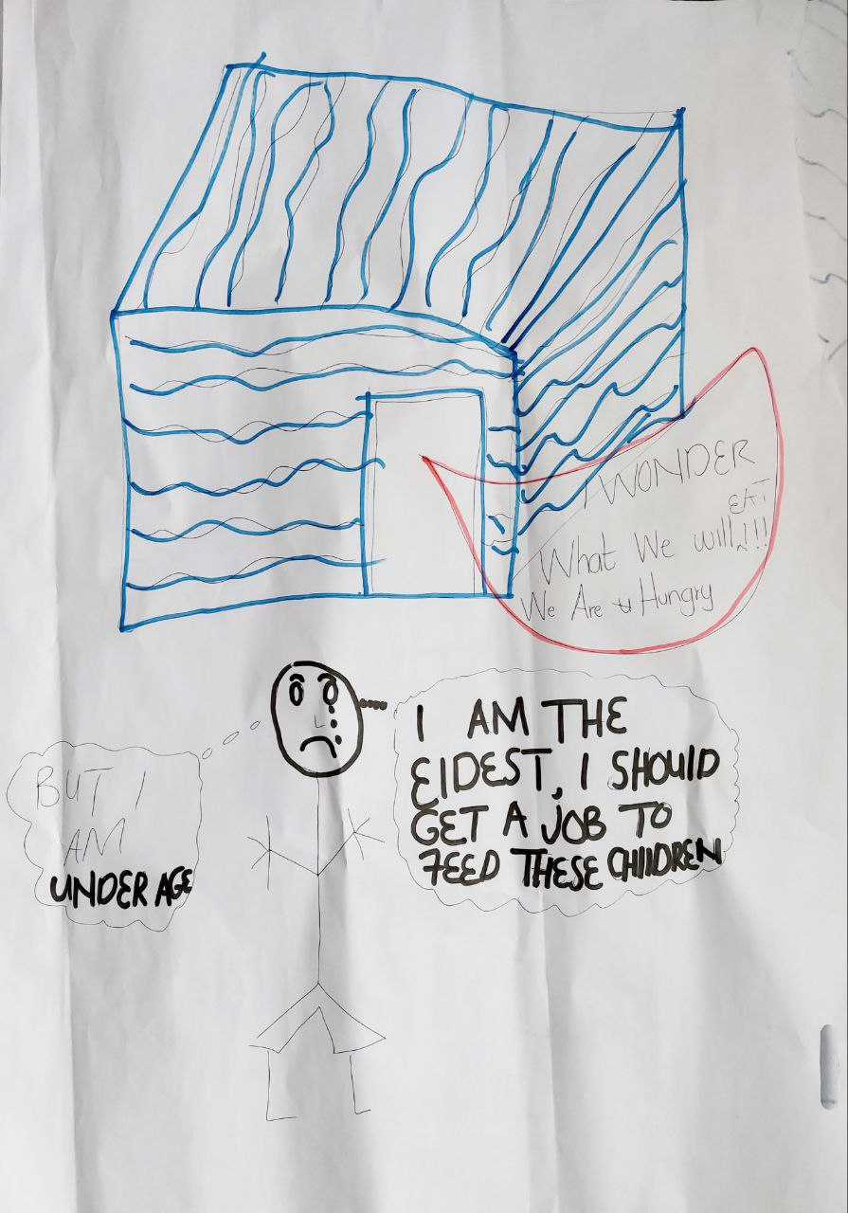
Figure 5: We are concerned about how poverty leads to child labour.

Many children, and their communities, do not know of the laws, policies, and action plans that are in place due to the lack of communication from government. Communities need to be educated and informed so they can contribute to the fight against the exploitation of children, especially in townships and rural communities. The SAG’s communications of plans must be extended to, and prioritise, disadvantaged communities, rural areas, people living with disabilities, and children. We want to see an effort from government to include those who do not have access to digital tools.

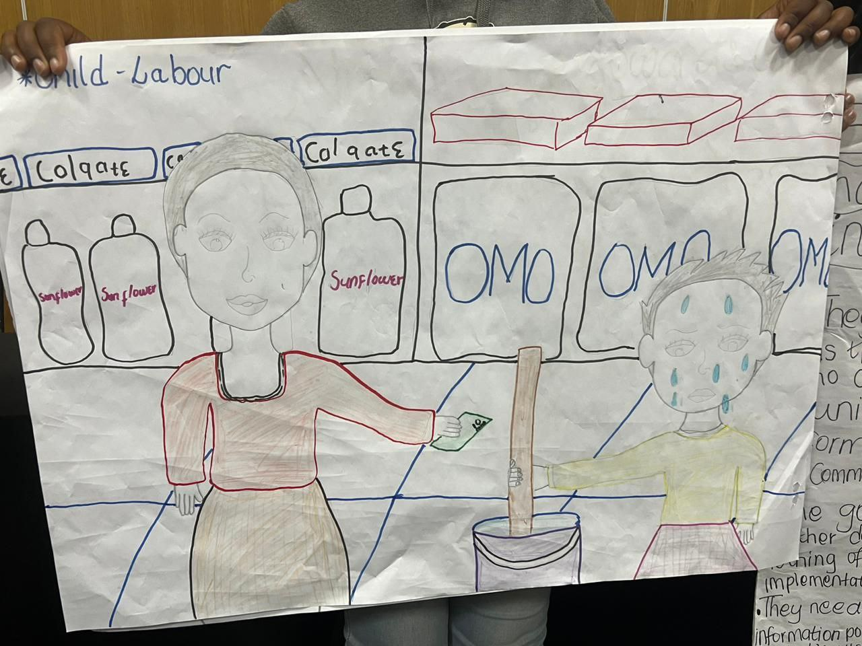
Figure 6: Child Labour

Conclusion
“The government is not showing a true reflection of what our reality is in South Africa in this report. We continue to suffer while they present a different picture than what is actually happening to treaty bodies.”

In summary:
- We acknowledge that the SAG has many laws, policies and plans in place to make sure that the children in South Africa have all that we need to survive and grow, but it is not doing enough to put the plans that they develop into action to the point that we can see is making a change for the better. We are not seeing the effects of these plans in our communities. This is shown in the SAG's report because it does not speak to how many lives have changed as a result of these laws, policies and plans.
- Many issues continue to be a problem because the SAG does not keep to its commitment to educate the public on social issues. We, as children in South Africa, cannot meaningfully contribute to important discussions, keep the SAG accountable to its promises to implement the UNCRC and contribute to decision-making processes that affect us as children if we are not informed in ways that are accessible to us. The work the SAG has done to educate children on their rights and the work that it plans to do, has been short-lived and does not aim to reach all children in the country. We want the SAG to prioritise public education and distribution of information that caters for all children to access and understand.
- Services that are meant to be made available to children in our communities such as protection services (SAPS), health services (clinics), civil services (Home Affairs) and education (educators) are still far from being provided in line with the general principles of the UNCRC. Children every day are unable to benefit from these services because they fear being treated like "second-class citizens" or even victimised by public servants. The SAG has not had enough of a hand in making sure the UNCRC's general principles are being carried out in local communities so children everywhere can enjoy the rights that they are entitled to.
- South Africa is known to be the most unequal country in the world, we agree with this assessment as we see the large inequalities in education, service delivery, emergency response (COVID-19), etc. in our communities. We are seeing that we are not receiving the same treatment or being given the same opportunities as wealthier communities.
- The development of a law, policy or plan of action are only the first steps in addressing issues that affect children and their communities. To truly address these issues, the SAG has the responsibility to make sure:
  - All children are informed of all matters that affect us,
  - All children have opportunities to fully understand what we are being informed or educated about,
  - All children have the necessary resources and platforms to action and monitor change,
  - There is a committed and invested government as well as other duty bearers that are equipped and motivated to support child participation and uphold the principles of the UNCRC,
  - There is a working system that governs all matters relating to child rights so all duty bearers can be held accountable for their responsibilities to children.

Kristin L. Dunkle and others, Prevalence and Patterns of Gender-based Violence and Revictimization among Women Attending Antenatal Clinics in Soweto, South Africa, American Journal of Epidemiology, Volume 160, Issue 3, 1 August 2004, Pages 230–239, https://doi.org/10.1093/aje/kwh194 Naeemah Abrahams, Rachel Jewkes, “Effects of South African Men’s Having Witnessed Abuse of Their Mothers During Childhood on Their Levels of Violence in Adulthood”, American Journal of Public Health 95, no. 10 (October 1, 2005): pp. 1811-1816. https://doi.org/10.2105/AJPH.2003.035006

